Kay Brown

Research in Practice
ADAD5004

Tutor - Julia Lockheart

Word Count – 2487

The significance of Japanese Kimonos, the symbols and motifs that adorn them and the significance of the colour usage.

Key Words: Kimono
Symbols
Colour

Pierces said that semiotics -
is a sign of something which stands to somebody for something in some
respect or capacity. It addresses somebody, that is, creates in the
mind of that person an equivalent sign, or perhaps a more
developed sign. That sign which it creates I call the interpretant of
the first sign. The sign stands for something, its object. It stands for
the object, not in all respects but in reference to a sort of an idea.
(Peirce1931-58, 2.228) (Chandler 2007, p 29)

A Kimono is an object of clothing that symbolizes the Japanese culture. We can use this
object to both identify and to separate it from a western piece of clothing. It is an
interesting item because it remains a constant in Japan to this day. The motifs and colour
still have meaning to the designer, maker, dyer of the fabric, as well as the person who
commissions or purchases the garment as well as the wearer. It can sometimes be handed
down in generations and then too it will still have meaning. The Motifs found on Kimonos
are the signifier and they signified a meaning to the observer and wearer. As a gift of a
kimono the motifs found on it were often chosen because they signified wealth and good
health. The motifs act as a code and the person who can see the motif has to decode it.
There is an assumption that the decoder understands the meanings behind the motifs to
further understand the significance of it as well as the visual beauty. Japanese people at the
time knew the meaning of the symbols as they were passed down by folk-law. “Those who
share the code are members of the same ‘interpretive community’”. (Fish 1980, 167ff., 335-6, 338). (Chandler 2007, p 194)

Image 1 (Taken out)
The History of the Kimono goes back to the Heian period 794 – 1192 and was designed to
fit all body shapes. It was made up of simple straight pieces of fabric. According to the V&A
Museum the poor Japanese people wore this as an outer clothing and the wealthy as a
simple undergarment. It was cool in the summer and with a lining it became a warm
winter garment. As a society Japanese men and women frequently sat on the ground and
a kimono made it possible, and they could keep their dignity whilst doing so. Green (2017)
notes that in the Edo period 1603-1868 it became an outer garment for all. It had smaller
armholes, and this gave it the name of a kosode which meant small sleeves. It was worn by
all, rich or poor, young, or old. People all looked the same. During this period Japan became
stratified. Because of this the wearers status needed to be shown. They used fabric types
and colour to show this as well as adding motifs and symbols as messages and stories.
The word kimono that we now know came in the Meiji period 1868-1912. During this time,
women were encouraged to continue wearing a kimono. The men were expected to under
Meiji law wear trousers as in western fashion. Government officials and the military had to
wear western clothing for official functions. The government realised that the kimono as a
garment was not something that the men could easily fight in. To make an army, they
needed the men to be able to move with ease. Therefore, they would be required to wear
trousers as the western men did. The wearing of the different clothing is a way of a
separation from the past to the future. This is a statement to onlookers who could interpret
the wearing of the clothing as a symbol of wearer’s acceptance of the governments wish.
The poor had to mend and wear their kosodes until they fell apart and therefore, there are
not many of poor people’s left to look at. The wealthier seen in museums. Others are likely
to be carefully kept and handed down as treasured possessions to each new generation.
Culturally Japanese people could show their status using more expensive fabrics. The fabric
itself was an object that could be used as a symbol because it can be an interpreter of their
wealth and position in society.

Siffert/JSTOR (1992) tells us that pattern books were produced so that Japanese people could
decide on what symbols and motifs to use and what they meant. These books were called,
hinagata bon which sometimes means design book or pattern book.
“But, in discussing the Japanese e-hon, or picture book, the expression was used more specifically to refer to the block-printed books of kosode or kimono patterns, the first of which was published in 1666 and was entitled Shinsen O-Hinagata (A New Selection of Respected Patterns).” (Siffert/JSTOR,1992)

Story telling in pictures can be thought of as symbols. Telling a story to the viewer. It can be wishes like symbols of good luck and prosperity or to protect against bad luck. These would have come from folklore passed down through generations. Sometimes they depicted stories from Japanese history or from Japanese literature.
Here is an example, “Chrysanthemums near or floating on a stream was a scene often depicted. This was about a boy called “Kikujido, whose vindicated innocence and miraculous gift of eternal youth became the subject of the No play of the same name” (Noble-Richards 1990, p. 176).

According to Noble-Richards (1990, p.181). There was a boy who worked as a page for the Chinese King. His name was Kikujido. One day he was wrongly accused of insulting the King, this was called lèse-majesté. He was banished from the court, and it was thought that anyone banished could not survive the wilderness on their own. According to local folk-law Kikujido survived because the morning dew dripped from the chrysanthemums that overhung a stream. Kikujido drank from this stream. It is thought that this was how he survived. Folk-law said that the dew was an “elixir of eternal youth. The theme is youth immortal and innocence triumphant” (Noble-Richards 1990, p.181).

Image 2

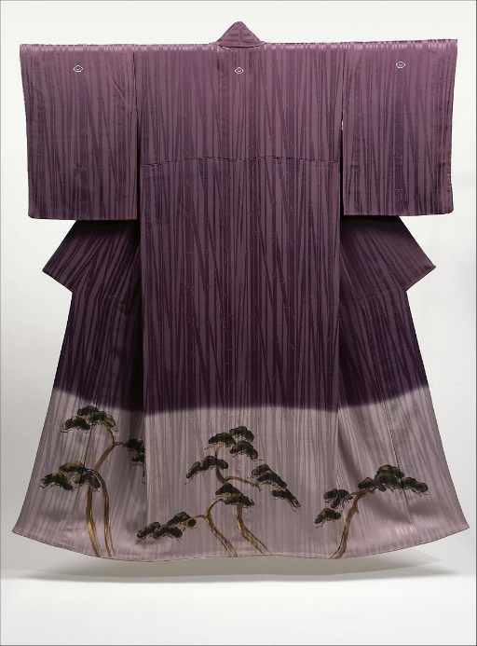
Image 3
The ‘Three Friends of Winter’ bamboo, plum blossom and pine also called shō-chiku-bai are often depicted together. They are often used by the Japanese for their symbolic use.
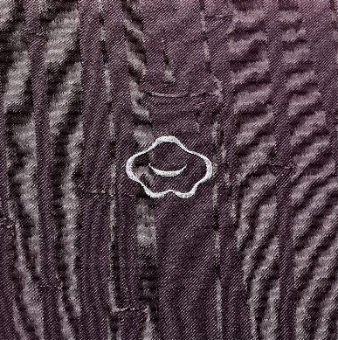 Image 4
Bamboo being the sign or object grows fast and will endure all weathers, will flex in the wind. We can interpret this as symbolising long life and endurance.
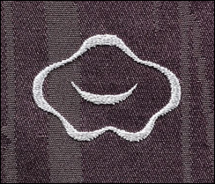 Image 5
The Plum blossom being the sign or object is the first flower to open in spring therefore it is an interpret of a fresh new start and is thought of as an auspicious symbol.
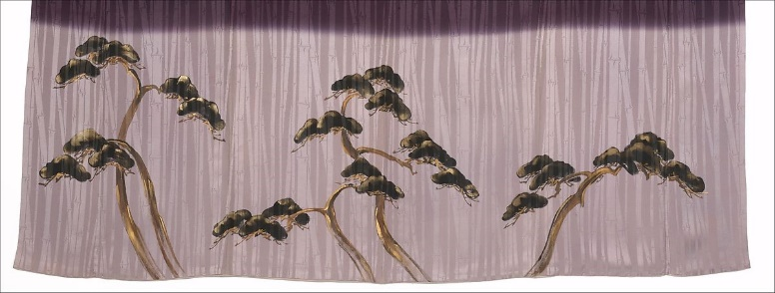 Image 6
The Pine as the sign or object is seen as enduring and so we can interpret it as a symbol of longevity.

Here is an example of an Edo wedding outer robe called a Uchikake

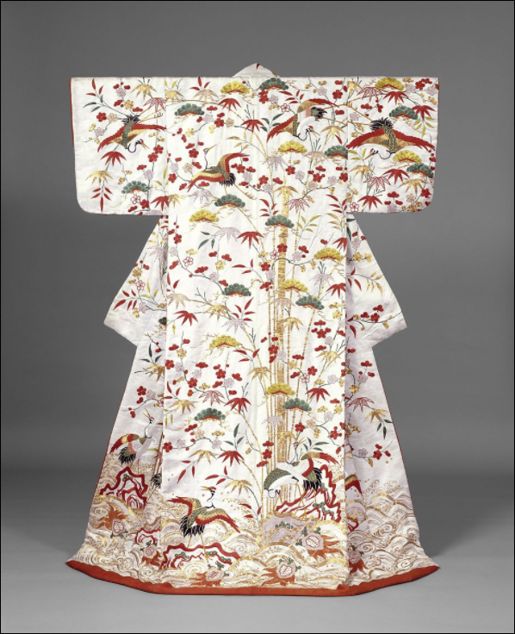 Image 7 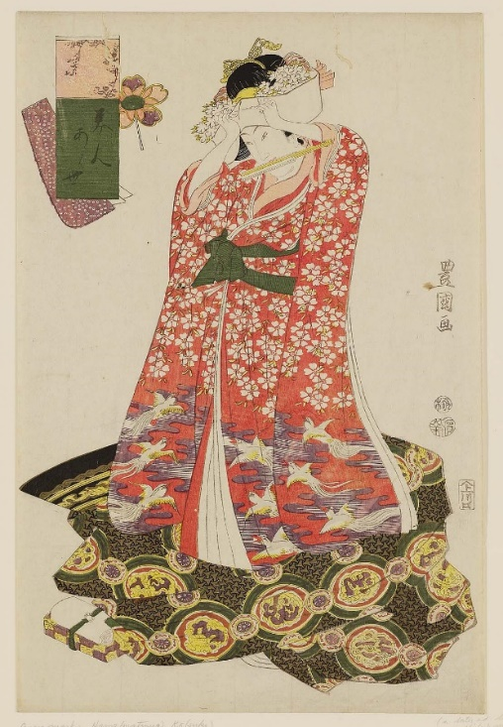 Image 8

Colours are as important as symbols on a Kimono in saying something about the wearer. According to Bincsik (2009) a bride of this period wore a kosode kimono and an outer robe of white during the ceremony as well as a white headdress, which covered another symbol/object called tsunokakushi (horns). This was to symbolise the bride agreeing that she would be gentle and obedient to her husband. Later that day the groom would present another kosode for his bride to change into. It could be red or black background with symbols of good fortune. They sometimes had gold and silver, but this depended on their wealth. (Bincsik/ metmuseum.org, 2009)

Red silk wedding kimono

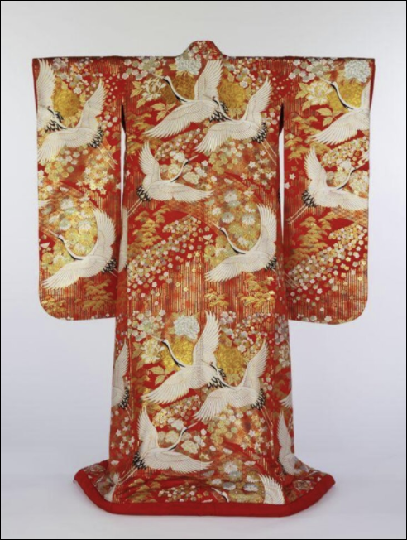 Image 9
The bride wears a white outer wedding kimono called a shiromuku for the marriage ceremony and after the husband presents his bride with a colourful kimono called a uchikake. On this example from the V&A collection we see multiple cranes flying up to the sky. The crane is “believed to live for a thousand years and to inhabit the land of the immortals, it is a symbol of longevity and good fortune.” V&A (no year). Here the crane is both object sign and the interpretant is that it is a symbol of long and auspicious life. The colour red in the background also symbolises good fortune. According to the V&A, ancient Japanese believed that dyes made from plants also harnessed its spirit as well as medicinal qualities. These properties would then be transferred to the cloth. The colours themselves had meaning, blue is made from indigo which was also used to treat insect bites as well as if the colour is worn, would repel insects as well as snakes. Purple is a symbol of undying love. This is because the plant to which the dye comes from as very long roots. It is called gromwell or murasaki. Red dye comes from the safflower also known as benibana. It represents allure and glamour. Black signifies water. This comes from the Five Elements of water, fire, wood, metal, and earth which the Japanese adopted from China from the 6th century onwards. They are also associated with direction as in season and virtue as well as colour. So black also means wisdom and winter as well as north.

Olsen (2021) tells us that red signifies blood flowing and so represents self-sacrifice, and
passion, while white represents truth and purity and signifies a fresh new start. Blue is for
fidelity and passivity. Blue is a colour considered to be lucky by the Japanese as well as the
colours yellow, purple, green and red. Green represents foliage and nature. Silver and gold
are used to denote wealth. Pink is for femininity as well as good health. Brown is an earth
colour representing durability and strength. Yellow depicts nature and sunshine. Purple
denotes royalty. Orange represents happiness and love.

According to Pound (2020) The Kimono was worn as a status symbol. Samuria women had
had structured and very restricted lives. They had to dress according to the event as well as
season and even to the time of day. Samuria men then had great success in battle which led
to them anting to show their greatness in their clothing. For special events the Samuria
women would wear ornate kimonos decorated with embroidery and prints. There was a strict
hierarchical rule and Japanese people could not enhance their status in society. Wealthier
merchants ceased the chance to show their style in their dress. Their kimonos signified their
status. The ruling elite did not like this and made new sumptuary laws which said that they
could not wear silk and certain colours. The people mainly ignored this new ruling. They
cunningly made their symbols smaller so that they would not be noticed. They made the
linings a bright colour and often wore a kimono of brown or grey with very tiny pattern of the
motifs. In the 18th century and the beginning of the early 19th century the sumptuary law was
upheld by the people and the geisha women. A geisha was a hostess who was trained
specially to entertain men in dance song and conversation. The geishas adopted this simple
style which was known as ‘iki’.

Art Nomura [internet] (no author or date) explain that the concept of iki started in the Edo period. The word
was then used to describe the geisha girls popular in Fukagawa in Edo, now known as Tokyo.
Iki means to be refined in manners and in dress and to be beautiful. In the Meireka period
Fukagawa was doing well with its harbour and commercial distribution, this brought about
a huge red-light area. Both male and female geisha were sought after. The merchants used
them to entertain their business contacts. The regular artisan customers preferred Tatsumi
Geisha who wore light make up and dressed in a plain way with colours such as grey and
had bare feet. These geishas were proud that they sold their skills and not their bodies. They
embodied the “spirit of Edo”.
According to Pound (2020) In the Meiji period (Meiji means enhanced rule) (1868-1912)
much changed. Emperor Mutsuhito concentrated on industry and the Japanese army to
form a new modern and powerful state. Japan opened its borders and so came foreign
trade. Officials including women wore western clothing. However, in the 1890’s due to their
newfound confidence as equals to the west and a want to show their heritage there was a
resurgence in kimono wearing and the demur and refined quality of their women who wore
them. The sumptuary laws were abolished and this with the new dying methods made the
new kimonos exciting and innovative. This made for a huge popularity in kimono wear which
could now be taken outside of Japan. Geisha remained in kimono as symbolising the “old
Japan”. In early 1900 Art Nouveau as well as Art Deco was popular and Japan welcomed the
inspiration. Japanese women started to combine this new style with their kimonos by
wearing western accessories. They still wanted to keep the kimono as a Japanese identity.
The Pacific war brought the end to people wearing kimonos every day and people opted for
the simpler clothing of the west.
This brought a gap in the generational knowledge of kimono wearing rules. There are now
schools that teach this ancient art.
Pound (2020) also says that Japan chose the symbolic nature of the Kimono and all that it

represented as a tool to rebrand after the war. A woman wearing a kimono was seen as

being eager to please.

An American PR company suggested that Japan Airlines have kimono clad air stewardesses to emphasise Japanese hospitality. Although this somewhat ridiculous suggestion was rejected on the grounds of air safety, the airline felt enough pressure to pander to the Western gaze that it adopted the custom of a single stewardess wearing kimono during its first-class cocktail service. Pound (2020)

In conclusion kimono, their symbols and colour and meanings behind them are a good example of semiotics. How they are seen as a thing of beauty to some and that to others who from folk-law passed down through generations of Japanese people can decode their wonderful meanings as well. Japanese rulers of the past had such strict laws has kept this garment alive. Then when they opened its boarders and let the west in, they saw the kimono as a symbol of Japan.

This has been an interesting subject to research and it links very well to surface pattern as we use motifs in our designs. I would like to further explore and look at other countries and their folk-law. I believe that both stories and the techniques they used to portray them are precious. The textile industry, the need and want for growing fashions have almost wiped out the wonderful skills of the past. They are an important part of history and therefore we should treasure them.

Bibliography

Baird. M, (2001) Symbols of Japan The Motifs in Art and Design New York Rizzoli

Chandler, D. (2007) Semiotics the Basics. 2nd Ed e-Library Taylor & Francis Chandler, D. (2007)

Semiotics the Basics. 2nd UK. Taylor & Francis Clapp, S. (2020) Kimono to Catwalk [Internet] Available at: Kimono: Kyoto to Catwalk review – the whole world up your sleeve | Design | The Guardian Accessed May 2021

Forman, L. (2017) Designers taking Kimono into the Future [Internet]Available at:
The designers taking the kimono into the future - BBC Culture Accessed May 2021

Hawley. W, (1971) Chinese Folk Designs 2nd Ed New York Dover Publications

Maker unknown (1926–89) Kimono with Design of Pines, Plum, and Bamboo (Shōchikubai) [Internet] The Met Museum. New York. Available at: https://www.metmuseum.org/art/collection/search/76985 Accessed May 2021

No Authors name or year given Iki [Internet] Available at: Art Iki / Japanese Aesthetic Sense - ART NOMURA - (nomurakakejiku.com). Accessed April 2021

Pound, C. (2020) Kimono: from status symbol to high fashion - BBC Culture [Internet] available at: Kimono: from status symbol to high fashion - BBC Culture Accessed April 2021

V&A [Internet] Collections available at: V&A · Explore The Collections (vam.ac.uk) Accessed April 2021
Wichmann. S, (2007) Japonisme the Japanese Influence on Western Art since 1858 UK Thames &
Hudson

Image 1 I took out as I ran out of time
Image 2 I ran out of time to find again for Ref
Image 3 - 6 Maker unknown (1926–89) Kimono with Design of Pines, Plum, and Bamboo (Shōchikubai) [Internet] The Met Museum. New York. Available at: Kimono with Design of Pines, Plum, and Bamboo (Shōchikubai) | Japan | Shōwa period (1926–89) | The Metropolitan Museum of Art (metmuseum.org)
with Design of Pines, Plum, and Bamboo (Shōchikubai) | Japan | Shōwa period (1926–89) | The Metropolitan Museum of Art (metmuseum.org)
Accessed May 2021
Image 7 Public Domain

Image 8 Woman Adjusting a Tsunokakushi, from the series Comparison of Beauties Artist Utagawa Toyokuni I (Japanese, 1769–1825), Publisher Kawaguchiya Uhei (Fukusendô) (Japanese)1811 (Bunka 8), 8th month Accessed April 2021
Image 9 https://collections.vam.ac.uk/item/O126698/kimono/

