Student name:
Agnieszka Janina Wilkosz
Student ID number: 2115098
Programme: BA Leadership and Management
Module: Understanding and Engaging in the Customer Experience
Module code: BMSW 5103
Lecturer:
Dr Kingsley Omeihe

Assignment Title:
Customer Relationship Management Emerging Themes

Table of contents

Summary

Introduction

Customer experience is essential for a competitive advantage in the food industry. Each time the customer meets a product, the company, brand, or service is subjected to experience, which may be at different times and channels (Stein, 2016). Positive customer experience can lead to many favourable outcomes, such as satisfaction, loyalty, attitude, and brand preferences (Mathayomchan, 2020). Online food delivery has become the new standard. (Kottakki, 2020). Customer experience encompasses products, services, and promises, but it also comes down to any interaction or issue that can make an indelible impression on the customer (Cleveland, 2021). Customer Experience is how customers perceive a given company due to the interaction between these two entities. A collection of consumer experiences, such as perceptions, memories, and feelings, builds brand loyalty (Meyer, 2007).

This report will focus on examining the Deliveroo customer experience. The company will be introduced first. Then it will be explained and presented the touchpoints, customer experiences and brand experience for the customer based on the Deliveroo company.

Background

Deliveroo is one of the world's leading food delivery companies. It is a food delivery platform that allows customers to order food from a restaurant using a smartphone app and delivery it. The company was established in 2013 in London by Will Shu and Greg Orlowski. It operates in England and other countries. It competes with Uber Eats and Just Eat (HUANG,2015). Deliveroo has no physical products but provides customer services through applications and websites. The company provides a food delivery service and, during the epidemic, has added the option to order products from stores (Pang, 2022
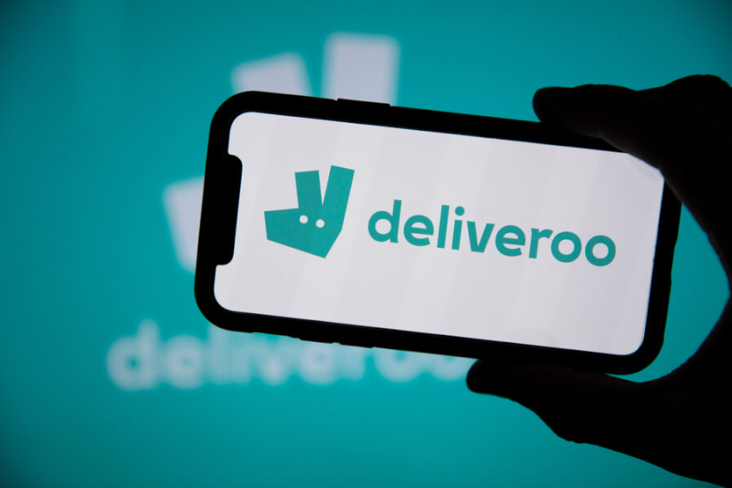
(Source: Website)

Examine the customer experience of Deliveroo.
Customer touchpoints
All the moments when a potential customer meets the brand are touchpoints. Their accurate adaptation to his needs may result in sales. (Dhebar, 2013)
Technological and digital innovations completely change the environment in which companies compete. Technological advances enable customers to interact through several access points. It is no longer possible to speak of a linear purchasing process. Customers now have ample opportunities to develop their purchasing journey (Grazino, 2019).
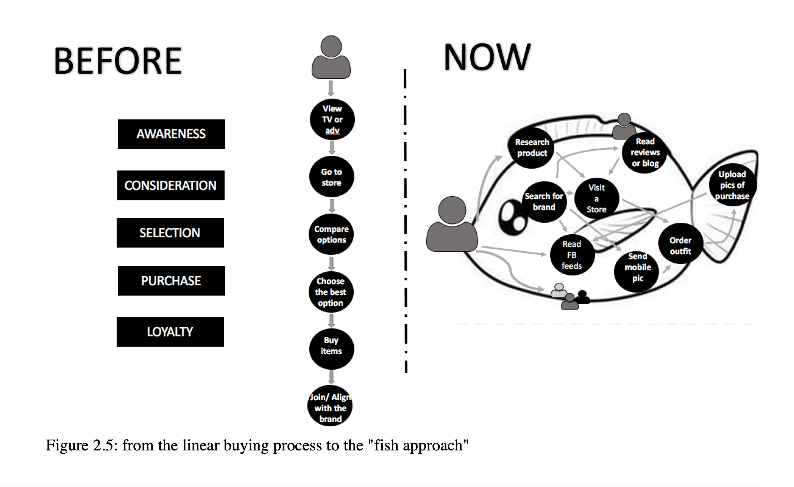
(Source: GRAZIANO, 2019).

People are constantly exposed to various brands. Information attacks customers from all sides. Customers need to do is go to the store or use internet. On the other hand, it is an excellent opportunity for an entrepreneur who can quickly build brand awareness among the audience (Dhebar, 2013).
Online retail is subject to a different set of rules and purchasing processes than the traditional visit to a store or restaurant by a customer (Gergi, 2016).
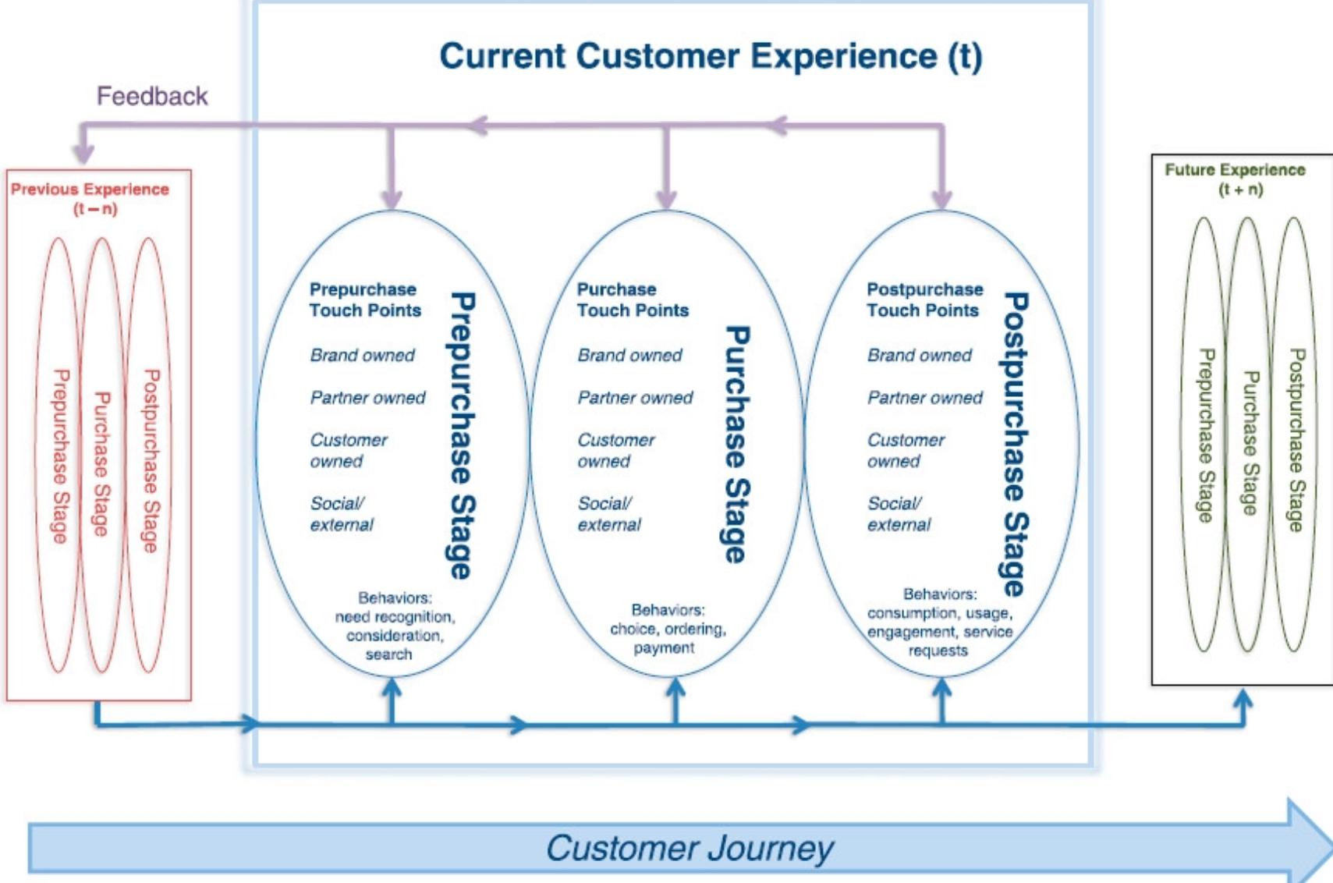
(Source: Leva, 2018)

Based on the above model, Deliveroo's customer journey will be presented in three stages: pre-purchase, purchase, and postpurchase (Lemon, 2016)

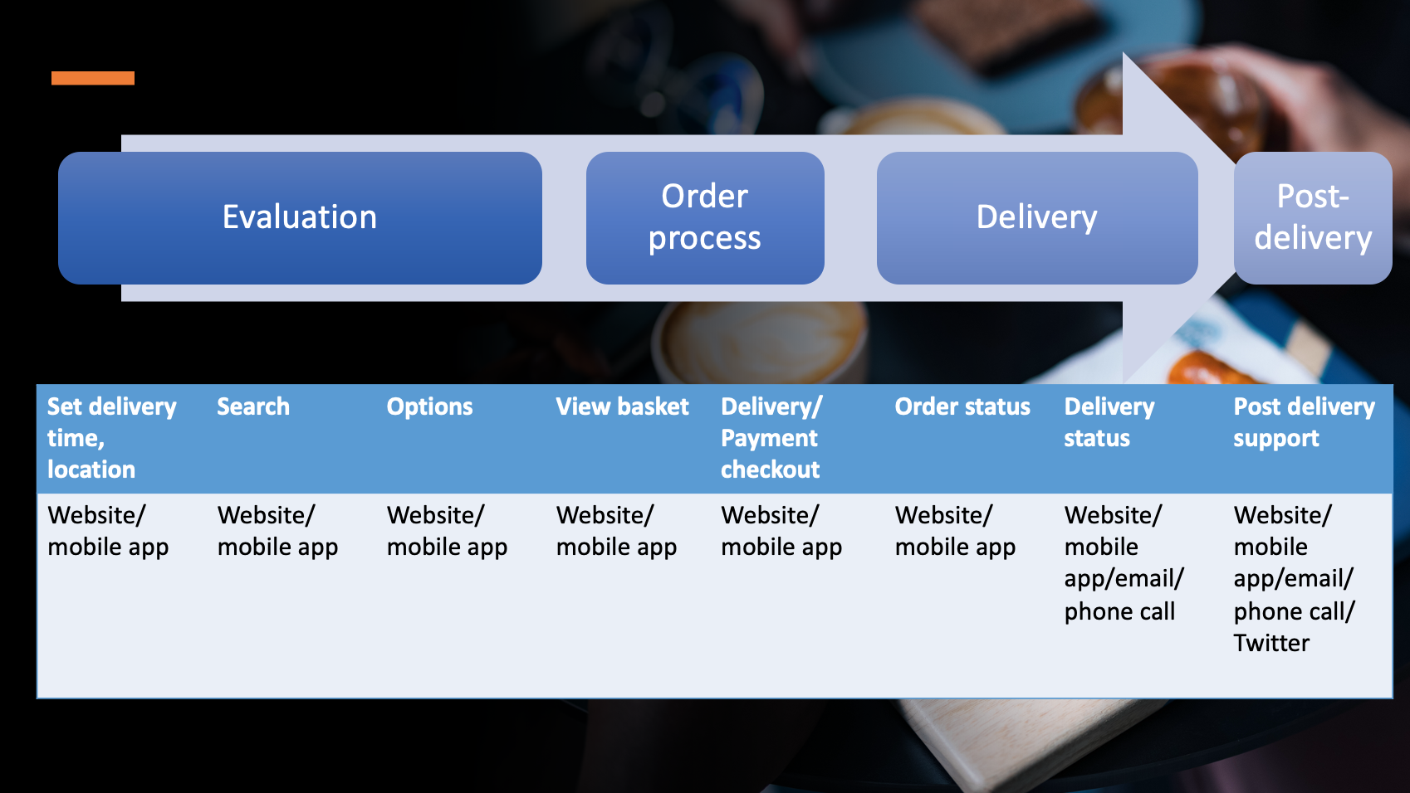
(Source: Wilkosz, 2022)
Deliveroo's client journey shows that main touchpoints are the digital interaction on the website/app where the purchase is taking place (Gergi, 2016). The website and application are the most critical touchpoints. Thanks to them, the process of servicing each customer is also supported (Abajo 2018). Social media: Facebook and Instagram, are intended to facilitate communication between Deliveroo and customers and to raise awareness about the company.
Pre-purchase stage
It includes all moments of the customer's interaction with the brand, category and environment before purchase (Lemon, 2016). Before the customer can place an order, must download the application and register, but then must find out that a company like Deliveroo exists (Abajo 2018). Deliveroo communicated about itself through social media and paid media such as advertising. Also, future clients can learn about the company from people through recommendations. Social media touchpoints provide real-time information about the service and news (Lemon, 2016) as announced on October 10 about opening the first store (MarketLine Report, 2022) They use high-quality photos and videos to attract the customer's attention. Thanks to Deliveroo's double partnership and restoration, the customer can choose food from a well-known place. The customer also has the opportunity to see the ratings of other customers and can do research.

Purchase stage:
All interactions of the customer with the brand and its environment during the purchase itself. It is characterized by such behaviours as selection, ordering and payment (Lemon, 2016). When the customer downloads the application/registers, they can complete the order. All clients must do is enter the postcode, and all restaurants will be displayed. They will be able to browse the menu with prices. The customer then places an order and makes the payment. The order goes to the restaurant and then is delivered to the address. After placing the order, the customer can track the progress, receive notifications and email. Customer has contact with the rider, Deliveroo and restaurant. The entire sales process is closed on the Internet / telephone sphere. The customer has direct face-to-face contact with the rider.
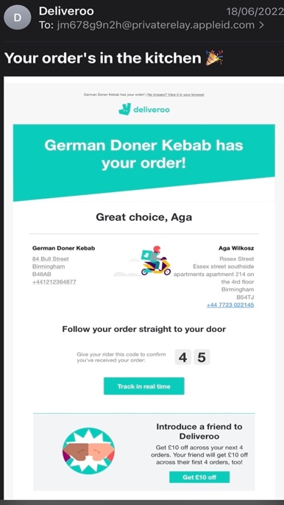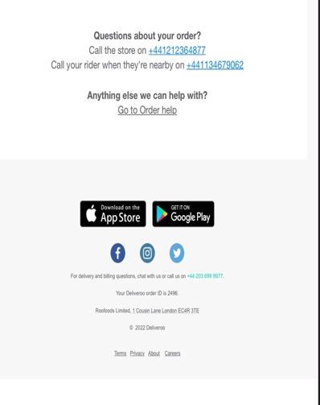
(Source: Deliveroo, 2022)

Postpurchase
These are the customer's interactions with the brand and its environment after the actual purchase. This stage includes behaviours such as use and consumption, post-purchase engagement and service requests, complaints, ratings (Lemon, 2016). After the customer receives the order, Deliveroo offers only essential support via phone, Twitter, and email. Buyers can leave ratings (Deliveroo, 2022).
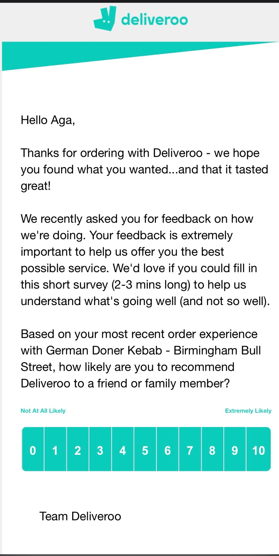
(Source: Deliveroo, 2022)
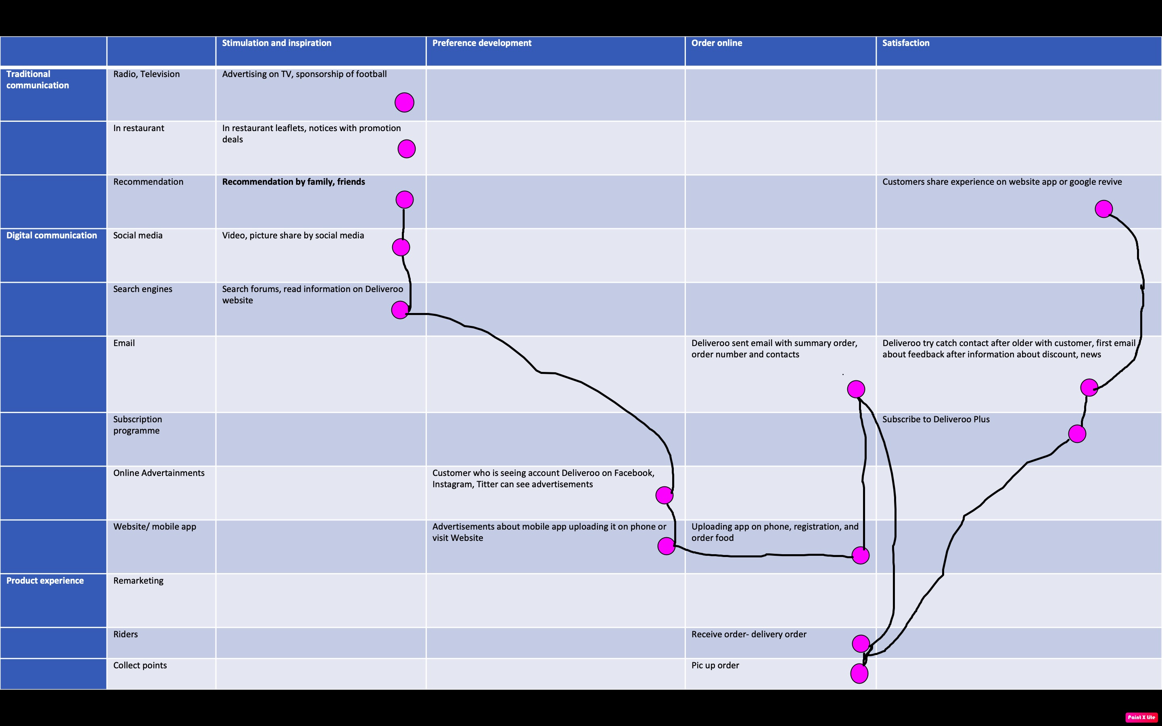
(Source: Wilkosz, 2022 Customer journey)

Customer Experience and Brand Experience
In the age of technological development, customers are not only looking for the perfect product but also for emotions, uniqueness, and something to remember. They want to have a personalized and fantastic experience that will allow them to experiment before making a choice (Graziano, 2019)
85% of business executives believe that the customer experience is the main advantage over the competition, not the product itself, quality, or price. (Godovykh,2020).
Online meal ordering has become the new standard in the food sector. Furthermore, in the current market, several platforms offer such services. (Kottakki, 2020)
Food has become popular online purchases and is growing by 12% annually. This development is an opportunity but also a challenge because it creates competition so having loyal customers is essential. (Suhartanto, 2019). The number of people ordering food online is growing, and they expect the same experience they get in restaurant. Therefore, for a successful business, it is essential to focus on the customer experience (Kottakki, 2020).
According to the research, 80% never or rarely leave the competition platform if a customer registers, so the customer must have positive experiences. (Hirschberg, 2016). The main goal of delivering customer experience is customer satisfaction, often associated with referrals, recommendations and repeat purchases (Ballard, 2017). Customer satisfaction is mainly influenced by the delivery time - as many as 60% of consumers think so (Hirschberg, 2016).
Customer ordering the food thinks of the delivery as last step of the chain, that is, from ordering to receiving the meal. If the restaurant fails Deliveroo suffers from a customer experience perspective (Furunes, 2019).
Deliveroo believes that it provides the consumer with a wide choice, fast and reliable delivery of food and products. Mainly focused on improving the scope of customer service. Deliveroo knows that consumers build bonds with their brand. In every city, people can find Deliveroo riders with a backpack bearing their logo, but the company does not only want to be recognized in society but also want to be part of it. The core of the company's activity is to connect people with food created by restaurants through riders (Deliveroo, 2022). Deliveroo employs only 2,612; the rest of the employees are self-employed. The company offers flexible working hours, good wages, and insurance. (MarketLine Advantage Reports,2022). Since raiders have direct contact with the client, it is essential that they are adequately motivated to do their work and that the quality of customer service is at the highest level. The high quality of customer service positively influences the assessment of customer experience. (Deliveroo, 2022)
When buying a product or service, customers experience the following: good, bad, or neutral (Berry,2002). One of the key elements of understanding and handling customer experiences is the capacity to count and observe customer response to company offers, mainly client perspectives and perceptions. One such assessment is a satisfaction rating (Lemon, 2016). It is also important to ask customers for feedback and appreciate their voices. Customers feel valued and attached to the company when they are asked for an opinion, and their brand loyalty grows. Deliveroo asks for feedback after each delivery (Adak, 2022).
(Source; Deliveroo, 2022)
cCompany has positive and negative opinions among customers. Based on Deliveroo, the App Store rating is 4.7 (Deliveroo, 2022)

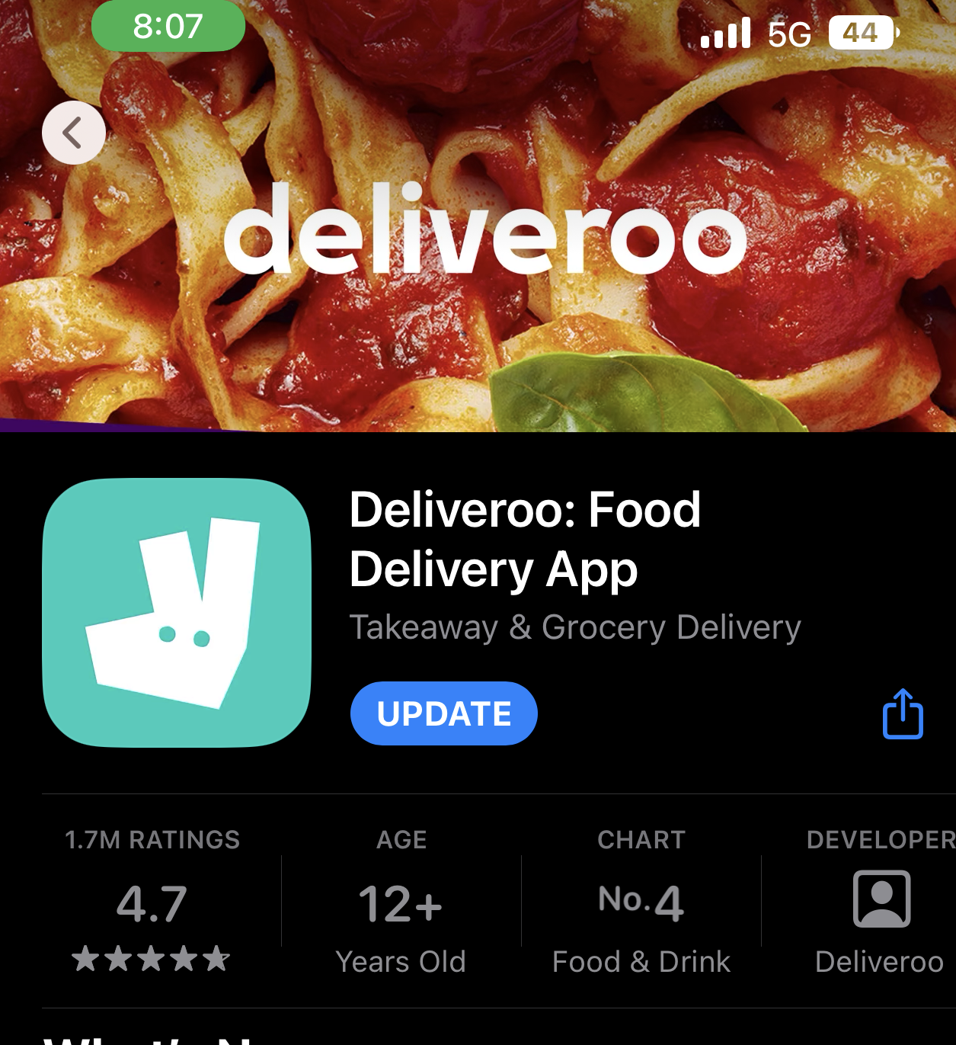
(Source: Deliveroo, 2022)
Many customers are dissatisfied with the services provided by Deliveroo because between 10-19%. Negative experiences included significant technology issues, additional costs, unreliability, lack of customer service and unavailability. For example, customers rated Deliveroo: they do not accept PayPal rating 2, need for the possibility to add a comment to the restoration with additional information rating 3, long waiting time for the meal and the food arrived cold and refused to return the money rating 1 with information would not order again. Deliveroo also has a lot of positive comments, such as the easy-to-use app with a rating of 5. Great way to order food, and the riders are friendly (Furunes, 2019).
Deliveroo has a positive experience thanks to its charity work. The company provided meals to the NHS and the family at risk during the pandemic (Deliveroo,2022).

Conclusion and Recommendations
Customer improvement is a collection of all emotions, feelings, and experiences about the company. By way of illustration, Deliveroo shows that customers can have positive and negative experiences that lead to success - customer retention, ordering, business profit or failure that leads to customer loss. Negative customer experience was usually associated with poor customer service; improving it and creating live chat to facilitate customer contact with the company is recommended.
Touchpoints are when the customer meets the company, from seeing advertising on social media to downloading the application/registration and placing an order. The most important contact points are the mobile application and the website, so it is recommended to improve the application and add new functions to keep up with the competition, which is very large in the food industry.

References:

- Abajo, L. (2018). Delivery App Design: Part 1 – Analysis. Available at: http://auroralabs.es/blog/delivery-app-design-part-1-analysis/?lang=en[Accessed 30/10/2022].
- Adak, A., Pradhan, B. and Shukla, N. (2022) ‘Sentiment Analysis of Customer Reviews of Food Delivery Services Using Deep Learning and Explainable Artificial Intelligence: Systematic Review’, Foods, 11(10), p. 1500–. Available at: https://doi.org/10.3390/foods11101500. [Accessed 20/10/2022].
- Ballard, E. (2017) ‘Deliveroo Posts Loss for 2016’, WSJ Pro. Private Equity [Preprint].
- Berry, L.L., Carbone, L.P. and Haeckel, S.H., 2002. Managing the total customer experience. MIT Sloan management review, 43(3), pp.85-89.
- Cleveland, B. (2021) Customer Experience Leadership. Carpenteria, CA: linkedin.com.
- Dhebar, A., 2013. Toward a compelling customer touchpoint architecture. Business Horizons, 56(2), pp.199-205.
- Furunes, T. and Mkono, M. (2019) ‘Service-delivery success and failure under the sharing economy’, International journal of contemporary hospitality management, 31(8), pp. 3352–3370. Available at: https://doi.org/10.1108/IJCHM-06-2018-0532[Accessed 20/10/2022].
- Furunes, T. and Mkono, M. (2019) ‘Service-delivery success and failure under the sharing economy’, International journal of contemporary hospitality management, 31(8), pp. 3352–3370. Available at: https://doi.org/10.1108/IJCHM-06-2018-0532.
- Gergi, G. and Kitowski, V., 2016. E-Business Models–The Physical Touchpoint of Online Retailers in Business Model Frameworks (Doctoral dissertation, Lund University).
- Godovykh, M. and Tasci, A.D.A. (2020) ‘Customer experience in tourism: A review of definitions, components, and measurements’, Tourism management perspectives, 35, p. 100694–. Available at: https://doi.org/10.1016/j.tmp.2020.100694 [Accessed 20/10/2022].
- GRAZIANO, F., 2019. The role of startups in winning the omnichannel customer experience challenge.
- Hirschberg, C., Rajko, A., Schumacher, T. & Wrulich, M. (2016). The changing market for food delivery. Available at: https://www.mckinsey.com/industries/technology-media-and-telecommunications/our-insights/the-changing-market-for-food-delivery[Accessed 20/10/2022].
- HUANG, W., Analyses of start-up Deliveroo.
- Ieva, M. and Ziliani, C., 2018. The role of customer experience touchpoints in driving loyalty intentions in services. The TQM Journal.
- Kottakki, K.K., Rathee, S., Adusumilli, K.M., Mathew, J., Nayak, B. and Ahuja, S., 2020, December. Customer experience driven assignment logic for online food delivery. In 2020 IEEE International Conference on Industrial Engineering and Engineering Management (IEEM) (pp. 827-831). IEEE.
- Kottakki, K.K., Rathee, S., Adusumilli, K.M., Mathew, J., Nayak, B. and Ahuja, S., 2020, December. Customer experience driven assignment logic for online food delivery. In 2020 IEEE International Conference on Industrial Engineering and Engineering Management (IEEM) (pp. 827-831). IEEE.
- Lemon, K.N. and Verhoef, P.C., 2016. Understanding customer experience throughout the customer journey. Journal of marketing, 80(6), pp.69-96.
- Mathayomchan, B. and Taecharungroj, V., 2020. “How was your meal?” Examining customer experience using Google maps reviews. International Journal of Hospitality Management, 90, p.102641.
- Meyer, C. and Schwager, A., 2007. Understanding customer experience. Harvard business review, 85(2), p.116.
- Pang, X., Shang, Y. and Song, J., 2022, March. An Analysis of Deliveroo’s Operation Strategy and Food Takeaway Industry. In 2022 7th International Conference on Financial Innovation and Economic Development (ICFIED 2022) (pp. 142-155). Atlantis Press.
- Stein, A. and Ramaseshan, B., 2016. Towards the identification of customer experience touch point elements. Journal of Retailing and Consumer Services, 30, pp.8-19.
- Suhartanto, D., Helmi Ali, M., Tan, K.H., Sjahroeddin, F. and Kusdibyo, L., 2019. Loyalty toward online food delivery service: the role of e-service quality and food quality. Journal of foodservice business research, 22(1), pp.81-97.

A critical literature review on the customer experience.

Introduction

Customer experience is any direct or indirect meetings between the client and the business. Direct touch usually happens during buy, usage, and service and is created by the client. Indirect contact is an accidental meeting with a company. It often brings the form of recommendations, complaints, and advertisements. (Meyer, 2007)
Designing, delivering, and managing a customer experience can be viewed from several perspectives—first, the point of view of the company that creates experiments. Second, from the customer's point of view or the co-creation perspective (Lemon, 2016).This report focuses on the customer experience from a company, customer and co-creation perspective based on two Information technology companies such as Revolut and Monzo.

Background
Technology companies occupy a central position in economies emphasising technology activities and technology-based products. They fuel economic growth, increase productivity and create new industries and innovative products and processes (Grinstein,2006). Information technology uniformly plays a vital role in automating business processes in every startup—for example, online consumer banking services from Revolut and Monzo (Mamonov, 2021). When delving into the banking sector, the concept of fintech should be explained as a combination of two concepts: "finance" and "technology", including innovative companies offering technology-based financial services (Barbu,2021).
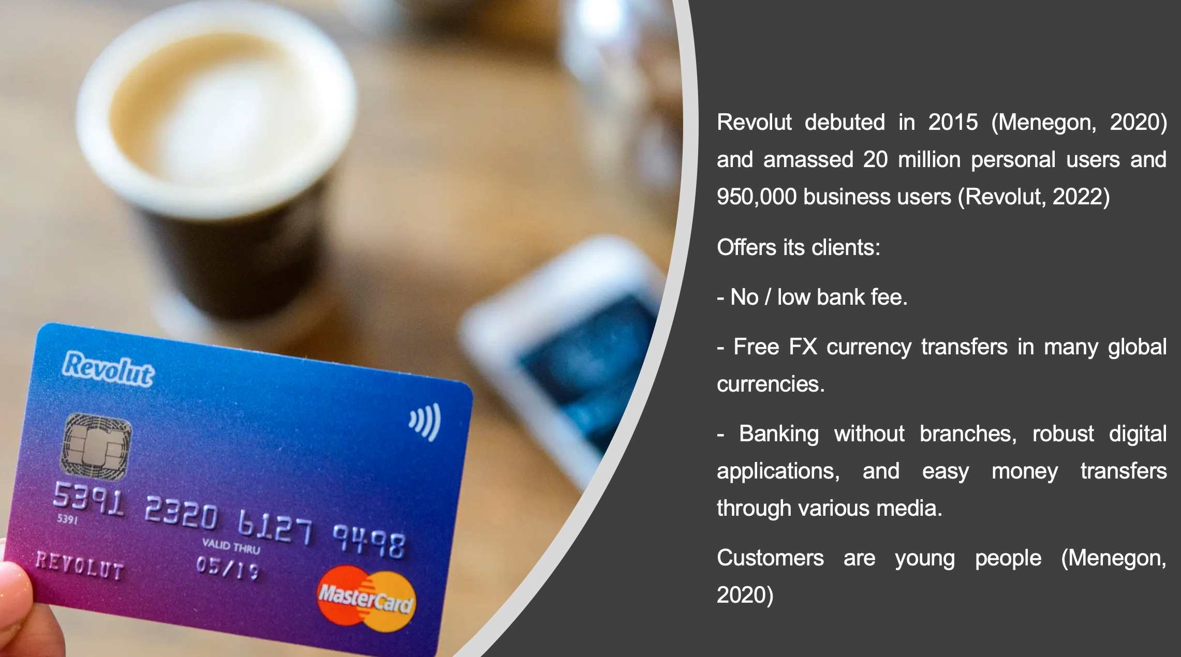
(Source: Wilkosz, 2022)
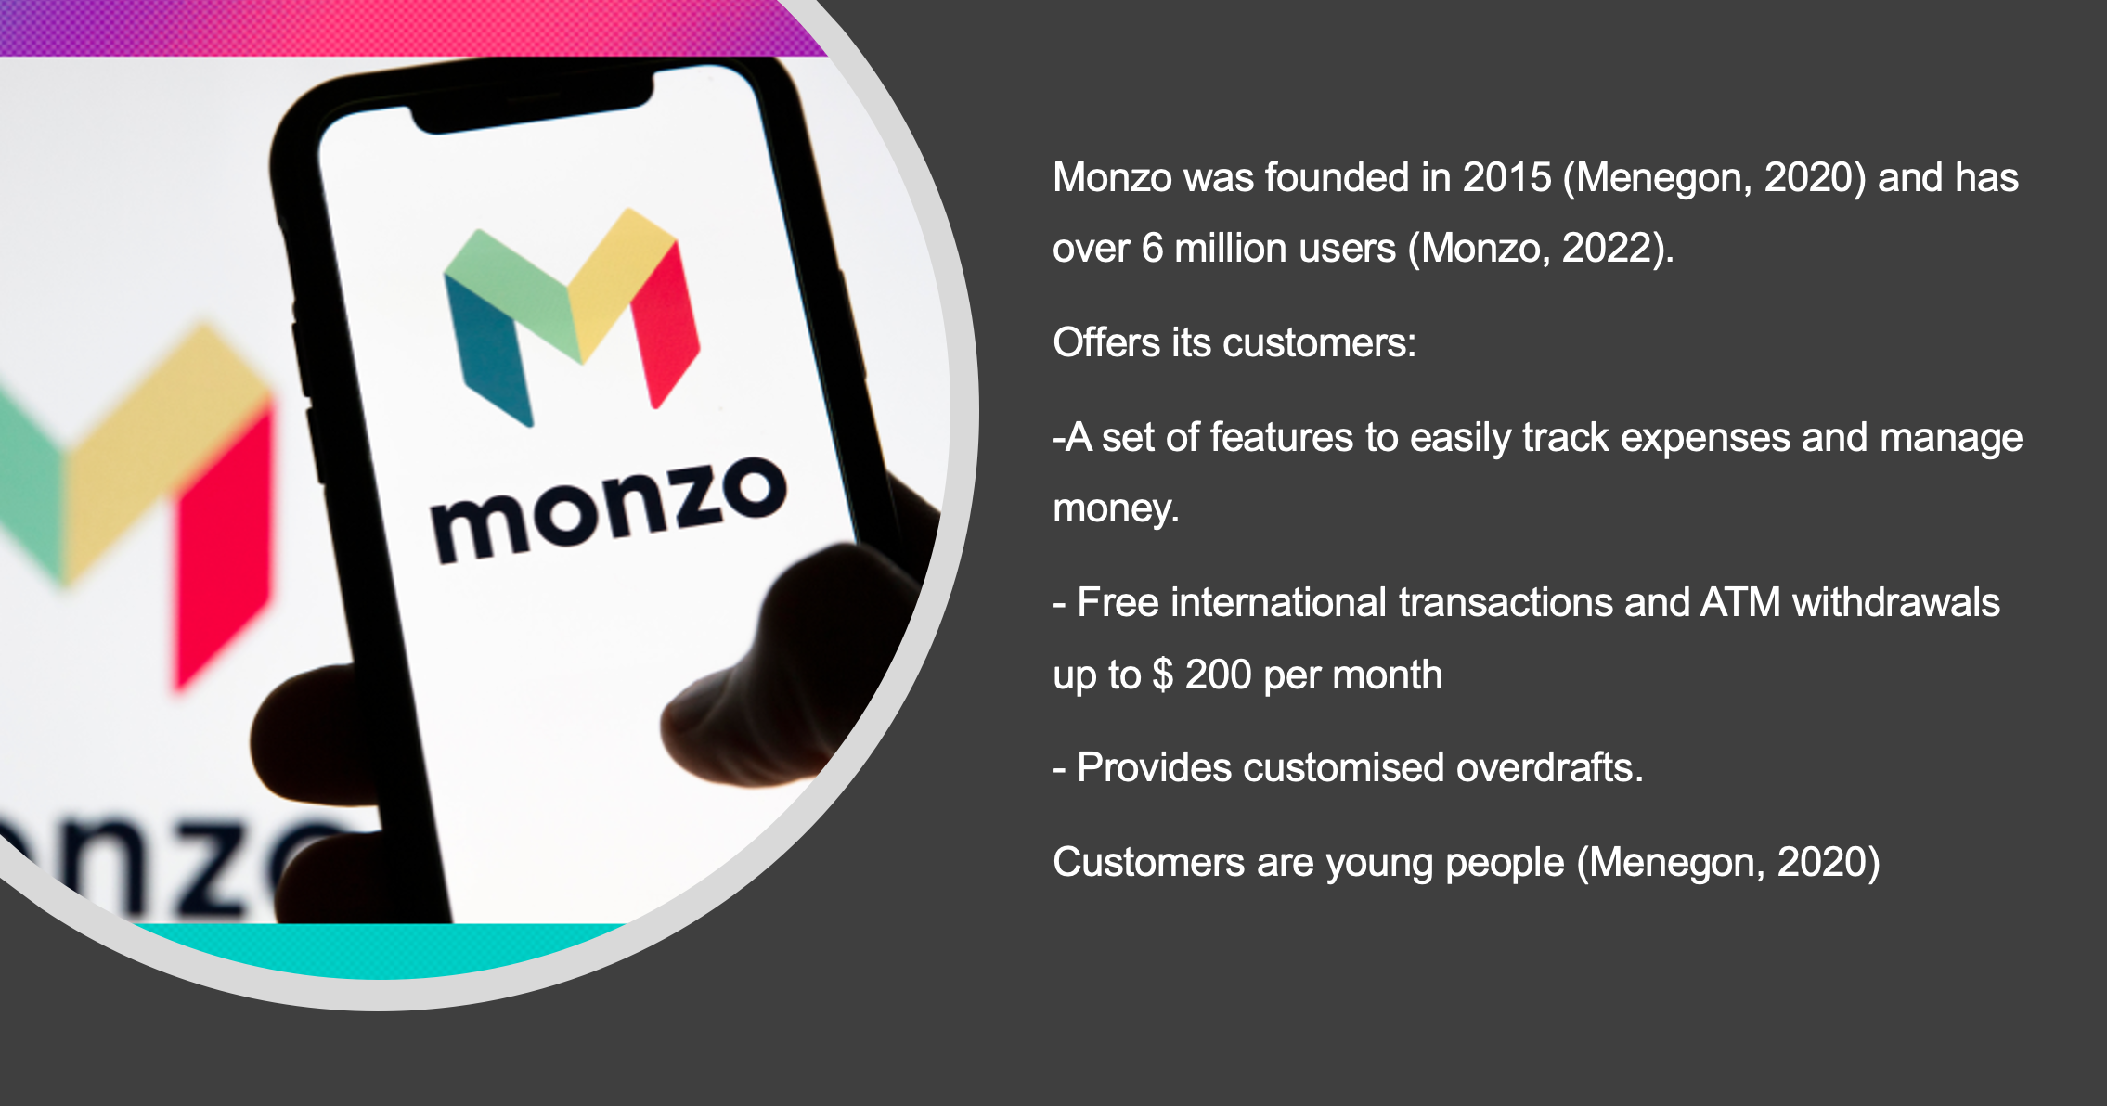
(Source: Wilkosz, 2022)

Customer experience perspectives: the firm's perspective and the co-creation customer perspective.
When customers think of a bank, the first image they see is a long queue for services such as opening an account, changing addresses, and making a cash deposit. It sounds not like good expirience. Revolut and Monzo are banking institutions without paper, signatures and branches. A survey o customers found that 56% prefer digital relationships to personal relationships with a bank. This kind of banks have ditched physical branches and provides banking services online (Dharamshi, 2019).
Firms cannot hold customer experiences; they can build them to some extent with impulses. Customer experience is based on the customer's cognitive, emotional, behavioural, sensory, and social responses to the company's offers during their journey. Cognitive experience - the way of thinking of customers. Emotional experience - how they feel; social experience - relations with other people, in the case of Monzo and Revolut, on the internet; physical experience includes interaction with the product (with the payment card); sensory experience - when the customer touches the card. Mobile applications and social media marketing consequence the dynamics of client experience. In an online environment, the digital and social realms come together to offer a personalised customer experience (Barbu, 2021)
The social environment influences the client's experience. As with customer-customer interactions in a traditional environment (Verhoef, 2009), customers can interact with other online clients by comparing their backgrounds with the organisation's offers (Mbama, 2018). It is a powerful impact and a new shape of classic word-of-mouth communication. Customers create virtual societies that can lead to a richer customer experience and support building client commitment. (Verhoef, 2009).
Revolut and Monzo customers, from their smartphones, can upload their documents, open bank accounts, and make transactions from home. Speed, convenience- where the client is, his bank is there, and a better customer experience are the key factors driving consumers to use. A better customer experience is the key factor driving consumers to use the application. Experiences that are easy, reliable, and effective build stronger loyalty (Dharamshi, 2019). According to a UK digital banking study, consumer experience positively correlates with client satisfaction, while customer experience positively impacts client commitment and loyalty (Barbu, 2021).
Mobile applications, especially for routine transactions, delight customers more often than experiences in branches or telephones in standard banks. The operating costs of digital banks are lower than traditional banks. A single bank transaction costs $ 4, and in mobile banking from $ 0.09 to $ 0.019. Lower costs mean lower fees for customers. Customers no longer have to worry about the bank's working hours. They can use banking services 24/7. Lack of a branch/lack of contact with a person may cause alienated feelings in consumers in the long run. Purely digital banks take various measures to attract new customers.
People use smartphones all the time. Revolut and Monzo use "real-time intelligence" to provide personalised information such as expense alerts and geographic-based offers. Such personalised services will increase customer loyalty in the long term.
With the advent of digital banks, the risk of fraud and cyber-attacks increases. Customers who fall victim to such an attack do not have a positive experience. (Dharamshi, 2019) Banks try to apply different safeguards and improve them. Because if the customer does not have a good experience, they will lose confidence in the brand, and this will result in the customer leaving (Mbama, 2018)

The basis of a bank's customer needs is onboarding, payments, saving, investing, loans and support. Banks such as Revolut and Monzo provide a more satisfactory experience in onboarding, savings and payments. They are poor in client assistance and have minimal experience or products to meet their lending and investing needs (Johnson, 2021).
Revolut and Monzo customer experience is enhanced by new products, services and features such as cryptocurrencies, global remittances, crowdfunding, online brokerage, and cross-border payments. They offer digital wallets and contribute to hassle-free customer service by simplifying processes (Dharamshi, 2019).
Monzo and Revolut are customer-oriented and able to offer simplified services without bureaucracy. They enrich customer experiences by offering access to computerised and streamlined functions. Biometrics has the potential to enhance the customer experience. Instead of remembering passwords or any code, people can access services via a face scan. The main determinants of a consumer experience are the comfort of use, sensed worth, customer service, confidence, quickness, and perceived creation of the company.
The app should be easy to navigate and use as the customer feels in control, leading to a good experience. It should make the client's life easier, not stress or irritation. (Mbama, 2018). On the other hand, customers who are afraid of technology will not decide to open such an account, and even if they do, they will not use it actively; fear and stress are, unfortunately, not the best experiences. (Barbu, 2021)
Conclusion and Recommendations:

Customer experience can be seen from the firm, customer, and co-creative perspective. Although Revolut and Monzo are Finch Bank. Customers can still communicate over the Internet. Therefore, it is essential to maintain a positive customer experience as one dissatisfied client can share experiences with others. Monzo and Revolut are banks without branches, and young clients mainly use their services. If they want to expand their activities among older adults, it is recommended to open smart branches or points where the client will be able to make friends with the mobile application.

References:

- Grinstein, A. and Goldman, A., 2006. Characterizing the technology firm: An exploratory study. Research Policy, 35(1), pp.121-143.
- Lemon, K.N. and Verhoef, P.C., 2016. Understanding customer experience throughout the customer journey. Journal of marketing, 80(6), pp.69-96.
- Meyer, C. and Schwager, A., 2007. Understanding customer experience. Harvard business review, 85(2), p.116.
- Mamonov, S., 2021. The role of information technology in fintech innovation: insights from the european fintech ecosystem.

- Barbu, C.M., Florea, D.L., Dabija, D.C. and Barbu, M.C.R., 2021. Customer experience in fintech. Journal of Theoretical and Applied Electronic Commerce Research, 16 (5), pp. 1415-1433.
- Dharamshi, L., 2019. Digital-only Banks (Next Level of Banking Experience). Journal of Global Economy, 15 (1 (Special), pp. 1-5.
- Menegon, A., 2020. FinTechs and Challenger Banks: Old Business, Brand New Approach. Iason Consulting Ltd.

- Verhoef, P.C., Lemon, K.N., Parasuraman, A., Roggeveen, A., Tsiros, M. and Schlesinger, L.A., 2009. Customer experience creation: Determinants, dynamics and management strategies. Journal of retailing, 85(1), pp.31-41.
- Dharamshi, L., 2019. Digital-only Banks (Next Level of Banking Experience). Journal of Global Economy, 15(1 (Special), pp.1-5.
- Barbu, C.M., Florea, D.L., Dabija, D.C. and Barbu, M.C.R., 2021. Customer experience in fintech. Journal of Theoretical and Applied Electronic Commerce Research, 16(5), pp.1415-1433.
- Johnson, M., 2021. Challenger banks are dead, long live challenger banks. Journal of Digital Banking, 5(4), pp.329-341.
- Mbama, C.I. and Ezepue, P.O., 2018. Digital banking, customer experience and bank financial performance: UK customers’ perceptions. International Journal of Bank Marketing.
- Mbama, C.I., Ezepue, P., Alboul, L. and Beer, M., 2018. Digital banking, customer experience and financial performance: UK bank managers’ perceptions. Journal of Research in Interactive Marketing.

(Mbama, 2018)

