
APPENDIX GA36c

LEVEL 6 ASSESSMENT SPECIFICATION

Student name: | Dominic Hole | Student ID number: | 1800402
Programme: | Physical Education and Outdoor Adventure Education
Module: | Curriculum Adventure
Module code: | BMOE6002 | Contribution to Overall Module Assessment (%): | 50%
Lecturer: | Dr Nalda Wainwright | Internal Verifier:
Assignment Title: | Problem Based learning assignment | Word count (or equivalent): | 2500
Submission deadline: |  | Return date of provisional marks & written feedback:
Submission method: | All written assessments, where practical and possible, must be submitted via Turnitin unless otherwise instructed by the Lecturer. (Please DO NOT put this assessment specification into Turnitin or it will match many similarities with other students’ submissions.)  Alternative submission method (if applicable):  Late submission of the assessment will result in a late penalty mark. Penalties for late submission: Up to one week late, maximum mark of 40%. Over one week late, 0%. Only the Extenuating Circumstances Panel may approve a change to submission dates.
Academic honesty / referencing: | Academic honesty is required. In the main body of your submission you must give credit to authors on whose research and ideas your work is based. Append to your submission a reference list that indicates the books, articles, etc. that you have used, cited or quoted in order to complete this assessment.

Student FEEDBACK FORM

This section details the extent to which the assessment criteria are demonstrated by you, which in turn determines your mark. The marks available for each category of skill are shown. Lecturers will use the space provided to comment on the achievement of the task(s), including those areas in which you have performed well and areas that would benefit from development/improvement.

Generic Assessment Criteria | Marks available | Marks  awarded
1. Engagement with Literature Skills
.
 | 30
2. Knowledge and Understanding Skills

 | 20
3. Cognitive and Intellectual Skills

 | 20
4. Practical Application Skills

 | 20
5. Transferable Skills for Life and Professional Practice

 | 10

Assessment Mark (Assessment marks are subject to ratification at the Exam Board. These comments and marks are to give feedback on module work and are for guidance only until they are confirmed. ) | Late Submission Penalties (tick if appropriate) |  | %
 | Up to 1 week late (40% Max) |  | %
 | Over 1 week late (0%) |  | %
There are a myriad of issues currently facing secondary schools and their students, most obviously the Covid-19 pandemic, but also an epidemic of health issues such as mental illness and obesity (NHS, 2021; Mental Health Foundation, 2016). Despite this schools remain a key force in fighting these issues, school children spend a large majority of their time within the school environment be it in lessons or on the grounds, so physical and pedagogical changes within the school may combat these issues (Dyment and Bell, 2008).

TSD Secondary currently represents a traditional secondary school development with a main block within which all classrooms are, a separate large sports hall with changing rooms and storage rooms, and a multipurpose tarmac playing area with lines drawn out for football/tennis/netball/basketball. Additionally, it has a large field area which is currently partly used for competitive sports such as rugby, football, rounders, cricket, and athletics. The proposed developments are:
- Nature Trail
- Mountain Bike Track
- ‘Outdoor Classrooms’
- Allotments
- Climbing wall
- Bouldering Wall

Concurrent increases in technology and societal risk aversion have led to significant decreases in children’s time in nature, and increases in time spent inside using technology (Palmer, 2006). Louv (2005) defines this decreased nature exposure as ‘Nature Deficit Disorder’ and suggests it contributes to a diminished use of the senses, attentional difficulties, obesity, and decreased ‘ecological literacy’. Gill (2007) suggests increases in ‘Nature Deficit Disorder’ are due to an increasingly risk-averse society, caused by a fear of facing blame and litigation, strangers, and child protection issues. Additionally, this decreased exposure to risk and ‘bubble wrapping’ of children may result in children being less able to manage those risks in the future (Gill, 2007; Malone, 2007). These decreases in activity are supported by Cooper et al (2020, in Wight et al, 2018) who found a sample of 1010 English students spent an average of just 41-minutes outside a day. Whilst children’s time outside is dramatically decreasing, there are increases in the rates of mental illness, anxiety, depression, ADHD, obesity, and diabetes (Gray, 2019).

New Curriculum
From 2022 till 2026 a new curriculum is being implemented throughout Welsh schools, giving schools greater autonomy over their curriculums and assessments (Welsh Gov, 2020). These assessments and teachings should allow all students to achieve the four purposes; “ambitious, capable learners, ready to learn throughout their lives”; “enterprising, creative contributors, ready to play a full part in life and work”; “ethical, informed citizens of Wales and the world”; “healthy, confident individuals, ready to lead fulfilling lives as valued members of society” (Hwb, 2021a). This curriculum includes 6 areas of learning and experience (AOLE), the most relevant for outdoor education being ‘Health and Well-being’ (Hwb, 2021b). This curriculum provides an opportunity to integrate school ground developments within the curriculum to create a more inclusive school environment with a wealth of cross-curricular learning opportunities (Hwb, 2020c).

Benefits of Outdoor Education
Recent research has presented the outdoors as a key tool for managing many of these problems affecting children. Green environments have been cited as promoting significant improvements on people’s mood and psychological health, explained through theories such as stress reduction theory, attention restoration theory and biophilia (Lin et al., 2020; Ulrich et al., 1991; Kaplan and Kaplan, 1989; Grinde and Patil, 2009). Outdoor exposure has also been related to the reduction of attention deficit disorder, myopia, obesity, aggression, and increases in concentration, physical activity, immune functioning, and positive wellbeing (Wight et al, 2018; Williams and Wainwright, 2014).

The impact of green space development in schools for outdoor activities has previously shown to positively affect people’s behaviour (Lin et al, 2020; Birch et al, 2020). Research has shown a relationship between improved school grounds and a reduction in behavioural problems (Hughes et al, 2016). This positive impact on behavioural problems has also been found in preliminary studies on the use of outdoor classrooms with improvements in reading comprehension, engagement, and on-task behaviour when teaching in outdoor scenarios rather than an indoor classroom (Wight et al, 2018).

Furthermore, learning is a holistic and explorative process which can occur in both formal and informal setting, this means that creative developments such as nature trails and mountain bike tracks can allow adventurous exploration and learning without the direct influence of teachers (Sahrakhiz, Harring, and Witte, 2018).

Why change schools?
According to Lawson (2009, p.113) current physical education (PE) lessons are based on “industrial age logic”, with competitive, often vigorous sports becoming dominant in PE, leaving many students to feel side-lined (Dyment and Bell, 2008; Wainwright and Williams, 2012). This competitive, vigorous nature has been criticised for reinforcing exclusionary problems, such as girls feeling marginalized compared to boys and having a lack of teacher support (Allender, Cowburn, and Foster, 2006).

The new pedagogical model for adventure (PMFA) represents the pedagogical basis that will inform the developments made to the school grounds (Williams and Wainwright, 2016a;2016b;2019; Figure 1). The PMFA is based on four key concepts; challenge by choice, experiential learning, constructivism, and outdoor environmental education (Williams and Wainwright, 2016a). The constructivist and experiential approaches place an emphasis on pupil centred and problem-based learning, which are integral skills within the new health and wellbeing AOLE (Hwb, 2021b; Kolb, 1984; Chase, 2015).

Benefits of outdoor learning within school grounds has been reinforced in previous research (Dyment and Bell, 2008; Gray, 2019; Beames, Higgins, and Nicol, 2012). The criticism made of PE and school grounds for limiting inclusion and adventurous learning (Lawson, 2009; Dyment and Bell, 2008), may be addressed through targeted developments of the school ground for the promotion of outdoor education and adventurous activity, a process Dyment and Bell (2008) refer to as ‘school greening’.

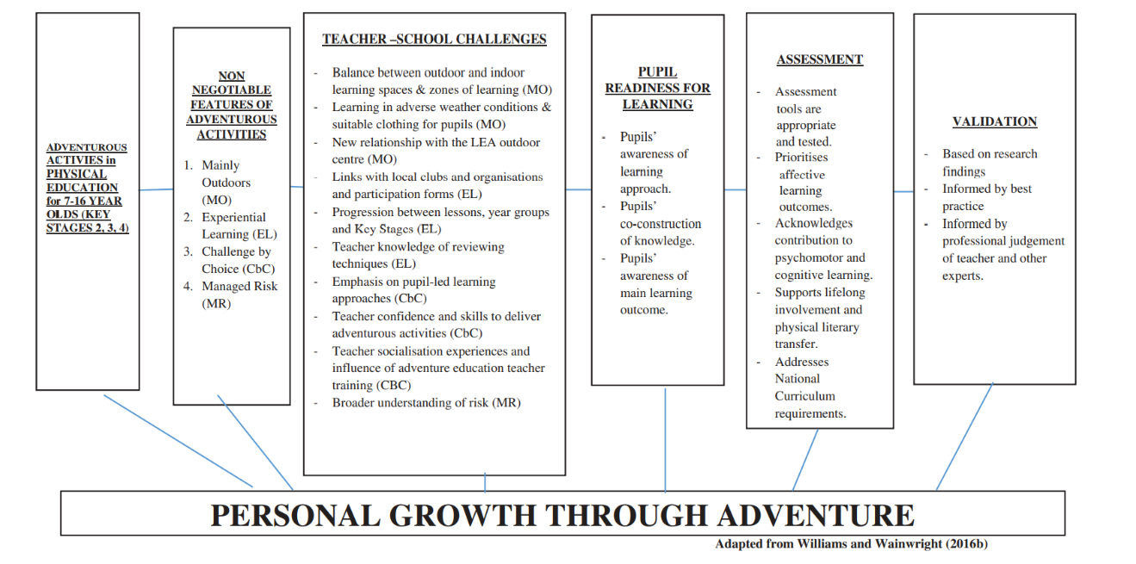
Figure 1 (Williams and Wainwright, 2019, p.4)

Nature Trail
Nature trails have precedence in previous school greening projects, especially those with a focus on environmental education, which is an important element of outdoor education within the background of growing climate issues and is therefore an important topic for developing “ethical, informed citizens of Wales and the world” (Dyment and Bell, 2008; Hwb 2021a).

This trail will include areas of trees, shrubs, rocks, and logs, which represent affordances to jump, run climb, hide and socialize (Dyment and Bell, 2008). These are key elements in developing physical literacy which may allow for progression of refined and specific movement patterns as well as allowing for inclusion of students of all abilities (Myers, Green, and Whitehead, 2018).

To develop problem-solving opportunities an orienteering map of the school grounds could be produced, these opportunities may be further developed by including students in the trail design process (DfCELLS, 2008a, p.18). These orienteering developments provide cross-curricular opportunities, with links to geography and maths by developing understanding of grid locations (DfCELLS, 2008b).

Sun exposure for students who have sensitive skin may be a contributing factor to lower participation in outdoor activity during school times due to a lack of shade, with overexposure from the sun in childhood being estimated to cause 80-90% of skin cancers in Western societies (Boldemann et al, 2006). Trees are highly effective for providing shaded environments, and studies have found environments including trees, shrubbery, and broken ground may trigger increased physical activity whilst providing sun protection, thus allowing more inclusive outdoor environments for all students (Boldemann et al, 2006).

Taking a less managed approach to this trail area by leaving natural moveable materials such as sticks branches and leaves on the ground once they have fallen may offer opportunities for creativity and design such as shelter and hut building (Dyment and Bell, 2008, p.958; Hwb, 2021b, Hwb, 2021c). Research has found that walking tracks may provide areas for students, especially younger students transitioning from primary education, to feel comfortable and safe in a natural area, thus presenting wellbeing benefits (Hughes et al, 2016).

Signs providing information on the surrounding ecology and animals will be included along the path. To improve accessibility and inclusion the path will be made wheelchair friendly with packed gravel, and the signs will have braille alternatives (Louv, 2005; Hughes et al, 2016).

Outdoor Classrooms
Connected to the new nature trail will be several ‘outdoor classrooms’, these will be within the same tree/bush environment as the trail and consist of wooden seats made from tree logs. The idea of having learning areas both inside and out is supported by Hughes et al (2016) who say that all spaces including those outside should be used for teaching and that a variety of formal and informal areas on the school site should be used to expand students’ perceptions on what a learning space is. These seats will be designed in a circular or horseshoe shape, following the recommendations of the ‘who sits where’ element of the Sunday afternoon drive debrief model (Figure 2), which prioritises having a seating formation that allows students to see each other and feel part of the conversation (Sutherland, Stuhr, and Ressler, 2014). This model is based on Kolb’s (1984) experiential learning cycle, and focuses on the use of group processing to reflect upon an activity and develop strategies for improvement, and has demonstrated benefits for students’ self-worth, belonging, self-esteem, positive student relationships, and group achievement (Sutherland, Stuhr, and Ressler, 2014, p.12). Furthermore, this means these outdoor classrooms are not purely for use of cross-curricular learning but can also be used as a base to debrief after adventure education experiences.

This seating area will have rain covers above to provide undercover outdoor spaces during wet weather. This element of cover is influenced by Williams and Wainwright (2016b) who say that providing covered outside spaces may support multisensory, outdoor learning experiences for pupils that would not be experienced inside.

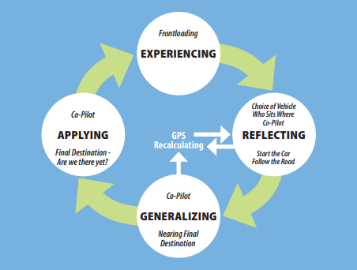
Figure 2(Sutherland, Stuhr, and Ressler, 2014, p.14)

Bike track:
A bike track will be developed within the school grounds in order to provide elements of adventure, competitiveness, self-development, challenge and progression, which may be more attractive to some students than traditional developments such as basketball courts (Schipperijn, Hansen, and Rask, 2015; Skar, Odden, Inge, 2008).

In order to ensure different levels of progression are present the design will be based on a previously studied track and include table tops, raised platforms with ramps, a pump track, and a see-saw (Schipperijn, Hansen, and Rask, 2015). This design is beneficial as it is useable without specific training, and its progressive nature allows for participation at a range of ability and activity levels (Schipperijn, Hansen, and Rask, 2015; Dyment and Bell, 2008).

The bikes used on the track will be supplied by the school to ensure they are appropriate for use and students who don’t own bikes are not restricted from using it. Maintenance of this bike fleet may be possible through schemes similar to Cardiff Councils ‘Schools Bike Fleet’ (Keeping Cardiff Moving, 2021). Maintenance of a bike fleet within the school may open up opportunities for greater inclusion, cross-curricular learning, and qualifications, as has been achieved in places such as Clarendon Secondary Centre, which specialises in teaching students with moderate learning needs (CSC, 2021). Vocational qualifications which could be integrated into this include AQA Bicycle Maintenance (AQA, 2017) and AQA Mountain Biking Skills (AQA, 2018). Furthermore, these qualifications may contribute to cross-curricular learning in the new curriculum for Wales as they fulfil elements of both health and wellbeing AOLE and science and technology AOLE, such as promoting physical activity; supporting sense of self-worth; developing confidence, motivation, knowledge and understanding; applying skills, experience, and knowledge to shape engineered solutions; and developing accuracy, precision, dexterity, and craftmanship through engineering processes (Hwb, 2021b; 2021c).

Previous green developments have shown to increase moderate and light activity levels within students not interested in traditional activities (Dyment and Bell, 2008). Mountain biking may provide an opportunity to experience vigorous activity levels, therefore, providing psychological and physical benefits such as preventing diabetes and obesity (Burr et al, 2012).

Allotments:
Allotment areas have been widely used within UK primary schools, however less widely within secondary schools (Speak, 2015). The inclusion of allotments within these school grounds may reduce the stress on new students transitioning from primary school by providing environmental continuity (Hughes et al, 2016). Progression from primary school learning is provided through cross-curricular applications. The health and wellbeing AOLE contain requirements for knowledge of health promoting behaviours such as balanced diet, personal care and hygiene, protection from infection, and applications of those elements to develop the skills and enjoyment of preparing food as part of a balanced diet (Hwb, 2021b; 2020b). Gardening in allotments is associated with improved physical, psychological, and social health, and may provide an alternative source of these benefits compared to vigorous exercise which some people may not be able, nor want to do (Soga et al, 2017). Furthermore, physical activities related to gardening meaningfully engage participants with their environment, presenting the opportunity to develop nature connections and pro-environmental behaviours which may contribute to them being “ethical, informed citizens of Wales” (Dyment and Bell, 2008; Zelenski and Nisbet, 2014; Welsh Gov, 2020).

Climbing
Climbing will be integrated into the school’s repertoire of adventure activity resources through two developments; a roped wall built inside the sports hall, and a bouldering area built on the outside of the sports hall. The PMFA’s non-negotiable feature of ‘mainly outdoors’ is not fulfilled by this roped wall, and as such may not provide the same level of skill progression and multisensory outdoor learning experiences (Williams and Wainwright, 2016b). However, climbing was chosen as an activity due to the local climbing clubs and venues. This decision follows Beames, Higgins, and Nicol (2012) ‘four zones of learning’ model (Figure, 3) and as a result the progressive learning is possible through links with these local providers. Dyment and Bell (2008) found that safety concerns about sight lines and climbing limited teachers use of green developments so putting the wall in a controlled environment with clear sight lines should improve chances of use.
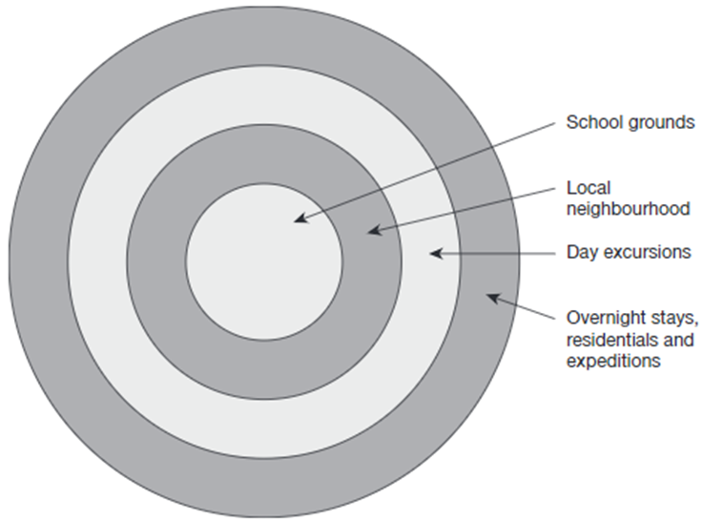
Figure 3 (Beames, Higgins, and Nicol, 2012, p.6).

The bouldering wall being outside will provide the progressive benefits sought by both the PMFA and school curriculum (Williams and Wainwright, 2016b; Hwb, 2021d). Being outside and exposed to environmental factors such as rain may allow for students to gain physical literacy and competency by developing knowledge and understanding of how environmental factors impact their movement styles (Myers, Green, and Whitehead, 2018). This development of bouldering walls within secondary schools is supported by Hughes et al (2016), but progression from primary school level must be ensured.

Rock climbing and mountain biking involve elements of hardship, adversity, and challenge which can result in feelings of elation and achievement, associated with improved confidence and self-efficacy (Barton, 2007; Beames, Mackie, and Atencio, 2019). Climbing walls also involve physical skills, elements of risk, and the need to trust in a climbing partner, these elements of undertaking decision-making to manage risks, and their possible implications for both the learner and others is a key principle of the health and wellbeing AOLE (Williams and Wainwright, 2016b; Hwb, 2021b).

With climbing becoming an Olympic sport in 2020, it may give way for opportunities to combine the benefits of the PMFA with the ‘Sport Education’ model which has experienced success in improving authenticity and inclusion within traditional sports compared to traditional short form multi-activity formats (Siedentop, 2013). The Sport Education model consists of 6 main features; seasons, affiliation, formal competition, culminating events, record keeping, and festivity (Siedentop, 2013). The benefits of this model to students include; socialisation through teamwork; greater student autonomy in decision making; opportunities to share learning with the team and learn leadership and coaching skills; improved literacy of the movement skills involved; learn about non-climber roles such as being an official; and being more inclusive without a gender divide (Hastie, 2013). These benefits not only fulfil multiple elements of the new health and wellbeing AOLE, but the application of the model to climbing may also be a stepping stone to progress students’ physical literacy to sport excellence levels (Hwb, 2021b; Jurbula, 2015).

Conclusion
This report has discussed previous literature and research into the field of outdoor learning and education and provided a reflection on the benefits they propose, and suggested creative developments TSD secondary can use to improve their provision of adventurous activities and outdoor learning. Through a combined effort of these developments, the new curriculum, and pedagogical models, all students of TSD secondary can become academically, physically, and ecologically literate, whilst also developing positive health and wellbeing.

Wordcount: 2714

References:
Allender, S., Cowburn, G., and Foster, C. (2006) ‘Understanding participation in sport and physical activity among children and adults: A review of qualitative studies’, Health education research, 21, pp.826-35. DOI:10.1093/her/cyl063.
AQA (2017) Unit Award Scheme 108699 BICYCLE MAINTENANCE. Available at: https://www.aqa.org.uk/programmes/unit-award-scheme/unit-details?unit=108699 (Accessed: 17/12/2021).
AQA (2018) Unit Award Scheme 111236 MOUNTAIN BIKING SKILLS. Available at: https://www.aqa.org.uk/programmes/unit-award-scheme/unit-details?unit=111236 (Accessed: 17/12/2021).
Barton, B. (2007) Safety, Risk & Adventure In Outdoor Activities. London: Sage Publications Ltd.
Beames, S. Mackie, C. and Atencio, M. (2019) Adventure and society. New York: Springer Berlin Heidelberg.
Beames, S., Higgins, P., and Nicol, R. (2012) Learning Outside the Classroom – Theory and Guidelines for Practice. London: Routledge.
Birch, J., et al. (2020) ‘Nature doesn't judge you – how urban nature supports young people's mental health and wellbeing in a diverse UK city’, Health & Place, 62. DOI: 10.1016/j.healthplace.2020.102296
Boldemann, C., et al. (2006) ‘Impact of preschool environment upon children’s physical activity and sun exposure’, Prev Med, 42, pp.301–8. DOI 10.1016/j.ypmed.2005.12.006
Burr, J. F., et al. (2012) ‘Physiological demands of downhill mountain biking’, Journal of sports sciences, 30(16), pp. 1777–1785. DOI:10.1080/02640414.2012.718091
Chase, D. L. (2015) ‘Does Challenge by Choice Increase Participation?’, Journal of Experiential Education, 38(2), pp. 108-128. DOI: 10.1177/1053825914524057
Clarendon Secondary Centre (CSC) (2021) Cycle Scheme. Available at: https://www.clarendon.richmond.sch.uk/page/?title=Cycle+Scheme&pid=114 (Accessed: 17/12/2021).
Department for Children, Education, Lifelong Learning and Skills (DfCELLS) (2008a) Key Stages 2–4 PE in the National Curriculum for Wales. Accessible at: https://hwb.gov.wales/api/storage/7b01cf26-9974-4c3d-bb1f-ee79e111b448/physical-education-inthe-national-curriculum.pdf (Accessed: 10/12/2021).
Department for Children, Education, Lifelong Learning and Skills (DfCELLS) (2008b) Geography in the National Curriculum for Wales. Available at: https://hwb.gov.wales/api/storage/6fce280a-8132-4969-b821-a7313a2be719/geography-in-the-national-curriculum.pdf (Accessed: 17/12/2021).
Dyment J. E., and Bell, A. C. (2008) ‘Grounds for movement: green school grounds as sites for promoting physical activity’, Health Education Research, 23(6), pp.952–962. DOI:10.1093/her/cym059
Gill, T. (2007) No Fear Growing up in a risk averse society. London: Calouste Gulbenkian Foundation.
Gray, T. (2019) ‘Outdoor learning and psychological resilience: making today’s students better prepared for tomorrow’s world’, Curric Perspect, 39, pp.67–72. DOI:10.1007/s41297-019-00069-1
Grinde, B. and Patil, G. G. (2009) ‘Biophilia: does visual contact with nature impact on health and well-being?’, International journal of environmental research and public health, 6(9), pp.2332–2343. DOI:10.3390/ijerph6092332.
Hastie, P. (2013) ‘Applied Benefits of the Sport Education Model’, Journal of Physical Education, Recreation and Dance, 69(4), pp.24. DOI: 10.1080/07303084.1998.10605530
Hughes, H. (2016) ‘High school spaces and student transitioning: Designing for student wellbeing’, Research report for Queensland Department of Education and Training. Queensland University of Technology: Australia. Available at: https://eprints.qut.edu.au/109555/ (Accessed: 17/12/2021).
Hwb (2020a) AREA OF LEARNING AND EXPERIENCEHealth and Well-being 5. Designing your curriculum. Available at:https://hwb.gov.wales/curriculum-for-wales/health-and-well-being/designing-your-curriculum/#cross-curricular-skills-and-integral-skills (Accessed: 17/12/2021).
Hwb (2020b) Curriculum for Wales: summary of proposed legislation. Available at:https://hwb.gov.wales/curriculum-for-wales/summary-of-proposed-legislation/ (Accessed: 17/12/2021).
Hwb (2021a) Developing a vision for curriculum design. Available at: https://hwb.gov.wales/curriculum-for-wales/designing-your-curriculum/developing-a-vision-for-curriculum-design/#curriculum-design-and-the-four-purposes (Accessed: 17/12/2021).
Hwb (2021b) AREA OF LEARNING AND EXPERIENCE Health and Well-being. Available at: https://hwb.gov.wales/curriculum-for-wales/health-and-well-being/statements-of-what-matters/ (Accessed: 17/12/2021).
Hwb (2021c) AREA OF LEARNING AND EXPERIENCE Science and Technology. Available at: https://hwb.gov.wales/curriculum-for-wales/science-and-technology/statements-of-what-matters/ (Accessed: 17/12/2021).
Hwb 2021d) Introduction to Curriculum for Wales guidance. Available at: https://hwb.gov.wales/curriculum-for-wales/introduction/ (Accessed: 17/12/2021).
Jurbala, P. (2015) ‘What Is Physical Literacy, Really?’, Quest, 67(4), pp.367-383. DOI: 10.1080/00336297.2015.1084341
Kaplan, R. and Kaplan, S. (1989) The Experience of Nature: A Psychological Perspective. Cambridge University Press: Cambridge
Keeping Cardiff Moving (2021) FACILITIES AND EQUIPMENT. Available at: https://keepingcardiffmoving.co.uk/project/4-facilities-and-equipment/ (Accessed: 17/12/2021).
Kolb, D. A. (1984) Experiential Learning: Experience as the Source of Learning and Development. 1st Ed. London: Prentice-Hall.
Lawson, H. A. (2009) ‘Paradigms, exemplars and social change’, Sport, Education and Society, 14(1), pp.97-119. DOI: 10.1080/13573320802615247
Lin, W. et al. (2020) ‘Sitting or Walking? Analyzing the Neural Emotional Indicators of Urban Green Space Behavior with Mobile EEG’, Journal of Urban Health, 97, pp.191-203. DOI: 10.1007/s11524-019-00407-8
Louv, R. (2005) Last Child in the Woods: Saving Our Children from Nature Deficit Disorder. London: Atlantic Books
Malone, K. (2007) ‘The bubble-wrap generation: Children growing up in walled gardens’, Environmental Education Research, 13(4), pp.513–527. DOI: 10.1080/13504620701581612
Mental Health Foundation. (2016) Fundamental Facts About Mental Health. Mental Health Foundation: London
Myers, E. J., Green, N. R., and Whitehead, M. E. (2018) ‘Implications for Promoting Physical Literacy’, Journal of Teaching in Physical Education, 37(3), pp.262-271. DOI:10.1123/jtpe.2018-0131
NHS (2021) Statistics on Obesity, Physical Activity and Diet, England 2021. Available at: https://digital.nhs.uk/data-and-information/publications/statistical/statistics-on-obesity-physical-activity-and-diet/england-2021# (Accessed: 17/12/2021).
Palmer, S. (2015) Toxic Childhood: How The Modern World Is Damaging Our Children And What We Can Do About It. United Kingdom: Orion.
Sahrakhiz, S., Harring, M., and Matthias, D. W. (2018) ‘Learning opportunities in the outdoor school–empirical findings on outdoor school in Germany from the children’s perspective’, Journal of Adventure Education and Outdoor Learning, 18(3), pp.214-226. DOI: 10.1080/14729679.2017.1413404
Schipperijn, J., Hansen, C. K., and Rask, S. (2015) ‘Use and activity levels on newly built bicycle playgrounds’, Urban Forestry & Urban Greening, 14(1), pp.163-169. DOI:10.1016/j.ufug.2014.09.003.
Siedentop, D. (1998) ‘What is Sport Education and How Does it Work?’, Journal of PE, Recreation & Dance, 69(4), pp.18-20. DOI: 10.1080/07303084.1998.10605528
Skår, M., Odden, A. and Inge Vistad, O. (2008) ‘Motivation for mountain biking in Norway: Change and stability in late-modern outdoor recreation’, Norsk geografisk tidsskrift, 62(1), pp. 36–45. DOI:10.1080/00291950701865101.
Soga, M., et al. (2017) ‘Health Benefits of Urban Allotment Gardening: Improved Physical and Psychological Well-Being and Social Integration’, International journal of environmental research and public health, 14(1), DOI:10.3390/ijerph14010071
Speak, A. F. (2015) ‘Allotment gardens and parks: Provision of ecosystem services with an emphasis on biodiversity’, Urban Forestry and Urban Greening, 14(4), pp.772-781. DOI: 10.1016/j.ufug.2015.07.007
Sutherland, S., Stuhr, P. T., and Ressler, J. (2014) ‘Group Processing in Cooperative Learning: Using the Sunday Afternoon Drive Debrief Model’, Australian Council for Health, PE and Recreation Magazine, 21(2/3). DOI: 10.1080/07303084.2019.1559676
Ulrich, R. S. et al (1991) ‘Stress recovery during exposure to natural and urban environments’, Journal of Environmental Psychology, 11(3), pp. 201-230. DOI: 10.1016/S0272-4944(05)80184-7
Wainwright, N., and Williams, A. (2012) ‘Adventurous Activities and Physical Education in Wales’, Physical Education Matters Summer 2012, pp.51-54.
Welsh Gov (2020) Curriculum for Wales: overview. Available at: https://gov.wales/curriculum-wales-overview (Accessed: 17/12/2021).
Wight, E. L., et al. (2018) ‘Nature contact at school: The impact of an outdoor classroom on children’s well-being’, International Journal of Environmental Health Research, 28(6), pp.653-666. DOI: 10.1080/09603123.2018.1502415
Williams, A. and Wainwright, N. (2014) ‘Camping on Concrete: Professional Development for Adventurous Activities in Wales’, The University of Wales Journal of Education, 17.
Williams, A., and Wainwright, N. (2016a) ‘A new pedagogical model for adventure in the curriculum: part one – advocating for the model’, PE and Sport Pedagogy, 21(5), pp.481-500. DOI: 10.1080/17408989.2015.1048211
Williams, A., and Wainwright, N. (2016b) ‘A new pedagogical model for adventure in the curriculum: part two – outlining the model’, PE and Sport Pedagogy, 21(6), pp.589-602. DOI: 10.1080/17408989.2015.1048212
Williams, A., and Wainwright, N. (2019) ‘Re-thinking adventurous activities in PE: models-based approaches’, Journal of Adventure Education and Outdoor Learning. DOI: 10.1080/14729679.2019.1634599
Zelenski, J, M., and Nisbet, E, K. (2014) ‘Happiness and Feeling Connected: The Distinct Role of Nature Relatedness’, Environment and Behaviour, 46(1), pp. 3-23. DOI: 10.1177/0013916512451901.

