
Using dark web as a source for cyber threat intelligence - 1900457
MSc Cyber Security & Digital Forensics

August 28, 2024
UWTSD
Dawid Trochim

Declaration of Originality

I, Dawid Trochim declare that I am the sole author of this Project; that all references cited have been consulted; that I have conducted all work of which this is a record, and that the finished work lies within the prescribed word limits.

This work has not previously been accepted as part of any other degree submission.

Signed : Dawid Trochim

Date : 26/06/2024

FORM OF CONSENT

I Dawid Trochim hereby consent that my Project, submitted in candidature for the MSc Cyber Security & Digital Forensics degree, if successful, may be made available for inter-library loan or photocopying (subject to the law of copyright), and that the title and abstract may be made available to outside organisations.

Signed : Dawid Trochim

Date : 26/06/2024

Copyright Acknowledgement

I acknowledge that the copyright of this project report, and any product developed as part of the project, belong to University of Wales Trinity Saint David, Swansea.

Abstract
This research project utilises the dark web in a good way so cyber security professionals can take an advantage of using dark web as a source for cyber threat intelligence and create a structure for developing a framework by scraping data from the dark web and prevent the dangers that emerge from there and improve overall security posture in general. The dark web can be access using a certain tool such as ‘Tor Browser’ which allows to browse through .onion links. The dark web is a gold mine when it comes to illegal activities, especially malware and dangers that have not yet seen the daylight and not been exploited in the wild. This project represents the use of custom python script inspired by ‘DarkScrape’ to gather the data from the dark web and use it to create a structure for developing a framework, the data that was collected was in an unreadable raw format, this shows the needs for conversion so the system can recognise it and put adequate security measures in place.
This project is divided into three logical parts – theoretical, design and implementation as well as findings. The first part includes a critical research and review of an already existing information about the dark web such as illegal activities, cyber threat intelligence and other related work. The second part is all about working through implementing the tool to scrape the data and designing everything from scratch to ensure safe environment and accurate results as this data was then converted into a readable format from raw data format and included the screenshots of the tool being utilised for its purpose. The last section – findings focus on presenting the results and showing how the extracted data can be used for creating a structure for developing a framework.
The main objective includes carrying out a detailed and detailed analysis of dark web scraping tools and developing secure cyber threat intelligence structure for creating a framework which provides additional information for professionals. The significance of this project is in demand as there are new emerging dangers coming from dark web every day, this seems to be an under looked area in cyber security, gaining knowledge about this subject can greatly increase the security and performance of the company.
The findings gathered in this research support professionals in creating a framework due to the structure that had been created. This research found a way of scraping the dark web to retrieve valuable data using python script, however data was in a raw and unreadable format meaning an intense cleaning process was needed to extract the most relevant parts. Onion links were retrieved through another python script which sent requests to ahmia.fi and saved many links into a single .txt file. Information such as popular attacks, illegal services offered and diverse types of attacks such as SS7 attack were recognised, data had been categorised and converted into a readable format which can be provided to cyber threat intelligence for attacks mitigation. An appropriate security measures such as VPN, maximum firewall setting an intrusion detection system combined with access controls to the device (PIN) were applied before starting the process.
Table of Contents
Copyright Acknowledgement 1
Abstract 2
CHAPTER 1 8
Using Dark web as a source for Cyber Threat Intelligence 8
1. Introduction 8
1.1 Research Aim 9
1.2 Objectives 9
1.3 Project structure 10
CHAPTER 2 11
Literature Review & Review of Literature 11
2.1 Introduction 11
2.2 Usage and Characteristics 12
2.2.1 Transactions 12
2.2.2 Law Enforcement 14
2.2.3 Hidden forums 15
2.2.4 Vulnerabilities and Exploits 16
2.2.5 Useful Attacks for Experiments 17
2.2.6 Emerging Trends 18
2.3 Economy 19
2.4 Cyber Threat Intelligence (CTI) 19
2.5 Frameworks 20
2.6 Related works 23
CHAPTER 3 26
3. Methodology 26
3.1 Introduction 26
3.2 Data Collection 27
3.3 Environment setup 28
3.4 Analysis 29
3.5 Results 30
3.6 Research Process 31
3.7 Research Philosophy 33
3.8 Methodology 34
3.9 Approach 34
3.10 Strategy 34
3.11 Time Horizons 35
3.12 Conclusion 36
CHAPTER 4 37
IMPLEMENTATION AND DESIGN 37
4.1 Introduction 37
4.2 Problem Formulation 37
4.3 Design 39
4.3.1 Tool and its configuration 40
4.3.2 Security 41
4.3.3 Architecture 42
4.4 Implementation 43
4.4.1 Environment setup and scraping process 43
4.5 Structure for developing a framework 60
4.5.1 Introduction 60
4.5.2 Overview of structure components 61
4.5.3 Snippet of Categorised Data 62
4.5.4 Risks 63
4.5.5 Security 64
4.5.6 Development plan for creating the framework structure 65
4.6 Conclusion 68
CHAPTER 5 70
Testing and Evaluation 70
5.1 Introduction 70
5.2 Experiment 71
5.3 Evaluation 84
5.4 Conclusion 89
CHAPTER 6 90
CONCLUSIONS AND RECOMMENDATIONS 90
6.1 Summary 90
6.2 Conclusion 91
6.3 Further research 92
CHAPTER 7 94
REFLECTION 94
8. Gantt Charts 97
9. Appendix 99
References 103

Table of Figures
Figure 1 - Framework delivery 22
Figure 2 - Representation of research process 32
Figure 3 - Problem formulation process 37
Figure 4 - Representation of network diagram 39
Figure 5 - Representation of environment setup and scraping process 43
Figure 6 - Representation of Kali Linux folder directory 44
Figure 7 - Representation of VirtualBox Kali Linux configuration 44
Figure 8 - Representation of Kali Linux successfully running 45
Figure 9 - Representation of git cloning into DarkScrape tool 45
Figure 10 – Representation of ‘cmake’ library installation 46
Figure 11 - Representation of necessary libraries being installed 47
Figure 12 - Representation of DarkScrape successfully installed 48
Figure 13 - Representation of DarkScrape in action 49
Figure 14 - Representation of data retrieved by DarkScrape 50
Figure 15 - Representation of installing requests library 50
Figure 16 - Representation of installing beautifulsoup4 library 51
Figure 17 - Representation of installing urllib3 library 51
Figure 18 - Representation of CyberGhost VPN running 52
Figure 19 - Representation of ‘malware’ query provided to the script 53
Figure 20 - Representation of terminal output after scraping .onion links 53
Figure 21 - Representation of .onion links scraped successfully 53
Figure 22 - Representation of Tor.exe process 54
Figure 23 - Representation of Tor.exe process running 54
Figure 24 - Representation of feeding .onion link to scraping python script 55
Figure 25 - Representation of script in action 55
Figure 26 - Representation of data successfully scraped 55
Figure 27 - Representation of HTML code behind pulled data files 57
Figure 28 - Representation of retrieved data in HTML format 58
Figure 29 - Representation of Tor.exe shut down 59
Figure 30 - Representation of VPN disabled 59
Figure 31 - Retrieved data snippet 62
Figure 32- Representation of development plan cycle 67
Figure 33 - Representation of requests installation via pip 71
Figure 34 - Representation of 'beautifulsoup4' being installed via pip 71
Figure 35 - Representation of 'urllib3' being installed via pip 72
Figure 36 - Representation of maximum firewall settings and IDS 72
Figure 37 - Representation of VPN running with a kill switch option enabled 73
Figure 38 - Representation of Tor browser security set to maximum 74
Figure 39 - Representation of 'ahmiascraper' execution 75
Figure 40 - Representation of 'Tor-Searcher' usage 77
Figure 41 - Representation of scraped content and folder name 79
Figure 42 - Representation of HTML scraped content 80
Figure 43 - Representation of HTML scraped file via Opera GX browser 81
Figure 44 - Representation of data cleaning process and checking for keywords 82
Figure 45 - Representation of categorised data to deliver to CTI 83
Figure 46 - Initial Gantt Chart 97
Figure 47- Representing scraped data for CTI 98
Figure 48 - Representing scraped data for CTI 99
Figure 49 - Representing scraped data for CTI 99
Figure 50 - Representing scraped data for CTI 99
Figure 51 - Representing scraped data for CTI 99
Figure 52- Representing scraped data for CTI 100
Figure 53- Representing scraped data for CTI 100
Figure 54- Representing scraped data for CTI 101
Figure 55- Representing scraped data for CTI 101
Figure 56- Representing scraped data for CTI 102

CHAPTER 1

Using Dark web as a source for Cyber Threat Intelligence

Introduction
The dark web is a part of deep web [1] which is not open for anyone to access unless a special search engine is being utilised to gain access such as ‘Tor’ browser. Tor browser has gained its popularity due to the ability to access dark web, provide anonymity and encryption. The reason why dark web is not publicly accessible is due to its nature and content such as illegal arms sales, trading the data that has been stolen, drug trafficking, human trafficking, paid hitman services and many more. This has become a ‘bird’s nest’ for cybercriminals as that is where they can perform illegal actions anonymously away from the authorities.
The anonymity supplied by Tor [2] and I2P makes it significantly more difficult to perform any kind of cybercrime investigation and makes it challenging for cybersecurity professionals to counter and prevent illegal activities carried out in the dark web. Tor makes it challenging by masking the activity of users by preventing professionals from finding out the legitimate identities of cyber criminals along with their real location and this is because Tor works by spreading and allocating data of the cyber criminals across many servers worldwide.
However, the dark web also has its bright side [3] such as using it in a positive way as it is a gold mine for enhancing the security with cyber threat intelligence. Professionals with good intentions can gather and analyse a wide variety of data and translate it into a robust security framework, dark web is the root of the problem meaning that all the dangers and unethical actions emerge from there; by having that data at the same time as the criminals, professionals can stay pro-active and free from the dangers.
To summarise the introduction of this project, it is safe to say that the dark web is a powerful and dangerous place, it can be used in a positive and negative way depending on individual’s intentions. By having an enriched knowledge about automated tools and human intelligence, companies can use the dark web as the source for creating a structure for developing a robust security framework. It is a heavily under looked topic, this is the reason companies get compromised. Having an appropriate infrastructure to continuously monitor the dark web, helps organisations to avoid falling a victim of the dark web unethical activities. It is worth to state that the main goal is to create a systematic structure for creating a framework achieved by the data gathered during the scraping process.

1.1 Research Aim:
This project aims to create a consistent and systematic structure for framework based on advanced data gathered by ‘data scraping’ using various scraping methods and to feed it to actionable intelligence.
1.2 Objectives:
- Carry out advanced and careful research about utilisation of dark web scraping tool and methodologies which can efficiently pierce through the dark web layers and reveal the data which cannot be accessed by standard individuals.
- Deep analysing each potential tool or technique while making sure that the safety of the research is kept at its highest without breaching any legal boundaries.
- Perform advanced data analysis to retrieve as much information as possible to later implement it in the structure for framework for security. This analysis dives deep into the methods that cyber criminals utilise to perform illegal actions.
- Create a structure for developing a framework which consists of the data scraped from the dark web and retrieved by utilising data analytics skills. This structure for framework should be made easy and simple to understand for all industry sectors and for current cyber security postures and infrastructures. This structure for developing a framework uncovers and provides a powerful set of tools available for companies to utilise to constantly monitor dark web activity and stay ahead of any cyber threat emerging trends.
Significance:
The important and significance of this research is classified as important [4]. It explores deeply into a massive forbidden security gap which is currently being under looked and under explored by cyber security professionals. By enhancing and constantly educating, cyber security professionals can ensure that security posture of the companies are up to date and robust through leading to a reduced chance of cyber breach occurring and allow companies to better understand the dangers that they are exposed to by not taking dark web topic seriously. In other words, this research aims to enhance the academic field when it comes to cyber security by allowing new methodologies to be explored and utilised by having a deep understanding and great insights into dark web illegal field.

Project structure
The project is divided into three sections. To begin, the theoretical work that presents and describes the project. The first part which is theoretical work is linked to discussing and reviewing literature review and any previous research that had been carried out based on using dark web as a source for cyber threat intelligence which supported the knowledge enrichment and behaved as a good beginning and foundation to support the results and outcome of this project. Secondly, the next part had focused on describing and discussing the implementation and design section of the research by representing the hardware, software and libraries which were essential to achieve aim and objectives. Lastly, the last section of the research represented the results and findings that supported the fulfilment of the aim and objectives. Also, a section where a conclusion along with the summary can be found was included in the final part of the research.

Chapter one provided a background summary of the research, outlining the aim and along with the objectives which are essential to fulfil the requirement of scraping data from the dark web and building a pro-active structure for developing a framework.

Chapter two focused on the critical literature review and explaining in detail about the processes and mechanisms that went behind the project.

Chapter three discussed the design and the approach taken to fulfil the research and outline how the project was carried out and what methodology was utilised.

Chapter four included details about implementation and design, this is where the screenshots of the practical part had been included.

Chapter five showcases’ tests and evaluation about the work that has been carried out.

Chapter six puts pressure upon conclusions and recommendations.

CHAPTER 2

Literature Review & Review of Literature
2.1 Introduction:
The dark web works by [5] providing users a solid level of high and enhanced security, this is achieved by utilis Tor browser which is responsible for rerouting inbound and outbound traffic via a wide variety of different and complex networks, each rerouting point applies an extra layer of security and encryption comes with it. This approach provides a deeper understanding of how the mechanism behind famous Tor works and how encryption is being achieved along with traffic decryption as there are different nodes in the networks and they are responsible for the process of encryption, however the data retrieved by nodes is limited as it is only extracting basic information such as the location the previous and also next node, this way users can browse via Tor safely. There are many studies proving that Tor performs better than l2P when it comes to infrastructure and stability, but it has been documented that l2P prevents the end user from being a victim of endpoint attacks, which in this case is essential.
Tor achieved its high-level security [6] due to an ability to navigate through a series of nodes. All nodes are structured in a way where the traffic enters the tunnel, travels through and exits the tunnel to the destination point for the traffic. Each node is essential and crucial due to data safety and encryption. It works by enabling users to send a request that travels through a random sequence of nodes where each node decrypts a layer, so the next code is validated to accept the traffic, it continues until the traffic is fully decrypted and reaches the exit node. However, for extra security, the transmitted traffic only contains basic information such as the location of the previous node, this is done to ensure that no node is fully able to find out the full path of the data and what nodes it had travelled through. This encryption & decryption process is what makes Tor browsing extra safe.
Additionally, the extremely rigorous level of security applied by Tor [7] makes it complicated for professionals to carry out investigations as the data is being transmitted through the random servers worldwide making it challenging and significantly adds complexity to tracking down criminals.
Federal agencies and cyber security professionals need to keep coming up with new techniques and methods to penetrate the security and to take down the criminals.

2.2 Usage and Characteristics
Dark web is a home to illegal marketplaces [8], however it is not the only aspect that populates it. Dark web is also a home to hidden forums specialising in breaching the privacy of users supported by whistleblowers as they mainly focus on privacy, so the information is later announced to the public. This section dives into popular marketplaces such as AlphaBay and Silk Road, volume of transactions and an amount of harvested funds was discussed along with the type of items or services being offered there. A brief overview of post-takedown was provided as the fall of the forums mentioned above caused an outbreak of smaller and less popular marketplaces.

2.2.1 Transactions
The two marketplaces – AlphaBay and Silk road [9] have recorded millions of dollars in transactions and most of it was provided by selling illegal drugs. Before the law enforcement stepped in to take it down in 2017, it was reported that AlphaBay had a record of $1.000.000.000. This just shows how powerful the dark web is, and the amount criminals managed to transact before it got eliminated by the law enforcement.
Cyber criminals use various cryptocurrencies in the dark web due to its anonymity and complexity of tracking back the real identity behind the transaction, Bitcoin is the main cryptocurrency being used in the dark web amongst other popular cryptocurrencies such as Ethereum. However, after some time, the anonymity of Bitcoin had been compromised and it was possible for the law enforcement to easily take down the cyber criminals, to counter this, cyber criminals started using a privacy-focused cryptocurrency called ‘Monero’.
The dark web allows you to buy almost anything an individual can think of [10], and it varies from illegal drugs to weapons and hitman services. Here is a bit more about various categories of items and services being offered on the dark web.
- Illegal Drugs: A huge portion of sales comes from the sale of illegal drugs [11] it varies from cannabis to deadly substances such as cocaine, heroin or drugs that have not yet been discovered.
- Weapons: Cyber criminals offer to sell almost any firearm [12] an individual can think of including ammunition. They offer untraceable weapons which is usually more expensive.
- Stolen Data: Individuals looking for illegal services on the dark web [13] can find offers such as personal information, credit card details and databases & login details for sale. This is mainly bought by other cybercriminals, then used for identity theft to collect more goods from innocent victims.
- Counterfeit items: Fake documents, fake currency and passports [14] are out there available for purchase by individuals, this is used for taking out illegal loans and crossing borders illegally.
- Hacking: One of the biggest factors that the dark web offers [15] is its variety and flexibility when it comes to hiring world-class hackers with bad intentions to perform illegal activities according to the requirements set out by the buyer. The dark side of the internet also offers unknown and undiscovered types of malware and other hacking tools which have not yet seen the daylight meaning it is impossible or near impossible to be detected by IDS and cyber professionals.

2.2.2 Law Enforcement
As mentioned above, the two takedowns of huge marketplaces had a significant bounce back on the dark web economy and ecosystem [16], it created an absolute chaos for sellers and disrupted a huge number of transactions and plans.
- Smaller marketplaces: The two takedowns caused chaos [17], leading to smaller marketplaces rise. These smaller marketplaces behave in the way to fix the hole and the void that was caused due to the takedown, this causes the dark web to be more spread and fragmented, instead of two large marketplaces, criminals can now visit many smaller marketplaces making it even more difficult for law enforcement to detect the illegal activity, before the takedown, law enforcement had to focus on two major marketplaces but now it had changed to thousands.
- Security: Due to the takedowns [18], cyber criminals decided to implement even stricter security rules to prevent takedowns again, they are trying to achieve it by applying loads of extra security layers to communication channels, more rigorous process of accepting new users to the forums and constantly using different privacy-based cryptocurrencies to purchase goods.
- Loop: Despite takedowns, the dark web community did not give up and decided to create many smaller marketplaces causing dark web to be fragmented, it is an endless cycle and there seems to be no solution for this and there always new marketplaces being born straight after the big ones get taken down.

2.2.3 Hidden forums
It has been established that the dark web is already hidden and contains a rigorous level of security [19], however, cyber criminals go even further and beyond to keep their illegal business flowing and running by creating hidden forums on the dark web in order to exchange information and perform whistleblowing activities. Hidden forums like that are primarily focus on maintaining the highest level of security possible so the users can freely navigate around without the fear of being exposed to law enforcement.
Here is a bit more about hidden forums:
- Privacy-based forums: Many forums on the dark web primarily focus on exchanging sensitive information that should not be exposed to the public; however, it can have its positive sides as many forums discuss mainly about privacy, security and techniques, this brings in many researchers and innocent individuals wanting to expand their knowledge about the security and making sure that they stay safe.
- Whistleblower: There are many popular whistleblower platforms and a good example of that is SecureDrop as it allows users to submit whatever information they want whilst staying anonymous, the information usually goes to journalists and different media groups who then release that information to the public exposing corruption, unfair activities, human rights abuse and many other problems.

2.2.4 Vulnerabilities and Exploits
As mentioned earlier, the dark web is known for its famous dark side that contains unknown vulnerabilities and exploits, here is a bit more about some of them:
- Zero-Day exploit: The dark web is an excellent place for getting zero-day exploits [20], zero-day exploits are created due to human error caused by the vendors as there are vulnerabilities in the fronted or backed infrastructure. Unless vendors are on the lookout and constantly reviewing the infrastructure, there is no possibility for vendors to find out what the vulnerability is unless the tragedy happens, and security breach occurs.

- Ransomware-as-a-Service (Raas): The dark web offers a service called Ransomware-as-a-Service [21] and this allow individuals to purchase or rent out ransomware exploits. The reason it is ‘as-a-Service’ is because the creators of ransomware have made it significantly easier to launch that ransomware exploit so even non-tech savvy individuals are able to deploy ransomware without having a usually required set of skills.
- Phishing: The dark web offers phishing packages [22] that allow individuals to host fake websites that look identical as the original one and creates emails that are mainly used for stealing information. Again, the package comes in handy for individuals with not very developed IT skills, so it is way too easy for anyone to deploy phishing attacks. Having a good and deep analysis of phishing packages aids professionals to understand the mechanism and logic behind the package and intentions of the creator.

2.2.5 Useful Attacks for Experiments
There are hundreds of different attacks available out there on the dark web and here is a bit more about the most popular choices on the dark web:
- Credential Stuffing: This attack is based on creating or gathering a list of breached usernames and passwords [23] that could very often be pulled from the dark web to obtain an unauthorised access to the sensitive information or accounts. This attack targets certain groups of people and primarily elders as elders tend not to change their password very often meaning the chance of the email and the password being in the list is quite high. Having a good and deep knowledge about credential stuffing contributes professionals in understanding the logic and mechanisms behind this attack and adjust the security framework to protect the users from being a victim.
- Social Engineering Attacks: Social engineering attacks [24] are one of the most common types of attacks and the dark web offers services exactly like that, social engineering attack works by manipulating individuals into performing actions requested by the attacker, the attacker might be pretending to be someone else to cover up the identity and stay anonymous. The dark web also offers guidance about social engineering attacks and how to perform them in best way to bypass the security measures applied by cyber teams. Having a good knowledge about social engineering might be difficult as there are thousands of ways of manipulating people into doing what should have never been done, performing a regular social engineering training significantly reduces the change of being a victim of social engineering attacks.
- Distributed Denial-of-Service (DDoS): This is the most popular type of attack and usually costs thousands or tens of thousands of pounds [25], this attack has only one aim – completely disable the network and system by sending an enormous number of packets to the point where network just gives up and becomes completely unavailable for use and stays unusable for days or even weeks. Having a good and deep understanding of DDoS is essential and needs to be very well understood by professionals to avoid losing millions of pounds or thousands depending how big the attack is. It is achieved by groups of professional hackers that take control over thousands of random devices around the world by employing the malware and deploy the attack.

2.2.6 Emerging Trends
The dark web is the cause root of great and helpful technologies and trends coming out daily [26], one of the prime and currently trending examples is Artificial Intelligence (AI) and there are tons of discussions about AI and Machine Learning (ML) technologies about improving the automatic and execution of cyber attacks so cyber criminals do not have to put any effort into causing damage to someone. The worst aspect is that phishing campaigns can very easily be automated with AI and cause chaos in the industry as majority of the employees are still not trained very well against phishing campaigns. Having a good understanding of detecting AI cyber-attacks patterns is crucial to prevent human error caused by employees.
AI allows cyber criminals to quickly extract the most relevant data from millions of records and save a lot of time [27], this makes sure that only the data needed by them is extracted. AI automation is a complete game changer in cyber criminal world as it also enables them to have an opportunity to create a custom software achieved by ML and AI by constantly reviewing the environment and security measures and how it behaves and develop malware in a way which bypasses the most up to date security measures without triggering any IOCs or alarms.
Blockchain technology is another important aspect that originates from the dark web [28] and is most related to cryptocurrencies, however the applicability of blockchain goes beyond that and expands in the dark web so criminals have a safe and secure way of transmitting payments in the dark web. Blockchain’s nature allows cyber criminals to stay secure and keep their privacy anonymous which leads to an increased number of illegal activities. Having a deep understanding about blockchain is a difficult topic but significantly changes the field for cyber security professionals as it creates an opportunity to capture the details being transmitted over the secure channel.
The dark web allows cyber criminals to have a fair and trade exchange of goods by implementing something called ‘smart contracts’, this works by having automated contracts with secret code behind to automatically release the payment to the seller once a specific action is triggered by the buyer, this ensures the trade is always fair.
Cyber criminals communicate via blockchain-based messaging services that allow them to have a confidential and secure conversation, services like that are hosted and based on the decentralised storage and this makes sure that conversations cannot be seen by anyone else, intercepted or modified.

2.3 Economy
There are hundreds of aspects known to humans about price fluctuations [29] when it comes to cryptocurrencies such as Bitcoin. A relationship between dark web and Bitcoin current price fluctuations had been deeply discussed as there are many hidden aspects embedded into dark web that have a significant impact on the price. It is not a secret that cyber criminals prefer their main currency to be Bitcoin as it is hard to trace it back, however it is still possible to achieve by utilising blockchain forensics. Cyber criminals use it to pay for goods and services, this affects the Bitcoin price by going up and down depending on how many transactions are being carried out. A discussion about how different countries with very influential governments utilise dark web. One of the strictest countries – China and Iran – users that originate from there utilise dark web as a place where the information can be freely shared, it is done due to the level of censorship and privacy applied by both governments, users can stay anonymous while sharing the information with other users. Dark web plays a heavy role in stricter countries and promotes speech free ability.

2.4 Cyber Threat Intelligence (CTI)
This section of the research discusses a timeline of important cyberattacks that have happened in the past [30] and how Cyber Threat Intelligence played a massive role in making sure that attacks that have occurred can be prevented in the future. Each cyberattack is different meaning Cyber Threat Intelligence covered many distinct aspects and explanations. This section explains how CTI ways of preventing illegal activities have been altered and tailored so it provides a complete incident-response solution while providing a prominent level of flexibility to stay up to date with the latest cyber security threats. However, there are ways to workaround and take off the stress from the security team by investing into a security operation centre (SOC), it works by downloading their agent and deploying it across the organisation, security administrators are able access to the dashboard where every single threat and indicators of compromise (IOC) and many more will be made visible or is already accessible for them if detected.

2.5 Frameworks
This part of the research provides a better understanding of an important aspect called ‘Intelligence Cycle’, [31] it discusses and explains each step being applied in real life scenarios. For example, the process of collecting data is called ‘data collection’ and intelligence cycle aids this process buy elaborating on how the information can be pulled effectively by using specific tools, this knowledge is essential to stay aware of the latest emerging trends in the illegal cyber world.
Additionally, there are many types of cyber threat indicators [32], and each indicator is ranked individually based on the impact and damage that it can prevent. It is a foundational framework that is essential when it comes to applying Cyber Threat Intelligence so the data and information can be stored and processed systematically and prevent cyber attacks efficiently. Here are the steps:
- Planning: This is where everything begins [33], individuals outline the aim and objectives for the project and set out any specific vulnerabilities as well as threats which need to be prevented. The main aspect of this step is to answer the questions that need to be answered such as resource allocation and effective planning. In this step, specific steps such as malware sales, breaches and hacking techniques.

- Several types of threats currently popular on the dark web
- Most populated marketplaces and forums for cyber threat exchanges
- Measures that can be implemented based on the data gathered.

- Data Collection: [34]In this step, data was gathered using specialised tools such as DarkScrape and a custom python script. Data was partially gathered by DarkScrape due to its inability to scrape websites, however a custom python script inspired by DarkScrape had been created to fulfil the needs and meet the requirements.
- Processing: Once the data is gathered and settled [35], it needs to be analysed and processed. The data that is collected comes in a raw basic format, to make it usable; individuals need to convert this data into a usable format tailored to their likings and requirements. This conversion process might include things such as translation, organising data into databases or even decrypting it. To make sure the data can be efficiently reviewed, data normalisation needs to be implemented e.g. a bunch of IP addresses gathered from the dark web and enhanced by having geolocation details.
- Conversion: This part of intelligence cycle makes sure the data that has been processed and reviewed [36] and is converted into intelligence. Professional analysts are putting all the efforts into making sure that any patterns, anomalies and trends are quickly identified. When individuals approach this issue with ‘Cyber Security’ type of approach – tactical analysis to constantly monitor for any new malware and phishing campaign, and this identifies as strategic analysis because it requires professionals to have a wider range of knowledge so many different techniques and procedures can be utilised by cyber adversaries. There are many diverse types of data, one of the problematic ones could be identified as ‘large datasets as it requires a specific approach which can be achieved by machine learning and make it easier for professionals to automate their actions. In this step, a report with specific threats that are likely to have an enormous impact on the organisation was provided along with countermeasures.
- Delivery: Once the final product is finally ready for ‘shipment’ [37], it needs to be provided to the stakeholders, and it is then up to them to make any decisions. This step of intelligence cycle ensures that the right people have the right information delivered to them in a way that is simplified and easy to follow. In other words, informing IT department about the actions that need to be taken and implemented immediately.
Here is an example that might be put against analysis later:
- Direct focus on a specific malware/vulnerability that is currently being populated and how it affects the system.
- Gather data from dark web that discusses or explains how it works.
- Analyse and process the data to extract the essential information about the mechanism behind the malware/vulnerability and look for any indicators of compromise (IOCs) and provide recommendations.
- Inform IT department about the necessary steps that need to be taken.
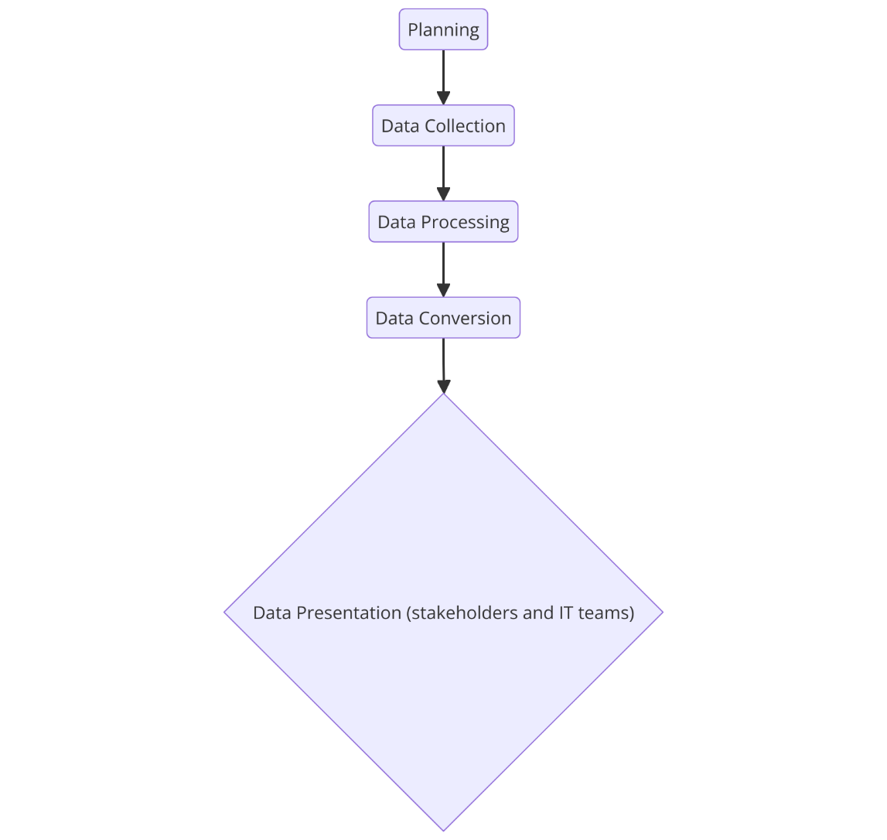
Figure 1 - Framework delivery

2.6 Related works
The article ‘A General and Modular Framework for Dark Web Analysis’ [38] represents a protractile and modular framework for gathering and analysing data from the dark web achieved by employing ‘Docker Swarm’. The proposed framework was created in a way to manage large numbers of data between the systems in an effective manner. The core abilities of the framework implemented efficient levels of automation, expandability and flexibility to combine a wide range of analysis tools. The framework is beneficial in the main priority is put on the security level and analysing huge datasets in an effective manner.
Key Findings of the Article:
- Expandability and Efficiency: An ability to manage large datasets when many nodes are operating, scalability is the main factor supporting the framework as it is essential for a constantly evolving dark web landscape.
- Modularity: The use of many separate services, commonly known as ‘microservices’ enables the cooperation of various analytical tools, immediately enhancing the framework by making it flexible to a constant research needs due to evolving perspective of the dark web.
- Automation: The framework focuses on the elimination of manual intervention and puts an intense pressure on automation making the data gathering phase seamless and allowing data analysis smoothness.
Current research:
This research emphasised setting up a robust environment for scraping data from the dark web by utilising Python script running on a machine hosting Windows operating system. This research focused on ensuring the security is robust by utilising a firewall with maximum security settings, intrusion detection system (IDS), and a highly rated Cyber Ghost VPN with a kill switch option enabled. The data collection process was achieved by a partially-automated approach, where two scripts – ‘AhmiaScraper’ and ‘Tor-Searcher’ worked together to collect the data. The reason the approach is classified as partially automated is due to the necessity of manual intervention to achieve the best data relevance and data relevance is extremely important when it comes to cyber security.
Key Findings of This Research:
- Security and Anonymity: This research prioritised handling data in a secure manner to ensure the researcher stays unrecognised and not exposed to dark web risks and dangers.
- Controlled Data Handling: A partially automated approach enabled the research to manually inspect and validate the data ultimately leading to an increased data relevance and accuracy.
- Manual Inspection: The core of this research was manually analysing and verifying the data to make sure that only the most needed data is captured and prepared for the next step which was data analysis.
Comparison of Findings
- Expandability vs Control: The article ‘A General and Modular Framework for Dark Web Analysis’ focused on expandability, ultimately making it suitable for processing large amounts of data. In comparison, this research emphasised handling data in a secure manner and is suitable for systems where data relevance and accuracy are prioritised, and scalability is not as important.
- Automation vs Manual Intervention: The article that was found puts an intense pressure on automating every single process in relation to microservices and this significantly increases the effectiveness and efficiency of the framework. Contrariwise, this research implements a balance between manual intervention and automation to provide reassurance for any data that is collected to be relevant and faultless which is a huge aspect when handling sensitive findings collected from the dark web.
- Modularity vs Customisation: Scavenging through the article that was found, it is clear to state that the modularity implemented into the framework makes it easy to cooperate with new tools while feeding the flexibility and applicability. This research is based on using custom-made scripts made especially for specific tasks, this opens the door to operating in a secure and controlled environment while reducing the flexibility when it comes to expanding.
- Security: This research accentuates security due to implementation of specific configurations and manually overseeing data accuracy and validation to ensure the researcher’s identity was not exposed and data cannot be intercepted. However, the article ‘A General and Modular Framework for Dark Web Analysis’ does not highlight the security to the same level, and this leads to dangerous situations if implemented in a real-time and real-world environment.

Conclusion:
The dark web is a complicated and strange place to be found in, it is a part of the internet that cannot be seen with standard browsers and procedures. It gained its popularity due to the anonymity and privacy. However, it is often linked to illegal activities and huge illegal marketplaces such as AlphaBay and Silk Road, but it has its positive sides such has whistleblowing platforms where corruption, illegal activities and human rights abuse gets exposed to the public by the media and journalists. The dark web is constantly moving forward making it difficult for cyber professionals and law enforcement to take down illegal forums and prevent unethical activities. This topic is extremely under looked and leads to many data breaches and companies getting hacked constantly as there are new threats and techniques that emerge from the dark web everyday and not properly monitoring dark web leads to not having a robust and dark web proof security framework that would most likely prevent the damage from occurring or at least reduce the damage caused by the attack.
Every single company should employ a way of monitoring dark web in real-time and everything that happened in the past to be prepared for what already exists and was deployed and what already exists but is not yet released to the public. Cyber security experts need to work harder and stay active and aware of the dangers that emerge from the dark web and be on a constant lookout by going through the monitoring system to detect any anomalies. However, cyber criminals do not need to work as hard as cyber security experts, their job is to create, deploy and cause damage while hoping for financial gain.
To summarise, the dark web has its positive and negative side. It is known for its negative side but if used correctly, it is an excellent place for securing the infrastructure and helping the population by exposing corruption, human rights abuse and other controversies that were never meant to reach the daylight. However, if used in a bad an unethical way, it can cause a lot of damage to individuals or companies or population in general.
The article discussed in related works provides treasured details about dark web analysis as well as this research, however the article that was discussed is suitable for different needs as it primarily prioritises expandability and effectiveness, that aspect is suitable during maintenance of large datasets, unlike this research due to its focus on setting up a secure and managed environment leading to a faultless approach during data collection and analysis process. Future work might expose cooperation of this research with the article that was found in terms of security-focused assets while adding the expandability considered in the article, combined approach could reveal a new – hybrid solution which would implement aspects from both – the article and this research and create a secure, scalable and flexible framework for dark web data scraping.

CHAPTER 3

3. Methodology

3.1 Introduction
The focus of this research was put on platforms that are spreading hacking tools and encouraging illegal activities, to achieve it, qualitative and quantitative research was completed to ensure that illegal activities discovered in the dark web are well understood and acknowledged. To collect the data, a custom Python script was developed to access .onion links. Tor’s rigorous standards and protocols provide users with the highest level of security of encryption and anonymity, this allows individuals to feel safe whilst browsing the dark web without fear of getting exposed. This is the foundation for this project as it allows the researcher to stay safe and anonymous during the data gathering process.
Custom Python script, a tool for gathering data from the dark web was utilised to gather the data, it works based on routing traffic through Tor proxies and opening port 9050, however this is not recommended. This custom smart python script scavenged through the marketplaces and forums pulling whatever it could to provide the researcher with a wide variety of data.
After the data collection process is finished, data gathered needs to be converted into a readable for cyber threat intelligence format and to achieve it, it needs to go through a rigorous cleaning process to make sure the data can be employed in an appropriate way. The cleaning process is extremely strict as it strips down the data to an absolute minimum and what is essential by removing anything unnecessary such as inconsistency, standardised formats etc. This makes sure that data is appropriate and easy to analyse by cyber threat intelligence.
To summarise, this approach employs using complexed custom python script and extra layers of security such military level secured VPN, intrusion detection system, access controls and firewall to provide the researcher with the highest level of data accuracy and anonymity. The mix of qualitative and quantitative research delivers a proof and robust security framework that covers a lot of, if not most dangers that emerge from the dark web.

3.2 Data Collection
This part of the research [39] was carried out by utilising a strategic approach to filter out specific dark web sources such as marketplaces, chat rooms and forums which is where cyber criminals often reside. This approach employed many various aspects such as activity, frequency and reputation established by cyber criminals. To establish a better understanding, a forum, marketplace or chat room that is mainly focused on the distribution and developed of hacking tools were the main targets as it consisted of the relevant data. Both – qualitative and quantitative research was carried out and gathered meaning the data was identified as number-based, countable, interpretation based and descriptive as it helps to understand the audience what happened, how and why.
Here are some major steps that need to be taken:
- Identification and targets: Forums and places with the highest activity were targeted because of the highest amount of traffic going through marketplaces and illegal forums, this means that populated places were targeted first when it comes to data collection.
- Monitoring & Data gathering: Constant and regular monitoring of data collection process was made possible by using a custom python script, which is a web crawling tool but highly and often used with Tor due to its ability to provide the researcher with the highest possible level of security, however this script is the researcher’s innovation and creation and can be altered to also scrape the normal and visible surface of the internet.
- Analysis: The data collected had been put through an analysis against many several factors such as common patterns, most frequent posts just to understand how cyber criminals move around and how they behave and work.
- Quantitative and Qualitative approach: This approach requires the researcher to work with numbers and content. Quantitative part of this research involves working with numbers to provide statistics about various activities, however qualitative part of this research focuses on understanding the methods, content, motivations and techniques employed by cyber criminals.
- Ethics: This methodology provided assurance that all laws, ethical standards and procedures are followed, and no person’s identity or privacy involvement was included and harmed during the data gathering process.

3.3 Environment setup
To gather the data [40], Tor proxies were utilised to guarantee the security and safety for the researcher. To pull the data from the dark web, a well-known and popular programming language had been employed to create a custom python script to pull the data from the dark web. It is used for retrieving data from dynamic web pages and complicated websites. For extra security, military level secured VPN with a kill switch option enabled protected researcher’s anonymity, a maximised setting firewall combines with an intrusion detection system.
This custom python script allows to pull the information from dynamic web pages and complicated websites, cyber criminals started using the most basic security measures such as CAPTCHA checks to view the content of the websites, a lot of tools struggle with bypassing that, however the development of the python script was carried out in a manner which bypassed the CAPTCHA checks.

3.4 Analysis
After the data was scavenged [41], the format was unreadable as it contained irrelevant and useless information. The extensive cleaning process focused on removing anything that is not relevant to cyber threats. Data normalisation had been involved to ensure that the data can be converted into a simplified and readable format. To provide an example, text data might be standardised when it comes to encoding making it incompatible with different datasets. Data normalisation consists of many processes that make it clear and tidy such as sorting out numerical values, categorising data, formatting dates etc.
The data that was collected and processed, had been allocated into a dataset to ensure that the researcher is has the ability to navigate between the information from the dark web; by following this simple approach, the data is appropriate for further analysis and reporting if needed.
To summarise the analysis, the data underwent a rigorous cleaning process and normalisation to transform it from an unreadable format into a categorised dataset that had been essential in creation of a robust structure for developing a security framework, so the cyber team has the ability to increase the detection and response time rates.

3.5 Results
Expected Outcomes:
This project focuses on proving how the data pulled from the dark web using automated scripts can be helpful and efficient in creating a robust security solution for modern companies. It aims to provide a detailed analysis of the pulled data. This was crucial to identify new threats and techniques that emerge from the dark web.
Type of Data and Details:
- Technical Difficulties: Many websites started protecting themselves from scraping tools and implemented CAPTCHA prevent measure.
- Security: Making sure that the activity and actions carried out by the investigator are not compromised the safety of the system.
- Legal and Ethics: Ensuring that legal and ethical problems were prevented by obeying to data privacy laws and avoid pulling the data from places that should not be included.
Testing:
Easy to use: Critical evaluation of how easy to use the tools are for non tech savvy individuals.
Effectiveness: Evaluation of the robustness of the structure for developing framework.
Feedback:
- Improvements: Gather feedback and acknowledge potential improvements for critical analysis and decide whether the suggestion is worth looking at and implementing or should it be rejected.
- Compatibility: Gather feedback about how easy it is to create a structure for developing a framework without interrupting the current in place system
Significance:
In this project, results were presented reflecting how well the structure for developing a framework was completed, and the data has been gathered by focusing on the crucial parts which is using dark web data as a source for cyber threat intelligence. By having a constant and consistent routine of reviewing the framework and tools used to stay away from emerging trends, companies can ensure that their security posture can stay robust.

3.6 Research Process
The research process for this project is structured in a way that allows the researcher to investigate the dark web when it comes to illegal and unreleased hacking tools and activities. This research is designed in a way to ensure the data collection and analysis process obeys all the legal standards and laws, while maximising the anonymity of the researcher while collecting the data. Here’s a breakdown of this process:
- Positivism:
This research employs a positivist approach [42] allowing the researcher to analyse the assets that can be seen and measured. This research is based on the real and actual data to come up with conclusions while striving to be unbiased and objective.
- Deductivism:
Deductivism is used in this project as already existing ideas and theories had been employed and used as a reference [43] to start the research. The hypothesise drawn from the ideas and theories and were put against the test to ensure its effectiveness and efficiency.
- Qualitative:
This research employs qualitative method of research [44] in order to get a detailed understanding and view of the content stored by the dark web, this includes aspects such as marketplaces, behaviours, transactions, discussions and possibly chat rooms if found.
- Experimental:
To fully have a control over the interactions occurring on the dark web [45], an experimental approach was employed to make sure the data is handled in a safe and controller manner.
- Mono:
This research implemented a mono strategy as it puts focus on a singular methodological approach which ensured that the data gathered was analysed in a consistent and efficient manner. The ability to complete this aspect was achieved by using custom python script.
- Data collection:
Data collection process was made possible by the Tor proxies as it allowed the researcher to visit .onion links while providing the highest level of security and anonymity. A military secured VPN protected researcher’s anonymity and provided data integrity.
After data collection process successfully finished, the raw data went through a rigorous cleaning process where it was broken down into only what is needed and all unnecessary information had been eliminated, to achieve this – data normalisation supported this process by categorising it into appropriate categories, formatting dates etc.
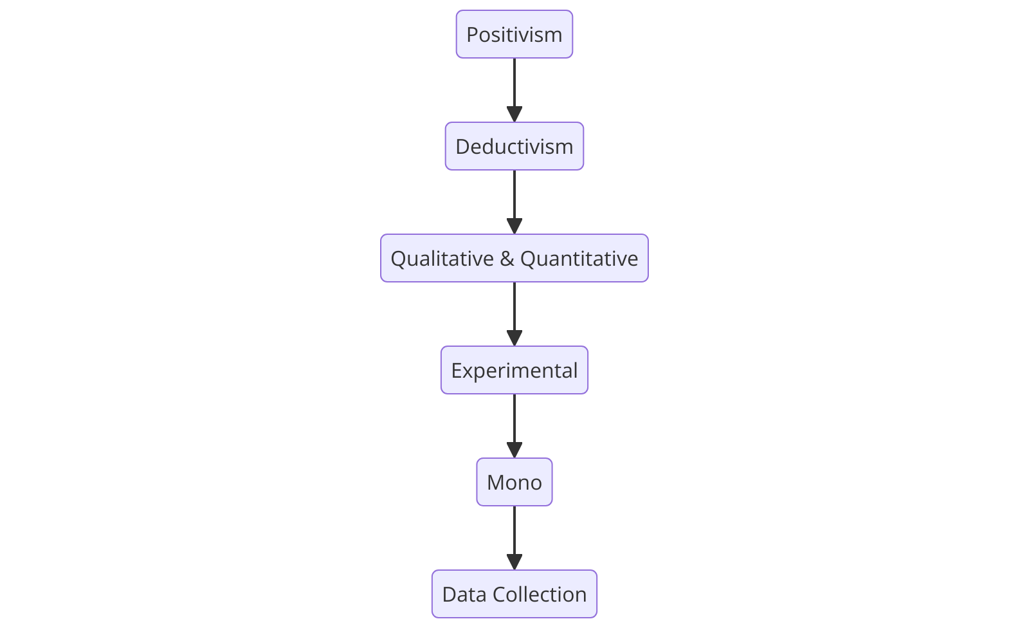
Figure 2 - Representation of research process

3.7 Research Philosophy
This project utilises a positivist philosophy [46], the reason for this is a constant need of data collection as well as quantitative analysis of the data scraped from the dark web to ensure CTI is efficient. The positivist approach puts pressure on objectives and measurable data, this ensured that the structure for framework is reliable and sable.
Justification & Advantages
This approach is beneficial because it concentrates on empirical data [47] to make sure that the data gathered can be verified. This provided assurance that statistical ways of data analysis are utilised to look out for any trends which might come useful when working on the efficiency and effectiveness of the framework.
Disadvantages
The main problem with this approach is that it is possible to accidentally overlook certain human behaviour. To avoid this issue, this research employs qualitative aspects if necessary.
Mixed approach
This project mainly utilises quantitative data gathering along with positivist method, it utilises phenomenological parts to ensure a deep a detailed understanding of criminal behaviour is well understood.

3.8 Methodology
This research was carried out with a use of a mixed method approach [48] that consists of quantitative and qualitative method to collect the data and analyse it. The main tool responsible for gathering data was a python-based custom script, it has been developed solely for that purpose of scraping the data, powerful when written right. The format of the data gathered was in a raw format meaning that it was converted into a readable and usable format so CTI can use it.

3.9 Approach
To achieve the aim and objectives of this project, a mono method was employed to ensure that the data gathered was analysed in a consistent and efficient manner, so it is reliable and suitable for CTI. Various dependencies, packages, VPN [49], intrusion detection system [50], firewall [51] and access controls [52] were applied and double checked to achieve the maximum security and anonymity level while operating a python script to scrape the dark web data from different locations. The VPN ensured that the researcher was able to stay isolated from any dangers that might emerge from the dark web during the process and stay anonymous.

3.10 Strategy
To ensure aim and objectives are fulfilled, a plan of action was developed and put in place, it can be found below. This plan involves on making sure that the dark web infrastructure gets thoroughly analysed by using academic sources to gain a deep understanding about cyber threat intelligence and its correlation to scraping:
- Carry out detailed research about dark web infrastructure and the types of illegal activities offered there as well as the tools used by criminals.
- Many different academical sources gathered from IEEE library, ResearchGate and Science Direct etc. were used.
- Gaining deeper understanding of how cyber threat intelligence processes data scraping
- Checking what is needed from investigator’s side to successfully fulfil the aim and objectives.

3.11 Time Horizons
This research brings a cross-sectional approach into the service as it required to carry out continuous data scraping and data analysis at a single point in time [53], this is the reason a cross-sectional approach is the most fitting type of approach for this research. This research was based on scraping data from the dark web to critically to assess cyber dangers and illegal activities. This perfectly aligns with a cross-sectional approach due to the necessity of recording the current state of dark web at a specific moment and a single point in time rather than analysing changes and dynamic over an extended period of time.
A cross-sectional approach enabled the researcher to retrieve a ‘snapshot’ of the dark web’s current state, enriching the researcher with high-valued details emerging from current threats, vulnerabilities and strategies utilised by criminals without the need for long-term assessment. This approach suits best the nature of this research as it allowed the researcher to adapt to dynamic nature of the dark web, where forums, content and sites are constantly changed and moved. A cross-sectional approach offered the researcher with an efficient data scraping process that reflects the current state of the dark web.
Furthermore, this approach allowed the researcher for a specific focus on the current findings, techniques and tools utilised in dark web scraping, this granted an analysis within a certain time frame. This is beneficial, especially because of the ability to feed the results to cyber threat intelligence to ultimately utilise an enhance cyber security practices and response time. However, a cross-sectional approach employs a detailed and strict investigation of distinct data points, such as the efficiency of scraping tools and security mechanisms without needing to constantly gather data and monitor it as this requires a longitudinal study to be employed.
To summarise, a cross-sectional time horizon approach was suitable for this research as it provided a great and swift understanding of the current state of the dark web, this lined up with the project’s objectives. This approach supported the researcher in ensuring that research remains accurate and impactful whilst providing details that can be utilised to reinforce cyber mitigation mechanisms and pro-actively prevent threats.

3.12 Conclusion
The purpose of this research is to prove how efficient the CTI is when combined with the dark web data which holds valuable information such as malware that was not yet released and exploited in the wild. By utilising data scraping script and an appropriate strategy, the researcher could ensure that the data collected was accurate and relevant to the project, converted into a usable format for CTI and then use that to enforce the effectiveness of the framework. The structure for developing a framework provides a flexible security solution for companies to help them to stay away from the dangers emerging from the dark web.
By integrating dark web data with cyber threat intelligence [54], cyber professionals can ensure that proactive threat detection can be utilised, this allows organisations to be on the lookout for any potential IOCs and warnings about cyber threats. This research provides a general view and landscape about the current state of threats by gaining a deeper understanding about the techniques and methods employed by cyber criminals. However, this is not the only advantage as having the integration in place also decreases the response time meaning the professionals are able to react to dangers quicker.
Furthermore, the cyber threat intelligence framework provides companies with a flexible approach and solution which can be adjusted based on the requirements and nature of the company, this ensures that a lot of dangers that emerge from the dark web can be prevented.

CHAPTER 4

IMPLEMENTATION AND DESIGN

4.1 Introduction
This chapter introduces a deep overview of the implementation and design process and the journey taken to reach the aim and objectives. The main goal is to develop a reliable, secure and efficient structure for developing a framework to scrape the data from the dark web and converting it into a readable format. This chapter starts by explaining the problem formulation which identifies the issues and objectives of this project. Afterwards, design stage was explained including the selection of the tool and justification why and how the structure for developing a framework in the future can be done as well as the path and methodology utilised to safely retrieve the data from the dark web. The implementation stage is the practical showcase of the tool in action and how it was configured and tested. Evaluation of the implementation and possible areas for improvement were included in the evaluation.

4.2 Problem Formulation
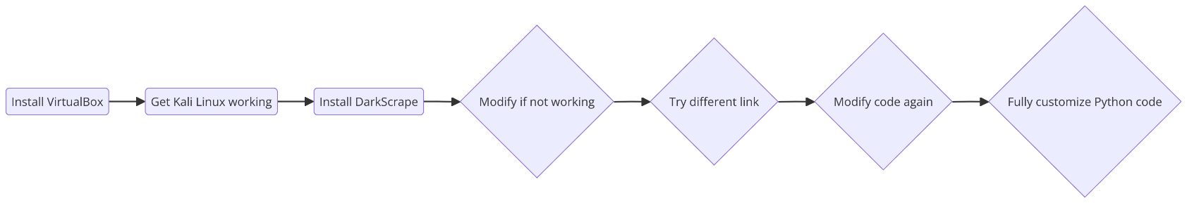
The main issue discussed in this project is the process of accessing and converting the data into a readable format in a way to keep the identity of the researcher private and anonymous whilst successfully scraping the data. The dark web is a gold mine for illegal information and services; however, it is also utilised in a proper manner where professionals can stay on the same level or one step ahead and retrieve the information about the dangers that have not yet seen the daylight and protect organisation before the tragedy takes place. This provides cyber security professionals with valuable information about the security in general.
Figure 3 - Problem formulation process

This problem formulation diagram illustrates the path taken through the problem formulation; it starts with installing VirtualBox which is essential for creating a virtual machine to
host the most up to date version of Kali Linux , once Kali Linux is installed the researcher needs to ensure that all networking preferences are set as appropriate. After launching Kali Linux, the researcher must ensure that all libraries and dependencies that originally come with Kali Linux are up to date by running certain commands in the terminal to make sure that the tool has the most up to date requirements to work with. After the necessary checks have been fulfilled, the researcher can proceed with the installation of ‘DarkScrape’ which is a Python based tool created by a third-party individual. If the tool is not working as intended, then a change in form of code troubleshooting is needed, however if it doesn’t remediate the issue, then proceeding with trying a different link is the next step as dark web websites are often moved around on daily or weekly basis. After trying a different link and not getting the desired result, the researcher ensured to modify the code again and go over it to make sure everything is correct, the final remediation is to use the current code as an inspiration and customise it fully (not partially) to make it work as intended
Here are the two objectives responsible for showing that the project has been successfully fulfilled:
Data collection: Create a systematic and fault-proof approach to scrape data from the dark web using a custom tool and technique to preserve the identity of the researcher anonymous and secure.
Data conversion and analysis: Collecting and stripping the data down into relevant parts and putting it into a clear and understandable structure which then can be analysed and extracted to feed it to cyber threat intelligence to support the recognition of unknown cyber threats and attacks.

4.3 Design
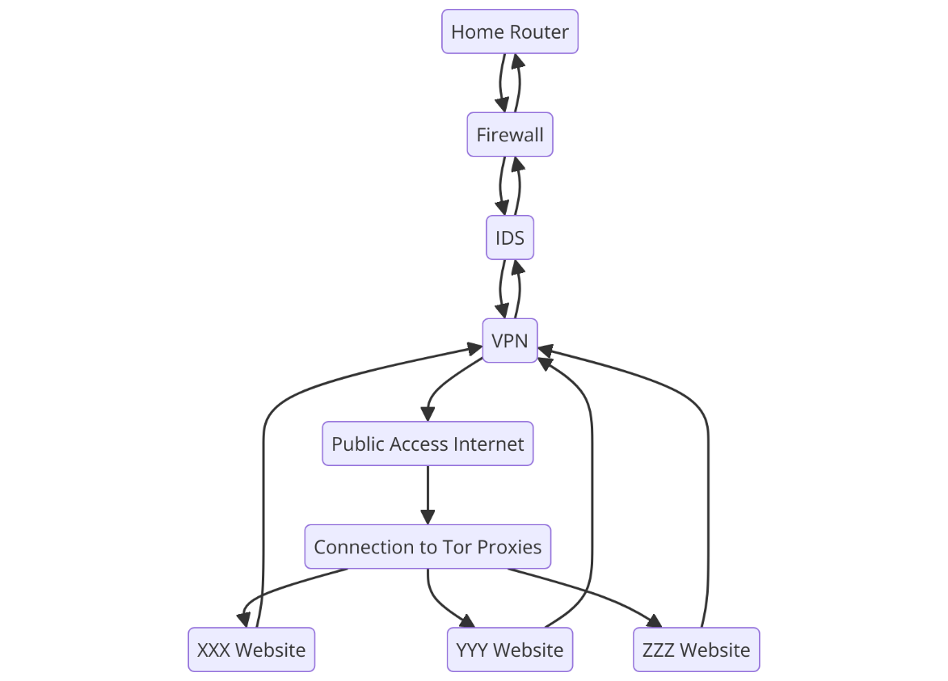
When it comes to scraping data from the dark web for cyber threat intelligence purposes, it is a requirement to apply appropriate security measures due to the risk radiating from the dark web. After a careful analysis of the literature review that had been completed, it is safe to state that the following design presented as a network diagram is the most suitable choice for this research as it contains four layers of security - Firewall, IDS, VPN and connection routed through various Tor proxies to remain anonymous. The firewall is responsible for filtering the traffic according to the rules set out in the configuration, however the rules were set to a maximum level of security, intrusion detection system is essential for any unrecognised intruders in the network to be detected and flagged up for the attention of the researcher, a VPN is an absolute must to mask researcher’s identity, location and IP address which could lead to further damage such as leakage of more personal aspects and finally, Tor proxies, Tor itself provides a high level of security by redirecting the traffic through a large number of nodes before it gets delivered to the desired recipient. Linking back to literature review, it has been established that the following security measures applied by the researcher can be found in the literature review and had significantly aided the process of staying safe and undetected.
Figure 4 - Representation of network diagram

4.3.1 Tool and its configuration
The first and crucial step to successfully scrape the data from the dark web is to carefully choose the tool, after many failed attempts with third party tools, a decision was made to create two custom Python scripts – one script responsible for scraping the links provides to the second and the main script which is responsible for scraping the link and pulling the data from it. Considering the dangers and risks, a reasonable security measures were applied provide the researcher with appropriate security, utilising scripts reduces the risks as there is not direct interaction with the Tor browser meaning that the researcher is not obliged to manually navigate to the links.
- Tor: The most important aspect of this project [55], it would be impossible to achieve desired results without using the Tor network, Tor network provides the researcher with the anonymity by redirecting the traffic through a large number of nodes and servers spread across the world. This provides the researcher with the security when it comes to IP address meaning the identity stays protected and unrevealed while the script is in running.
- Torsocks: This dependency is responsible for making commands such as ‘CURL’ to divert the traffic through the Tor network [56]. Torsocks’ purpose is to ensure that any traffic generated that passed through the Tor network is secured and anonymised to reduce the risk of the researcher getting exposed to dangers.
- Requests and PySocks: To achieve advanced and complexed data scraping ability which requires managing cooking [57], session and parsing HTML, a python script was developed to utilise the ‘requests’ dependency along with ‘PySocks’. This allows the researcher to achieve better results due to the flexibility provided by ‘PySocks’ while ensuring that any traffic diverted and routed through the Tor is secured and anonymised.
- Beautifulsoup4: This is a type of library responsible for making scraping information from web pages simplified [58]. Any information processed by beautifulsoup4 had been put through its built-in HTML and XML parser made a notable change in simplification and readiness for a human eye.
- Urllib3: This library is already pre-installed and comes with Python and is called ‘urllib’ [59], however a more comprehensive and expanded version called ‘urllib3’ can be installed and urllib3 acts as a user-friendly HTTP solution and fills out the gaps overlooked by Python developers to provide users with more flexibility.
- Time, os, datetime: These dependencies are already pre-installed and come with Python installation.

4.3.2 Security
Considering the dangers and risks emerging from the dark web, certain security measures were applied before running both scripts to ensure researcher’s identity stayed anonymous and unexposed:
- Access controls: Rigorous access controls measures were applied to ensure the researcher is the only individual [60] with access to the VPN network and scripts along with the data scraped. The IP address was changed with every request sent via the script to the dark web. After each scraping session, the researcher ensured that the Tor.exe process responsible for opening 9050 port used by the dark web is closed and that no script is running while unattended. The device that stores the data was secured with PIN and was only accessible to the researcher.
- VPN: A solid and trusted VPN solution was used and implemented before the process of scraping .onion links and data from them [61], ‘Cyber Ghost’ is the name of the VPN that was utilised, it provides a solid military-level encryption and security with kill switch meaning that if the connection drops, the internet access was instantly terminated leaving the researcher with maximum security due to interrupted internet access.

4.3.3 Architecture
The architecture for developing a structure for a framework in the future was developed and was divided into three layers clearly outlining the efficient and secure process for scraping the dark web data:
- Data collection: This layer is strictly responsible for securely pulling the data from the dark web [62]. It consists of different dependencies such as Torsocks, requests, pysocks, beautifulsoup4, urllib3, time, date and os. All libraries and dependencies are working together to make the script. It had been created in a way to bypass certain security features such as captcha or login requirements and obtain the data.
- Data conversion: This layer is responsible for ensuring that the data collected is converted into a readable format and structured [63]. Data conversion included transforming raw HTML data into a readable format where only the necessary information had been obtained. Beautifulsoup4 dependency is responsible for pulling the data in a HTML format ensuring the consistency and accuracy.
- Data Analysis: This layer ensures that the data collected is analysed to provide the relevant information for developing a structure for the framework in the future [64]. Data then was categorised in various categories e.g. Malware, Attacks etc.

4.4 Implementation
Implementation stage outlined the new path that was taken to get the customised script up and running to achieve the desired results on a Windows device. This stage included showcasing of setting up a safe environment, installing different dependencies and showing the output from the terminal to ensure that the script is working. However, the process of obtaining the links from the dark web had been automated, users are free to search for links online here https://ahmia.fi and this website [65] allows users to search for Tor hidden services without visiting the dark web. To automate this process and pull many links at the same time, another script has been developed which allows to search for any phrase and send a request to ahmia and retrieve the results.

4.4.1 Environment setup and scraping process.
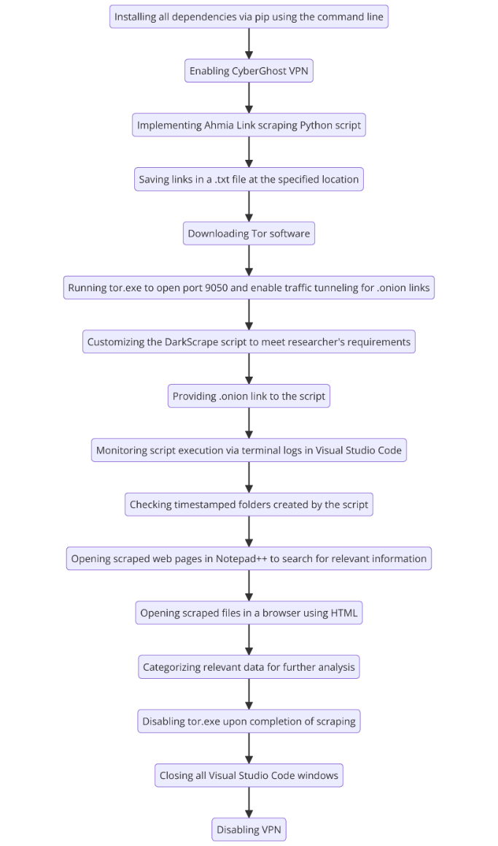
The environment was set up on a secure machine to ensure the exposure is minimised. The machine was configured with the most up to date versions of Tor, Torsocks, Python, Beautifulsoup4, urllib3, time, date, os and requests dependencies. Additionally, the router was configured with IDS option enabled and firewall maximum security level to ensure the safety of researcher. An ability to view the traffic logs was provided by the router used for the project.

Figure 5 - Representation of environment setup and scraping process
The focus of this project is to create a systematic structure for developing a framework in the future that can evolve along with the dark web at the same time. The design process consists of a careful selection of the tool and planning its development along with the methodologies being utilised to make sure that the objectives are fulfilled, and researcher’s identity stays unknown. Figure 6 shows the tool running and an .onion link is required to start scraping and the process which outlines the journey to get it running. Presented below, is the process for installing Kali Linux via VirtualBox, configuring it to make it usable and implementing ‘DarkScrape’ tool which then had to be modified into a custom python script.
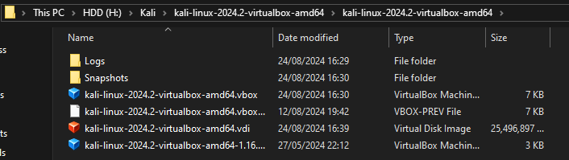
Figure 6 - Representation of Kali Linux folder directory
Kali Linux was downloaded from the official website https://www.kali.org. After downloading, the researcher simply launched Kali Linux via VirtualBox by clicking .vdi file. It automatically installs Kali Linux.
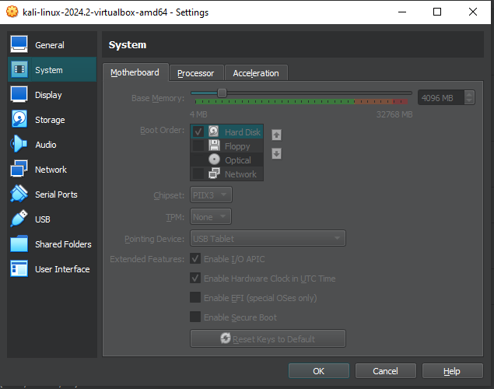

Figure 7 - Representation of VirtualBox Kali Linux configuration
Figure 7 represents the necessary changes to Kali Linux instance to make it run smoothly, it is necessary to assign it a minimum of 4 GB of RAM to make it usable.

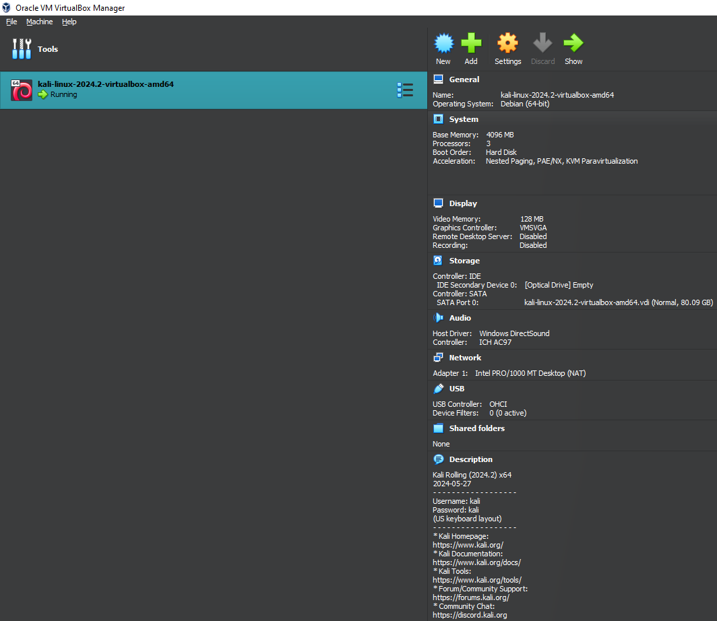

Figure 8 - Representation of Kali Linux successfully running

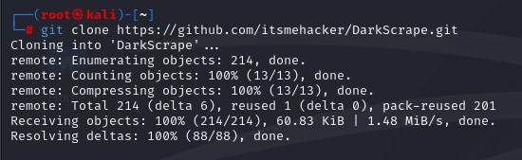
Figure 8 above represents a screenshot of Kali Linux successfully running and installed allowing the researcher to carry on with the installation of ‘DarkScrape’ below.
Figure 9 - Representation of git cloning into DarkScrape tool

Figure 9 represents the very first initial step of cloning into the github repository that contains ‘Darkscrape’ tool. ‘Git’ tool is already pre-installed and comes with Kali Linux. This screenshot proves that cloning into github repository was successful.

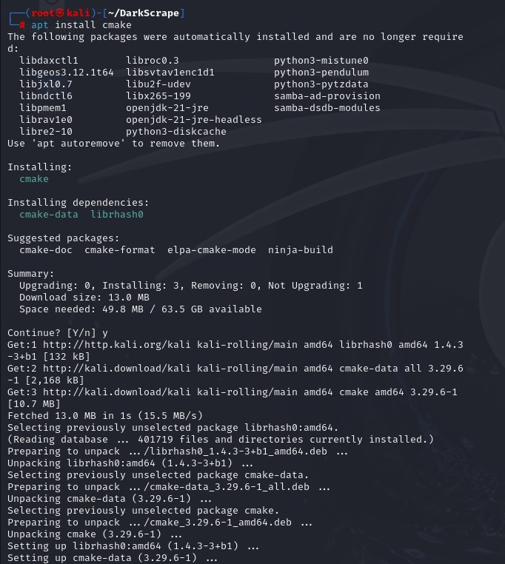
Figure 10 – Representation of ‘cmake’ library installation
Figure 10 shows the installation of ‘cmake’ library which is essential to run ‘darkscrape’ tool. It is necessary as it manages the building process for DarkScrape and dependencies. This library is necessary as it makes sure that all segments of the tool are installed appropriately and compatible with Kali Linux which is absolutely needed for security-based tools.
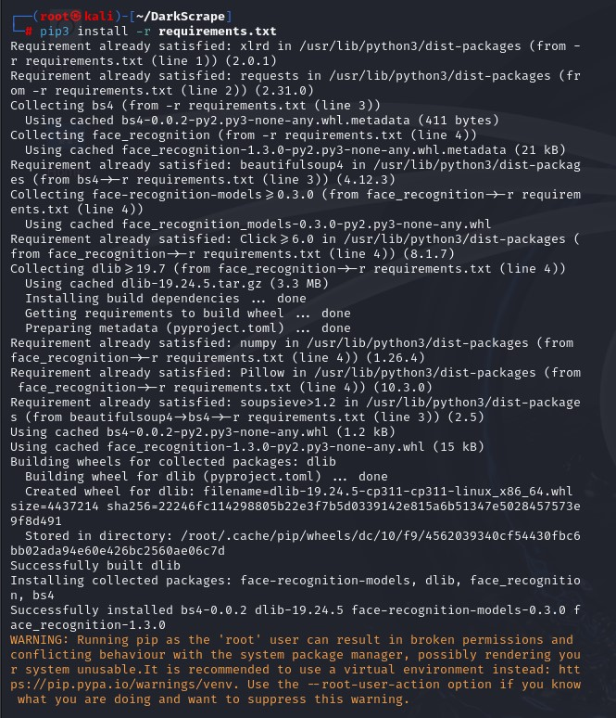
Figure 11 - Representation of necessary libraries being installed
Figure 11 demonstrates the installation of ‘requirements.txt’ which comes appears in the ‘DarkScrape’ directory in Kali Linux. Requirements.txt is a file which contains a pre-made script that install all dependencies such as beautifulsoup4, requests and all other essential libraries. Instead of installing everything manually, it had been simplified by the developer and can be executed just by installing ‘requirements.txt’.
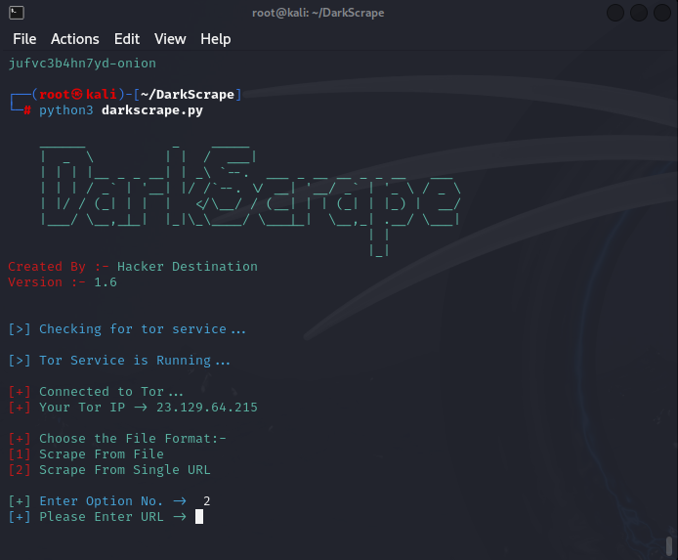
Figure 12 - Representation of DarkScrape successfully installed

Figure 12 illustrates a tool after installation, it is launched via python3 darkscrape.py and was created by ‘Hacker Destination’, it ensures that Tor is running first and Tor service was already pre-installed in that version of Kali Linux, it informs the user that the Tor service is running and shows detailed breakdown of logging in form of ‘Connected tor …’ etc. after that the user is able to see their anonymised IP address provided by the tool and offers an option to choose if the scrape should start from a file e.g. .txt files containing a lot of .onion links or from single URL and this option requires the user to manually copy and paste the link and submit it. It is worth to mention that this tool already comes with pre-configured proxies leaving it as ‘plug and play’ without the need to modify the code before the first launch.
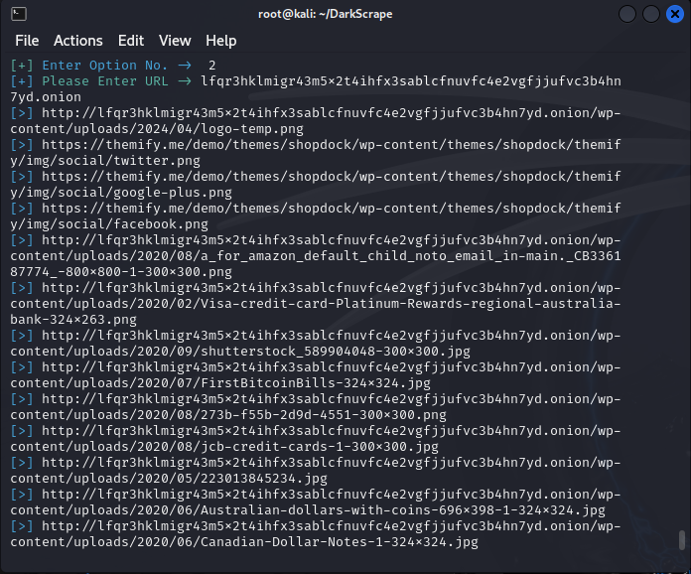
Figure 13 - Representation of DarkScrape in action

Figure 13 presents the tool in action; however, this tool does not work as intended and only pulls media files meaning only images and videos are being saved, this information does not contribute or provide much value to fulfil the objective.

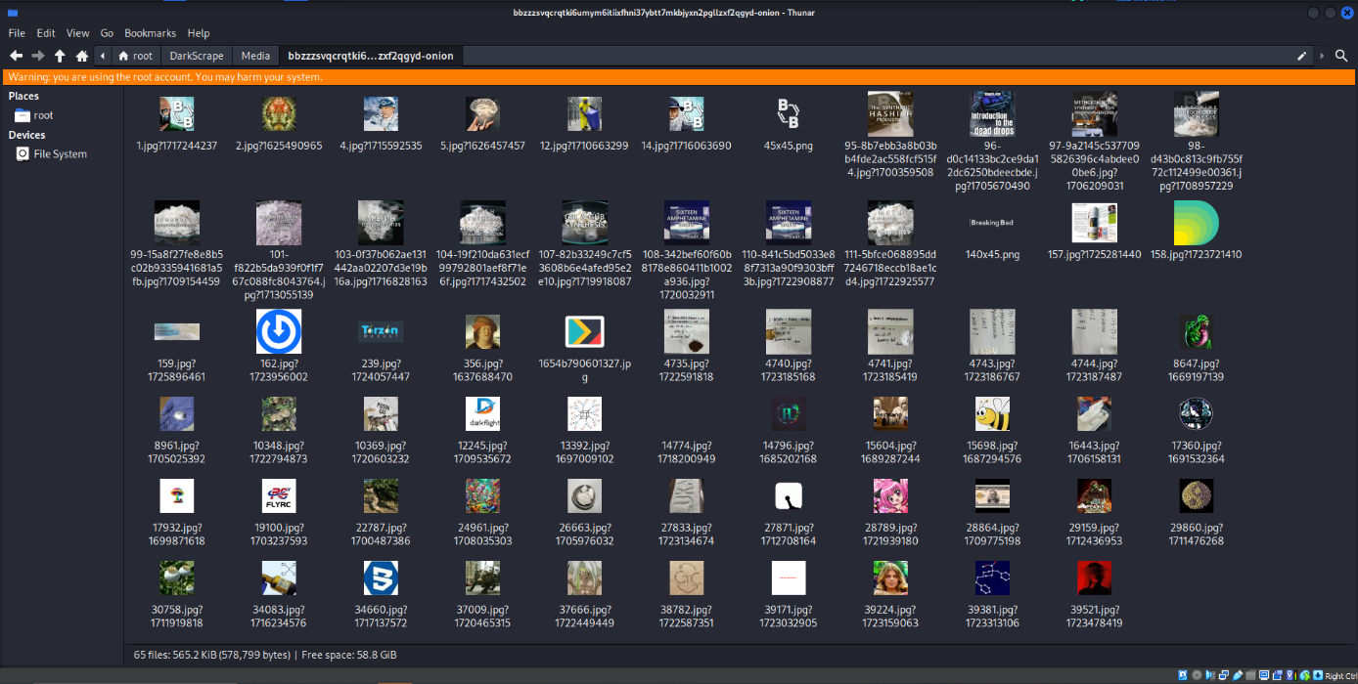
Figure 14 represents the data that was scraped from a completely random .onion link, it is clear to see that this information does not provide much value, however pictures of illegal drug distribution can be found there, however this is not relevant.
Figure 14 - Representation of data retrieved by DarkScrape
The next step is focused on setting up environment for a custom version of python code by having ‘DarkScrape’ as an inspiration.
Here’s a breakdown of each step needed to successfully run the python script:
Step 1: Installing all dependencies via pip using the command line:
Requests:
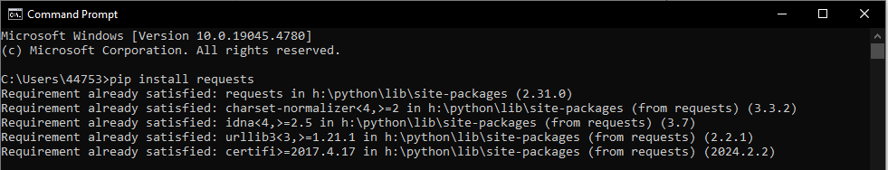
Figure 15 - Representation of installing requests library
Achieved with Python, the researcher had the ability to use ‘pip’. Pip is a package manager for python packages and dependencies. ‘Requests’ is one of the dependencies needed to make the script work. Requests dependency handles enabling a HTTP library that allows the passage of HTTP requests.

Beautifulsoup4:
Figure 16 - Representation of installing beautifulsoup4 library
Python allows the researcher to again use the package manager for known as pip to install beautifulsoup4 dependency. ‘Beautifulsoup4’ dependency is needed to get the script running. It allows the researcher to parse HTML documents and enables a straightforward process for extracting the data by creating a parse tree from page source code.
Urllib3:
Figure 17 - Representation of installing urllib3 library
Urllib3 is a very efficient library that allows the researcher to send high-level interface, robust and efficient HTTP requests compared to urllib which already comes preinstalled with python. It offers many unique features such as connection pooling, threat safety, proxy support, retries, timeouts, Unicode support, SSL/TLS support, custom headers and file posting. One of the main differences between urllib3 and urllib is that urllib3 offers the researcher to implement retries so the script runs repeatedly until the specified number of retries is met.
Datetime, os, time:
Mentioned above are already preinstalled and come with Python.

Step 2: Enabling CyberGhost VPN
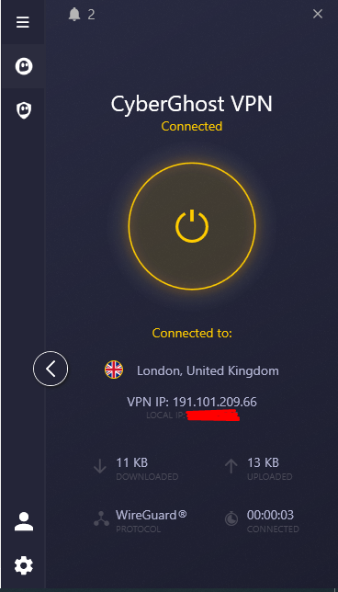

Figure 18 - Representation of CyberGhost VPN running

Figure 18 displays a proof that the researcher had met the necessary security measures to anonymise the IP address before starting the scraping process, CyberGhost VPN was used, it provides a very secure and military-level encryption with a ‘kill switch’ enabled, meaning that if the VPN connection dropped then the researcher’s ability to use the internet was immediately terminated from the accessing the internet and the device would not automatically reconnect to the original network. This step ensures the researcher stays anonymous and the script only runs when the VPN is turned on. Additionally, WireGuard protocol [66] had been utilised and WireGuard is a high-performance and easy to use protocol as it contains only around 4000 lines of code leaving the attackers with less vulnerabilities to exploit and reduces the attack surface.

Step 3: Implementing Ahmia Link scraping Python script

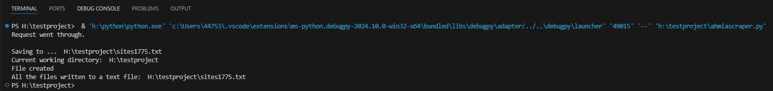
Figure 19 - Representation of ‘malware’ query provided to the script
Figure 20 - Representation of terminal output after scraping .onion links
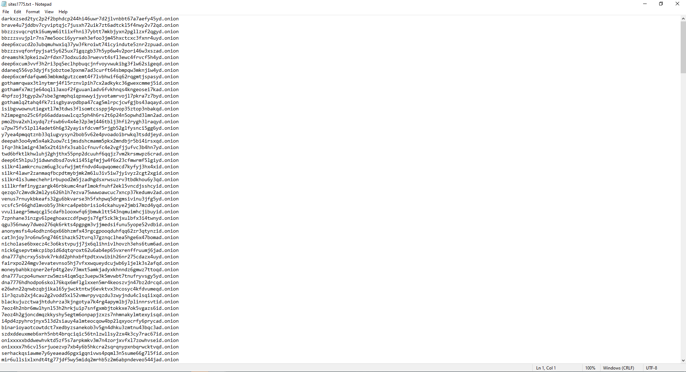
Figure 21 - Representation of .onion links scraped successfully
Figure 21 represents the query that was provided to ahmia search engine, the query is ‘malware’ which means that anything accessible via ahmia was retrieved by the ahmia link scraping script.
Figure 21 illustrates the output after running the script. Extra logging features such as ‘Request went through’, ‘File created’ etc. were implemented for the researcher to obtain a clear overview and constant control over the script making it user-friendly and easy to understand. The output states that the request was successful and informs the researcher about the directory where .txt file can be found, it also provides the names of the file. It is structured to always assign ‘sites+random number.txt’ e.g. ‘sites1375.txt’ to make it easy to identify the file in the directory.
The third screenshot represents the desired result of the script which is a random named .txt file with a large amount of .onion links ready to be fed to another customised DarkScrape python inspired script.
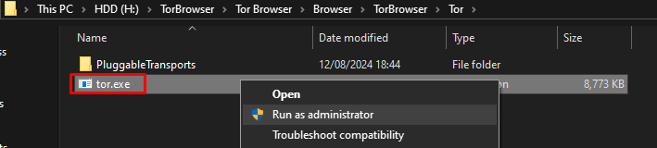
Step 4: Running Tor.exe
Figure 22 - Representation of Tor.exe process

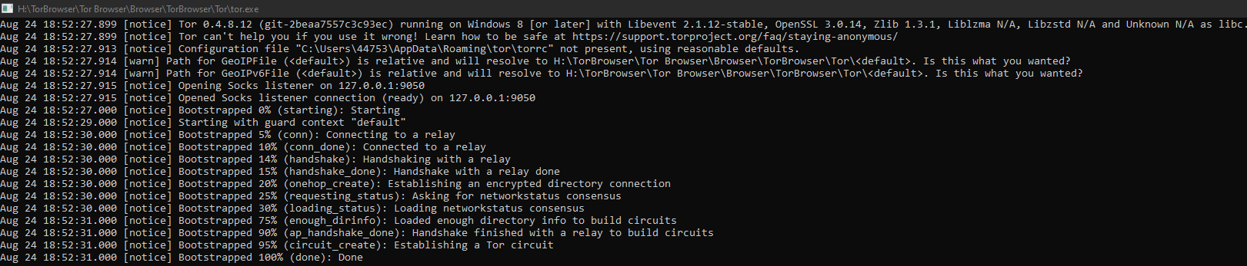
Figure 22 shows that ‘Tor Browser’ had been installed successfully allowing the researcher to tunnel the traffic freely via Tor proxies. Tor had been downloaded from the official website https://www.torproject.org/download/. ‘Tor.exe’ process is essential for opening port 9050 which is a port used by the dark web and it constantly listens on port 9050.
Figure 23 - Representation of Tor.exe process running

Figure 23 illustrates the result of running ‘tor.exe’ as administrator. It opens socks listener on 127.0.0.1:9050 and informs the researcher that it is ready. Additionally, it bootstraps processes such as connecting to a relay, establishing handshake with a relay, encrypts directory connection, retrieves network status and builds directory circuit and finally informs the user when the process is done.

Step 5: Providing .onion link to the script
Figure 24 - Representation of feeding .onion link to scraping python script
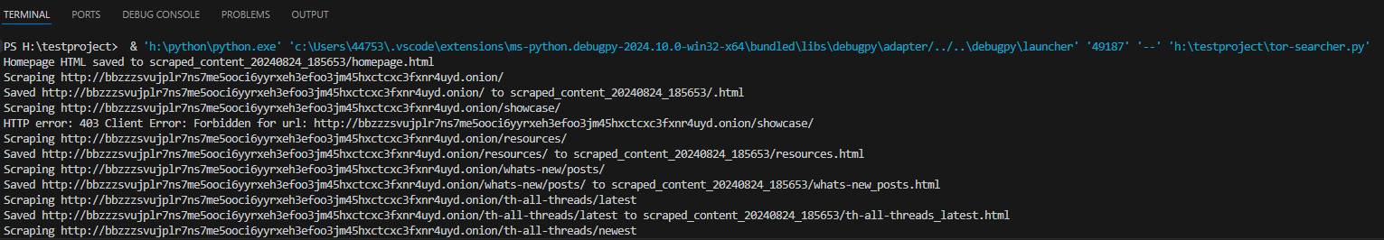
Figure 24 represents the process for feeding the link from the list provided by ahmia link scraper tool and running it. It is important to remember that http:// is required for successful scrape. The process for feeding the link is simplified, a simple copy and paste.
Figure 25 - Representation of script in action
Figure 25 shows the results after executing the script, it shows each web page scraped from the provided link. Additional logging features were implemented to inform the researcher about the status of the scrape by including ‘Scraping’ + link and ‘Saved’ + link. Occasional errors might appear, this means that web page is no longer active.
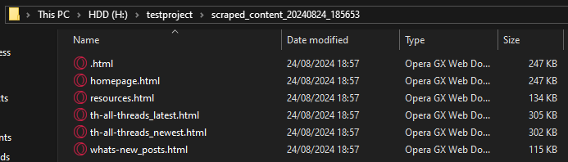
Step 6: Checking timestamped folders created by the script
Figure 26 - Representation of data successfully scraped

Figure 26 shows scraping as complete, the researcher was able to navigate to the directory where the scraped folder with data is located, this was always saved in the same directory as the script used to retrieve it. It is clear to see that 6 web pages were scraped, however scraping the dark web is a hit or miss meaning that not every single link contained high valued information or active website. Files were saved in a HTML format by beautifulsoup4 dependency.

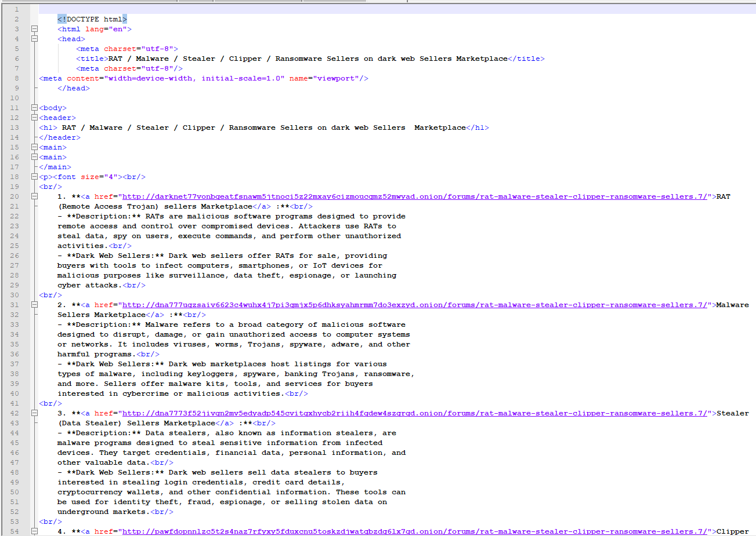
Step 7: Opening scraped web pages in Notepad++ to search for relevant information
Figure 27 - Representation of HTML code behind pulled data files
Figure 27 displays the web page called ‘5.html’. The name was not altered by the script and was configured by the developers of that website. This is content and structure the researcher was able to witness after opening the file in Notepad++ [67], this allows for a very easy identification of the relevant information, as presented above – that website contained some information about malware and further links to purchase the malware or hire a person to deploy it. Just by looking at the <title>, it is easy to state that this is a website based around dark web illegal services – dark web marketplace.

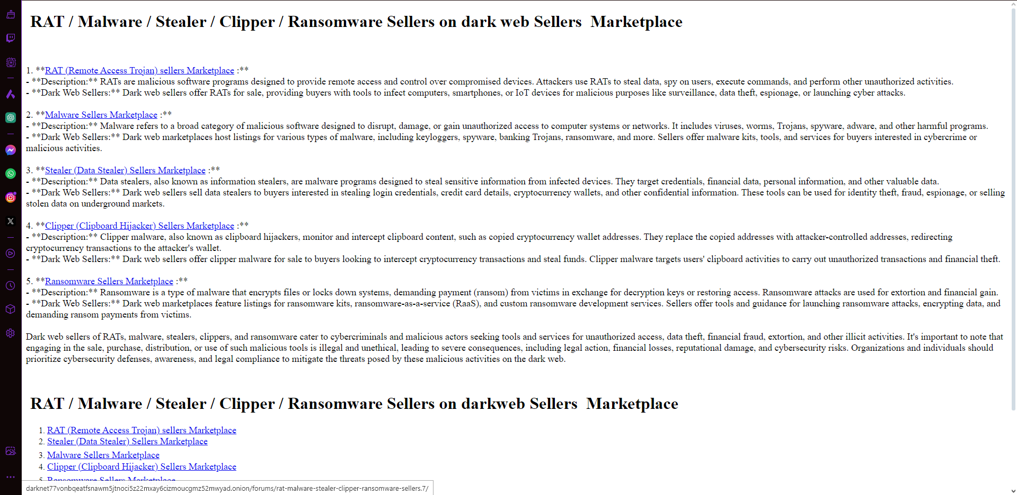
Step 8: Opening scraped files in a browser using HTML
Figure 28 - Representation of retrieved data in HTML format

Figure 28 displays the HTML code shown in the previous step, however this is launched in ‘Opera GX’ browser just to prove the real layout of the website, however CSS code is not included as it is not essential. Hovering over the links, previews the link in the bottom left corner of the screen. Opening scraped web pages in a browser makes it easier for the researcher to extract the relevant information as it is more user-friendly and does not look as complicated as the code.

Step 9: Disabling tor.exe upon completion of scraping
Figure 29 - Representation of Tor.exe shut down

Figure 29 represents that ‘tor.exe’ is still running, this was obtained via ‘Task Manager’ and right clicking the process and proceeding with ‘End task’ completely and entirely shuts it down and stops to ensure the port 9050 is no longer active and listening reducing the exposure of the researcher significantly. This is essential security measure that needs to be followed the scraping is done. Leaving it running, provides the link between the researcher and dangers emerging from the dark web.
Step 10: Disabling VPN
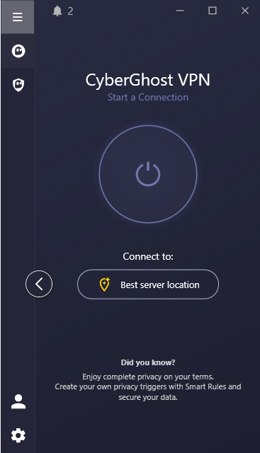
Figure 30 - Representation of VPN disabled

4.5 Structure for developing a framework

4.5.1 Introduction
The structure for a framework develops is essential for successful data scraping from the dark web and achieve the desired result of feeding the data to cyber threat intelligence. This structure has been inspired by [68] and modified to suit the needs of this research. The dark web is popularised due to its ability to stay anonymous and carry out or offer illegal services in exchange for crypto currencies. However, if utilised in an appropriate way, the dark web can be a gold mine for cyber security professionals to retrieve essential information and use it in a positive way and mitigate threats that are emerging from the dark web. This structure displayed the essential parts and the journey that needs to be taken to achieve an efficient, secure and scalable structure for framework to scrape the data and analyse it. The main pressure was put on ensuring that all activities are carried out ethically and most importantly securely whilst achieving the most out of the tool to collect the essential data for cyber threat intelligence and structure for framework reasons.
This document outlines the path for obtaining and creating a structure for developing a framework rather than proceeding with its actual creation. A full overview of each aspect including specific tools, libraries, and configurations – however, everything is discussed in its own appropriate section.

4.5.2 Overview of structure components
To successfully pull data from the dark web and feed it to cyber threat intelligence, several essential aspects must be implemented. All components and libraries cooperate to provide a secure, systematic and efficient data acquisition & analysis process:
- Data Acquisition: A tool and technique employed to successfully scrape data from the dark web [69] links provided by ahmia scraper, for this layer of the structure, the following were used: Tor and Torsocks.
- Data Cleaning: A process where data goes through a rigorous cleaning process [70] by structuring and formatting the raw data pulled from the dark web into a table so it can be fed to cyber threat intelligence.
- Data Analysis: A thorough analysis of data [71] and choosing which piece of data is usable enough to feed it to cyber threat intelligence. Not every piece of data is usable, feeding anything to cyber threat intelligence can lead to mistakes and false positives when detection occurs.
- Security: A reasonable and appropriate security measures such as VPN and Access controls to ensure the connection of the researcher stays anonymised and unexposed to the dangers emerging from the dark web, including a kill switch [72] option enabled, if connection drop occurs, the researcher is automatically prevented from any access to the internet. Access controls are responsible for ensuring that the device used for the experiment is secured properly and only the researcher can access that device.

4.5.3 Snippet of Categorised Data
Figure 31 - Retrieved data snippet
Figure 31 represents a short snippet of the data table where information was reasonably categorised and described to ensure the simplicity of implementing it into cyber threat intelligence. The table outlines and highlights the most important and valuable to cyber threat intelligence findings while providing the relevance to cyber threat intelligence. The table had been created in Excel due to easiness of creation and compatibility for other users.

Note: The full version of data table can be found in the appendix, please zoom in for better quality. For a better overview of structured data, please refer to ‘other files’ section to download Excel spreadsheets.

4.5.4 Risks
The process for creating a structure for developing a framework to scrape the dark web data can be risky and dangerous [73] and it is crucial for the researcher to understand the consequences and mitigation techniques to avoid falling a victim of such exposure. It is also essential to understand how mitigating the risks discovered by the experiment is beneficial towards the companies due to the structure for developing a framework.
- Exposure: The dark web is a place where the researcher or any other person could get infected unconsciously [74], meaning that the infection happened without the knowledge of the person surfing the dark web. It leaves users to exposure of malicious software, ransomware, blackmailing and reveal of identity. Scraping the data from the dark web can plant malware into the scraping environment unwillingly. To stay aware from dangers like this, it is essential to use anti-virus, VPN or proxy chains, maximised firewall and intrusion detection system and be extra cautious when analysing the content.
- Legal considerations: Scraping the data comes with various risks such as violation of international, federal and local laws [75] due to accessing information without appropriate access. It is advised to contact the right authorities and parties before starting to scrape big. The framework that can be created due to the structure and contain records in case any law is violated and present the right authority with compliance if essential.
- Ethical considerations: Interacting with malicious content and illegal forums raises many ethical flags, even if the actions are carried out for research reasons. The framework that can be created due to the structure, should involve clear instructions on ethical guidelines to make sure that researcher stays away from any illegal activity or malicious content which could violate the laws and support unethical activities. Before the implementation of the framework, the organisation should contact ethical professionals to ensure the framework obeys all ethical and legal procedures and standards.

4.5.5 Security
Security is the main component and responsibility of the researcher before starting the scrape of the dark web data. There are many measures that need to be applied to the infrastructure and the data itself, here they are:
- Data encryption: Any piece of data that belongs to the organisation needs to be encrypted at all times [76], no matter the consequences – in transit to a different building or at rest, additionally, strong algorithms needs to be employed to ensure the safety of the information. In case the data gets intercepted by a perpetrator, the company can ensure it is not revealed and remains secure and confidential.
- Network security: Tor itself is solid when it comes to providing security to the researcher and prevents the exposure and reveal of location [77], identity and other personal aspects. However, the security provided by Tor is not powerful enough to stop certain attacks and people. It is essential to use a various of network security measures such as intrusion detection system (IDS), firewalls, intrusion prevention system (IPS) and all the above mentioned ensure the data and the researcher’s organisation stay anonymous, secure and confidential.
- Access controls: A rigorous access control policies need to be introduced to prevent unauthorised access to data [78] to make sure that only selected authorised employees are able to access the data. A various of different security measures such as multi-factor authentication (MFA), role-based access control (RBAC) and audit logs needs to be utilised and implemented as soon as possible. Audit logs are essential to monitor everything going on in the network and look out for any anomalies and potential indicators of compromise to prevent unauthorised access.
- Audit checks: The framework aided by the structure for developing a framework should be constantly put against regular checks [79] to identify and potential loopholes and vulnerabilities to take immediate action in patching everything that is possible. There are two types of audits – internal and external. However, external ones are more advanced as it requires hiring an expert to test the framework.

4.5.6 Development plan for creating the framework structure
One of the essential parts for creating a framework is the development plan to scrape the data successfully and aids the process of planning stages. This development plan focuses on making clear any necessary steps and resources, musts and considerations to establish a scalable, secure and working framework.
Step 1: Objectives and scope
- Clearly outline the main objective of the framework and this could be actions such as data gathering, data analysis and converting it into an efficient cyber threat intelligence.
- Besides the objective, a scope is essential to specify what type of data could be collected, targets and define what the goal of the data gathered would be and how it can be used.
Step 2: Study
- Before applying and feeding data to the cyber threat intelligence, it needs to be carefully reviewed for legal, ethical and technical standards and procedures.
- Ensure to determine possible dangers and issues and that includes technological issues and legal / ethical problems.
- Determine the range of available tools that can be used to aid the creation of building the framework.
Step 3: Requirements
- Gather the necessary information from stakeholders, this includes cyber experts, international and local law advisors and ethical professionals to determine whether it can be implemented or not.
- Determine which technical aspects are essential to aid the implementation of the framework and this includes the tools e.g. Analysis tools, Torsocks, Tor and data storage ideas.
- Determine which compliance and security measures need to be met to make the framework valid and deployable to meet all ethical procedures and laws.
Step 4: Framework infrastructure
- Create an advanced infrastructure for the framework which determines the core aspects such as data collection, data conversion, data storage and analysis.
- Create an advanced infrastructure for the framework to allow flexibility and scalability to ensure the framework is adaptable to constantly evolving and emerging dangers from the dark web.
- Create a clear and simple to follow flow diagram to demonstrate the journey that data travels such as collection, processing analysis, storage to be implemented into the framework.
Step 5: Risk management plan
- Determine possible dangers associated with the dark web scraping activities and this could include malicious content, legal and ethical problems and direct exposure which could leave the researcher with identity reveal.
- Create a strategy to prevent the recognised risks and this includes introduction of hardened security measures and obeying the legal and ethical standards and procedures.
- Determine which would be the best process to keep the consistent framework and systematic monitoring of identified risks while the framework is implemented.
Step 6: Development roadmap
- Create a detailed plan to highlight development of the framework and this might include deliverables, timelines and milestones.
- Introduce essential phases such as the initial framework development testing, acceptance and validation and official release and applicability.
- Determine tools and resources which are needed for each phase, this might include specific employees and tools.
Step 7: Testing
- Create a reliable testing methodology to ensure that the framework which is undergoing rigorous testing functions as intended and be efficient.
- Outline test cases in terms of functionality, how secure the framework is and how well it is performing to make sure that all aspects are met.
- Create a strategy for testing to validate the effectiveness of the framework and determine issues and vulnerabilities in pre-deployment stage to avoid issues when released officially.
Step 8: Documentation requirements
- Create a detailed and easy to follow plan to instruct users about user guides, configuration process and any troubleshooting steps to quickly and efficiently restore the functionality of the framework.
- Create training resources and guides for non-technical people to instruct users about the usage of the framework in a secure and efficient manner, users need to acknowledge and understand the ethical and legal issues that can results in an appropriate usage of the framework.
Step 9: Maintenance and updates
- Create a maintenance plan to ensure the framework is functioning as intended and stays up to date with the most recent threats and gets provided with security updates, tool patches and any law and ethical alterations.
- Develop a plan to allow professionals to regularly and efficiently feed updates to the framework and instruct users on providing feedback about the framework to make any necessary and validated adjustments.
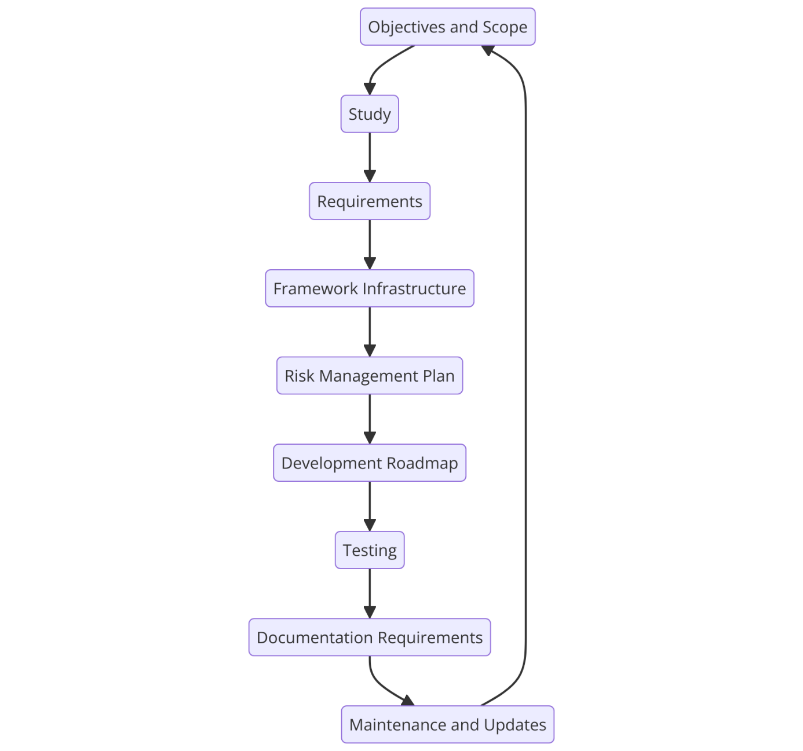
Figure 32- Representation of development plan cycle

4.6 Conclusion
In this chapter, an overview of the implementation and design stage set up was provided to create a secure and effective structure for the process of scraping data from the dark web and convert it into a data recognisable by cyber threat intelligence to aid cyber security measures. This chapter started with introductory of project’s objectives and effective development of the framework to safely access and analyse dark web findings while keeping a consistent security and anonymity of the researcher.
After introduction, a section about the problem formulation was introduced which clearly identified the main issues faced in this project, putting pressure on the must of collecting data in a safely manner and process it without being affected by dangers and risks from the dark web in a negative way to ensure the anonymity of the researcher stays unknown to external parties. This included exploring and accessing hard to view hidden services to make sure data that had been collected can efficiently be converted into a well-structured formatted table which can then later be fed to cyber threat intelligence.
The design section introduced a considerate discussion about tools and methodologies employed to achieve a framework. This section included discussion about Tor network, tor socks and custom python inspired scripts created purely to scrape data in a secure manner from the dark web whilst obeying and applying all necessary security measures and adhering to legal and ethical standards. The design process also demonstrated configuration phase which clearly showed how tools cooperate in a secured environment while presenting the practical journey and steps that is required to prepare the company for data collection.
The implementation section introduced a practical demonstration in form of figures while working and presented the setup and management of security measures along with the installation of essential libraries and dependencies to test the ‘DarkScrape’ tool. This section included any challenges and remediations to any issue that was encountered, and it was remediated by creating a custom script for python while using DarkScrape as an inspiration and rectify any issues encountered that could not be rectified during the initial usage of DarkScrape tool and retrieve the data. The implementation phase also provided a discussion about areas for improvement and the necessity for constant maintenance to keep up with the latest dangerous emerging dark web trends to adapt and keep the framework consistent.
This chapter in general had discussed the structure for developing a framework in the future. The design and implementation section had defined the aspects and phases that are necessary to create a flexible, scalable and secure framework to retrieve data from the dark web in a safely manner and put it through a rigorous cleaning process and analysis. It also outlined a development plan that states and talks about every step and resource along with potential aspects to consider when building a framework for scraping data from the dark web and it ranged from defining objectives to scope and carrying out detailed studies about creating the infrastructure to apply the security measures.

CHAPTER 5

Testing and Evaluation

5.1 Introduction
This chapter provides an overview on an extensive analysis of the experiment carried out as a portion of the project implementation section. Building upon the tools, ways and frameworks bounded to the previous chapter related to implementation and design, this section exclusively takes into consideration configuring, executing and monitoring the dark web data mining manoeuvring the use of the custom-written python script that was inspired by the ‘DarkScrape’ tool. This was achieved by presenting several screenshots that come in a bundle with descriptive explanations. This section provides a step-by-step ‘manual’ for the experiment, contrasting both – technical problems and achievements that occurred whilst the data was being scraped.
Furthermore, this section dives deep into a critical assessment of the results delivered by the experiment. It evaluates the effectiveness of the methodologies utilised, states any limitations or issues that occurred during testing process and refers to the literature review findings and related works specifically for this research. This advanced approach not only emphasises the practical issues encountered during the research but also discusses the project’s results on a wider scale when it comes to ultra-modern cyber threat intelligence methodologies, by that means including a refined interpretation of the project’s validity, significance and impact.

5.2 Experiment
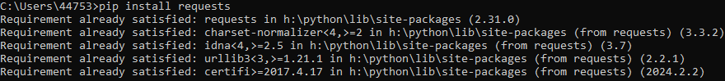
Figure 33 - Representation of requests installation via pip
Figure 33 acts as a representation of ‘requests’ being installed. While the installation is running, pip checked for any libraries required to install ‘requests’, if any are identified, then additional installation was carried out. If there are any missing dependencies, it is to be found in a temporary folder where installation files can be stored for the time being while the installation is running. After the researcher was prompted after a successful installation of ‘requests’, the files are findable in ‘site-packages’ folder which is in the same directory as the original Python installation. Pip was also responsible for updating environment variables path in the system settings and bundling up metadata to make ‘requests’ available for use with Python scripts. Requests were essential to achieve the aim and objectives due to its great ability to send HTTP requests and deliver them to web servers while managing responses in a simplified way. This makes ‘requests’ so essential and crucial for web scraping.
Figure 34 - Representation of 'beautifulsoup4' being installed via pip
The above describes and displays the process of installing ‘beautfiulsoup4’ via pip. Again, firstly beautifulsoup4 ensured that all necessary dependencies and libraries are already installed. The next step of the process includes pip to communicate with Python Package Index commonly known as ‘PyPI’. After the communication had been established, the content of ‘beautifulsoup4’ was extracted to the same directory as ‘requests’ which is ‘site-packages’. Last step required pip to update the environmental variables to make ‘beautifulsoup4’ known to the system and recognised by Python scripts. ‘Beautifulsoup4’ is an essential library which was required in this research to parse HTML and XML files, it aids the extraction process of data from web pages, this made it an ideal solution for web scraping due to its structure called ‘tree-like’ to simplify the process of manipulating and finding elements.

Figure 35 - Representation of 'urllib3' being installed via pip
The last and final library is shown in figure 35 above as it presents the process for installing ‘urllib’ package. Before anything else, pip made sure that ‘urllib3’ is not installed yet, if it is not present, then the installation began. Following this, pip communicated with ‘PyPI’. The installation process begins, and all contents are transferred into the ‘site-packages’ directory. Final part includes pip to update the environmental variables to make ‘urllib3’ active in the system and ready for future use with Python scripts. ‘Urllib3’ library belong to Python and is maintaining HTTP requests and allowed the researcher to implement retries function inside the code and establish robust HTTPS connection, this is much more reliable and safer than a standard ‘urllib’ library which comes with the initial Python installation. This made it an ideal candidate for handling network requests when it comes to web scraping.
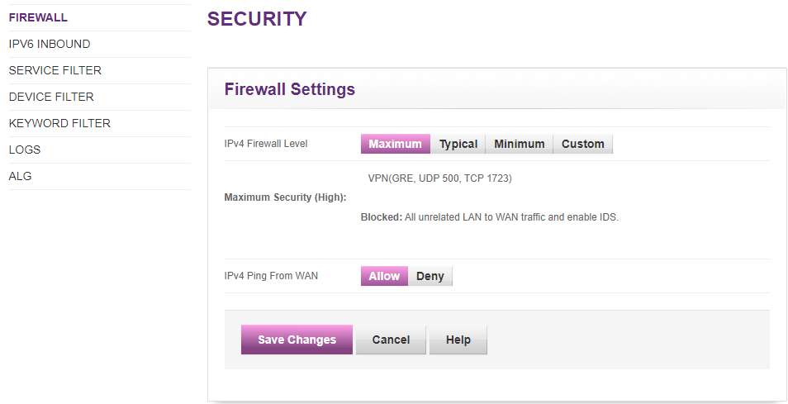
The next step was to implement security and figure 36 depicts a local firewall settings configuration with an emphasis on maximum security setting enabled that rejects all unknown Local Area Network (LAN) to Wide Area Network (WAN) traffic. Figure 36 also displays the use intrusion detection system (IDS) being active to stay pro-active and avoid possible threats. The option below ‘IPv4 Ping From WAN’ shows the ability for the network to accept and reply to any pings coming from the outside of LAN and this aided the researcher in making sure that any unauthorised attempt can be recorded and analysed if network diagnostics was needed. Overall, the above delivers a proof of a highly secured environment by minimising the availability of access to the network and improving threat monitoring.
Figure 36 - Representation of maximum firewall settings and IDS
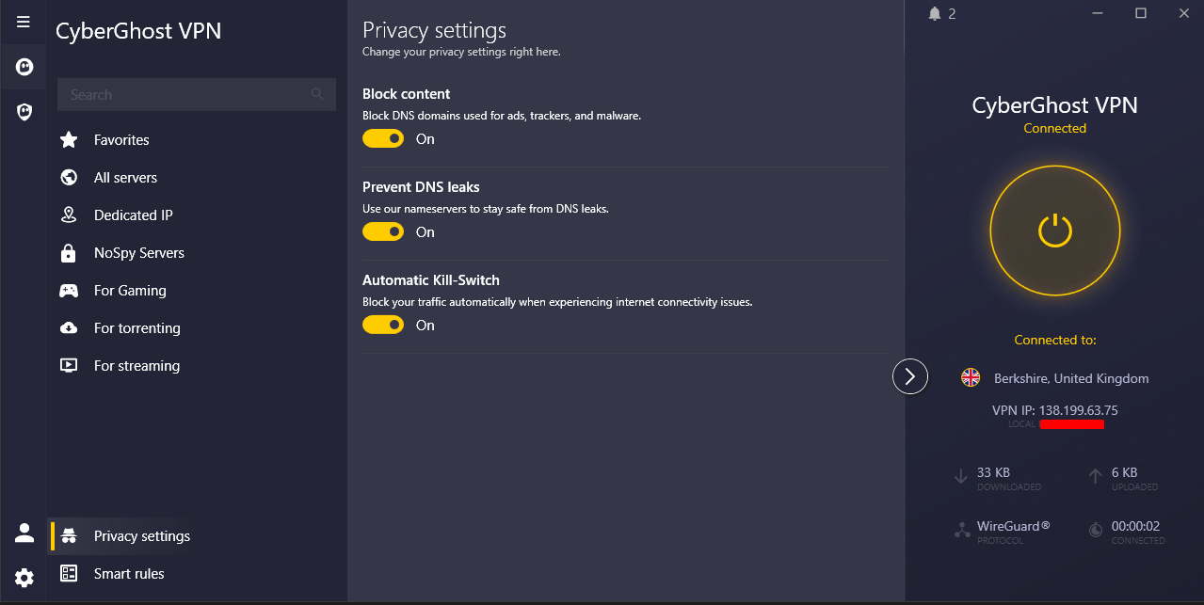
Figure 37 illustrates another security measure applied before starting the scraping process by showing the settings such as ‘Block Content’ to block DNS domains used for unwanted traffic such as ads, trackers and malware. Secondly, ‘Prevent DNS leaks’ option was enabled to use name servers provided by Cyber Ghost VPN, so researcher was safe from falling a victim of DNS leaks. Thirdly, a kill-switch option was enabled to make sure the researcher’s traffic flow was completely terminated if any connection interruption occurs preventing the automatic reconnection to the original source which is the connection provided by the ISP. Lastly, the VPN was enabled during the full process of scraping and the connection is established to the best server located in the UK, at that time, it appeared to be ‘Berkshire’. Additionally, the connection was aided and secured by WireGuard protocol to ensure secure and effective data encryption.
Figure 37 - Representation of VPN running with a kill switch option enabled
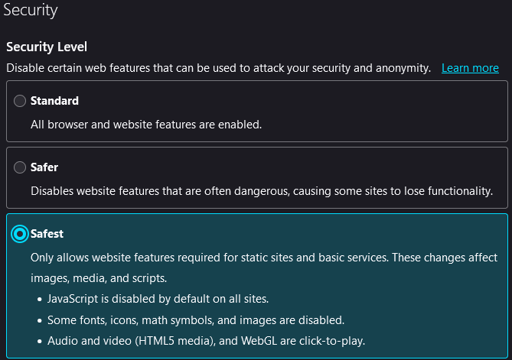
Figure 38 - Representation of Tor browser security set to maximum
Figure 38 presents the security settings within the Tor browser, outlining various levels of security such as ‘standard’, ‘safer’, ‘safest’. The last option stating ‘Safest’ was chosen during the scraping process as it only allowed website with certain features to be accessed, static and basic services were available. It affected a few aspects such as images, media and scripts by disabling JavaScript, fonts, icons and maths symbols. Auto-play of audio and video was prevented during the scraping process. This helped the researcher in achieving a better level of security to ensure researchers’ identity stays unknown to dark web users.

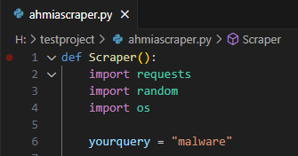
Figure 39 - Representation of 'ahmiascraper' execution

Figure 39 highlights the use of ‘ahmiascraper’ when ‘malware’ query was provided to the script. Specifying the query to retrieve the .onion links complied into a .txt file was essential. At the end of the script, when ‘Scraper’ function was called, there were many processes going in the background working together that made the script work.
1. Importing Libraries: Upon execution, the script imported any required libraries installed earlier such as ‘requests’ located in ‘site-packages’ folder, ‘random’ and ‘os’ are two libraries that were pre-installed with the initial Python installation. ‘Requests’ was called to make HTTP requests, ‘random’ was utilised to select random items and finally, ‘os’ was essential for handling files.
2. Query: The second step utilises the acknowledgment of a specified query ‘malware’ inside ‘yourquery’ variable. If phrase specified contained spaces, they were replaced by a ‘+’ to make it URL compatible. This step aided the researcher in fulfilling the aim and objectives by feeding the ‘ahmiascript’ with the content to search for.
3. URL Structure: The third step aided the researcher in a successful execution of the script by structuring the search URL to be compatible with the Ahmia search engine by using the formatted in-code query.
4. User-Agent Selection: The fourth step supported the researcher by converting all the traffic send from the script to be recognised as a legitimate user from a predefined list of fake users. Fake user agents were utilised inside the HTTP request header to make the website think that the requests are genuine and are coming from a legitimate source.
5. HTTP GET Request: The fifth step helped the researcher to achieve a success by delivering an HTTP GET request to the Ahmia search engine with the structured URL and a group of fake user agents.
6. Content Retrieval: The sixth step guided the researcher by allowing to identify if the request was successful by printing a ‘status: 200’ message in the terminal, any retrieved HTML web page was saved and stored inside the directory where the script was located.
7. Link Extraction: The seventh step underpinned researcher’s success by implementing the ‘findlinks’ function to retrieve ‘.onion’ content using regex pattern. The script went through the content specifically for ‘.onion’ links that mirrored the trend, pattern and stored it inside a list ‘minedata’.
8. Data Deduplication and Storage: The eight-step assisted researcher by eliminating duplicated links and filter them out to save each link inside a compiled .txt file with a structure of ‘sitesRandomNumberHere.txt’ e.g. ‘sites7724.txt’ in the determined earlier directory. The number added to each file is fully random to avoid file duplication and further implications.
9. File Writing: The ninth step carried researcher’s success by creating the script in a way to save ‘.onion’ links, each link was saved in a new line.
10. Completion Message: The tenth step supported researcher by informing and constantly printing out the message about each step that was carried out e.g. a successful request handling, a message that file was created and information was written to that file under a specified directory.
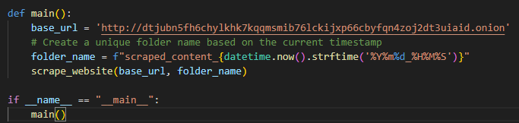
Figure 40 visible above shows a snippet of code used to execute the scraping process by specifying a random ‘.onion’ link to start the scraping process and save the output and findings into a unique folder called ‘scraped_contentDate_Time’ e.g. ‘scraped_content20240708_142538’. A new folder with the current time stamp was created with each separate scraping attempt.
Figure 40 - Representation of 'Tor-Searcher' usage
1. Library Imports: The script began its execution by importing all previously installed libraries such as ‘requests’ for sending GET requests, ‘beautifulsoup4’ from ‘bs4’ for parsing HTML content, ‘Retry’ was taken out of ‘urllib3’ to ensure smooth handling of request retries, ‘HTTPAdapter’ was provided by ‘requests.adapters’ for initialising reties, ‘time’ was used for adding delay to avoid overloading the server, ‘os’ was implemented for file handling and finally ‘datetime’ to create time stamped folders for each new scrape. This helped researcher to ensure that all basic functions responsible for scraping the data are initialised properly.
2. Tor Configuration and Privacy: The ‘torSearcher’ function was defined for establishing a session and to be configured in a way to use Tor by changing HTTP and HTTPS proxies to modified ones – ‘socks5h:127.0.0.1’. This part of code was responsible for configuration of traffic so that was routed via the Tor network whilst maximising the anonymity of researcher.
3. Retry Mechanism: A retry mechanism was implemented to maximise the chances of scraping the content, it was provided by ‘urllib3’ and was modified to retry the script up to 10 times, every time a retry was made, the relay was doubled. This was essential to implement in case of any network issues or server availability, it was applied to both aspects – HTTP and HTTPS.
4. Sending Requests: The script was sending customised HTTP GET requests the specified ‘.onion’ URL using the Tor network because of the proxies. If the request was successful, a message stating that was returned in the terminal and the content was saved, however, if the request was not successful, the error handling and logging capability implemented into the code guided the researcher by returning relevant error messages such as timeouts, HTTP errors.

5. HTML Parsing and Custom HTML structure: The function ‘create_custom_html’ parsed the HTML findings using ‘beautifulsoup’ by retrieving the ‘title’ and ‘meta’ tags involved to create a modified HTML structure. After the HTML content was successfully retrieved, it was saved in the given HTML structure to ensure the simplicity of readiness.
6. Saving HTML web pages: The implemented ‘save_html’ function was responsible for checking if the specified folder exists, if it does not exist then the script created it. After the folder was successfully created, all HTML web pages were saved to that folder for storing scraped data.
7. Extracting and Following Links: The ‘get_all_links’ function was introduced into the code to support the location of ‘<a>’ tags within the HTML content just to retrieve ‘href’ assets. It creates absolute URLs from neighbour paths and preserves them for future scraping.
8. Recursive Scraping: The ‘scrape_website’ function was applied to firstly scrape the foundation URL and any pages that are related to it to retrieve every single web page instead of just a homepage. This function saves the HTML content, produces new links and adds them to the list of valid links to be scraped, this provided researcher with the assurance of data validity by not scraping the same web page more than once, a slight delay was implemented to avoid overloading the server.
9. Main Function: The ‘main’ function allowed researcher to specify the ‘.onion’ URL to scrape and create a timestamped folder, this function calls another process by looking for ‘scrape_website’ and executing it.
10. Output and Process Termination: During the process, the script was responsible for printing the progress into the terminal and provide logging status messages, this allowed researcher to be aware of any successful requests and to identify whether the scraping was finished or not and produced any errors. After the execution was completed, the script recorded all necessary HTML web pages to the time stamped folder.

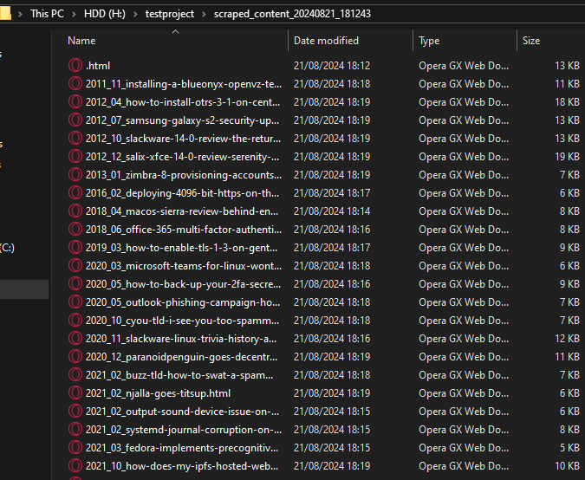
Figure 41 - Representation of scraped content and folder name
Figure 41 demonstrates the HTML content that was saved from one of the scraping attempts, as visible in the folder directory, it was stored inside the folder called ‘scraped_content_20240821_181243’, this folder contained various HTML files, every single file is a different web page retrieved from a singular ‘.onion’ link. There were two files saved ‘homepage.html’ that allowed further exploration and analysis. The image above displays the success of the script and its efficiency in collecting and storing data that was gathered from multiple pages.

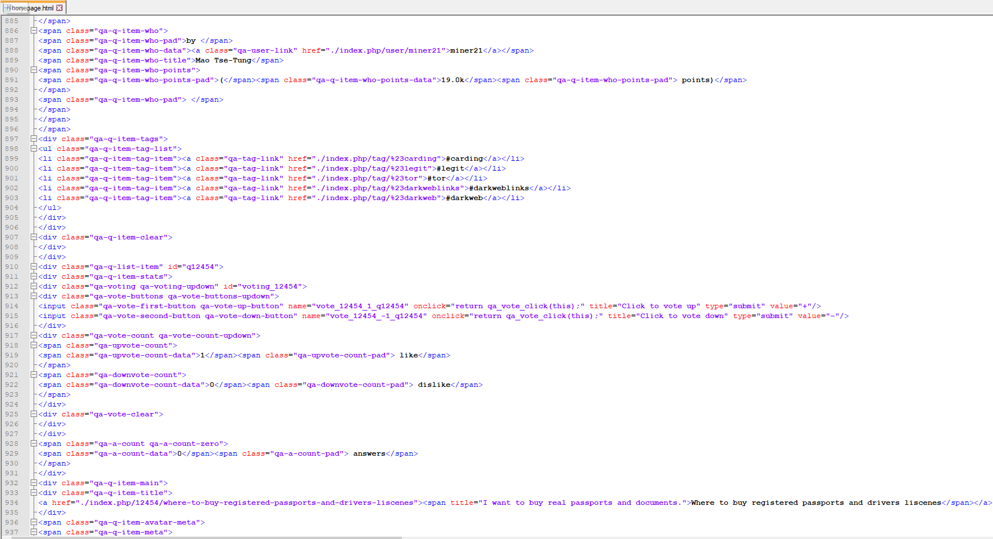
Figure 42 illustrates the inside of HTML web page that was scraped from the dark web by using ‘tor-searcher’ script. It is a raw HTML source code supported by the custom structure specified in the code. The researcher was able to navigate through the code and began the cleaning process of eliminating any unnecessary information to be left with only what is relevant and accurate. This was possible by using ‘Notepad++’ software.
Figure 42 - Representation of HTML scraped content

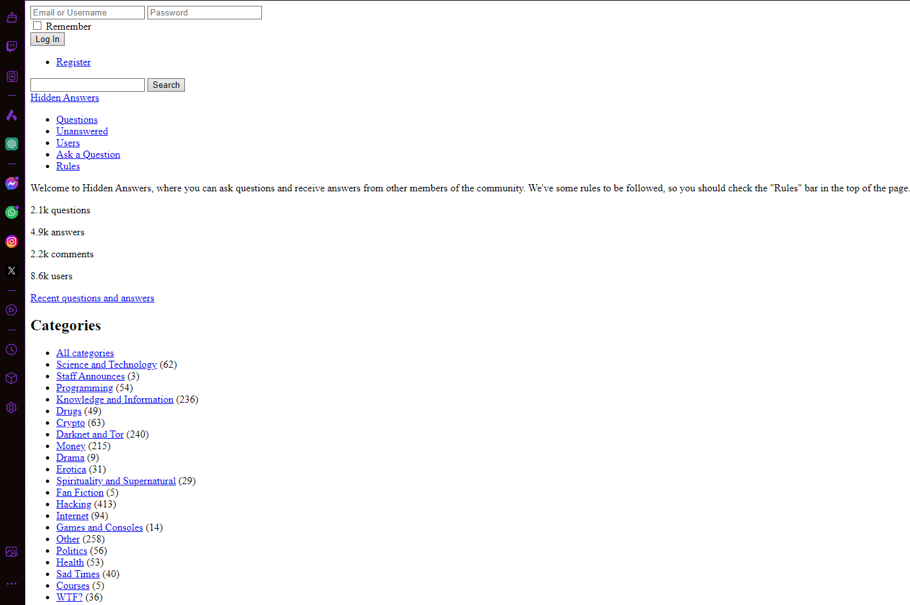
Figure 43 - Representation of HTML scraped file via Opera GX browser
Figure 43 represents the raw HTML content that was scraped, anything on the visible above was reflected in the HTML code, however this provided the researcher with a friendly way of filtering for data by having a better layout as this simplified the keyword filtering process.

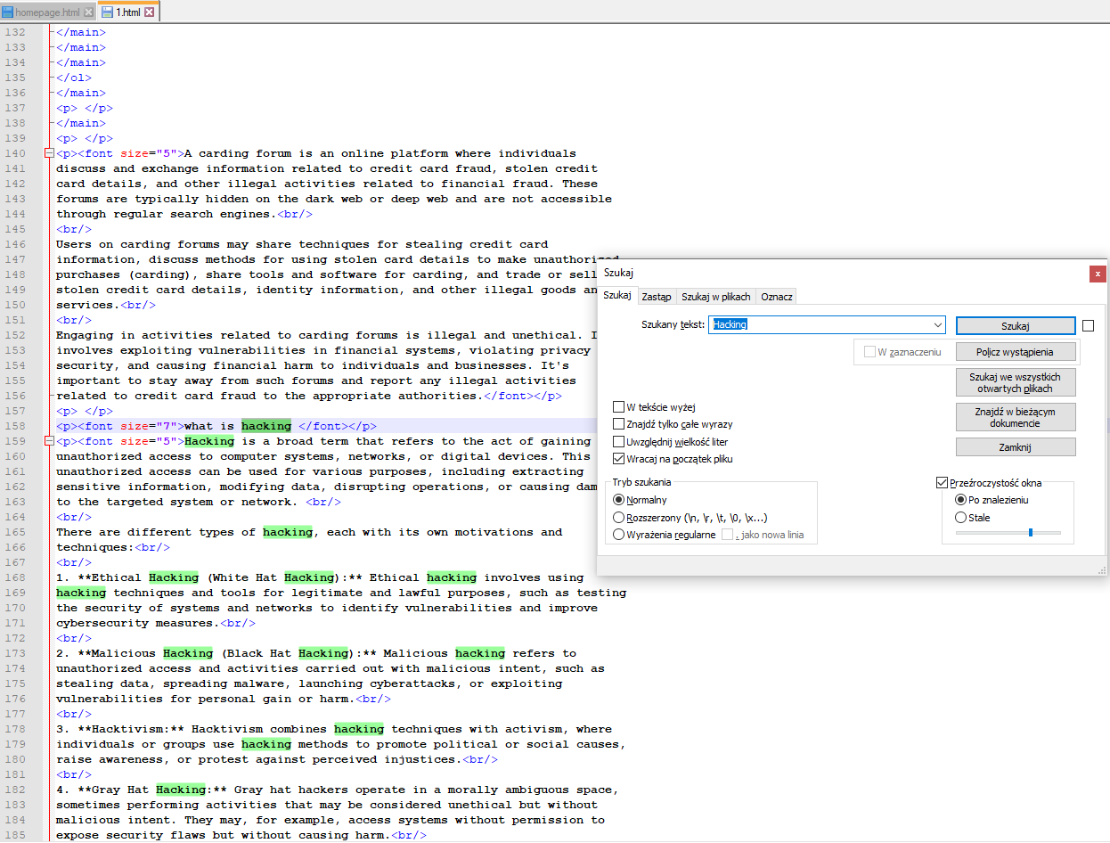
Figure 44 presented above shows how researcher approached the data cleaning process by filtering for certain keywords such as ‘hacking’, ‘malware’, ‘ransomware’. A built-in function to start an advanced lookup in ‘Notepad++’ helped researcher to only extract and save the most relevant and accurate data, after the data was found. It was provided in the Excel spreadsheet where all data had been categorised.
Figure 44 - Representation of data cleaning process and checking for keywords

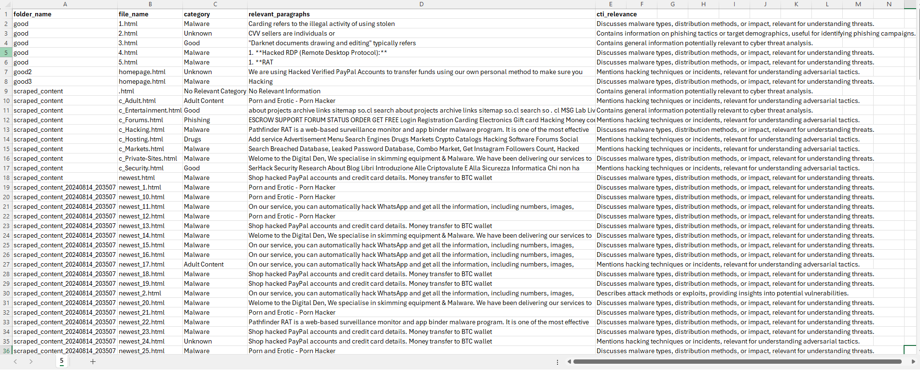
The above represents a snippet of categorised data stating the folder name, file name, category, relevant content and how it suits the needs of cyber threat intelligence. This was helpful for researcher to have a clear overview over all scraped data, this is suitable for cyber threat intelligence delivery to detect e.g. ‘Hacked RDP (Remote Desktop Protocol)’. The structure of that table made it clear for researcher about the destination of the folder and file name to enhance the simplicity of navigating to the directory in case any changes were needed.
Figure 45 - Representation of categorised data to deliver to CTI

5.3 Evaluation
This section consists of a critical assessment of the testing and experimentation section to identify the reliability and efficiency of the tools and methodologies utilised to successfully retrieve data from the dark web. The testing part included configuration of a robust environment on a machine running Windows operating system, there were numerous extra libraries which had to be imported from the web via ‘pip’ tool that comes pre-installed with Python. The testing process also introduced the implementation of solid security appliances and launching custom-written python script inspired by ‘DarkScrape’ tool to obtain data from the dark web. This evaluation determines the outcome of the experimental configuration and if the aim and objectives were achieved, discusses any issues faced and refers to the already created literature review and related work section specifically for this subject.

1. Environment Setup and Security configurations
The experiment started with building a robust environment on a machine running Windows operating system, this step is crucial and essential to achieve the most efficient security before data scraping began. This configuration process involved the execution of ‘pip’ commands via command-line as the following libraries – requests, pysocks, beautifulsoup4 and urllib3 are the core of this research and a successful script execution depended on the functionality of those libraries. The main purpose for installation of the libraries mentioned above is allowing HTPP requests to be tunnelled via the Tor network, configuring proxies, managing HTML content and to increase the easiness and efficiency of the process in general. The installation was completed with no errors or implications, all the above were successfully installed and worked as intended, this crucial step provided the foundation for every next step and process involved in the dark web scraping.
Furthermore, to obtain the most rigorous level of security available for the environment in which the experiment was carried out, maximum settings have been set for the firewall and any unknown and unrecognised packets should be rejected. To ensure its efficiency, an extra layer of security was implemented and to be precise – Intrusion Detection System (IDS) in case any suspicious activity inside the network occurs and the researcher would be informed if such happened. The intrusion detection system was enabled and operated as intended, however no major notification and alerts were delivered to the researcher during the testing process, this proves the robustness of the environment and security measures that were applied.
Additionally, CyberGhost VPN was implemented with a kill switch option enabled to give the assurance that any packet which is sent via an encrypted route was not intercepted by a third-party person and kept the anonymity of the researcher. To ensure this, the kill switch feature was thoroughly tested to confirm its functionality to be sure the researcher was not revealed to the dangers and people surfing the dark web in case the VPN connection was terminated. This rigorous setup served as a foundation required before starting the data scraping process and successfully represented environment robustness against the dangers that emerge from the dark web.
Outcome Analysis: The setup applied to the environment to achieve the security was carried out and worked as intended with no implications, the following were applied – firewall maximum settings, intrusion detection system, VPN combined with a kill switch and kept the identity of the researcher anonymised and unknown to risks coming out of the dark web.

2. Execution and accuracy of the AhmiaScraper script
The ‘AhmiaScraper’ script was launched and served as the foundation for data collection phase. The foundation of this script was based on establishing a secure connection with Ahmia search engine, a specialised and widely available website used for identifying Tor hidden services by using queries of choice such ‘malware’, ‘virus’, ‘trojan’. After the script was deployed via Microsoft Visual Studio Code software using python debugger, it generated a list of links which were linked to the specified in the script query, in this case the query was set to ‘malware’. The list was generated as a .txt file with a structure ‘site+setofrandomnumbers.txt’ e.g. ‘site7893.txt’. The unique number was added after every execution of the script to simplify identification of the file. This great process implemented automation into the research and changed a lot of valuable aspects such as time management as the researcher was able to download a large amount of .onion links with just one click.
To discuss further, the script was fully functional and worked as intended, however some links compiled by the script were inactive or simply no longer working due to the dynamic landscape in the dark web; to tackle this process, a manual removal was required to eliminate any irrelevant links from the list. This introduced a minor implication and affected the speed and efficiency of the data collection process. Regardless of the issues, the ‘AhmiaScraper’ script worked as intended and produced an unlimited amount of .txt lists with links related to the query and was the only tool responsible for partial data collection process which in this case was link gathering.
Outcome Analysis: The ‘AhmiaScraper’ creation worked as intended in most of the parts as it successfully implemented automation into the data gathering process by compiling a list of numerous .onion links, however not all links were fully valid e.g. active and a manual intervention to eliminate unnecessary entities was needed. This perfectly aligns with the findings noted in ‘Related works’ section found under literature review as other individuals were required to manually intervene to ensure the links were valid and relevant.
3. Performance and Usability – Tor-Searcher Script
The ‘Tor-Searcher’ script was deployed to retrieve data from the dark web utilising the links from a compiled .txt list generated by ‘AhmiaScraper’ script. This script functioned by requiring a manual intervention to input .onion link and begin the scraping process by running it via Python debugger which is built-in to Microsoft Visual Studio code software. When the script was actively working, any implications such as error messages, warnings and similar were displayed in the terminal and it was made possible because of the logging part of coding implemented to inform the researcher about the current process of the script, once the scraping was completed successfully, the researcher was informed in the terminal. That process has significantly improved the logging and information process as the researcher was constantly aware of the status of the script.
The script functioned as needed and retrieved the data from valid .onion links and successfully recorded the findings by creating a unique folder with a structure ‘scraped_contentDataStampHere’ e.g. ‘scraped_content20240108_143035’. This function implemented in the code simplified the process of folder identification and made it easy to identify the desired folder out of hundred folders and increased the speed of data analysis.
Outcome Analysis: The ‘Tor-Searcher’ script performed as required during the scraping process and recording the findings. However, one major implication was encountered as it required the researcher to manually input the .onion link from the list provided by ‘AhmiaScraper’ and the manual process to eliminate inactive or irrelevant links was carried out and this aspect leaves a plenty of space for future improvements. The performance of ‘Tor-Searcher’ perfectly aligns with the findings recorded in ‘Related works’ section which can be found under literature review as it discusses the necessity for having a semi-automated tool/script to achieve flexibility and accuracy in dark web data mining.
4. Data Analysis and Validation phase
The final phase of the experiment included an analysis of the retrieved data to determine the most necessary and relevant information. This started with inspecting the HTML source code provided by ‘Tor-Searcher’ script. The inspection was achieved by virtue of ‘Notepad++’ software and allowed the researcher to clean the data by filtering for specific individual keywords such as ‘malware’, ’virus ’, ’trojan ’. This approach was efficient for a swift identification of the relevant information in a large amount of unnecessary data.
To enhance the viewing process, the HTML web pages launched in the Opera GX browser to achieve a greater understanding about the HTML source code and what is hiding behind it by being able to view an enhanced version of the HTML code, however the CSS code was not included but still made it readable and viewable. This dual approach allowed the researcher to achieve the maximum efficiency when analysing the data due to being able view the direct code and its graphical representation. If the valid and necessary findings were recorded, it was compared through cross-referencing with the most popular cyber threat intelligence databases.
Once enough information was collected, it was put through a systematic and constant categorisation by allocating the relevant information into relevant table fields in Excel. This well-organised approach enabled an efficient process for data analysis and usage of gathered data.
Outcome analysis: The validation and data analysis process were carried out as required and worked with no implications faced by efficiently determining and allocating valuable findings into the table. This approach perfectly aligns with methodologies mentioned in the literature review e.g. using automated data scraping solution with manual data analysis for a maximum scraping process efficiency and the most accurate data analysis process to make sure the cyber threat intelligence makes the most out of the findings.
5. Benchmarking and Cross-Referencing with Related Works
The results recorded through this experiment were benchmarked against related works, specifically related to the dark web monitoring and CTI. Alike studies have shown that having a solution that consists of automated tools and manual analysis to retrieve and process data from the dark web is optimal and efficient, this aligns with the approach and route taken throughout this research. The implications encountered such as irrelevant and invalid links which required manual intervention are a very common occurrence in this topic and it shows the similarity and validity of the findings recorded by other individuals that put pressure on the necessity for having tools that can handle the swift and unpredictable landscape of the dark web.

5.4 Conclusion
The testing and evaluation section of this research efficiently represented the possibilities of utilising a custom-written Python script and setting up a robust environment to retrieve data from the dark web. The experiment was successful and fulfilled the objectives by carefully and securely collecting, analysing and categorising valuable findings to CTI whilst staying anonymous and unrecognised.
Effectiveness of Tools and Methodologies:
The ‘AhmiaScraper’ was implemented due to a huge efficiency increase as it was automated and acted as the main mechanism to retrieve the .onion links about the relevant query such as ‘malware’. Even after facing minor issues such as invalid links or inactive websites, it still behaved as the core process for data gathering process and changed it significantly. The ‘Tor-Searcher’ script was responsible for allowing the researcher to maintain an efficient and reliable scraping process whilst being provided with a real-time feedback returned in the terminal and enabled a consistent management of findings by recording the data in separate folders combined with the timestamp.
Security Measures and Configuration: The introduction of solid security measures – maximum firewall settings, intrusion detection system (IDS), and a robust universally recognised Cyber Ghost VPN with a kill switch option enabled to efficiently secure the environment. The security measures that were applied reassured the researcher that no security issues can happen, confirming the accuracy and robustness of the setup.
Data Analysis and Validation: The data analysis phase utilised an accurate approach by using Notepadd++ for HTML source code inspection for each retrieved web page and OperaGX for viewing the web page to achieve a better view of what the web page looks like to maximise the findings. This allowed the researcher to achieve the most accurate result and structure the data by organising and allocating it into the relevant fields in an Excel spreadsheet, this lines up with the most recommended security practices.
Benchmarking Against Related Works: The data retrieved through this experiment lines up with official methodologies used in dark web monitoring and CTI. The partially automated approach mixed with manual analysis of automated data gathering reflects on alike studies carried out in the past. This pinpoints the validity and relevance of the research in the cyber security field.
Possible Improvements: Regardless of the experiment being achieved as intended, there are areas for improvement, and this could potentially involve ‘AhmiaScraper’ script to eliminate the need for manual intervention with inactive or invalid links and modifying the ‘Tor-Searcher’ script to manage and remediate errors in a better and more efficient manner. Integration of machine learning is another improvement that can be researched to enhance data categorisation from the lowest to urgent.

CHAPTER 6

CONCLUSIONS AND RECOMMENDATIONS

6.1 Summary
This research was directed towards the possibilities of utilising the dark web as a source for cyber threat intelligence. The main goal was to develop an appropriately secured and consistent structure for scraping data from the dark web and put it through a rigorous cleaning process to later feed it to cyber threat intelligence which would aid cyber security fields and measures. In this study, different tools were examined and analysed along with methodologies, dependencies and libraries to gain a secure access to dark web data and put it through analysis.
This research began with a detailed exploration of the dark web structure, functionality and usage for cyber threat intelligence. A wide variety of illegal activities were discussed along with the marketplaces such as AlphaBay or Silk that were hosted on the dark web were discussed providing the core issues encountered while monitoring and trying to prevent these dangers and threats. The research then outlined the design and implementation of a python based dark scrape inspired custom python script configured in a way to run within the safe environment for the purposes of gathering data and making sure that researcher’s identity stays unexposed and away from being revealed – identity, network information and other personal data.
The final part of this research was to put together a structured plan for creating a framework that can be implemented to achieve a consistent and systematic monitoring of the dark web while simultaneously scraping the data as needed. The design of the framework pressured scalability, modularity and most importantly security to make sure that the framework is flexible and adaptable to a constantly changing dark web environment that comes along with a various of unknown cyber threats. It clearly outlined that using dark web as a source for cyber threat intelligence provides professionals with the ability to stay on the same level or one step ahead with the latest security trends and implement the necessary security measures in advance.

6.2 Conclusion
The dark web is a strange place which represents both sides – a good and a bad. A good side is made for cyber experts, and it allows them to pull data from the dark web and use it in a positive way, however the dark web is commonly known for the illegal activities and services where tools, information, data and other services are being exchanged for crypto currency. However, if utilised in the right way, it can become a gold mine and valuable place for creating a robust solution framework to protect company’s assets and prevent attacks by implementing patches and fixing vulnerabilities before the company falls a victim of such.
This document clearly represents that scraping the dark web in a safe efficient manner to retrieve the information for cyber threat intelligence is achievable with the use of appropriate tools and methodologies along with security measures. The usage of a python script inspired by DarkScrape [80] was created in a way to make using Tor a successful approach whilst maximising security and anonymity during scraping process. However, the data was put against an intense and rigorous data cleaning processes which was defined above in the document to have the assurance that data gathered is relevant to cyber threat intelligence purposes.
The structure for the framework that was created provided a foundation for building a secure and solid framework for companies that are looking to reinforce their security posture by monitoring the dark web and scraping data looking for any potential exposure. By putting pressure on scalability, security and modularity, the proposed structure for creating framework can reinforce company’s security posture while dynamically evolving along with the landscape of the dark web. Utilising a pro-active approach to threat intelligence allows organisations to stay aware in advance about any emerging threats from the dark web and avoid the damage or attack execution against company’s security posture.

6.3 Further research
This study provides detailed insights about exploring the dark web and retrieving data from it and feeding it to cyber threat intelligence, however there are many potential areas where significant improvements could be made, here are some of them:
- Advanced data scraping techniques: If further research will be carried out in the future [81], it could uncover more advanced scraping techniques which could involve machine learning algorithms to make identification of threats easier by automating it and retrieve valuable information. This would lead to a notable change in time management and data accuracy as it would not involve human interaction.
- Real-time processing: While having automation provided because of machine learning algorithms, having a mechanism which could analyse data in real-time and make cyber experts aware of any findings would significantly increase the change of dangers and vulnerabilities being picked up and patched [82]. This allows the tool to analyse large datasets meaning any common patterns and trends could be fed to cyber threat intelligence and avoided in advance.
- Integration: The framework could be even more useful if its flexibility would allow to integrate with other security system such as Security Information and Event Management commonly known as ‘SIEM’ and threat intelligence platforms ‘TIPs’ [83]. Cooperating of the framework and other systems would allow for an easy and accurate transfer of information and identification of common patterns and trends meaning the rate of threat detection would significantly increase.
- Legal and ethical issues: The implementation of utilisation dark web as a source for cyber threat intelligence is growing everyday and becomes popular. This leaves professionals with an area to improve and to be exact legal and ethical considerations field to make sure every action is carried out legally and ethically [84]. Future research could potentially uncover an easier way to obey the legal and ethical standards and procedures including local and international law.
- Human Intelligence integration: Considering the integration of automated data and human intelligence, a meaningful change could be made in terms of providing more detailed overview about the dark web. Any future research carried out would maximise the efficiency of threat intelligence collection by combining both approaches.
- Countermeasures: Collecting and analysing data is one important aspect, however it is not enough as appropriate countermeasures need to be put in place to make data efficient and combat the threats retrieved from the dark web [85]. This can be tackled by creating new response protocols and mechanisms, implementing new detection signatures and coming up with new mechanisms and detections based on the findings.

By considering all areas mentioned above, future research can significantly improve the efficiency of the framework that can be created because the structure by enabling cyber experts to improve their systems and security measures due to using dark web gatherings as a source for cyber threat intelligence.

CHAPTER 7

REFLECTION
Engaging on this research project ‘Using Dark Web as a Source for Cyber Threat Intelligence’, was a new and certainly challenging yet educational experience which had widely widened my knowledge about the cyber security field and to be exact – dark web when it comes to data scraping and feeding it to cyber threat intelligence. There were many technical issues during my journey with this project, legal and ethical aspects that needed to be looked at before starting the official practical process and my problem-solving and critical skills were highly developed. Owing to the entire process, ranging from the very start to the final part, I have enriched myself with many detailed insights and high-valued information which will surely aid my future findings and experience with cyber security.
Learning and development
One of the most important aspects that had been earned thanks for this research was the knowledge about how difficult it is to scrape data effectively and in a safe manner. At first, I did not acknowledge the difficulty in relation to viewing and accessing the services provided by the dark web. The necessity to always remain anonymous to avoid detection and obey all ethical and legal standards and procedures made my journey more complexed than I assumed it would be. The development of a custom python script created to suits the needs of this research was inspired by ‘DarkScrape’ and made me realise how important it is to have a plan beforehand, coding in python had to be perfect and I needed to ensure everything is spotless to achieve a constant and systematic ability to test the script and make it fully functional to meet the aim and objectives. However, I have developed skills in one significant area by reason of this research and to be exact – programming using Python language and enriched me with the use of network security tools such as Torsocks and Tor.
Furthermore, this research also had educated me about the importance of having multiple layers of security before data scraping process began to avoid direct contact with infected environment and to be exact – dark web. Utilising multiple security layers such as virtual private network (VPN), access controls, maximised firewall and intrusion detection system (IDS) prevented me from getting exposed to the dangers, services and people with bad intentions on the dark web. This research was crucial in expanding my knowledge and skills about the best cyber security practices.

Issues and problem-solving
My journey required me to encounter multiple issues which required creative critical thinking skills from me. One of the big problems encountered was the availability and stability of dark web websites as they are constantly changing and evolving and some of them were offline. This required me to write my python script in a way which will inform me about such issues and handle errors accordingly. However, many websites implemented their own security solutions by adding CAPTCHA and many other scraping preventable measures, this caused me to redo my script to tackle these challenges whilst still obeying ethical & law standards and procedures.
The second crucial challenge was the gatherings that I have managed to obtain from the dark web. The data that was scraped was often in an unfriendly format and contained a lot of unnecessary information, to counter this, I had to create an efficient process which aided me in retrieving the necessary information from the gatherings as the data needs to be fed to cyber threat intelligence. This significantly highlighted and educated me about the need to carefully handle sensitive information and prepare the data in an appropriate way.
Ethical and Legal considerations
A major part of this research involved dealing with legal and ethical considerations. Gathering data from the dark web, even for research reasons is an overly sensitive topic as there are many ethical and legal procedures that need to be followed beforehand. When it came to data handling, a thought of unauthorised access and breaching data privacy was a constant worry. This part of the research had significantly enlightened me about the need to stay professional and deal with the information in a professional manner to keep standard of data integrity high and not reveal any possible sensitive data which could cause further damage.
Reflections on methodology
By utilising both – qualitative and quantitative approach, it allowed me to gain a valuable overview of the dark web and its wide perspectives. A mixed approach allowed me to acknowledge and understand more about the dark web and what type of data can be retrieved from there which could be in relevance to cyber threat intelligence. However, by combining automated data scraping with manual data analysis, it allowed me to sacrifice a decent amount of time to achieve the desired results when analysing a lot of scraped content.
One of the aspects that certainly enhanced my research skills and cyber security knowledge was the research process itself, it required me to carry out regular tests and make any necessary adjustments as needed to make the script work and achieve the desired results. This significantly supported me in providing the reliability and security of the data gathering phase and presented how important it is to be innovative and flexible during the research process.

Personal and professional growth
By giving this research another look, I can confidently state that there are many areas where future research and practical changes could support any future work referencing to this study. Firstly, a more advanced approach to scrape data could be implemented as mentioned above and this could be achieved with machine learning and natural language processing to allow filter automation and present the researcher with the important and relevant data first. This would significantly increase the efficiency and time management.
Secondly, by implementing a real-time data analysis solution and making cyber experts aware of any alerts, it would certainly change the dynamics of the framework allowing to provide a better response time to unknown threats emerging from the dark web to create a robust security framework. However, another area mentioned was integration, it would massively impact the framework if it could be integrated with other security systems such as SIEM, this would lead to a better data detection rates and cyber expert’s incident response time.
At last, it is mandatory to keep improving the positive side of cyber security in relation to dark web as the negative side of the dark web is constantly evolving and will always be one step ahead of cyber experts, this can be reduced or avoided by implementing cyber threat intelligence in relation to scraping dark web data.
Conclusion
Overall, this research provided so much unique and valuable knowledge, experience and significantly improved a wide range of personal skills such as critical thinking, problem solving and time management. This research certainly enriched me with invaluable knowledge which will surely provide me with the necessary support for my future work. I am positive that this study can be beneficial and provide enhancements combined with effectiveness to improve cybersecurity practises.

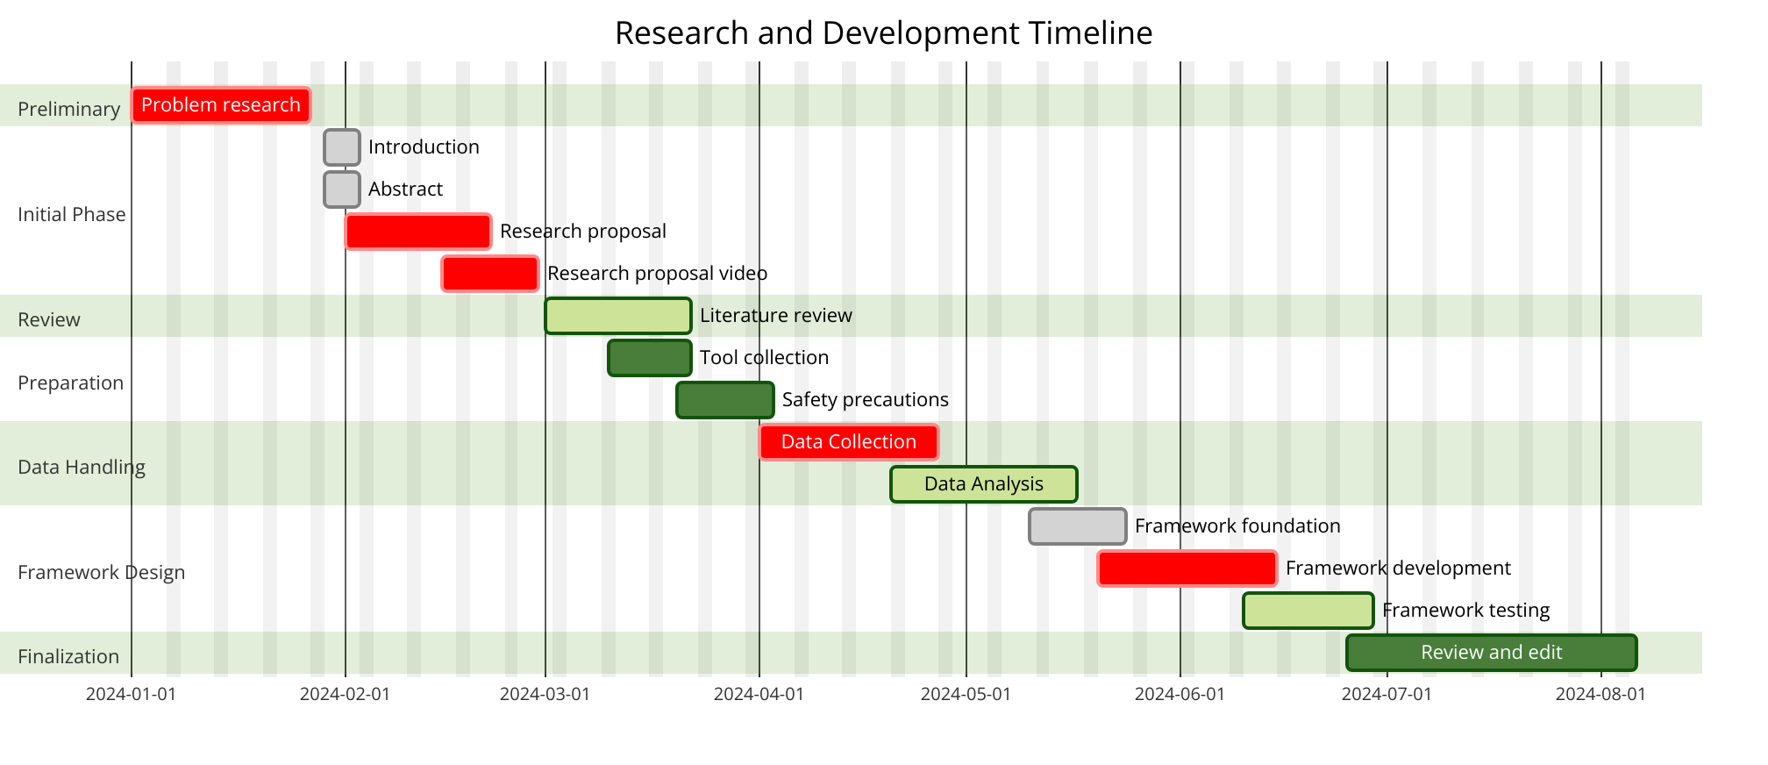
Gantt Charts
Figure 46 - Initial Gantt Chart
This Gantt chart clearly outlines the journey that was taken throughout the entire process while the research lasts. At first, research was done to determine if this is a good subject to discuss, once it was confirmed – the research began. However, research is still not finished and practical part will be carried out soon and results will be presented in a clear and simplified way, so practitioners are able to use this research without any further implications.
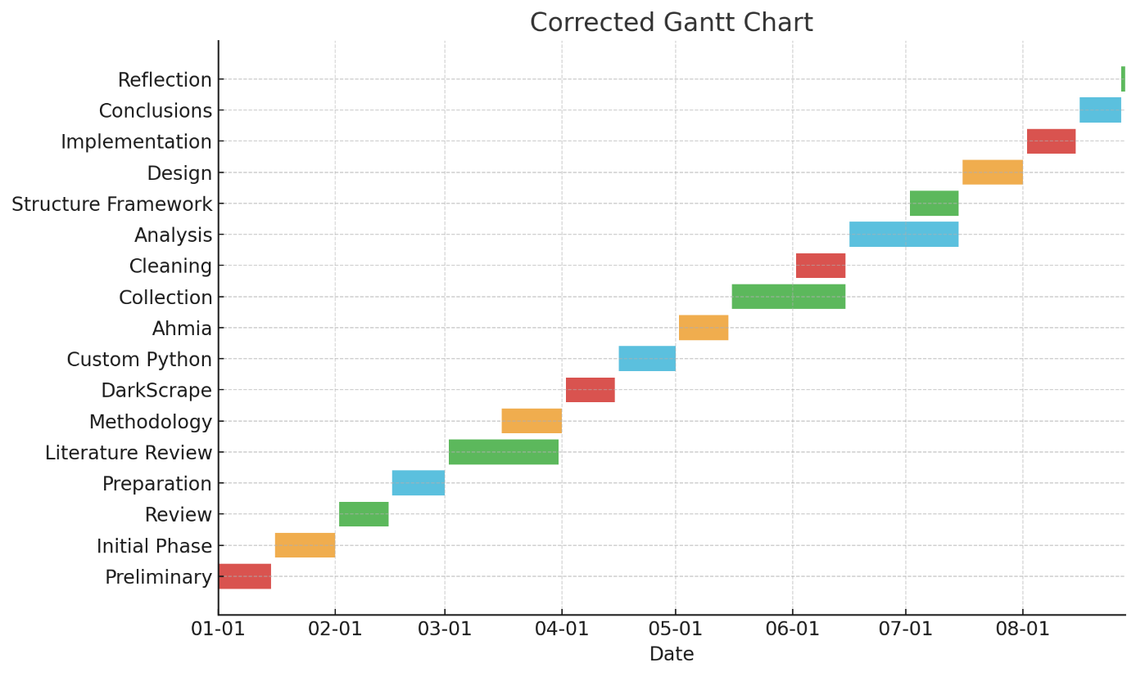
This updated Gantt chart clearly outlines how the journey throughout this research has changed, meaning there are more stages included, considerations, some of the dates had to be extended to meet the aim and objectives. This research ranged from 01/01/2024 until 27/08/2024.
Figure 47- Representing scraped data for CTI

References

[1] | G. Weimann, “Introduction,” Going Dark: Terrorism on the Dark Web, vol. 39, no. 3, pp. 195-206, 2016.
[2] | C. H. H. M. &. R. W. Jun Cui, “Tor anonymity,” Tor network anonymity evaluation based on node anonymity, vol. 6, no. 55, 2023.
[3] | B. A. Randa Basheer, “Dark web for CTI,” Threats from the Dark: A Review over Dark Web Investigation Research for Cyber Threat Intelligence, pp. 1-21, 2021.
[4] | P. Shakarian, “Signifiance,” Dark-Web Cyber Threat Intelligence: From Data to Intelligence to Prediction, vol. 9, no. 12, 2018.
[5] | H. Chen, “Dark web process,” Dark Web: Exploring and Mining the Dark Side of the Web, pp. 1-2, 2011.
[6] | R. S. &. D. D. Mahdieh Zabihimayvan, “Tor security,” Security, information, and structure characterization of Tor: a survey, 2024.
[7] | B. C. a. J. Stewart, “Tor security,” Privacy Worlds: Exploring Values and Design in the Development of the Tor Anonymity Network, vol. 47, no. 5, 2021.
[8] | S. K. &. S. Randhawa, “Characteristics of dark web,” Dark Web: A Web of Crimes, vol. 112, pp. 2131-2158, 2020.
[9] | N. H. Yoichi Tsuchiya, “Dark web transactions,” Dark web in the dark: Investigating when transactions take place on cryptomarkets, vol. 36, 2021.
[10] | Y. T. Naoki Hiramoto, “Tor transactions,” Measuring dark web marketplaces via Bitcoin transactions: From birth to independence, vol. 35, 2020.
[11] | V. K. N. P. N. I. R. K. A. Raghu Raman, “Dark web illegal substances,” Darkweb research: Past, present, and future trends and mapping to sustainable development goals, vol. 9, no. 11, 2023.
[12] | T. J. H. a. O. S. Jin R. Lee, “Dark web firearms,” An assessment of the state of firearm sales on the Dark Web, vol. 47, no. 1, pp. 46-60, 2022.
[13] | M. Rahmouni, “Dark web stolen data,” Dark Data: Why What You Don’t Know Matters, vol. 65, no. 1, pp. 129-131, 2023.
[14] | B. K. &. S. D. J. Felix Soldner, “Dark web counterfeits,” Counterfeits on dark markets: a measurement between Jan-2014 and Sep-2015, 2023.
[15] | C. M. a. S. B. Fawn T. Ngo fawnngo, “Dark web hacking,” The Dark Web: What Is It, How to Access It, and Why We Need to Study It, vol. 39, no. 2, 2023.
[16] | G. O. Joanna Curtis, “Dark web law enforcement,” Understanding cybercrime in ‘real world’ policing and law enforcement, vol. 96, no. 4, 2022.
[17] | A. K. M. M. a. P. B. kate Connolly, “Dark web small marketplaces,” Dark Web Marketplaces: Data for Collaborative Threat Intelligence, pp. 1-12, 2023.
[18] | I. Pete, J. Hughes, Y. T. Chua and M. Bada, “Dark web forum security,” in A Social Network Analysis and Comparison of Six Dark Web Forums, Genoa, Italy, 2020.
[19] | J. R. N. M. G. S. C. Elizabeth Phillips, “Dark web hidden forums,” in Extracting Social Structure from DarkWeb Forums, UK, Oxford, 2015.
[20] | J. Burgess, “Dark web zero day exploit,” Malware and Exploits on the Dark Web, 2017.
[21] | Y. F. F. B. G. S. Per Håkon Meland, “Dark web ransomware,” The Ransomware-as-a-Service economy within the darknet, vol. 92, 2020.
[22] | K. K. Y. K. S. S. S. S. Changhoon Yoon, “Dark web phishing,” Doppelgängers on the Dark Web: A Large-scale Assessment on Phishing Hidden Web Services, pp. 2225-2235, 2019.
[23] | M. Nathan, “Dark web credential stuffing,” Credential stuffing: new tools and stolen data drive continued attacks, vol. 2020, no. 12, pp. 18-19, 2020.
[24] | A. W. Nina Klimburg-Witjes, “Dark web social engineering,” Hacking Humans? Social Engineering and the Construction of the “Deficient User” in Cybersecurity Discourses, vol. 46, no. 6, 2021.
[25] | Y. X. a. W. J. Tasnuva Mahjabin, “Dark web DDoS attack,” A survey of distributed denial-of-service attack, prevention, and mitigation techniques, 2017.
[26] | V. K. N. P. N. I. R. a. K. A. Raghu Raman, “Dark web emerging trends,” Darkweb research: Past, present, and future trends and mapping to sustainable development goals, vol. 9, no. 11, 2023.
[27] | P. Shakarian, “Dark web AI,” Dark-Web Cyber Threat Intelligence: From Data to Intelligence to Prediction, vol. 9, no. 12, 2018.
[28] | Y. Xu, Z. Wu, J. Cao, J. Xu and G. Cheng, “Dark web blockchain,” in DarkTrans: A Blockchain-based Covert Communication Scheme with High Channel Capacity and Strong Concealment, Ocean Flower Island, China, 2023.
[29] | R. A. K. Mohd Faizan, “Economy,” Exploring and analyzing the dark Web: A new alchemy, vol. 24, no. 5, 2019.
[30] | W. L. V. B. H. C. Sagar Samtani, “CTI,” Informing Cyber Threat Intelligence through Dark Web Situational Awareness: The AZSecure Hacker Assets Portal, vol. 2, no. 4, pp. 1-10, 2021.
[31] | B. A. Randa Basheer, “Intelligence Cycle,” Threats from the Dark: A Review over Dark Web Investigation Research for Cyber Threat Intelligence, 2021.
[32] | I. A. J. D. Mohammad Al-Ramahi, “IOC,” Exploring hackers assets: topics of interest as indicators of compromise, pp. 1-4, 2020.
[33] | A. D. E. M. E. N. V. P. J. S. P. S. John Robertson, Darkweb Cyber Threat Intelligence Mining, Cambridge University Press, 2017.
[34] | Y. L. et.al, “Data collection,” in Identifying, Collecting, and Monitoring Personally Identifiable Information: From the Dark Web to the Surface Web, Arlington,, 2020.
[35] | I. A. Sugiu Takaaki, “Data processing,” in Dark Web Content Analysis and Visualization, 2019.
[36] | H. Chen, Data conversion, Springer, New York, NY, 2011.
[37] | D. M. E. K. E. L. G. G. E. D. Dimitrios Kavallieros, “Delivery,” in Understanding the Dark Web, Springer, Cham, 2021, pp. 3-26.
[38] | J. P.-G. &. F. G. M. José Manuel Ruiz Ródenas, “Related Works,” A general and modular framework for dark web analysis, vol. 27, pp. 4687-4703, 2023.
[39] | N. C. Roberts, “Data colleciton,” Tracking and disrupting dark networks: Challenges of data collection and analysis, vol. 13, pp. 5-19, 2020.
[40] | S. Retzkin, Hands-On Dark Web Analysis: Learn what goes on in the Dark Web, and how to work with it, Packt Publishing Ltd, 2018.
[41] | Y. L. e. al, “Analysis,” in Identifying, Collecting, and Monitoring Personally Identifiable Information: From the Dark Web to the Surface Web, Arlington, 2020.
[42] | A. S. Lee, R. Briggs and A. R. Dennis, “Positivism,” in Crafting Theory to Satisfy the Requirements of Explanation, Waikoloa, HI, USA, 2014.
[43] | A. S. Lee, R. Briggs and A. R. Dennis, “Deductivism,” in Crafting Theory to Satisfy the Requirements of Explanation, Waikoloa, HI, USA, 2014.
[44] | C. Seaman, “Qualitative,” Qualitative methods in empirical studies of software engineering, vol. 25, no. 4, pp. 557-572, 2002.
[45] | R. K. Boettger and C. Lam, “Experimental,” An Overview of Experimental and Quasi-Experimental Research in Technical Communication Journals (1992–2011), vol. 56, no. 4, pp. 272-293, 2013.
[46] | P. A. T. Mark NK Saunders, “Understanding research philosophies,” Understanding research philosophies and approaches, pp. 106-135, 2009.
[47] | E. T. Njoku, “Empirical data,” Empirical Research, pp. 782-783, 2020.
[48] | P. W. &. J. H. Rob Timans, “Mixed method,” Mixed methods research: what it is and what it could be, vol. 48, pp. 193-216, 2019.
[49] | Z. Xu and J. Ni, “VPN,” in Research on network security of VPN technology, Sanya, China, 2020.
[50] | M. A. E. Sowmya T. a, “IDS,” A comprehensive review of AI based intrusion detection system, vol. 28, 2023.
[51] | F. A. B. H. Ali, “Firewall,” in A study of technology in firewall system, Langkawi, Malaysia, 2011.
[52] | R. Sandhu and P. Samarati, “Access controls,” Access control: principle and practice, vol. 32, no. 9, pp. 40-48, 1994.
[53] | Z. C. Xiaofeng Wang, “A cross-sectional approach,” Cross-Sectional Studies: Strengths, Weaknesses, and Recommendations, 2020.
[54] | B. A. Randa Basheer, “Dark web and CTI integration,” Threats from the Dark: A Review over Dark Web Investigation Research for Cyber Threat Intelligence, pp. 1-21, 2021.
[55] | F. Shirazi, M. Goehring and C. Diaz, “Tor,” in Tor Experimentation Tools, San Jose, CA, USA, 2015.
[56] | M. E. a. P. F. Syverson, “Torsocks,” On the Security of Traffic Analysis Resistant Anonymity Networks, vol. 9, no. 4, pp. 54-62, 2011.
[57] | S. S. a. M. A. A. Kumar, “Requests and PySocks,” Python-based Web Scraping Techniques for Data Extraction from Dynamic Websites, vol. 9, pp. 11234-11242, 2011.
[58] | M. X. Z. a. A. S. J. Doe, “Beautifulsoup4,” Leveraging BeautifulSoup and Python for Efficient Web Data Extraction in Cybersecurity Research, vol. 15, pp. 3445-3458, 2020.
[59] | M. K. S. a. A. S. A. J. R. Parker, “Urllib3,” Web Data Scraping Techniques in Cybersecurity Research: Tools and Best Practices, vol. 15, pp. 3445-3458, 2020.
[60] | A. Valenzano, “Access controls,” Industrial Cybersecurity: Improving Security Through Access Control Policy Models, vol. 8, no. 2, pp. 6-17, 2014.
[61] | R. Venkateswaran, “VPN,” Virtual private networks, vol. 20, no. 1, pp. 11-15, 2001.
[62] | S. Sobhan, T. Williams, M. J. H. Faruk, J. Rodriguez, M. Tasnim, E. Mathew, J. Wright and H. Shahr, “Data collection,” in A Review of Dark Web: Trends and Future Directions, Los Alamitos, CA, USA, 2022.
[63] | A. Al-Omari, A. Allhusen, A. Wahbeh, M. Al-Ramahi and I. Alsmadi, “Data conversion,” in Dark Web Analytics: A Comparative Study of Feature Selection and Prediction Algorithms, San Antonio, TX, USA, 2022.
[64] | T. M. Abdellatif, R. A. Said and T. M. Ghazal, “Data Analysis,” in Understanding Dark Web: A Systematic Literature Review, Dubai, United Arab Emirates, 2022.
[65] | S. S. a. M. A. A. Kumar, “ahmia search engine,” Survey on Dark Web Search Engines and Indexing Techniques, vol. 9, pp. 12456-12467, 2021.
[66] | S. S. a. P. G. A. Kumar, “WireGuard protocol,” in A Mechanised Cryptographic Proof of the WireGuard Virtual Private Network Protocol, 2021.
[67] | Notepad++, Notepad++, [Online]. Available: https://notepad-plus-plus.org/. [Accessed 26 August 2024].
[68] | J. P.-G. &. F. G. M. José Manuel Ruiz Ródenas, “Inspiration structure,” A general and modular framework for dark web analysis, vol. 27, pp. 4687-4703, 2024.
[69] | O. P. Jesper Bergman, “Data Acquisition,” Exploring Dark Web Crawlers: A Systematic Literature Review of Dark Web Crawlers and Their Implementation, 2023.
[70] | R. M. A. H. T. S. A. b. A. Abdul Hadi Mohammed Alaidi, “Data cleaning,” Dark Web Illegal Activities Crawling and Classifying Using Data Mining Techniques, vol. 16, no. 10, 2022.
[71] | “Data Analysis,” Evolution of Dark Web Threat Analysis and Detection: A Systematic Approach, vol. 8, pp. 171796 - 171819, 2020.
[72] | M. L. a. L. W. E. C. Chang, “VPN Killswitch,” Advanced Security Measures in Virtual Private Networks: A Survey, vol. 18, no. 5, pp. 72-80, 2020.
[73] | T. P. Upulie Handalage, “Dark web risks,” Dark Web, Its Impact on the Internet and the Society: A Review, 2021.
[74] | M. K. S. a. A. S. A. J. R. Parker, “Dark web exposure,” Dark Web Forensics: An Investigation of Tracking Dark Web Activity with Digital Forensics Tools, vol. 16, pp. 3567-3580, 2021.
[75] | M. Chertoff, “Ethical and Legal considerations,” A public policy perspective of the Dark Web, vol. 2, no. 1, pp. 26-38, 2017.
[76] | “Data encryption,” The data encryption standard in perspective, vol. 16, no. 6, pp. 5-9, 1978.
[77] | M. Fuentes-García, J. Camacho and G. Maciá-Fernández, “Network security,” Present and Future of Network Security Monitoring, vol. 9, pp. 112744-112760, 2021.
[78] | M. Wills, “Access Controls,” in Access Controls, Wiley Data and Cybersecurity, 2020, pp. 1-63.
[79] | S. Hong, H. Seo and M. Yoon, “Audit checks,” Data Auditing for Intelligent Network Security Monitoring, vol. 61, no. 3, pp. 74-79, 2022.
[80] | itsmehacker. [Online]. Available: https://github.com/itsmehacker/DarkScrape. [Accessed 26 August 2024].
[81] | I. Valova, T. Mladenova, G. Kanev and T. Halacheva, “Advanced scraping techniques,” in Web Scraping - State of Art, Techniques and Approaches, Sofia, Bulgaria, 2023.
[82] | J. Ghadermazi, A. Shah and N. D. Bastian, “Real-Time processing and detection,” Towards Real-time Network Intrusion Detection with Image-based Sequential Packets Representation, pp. 1-17, 2024.
[83] | H. Mokalled, R. Catelli, V. Casola, D. Debertol, E. Meda and R. Zunino, “Framework integration,” in The Applicability of a SIEM Solution: Requirements and Evaluation, Napoli, Italy, 2019.
[84] | L. Acosta, S. E. Hosseini and S. Pervez, “Legal and ethical issues,” in Ethical Challenges Associated with Security Vulnerabilities and Data Privacy in Social Networking, Instabul Turkiye, 2023.
[85] | C. A. S. Murty, H. Rana, R. Verma, R. Pathak and P. H. Rughani, “Dark web countermeasures,” in A Review of Web Application Security Risks: Auditing and Assessment of the Dark Web, Mauritius, Mauritius, 2021.
[86] | S. H. Tewari, “Blockchain,” Abuses of Blockchain and Cryptocurrency in Dark Web and How to Regulate Them, 2021.
[87] | S. S. Samar Ansh, “Emerging threats,” in Analyze Dark Web and Security Threats, 2023.
[88] | T. S. Michael Chertoff, “Policies,” The Impact of the Dark Webo on Internet Governance and, no. 6, 2015.
[89] | I. z. članak, “Contributions,” Journal of computing and information technology, vol. 22, pp. 21-30, 2014.
[90] | Y. I.-N. K. H. W. C. Angel D. Chavez-Rivera, “Longtidudinal approach,” Chapter 38 - Longitudinal study: design, measures, and classic example, pp. 223-226, 2023.

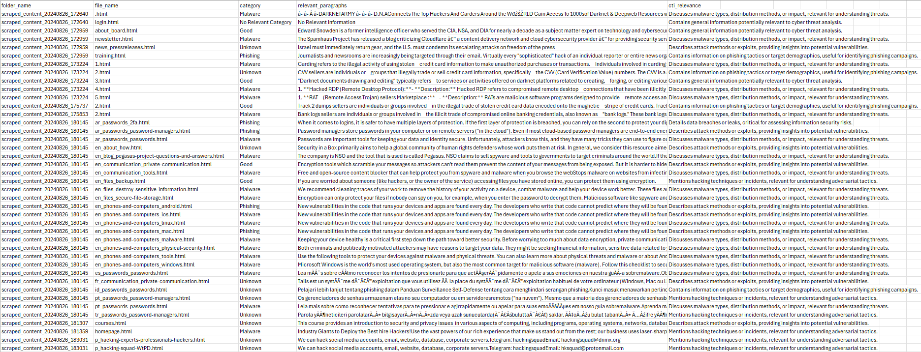
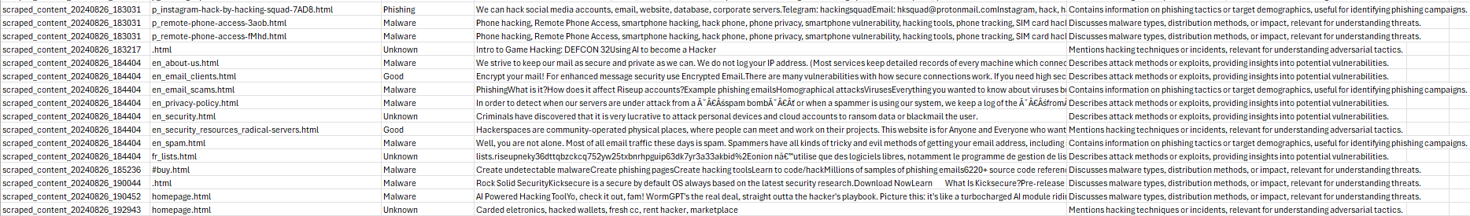
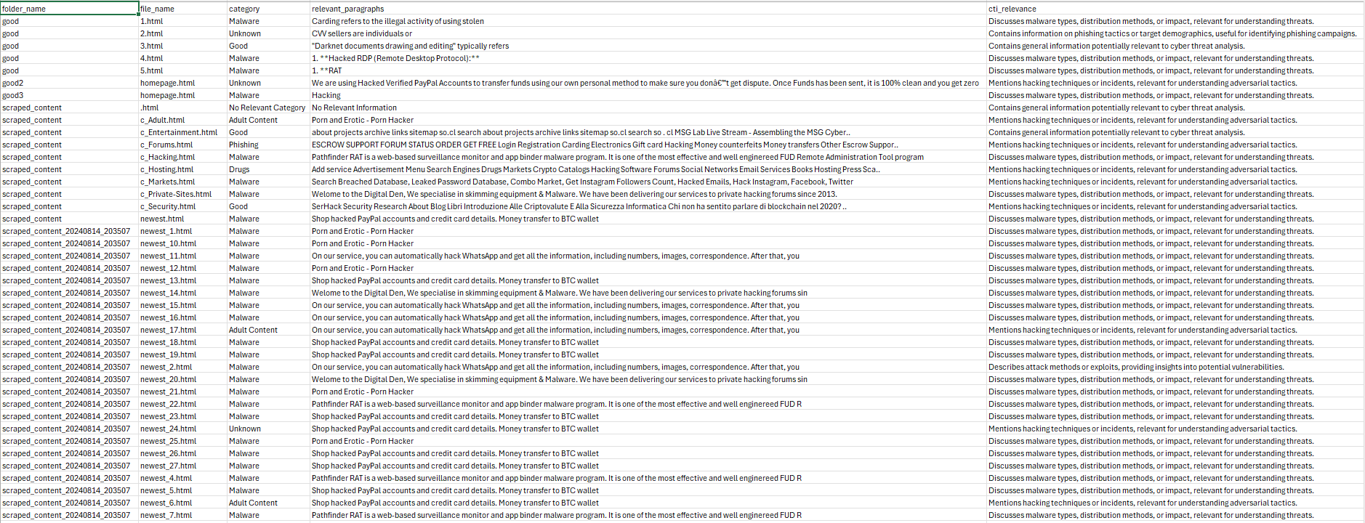
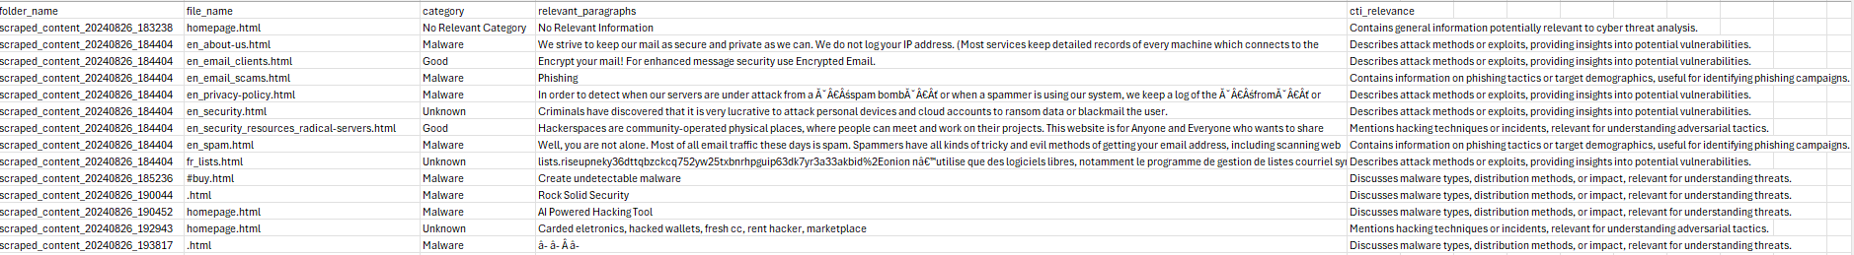
Appendix
Figure 48 - Representing scraped data for CTI
Figure 49 - Representing scraped data for CTI
Figure 50 - Representing scraped data for CTI
Figure 51 - Representing scraped data for CTI

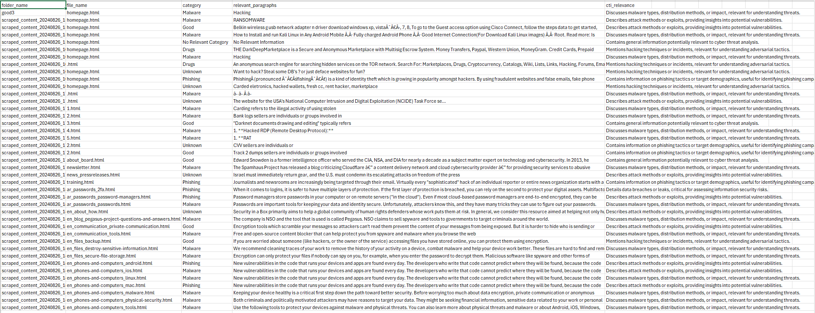
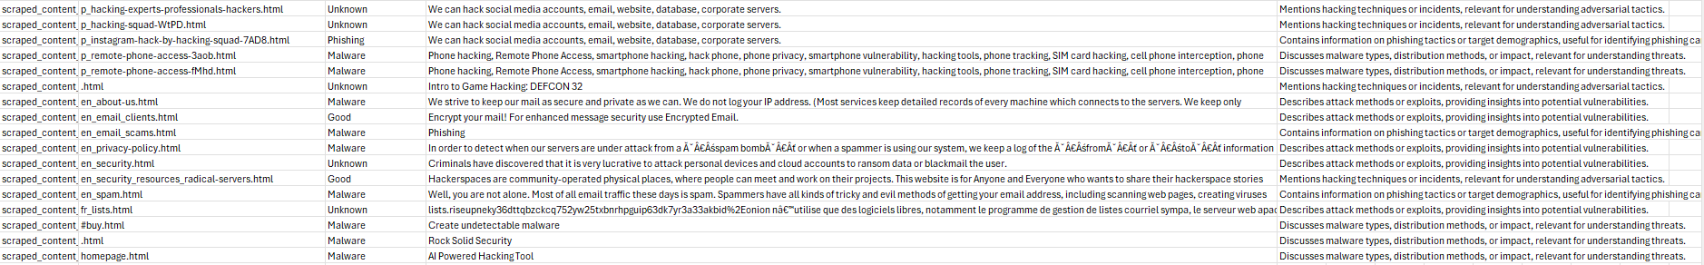
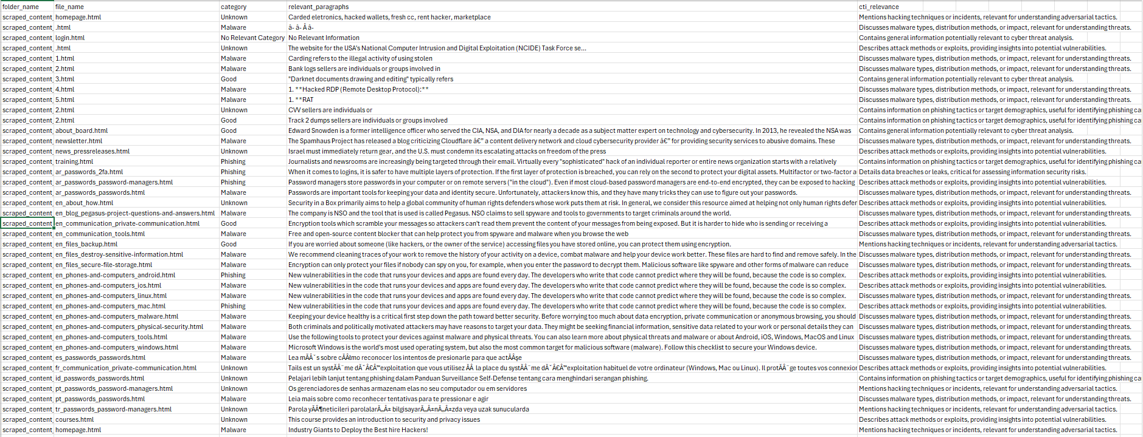
Figure 52- Representing scraped data for CTI
Figure 53- Representing scraped data for CTI
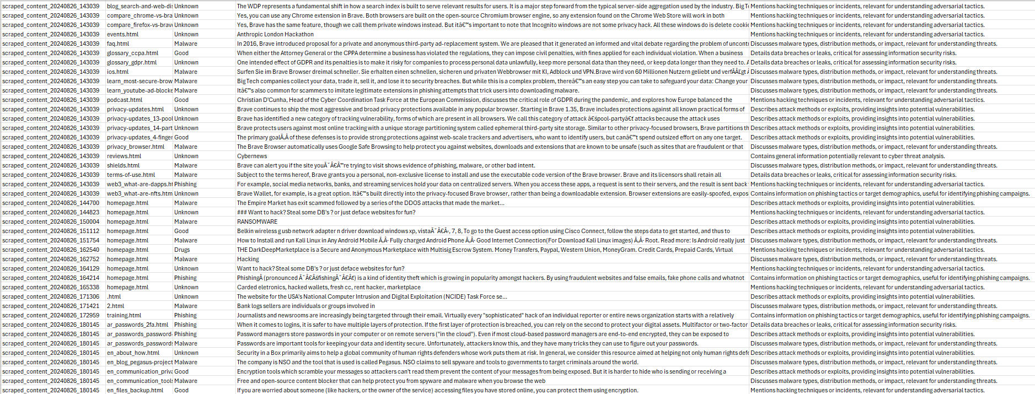
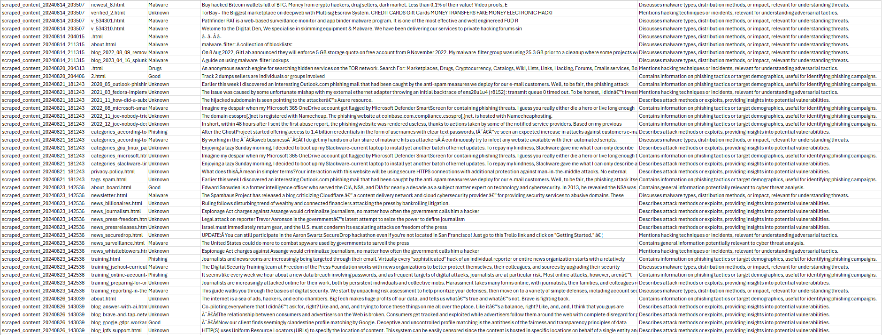
Figure 54- Representing scraped data for CTI
Figure 55- Representing scraped data for CTI

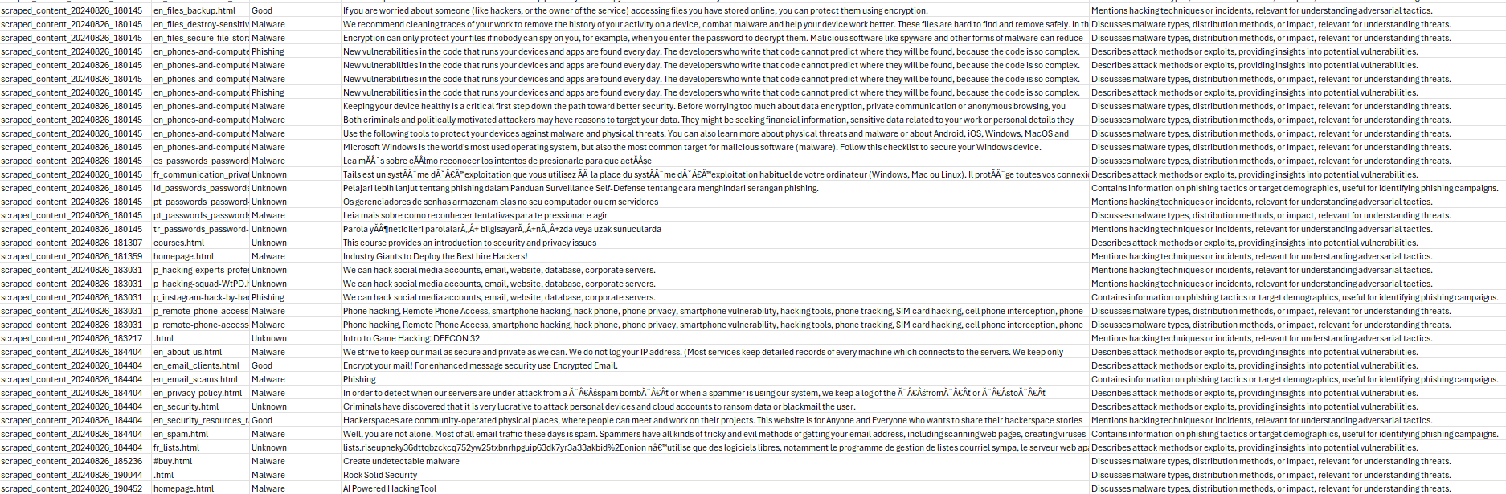
Figure 56- Representing scraped data for CTI

