Common Assessment Criteria Applied
Common Assessment Criteria Applied | REFER |  | D |  | C |  | B | A
 | OUTRIGHT FAIL | UNSATISFACTORY | SATISFACTORY | GOOD |  | VERY GOOD |  | EXCELLENT
1. Subject Knowledge and Understanding (which includes using research-informed literature and knowledge and understanding of the subject)
2. Intellectual Skills (Analysis)
3. Pedagogic and Professional Applications (Practical Application and Deployment)
4. Key Transferable Skills

PLEASE COMMENT ON AREAS IN WHICH YOU FEEL THAT YOU HAVE PERFORMED WELL | PLEASE COMMENT ON AREAS you feel that you need TO DEVELOP
I feel I have provided detailed descriptions of both lesson studies and have clearly shown evidence of the data collected.  I feel that the research study is presented in a way that make it easy for the reader to follow. | I feel I could go into more depth with the literature review.  I feel like I could have also mentioned more about the pedagogic application throughout the assignment.

Student’s Name | Richard Lewis | Date | 12/04/18
Student’s Signature | Richard Lewis

Table of Contents

Research Focus……………………………………………………………………………3
Research Context………………………………………………………………………….4
Literature Review…………………………………………………………………………..4
Explanation of Study………………………………………………………………………7
Ethical Considerations…………………………………………………………………..11
Lesson Study 1……………………………………………………………………………12
Lesson Study 2……………………………………………………………………………15
Discussion of Research Findings……………………………………………………..17
Conclusion…………………………………………………………………………………18
Recommendations……………………………………………………………………….20
References…………………………………………………………………………………22
Appendices………………………………………………………………………………..25

Word Count - 6540

The Enquiring Teacher – Research Study
‘Does the use of open ended questioning help to produce extended answers?’

Research Focus
An interesting observation that arose during professional teaching experience (PTE) was the different types of responses pupils would produce based on the type of question they were asked. Grigg (2015) suggests that teachers can sometimes ask too many closed questions during lessons, without giving children a chance to think about responses. This can result in answers that are short and non-factual. During professional teaching experience (PTE) the use of questioning had been an area of focus for the whole school over the previous year. The school had provided teachers and teaching assistants with relevant training to help improve the types of questions they propose to the pupils. Fisher (2005b) suggests that teachers are more likely to receive extended responses if they ask fewer but better questions.
The teacher within the reception class of School B (see details below) advised the use of open ended questioning as much as possible when interacting with pupils. The idea of the school introducing this strategy was to encourage the learners to think independently and to ‘find the answer for themselves’ as often as possible. Grigg (2015) proposed that if teachers are genuinely interested in pupils becoming critical thinkers and being more ‘open minded’ i.e. willing to listen to and consider new ideas, then they should ask questions that cannot be immediately answered correctly.
The aim of this research project is to determine if open ended questioning can help pupils to produce extended answers and encourage them to activate prior knowledge. This can allow pupils to enter a deeper level of thinking (The Open University, 2008), helping them to interpret and understand new information. Grigg (2015) states that The Guardian (2013) reviewed the top ten most desirable skills featured in job advertisements, two of which were flexible thinking and problem solving. Donaldson (2015) proposed in his ‘successful futures’ report that children should receive support from schools to help develop themselves into the four principles of the new curriculum. Which are; to become ambitious, capable learners, enterprising, creative contributors, ethical, informed citizens and healthy, confident individuals.
Through discussion between research partners a question was proposed, tailored and agreed to be used for this research project:
‘Does the use of open ended questioning help to produce extended answers?’

Research Context
School A is located on the outskirts of Swansea. It is built within the vicinity of surrounding houses and flats. There are approximately 220 pupils aged from 3-11 years old at the school, including 36 part-time pupils in the nursery. There are 10 classes including 20 pupils aged from 3-11 in two specialist teaching facility classes. Approximately 27% of pupils are eligible for free school meals.
School B is also located in Swansea, situated in the middle of a small close-knit community. There are approximately 175 pupils aged 3-11 years old. There are approximately 25 full time teachers working within the school. There are 7 full time classes as well as a half day nursery class and flying start. Based on figures from ESTYN (2010) report there are approximately 47% of pupils entitled to free school meals and approximately 35% of pupils are designated as having additional learning needs.

Literature Review
Assessment for learning (AFL) is a major component in the world of teaching, as Jones (2005 p10) states “it is not how well the teacher has performed, but the reaction of the learners that matters”. Jones (2005) suggests that assessment for learning supports practitioners and helps them focus on the development of learners within the classroom. It also helps teachers to provide quality feedback in the hope of improving learners progress. According to Madden (1980) the most common activity in a learning environment is for a teacher to ask questions to test the pupils' understanding. In agreement, Jones (2005) states that teachers use questioning in a natural manner and becomes a part of their daily routine. West Lothian Council Educational Psychology Service (WLCEPS, 2018) suggest that effective questioning is an important instrument used in assessment for learning strategies. Effective questioning can help the learner to find a balance between content (who, what, when) and process (how, why) (WLCEPS, 2018). Leading on from this point, Welsh Assembly Government (WAG, 2010) propose that questioning is integral to developing thinking and assessment for learning in the classroom. The use of effective questioning within the classroom can encourage pupils to think more critically, which can help to give them a deeper understanding of a topic or subject (The Open University, 2008).
Gast (2013) states the principle underlying factor of effective questioning is that each question should necessitate a factual answer. Gast (2013) also suggests that ‘effective questions’ cannot be answered with a simple “yes” or "no". The two main types of questions are ‘closed’ and ‘open’. Closed questions are generally used to check students understanding and usually have only one correct answer. This type of questioning can be answered with a one-word response such as ‘yes’ or ‘no’ and does not require a factual or extended answer.
According to Reja (2003), one of the main advantages of open-ended questions is the possibility of discovering spontaneous responses, as opposed to the need for a ‘correct’ answer. Open-ended questions require students to think about their answers more, include more information and give a factual answer (Gast, 2003). Open ended questions usually have more than one answer and can help to stimulate higher order thinking skills (WLCEPS 2018).
However, a disadvantage of open-ended questioning could be an over emphasis on speaking, Bolitho (2006) suggests that an over encouragement on speaking in the classroom can lead to ‘low quality’ or ‘meaningless’ talk. Meaning the pupils could be providing an extended response, that bares no meaning to the initial question or subject in hand.
It appears the effectiveness of this method of assessment for learning, depends on the quality of question being asked. Fisher (2005b) states that if teachers ask ‘better’ questions less often, they are more likely to receive an extended response. WLCEPS (2018) refers to a high-quality question as purposeful and will promote learning. If a ‘high quality’ question is proposed to a pupil then it could illicit a meaningful honest answer. However, if the question is of poor quality a teacher could put themselves at risk of having to code answers to search for an appropriate response. Christensen (2008) proposes that asking ‘follow up’ questions, can help to prompt pupils. University of Leicester (2005) suggest that using follow up questions can act as an indicator to show that they wish to hear more. This can then become a form of dialogue between interviewer and interviewee.
Alexander (2012) suggests talk is essential to a child’s thinking and learning, and to their continued engagement in the classroom. As stated above, open-ended questions illicit factual answers which can help to produce a higher quality of extended responses meaning the quality of talk could also improve. WAG (2010) advocate that questions posed to pupils should be open-ended wherever possible, which could then lead to discussion. “High quality questions lead to high quality talk.” (WAG, 2010 p15). Chi et al., (2008) propose discussion helps to promote learning because it encourages students to make sense of information. Vygotsky (1978) believed that social interaction can be essential to learning, he challenged that child development is a natural process, suggesting that children develop their skills and knowledge through social interactions. Discussions with teachers, fellow pupils and other adults can help children to interpret new information that they would be unsure of independently.

Grigg (2015) suggests that creating a thinking culture can be essential to children if they wish to make progress within lessons. Adey et al (2002) propose that using questioning as a form of ‘cognitive acceleration’ can help to improve thinking skills by challenging pupils during lessons. Grigg (2015) states that the use of ‘cognitive acceleration’ can help teachers to bridge new learning with previous experiences, helping pupils to interpret new information. Grigg (2015) proposes learners build on their prior experiences, with teachers acting more as facilitators rather than instructors. Svinicki (1994) agrees that prior knowledge can help pupils to perceive and organise new information. Svinicki (1994) also suggests that the more connections made between new information and relevant prior knowledge, the easier it can be to understand. Teachers hold the ability to plan to ensure these connections can be made and can ensure effective learning experiences occur in the classroom. However, it is essential that this is a two-way process meaning students must take play a part in developing strategies to control how they think, which is known as ‘Metacognition’ (Grigg, 2015).

Explanation of Lesson Study
The methodology used for this research project is known as ‘lesson study’ research. Dudley (2011) describes lesson study as a form of action research within the classroom that focuses on the development of teacher practice. It involves groups of teachers, planning delivering, observing and analysing the teaching and learning during designated lessons. Dudley (2011) advocates that lesson study has been used successfully in the past to improve pupil progress and teaching techniques. One of the main reasons lesson study has been a successful form of methodology is that external teachers can be made available to purely focus on pupils learning in real time. This can help to identify teaching strategies or techniques that are more effective for each pupil. This information can be utilised when planning to ensure lessons are better matched to students’ needs (Dudley, 2011). Based on these findings, it was decided that lesson study research would be used for this project and would hopefully provide the decisive data that could then be used to answer the research question.
According to Grigg (2015) the main purpose of observing children is to determine the most effective way in which they learn. Department for Children, Education, Lifelong Learning and Skills (DCELLS, 2008) suggest that through observing and listening, practitioners can gather evidence before and after children have been taught a skill. This helps to assess how much progress the children have made. By using a variety of methods, teachers can recognise the learning preferences of individuals.
It was decided between research partner that non-participant observation would be utilised for this study. Non-participant observation is explained as, when someone becomes a part of the setting but does not directly influence the activity, an observer attempting to make notes in short breaks (Grigg, 2015). This approach appeared to be the best fit for this study, as the observer would be close enough to hear discussions without impeding the natural flow of the activity (Jorgensen, 1989).
A factor that may have affected the findings from this type of observation could have been the presence of an unknown teacher or observer within the group activity. Grigg (2015) states that the presence of an observer could have some effect on those observed. Students may have felt self-conscious, nervous or pressured with an added observer, which may have resulted in inaccurate findings. Another limitation of participant observation would be that concentration levels may have been affected which could influence the pupils’ engagement with the activity. To increase the possibility of accurate findings, there could have been multiple lessons leading up to the data collection activity. This way, a sense of trust could have been built between teacher, observer and pupils.
Another method of observation that could have been utilised, would have been to record the activity with a video camera or a voice recording device. The footage could then be analysed and discussed following the activity. This would have lowered the possibility of missing an important aspect of the study, however, it would further increase the need to consider ethical issues surrounding pupils being recorded. After consideration of the potential methods of data collection, non-participant observation proved to be the best fit for this project.
It was decided that the focus group activity would consist of five foundation phase pupils of differing attainment levels. Schaffer (1996) suggests that when a child undertakes a task or activity with someone who can demonstrate basic strategies, it allows the child to become more confident and competent. That being said, lower attaining pupils can be motivated by the presence of higher ability peers as they believe it gives them greater opportunities to improve their own performance (Heath, 1999, cited in Heltemes 2009). Heltemes (2009) also suggests that higher attaining pupils gain motivation from helping others. The literature mentioned above provided the research project with a justification for selecting children with mixed levels of attainment.
The focus group activities would be shown four different pictures, one at a time. Two beaches and two parks within Swansea. The reason for selecting areas within Swansea was that the pupils may have recognised the areas with the hope of linking it to a possible previous personal experience. The first two pictures were to be shown to the pupils with little or no input from the lesson lead, the pupils had time to look at each picture and then had an opportunity to say something about it. The remaining two pictures were to be shown to the pupils and were to be given time to examine as before. This time the lesson lead would ask open ended questions about each of the remaining two pictures to identity if this use of questioning helped pupils to provide extended answers. The questions were developed using Blooms Taxonomy (see figure1 below).
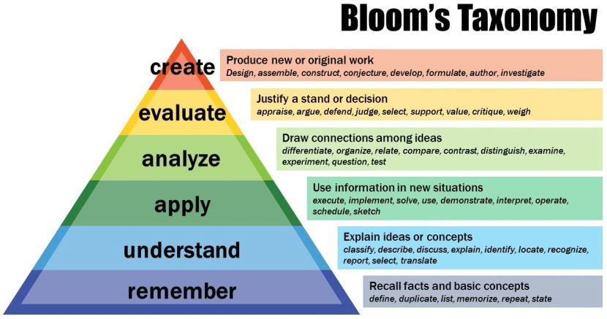
(Figure 1 – Blooms Taxonomy)
The ‘remember’ stage of blooms taxonomy was primarily used to develop questions such as:
‘what can you tell me about the last time you visited a place like this?’
‘what is your favourite memory of being on a beach?’
However, the ‘understand’ stage of blooms taxonomy was used also to develop questions such as:
‘Can you tell me what the people are doing here?’
‘How do you know that this is a park/beach?’
The research partners were hopeful that the introduction of open ended questions would encourage the children to think about their answers in more detail as opposed to responding with a simple one-word answer.
During each of the two lesson studies, the non-participant observations were captured using an observational grid developed and created by both research partners (see appendix 5). The grid was split into 4 sections (see figure 2 below), each time a child responded the observer would tally in the corresponding column.
(Figure 2 – Observational Grid Example)
Due to the activity requiring lots of discussion and feedback, it would have proven difficult to write down what the pupils had said, accurately. This method of data collection proved effective as the data could be measured with a simple tally chart system. This was essentially a combination of qualitative and quantitative data collection. The information being provided by the children was qualitative as extended dialogue was required for some responses. However, the aim of the study was to find out how many extended responses could be produced using open-ended questions, which was far easier to use a quantitative method of data collection. If a child responded with a certain amount of words, the observer would mark down in the corresponding box i.e. a response with 6 words would be marked down as a ‘short answer’.
Leading on from the introduction of open ended questions, the lesson lead and observer were hopeful that the extended responses would spark discussion throughout the groups. Vygotsky (1978) believed that discussion and social interaction is essential to learning, suggesting that children develop knowledge and skills through social interactions. He determined that learning with others had the potential to be substantially more effective than learning alone (Vygotsky, 1978). With this in mind, discussion was to be encouraged amongst the pupils through further open-ended questions, to motivate all pupils to contribute.

Ethical Considerations
The process in which information for this research project was collected, occurred during non-participant observations within focus group activities with foundation phase pupils. Prior to the activity commencing it was the research partners’ responsibility to ensure the parents of pupils were made aware of the ethical issues involved, before accepting to contribute. The parents were informed that taking part was voluntary and that their participation in the activity was not compulsory (BERA, 2011). Consent forms were handed out to all pupils in both schools to ensure parents had the choice for their child to participate or not and would be returned to the school at their earliest convenience. Once consent forms had been signed and returned, pupils would then be able to vote independently ‘Yes’ or ‘No’ depending on whether they wish to take part or not. This was conducted by providing each pupil with their own name card which they could place in a ‘Yes’ box or a ‘No’ box (see appendix 3). This ensured pupils could independently decide to participate or not participate in the activity.
Students were also made aware that they could withdraw from the observation activity at any point with or without reason. If such an instance arose it would be down to the research partners to scrutinise their approach to see whether it had contributed to the decision to withdraw. It could then be discussed that if possible changes were made, would they encourage participants to re-engage. However, accepting the withdrawal would have been the best course of action (BERA, 2011). Following the ethical issues brief, it was agreed that the focus group activities would consist of five foundation phase students in two separate schools (School B and then School A).

Lesson Study 1
The first lesson study was conducted at School B (see research context for details) with a group of reception pupils. The lesson lead for that day introduced the activity as a task that would be fun and something a little different to what the pupils would normally take part in (see Appendix 1 for lesson plan). This was to try and capture the interest of the pupils and motivate them to take part. Saeed & Zyngier (2012) advocate that motivation is seen as a necessary element for student engagement in learning. It was the research partners responsibility to provide this motivation in order for the children to become fully engaged, in order to achieve the lesson outcomes.
Prior to the focus group activity commencing the five pupils were to be selected. Consent forms that had been returned by parents were organised into groups of eligible pupils. All eligible pupils received a name tag which they would use to place in a ‘yes’ box or a ‘no’ box prior to leaving the classroom for assembly. This was crucial as it showed if the pupils were willing to participate in the activity or not (see ethical considerations). The pupils were made aware that only a group of five would be selected and not all pupils would be able to take part. The group was chosen selecting two students from a higher attaining group, two students from a middling attaining group and one student from a lower attaining group. Student Learning Centre (2013) labels this type of sampling as ‘stratified sampling’ where the eligible participants were organised into separate groups prior to selecting the final cluster. In this case the four classroom groups for attainment levels were utilised and pupils were selected from each of those groups. Schaffer (1996) suggests that when pupils interact with fellow learners, who demonstrate basic strategies and are able to complete tasks, they are able to gain confidence and motivation. This means that using a group of mixed attainment levels it could allow each of the pupils to model one of their fellow students. This could result in growing confidence and a willingness to contribute to the activity.
Once the sampling group was finalised a table within the classroom was made available for the activity to take place, students and the lesson lead sat around a circular table with the observer sitting on a chair immediately next to the table. The pupils were instructed that they would be shown four pictures, one at a time. As mentioned previously, the first two shown, would have little or no input from the lesson lead and the remaining two pictures would be shown along with accompanying questions.
Once the first picture had been given out the lesson lead prompted the children by saying “could you all please have a look at this photograph and if you would like to say something about it, we will take it in turns to talk”. The group were very quiet and were unsure how to approach the activity initially. This was expected due to a combination of a new person within their classroom (observer) and an activity being presented which they had not attempted before. However, all five of the pupils raised their hands once the lesson lead asked if they would like to say anything. Referring to Appendix 7 – Lesson Study 1, there was one (1) count of a one-word answers being given, ten (10) counts of a short answer being given (2-10 words) and two (2) counts of an extended answer being provided (10+ words). The students were able to provide us with information directly related to the picture (Appendix 4 – Picture A) such as “it is colourful”, “there are lots of flowers” and “I see trees and grass”. These responses did not show any evidence that the children had deeply thought about what they wanted to say. They were simply analysing the picture and providing information about what they could see.
The second picture (Appendix 4 – Picture B) was shown to the pupils, as stated in the lesson plan, little or no input was provided by the lesson lead. The children had approximately one minute to look at the photograph before being asked if they would like to say anything. The pupils were asked again “if you would like to say anything, please raise your hand”. There were three (3) counts of one-word answers, five (5) counts of short answers and two (2) counts of extended answers. Much like the first picture, the children were able to point out details directly from the picture such as “it looks like a beach”, “I can see waves and sand” and “the two people are walking to the beach”. However, this time there was one instance where a child said, “I like running around and playing on the sand”. This prompted other children to agree and state that they also enjoyed playing on the beach. The lesson lead was not able to add any input and the brief discussion between the children stopped.
The third and fourth pictures were shown to the children in the same way as before. They were given time to look at the pictures, one at a time and would be given a chance to say something about them. This time the lesson lead would ask open ended questions to the children with the hope that it would illicit an extended response. The third picture was shown (Appendix 4 – Picture C) and children were given time to analyse. The lesson lead opened with a question from a predetermined set of questions (see Appendix 2) “what type of place do you think this might be?”
The children responded with; “I think it’s a park”.
The lesson lead continued; “how do you know it is a park?”
The pupil responded with “I think it is a park because there are lots of children running and playing with their friends”.
Immediately the use of open-ended questions along with follow up questions were starting to provide extended answers. The lesson lead then went on to ask, “can anyone tell me about a time they remember being at a park?”. The children were extremely responsive to this question and all wanted to talk about their experiences of being in a park. This picture along with open-ended questions provided two (2) counts of one-word answers, seven (7) counts of short answers and eight (8) counts of extended answers. Along with the increased extended answers, all five pupils were able to provide details of a personal experience of them being in a park. It seemed apparent that to provide such responses, children must have activated their prior knowledge or understanding of a similar place. As mentioned previously, Svinicki (1994) suggests that prior knowledge can help pupils to perceive and organise new information. Leading on from this, Grigg (2015) proposes learners build on their prior experiences, with teachers acting more as facilitators rather than instructors.
The fourth and final picture (Appendix 4 – Picture D) was shown to the pupils in the same way as the third. Once the children had time the lesson lead continued with open ended questions to see what responses the children would produce. One example was “who can remember what they did last time they visited a beach?”. Much like the previous picture the children were extremely responsive and were able to provide extended answers as well as relating back to personal experiences. The responses recorded were one (1) one-word answer, ten (10) short answers, thirteen (13) extended answers and one example of a children asking another child a question about their experience.
It was clear that the use of open ended questioning was able to help the pupils produce extended answers. Also, it enabled them to relate what they were seeing in the pictures to what they had experienced earlier on in their lives.
Having discussed how the first lesson study unfolded, it was decided that to make data collection easier, students would be given ‘name tags’. These name tags had numbers rather name names written on them which corresponded to the observation grid i.e. ‘child 1’ was provided with a badge with ‘1’ written on it, ‘child 2’ was provided with ‘2’ and so on. The research partners also discussed the possibility of developing some of the questions prior to lesson study 2 as the age group would be older. Based on key vocabulary sheets collected from PTE experience, it seemed the year 2 children were expected to have a larger range of vocabulary in comparison to reception (see appendix 1 and 2).

Lesson Study 2
The second lesson study was conducted the next day at School A (see research context for details) with a group of five year 2 pupils. As before, the lesson lead introduced the activity for the day and gave the reason for our presence within the classroom. Prior to the activity commencing the sampling group was to be selected. As with lesson study 1, all eligible pupils received a name tag which they would use to give assent for taking part in the activity. The pupils were again, made aware that a group of five students would be selected for the activity. To ensure consistency was kept throughout the data collection process, the cluster group was chosen selecting two students from a higher attaining group, two students from a middling attaining group and one student from a lower attaining group. Five pupils were selected by the lesson lead for that day based on the availability of Students. Learning Centre (2013) describes this type of sampling as ‘convenience sampling’ where the eligible participants were selected to participate in the cluster group based on their accessibility on the day.
Once the sampling group was finalised all members of the data collection activity entered a separate room which was made available for the activity to take place. The five students and the lesson lead sat in a circle on the floor with the observer sitting on a chair immediately next to the circle. The pupils were instructed that they would be shown four pictures, one at a time. As mentioned in the lesson plan, the first two pictures, would be accompanied by little or no input from the lesson lead. With the remaining two pictures being shown along with open-ended questions being asked.
The first picture was shown to the year 2 students and again were a little quiet at first but being older and having been in school longer they were more accustomed to this kind of activity. Once the first picture had been given out the lesson lead mentioned that the pupils would have time to look at it before being asked if they would like to say something about it. Referring to Appendix 8 – Lesson Study 2, there was two (2) counts of one-word answers given, four (4) counts short answers and two (2) counts of extended answers being provided. Relating to the picture (Appendix 4 – Picture A), the pupils were able to provide information about it, such as; “this is a park with people walking in it” and “I see lots of trees, flowers and the sky”. There were similarities between lesson study 1 and lesson study 2. With no input from the lesson lead the children were simply saying what they could see in the picture, with no evidence of linking to previous personal experience.
The second picture shown (Appendix 4 – Picture B) returned similar responses to those of the previous pictures shown which had little input and no questioning from the lesson lead. There was one (1) count of a one-word answer, six (6) counts of short answers and three (3) counts of extended answers. With no input from the lesson lead the children provided short responses that included information directly related to the picture. Prior to moving onto the third and fourth pictures the children were asked if they would like to say anything else about the picture. To which one child responded, “I remember going to the beach with my mummy and daddy, we played in the waves and I splashed my daddy.” This extended response included the child connecting the picture to a previous personal experience. This could have been used as an example for other children to follow and model. However, due to the strict nature of the activity the lesson lead was unable to ask any open-ended questions to illicit a further response. The rest of the group did not seem to react to the pupils’ response, instead they looked and waited for the lesson lead to continue. This was interesting as it was as though the children were waiting for permission to be given to talk, from the lesson lead.
The third and fourth pictures were shown to the pupils (Appendix 4 – Picture C and D) with accompanying open-ended questions, as with lesson study 1. Once the children had time to look at the picture the types of questions asked were:
“How do you know that this is a park/beach?”
“Can anyone tell about a time they visited a park/beach?”
“What do you remember?”
This time the responses were more prolonged and bountiful, with the children finding it difficult to wait for other pupils to finish talking before they started. The third picture returned; three (3) one-word answers, thirteen (13) short answers and fifteen (15) extended answers. The fourth picture returned zero (0) one-word answers, ten (10) short answers, twelve (12) extended answers and two questions asked between the pupils. In these final two pictures each of the children were able to provide extended responses which included some relation to something they had previously experienced. Leading on from the experiences the children started to discuss in more detail what they remembered. At this point the lesson lead was simply facilitating the discussion ensuring the pupils were not talking over each other. The lesson lead drew the activity to an end and thanked the pupils for their input and that they could return to class.

Discussion of Research Findings
Having analysed the data collected from the two lesson studies, it is clear to see that the introduction of open-ended questions had a significant effect on the increase in volume and length of pupil response (see figure 3 below).
(Figure 3 – Findings from Lesson Study 1 and 2)
The study found that by providing open-ended questions along with pictures helped to increase the volume of responses given by pupils. Referring to figure 3, the total amount of responses increased by 60 (41 to 101). Reja (2003) proposes that an advantage of using open-ended questions is the possibility of discovering spontaneous responses from pupils. Pupils were able to answer more frequently due to the questions being used as prompts by the lesson lead.
The study also found that the amount of extended responses increased by 39 (9 to 48). As eluded to earlier on in this assignment, the use of open-ended questions necessitates the need for learners to think about their answers more, include more information and try to give a factual answer (Gast, 2003). As mentioned previously the quality of the question determines the quality of the answer, it could be believed that each of these responses were just ‘meaningless talk’ (Bolitho, 2006). However, there was evidence in both lesson study 1 and 2 of children relating pictures to previous personal experiences with the aid of predetermined and linked open-ended questions. Svinicki (1994) suggests that prior knowledge can help pupils to perceive and organise new information. By connecting to a previous experience, the pupils were able to discuss the pictures in more detail, entering a deeper level of thinking. As stated previously WLCEPS (2018) advocate that open ended questions usually have more than one answer and can help to stimulate higher order thinking skills
According to the data shown above, it appears open-ended questioning can be used as a means of increasing volume of responses and length of responses in the classroom. These findings relate directly to the initial research question ‘Do open ended questions help to produce extended answers?’. However, there are key underlying factors that must be considered when developing the questions. The questions must be purposeful and develop learning (WLCEPS, 2018) and must be tailored specifically to the subject to avoid meaningless talk (Bolitho, 2006). The discussions that arise from the extended responses must also be facilitated by follow up questions (University of Leicester, 2005), to ensure the discussion stays ‘on topic’.

Conclusion
The method of data collection used for this study, which was non-participant observation, has been successful in gathering information related to the research question. An advantage of this type of observation is that the observer can be close enough to the activity without affecting too much of the natural flow (Jorgensen, 1989). However, there are some limitations that have been acknowledged, such as both lesson studies being conducted with children who had not met one of the research partners previously. Grigg (2015) states that there is little doubt that the presence of an observer will have some effect on those observed. This presence of an unknown observer may have caused some pupils to feel self-conscious and thus could affect the accuracy of data collected. Cooper., Lewis and Urquhart (2004) suggest that non-participant observation may need to be accompanied with some sort of strategy to ensure the observer can be accepted and trusted. As mentioned previously, multiple activities could have been conducted, leading up to the final data collection. This way the pupils could have become more accustomed to both research partners and a sense of trust could have been built.
Another area that was also discussed was the idea of adding an extra column labelled ‘personal experience’ which the observer could use to mark down when a pupil refers directly to something they had experienced themselves, thus activating their prior knowledge. The research partners were able to make separate notes linked to previous experiences as the lessons unfolded, but with an adapted observation grid the data could be collected more efficiently.
Based on data collected in this study there are some key elements I will ensure I follow, moving into my next professional teaching experience. I must ensure the type of questions I wish to ask are appropriate to the lesson in hand. I must think of the type of response I wish to receive whether it is a ‘correct’ answer or a factual response. The questions I ask must be purposeful and must help to promote and improve the learning of the students. By following these key areas, I can tailor questions to illicit extended meaningful responses that can help to improve pupils understanding of an area. The questions I produce must be interesting enough to provide the students with the motivation to stay engaged with the activity. As well as these points I must ensure I have a sound understanding of the subject in order to ask effective follow up questions to further help pupils to understand and respond accordingly.

Recommendations
Based on findings from this study and relevant literature it is apparent that teachers must deploy open-ended questions in a premeditated manner. Open ended questions should not be too broad and should be tailored to suit the subject in hand. For example, during both lesson studies, the lesson lead presented the pupils with a picture of a beach, before asking if anyone could remember a time they visited the beach. This visual along with the open-ended question allowed the pupils to activate their prior knowledge before providing a meaningful extended response.
Teachers must also be aware that students may not always have a response to every open-ended question, this is where follow up questions can become effective. Christensen (2008) states that asking follow up questions can help to prompt pupils if they are unsure of the previous question. These follow up questions should be tailored in such a way that they help students to understand what the teacher is asking, whilst at the same time avoiding any leading questions. To ensure learners do not become discouraged or start to lack in confidence, teachers must ensure they provide pupils with an environment that stimulates curiosity and challenge (Piaget, 1976). This environment should help pupils to make sense of the information allowing them to develop an adequate response as well as enabling the children to develop strategies to control their ways of thinking (metacognition) (Grigg, 2015). An extremely useful tool that could be implemented by teachers is a model proposed by Zakin (2007) to support learners and teachers. It is labelled Act, Relfect and Evaluate (ARE) model (Zakin, 2007), which is split into three elements:
‘Thinking Steps’ where a learner questions themselves first and foremost, for example “what is the problem?” and “what do I already know?”
‘Facilitating Comments’ where the learners are starting to comprehend the query, for example “I think this means…” or “I remember something similar to this”.
‘Evaluation’ is the final element of the model where the learner determines their understanding of the area, for example “I understand this now” or “This is okay but to improve I need to…”
This model could be gradually introduced to encourage pupils to become more independent and thus improve their thinking skills.
Lots of information mentioned throughout this assignment relates to encouraging children to enhance their thinking skills. However, it is essential that teachers do not focus all of their efforts into one type of learning. Grigg (2015) suggests that teachers must encourage pupils to become ‘flexible’ learners, using different types of learning as required. A consequence of heavy focus into one area may have an impact on other areas of learning. Teachers must ensure they provide equal focus to all three of the cross curricular responsibilities proposed by Donaldson (2015) which are literacy, numeracy and digital competency.

References

Alexander, R. (2012). Dialogic Teaching and The Study of Classroom talk. Universities of Cambridge and York.
Adey et al., (1996) cited in, R, Grigg (2015) Becoming an Outstanding Primary School Teacher. Second Edition. Routledge Taylor & Francis Group.
BERA. (2011). Ethical Guidelines for British Research. British Educational Journal. London.
Bolitho, R. (2006). Teacher Talk and Learner Talk. United Kingdom: Project C8 – GroupLead
Chi, M. T. H., Roy, M. and Hausmann, R. G. M. (2008), Observing Tutorial Dialogues Collaboratively: Insights About Human Tutoring Effectiveness from Vicarious Learning. Cognitive Science.
Christensen, C. R. (2008). Questions for Class Discussions. Center for Teaching and Learning, Harvard Business School.
Cooper, J., Lewis, R and Urquhart, C. (2004). Using participant or non-participant observation to explain information behaviour. Department of Information Studies. University of Wales Aberystwyth, UK
Department for Children, Education, Lifelong Learning and Skills. (2008). Observing Children, Cardiff: DCELLS.
Donaldson, G. P. (2015). Successful Futures – Report on the Curriculum and Assessment Arrangements in Wales. Welsh Government. Wales
Dudley, P. (2011). Lesson Study: a handbook. Cambridge University.
Fisher. (1995b) cited in, Grigg, R. (2015). Becoming an Outstanding Primary School Teacher. Second Edition. Routledge Taylor & Francis Group.
Gast, G. (2013). Effective Questioning and Classroom Talk. Ged Gast Creativity Consultant.
Grigg, R. (2015). Becoming an Outstanding Primary School Teacher. Second Edition. Routledge Taylor & Francis Group.
Heath. (1999) cited in, Heltemes, L. (2009) Social and Academic Advantages and Disadvantages of Within-class Heterogeneous and Homogeneous Ability Grouping. Mathematical and Computing Sciences Masters.
Heltemes, L. (2009). Social and Academic Advantages and Disadvantages of Within-class Heterogeneous and Homogeneous Ability Grouping. Mathematical and Computing Sciences Masters.
Jones, C, A. (2005). Assessment for Learning. Learning and Skills Development Agency.
Jorgensen. D, L. (1989). Participant Observation a Methodology for Human Studies. Sage Publications.
Madden, J. F. (1980). Questioning in The Classroom. Institute of Education. Singapore.
Piaget, J (1976) cited in, R, Grigg (2015) Becoming an Outstanding Primary School Teacher. Second Edition. Routledge Taylor & Francis Group.
Reja, U., Manfreda, K. L., Hlebec, V and Vehovar, V. (2003). Open-ended vs. Close-ended Questions in Web Questionnaires. Faculty of Social Sciences, University of Ljubljana.
Saeed, S. and Zyngier, D. (2012). How Motivation Influences Student Engagement: A Qualitative Case Study. Faculty of Education Monash University, Melbourne Australia.
Schaffer. (1996) cited in, R, Grigg (2015) Becoming an Outstanding Primary School Teacher. Second Edition. Routledge Taylor & Francis Group.
Student Learning Centre. (2013). Sampling. Flinders University.
Svinicki, M. (1994). What they don’t know can hurt them: The role of prior knowledge in learning. The University of Texas.
The Guardian. (2013) cited in, Grigg, R. (2015). Becoming an Outstanding Primary School Teacher. Second Edition. Routledge Taylor & Francis Group.
The Open University. (2008). Thinking Critically. The Open University Walton Hall, Milton Keynes.
University of Leicester. (2005). Interviewing for Research - Asking the Questions. East Midlands Oral History Archive Centre for Urban History.
Vygotsky, L. (1978) cited in, R, Grigg (2015) Becoming an Outstanding Primary School Teacher. Second Edition. Routledge Taylor & Francis Group.
Welsh Assembly Government. (2010). How to develop thinking and assessment for learning in the classroom. Crown Copyright.
West Lothian Council Educational Psychology Service (2018). Effective Questioning. West Lothian Council
Web Link (Blooms Taxonomy) https://kaouenn-elearning.fr/blog-post/appliquer-taxonomie-de-bloom-a-formation-a-distance/
Zakin. (2007) cited in, R, Grigg (2015) Becoming an Outstanding Primary School Teacher. Second Edition. Routledge Taylor & Francis Group.

Appendices
Appendix 1 – Lesson Plan

Name of Trainee(s): Richard Lewis and Ross Young Date: 26/3/18 & 27/3/18 Session Ref: Research Project Data Collection  Class: Reception/ Year 2 Class Size: 22/29 Age: 4/5 Years & 6/7 Years  Personal Targets in relation to QTS: S1.3 They demonstrate combinations of professional characteristics which aim to motivate and inspire learners and secure their intellectual and personal development. |  |  |  |  | Focus Planning:  Data Collection
WALT:  Talk about things from experience and share information. |  |  | WILF:  Speaking audibly.  Use words, phrases and simple sentences.  Asking questions.  Express what they like and dislike.
Hook:  The activity will be outlined to children once they have checked in and settled on the carpet (details below). We will be taking part in a fun activity today looking at and discussing different pictures.  All children will be given a label with their name on it, so they can vote to decide if they would like to take part in the activity or not. This will be done prior to assembly.  Focus group will be decided from the children who voted ‘yes’ and have returned a consent form. |  |  | Vocabulary:  Who are you?  Pwy wyt ti?  Well done/da iawn  Sorting/grouping  Find/search  How many?  Similar/same  Colour/draw/write | Resources Used:  Assent box’s  Pictures  Observation grid | Questioning  See sheet attached for list of questions.
Introduction:  I will inform the children of the mixed groups and will briefly outline the activities for the afternoon, I will then put a group on each activity ensuring all groups get a chance at each activity. |  |  |  | Resources Used:  Assent box’s  Pictures  Observation grid | Questioning  See sheet attached for list of questions.
Main Activity:  A focus group of mixed attainment (around 4-6 pupils) will be selected from children who have returned consent forms allowing participation. Group will be decided during morning assembly.  The activity will consist of looking at four pictures (2 beaches and 2 parks).  The first two pictures (1 beach, 1 park) will be given to children to look at and discuss with only closed questions being asked by the teacher.  Responses will be recorded by an observer who will not be taking an active part in the activity. (See observation grid for recording details).  The next two pictures will be given to children to look at, but this time will be asked open ended questions in hope of receiving extended answers from the pupils.  Again, responses will be recorded on accompanying observation grid.  The aim of this activity is to see how open-ended questioning can help children think more critically and relate to personal experiences.  *Following lesson Study 1, my research partner and I discussed possible ways of improving the lesson – this is discussed within the assignment.* |  |  |  | Resources Used:  Assent box’s  Pictures  Observation grid | Questioning  See sheet attached for list of questions.
Additional Adults used:  1x Non participant observer |  |  |  | Resources Used:  Assent box’s  Pictures  Observation grid | Questioning  See sheet attached for list of questions.
Independent Learning Opportunities:  Relating to personal experiences. |  |  |  | Resources Used:  Assent box’s  Pictures  Observation grid | Questioning  See sheet attached for list of questions.
Plenary:  Toward the end of the activity I will ask the children if there is anything else they would like to discus about any of the pictures.  What did you learn?  What has this made you think about?  How does this make you feel? |  |  |  | Resources Used:  Assent box’s  Pictures  Observation grid | Questioning  See sheet attached for list of questions.
Curriculum Coverage:  Literacy – Oracy |  | Assessment for learning:  Effective questioning throughout the session.
Literacy  Talk about things from their experience and share information.  Express what they like and dislike.  Speak audibly.  Answer open ended questions related to their own experiences.  Take part in activities alongside others with some interaction.  Exchange ideas in group discussion. | Numeracy  N/A |  | DCF  N/A
Thinking  Activating prior knowledge.  Thinking logically.  Forming opinions and making decisions. | ESDGC  N/A |  | YCC  See pictures attached.

.

Appendix 2 – Open Ended Questions

Open ended questions for focus group activity.

Some of the open-ended questions that will be asked in Part 2 of the focus group activity are as follows:

Non-specific questioning:
- What do think of this ...?
- Why do you think this...?
- How did you decide...?
- Where do you think...?
- Who do you think...?

Specific questioning:
- Where do you think this is? (pointing at pictures).
- How do you know this?
- Can you tell me something you remember about...?
- What clothes did you wear?
- What did you do there?
- Who do you think these people are doing?
- Where do you think they have been?
- Where do you think they are going?

These open-ended questions will help encourage critical thinking which should provide an increased cognitive response from pupils.

Appendix 3 – Assent from Children

Following the consent forms completed by parents for children to take part in our research project we are required to provide the pupils with the opportunity to decide whether they would like to take part or not.
We have decided to provide the pupils with a stick or label with their name on.
We will outline to pupils what we will be doing throughout the day i.e. focus group activity looking at and discussing pictures in a relaxed environment such as the school classroom/hall/stage or even outdoors.
Following our introduction pupils will be asked to place their label into Box ‘Yes’ or Box ‘No’ which will be created ahead of time and will be clearly labelled. It will also be covered to ensure their decisions are not affected by others.
Once we have established the students who have voted yes (meaning they are willing to take part) we will select mixed ability groups to take part in the focus groups activity.
We are aware that this might take up a bit of time allowing each group to vote however we believe this is a fair way and allows children to independently decide whether they would like to take part or not.

Richard Lewis
Date: ____________
Signed: ____________

Ross Young
Date: ____________
Signed: ____________

Appendix 4 – Pictures used during lesson

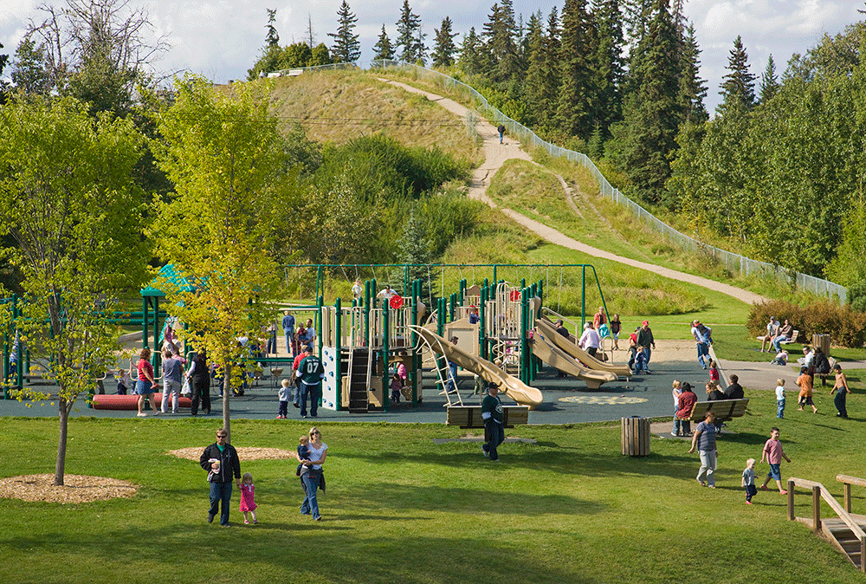
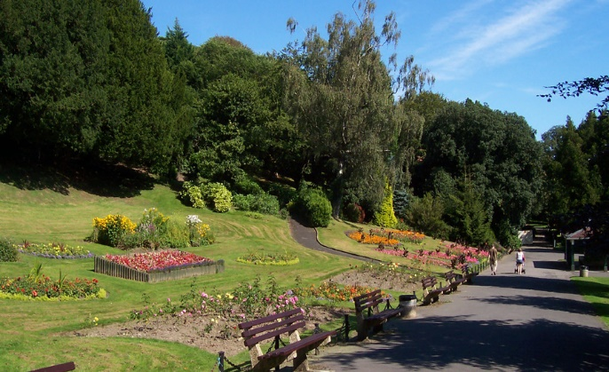
Picture A Picture C

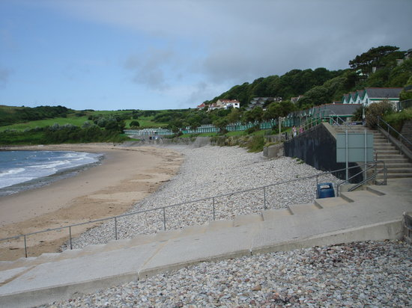
Picture B Picture D
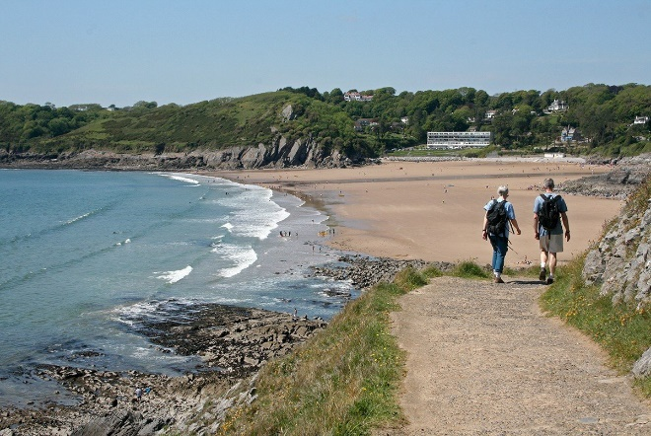

Appendix 5 – Observation Grid (Blank)

Picture 1  (closed questions) | One-word answers  (1 word) | Short answers  (2-10 words) | Extended answers  (10+ words) | Question asked  (by child)
Child 1
Child 2
Child 3
Child 4
Child 5

Picture 2  (closed questions) | One-word answers  (1 word) | Short answers  (2-10 words) | Extended answers  (10+ words) | Question asked  (by child)
Child 1
Child 2
Child 3
Child 4
Child 5

Picture 3  (open ended questions) | One-word answers  (1 word) | Short answers  (2-10 words) | Extended answers  (10+ words) | Question asked  (by child)
Child 1
Child 2
Child 3
Child 4
Child 5

Picture 4  (open ended questions) | One-word answers  (1 word) | Short answers  (2-10 words) | Extended answers  (10+ words) | Question asked  (by child)
Child 1
Child 2
Child 3
Child 4
Child 5

Appendix 6 – Questions prior/post activity

Questions to build rapport
- Did you have a nice lunch?
- How are you feeling today?
- Are you excited for the Easter holidays?

Focus group questions
- What did you enjoy about today’s lesson?
- If we were to teach this lesson to another class, what would you change?
- How could I make it more enjoyable?
- What didn’t you like about the lesson?
- How did you feel about us asking you questions about the pictures?
- Do you like the way that we took it in turns to talk? Why?

At the end of the lesson I will ask questions to the researcher (student teacher/partner)
- How do you feel the lesson went?
- Were the children engaged?
- Do you think you the lesson activity was suitable for the research question?
- What could we do differently next time to help influence cognitive response even more?

Appendix 7 – Lesson Study 1
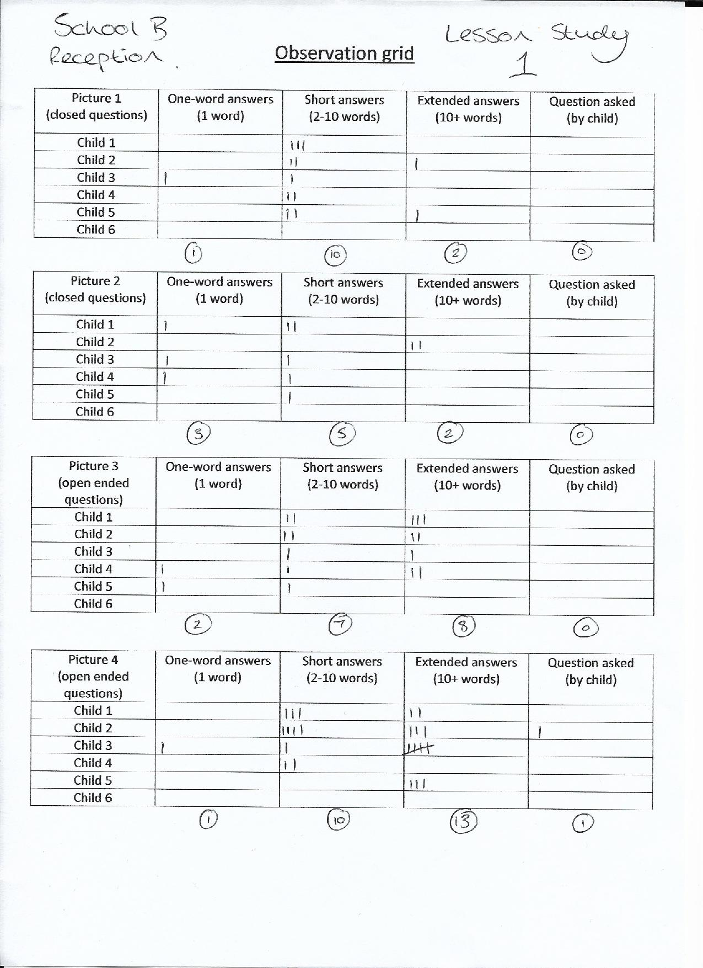

Appendix 8 – Lesson Study 2


