A Simple Distributed Network

Saffina H – 2322601
BEng (Hons) in Embedded Electronic Systems
Distributed Intelligence Systems – ACDA5018

Table of Contents

Table of Figures 4
Table of Equations 5
Table of Tables 5
1. Introduction 7
2. Literature Review 7
2.1. Quality Management Systems 7
2.1.1. Background 7
2.1.2. Importance 7
2.1.3. Impact on Industry 8
2.2. Transmission Systems 8
2.2.1. Point-to-Point 8
2.2.2. Point-to-Multipoint 9
2.2.3. Multi-Master 9
3. Design 11
3.1. Microcontroller Choice 11
3.2. Output Design 11
3.2.1. 555 Timer 11
3.2.2. LED outputs 13
3.3. Input Design 15
3.4. Connections 17
4. Development 19
4.1. Flow Chart 19
4.2. Code Design 20
4.3. Master Code 20
4.4. Slave Code 21
4.4.1. Set-up 21
4.4.2. Main Function 21
4.4.3. Data Processing and Output 23
5. Analysis 24
5.1. Operational Block Diagram 24
5.2. Test Plan 25
5.3. Simulation Results 25
5.4. Evaluation 33
5.4.1. Test Success 33
5.4.2. Comparison to Existing Research 33
6. Conclusion 35
6.1. Recommendations on Future Work 35
7. References 36
8. Appendices 39
Appendix A – Full Master Code 39
Appendix B – Full Slave Code 40

Table of Figures

Figure 1: Diagram of point-to-point systems 8
Figure 2: Diagram of a point-to-multipoint system 9
Figure 3: Diagram of multi-master system 10
Figure 4: PIC18F2525 Proteus schematic symbol 11
Figure 5: Diagram of 555 astable timing 12
Figure 6: 555 timer Proteus schematic 13
Figure 7: Diagram of rear lights on a car 13
Figure 8: LED connections on Proteus schematic 15
Figure 9: Input/Output diagram 16
Figure 10: Input connections on Proteus schematic 17
Figure 11: Full Proteus schematic 18
Figure 12: Programming flow chart 19
Figure 13: Master microcontroller code 20
Figure 14: Slave microcontroller set-up code 21
Figure 15: Slave microcontroller main code 22
Figure 16: Slave microcontroller data changing code 22
Figure 17: Slave microcontroller output functions code 23
Figure 18: System operation flow chart 24

Table of Equations

Equation 1: Formula for calculating frequency of a 555 timer 12
Equation 2: Formula to calculate the value of a current limiting resistor 14

Table of Tables

Table 1: Table of lights for the rear of a car 14
Table 2: Test plan 25
Table 3: Test results 25

Introduction
Quality management systems are critical to modern industry, this paper will look at their importance, impact and future potential. It will also analyze different transmission methods, including point-to-point, point-to-multipoint and multi-master.
A simulation has also been created in Proteus, with the design based off a simple point-to-point system within a car, looking at the rear, driver-side lights. The results of this test are evaluated, and their impact compared to initial research and potential future developments.

Literature Review

Quality Management Systems

Background

Quality Management Systems have been developed for decades, due to the importance of having crucial requirements for critical systems, especially safety systems [1]. There are now international standards for quality management, one of which is set out in the ISO 9001 QMS official documentation [2]. This discusses the importance of these systems to build relationships between suppliers and consumers, ensuring that products and services meet expectations and requirements.

Importance
A peer-reviewed article from the journal ‘Societies’ [3], suggests that in the future, QMS must also focus on efficiency, sustainability and quality of life, especially as society becomes more dependent on technology. Another, from the Science Journal of Business and Management [4] stresses the importance of QMS, and that while there are different theories as to why, the article finds a significant relationship between good QMS and performance across diverse industries around the globe.

Impact on Industry
Cars and vehicles can be dangerous, meaning that standards to ensure safety are crucial [5]. Several studies [6] have been conducted across academia, looking at the impact the QMS has on safety systems, some specifically focusing on the automotive industry [7] [8] [9]. One study looked at the methods of implementing QMS, such as internal audits, however the use of multiple quality validation methods produces better results than just one. Following this, a study [6] proposes a method of merging two systems and suggests documentation that complies with both ISO 9001 and ISO 10377 standards and looks at the future potential of this improving safety systems. Some of the current studies mentioned above have limitations, such as the diverse range of management systems in different automotive organizations making it challenging to compare their implementation, and the conflict between priorities including environmental, efficiency and quality. This makes it hard to narrow down effects of QMS to analyze any single impact, and the restriction of only accredited experts being able to perform audits makes companies averse to study this [7].

Transmission Systems

Point-to-Point
Point to point systems include at least two endpoints (in this case microcontrollers) which are connected directly via a dedicated communication channel. Due to the dedicated channel, it can be simpler and more efficient than alternate systems as there is no need for addressing, and less risk of collisions [10]. A diagram of this system is shown below in Figure 1.
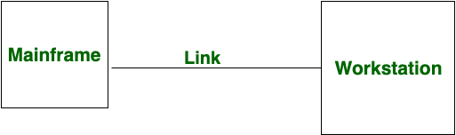 [11]
Figure 1: Diagram of point-to-point systems

The system designed in this report is based on a point-to-point system, as it requires only a single master and slave microcontroller. Some research papers [12] [13] have looked at the applications of point-to-point systems in industry, such as robotics. They also mention how the use of point-to-point distributed systems require more optimization of power when more peripherals are added, as every additional node increases the complexity. This means that it may be less practical for larger systems.

Point-to-Multipoint
Point-to-multipoint systems operate by having multiple nodes sharing the same communication channel. This requires more control by the master microcontroller, which much address each slave when communicating with it, and control what data is received and sent along the channel at any given time [14]. An example diagram of this is shown below in Figure 2.
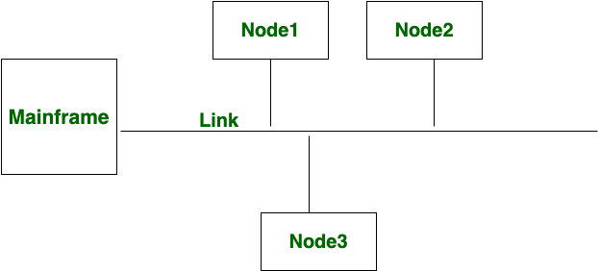 [11]
Figure 2: Diagram of a point-to-multipoint system

While point-to-multipoint systems may be more complex to design and program due to the addressing, a paper from the Oriental Journal of Computer Science & Technology [15] discussed many advantages of these systems. This includes scalability, as additional nodes can easily be added to the same channel, and saves resources compared to creating a unique channel for each slave microcontroller.

Multi-Master
Multi-master systems have a similar bus-like topology as point-to-multipoint systems, however, can feature more than one master microcontroller. A diagram of this system is shown below in Figure 3.
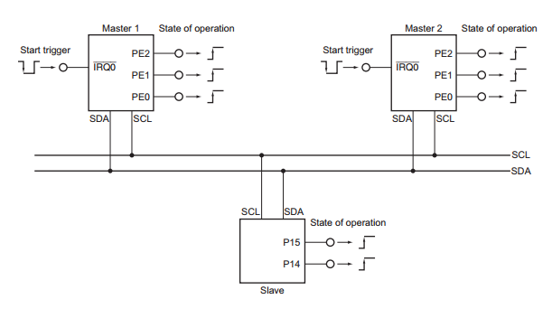 [16]
Figure 3: Diagram of multi-master system

This allows for much larger systems with more processing power [17]. However, this makes it much more complex to program, with master microcontrollers having to coordinate, as only one device can use the communication channel at a time to prevent data collisions [18].

Design

Microcontroller Choice
The PIC18F2525 was chosen as both the master and slave microcontroller. This was due to the reasonable number of I/O ports, each having 3, allowing one to be assigned for communication, one for inputs/outputs, and one port remaining for future work e.g. advanced input sensors such as photoresistors. This provides the system with flexibility while not having an excessive number of pins. The microcontroller has an internal clock of 8MHz, which will be used in later code, and supports I2C communication, as shown with the connections to the SDA and SCL pins [19]. I2C communication was chosen due to the simplicity of only needing 2 wires and ability to support multiple masters and slaves for future development [20]. Within the datasheet, it is specified to be able to sink/source 25mA on the I/O pins, which is sufficient for toggling LEDs. It pulls the I/O pins to 5V when on [19].
Below in Figure 4 is a screenshot of the microcontroller schematic symbol in Proteus. The MCLR pin is pulled high as it is active-low to reset the device [19].
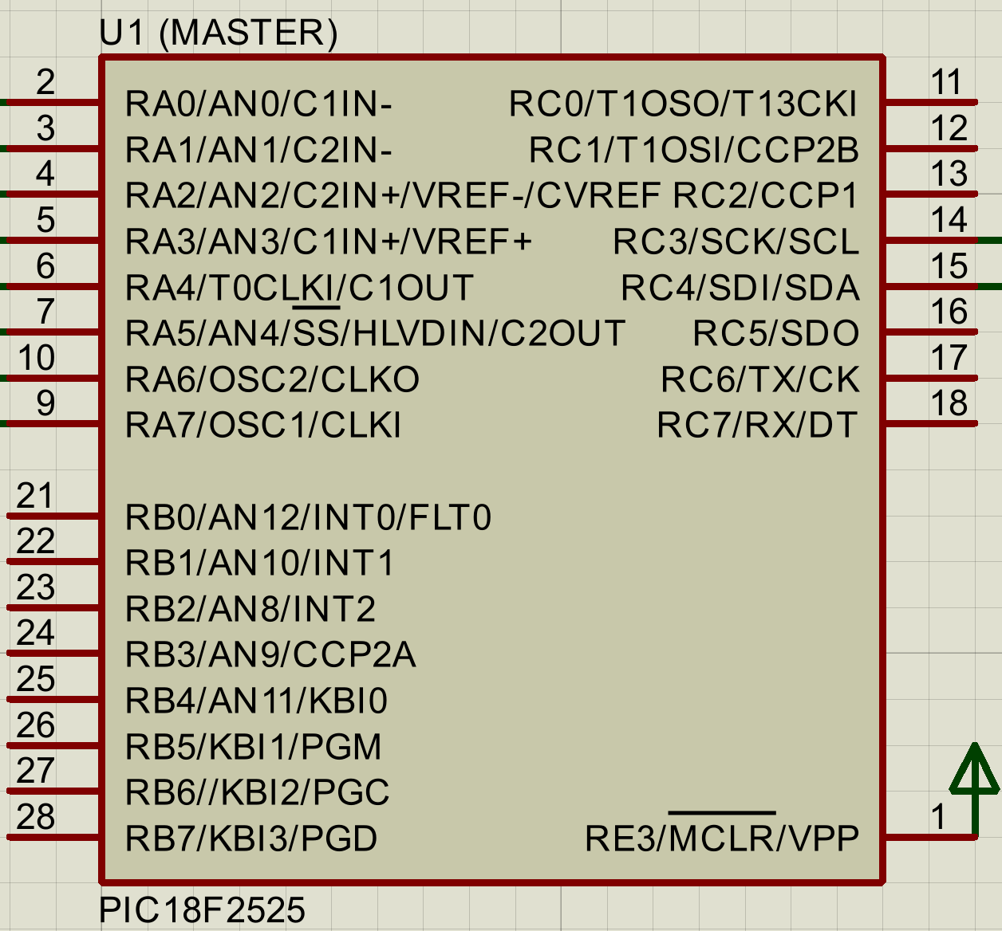
Figure 4: PIC18F2525 Proteus schematic symbol

Output Design

555 Timer
To have regular periodic flashing of the indicator light, while being toggled by a switch, the output pin of the PIC was connected to a MOSFET which controls the power to a 555 timer, turning it’s output on and off. The indicator LED was then connected to the output pin. The timer is in an astable configuration, which toggles on and off based on the charge of the RC circuit, shown in an image from a report by Texas Instruments in Figure 5.
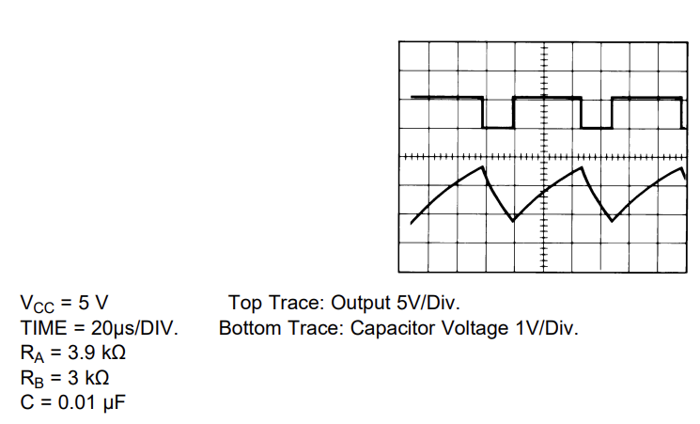 [21]
Figure 5: Diagram of 555 astable timing

From this same datasheet, the values of the resistors and capacitors were calculated using the formula shown in Equation 1 below [21].

Equation 1: Formula for calculating frequency of a 555 timer
$$f= \frac{1}{T}= \frac{1.44}{\left(R_{1}+2R_{2}\right)C_{2}}$$

The values were calculated as follows, based on a frequency of 1.5Hz, taken from the gov.uk MOT requirements for UK cars, requiring the indicators to flash between 60-120 times per minute [22]. The resistors were chosen to be a value from the standard E-24 series, to make it easier to build with common values.
R1 = 18kΩ
R2 = 470kΩ
C1 = 0.01uF (pre-set value for trigger)
C2 = 1uFΩ
Final frequency = 1.503Hz
The timer set up in Proteus is shown below in Figure 6, with the reset pin pulled high (active-low pin) to prevent the timer from resetting.
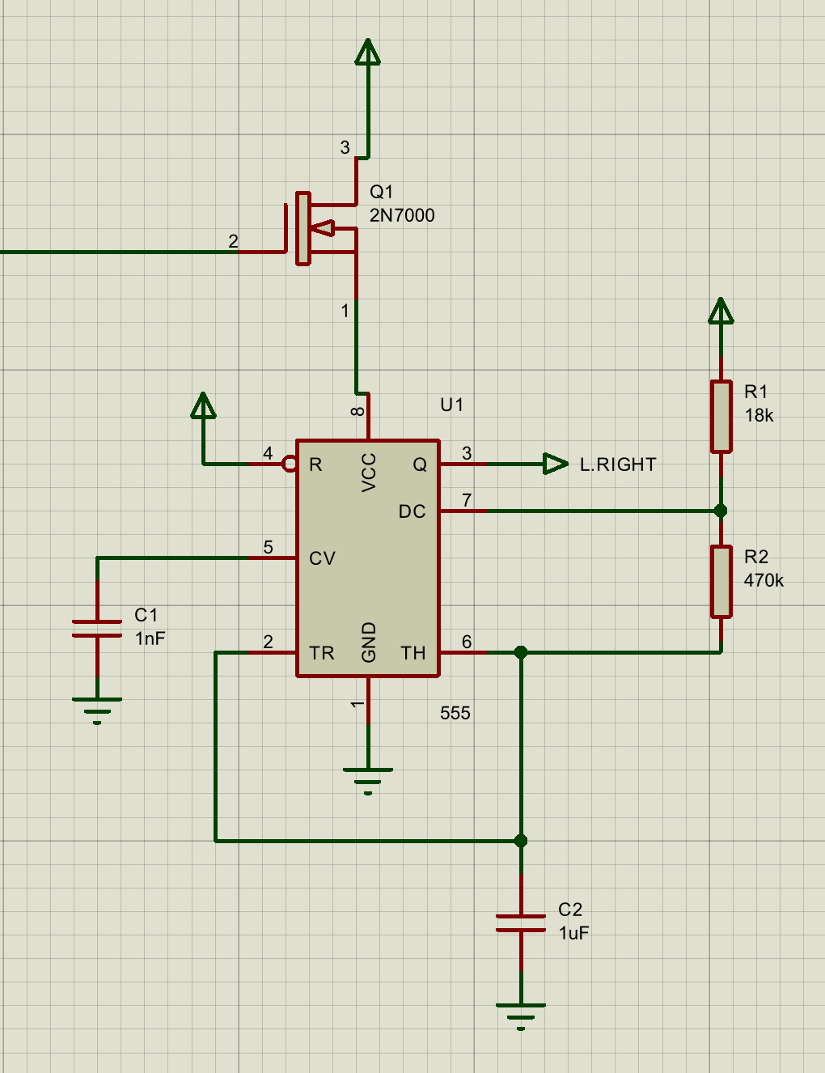
Figure 6: 555 timer Proteus schematic

LED outputs
To simulate the rear lights of a car, the official documentation from Hella, who are lead manufacturers of automotive lighting, was referred to.
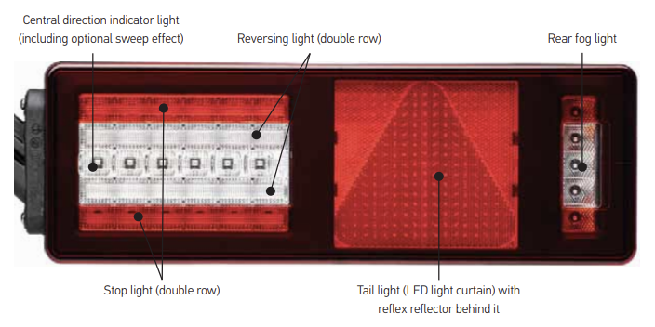 [23]
Figure 7: Diagram of rear lights on a car
From this, a standard diagram of rear lights was found (shown in Figure 7 above), which the LED outputs in the simulation were based off. The final LEDs used are shown in table 1 below.
Table 1: Table of lights for the rear of a car
LED | Color
Tail light | Red
Reverse light | White
Indicator | Yellow
Brake/Stop light | Red
Rear fog light | Red

The final simulation set up also included some current limiting resistors (R15-18), their values were calculated using standard voltage drops of red and white LEDs (as yellow is connected to the 555 timer). The white LED has a typical voltage drop of 3V, and the red 1.8V [24]. The calculations for series resistors were done using a standard forward current of 20mA [25]. Using the formula in equation 2 below [24], the red LED was calculated to need a 160Ω resistor, and the white one needing 100Ω.

Equation 2: Formula to calculate the value of a current limiting resistor
$$R=\frac{V_{s}{-V}_{led}}{I_{led}}$$

Five pull-down resistors were also added to the output pins of the microcontroller, seen in Figure 8. Similarly to the input resistors, these prevent floating voltages on these pins, which is good practice. This also ensures the pins toggle to set values and a more in-depth analysis of this can be found in a report from Elizabethtown College [26].
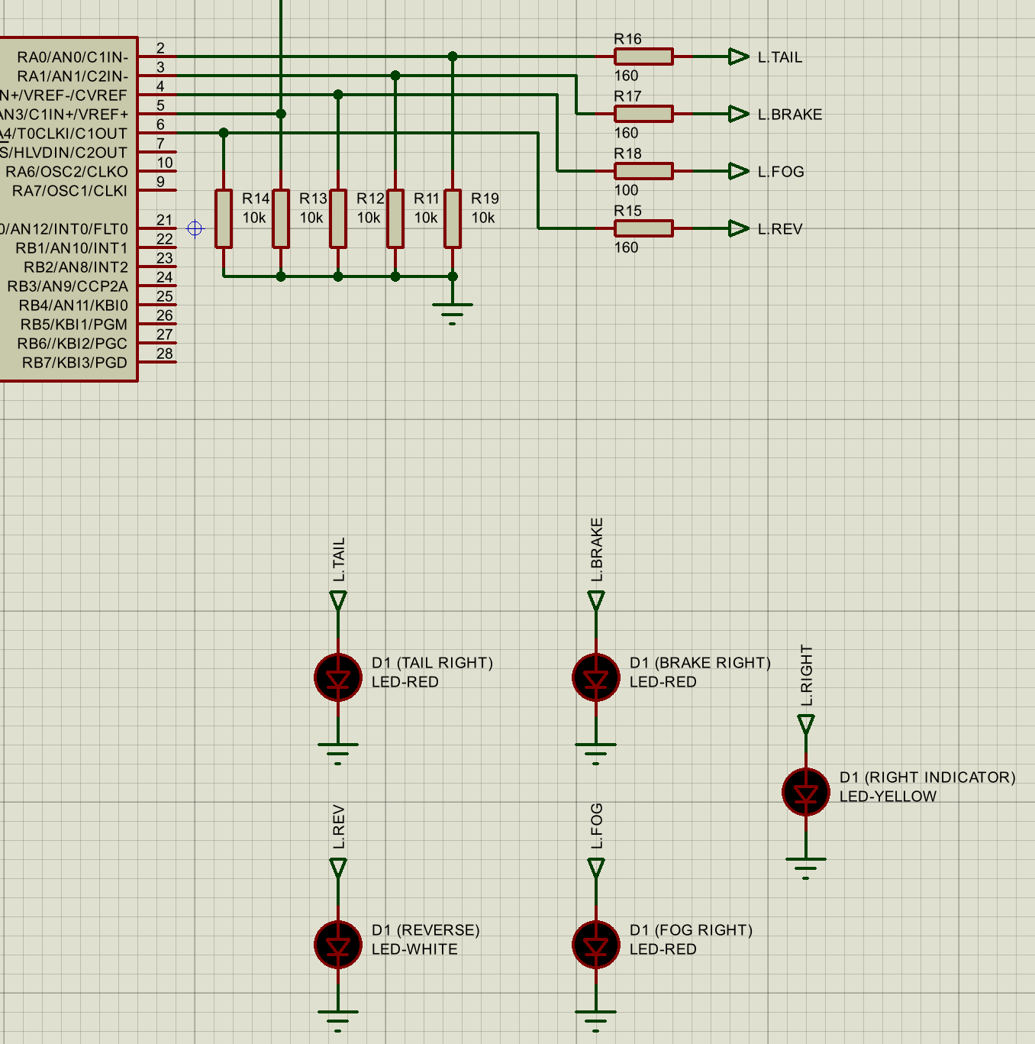
Figure 8: LED connections on Proteus schematic

Input Design
For the inputs, I considered the typical inputs that would impact the rear lights of a car. These identified, and a rough diagram created to analyze this, shown in Figure 9 below.
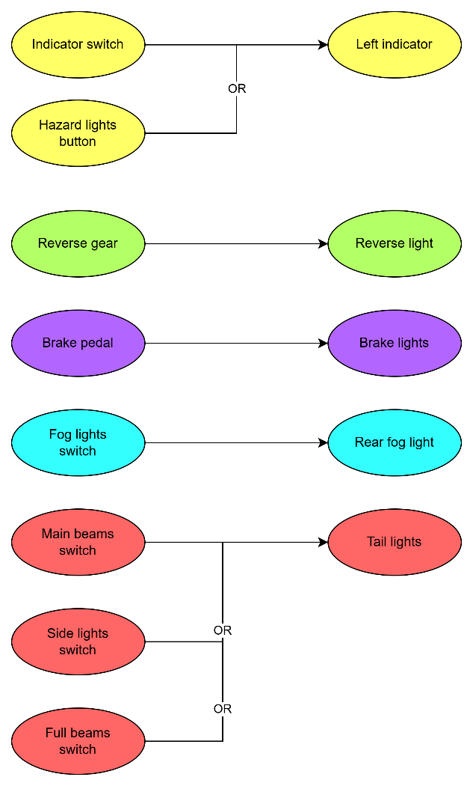
Figure 9: Input/Output diagram

Using this diagram as reference, each input was assigned a user-controlled button or switch in Proteus, depending on which best represented the device on a real car. Each of these was connected to a pin on port A of the master microcontroller, with a pull-down resistor for the same reasons as discussed for the outputs. This means when a switch or button is pressed, the relevant pin will be pulled high on the microcontroller, shown below in Figure 10.
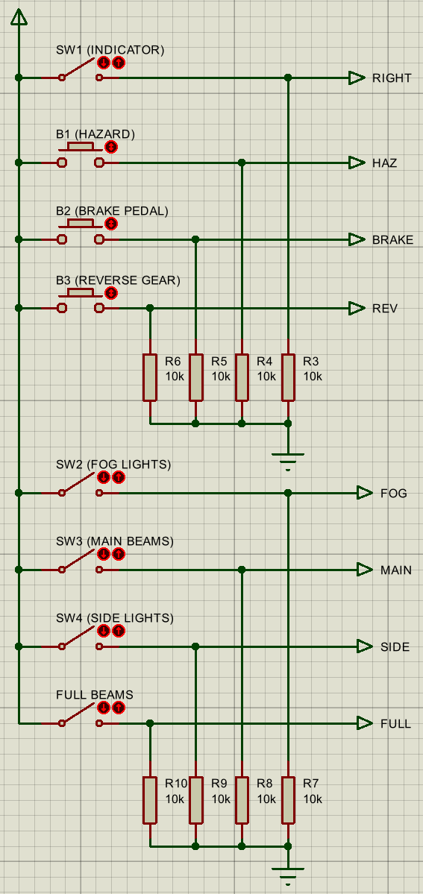
Figure 10: Input connections on Proteus schematic

Connections
On the following page, Figure 11 presents the entire Proteus schematic. This shows the connections between the master and slave microcontroller, with an I2C debugger added to view what data is being sent.
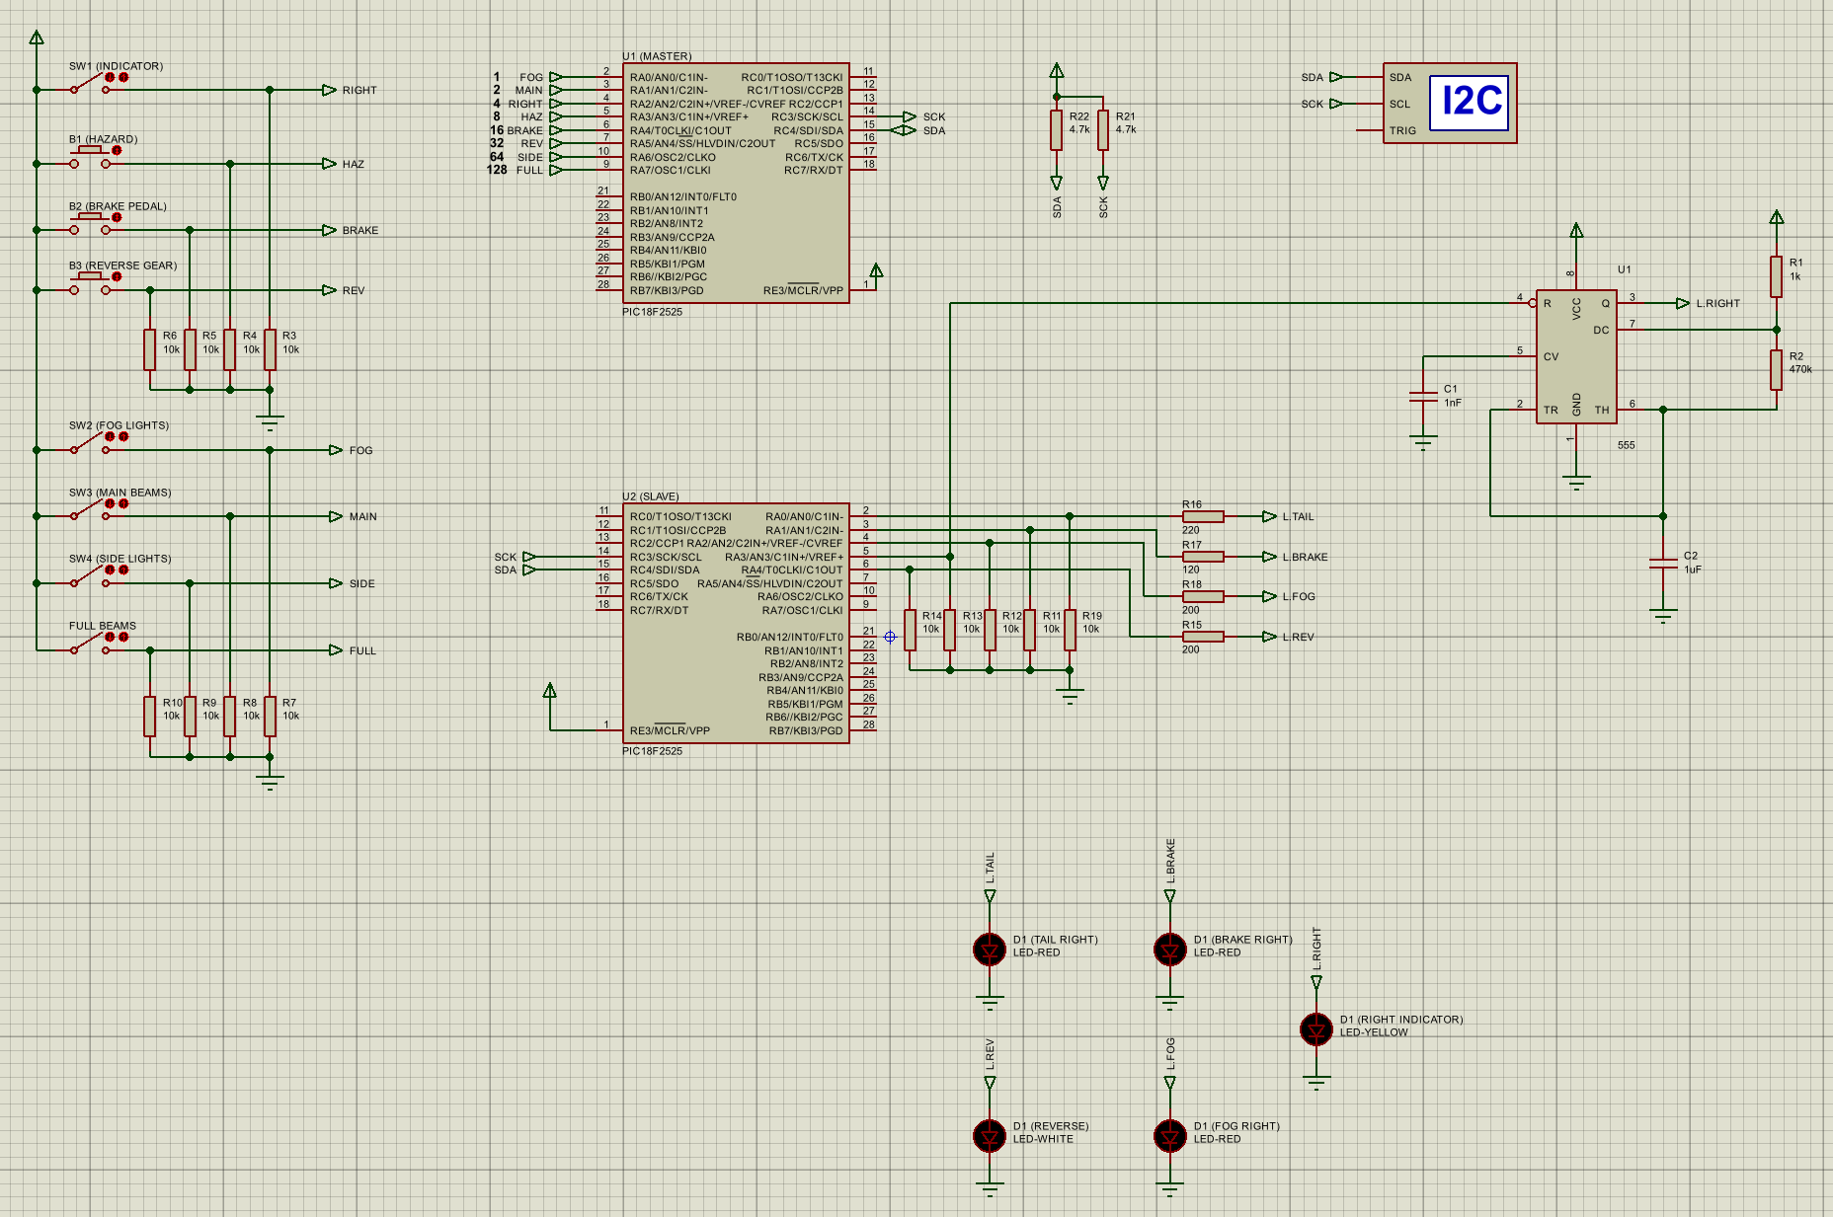
Figure 11: Full Proteus schematic

Development

Flow Chart
A flow chart for the master and slave programs was created to then logically translate to code, this is shown below in Figure 12.
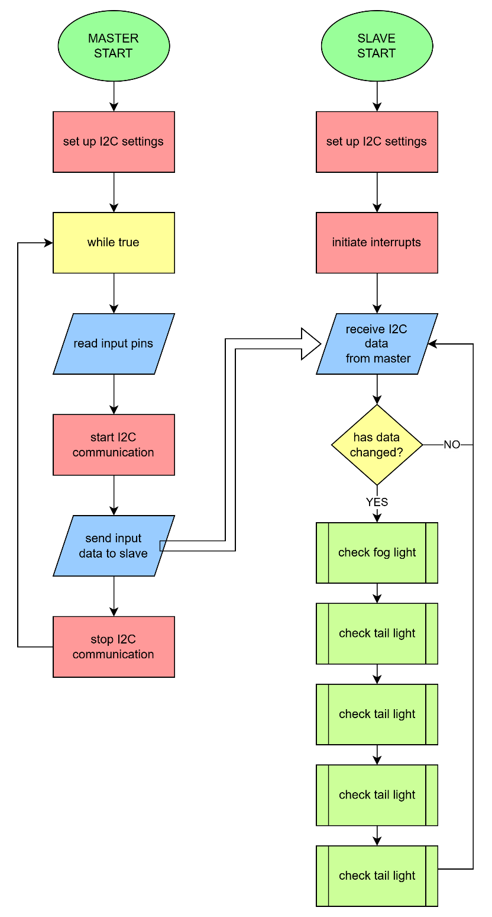
Figure 12: Programming flow chart

Code Design
With this program logic, it may be less efficient than simply connecting the inputs to the outputs or exactly outputting the data received to the LEDs. However the future potential of this system beyond the assignment brief was considered, and this method is much more adaptable. Each of the inputs is identified by the slave microcontroller and assigned an output pin to affect. In the future, if more LEDs or functionality are added, it will be much easier to change outputs by editing the coded functions than changing the physical hardware.

Master Code
Figure 13 below shows all the code for the master microcontroller. It starts by initiating the microcontroller settings, such as the fuses, 8MHz clock, and setting the I2C communication pins, also specifying that it is a master. The program sets the port A pins that the switches and buttons are connected to, to be inputs, and reads their value every 50ms to send to the slave microcontroller. This full code can also be found in Appendix A.
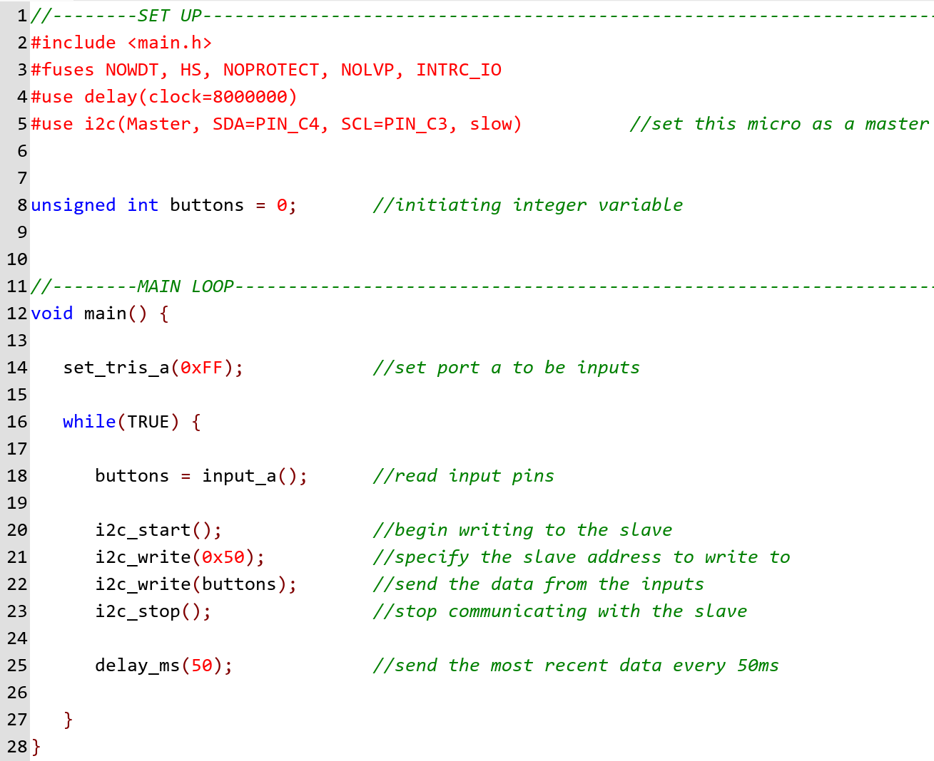
Figure 13: Master microcontroller code

Slave Code

Set-up
Below in Figure 14 the initial set up is shown, which is very similar to the master code, but assigning it as a slave, and initiating the functions required for the data processing.
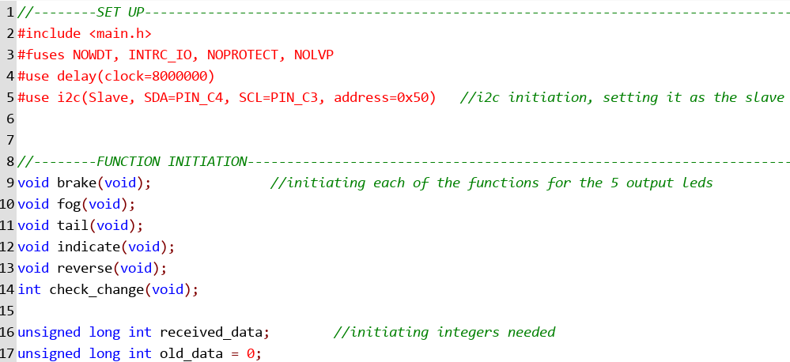
Figure 14: Slave microcontroller set-up code

Main Function
The main block of code for the slave is shown below in Figure 15. The INT_SSP interrupt will be called whenever data has been received, and it reads the I2C pins, saving it into a variable. This means that the interrupts need to be initiated in the main function, as well as assigning the port A pins to be outputs (pins are connected to the LEDs). Every 50ms, it checks if the data has changed, and if so, runs functions for each output light to see what should be turned on/off.
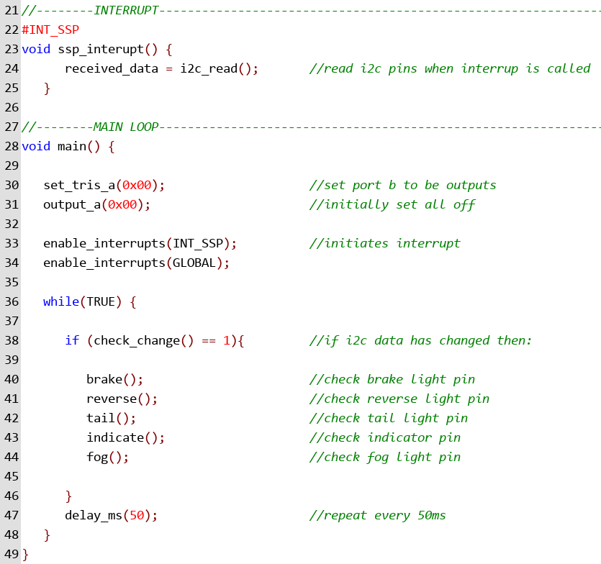
Figure 15: Slave microcontroller main code

The check_change function below was written to compare the value of the read I2C data with the last known data and will return a value to check if any of the lights need to be updated.
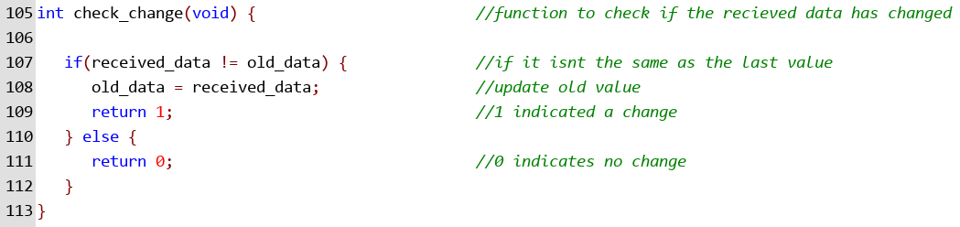
Figure 16: Slave microcontroller data changing code

Data Processing and Output
Having functions assigned for each output makes the code more efficient and organized, also making it easier to debug. The functions for the brake, fog, and reverse light are simple, only being changed by a single input. Using the I2C debugger, the bit that each input changes was identified, and was saved as the bit position. An AND operation was performed with this position and the latest read data from the master to identify if that light should be changed. With the indicator and tail-light, this had to be combined with an OR function, which checks each possible input that will turn the light on and only turns the light off if none of them are on. A few examples are shown below in Figure 17, the full code can be found in Appendix B.
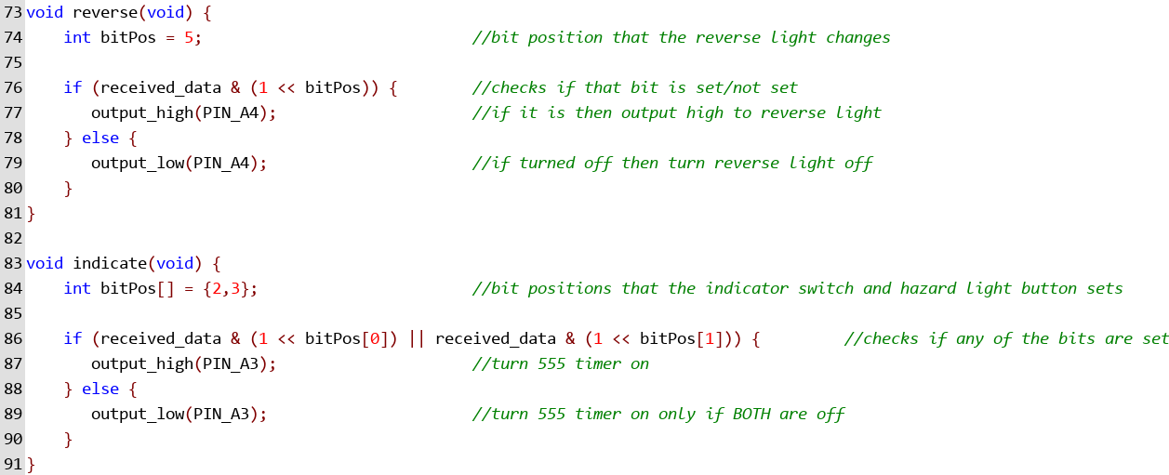
Figure 17: Slave microcontroller output functions code

Analysis

Operational Block Diagram
The system works as outlined in the diagram seen below in Figure 18.
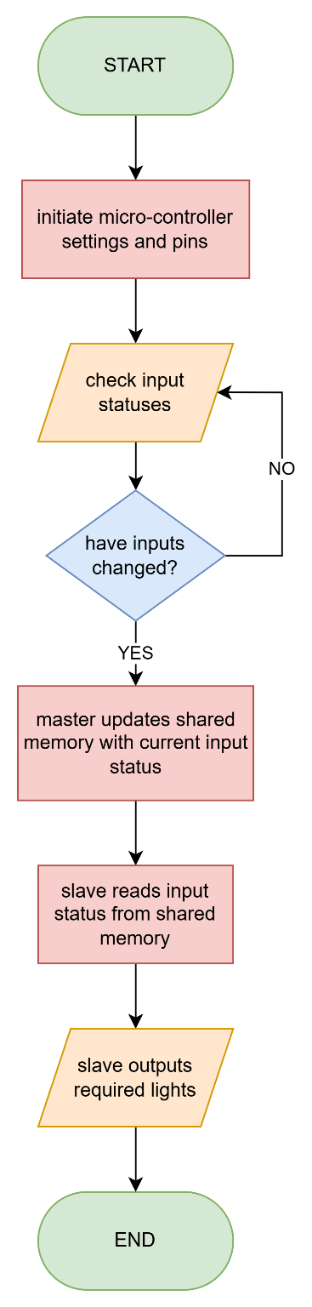
Figure 18: System operation flow chart

Test Plan
The test plan to verify the operation of the simulation was created and can be seen below in Table 2. This involves testing each input individually, having all the inputs on and off, and a series of combinations to test how the different inputs interact.
Table 2: Test plan
Test Number | Description | Expected result
1 | Indicator on only | Indicator flashes
2 | Hazard on only | Indicator flashes
3 | Brake pedal on only | Brake light on
4 | Reverse gear on only | Reverse light on
5 | Fog light on only | Fog light on
6 | Main beams on only | Tail light on
7 | Side lights on only | Tail light on
8 | Full beams on only | Tail light on
9 | Everything off | No lights on
10 | Everything on | All lights on
11 | Indicator and full beam on | Indicator flashes, tail light on
12 | Brake pedal and fog light on | Brake and fog light on
13 | Side light and reverse gear on | Reverse and tail light on
14 | Indicator and hazard on | Indicator flashes
15 | Main beam and side light on | Tail light on

Simulation Results
The results from the test plan is shown in Table 3 below, including a screenshot of the Proteus schematic to evidence the inputs and outputs of each test.

Table 3: Test results
Test Number | Screenshot | Result | Pass/ fail
1 | 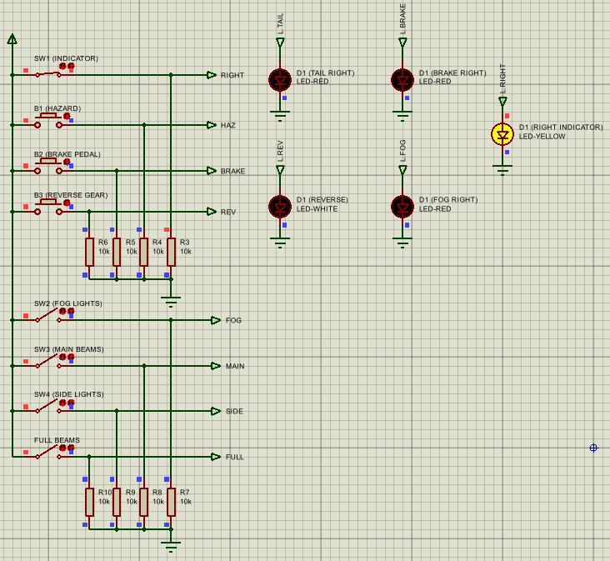 | Indicator flashes | Pass
2 | 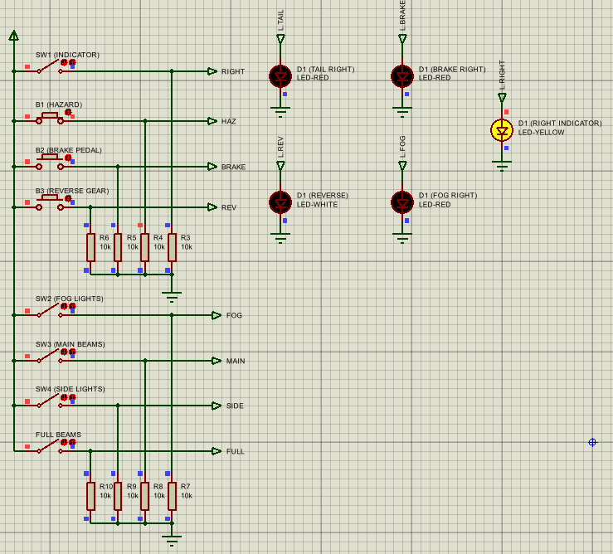 | Indicator flashes | Pass
3 | 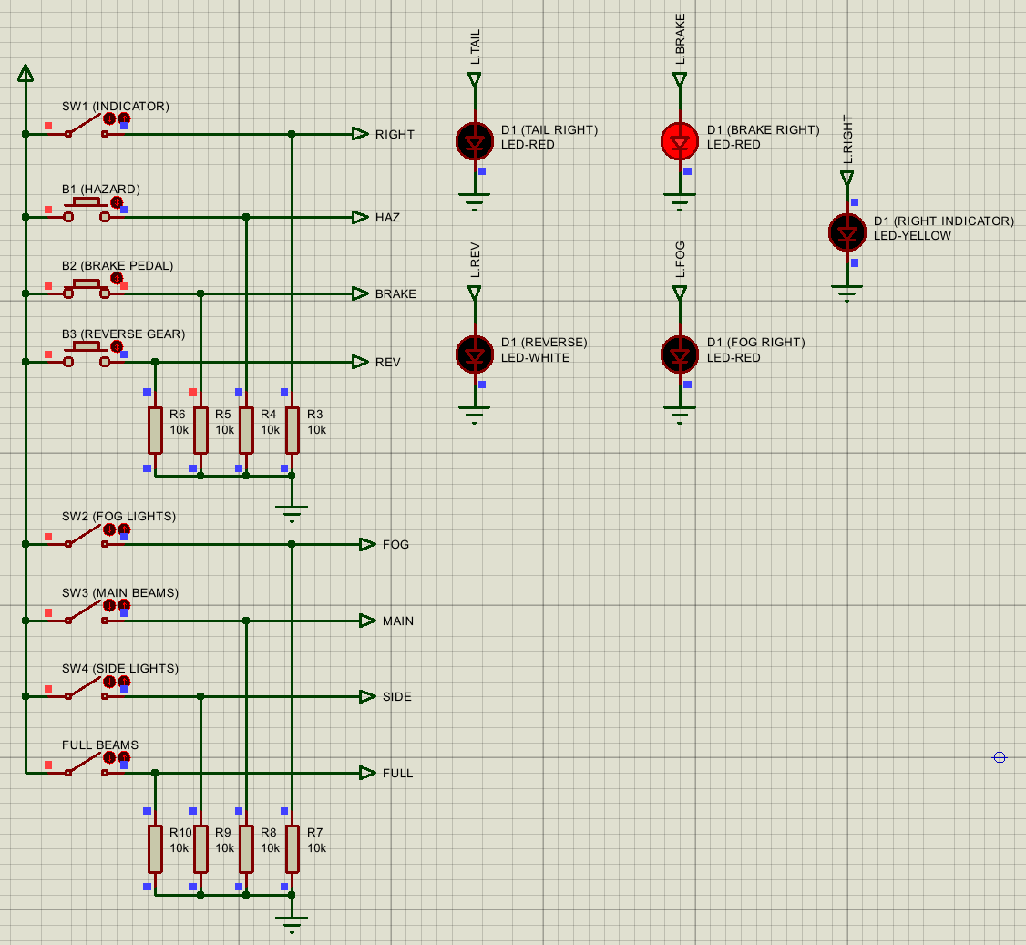 | Brake light on | Pass
4 | 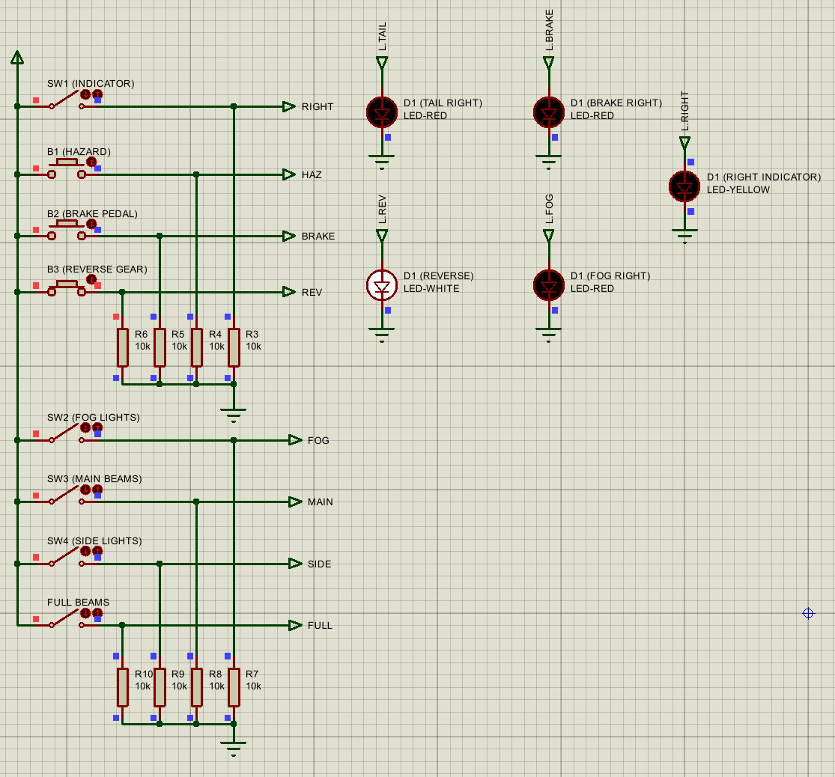 | Reverse light on | Pass
5 | 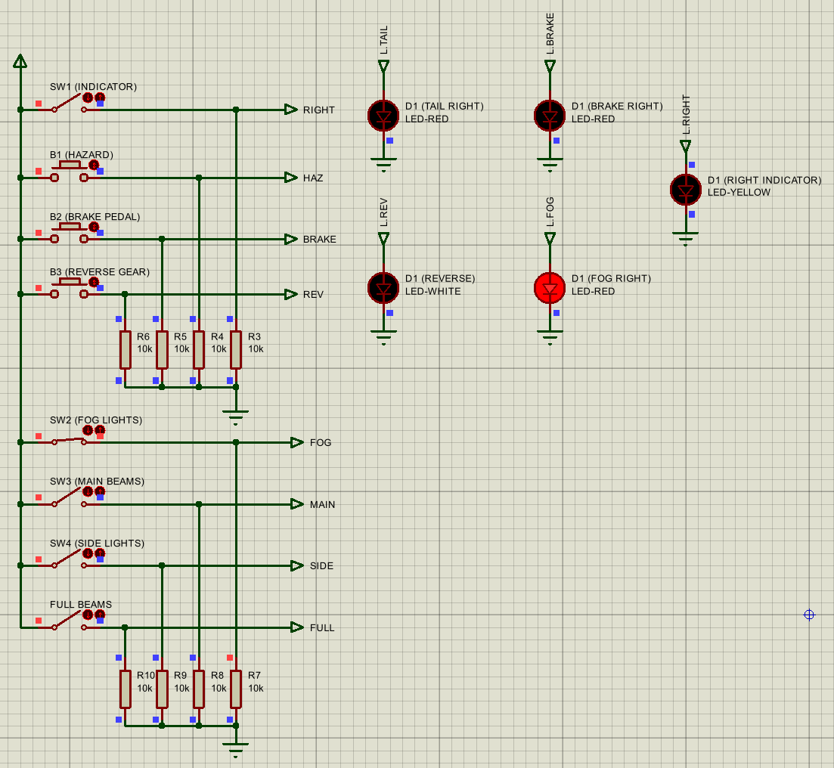 | Fog light on | Pass
6 | 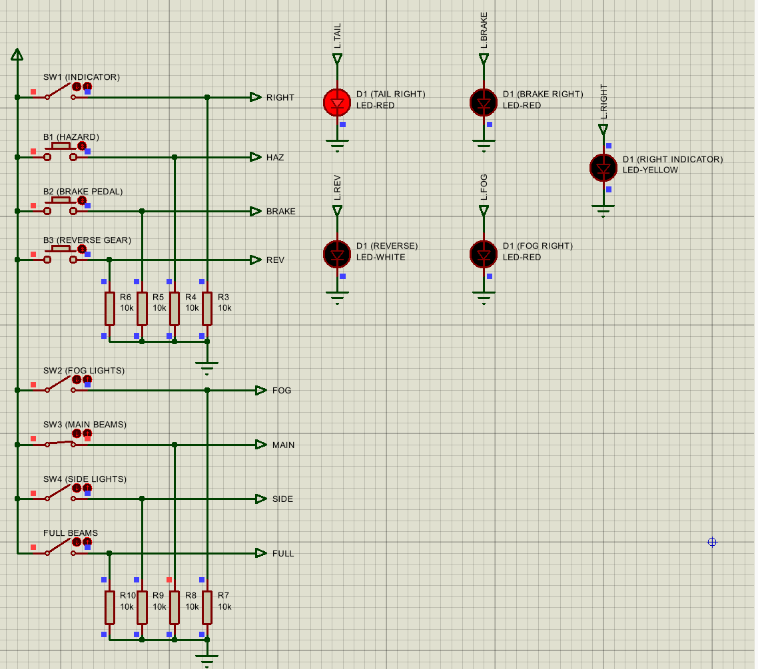 | Tail light on | Pass
7 | 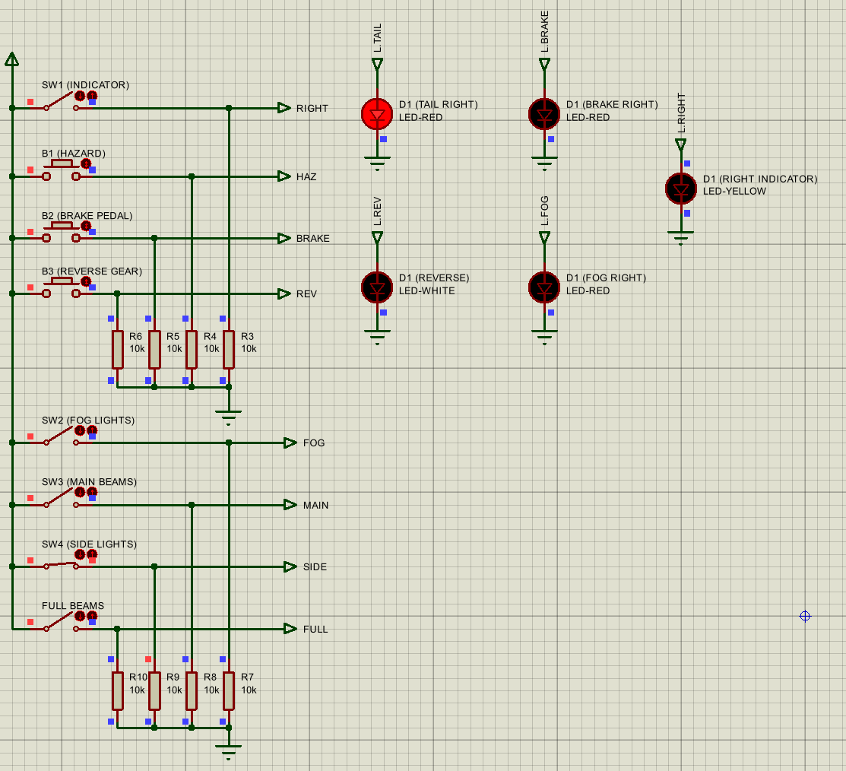 | Tail light on | Pass
8 | 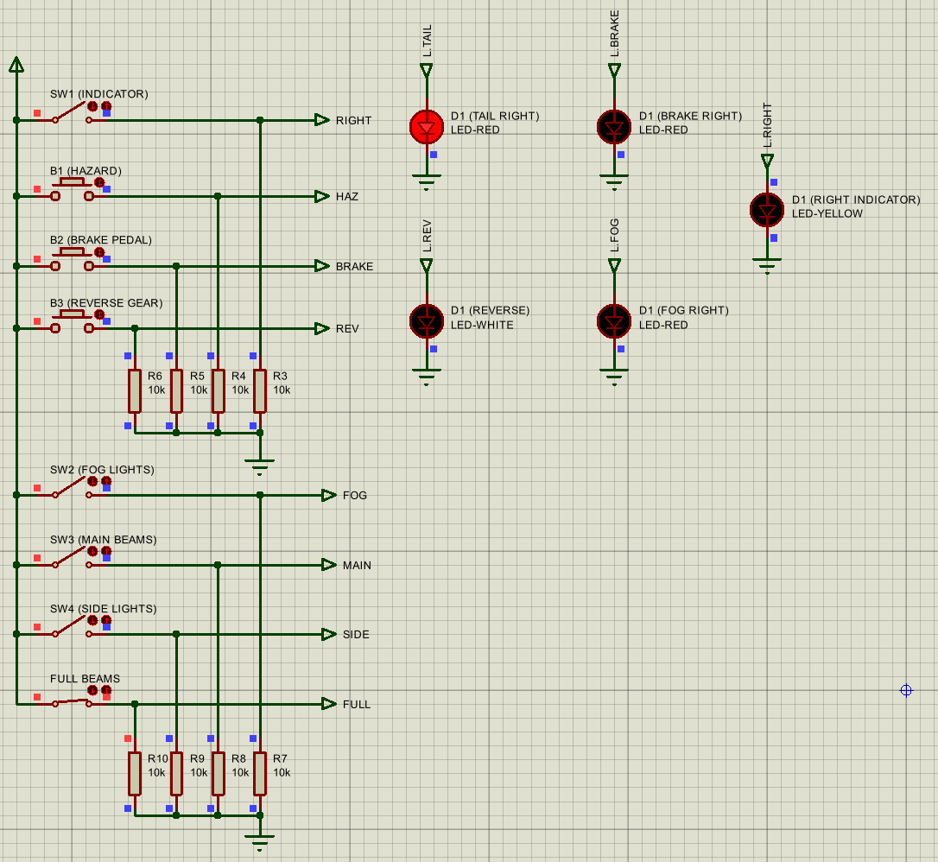 | Tail light on | Pass
9 | 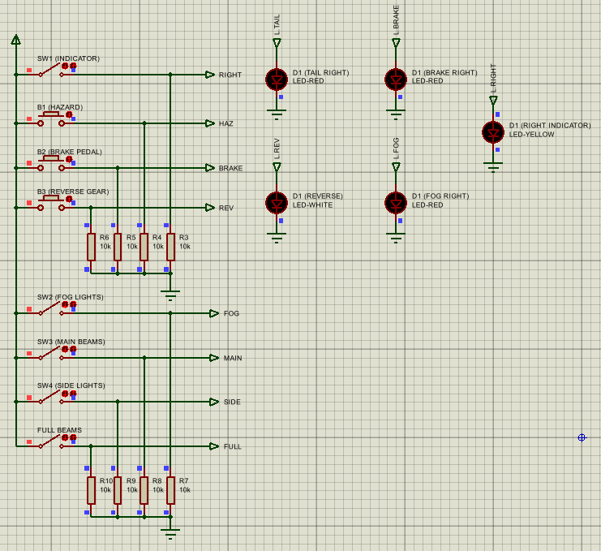 | No lights on | Pass
10 | 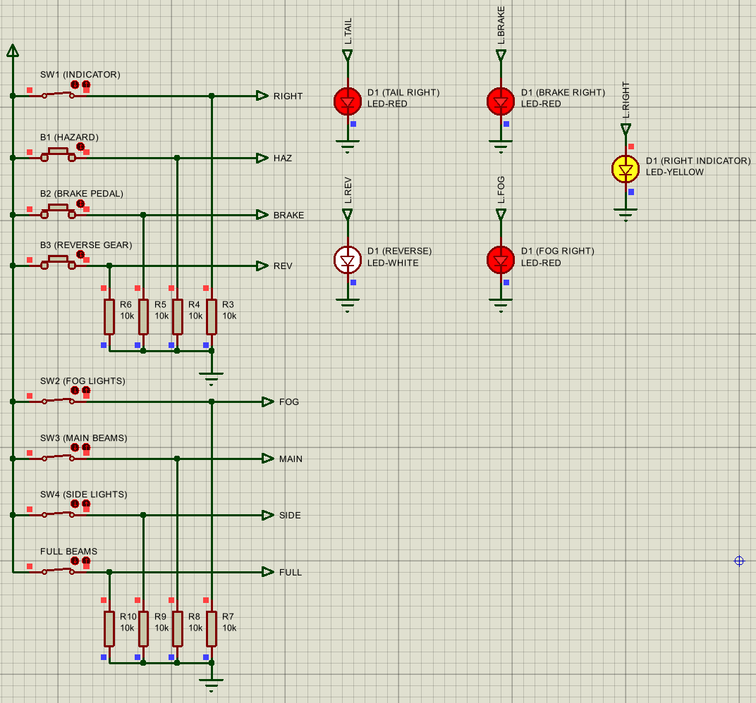 | All lights on | Pass
11 | 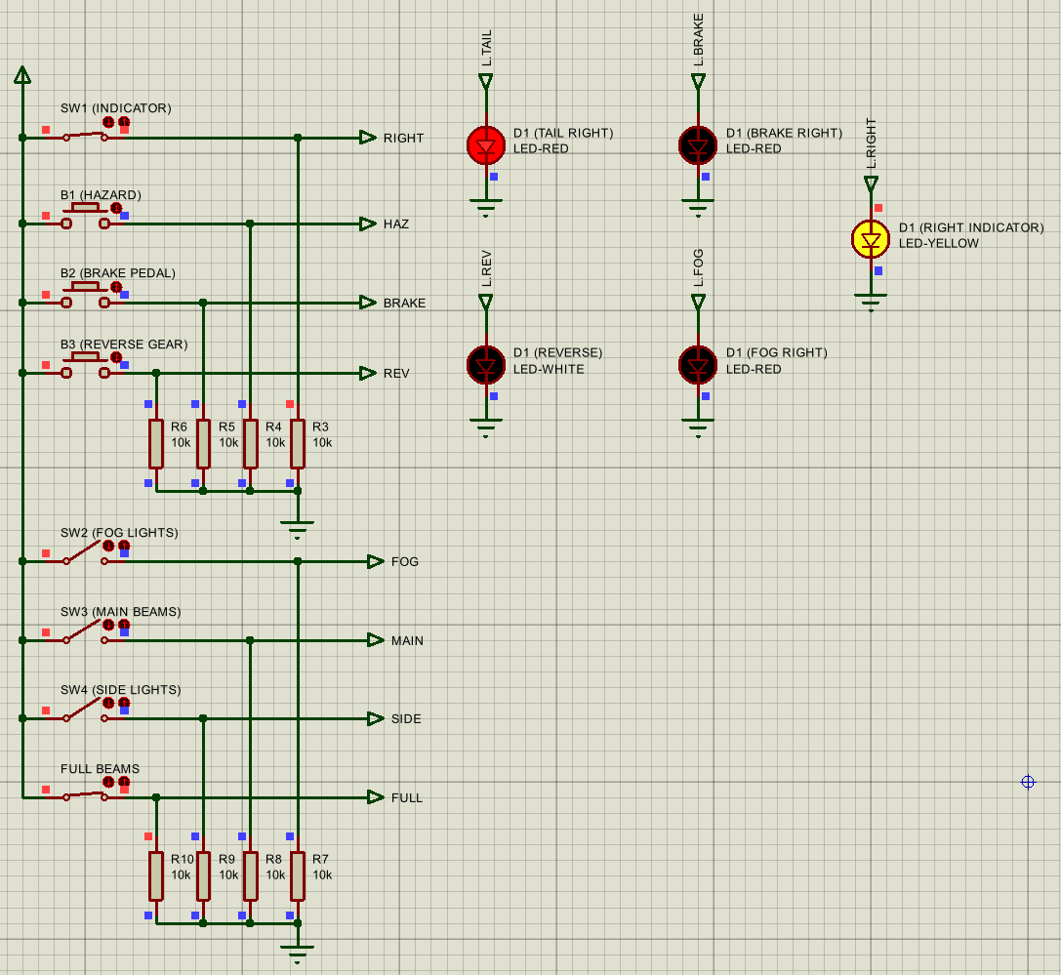 | Indicator flashes, tail light on | Pass
12 | 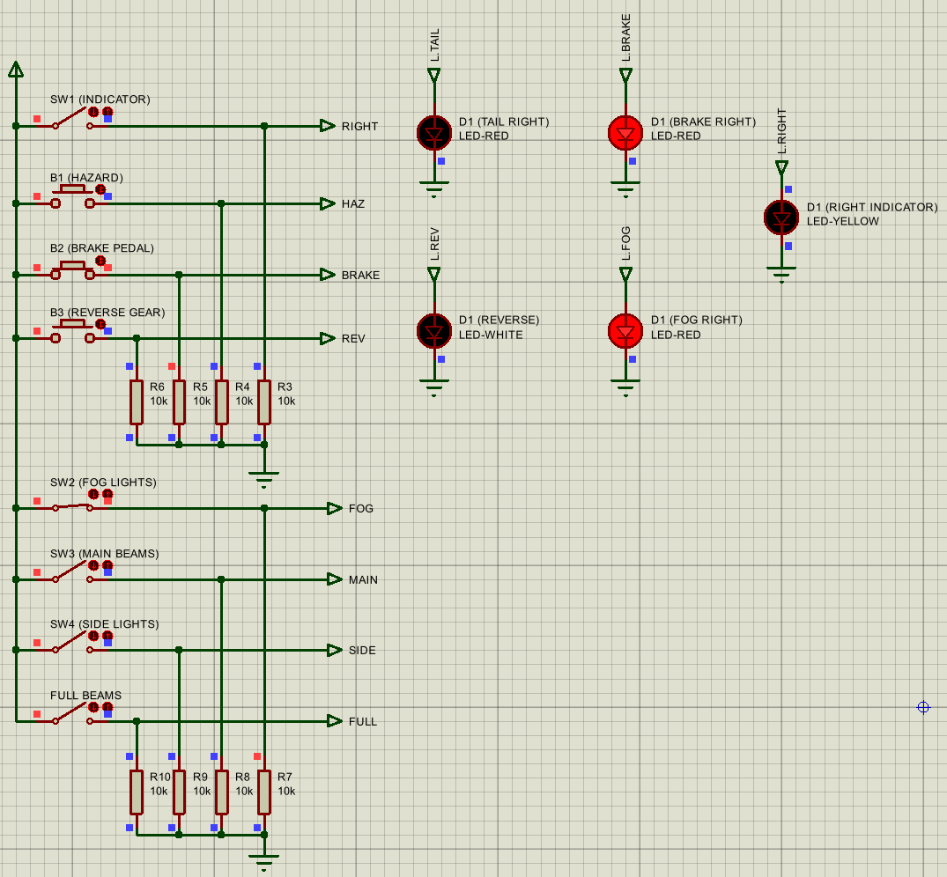 | Brake and fog light on | Pass
13 | 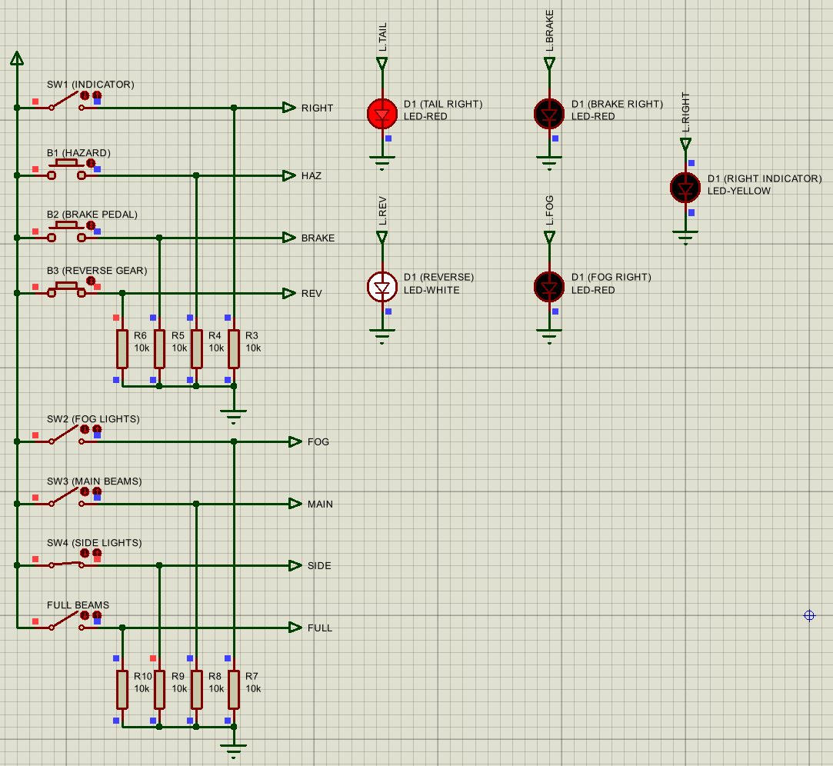 | Reverse and tail light on | Pass
14 | 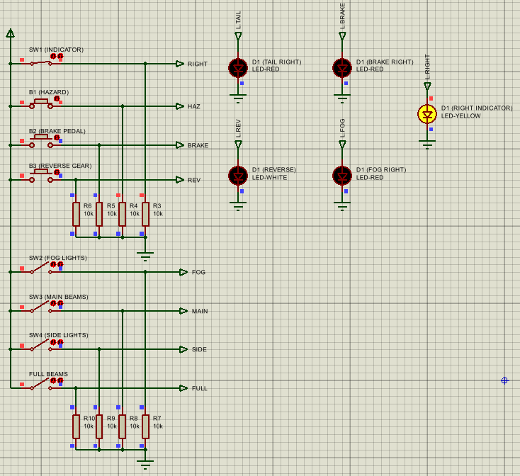 | Indicator flashes | Pass
15 | 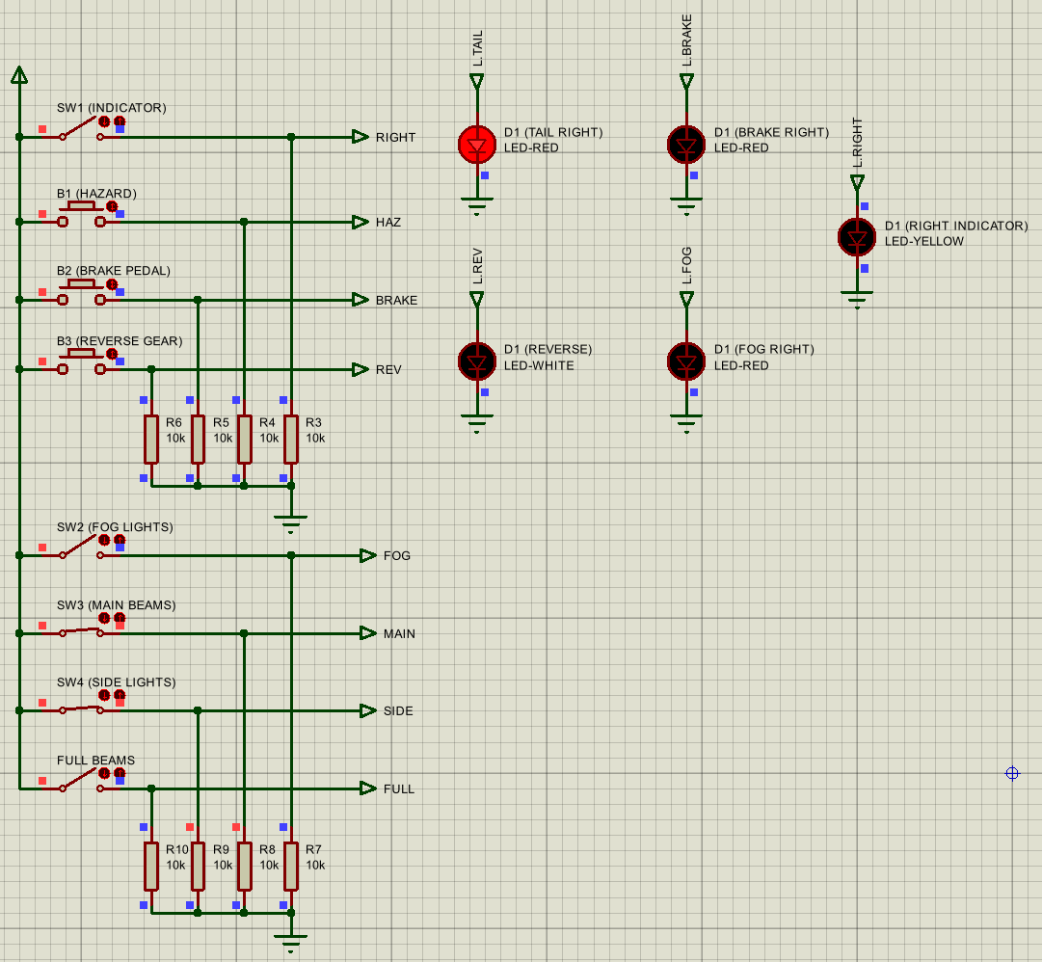 | Tail light on | Pass

Evaluation

Test Success
As seen from the results above, the simulation met all specified requirements and provided the expected results for each test. This indicates that it is a reasonable representation of the rear lights of a car, and comparisons can be made to real-world systems. The simulation also conformed to the previously mentioned required frequency for indicators as specified by the UK government [22].

Comparison to Existing Research
The importance of QMS systems can be seen in the testing of this simulation. Clear requirements were set out, and documentation for each test recorded. As a result, one can be confident in the validity and reliability of the results [2]. Applied to a real-world situation, this is even more important, as lights on a car are a critical indicator of other drivers, directly impacting driver safety. By having good QMS such as this, consumers can be assured that their vehicle meets required safety standards and that it has passed all required tests [1].
Additionally, these tests support the studies looking at the efficiency of point-to-point systems [12]. Although addressing was still used in the code to add extra slave microcontrollers in the future, the code was simple and easy to implement, as it can be guaranteed that there is only one other device on the channel. By providing the address of the slave microcontroller, the potential addition of devices would be a simple process, using the same I2C bus. This further supports the studies suggesting that point-to-multipoint systems can more easily be expanded than point-to-point systems [15].

Conclusion
Overall, this paper has produced promising results and looked at existing studies regarding quality management systems and transmission systems. The simulation has been thoroughly verified and the tests all passed successfully, making it an effective proof-of-concept as to how distributed intelligence systems can be applied to the automotive industry, while having a lot of potential for future development.

Recommendations on Future Work
This paper has had several limitations. For one, the simulation assumes ideal components and only represents a partial section of a full vehicle, so it cannot guarantee that the existing set-up will be able to support a more advanced system.
To test real-world efficiency and operation from this simulation, a physical prototype could be created. This gives a much more realistic view of the success of the design, as the components will not be ‘ideal’ and parasitics will have to be considered.
One key development of this project would be to expand the distributed intelligence system. By adding additional slave microcontrollers, it would be possible to integrate more of the car’s lights, including the front lights, making it more representative of an entire car. Similarly, an extra slave added could be receiving sensor data, such as a light levels, and send data to the master which can turn the headlights on automatically. This feature is already present in many current cars [27], and will allow for further testing into system efficiency using the simulation.
There are several papers expanding on the topics discussed, they look at automation of headlights and intelligent lighting on cars [28] [29].

References

[1] | S. Hamid and a. et., “Quality Management Evolution from the Past to Present: Challenges for Tomorrow,” Organizacija, vol. 52, no. 3, pp. 157-186, 2019.
[2] | D. Natarajan, ISO 9001 Quality Management Systems, Cham: Springer Cham, 2017.
[3] | B. Maljugic and a. et., “The Role of the Quality Management Process within Society 5.0,” Societies, vol. 14, no. 7, p. 111, 2024.
[4] | Z. K. Muiruri, “Quality Management Systems and Organizational Performance: A Theoretical Review in Kenya’s Public Sector Organizations,” Science Journal of Business and Management , vol. 4, no. 5, pp. 150-155, 2016.
[5] | UK Car Discount, “The Essential Guide for New Car Buyers Ensuring New Car Safety with UK Car Discount,” UKCD, 24 03 2024. [Online]. Available: https://www.uk-car-discount.co.uk/news/the-importance-of-vehicle-safety-features. [Accessed 03 12 2025].
[6] | S. H. Jung, “A Study on the Integration of Quality Management and Product Safety Management System based on International Standards,” Journal of Society of Korea Industrial and Systems Engineering, vol. 44, no. 2, pp. 124-131, 2021.
[7] | A. v. Ahsen, “The Integration of Quality, Environmental and Health and Safety Management by Car Manufacturers – a Long-Term Empirical Study,” Business Strategy and the Environment, vol. 23, no. 6, pp. 395-416, 2013.
[8] | “Tools and methods used by the Polish leading automotie commpanies in quality management system. Results of empirical research,” Journal of Achievements in Materials and Manufacturing Engineering, vol. 63, no. 1, pp. 30-37, 2014.
[9] | F. d. Oliveira Neves, “Analysis of the quality management system for automotive industry- ISO/TS 16949 in the world,” Total Quality Management & Business Excellence, vol. 32, no. 1, pp. 153-176, 2021.
[10] | M. Gallo and W. M. Hancock, Networking Explained, Woburn: Butterworth-Heinemann, 2002.
[11] | GeeksforGeeks, “Differences between Point-to-Point and Multi-point Communication,” Geeks for Geeks, 11 07 2025. [Online]. Available: https://www.geeksforgeeks.org/computer-networks/differences-between-point-to-point-and-multi-point-communication. [Accessed 03 12 2025].
[12] | K. Manjula and S. M. Sundaram, “A Review of Various Approaches for the Coordination Among Nodes in Distributed Systems,” NCICCNDA, vol. 5, no. 22, 2017.
[13] | M. L. Gambo, “A Systematic Literature Review of DDS Middleware in Robotic Systems,” Robotics, vol. 14, no. 5, pp. 63-75, 2025.
[14] | M. Ding and L. Hanwen , Multi-point Cooperative Communication Systems: Theory and Applications, Cham: Springer, 2013.
[15] | K. R. Krishnaiah, “Wireless Mesh Networks - Reliability and Flexibility,” Oriental Journal of Computer Science & Technology, vol. 2, no. 1, pp. 23-29, 2009.
[16] | hariudkmr, “How does multimaster I2C work and its significance?,” Electrical engineering Stack Exchange, 2014.
[17] | H. Saluja and N. Grover, “Multiple Master Communication in AHB IP using Arbiter,” International Journal of Engineering and Manufacturing, vol. 20, no. 1, pp. 29-40, 2020.
[18] | T. Noergaard, Embedded Systems Architecture, Oxford: Newnes, 2012.
[19] | Microchip, “PIC18F2525/2620/4525/4620 Data Sheet,” 2009. [Online]. Available: https://docs.rs-online.com/0d3e/0900766b81383178.pdf. [Accessed 02 12 2025].
[20] | S. Heath, Embedded Systems Design, Oxford: Newnes, 2003.
[21] | Texas Instruments, “LM555 Timer Datasheet,” Texas Instruments Incorporated, Dallas, 2015.
[22] | D. a. V. S. Agency, “MOT inspection manual: cars and passenger vehicles,” 13 11 2025. [Online]. Available: https://www.gov.uk/guidance/mot-inspection-manual-for-private-passenger-and-light-commercial-vehicles/4-lamps-reflectors-and-electrical-equipment#section-4-4-4. [Accessed 02 12 2025].
[23] | Hella, “Rear and Single-Fuction Lamps,” Hella Limited, Banbury, 2022.
[24] | K. D. Edwards, “Light Emitting Diodes,” University of California, Irvine, 2005.
[25] | Electronics Tutorials, “The Light Emitting Diode,” Electronics Tutorials, 17 03 2014. [Online]. Available: https://www.electronics-tutorials.ws/diode/diode_8.html. [Accessed 02 12 2025].
[26] | J. Wunderlich, “Floating Inputs and Resistors for Pull-up Pull-down and Current Limiting,” 2020. [Online]. Available: https://users.etown.edu/w/wunderjt/333_RESISTORS.pdf. [Accessed 02 12 2025].
[27] | C. Krome, “10 Cars with Adaptive Headlights,” autoweb, 08 06 2016. [Online]. Available: https://www.autoweb.com/10-cars-with-adaptive-headlights. [Accessed 04 12 2025].
[28] | W. Neale and D. Hessel, “Simulating Headlamp Illumination Using Photometric Light Clusters,” SAE International, Washington, 2009.
[29] | D. Heitbrink, C. Schwarz and W. Wang, “SIMULATION OF AUTOMOTIVE HEADLIGHTS FOR HUMAN FACTORS RESEARCH,” in IMAGE, Dayton, 2017.
[30] | E. F. Schubert, Light-Emitting Diodes, Cambridge: Cambride University Press, 2003.

Appendices

Appendix A – Full Master Code

//--------SET UP--------------------------------------------------------------------------------------------------------
#include <main.h>
#fuses NOWDT, HS, NOPROTECT, NOLVP, INTRC_IO
#use delay(clock=8000000)
#use i2c(Master, SDA=PIN_C4, SCL=PIN_C3, slow) //set this micro as a master

unsigned int buttons = 0; //initiating integer variable

//--------MAIN LOOP------------------------------------------------------------------------------------------------------
void main() {

set_tris_a(0xFF); //set port a to be inputs

while(TRUE) {

buttons = input_a(); //read input pins

i2c_start(); //begin writing to the slave
i2c_write(0x50); //specify the slave address to write to
i2c_write(buttons); //send the data from the inputs
i2c_stop(); //stop communicating with the slave

delay_ms(50); //send the most recent data every 50ms

}
}

Appendix B – Full Slave Code

//--------SET UP--------------------------------------------------------------------------------------------------------
#include <main.h>
#fuses NOWDT, INTRC_IO, NOPROTECT, NOLVP
#use delay(clock=8000000)
#use i2c(Slave, SDA=PIN_C4, SCL=PIN_C3, address=0x50) //i2c initiation, setting it as the slave

//--------FUNCTION INITIATION--------------------------------------------------------------------------------------------
void brake(void); //initiating each of the functions for the 5 output leds
void fog(void);
void tail(void);
void indicate(void);
void reverse(void);
int check_change(void);

unsigned long int received_data; //initiating integers needed
unsigned long int old_data = 0;

//--------INTERRUPT-------------------------------------------------------------------------------------------------------
#INT_SSP
void ssp_interupt() {
received_data = i2c_read(); //read i2c pins when interrup is called
}

//--------MAIN LOOP------------------------------------------------------------------------------------------------------
void main() {

set_tris_a(0x00); //set port b to be outputs
output_a(0x00); //initially set all off

enable_interrupts(INT_SSP); //initiates interrupt
enable_interrupts(GLOBAL);

while(TRUE) {

if (check_change() == 1){ //if i2c data has changed then:

brake(); //check brake light pin
reverse(); //check reverse light pin
tail(); //check tail light pin
indicate(); //check indicator pin
fog(); //check fog light pin

}
delay_ms(50); //repeat every 50ms
}
}

//-------MODULAR FUNCTIONS--------------------------------------------------------------------------------------------------
void brake(void) {
int bitPos = 4; //bit position that the brake light changes

if (received_data & (1 << bitPos)) { //checks if that bit is set/not set
output_high(PIN_A1); //if it is then output high to brake light
} else {
output_low(PIN_A1); //if turned off then turn brake light off
}
}

void fog(void) {
int bitPos = 0; //bit position that the fog light changes

if (received_data & (1 << bitPos)) { //checks if that bit is set/not set
output_high(PIN_A2); //if it is then output high to fog light
} else {
output_low(PIN_A2); //if turned off then turn fog light off
}
}

void reverse(void) {
int bitPos = 5; //bit position that the reverse light changes

if (received_data & (1 << bitPos)) { //checks if that bit is set/not set
output_high(PIN_A4); //if it is then output high to reverse light
} else {
output_low(PIN_A4); //if turned off then turn reverse light off
}
}

void indicate(void) {
int bitPos[] = {2,3}; //bit positions that the indicator switch and hazard light button sets

if (received_data & (1 << bitPos[0]) || received_data & (1 << bitPos[1])) { //checks if any of the bits are set
output_high(PIN_A3); //turn 555 timer on
} else {
output_low(PIN_A3); //turn 555 timer on only if BOTH are off
}
}

void tail(void) {
int bitPos[] = {1,6,7}; //bit positions that the full beams, side, or main light buttons set

if (received_data & (1 << bitPos[0]) || received_data & (1 << bitPos[1]) || received_data & (1 << bitPos[2]) ) { //checks if any of the bits are set
output_high(PIN_A0); //outputs high to tail light
} else {
output_low(PIN_A0); //outputs low to tail light only if none of the bits are set
}
}

int check_change(void) { //function to check if the recieved data has changed

if(received_data != old_data) { //if it isnt the same as the last value
old_data = received_data; //update old value
return 1; //1 indicated a change
} else {
return 0; //0 indicates no change
}
}

