Student Name Asen Genov
Student ID 1906814
University of wales Trinity Saint David
BSc cloud computing
ACCC4004
Date 08/01/2020
DFD,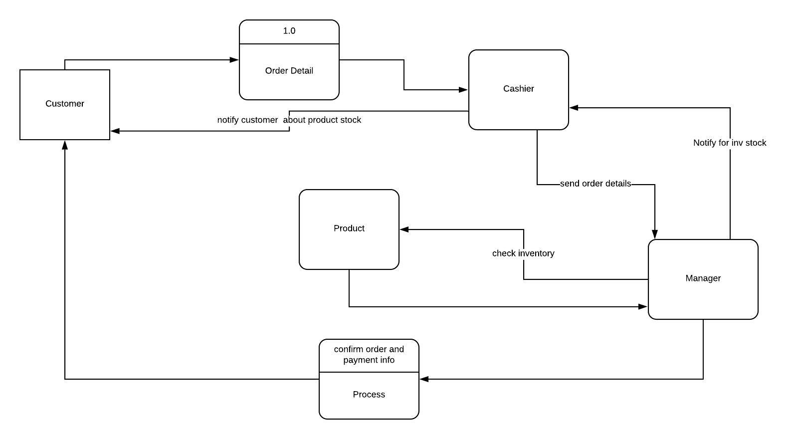ERD Diagram

