
Past Peoples, Present Societies

Documenting and Analysing Contemporary Pottery Production in Middle Egypt: A Study of the Anvil and Hammer Technique (Borah Technique) and its Technological and Social Organisation

22nd November, Wednesday, 5pm (GMT) online

A talk presented by Ahmad Mohammed, Durham University

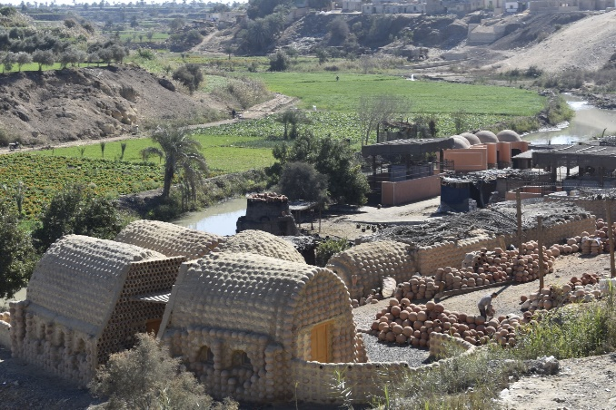

Abstract
A study of contemporary pottery workshops in Egypt, both ancient and modern, can provide valuable insights into the cultural practices and behaviours of these unique societies. However, the rapid modernization of Egypt since the post-Nasser era has led to significant changes in the pottery industry, with many potters departing from their traditional craft in favour of other occupations.

In the village of Nazlah, located in the Fayoum Oasis, potters struggle to maintain traditional techniques and methods. This study aims to document and analyse contemporary pottery production in Nazlah, with a particular focus on the anvil and hammer technique (Borah technique), which has not been widely investigated or recorded. This research also seeks to analyse the technological and social organisation of pottery production processes using ethnoarchaeology and the chaîne opératoire as research strategies.

My fieldwork in Nazlah in early 2022 allowed firsthand experience of this method and my data includes video and audio recordings, photography, and participant observation.

Tickets and links available on Eventbrite (Past Peoples, Present Societies) or through email to 1811607@student.uwtsd.ac.uk (Please use Subject: TICKETS PPPS)

