Communication – ETW 1
Student Name:MIHAELA GILCESCU
Student ID:2124585

Table of Contents
1. Introduction 3
2. Models of Communication 3
2.1 Shannon and Weaver (1948/49) 3
2.2 Schramm (1954) 4
2.3 Berlo (1964) 6
3. Communication skills 7
3.1 Verbal 7
3.2 Non-Verbal 7
3.3 Listening 8
4. Advantages and disadvantages of communication technology 9
5. Conclusion 9
References 10

1. Introduction
‘Communication’ is the process through which information is exchanged between two or more individuals through a common system that could include signs, symbols or gestures, consisting of essential elements such as the source, message, channel and receiver (Andriitso et al., 2021). At every workplace, it is based on a robust communication system that information is shared, both verbally and non-verbally be it face to face, emails, voice or video conferencing and the like. However, workplaces are not free from communication challenges in the form of information jargon because of complication of terms and lack of familiarity. Lack of clarity of context, difference in expectation and cultural differences serve as barriers that are often multiplied by emotional or physical barriers between the sender and the receiver and information overload. Without good lines of communication, the people of an organisation are not in line with the goal of the management and the growth of the organisation. This in turn affects their loyalty and commitment for the organisation and often causes rising tension that ends up in potential conflict, dissatisfaction and disloyalty amongst employees. This report aims to explore the models of communication in light of workplace experiences and the case study of Maria and Pedro.

2. Models of Communication

2.1 Shannon and Weaver (1948/49)
Shannon and Weaver model of communication is well known as the mother of all models of communication. The model comprises six elements: sender, encoder, channel, decoder, receiver and noise (Kubota, 2019). The sender is the source of the message, responsible for choosing the channel, the medium, to send the message across to the receiver, the end destination of the message. Encoder and decoder refer to the sender’s and receiver’s machines translating the data into binary codes and vice versa. Amongst all of this, noise plays a disruptive role in the form of physical disturbances, disturbing he clarity of sound. At first, the model was directed towards understanding only technical communication across telephones, Shannon being an engineer. Later, Weaver had applied it to enhance and achieve effective communication in general. The following figure shows the gist of the model.
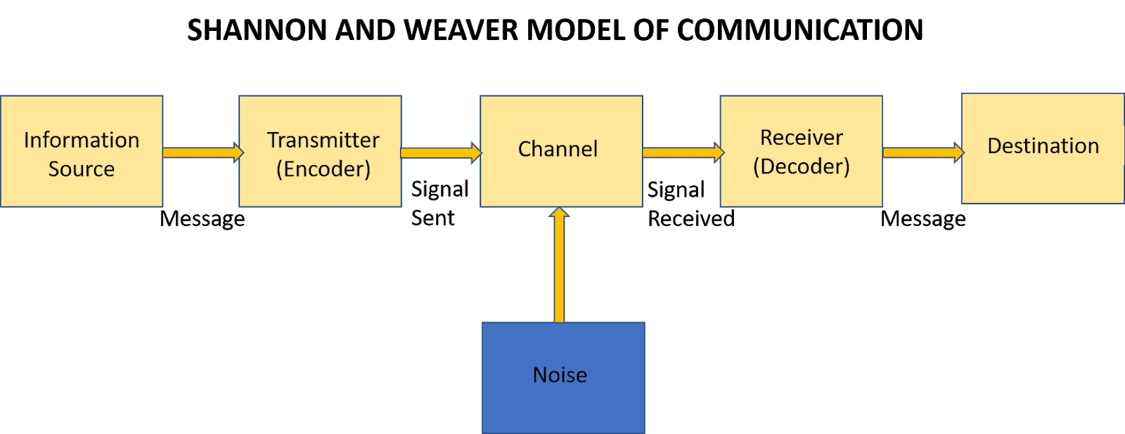
Figure 1: Shannon and Weaver Model of Communication
(Source: Kubota, 2019)
In the case study of Maria and Pedro, the latter misinterpreted the word kitchen for chicken probably because of the noise generated from the building site. It is only after the miscommunication was aparent that they could realise that their communication failed because of physical noise. At my workplace, remote working was an everyday challenge as video or voice conferences with a disturbing environment would degrade the quality of communication.
The Shannon Weaver Model does point out how important it is to have an environment without noise and how noise hinders a complete effective communication (Rohayatin et al., 2022). However, the model in its 1949 version does not mention how the challenge could be overcome. The challenge of noise could be overcome if the sender and the receiver consider feedback, whereby the receiver of the message could reconfirm what he or she understood and point out the physical disturbances in comunication if any. Inaudibility and voice breaking were common feedbacks that used to come across from the receivers to the sender of the message in my remote working experience.

2.2 Schramm (1954)
As opposed to Shannon and Weaver’s model of communication, Schramm’s model of communication is not linear but circular, though rooted in the former (Kuznar and Yager, 2020). The following figure shows the model focused more on encoding and decoding as compared to Shannon and Weaver’s model.
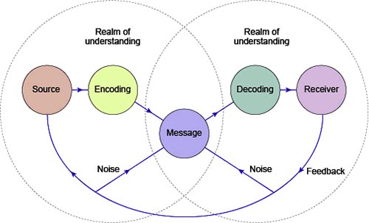
Figure 2: Schramm’s Model of Communication
(Source: Kuznar and Yager, 2020)
It can be seen from the above figure that the communication path is circular starting from the sender to the receiver and back to sender in the form of a feedback. According to the model, the communication path remains incomplete without the feedback based on the realms of understanding and unless the source and the receiver are on the same page concerning the message. Hence, each person is both the sender and the receiver, as Schramm noted that it is misleading to assume that communication has a start and an end, as communication is continuous and endless. Schramm was of the belief that other than physical disturbances, factors like level of an individual’s knowledge, differences in culture, background of experience, all play a very in ensuring the quality of communication (Dissanayake, 2018).
Given the continuous and circular nature of communication, the ongoing two ways communication reduces the noise factor and the understanding between the individuals are maximised with continuous feedback too. In the case of Maria and Pedro could have adopted feedback and Pedro could have asked Maria to ask whether she really asked for him to meet her in the kitchen, or why was it necessary to meet her in the kitchen and not any other part of the house. As per the model, equal and reciprocal communication is crucial, as both members of the communication are capable of encoding, decoding and interpreting. At my workplace, we were advised to stay in continuous touch with each other and keep everyone in the team updated about individual progress so that no two people did the same task because of failed understanding.

2.3 Berlo (1964)
Berlo’s Sender-Message-Channel-Receiver (SMCR) model was another model of communication that was inspired by Shannon and Weaver. Like Shannon and Weaver, 1949, it is linear and without feedback. The following figure shows the SMCR communication model by Berlo.
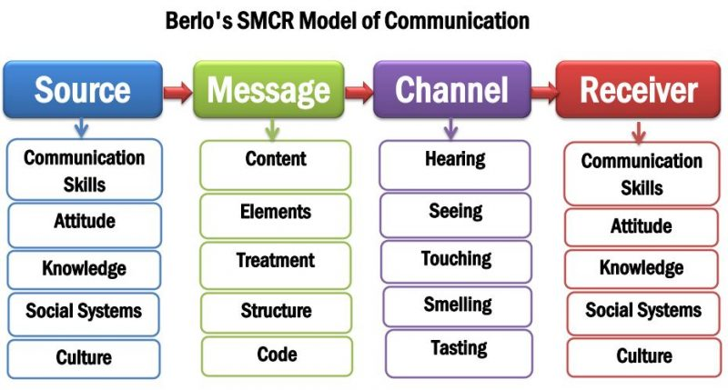
Figure 3: Berlo’s SMCR model of communication
(Source: Muyanga and Phiri, 2020)
Factors affecting the communication efficiency of the sender and the receiver are same, namely communication skills, attitude, knowledge, social systems and culture. Communication skills comprise reading, listening, and speaking, which can be affected by language differences (Li, 2021). Though Maria and Pedro did not have lack in communication skills, Maria speaking more loud and clear and Pedro having better listening skills could have beaten the noise. Lacking the correct attitude, when the receiver assumes things without questioning the absurd can hamper communication, like Pedro. He assumed that Maria asked him to meet in the kitchen. Effective communication can be hampered when there is a difference in a level of knowledge, which however, was not the case for Maria and Pedro, although I did experience such instances at my workplace team members find it difficult to readily understand what the team leader is trying to convey, and clarifies only through repeated explanations.
Noise, in Berlo’s SMCR, is widely discussed in the form of external noise and internal noise (Li, 2021). The factors considered are also a part of Schramm’s model of communication, but not segregated between external and internal noise like in Berlo’s. While external noise, like in Shannon and Weaver’s model, is caused by physical disturbances as in the case study, internal noise is caused by the underlying differences between sender and receiver. The differences could be concerning communication skills, attitude, knowledge as discussed above, also social systems, and culture. At my workplace, within a team there were members belonging to different cultures who often found it difficult to connect readily. This difference, however, was absent between Maria and Pedro.

3. Communication skills

3.1 Verbal
Verbal communication encompasses use of words spoken and written. The quality of verbal communication is dependent on the choice of words, tone and pitch. Effectiveness of verbal communication is the most important for workplaces as it is not open for interpretation, and has greater clarity compared to non-verbal communication (Vogel, Meyer and Harendza, 2018). Having the presence of sender and the receiver, verbal communication allows immediate feedback and instant clarification, preventing future harm of miscommunication. Maria and Pedro had between them a verbal communication over phone.

3.2 Non-Verbal
The effectiveness of non-verbal communication begins where the effectiveness of verbal communication ends. It is dependent on body language, facial expressions and gestures (Grandgeorge, 2020). Effective teamwork at workplace is a lot dependent on non-verbal communication. At my workplace when the team leader is angry, others try to be more respectful and talking at lower volumes and lower pitches than what they usually do. Proxemics, body language posture, appearance or eye gaze can be understood without using words. Whether a person is happy, angry, afraid, confused or disappointed can be judged only through non-verbal communication skills, universal across the world as shown below.
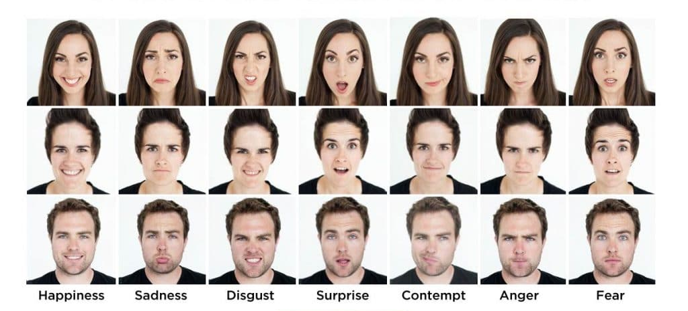
Figure 3: Non-verbal facial expressions
(Source: Science of People, 2022)

3.3 Listening
Active Listening refers to paying attention while a person is speaking and not doing other things that could divide the attention (Jonsdottir and Fridriksdottir, 2020). Active listening comprises responding and reflecting based on what the speaker had to say. Maria and Pedro, both were undoubtedly engaged in the conversation, but the background noise caused divided attention. The confusion could be avoided if Pedro would have immediately reflected and responded. At my workplace, after a team leader explains the role of each member in doing the tasks, one is supposed to respond by briefly stating what needs to be done from one’s end.
Empathetic listening is the next step that is based on active listening, that allows the development and enhancement of relationships with a stronger understanding of what is being conveyed that is concerned with both intellect and emotions (Jonsdottir and Fridriksdottir, 2020). One of the very important aspects of empathetic listening is patience, and in the case of disagreement, it is important to handle the situation without hurting the feelings of the other person. In either case, the person must feel understood. The listener must be mindful of how to respond by being mindful of what is being said and what is not being said. At my workplace, the management had adopted an open door policy, whereby the employees have the liberty to engage in personal conversations with their bosses. However, most employees were not comfortable with the entire idea. Seeing this, keeping the policy intact, the management let the team leaders handle their members on a regular basis and tag along with the employees to the management only in case of personal emergency that the employee needs to share. The employees are now also welcome if they want to visit the management without the team leader.

4. Advantages and disadvantages of communication technology
Communication technology is a collective term for electronic systems used for communication between individuals or groups (Bhbosale, Pujari and Multani, 2020). The system is effective especially when the persons are not present at the same location. These systems include telecommunication, emails, radio, social media and other computer based technology. The following are the advantages of communication technology:
- Shorter time: Communication can be achieved at a much higher speed, as location is no bar. Remote working has only been possible because of communication technology and use of applications like Zoom, Whatsapp and Gmail.
- Cost-effective: Communication technology comes at very cheap rates, and is free for limited number of people or for limited time span. The role of internet is undeniable in this regard in systemising business practices.
- Greater business opportunities: Communication technology clubbed with information technology has allowed automation in many industries. Hospitality sector uses robots, education sector uses moodle, and almost sectors use virtual assistants in their websites, eliminating the cultural gap too.
However, communication technology has a set of disadvantages in the form of privacy, as hacking, phising and phone signal interceptions, private information is leaked. With lesser need for people to communicate, unemployment has increased, although empathetic understanding is somewhere the technology still lacks. The technology is also capable of overruling cultures and consuming the native uniqueness as a process of globalisation.

5. Conclusion
This report has been focused on identifying the various aspects of communication. Three models namely, Shannon and Weaver, Schramm’s and Berlo’s SCRM had been discussed in the lines of my workplace experiences and the case study of Maria and Pedro. The important communication skills in general and the advantages and disadvantages of Communication technology has also been discussed briefly.

References
Andriitso, V.M., Tsyhanyk, M.I., Shevtsova, I.M., Shiutiv, M.A. and Kutsyk, O.P., (2021). Features of communication between the stage director and members of the group during the preparation of choreographic performances. Linguistics and Culture Review, 5(S2), pp.697-707.
Bhbosale, S., Pujari, V. and Multani, Z., (2020). Advantages And Disadvantages Of Artificial Intellegence. Aayushi International Interdisciplinary Research Journal, 77, pp.227-230.
Dissanayake, W., (2018). Language and communication. World Englishes, 37(3), pp.461-463.
Grandgeorge, M., (2020). Communication Between Humans: Towards an Interdisciplinary Model of Intercomprehension. In Human-Robot Interaction (pp. 3-19). Springer, Cham.
Jonsdottir, I.J. and Fridriksdottir, K., (2020). Active listening: Is it the forgotten dimension in managerial communication?. International Journal of Listening, 34(3), pp.178-188.
Kubota, M., (2019). What is “Communication”?―Beyond the Shannon & Weaver’s Model―. International Journal, 13(1), pp.54-65.
Kuznar, L.A. and Yager, M., (2020). The Development of Communication Models, Quick Look. Joint Staff J39, Strategic Multi-layer Assessment Washington, DC United States.
Li, Z., (2021). Analysis on ‘Role’Transformation of English Teachers in Chinese Higher Vocational Colleges from Traditional Classroom to Flipped Classroom under SMCR Model. In 7th International Conference on Humanities and Social Science Research (ICHSSR 2021) (pp. 329-332). Atlantis Press.
Muyanga, C.C. and Phiri, J., (2020). Assessment of Effective Communication in International Schools in Developing Countries Based on the Berlo’s SMCR Model. Open Journal of Business and Management, 9(1), pp.448-459.
Rohayatin, T., Subagyo, A., Setiawan, A. and Wulandari, W., (2022). Bureaucratic Reform Strategy In Improving The Quality Of Public Services By Implementing Bureaucratic Communication Model in Cimahi City. PERSPEKTIF, 11(3), pp.963-969.
Science of People (2022). Available at: https://www.scienceofpeople.com/microexpressions/ (Accessed: 20 July 2022).
Vogel, D., Meyer, M. and Harendza, S., (2018). Verbal and non-verbal communication skills including empathy during history taking of undergraduate medical students. BMC medical education, 18(1), pp.1-7.

