University of Wales Trinity Saint David
Wales Institute of Science and Art


Materials Testing and Sustainability of Composites for Motorsport and Automotive Industries

Automotive Materials and Sustainability ACHA6012

Tamzin Cooper
2300764
26th April 2026

Word Count: 3285
Contents
1 Introduction 4
1.1 Aims 4
2 Literature Review 5
2.1 Structure of a composite 5
2.1.1 Fibres 5
2.1.2 Matrix 5
2.1.3 Weave 5
2.2 Composite Types 6
2.3 Manufacturing Processes 7
2.4 Material Properties 7
2.4.1 Young’s Modulus 8
2.4.2 Tensile Strength (UTS) 8
2.4.3 Failure Strain 8
3 Sustainability Analysis 9
3.1 Life Cycle Analysis 9
3.1.1 Raw Material Extraction 10
3.1.2 Manufacturing 11
3.1.3 Material Use 11
3.1.4 Recycling and end-of-life disposal 12
3.2 Legislations 12
3.3 Feasibility of introducing sustainable alternatives in motorsport 13
4 Methodology 14
4.1 Validation Example 14
4.1.1 Law of Mixtures 15
5 Experimental Results and Analysis 16
5.1 Test Observations 16
5.2 Mechanical Behaviour 17
5.2.1 Aluminium Baseline 17
5.2.2 Carbon Woven Bioresin 18
5.3 Fibre Comparison 19
5.4 Weave Comparison 21
5.5 Resin Comparison 22
5.6 Variation Study 23
5.7 Limitations of the test 24
6 Conclusion 25
6.1 Recommendations and Sustainable Developments 25
7 References 26
8 Appendix 29

Table of Figures
Figure 1 - Demonstrating the possible optimisation of properties when combining fibres and resin to form a composite material (Hatton, 2019) 4
Figure 2 - Typical stress-strain curve for a polymer (Li et al, 2017). 8
Figure 3 - Life-cycle assessment process (Mi, 2024). 9
Figure 4 - Environmental Analysis of carbon fibre composites and bio composites (Ramachandran, 2023). 9
Figure 5 - Experimental image of the Denison tensile testing machine. 14
Figure 6 - Materials post failure left to right Aluminium 1050A, Carbon Fibre Non-Woven Bio, Carbon Fibre Woven Bio, Flax Woven Bio, Flax Non-Woven Bio, Carbon Fibre Woven Epoxy, Kevlar. 17
Figure 7 - Aluminium stress-strain sample comparison (experimental results). 17
Figure 8 - Literature stress-strain curve for aluminium (Chen, 2014). 18
Figure 9 - Carbon Woven bioresin stress-strain sample comparison (experimental results). 19
Figure 10 - Literature carbon epoxy stress strain curve (Tosto, 2024). 19
Figure 11 – Comparing the experimental stress-strain curves of different Woven Bioresin fibres (Carbon, Flax and Kevlar). 20
Figure 12 - Ashby chart comparing the Youngs Modulus of differing composites (Department of Materials Science and Metallurgy - University of Cambridge, 2026) 21
Figure 13 - Comparing woven and non-woven carbon fibres stress-strain curve. 22
Figure 14 – Comparing stress-strain curves of resin types (epoxy and bioresin) of carbon fibres. 23
Figure 15 - Comparing stress-strain curves of flax woven and non-woven. 29
Figure 16 – Carbon Woven Epoxy stress-strain sample comparison (experimental results). 29
Figure 17 - Carbon Non-Woven bioresin stress-strain sample comparison (experimental results). 30
Figure 18 -Flax Woven bioresin stress-strain sample comparison (experimental results). 30
Figure 19 - Flax Non-Woven bioresin stress-strain sample comparison (experimental results). 31
Figure 20 - Smiths (2023) 1050 Aluminium datasheet. 31

Table of Tables
Table 1 - Comparing carbon fibre, natural fibres (flax) and synthetic fibres (Kevlar) and discussing their application in motorsport. 6
Table 2 - Comparing differing composite manufacturing types using literature from Rajak et al (2019) and Rusnakova (1970). 7
Table 3 – Comparing the sustainability of differing fibre types in the raw material extraction stage. 10
Table 4 - Comparing the sustainability of differing fibre types in the manufacturing stage. 11
Table 5 - Comparing the sustainability of differing fibre types in the material use stage. 11
Table 6 - Comparing the sustainability of differing fibre types in recycling and end-of-life disposal stage. 12
Table 7 - Materials tested in the experimental test, with their cross-sectional area (mm^2). 14
Table 8 - Comparing the materials UTS and Youngs Modulus to reference data sheets, whilst also displaying experimental failure strain of each material (EZ Composites; Oliwa, 2020; Smiths, 2023). 16
Table 9 - Comparing the experimental UTS and Young's Modulus across the full 20 sample set, excluding samples which prove error ridden and unrealistic. 23
Table 10 - Performance and sustainability trade-offs across composites, scored out of 5 based on experimental results, LCA analysis, feasibility section and literature (chapters 3 and 5). 25

Table of Equations
Equation 1 - Stress. 14
Equation 2 - Strain. 14
Equation 3 - Youngs Modulus. 14
Equation 4 - Youngs Modulus Upper Limit calculation. 15
Equation 5 - Youngs Modulus Lower Limit calculation. 15
Equation 6 - Experimental carbon epoxy upper limit calculation. 15
Equation 7 - Experimental carbon epoxy lower limit calculation. 15

Introduction

Composite materials are widely used in engineering due to their ability to combine desirable properties, resulting in optimised mechanical performance (Bhong, 2023). Figure 1 confirms fibres provide high strength and stiffness, while the matrix contributes to the elongation of the composite, allowing a balance of properties not achievable by individual materials (Rajak et al., 2019).
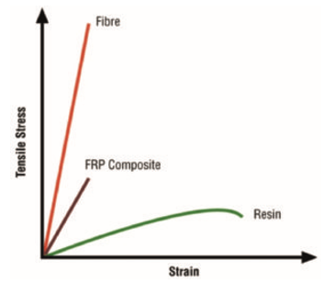
Figure 1 - Demonstrating the possible optimisation of properties when combining fibres and resin to form a composite material (Hatton, 2019)
With motorsport’s ongoing challenge of balancing increased pressures of sustainability, there is growing interest in alternative materials such as natural fibres and bio-based resins.

Aims
To evaluate the mechanical performance of a range of composite materials through tensile testing, focusing on the influence of fibre type, resin and weaves, whilst analysing the sustainability of composites through a life cycle assessment.

Literature Review

Structure of a composite

Fibres
Fibres are the primary load-carrying component in composite materials, providing strength and stiffness (Clyne and Hull, 2019). Hatton (2019) highlights how fibres are effective in tension, however, become weak under compression and bending loads, explaining why they are embedded within a polymer matrix, to provide structural support and stability. Fibre orientation and arrangement play a critical role in the mechanical properties and structural behaviour of a composite, with aligned fibres providing high strength in one direction, whilst complex arrangements improve load distribution (Rajak et al, 2019).

Matrix
The matrix binds fibres together and maintain their required position (Rajak et al, 2019). As demonstrated by Hatton (2019), matrices support the fibres, enabling them to carry compressive loads, and transfer shear stresses between fibres so loads can be distributed evenly throughout the material. Epoxy resins are used in motorsport engine bays or brake ducts due to their ability to retain mechanical properties at elevated temperatures, unlike thermoplastics, which soften when above their glass transition temperature (Hatton, 2019). Bio-based resins offer a sustainable alternative, derived from renewable sources such as plant oils (Capretti, 2023). Compared to petroleum-based resins, they offer reduced environmental impact but lower mechanical and thermal performance (Pickering, 2016). Therefore, bioresins are used in motorsport for non-structural components where sustainability can be prioritised without significantly compromising performance.

Weave
Chowdhury (2024) explains that woven composites are constructed by weaving yarns together, providing a more controlled fibre orientation and improved strength in multiple directions, making them suitable for applications including bodywork (Hatton, 2019). Non-woven composites are produced by bonding fibres through chemical, mechanical or thermal processes, resulting in random fibre orientation (Chowdhury, 2024). Although non-woven materials can be strengthened by increasing the number of layers, they generally produce lower stiffness and strength compared to woven structures due to less efficient load transfer (Ratim, 2012).

Composite Types

Table 1 - Comparing carbon fibre, natural fibres (flax) and synthetic fibres (Kevlar) and discussing their application in motorsport.
Composite Type | Key Properties | Motorsport Application
Carbon Fibre | Exceptional strength to weight ratio and great mouldability (Hatton, 2019).  Combined with honeycomb cores to form sandwich structures, significantly increasing stiffness whilst maintaining low mass through plies being bonded either side of the low-density core material. | F1 monocoque chassis due to their excellent energy absorption which is critical for safety (O’Rourke,1990).  Complex geometries (underfloor and bodywork) due to mouldability.
Natural Fibres (Flax) | Derived from plant-based sources (such as Linum usitatissimum for flax), so are biodegradable, renewable, widely available and low cost per unit volume (Pickering, 2016). | Interior components due to ability to absorb sound and vibration, as well as their capacity to withstand bending loads (Rajak et al, 2019).
Synthetic Fibres (Kevlar) | Human made fibres produced through chemical synthesis (Rajak et al, 2019).  Kevlar is known for high tensile strength and good impact resistance. | Crash structures where energy absorption is important.  Fuel tanks and protective layers within composite panels, where resistance to impact helps improve safety.

Manufacturing Processes

Table 2 - Comparing differing composite manufacturing types using literature from Rajak et al (2019) and Rusnakova (1970).
Manufacturing Type | Description | Advantages | Disadvantages
Pre-impregnation | Fibres are pre-impregnated with resin and require heat and pressure (autoclave or oven) to cure. | High consistency and fibre volume fractions, low void content. | High cost due to specialised equipment such as the autoclave, also time consuming so not suitable for rapid production.
Vacuum bag moulding | A sealed vacuum bag is applied over the laminate to compress layers and remove air during curing. | Improves fibre-resin interaction and reduces defects. | Risk of leaks and less consistent than pre-impregnation.
Resin Infusion | Dry fibres are place into a mould, sealed with a vacuum bag, and resin introduced under vacuum pressure. | Reduced emissions due to closed mould system, as well as being practical for large-scale productions. | Complex set up due to sealing and vacuum checks, also high initial costs due to the requirement of specialised equipment.
Wet lay | Manually placing fibres into a mould and applying resin using brushes or rollers. | Cost effective as requires minimal investment in equipment and tooling, as well as its immediate application enabling on-the-spot repairs. | Variability in resin distribution, with higher void content due to risk of air entrapment. Also limited quality control as uniformity is difficult.

Material Properties
The mechanical behaviour of materials is characterised using a stress-strain curve, which provides insight into key properties (Clyne and Hull, 2019).

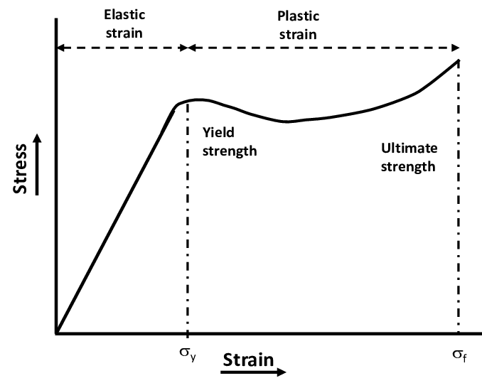
Figure 2 - Typical stress-strain curve for a polymer (Li et al, 2017).
Qualitest (2025) explains the initial linear region represents elastic deformation, with its gradient defining stiffness (Young’s Modulus). Deviations from linearity show plastic deformation in ductile materials, whilst brittle materials fail at minimal strain. The area under the curve represents toughness (energy absorption), critical in motorsport for impact resistance and structural integrity.

Young’s Modulus
In fibre composites, stiffness is governed by the reinforcing fibres, with carbon fibres producing higher modulus values than natural fibres including flax (Clyne and Hull, 2019), resulting in carbon fibre composites demonstrating superior resistance to deformation under load.

Tensile Strength (UTS)
UTS represents the maximum stress a material can withstand before failure, indicating its load-carrying capability. Carbon fibre composites produce high tensile strength due to strong fibre bonding and alignment, whereas flax composites show lower strength due to fibre variability and weaker fibre-matrix interaction (Pickering, 2016). Fibre orientation and defects can significantly influence tensile performance (Rajak et al, 2019).

Failure Strain
Failure strain indicates failure behaviour, with higher strain values corresponding to ductile materials. Fibre composites show linear elastic behaviour followed by brittle failure, due to limited plastic deformation in fibres and matrix (Clyne and Hull, 2019). Ductile metals demonstrate a distinct yield point and an extended plastic region prior to failure (demonstrated by aluminium) (Ashby, 2025).

Sustainability Analysis

The increasing pressure on motorsport to improve environmental performance has led to growing interest in sustainable material selection.

Life Cycle Analysis
A Life Cycle Assessment (LCA) is used to quantify the environmental impact of materials across their lifespan (figure 3 by Barbhuiya, 2023). Sectors including transportation and manufacturing contribute significantly to global greenhouse gas emissions, with manufacturing alone accounting for approximately 30% of emissions (Ramachandran, 2023).
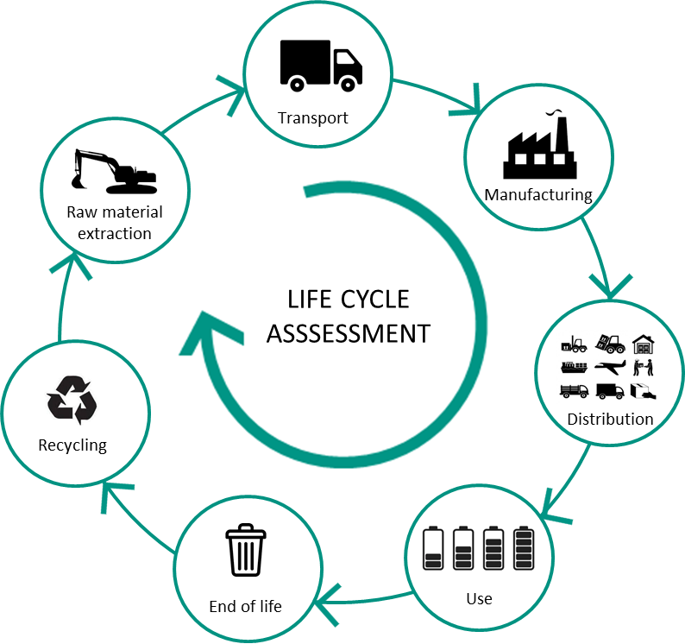
Figure 3 - Life-cycle assessment process (Mi, 2024).
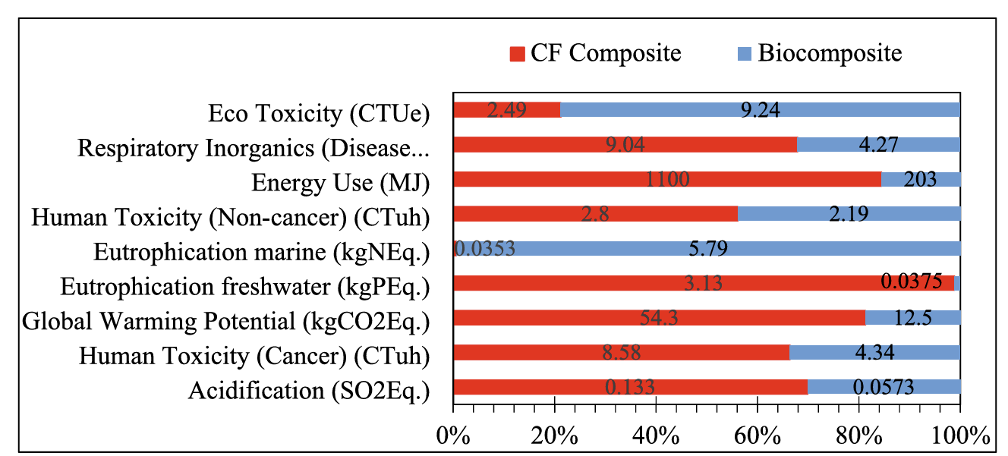
Figure 4 - Environmental Analysis of carbon fibre composites and bio composites (Ramachandran, 2023).
A study by Ramachandran (2023) compares carbon fibre composites and bio composites. Carbon fibre composites produce higher global warming potential, with values of approximately 54.3 kgCO₂Eq compared to 12.5 kgCO₂Eq for bio composites (Ramachandran, 2023). This is reflected across energy consumption (1100 MJ vs 203 MJ), acidification and human toxicity (figure 4). This is attributed to the high energy carbonisation process in carbon fibre production. However, bio composites show increased eco-toxicity and eutrophication impacts, which are associated with fertiliser and pesticide use. This highlights the need for investigations into the lifecycle of materials to understand their environmental impact if adopted in motorsport, to conform to the EU End-of-Life Vehicles Regulation (European Parliament, 2025), which states that vehicles are designed for disassembly and sets recycled material targets across the full vehicle lifecycle.

Raw Material Extraction

Table 3 – Comparing the sustainability of differing fibre types in the raw material extraction stage.
Carbon Fibre | Flax Fibre | Kevlar
Rely on polyacrylonitrile (PAN), a petroleum-derived precursor making carbon fibre dependent on non-renewable resources. (Ramachandran (2023) | Derived from renewable plant sources, reducing reliance on fossil fuels and lower energy requirements  (Ramachandran, 2023). | Derived from petrochemical sources and requires high energy processing, resulting in resource depletion (Heqin, 2026).
Extraction of these materials contribute to high energy demand and greenhouse gases. (Ramachandran, 2023) | Agricultural production -introduce environmental concerns including fertiliser and pesticide use, contributing to water pollution and soil degradation (Ramesh, 2020). | Relies on fossil-based chains with harmful environmental risks.
Environmental damage including habitat destruction associated with oil extraction, such as spills that contribute to biodiversity loss. | Land use for crops can lead to deforestation and biodiversity loss (Ramesh, 2020).

Manufacturing

Table 4 - Comparing the sustainability of differing fibre types in the manufacturing stage.
Carbon Fibre | Flax Fibre | Kevlar
Carbonisation of PAN fibres requires temperatures exceeding 1000 degrees which increases energy consumption and high toxicity levels (Li, 2021). | Reduced energy demand due to lower processing temperatures. | High energy polymerisation and fibre spinning processes contribute to environmental harm.
Autoclave curing can increase energy demand due to high pressure and temperature requirements. | Wet spinning and resin curing contribute to emissions (Ramachandran, 2023). | Difficult to process due to fibre toughness.
Non-woven and random fibre composites are easier and cheaper to produce (Li, 2021). | Variability in fibre quality leads to increased material waste during manufacturing (Ramachandran, 2023).

Material Use

Table 5 - Comparing the sustainability of differing fibre types in the material use stage.
Carbon Fibre | Flax Fibre | Kevlar
High strength to weight ratio enables mass reduction, improving fuel efficiency and operational emissions (Duflou et al, 2012). | Improved vibration damping and reduced noise, improving vehicle efficiency. (Pickering et al, 2016) | Lower compressive strength compared to carbon fibre limits use in primary structural components.
Expensive repairs due to delamination requiring specialised inspection and repair techniques (Mallick, 2007). | Lower mechanical performance limits their application to non-structural components. | High impact resistance and energy absorption allows for use in safety-critical components.
Mechanical performance allows use in structural components. | Moisture sensitivity reduces long-term durability.

Recycling and end-of-life disposal

Table 6 - Comparing the sustainability of differing fibre types in recycling and end-of-life disposal stage.
Carbon Fibre | Flax Fibre | Kevlar
Thermoset resins within carbon fibre composites cannot be remelted or recycled (Li, 2021). | Biodegradable and reduce long-term environmental impact, reducing long-term environmental persistence (Ramesh, 2020). | High durability and resistance to degradation resulting in long environmental persistence.
Disposed of through landfills or incineration, contributing to environmental pollution (Ramachandran, 2023). | The synthetic resins within bio composites limits full biodegradability, meaning they cannot be completely composted (Ramesh, 2020). | Limited recycling options mean that Kevlar-based composites are also commonly disposed of through landfill (Heqin, 2026).
Pyrolysis recycling method - energy intensive and results in reduced fibre quality, limiting reuse in high-performance application (Li, 2021). | Can be incinerated for energy recovery, improving environmental impact.

When considering all lifecycle stages, flax fibre demonstrates the strongest sustainability, benefiting from renewable sourcing and biodegradability at extraction and end-of-life stages. However, its reliance on synthetic resins limits full biodegradability. Carbon fibre provides sustainability benefits during the use stage through mass reduction and improved fuel efficiency (Duflou et al., 2012), however, its high energy carbonisation process and poor recyclability result in the greatest environmental impact, making it difficult to justify under FIA net-zero targets despite its mechanical superiority. No material satisfies all lifecycle stages, highlighting the need for development of hybrid and thermoplastic matrix systems (chapter 6.1), to meet the requirements of the EU End-of-Life Vehicles Regulation (European Parliament, 2025) and FIA net-zero targets (FIA, 2023).

Legislations
Motorsport is influenced by sustainability regulations that aim to reduce environmental impact. F1 (2019) explains that the FIA and Formula 1 have introduced the goal to achieve net-zero carbon emissions by 2030, covering cars, on-track activity, manufacturing and operational processes. This is supported by the FIA’s broader sustainability strategy, promoting carbon reduction and sustainable material use across motorsport (FIA, 2023). This impacts material selection as whilst carbon fibre offers desirable mechanical properties (discussed in chapter 5), it has poor sustainability with limited recyclability. Biocomposites including flax and bioresins align closer with the net-zero goal due to their lower carbon footprint, demonstrating the potential for incorporation in the new sustainable era. Future regulations are likely to drive the development of these materials to enhance their mechanical properties making them an improved replacement to carbon fibre. Furthermore, optimising manufacturing processes, such as reducing energy consumption in autoclave curing or increasing the use of resin infusion techniques, can further minimise environmental impact (Duflou, 2012). Recycling methods such as pyrolysis may also be utilised to recover carbon fibres.

Feasibility of introducing sustainable alternatives in motorsport
There are limitations to sustainable implementations as addressed by Oliveux (2015), with the main barrier being cost. Carbon fibre has a well-established supply chain, enabling consistent quality and predictable production costs. Sustainable alternatives require additional processing, enhanced quality control, and extensive material validation, increasing manufacturing complexity and cost. Transitioning to bioresins may require modifications to existing production processes and to meet strict motorsport safety standards, introducing significant financial and time-related limitations.

Methodology

Using the Denison Test Equipment (figure 5), a tensile test was conducted to evaluate the properties of different composite materials as displayed in table 7.
Table 7 - Materials tested in the experimental test, with their cross-sectional area (mm^2).
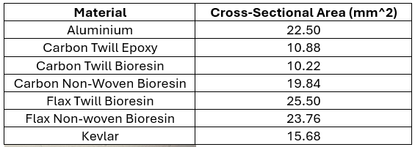
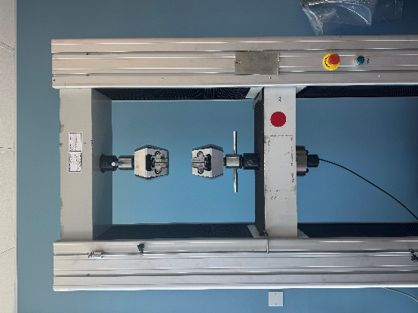

Figure 5 - Experimental image of the Denison tensile testing machine.

Hatton (2019) states that the lay-up and orientation of fibres impact the composites’ mechanical properties. The twill materials consisted of 3 layers of 200g carbon and flax twill, resulting in 600g for each laminate. These plies were placed at 45 degrees, meaning the sample is not perfectly unidirectional. The non-woven materials consisted of 1 layer of 300g non-woven flax and carbon.
The Denison tensile testing machine outputted each materials properties using the following equations:
$$σ=\frac{F}{A}$$
Equation 1 - Stress.
$$ε=\frac{Δl}{l}$$
Equation 2 - Strain.
$$E=\frac{σ}{ε}$$
Equation 3 - Youngs Modulus.

Validation Example
Easy Composites (EZ) datasheets were provided for each material and used to obtain expected values of Young’s Modulus and Ultimate Tensile Strength (UTS).
However, for the carbon woven composites, the datasheets provided the properties for the fibre and matrix separately, and so a Law of Mixtures calculation was required to determine the range of Young’s Modulus expected for these laminates.

Law of Mixtures
A fibre volume fraction of 50% was assumed for the carbon composites, as specified in the testing methodology. The Young’s Modulus of the carbon fibre was taken as 234 GPa from the supplier datasheet (3000K filaments), while the epoxy resin was taken as 3.3 GPa (converted from average of 3300 M N/mm^2).
$$E_{c}Upper= E_{m}V_{m}+E_{p}V_{p}$$
Equation 4 - Youngs Modulus Upper Limit calculation.
$$E_{c}Lower= \frac{E_{m}E_{f}}{{(V}_{m}E_{f})+(V_{f}E_{m})}$$
Equation 5 - Youngs Modulus Lower Limit calculation.
Carbon Epoxy:
$$E_{C}Upper=\left(3.1 ×0.5\right)+\left(234 ×0.5\right)=118.55 GPa$$
Equation 6 - Experimental carbon epoxy upper limit calculation.
$$E_{c}Lower= \frac{3.1 ×234}{\left(0.5 ×234\right)+(0.5 ×3.1)}=6.12 GPa$$
Equation 7 - Experimental carbon epoxy lower limit calculation.
The same method was applied for both woven epoxy and bioresins, with full calculations for the Bioresin in the appendix.

Experimental Results and Analysis

Table 8 highlights agreement and deviation between experimental and manufacturer data. The carbon woven bioresin results show good alignment with expected ranges for UTS and Young’s Modulus. The carbon non-woven bioresin exhibits lower UTS and stiffness than the datasheet values, likely due to inaccuracies in lay-up orientation and fibre distribution during manufacturing, reducing load transfer efficiency. (Clyne and Hull, 2019) Flax composites show lower stiffness values consistent with the datasheet, however, the experimental UTS values are higher. This can be attributed to variations in fibre volume fraction, specimen quality, or testing conditions, particularly in natural fibre composites where material variability is inherently higher (Pickering, 2016).
The greater deviation in UTS compared to Young’s Modulus can be explained by the sensitivity of failure to material defects. Young’s Modulus is determined from the initial elastic region, where the material remains unaffected by defects, whereas UTS depends on the onset of failure, which is influenced by fibre distribution and material variability (Callister and Rethwisch, 2021).
Table 8 - Comparing the materials UTS and Youngs Modulus to reference data sheets, whilst also displaying experimental failure strain of each material (EZ Composites; Oliwa, 2020; Smiths, 2023).
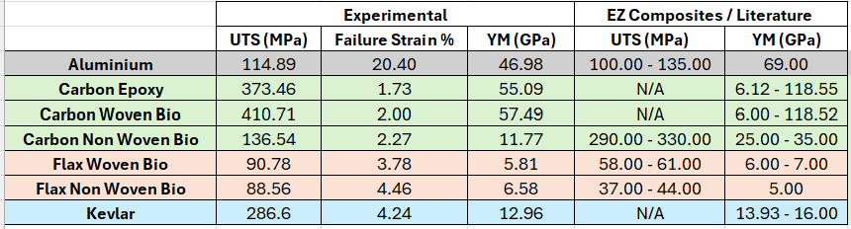
Deviations between experimental and EZ composite values can be attributed to the differing layup and manufacturing processes. For example, EZ composites states that the carbon non-woven bioresin laminate was hand laid-up with 70:30 fibre-fraction volume, compared to the experimental being 50:50 resin infused.

Test Observations
Figure 6 shows aluminium with a central fracture and clear necking. Agreeing with literature, Callister and Rethwisch (2021) explains ductile materials plastic deformation localises before fracture. Composite materials show few signs of necking, suggesting sudden, brittle fracture with delamination between plies.
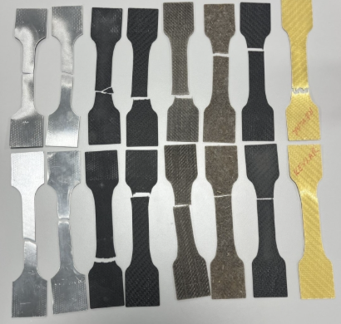
Figure 6 - Materials post failure left to right Aluminium 1050A, Carbon Fibre Non-Woven Bio, Carbon Fibre Woven Bio, Flax Woven Bio, Flax Non-Woven Bio, Carbon Fibre Woven Epoxy, Kevlar.
The woven composites, as expected, show non-uniform fractures with uneven breaks, explained by their intertwined fibres in multiple directions, causing crack propagation to follow complex paths (Clyne and Hull, 2019).

Mechanical Behaviour

Aluminium Baseline
Aluminium 1050 was tested as a baseline due to its well reported mechanical properties and typical ductile behaviour. As an isotropic metal, it provides a clear comparison to fibre-reinforced composites which are anisotropic and result in brittle failure (Mallick, 2007).

Figure 7 - Aluminium stress-strain sample comparison (experimental results).
Figure 7 demonstrates all three samples producing a short elastic region which, as supported by Bhuyan (2025), means that aluminium undergoes little strain before yielding. The long elongation phase is a direct response to aluminium’s high ductility, reaching approximately 20% strain before failing. This is higher than the composite materials which reach 4.46% (table 8). This occurs due to dislocation movement within the aluminium face-centred cubic lattice, allowing the material to deform plastically under load (Bell, 1965). As a result, aluminium can absorb significant energy prior to fracture, making it suitable for applications requiring deformation and energy absorption, such as crash structures in motorsport.

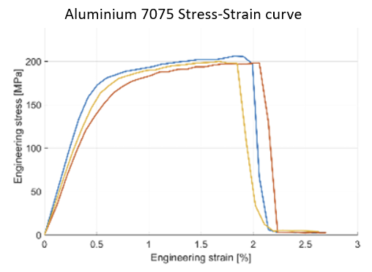
Figure 8 - Literature stress-strain curve for aluminium (Chen, 2014).
Comparing to literature (figure 8), there is a clear agreement in trends, with the transition from elastic to plastic behaviour occurring within 0.5% strain for literature (Chen, 2014) and experimental data. However, the UTS proves below literature, with collated data being 114.89 MPa, compared to approximately 200 MPa by Chen, (2014). This is explained by the literature using 7075 aluminium alloy compared to the experimental test using aluminium 1050 (as explained in the appendix). This is supported by Smiths data sheet confirming UTS of aluminium 1050 being between 100-135 MPa. Furthermore, gripping conditions in the Denison tensile test can result in a reduce stress measurement, especially due to only 3 samples investigated.

Carbon Woven Bioresin
Contrasting from aluminium’s ductile behaviour, carbon woven bioresin shows brittle behaviour failing at approximately 2% strain. However, the composite achieves a higher UTS, exceeding 400 MPa, which is consistent with literature by Tosto (2024) (figure 10), where carbon fibre composites demonstrate high stiffness and strength but limited strain to failure (Callister and Rethwisch, 2020).

Figure 9 - Carbon Woven bioresin stress-strain sample comparison (experimental results).
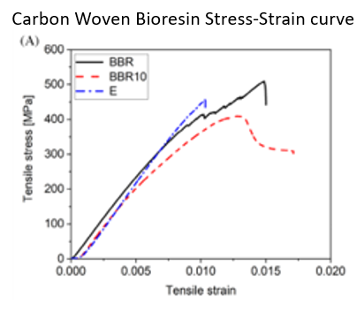
Figure 10 - Literature carbon epoxy stress strain curve (Tosto, 2024).
The low strain is governed by the carbon fibres, which have strong covalent bonds. This results in high stiffness but restricts plastic deformation, causing failure to occur through bonds breaking rather than continuous yielding (Mallick, 2007). Additionally, as supported by the differing stress-strain curves between literature of aluminium and carbon fibre (figures 8 & 10), the polymer matrix in the composite limits the ductility due to its high cross-linked structure reducing plastic deformation (Callister and Rethwisch, 2021). The gradual stress increase between 0.5-2% strain indicates stable load transfer between fibres with desirable structural integrity under loading, consistent with carbon fibres high durability.

Fibre Comparison
Carbon fibre shows the highest UTS due to its aligned covalent carbon bonds which require high forces to fail (Bhuyan, 2025). Kevlar, whilst achieving a lower UTS, has greater failure strain as its polymer chains are linked by weaker hydrogen bonds, allowing more energy absorption before failure (Heqin, 2026). Flax achieves the lowest UTS due to its natural variability in fibre properties, resulting in poor bonding and inefficient load transfer (Foulk, 2009). This deficit is still observed in non-woven carbon vs flax (as shown in the appendix), confirming this trade-off between fibres, regardless of weave arrangement. This suggests flax is yet to become a desired replacement to carbon fibre, despite its sustainable properties mention in chapter 3.

Figure 11 – Comparing the experimental stress-strain curves of different Woven Bioresin fibres (Carbon, Flax and Kevlar).
The Young’s Modulus values in table 8 and demonstrated in figure 11 show a clear dependence on fibre type, with carbon fibre composites showing the highest stiffness. This is consistent with The Department of Materials Science and Metallurgy - University of Cambridge (2026) (figure 12), where carbon fibre composites occupy a high stiffness region compared to natural fibres. However, the Ashby chart illustrates that composite stiffness is lower than individual carbon fibres due to the influence of polymer matrix and fibre orientation, which reduces the overall modulus (Callister and Rethwisch, 2021). The overlap between Kevlar and carbon fibre composites indicates that stiffness is not solely governed by fibre type but is dependent on factors including fibre alignment and volume fraction.
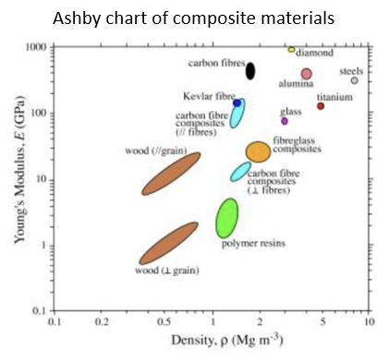
Figure 12 - Ashby chart comparing the Youngs Modulus of differing composites (Department of Materials Science and Metallurgy - University of Cambridge, 2026)

Weave Comparison
Figure 13 shows carbon woven bioresin achieving a higher UTS than carbon non-woven. This is expected, as woven fibres provide controlled and continuous load paths, allowing stress to be transferred efficiently through the laminate (Mallick, 2007). The non-woven material contains randomly orientated shorter fibres, meaning load transfer is less efficient and failure occurs at a much lower stress. Agreeing with literature which explains that fibre orientation and continuity influence composite strength and stiffness (Clyne and Hull, 2019).

Figure 13 - Comparing woven and non-woven carbon fibres stress-strain curve.
The failure strain remains similar (woven with 2% and non-woven with 2.27%), suggesting that weave pattern has a greater influence on load-carrying capacity than elongation. This is supported by Mallick (2007), where strain is less sensitive to fibre alignment and more dependent on the behaviour of the fibre-matrix system. The large difference in strength may be influenced by the methodology, as the woven laminates used three 200 g layers, whereas the non-woven laminates used only one 300 g layer, meaning the comparison is not purely based on woven type but also the total fibre content. However, the flax woven and non-woven comparison proves less prominent (graph shown in the appendix), with only a 2.51% UTS increase between the two, suggesting the manufacturing process inaccuracies have a large impact on figure 13 deviation.

Resin Comparison
Figure 14 shows a small difference (10% difference in UTS) between epoxy and bioresin in carbon fibre, with the bioresin producing a higher UTS. This contradicts literature, where epoxy systems are expected to provide superior mechanical performance due to their higher stiffness and stronger fibre-matrix bonding (Callister and Rethwisch, 2021). However, the minimal difference observed supports the understanding that composite strength is governed by the fibres rather than the matrix, as explained in chapter 2.1.1. This suggests that bioresin is an appropriate sustainable replacement for epoxy, conforming with the EU End-of-Life Vehicles Directive (European Commission, 2000), which requires manufacturers to reduce hazardous substances and improve material recyclability across the automotive industry.

Figure 14 – Comparing stress-strain curves of resin types (epoxy and bioresin) of carbon fibres.
The small variation between the two curves can be attributed to experimental factors such as inconsistencies in resin-infusion through uneven resin flow, due to a lack of resin control. This is supported by Shen et al (2024a) explaining variability is still seen in fibre volume fraction for resin-infused processes compared to pre-impregnated manufacturing methods. As a result, the difference may not be statistically significant and requires a larger sample size to draw conclusions (chapter 5.6).

Variation Study
To enable a fair comparison of variability across materials with different values, the coefficient of variation (CoV) was used. Unlike standard deviation, CoV normalises variability relative to the mean, providing a more representative measure of consistency (Feng, 2011). Table 9 shows that for UTS, carbon woven bioresin and flax non-woven bioresin produce the highest coefficient of variation, whereas for Young’s Modulus, the greatest variation is seen in both non-woven fibres.
Table 9 - Comparing the experimental UTS and Young's Modulus across the full 20 sample set, excluding samples which prove error ridden and unrealistic.
The increased variability in non-woven composites is expected as their random fibre orientation results in inconsistent load paths and uneven stress distribution, leading to greater deviations in mechanical properties (Clyne and Hull, 2019). Woven composites provide a controlled fibre alignment, and so the unexpected increase in variation for the UTS of carbon woven is attributed to manufacturing factors including the layer alignment of 45 degrees, which is more complex and creates an increased chance of misalignment and uneven resin distribution. This is supported by the wide range between minimum and maximum values, indicating that small differences in lay-up quality can significantly influence failure behaviour.
In terms of fibre type, flax composites produce the highest overall variability, which is consistent with literature describing the inherent inconsistency of natural fibres due to variations in fibre quality and extraction processes (Pickering et al, 2016).

Limitations of the test
While resin infusion improves consistency, full control over resin distribution and fibre wetting is not guaranteed, which may introduce local variations in fibre volume fraction (Oliveux, 2015). Inaccuracies in cross-sectional area measurement can influence calculated stress values due to the relationship (equation 1), meaning small measurement errors may lead to poor estimations of UTS (Gauber, 2000). The small sample size reduces the statistical reliability of the results with coefficient of variation values above 50% suggesting that deviations are not solely due to material behaviour, but rather the sample preparation.

Conclusion
The experimental results demonstrate fibre type as the dominant factor influencing tensile behaviour, with carbon fibre composites achieving UTS values of 370-410 MPa, compared to 70-90 MPa for flax. The weave type was the second most influential factor, with woven configurations outperforming non-woven due to improved load transfer through continuous fibre paths. Resin type showed minimal influence, with only a 10% variation between epoxy and bioresin systems, confirming that tensile behaviour is primarily fibre-dominated and bioresin is an appropriate sustainable alternative for epoxy.

Recommendations and Sustainable Developments
Table 10 demonstrates that no material achieves optimal performance across all criteria, confirming material selection requires compromise. Carbon fibre composites provide superior strength and stiffness but are associated with high energy consumption and poor recyclability (54 kgCO₂Eq), making them most suitable for high-performance structural applications including monocoque chassis. Flax composites offer improved sustainability (12.5 kgCO₂Eq) and higher failure strain, but their reduced strength (79% reduction in UTS according to experimental results) limits their use in structural components.
Table 10 - Performance and sustainability trade-offs across composites, scored out of 5 based on experimental results, LCA analysis, feasibility section and literature (chapters 3 and 5).
Building on the findings of this report, future development of thermoplastic matrix composites, such as biodegradable polylactic acid (PLA) would address epoxy and bioresins poor end-of-life issues, as thermoplastics can be reprocessed and remelted, improving recyclability (Oliveux et al., 2015). The observed trade-off between carbon fibre strength and flax sustainability leads to investigation into hybrid carbon-flax composites, retaining carbon fibre in primary load-bearing plies, whilst incorporating flax in secondary layers to reduce overall environmental impact without compromising structural performance (Ramesh, 2020).

References

Ashby, M.F. (2025) Materials selection in mechanical design. London: Butterworth-Heinemann.
Barbhuiya (2023) Life cycle assessment of construction materials: Methodologies, applications and future directions for sustainable decision-making - sciencedirect. Available at: https://www.sciencedirect.com/science/article/pii/S2214509523005065.
Bell, J. F. (1965) ‘Generalized large deformation behaviour for face-centred cubic solids: Nickel, aluminium, gold, silver and lead’, The Philosophical Magazine: A Journal of Theoretical Experimental and Applied Physics, 11(114), pp. 1135–1156. doi: 10.1080/14786436508224924.
Bhong (2023) Review of composite materials and applications - sciencedirect. Available at: https://www.sciencedirect.com/science/article/abs/pii/S2214785323049313
Bhuyan, S. (2025) Stress-strain curve: Definition, characteristics, and regions, Science Facts. Available at: https://www.sciencefacts.net/stress-strain-curve.html (Accessed: 25 April 2026).
Capretti (2023) Use of bio-epoxies and their effect on the performance of Polymer Composites: A critical review. Available at: https://www.researchgate.net/publication/376635682_Use_of_Bio-Epoxies_and_Their_Effect_on_the_Performance_of_Polymer_Composites_A_Critical_Review.
Chen (2014) Analysis and experiment of 7075 aluminum alloy tensile test - sciencedirect, Science Direct. Available at: https://www.sciencedirect.com/science/article/pii/S1877705814013782.
Clyne, T.W. and Hull, D. (2019) An introduction to composite materials. Cambridge, United Kingdom: Cambridge University Press.
Department of Materials Science and Metallurgy - University of Cambridge (2026) DoITPoMS, Mechanics of fibre-reinforced composites . Available at: https://www.doitpoms.ac.uk/tlplib/fibre_composites/printall.php (Accessed: 25 April 2026).
Duflou, J.R., Acker, K.V. and Dewulf, W. (2012) Do fiber-reinforced polymer composites provide environmentally benign alternatives? A life-cycle-assessment-based study - mrs bulletin, SpringerLink. Available at: https://link.springer.com/article/10.1557/mrs.2012.33.
European Commission (2000) Directive 2000/53/EC of the European Parliament and of the Council on end-of-life vehicles. Available at: https://environment.ec.europa.eu/topics/waste-and-recycling/end-life-vehicles_en.
European Parliament (2025) Circular economy: deal on new EU rules for the automotive sector. Available at: https://www.europarl.europa.eu/news/en/press-room/20251209IPR32114/circular-economy-deal-on-new-eu-rules-for-the-automotive-sector.
Feng (2011) Analysis on the variances of material and structural properties based on random field theory, Science Direct. Available at: https://www.sciencedirect.com/science/article/abs/pii/S0266892010000615.
FIA (2023) FIA Environmental Report 2023, FIA Sustainability. Available at: https://www.environmentalreport.fia.com
Foulk (2009) Flax Fibre Quality and influence on interfacial properties of Composites, International Journal of Sustainable Engineering. Available at: https://www.tandfonline.com/doi/full/10.1080/19397030903348710.
F1 (2019) Formula 1 announces plan to be net zero carbon by 2030, Formula 1®. Available at: https://www.formula1.com/en/latest/article/formula-1-announces-plan-to-be-net-zero-carbon-by-2030.5IaX2AZHyy7jqxl6wra6CZ.
Gabauer (2000) Manual of Codes of practice for the determination of uncertainties in mechanical tests on metallic materials | semantic scholar. Available at: https://www.semanticscholar.org/paper/Manual-of-Codes-of-Practice-for-the-Determination-Kandil/4d8205e10c7a4f6558accb2def61f860bcb39705
Hatton, G. (2019) How are composites used in motorsport? Race car Engineering. Available at: https://www.racecar-engineering.com/tech-explained/how-are-composites-used-in-motorsport/ (Accessed: 24 April 2026).
Heqin, L. (2026) Kevlar vs carbon fiber: Key differences, pros, cons & applications, ShaShaCarbon. Available at: https://shashacarbon.com/kevlar-vs-carbon-fiber-key-differences/.
Li (2021) Flexible multilayered aramid nanofiber/silver nanowire films with outstanding thermal durability for electromagnetic interference shielding - sciencedirect. Available at: https://www.sciencedirect.com/science/article/abs/pii/S1359835X21003602.
Mi, Z. (2024) Home, Theoretical and Natural Science. Available at: https://tns.ewapub.com/article/view/13405.
Oliveux (2015) Current status of recycling of fibre reinforced polymers: Review of technologies, Reuse and resulting properties - sciencedirect, Science Direct. Available at: https://www.sciencedirect.com/science/article/pii/S0079642515000316.
Oliwa, R. (2020) The mechanical properties of Kevlar fabric/epoxy composites containing aluminosilicates modified with quaternary ammonium and phosphonium salts, Materials (Basel, Switzerland). Available at: https://pmc.ncbi.nlm.nih.gov/articles/PMC7503872/.
O’Rourke (1990) The uses of composite materials in the design and manufacture of Formula 1 racing cars, Sage Journals. Available at: https://journals.sagepub.com/doi/10.1243/PIME_PROC_1990_204_131_02
Mallick (2007) Fiber-reinforced composite - an overview | sciencedirect topics. Available at: https://www.sciencedirect.com/topics/materials-science/fiber-reinforced-composite.
Pickering (2016) A review of recent developments in natural fibre composites and their mechanical performance - sciencedirect. Available at: https://www.sciencedirect.com/science/article/pii/S1359835X15003115.
Qualitest (2025) The stress strain curve explained, Qualitest. Available at: https://qualitest.ae/article/stress-strain-curve/#:~:text=The%20true%20value%20comes%20from,flexible%20under%20the%20same%20load
Rajak, D.K. et al. (2019) Fiber-reinforced polymer composites: Manufacturing, properties, and applications, Polymers. Available at: https://pmc.ncbi.nlm.nih.gov/articles/PMC6835861/
Ramachandran (2023) Life cycle assessment of carbon fiber and bio-fiber Composites prepared via vacuum bagging technique - sciencedirect. Available at: https://www.sciencedirect.com/science/article/pii/S1526612523000944
Ramesh (2020) Lifecycle and environmental impact assessments on processing of plant fibres and its bio-composites: A critical review. Available at: https://www.researchgate.net/publication/341557064_Life-cycle_and_environmental_impact_assessments_on_processing_of_plant_fibres_and_its_bio-composites_A_critical_review (Accessed: 24 April 2026).
Ratim (2012) The effect of woven and non-woven fiber structure on mechanical properties polyester composite reinforced kenaf, AIP. Available at: https://www.researchgate.net/publication/258571686_The_Effect_of_Woven_and_Non-Woven_Fiber_Structure_on_Mechanical_Properties_Polyester_Composite_Reinforced_Kenaf.
Rusnáková, S., Kalová, M. and Jonšta, Z. (1970) Overview of production of pre-preg, prototype and testing, University of Bristol. Available at: https://research-information.bris.ac.uk/en/publications/overview-of-production-of-pre-preg-prototype-and-testing.
Shen, R. et al. (2024a) An enhanced vacuum-assisted resin transfer moulding process and its pressure effect on resin infusion behaviour and composite material performance, Polymers. Available at: https://pmc.ncbi.nlm.nih.gov/articles/PMC11125118/
Smiths (2023) 1050A (S1B) technical datasheet, Smith Metal. Available at: https://www.smithmetal.com/pdf/aluminium/1xxx/1050a.pdf.
Tosto (2024) Comparison of carbon‐reinforced composites manufactured by vacuum assisted resin infusion with traditional and fully recyclable epoxy resins. Available at: https://4spepublications.onlinelibrary.wiley.com/doi/10.1002/pc.28858.

Appendix

Figure 15 - Comparing stress-strain curves of flax woven and non-woven.

Figure 16 – Carbon Woven Epoxy stress-strain sample comparison (experimental results).

Figure 17 - Carbon Non-Woven bioresin stress-strain sample comparison (experimental results).

Figure 18 -Flax Woven bioresin stress-strain sample comparison (experimental results).

Figure 19 - Flax Non-Woven bioresin stress-strain sample comparison (experimental results).
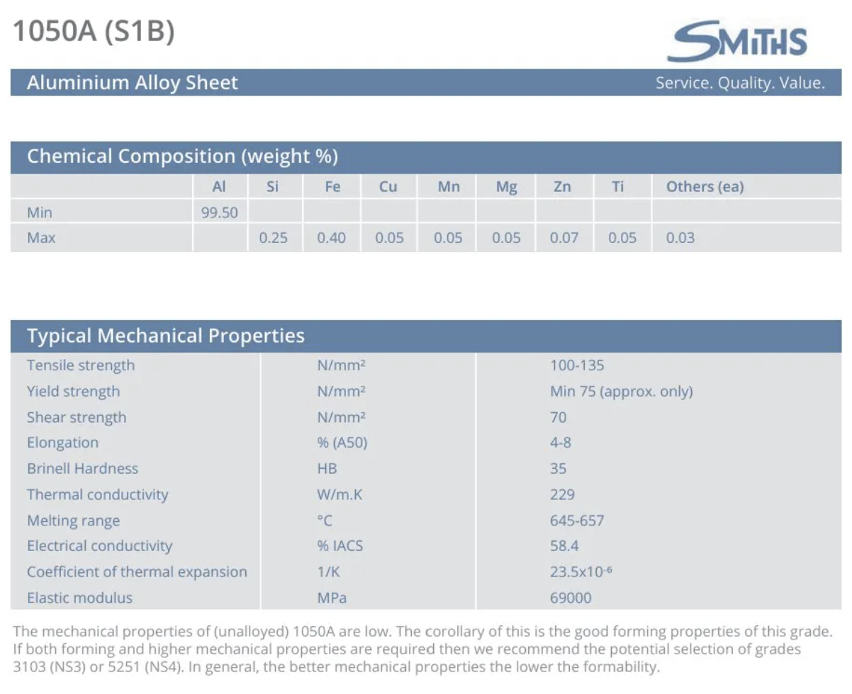
Figure 20 - Smiths (2023) 1050 Aluminium datasheet.
Figure 20 consolidates aluminium 1050 as the material used in the experimental test with a tensile strength range of 100–135 N/mm^2, consistent with the experimental UTS of 114.89 MPa recorded in this report.

