Stroke in Ethnic Minority in the UK

Name: Abdullah Ismail Nana
Lecturer Name: Dr. Raheela Shaikh
Student’s ID: 2526419
Module Name/Code: Community care and Management Of Longer-term Conditions/ LCHS7003
Course: MSc Public Health and Social Care In Practice
Date: 27/02/2026.

Stroke in Ethnic Minority in the UK



Contents
Stroke in Ethnic Minority Populations in the UK 4
Introduction 4
Global and UK Burden of Stroke 5
Types of Strokes 6
1. Ischemic Stroke 6
2. Haemorrhagic Stroke 6
Risk Factors in Ethnic Minority Populations: Modifiable and Non-Modifiable Determinants 7
Non-Modifiable Determinants 7
Signs and Symptoms of Stroke 8
Modifiable Determinants 9
Aetiology of Stroke in Ethnic Minority Populations 9
Physical Impact and Long-Term Disability 10
Emotional and Psychological Impact 11
Society and family implications 12
Evidence-Based management of the NHS 13
Hyperacute Care 13
Secondary Prevention 13
Rehabilitation 14
Theoretical Frameworks for Improving Outcomes 14
UK Model: Integrated Care Systems and Population Health 14
International Model: Social Determinants of Health 14
Health Policy and Political context 15
Cultural Competence and Person-Centered Care 15
Supporting Self-Management and End-of-Life Care 16
Conclusion 17
Reference list 17

Introduction
- Stroke is a leading cause of death and long-term disability in everywhere across the globe and the United Kingdom (Venketasubramanian, 2025).
- However, hyperacute care improvement, including thrombolysis, thrombectomy, and the improvement of the secondary prevention program, does not stop stroke as a cause of a significant individual, family, and social burden (Al-Batat et al., 2025; Venkitasubramanian, 2025).
- It is worth noting that the rates of stroke, the severity of a stroke, and stroke outcomes do not impact the entire population equally, and the same disparities have been observed to remain within ethnic groups (Emmett et al., 2025; Marshall et al., 2023).
- The ethnic minority groups and lower age of stroke onset in comparison with the White British population indicate that stroke is more common in the ethnic minorities and the age of disease onset is younger (Marshall et al., 2023; Emmett et al., 2025; the UK population-based data).
- Besides, the incidence is also not the only type of inequality, as there is a disparity regarding access to revascularization therapies and post-stroke outcomes (Al-Batat et al., 2025; Metcalf & Zhang, 2023).

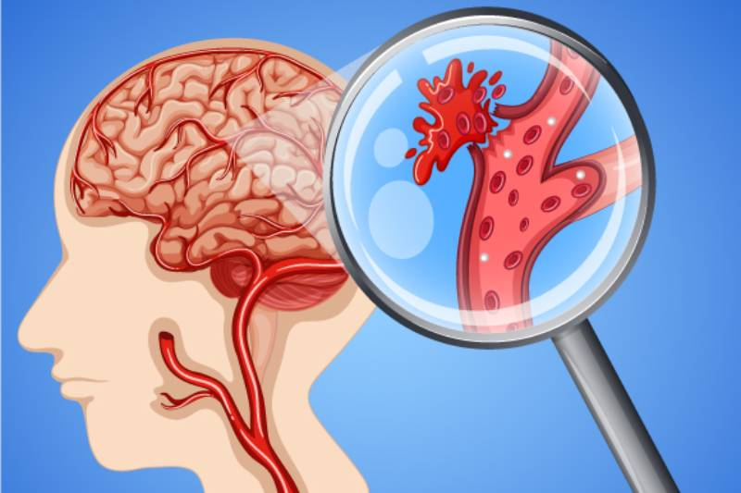

https://www.bordeclinicpune.com/wp-content/uploads/2023/10/Understanding-Stroke2.jpg

- This kind of inequality assumes that biological discrimination, variability in the weight of the vascular risk factors, and structural determinants, including socioeconomic disparities and unequal access to healthcare, work in complexes (Venketasubramanian, 2025; Marshall et al., 2023).
- They are also present in the healthcare delivery systems and have been observed to cause the creation of unequal treatment flows and access to rehabilitation (Emmett et al., 2025; Metcalf & Zhang, 2023).
- A critical approach to the analysis of stroke among ethnic minorities in UK, in its turn, would include getting out of the descriptive epidemiology of the issue and into the interrogation of the process, service systems and policy systems that continue to be part of the stroke pathway that remain such a lack of equity (Venketasubramanian, 2025; Emmett et al., 2025).
- This booklet critically analyses stroke as a chronic condition among ethnic minorities in the UK in terms of epidemiology, the distribution of risk factors, physical and and psychosocial consequences, theoretical models for improving outcomes, NHS management pathways and national political agendas (Marshall et al., 2023; Venketasubramanian, 2025).
- It concludes by proposing recommendations aimed at strengthening person-centered, culturally competent and equity-focused care across the stroke pathway (Emmett et al., 2025; Al-Batat et al., 2025).

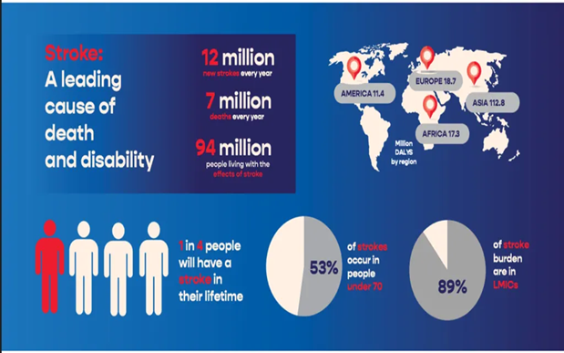

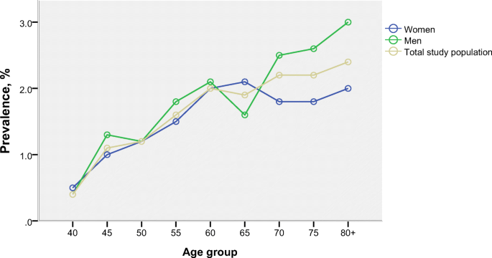

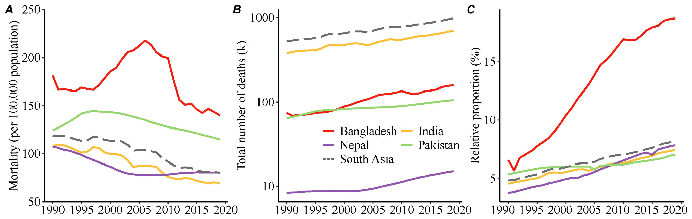

Global and UK Burden of Stroke
- Globally, stroke is the second leading cause of death, and a major contributor to disability adjusted life years (Owolabi et al., 2017). It is disproportionate to socially disadvantaged and structurally disadvantaged groups (Owolabi et al., 2017).
- The incidence and mortality rates are found to vary significantly between African and European populations, with a higher incidence and mortality among African populations, as indicated by Owolabi et al. (2017).
- The UK stroke rates stand at approximately 100,000 cases every year, with inequalities in the ethnic outcome always existing (Fluck et al., 2023). According to Marshall et al. (2023), it is more common among younger Black populations.
- The occurrence of such differences in stroke severity has also been reported in other countries (Fayed et al., 2025), which further supports the role of socioeconomic and structural factors (Bonnechere et al., 2023).

Types of Strokes
Strokes are classified into two main types based on the underlying cause and pathology:
- Ischemic stroke: It is a disorder whereby blood supply to the brain is compromised by the presence of a clot or another blockage, and it will lead to a hindrance of the blood flow to the brain tissues, carrying oxygen and other nutrient-rich substances.
- It is the most common type of stroke and it is this type of stroke that is the cause of the strokes at 80-85 percent of the total strokes.

It is also divided into two subtypes:

- Thrombotic Stroke: It is a stroke that develops due to the development of a clot in one of the blood vessels supplying the brain.
- Embolic Stroke: It is a stroke that is caused by the formation of a clot or other debris in another portion of the body, such as the heart, and is then transferred to the brain, where it blocks a smaller artery.

- Haemorrhagic Stroke
- Haemorrhagic stroke is a bleeding (haemorrhage) of the brain that occurs as a consequence of the rupture of a blood vessel in the brain or one that is close to the brain.

- They claim that this form of stroke accounts for 15-20% of all strokes. The haemorrhagic stroke.
- however, can be classified into two broad categories:

- Intracerebral Haemorrhage: There is the presence of blood in the tissue of the brain per se, and this may be due to hypertension, aneurysm, or trauma.
- Subarachnoid Haemorrhage: This is a brain complication or disorder that causes the development of blood between the brain and the brain cover, which is an abnormality and is usually caused by the rupture of an aneurysm.
- Both such strokes result in damage to the brain, but the manner in which these disorders are addressed, as well as the processes, is different.

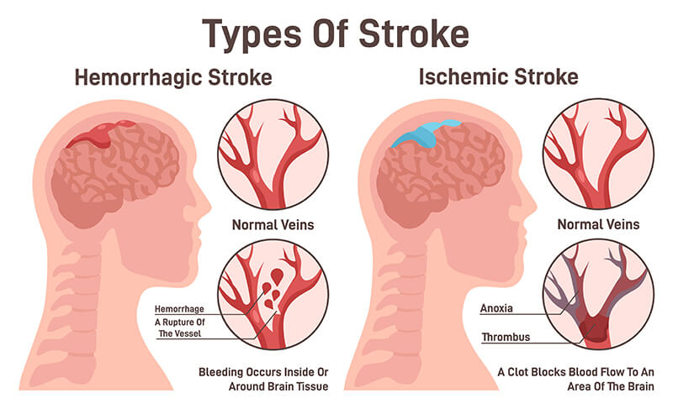

Risk Factors in the Ethnic Minority Populations: Modifiable and non-modifiable.
- Modifiable Determinants
- Age: the older an individual, the greater the risk of getting a stroke. The ethnic minorities in the UK face the risk of contracting a stroke earlier compared to the whites in Britain.
- Sex: There is the factor that gender is predictive of stroke, and men are more prone to stroke, but this will be determined based on ethnicity.
- Genetic Predisposition: Genetic factors could be used to predispose to stroke, i.e., salt sensitivity, insulin insensitivity, and fat metabolism.
- Vascular Pathology: There are ethnic groups that are more vulnerable to haemorrhagic stroke and other vascular pathologies, such as the African population.

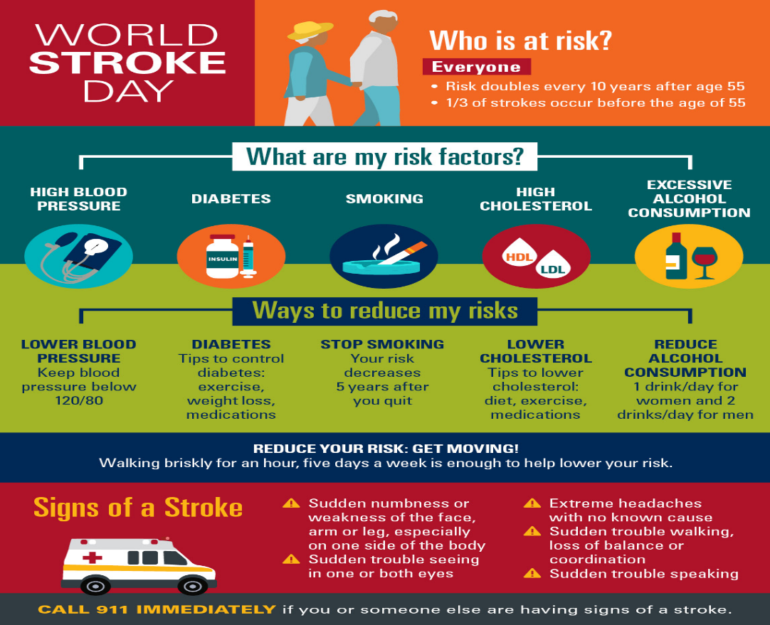

- Signs and Symptoms of Stroke

- Sudden numbness or weakness: It usually impacts a section of the body, though it is especially prevalent in the face, arm, or leg, in particular.
- Sullied Speech: Problems with speaking, speech understanding.

- Vision problems: They develop an abrupt impairment in the employment of one eye/ both eyes, and it may be blurred or cause the individual to see two objects.
- Sudden difficulty walking: Dizziness, lack of balance, or performance issues.
- Acute headache of undetermined etiology, best typified by the most severe headache the patient has ever experienced (characteristics of hemorrhagic stroke).
- Swallowing (dysphagia) is the inability to ingest food or liquids, which leads to the feeling of being choked or coughing upon ingesting food.
- Alternatively, acute coordination/motor control deficiency: Fine motor problems, e.g., shirt buttoning or holding something.
- They are also unexpected and sudden symptoms, and so, there is a prerequisite to take an excessive action to avail health care immediately. These pointers are determinable to alleviate the impact of the strokes in the long run.
- Act FAST:
- F: Face drooping
- A: Arm weakness
- S: Speech difficulty
- T: Time to call 999
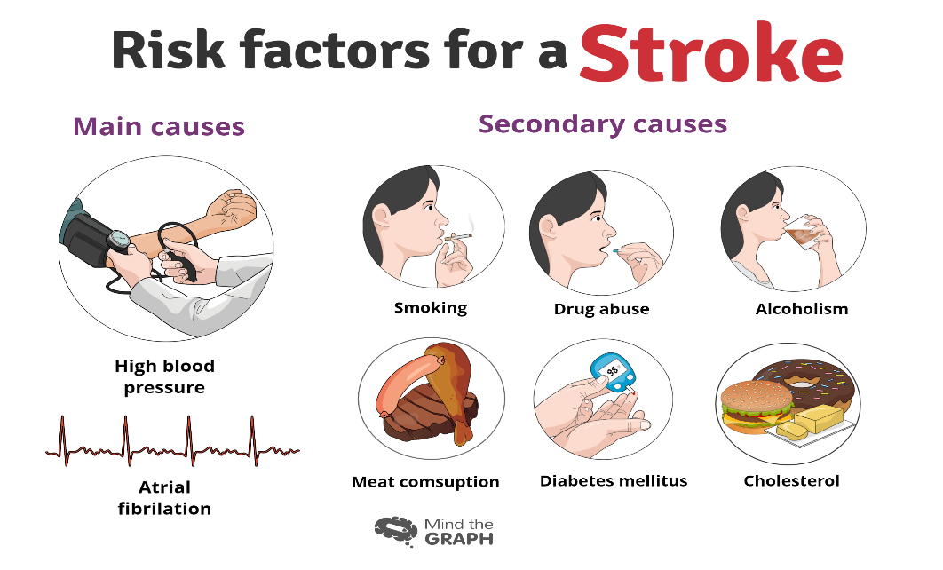

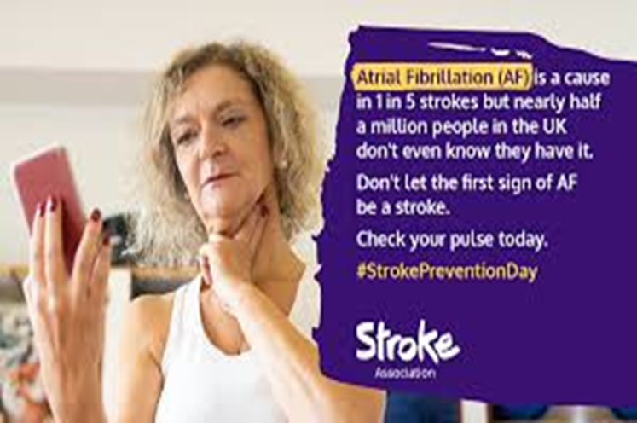
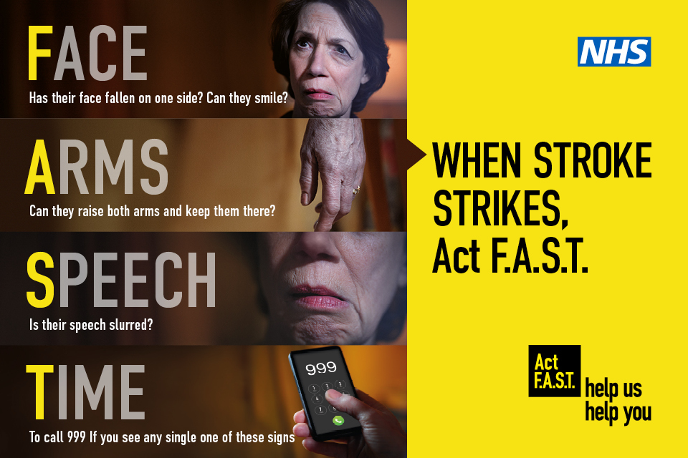

Modifiable Determinants
- Hypertension: The most significant modifiable risk factor, especially prevalent in Black African and Caribbean populations.
- Diabetes and Metabolic Syndrome: Increased risk of ischemic stroke, particularly in South Asian populations in the UK.
- Obesity and Central Adiposity: Increased risk of stroke, particularly in South Asian populations.
- Socioeconomic Factors: Poor socioeconomic status can exacerbate stroke risk, influencing access to care and healthy living conditions.
- Lifestyle Factors: Diet and physical inactivity, influenced by socioeconomic conditions, contribute significantly to stroke risk.
- Structural Determinants: Racism, work stress, lack of preventive care, and healthcare access barriers further heighten stroke risk in ethnic minorities.

Aetiology of Stroke in Ethnic Minority Populations
- The etiology of stroke in ethnic minority populations is complicated, and it reflects the combination of biological predisposition, vascular pathology and structural risk factors (Aparicio et al., 2025; Bonnechere et al., 2023).
- While stroke is fundamentally a vascular phenomenon, its aetiology is heterogeneous and differs across ethnicities (Qian et al., 2025).
- It has also been indicated that the African descendants are more likely to have hemorrhagic stroke and a later onset age of cerebrovascular disease compared to European citizens (Aparicio & Springer, 2025).
- The reason may be the difference in vascular responsiveness, salt sensitivity, and endothelial dysfunction caused by hypertension (Bonnechere et al., 2023).
- However, a biomedical explanation cannot be considered the only one to account for the persistent differences (Green et al., 2019).
- The socio-ecological model is also a suitable conceptualization of stroke aetiology, accounting for social status and access to care (Frisullo et al., 2024).
- The pathways of inflammation and hypertension perpetuation that support vascular damage are perpetuated through the role of the chronic conditions of psychosocial stressors, including structural

racism, socioeconomic deprivation and employment stress, and so on (Green et al., 2019; Aparicio & Springer, 2025).
- The obstacles to healthcare and timely treatment also affect the disease course and its consequences (Frisullo et al., 2024). Therefore, the aetiology of stroke in ethnic minorities cannot be reduced to genetic determinism (Bonnechere et al., 2023).
- Instead, it is the consequence of a biological weakness, in combination with structural and social injustices across the life span (Aparicio & Springer, 2025; Qian et al., 2025).

Physical Impact and Long-Term Disability
- Hemiplegia, aphasia, dysphagia, impaired cognition and chronic fatigue are some of the long-term consequences of stroke (Mital et al., 2021).
- The disabilities may lead to the irreversible collapse of work in the long term and to an inability to function without the services of healthcare and social care (Bonnechere et al., 2023).
- As they are unveiled, the representatives of racial and ethnic groups differ in terms of possibilities of hyperacute treatments and the after-stroke conditions (Acton et al., 2022; Nanavati et al., 2024).

- The acute stroke trials also fail to represent minority groups, and there is no opportunity to generalize the evidence, leading to the equity in care pathways (Nanavati et al., 2024; Acton et al., 2022).
- The availability of reperfusion therapies would decrease, as cases are reported late and health care visits cannot be offered due to institutional barriers, leading to long-term disability (Mital et al., 2021).
- Long-term disability is one of the disabilities because it presupposes conditions that can be considered economically reasonable under the assumption that nothing exists in the form of occupation, social interdependence, and dependence (Bonnechere et al., 2023).
- The impacts are particularly high in reference to socioeconomic status among the socially disadvantaged populations and minority groups who contribute to the preexisting inequalities (Diaz & Rosendale,2023).


Emotional and Psychological Impact
- Post-stroke depression affects a substantial proportion of the survivors and is also associated with the reduced rate of visits to the rehabilitation center and the higher mortality rate (Mital et al., 2021). Anxiety, mental suffering, and mental decline are also related to stroke (Bonnechere et al., 2023).
- The other factor, in which ethnic and racial disparities in the post-stroke outcome may even be worsened, is the disparity in access to culturally competent mental health services (Nanavati et al., 2024).
- Cultural beliefs of mental illness and distrust in healthcare systems in relation to widespread awareness and reporting of their symptoms may affect minority communities (Diaz & Rosendale, 2023).
- The unequal healthcare services can also be another possible barrier to the delivery of psychological rehabilitation services (Acton et al., 2022).
- Consequently, to ensure that the aspects of the holistic stroke care are culturally sensitive, screening and joint psychological support should be provided (Mital et al., 2021).

Society and family implications
- Stroke disrupts the family and the process of care, which in the majority of instances involves informal long-term care (Bonnechere et al., 2023).
- In many cases, informal carers experience psychological burden, which places a strain on the economy and leads to non-participation in the labor market (Diaz & Rosendale, 2023).
- Other obstacles minority ethnic family members may encounter include language barriers and the unavailability of culturally desirable rehabilitation services (Nanavati et al., 2024).
- The socioeconomic deprivation is shown to be closely interrelated with poor stroke outcomes and increased dependency on care (Bonnechere et al., 2023).
- Long-term recovery patterns also vary due to inequalities in the receipt of stroke services (Acton et al., 2022).
- These findings suggest that managing the question of social care provision and culturally responsive health in an ethnically diverse community requires a complex approach (Mital et al., 2021).



Evidence-Based management of the NHS

Hyperacute Care
- The NHS stroke care emphasizes rapid assessment of the specialist stroke units, neuroimaging, intravenous thrombolysis within 4.5 hours and mechanical dislodgement of the large vessel occlusion.
- This has been made possible by the centralization of services in metropolitan regions, which has improved survival outcomes (Marshall et al., 2023).
- Equal access remains vital. Variations in the application of treatments across countries raise
concerns about inequalities in UK systems (Metcalf & Zhang, 2023).

Secondary Prevention
- The secondary interventions include antiplatelet therapy, anticoagulation during atrial fibrillation, statin therapy, hypertension treatment, and glycemic control (Pantoja-Ruiz et al., 2026).
- Atrial fibrillation is a sensitive condition that requires detection and treatment to reduce recurrence (Venketasubramanian, 2025). Community-based blood pressure screening and education tailored to cultural requirements should be provided to high-risk ethnic groups (Ryan, 2010).

Rehabilitation
- Multidisciplinary rehabilitation helps facilitate functional recovery and reintegrate. The result is improved with the availability of special stroke units (Marshall et al., 2023).
- However, the services may have uneven availability across both cultural and geographical sites (Ryan, 2010).

Theoretical Frameworks for Improving Outcomes

UK Model: Integrated Care Systems and Population Health
- The model of the NHS Long Term Plan and Integrated Care Systems (ICSs) aims to control and minimize inequalities within the nation.
- The ethnic minorities are the priority populations that the Core20PLUS5 identifies ethnic minorities as priority cardiovascular intervention. The SLSR demonstrates that data from the population can be used to make service development equitable (Marshall et al., 2023).
- However, the policy rhetoric must be translated intoreduced.

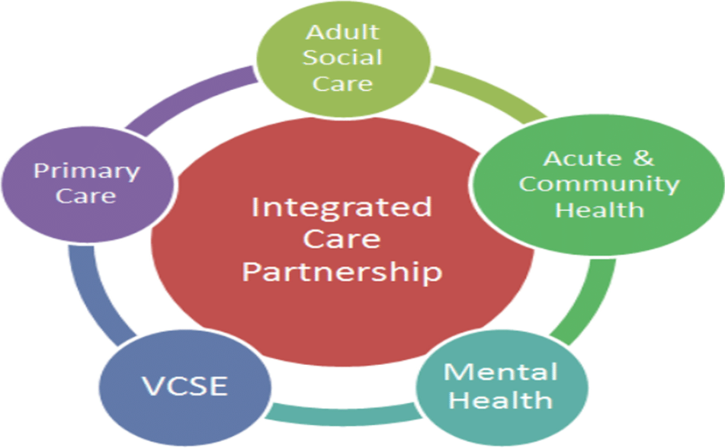

International Model: Social Determinants of Health
- The concept of equity in health disparities, as developed by the WHO Social Determinants of Health, views health disparities as outcomes of socioeconomic and political systems. Venkitasubramanian et al. (2023) emphasize that disparities in
strokes are more institutional in nature and should be addressed by remodeling the institutional context.
- According to this model, stroke management is redefined as a societal problem rather than a behavioral failure (Razieh et al., 2022).

Health Policy and Political context
- The National Stroke Strategy and the Sentinel Stroke National Audit Programme (SSNAP) have helped improve accountability and standardize care.
- However, both ethnic disparities indicate partial implementation of the policy (Pantoja-Ruiz et al., 2026).
- Ethnicity-stratification audit data should be obtained regularly to monitor equity. Although overall death rates have been declining, not every group has declined by the same amount (Marshall et al., 2023).
- Greater political dedication to tackling health disparities must cease to be premised solely on aspirations and instead be underpinned by specific, culturally competent measures (Razieh et al., 2022).

Cultural Competence and Person-Centered Care
- Person-centered care presupposes the necessity to value cultural beliefs of patients and their views on health and social environment within the context of different ethnic groups (Razieh et al., 2022).
- They ought to engage professional interpreters regularly to ensure effective communication and equitable clinical decision-making (Ikeme et al., 2022).
- Shared decision-making should also involve family members, particularly in communities where decision-making is collective (Kamtchum-Tatuene et al., 2025).
- Culturally competent practice must avoid ethnic differences in stroke outcomes along the stroke pathway (Peters et al., 2020; Shiekh et al., 2019).
- The promotion of cultural competence is one of the special requirements, given that ethnic differences in cardiovascular risk profiles persist in the UK (Razieh et al., 2022).
- Underrepresentation of minority populations in stroke studies causes the lack of evidence in clinical practices and renders them not externally valid (Ikeme et al., 2022).
- Increased inclusivity of research also makes the intervention more applicable and increases confidence in healthcare systems (Kamtchum-Tatuene et al., 2025).
- Stroke research must be well-balanced to avoid culturally inappropriate prevention and treatment (Peters et al., 2020).

Supporting Self-Management and End-of-Life Care
- Engagement and control risks in the long term should be improved through cultural adaptation and linguistic accessibility of self-management education (Razieh et al., 2022).
- Peer support groups and community collaboration can enhance participation and reduce social isolation, both of which are independent predictors of stroke risk (Smith et al., 2021).
- Digital health interventions must consider literacy levels, access to technology, and socioeconomic differences to avoid the growing inequalities (Ikeme et al., 2022).
- Community-based solutions are particularly applicable when the incidence of stroke and the cost of care are expected to rise in the UK (King et al., 2020).
- The severe stroke situation requires advanced care planning to be done in a culturally and religiously sensitive manner (Clery et al., 2020).
- Culturally responsive palliative care helps foster dignity and reduce end-of-life psychological distress (Peters et al., 2020).
- The recognition of ethnic disparities in stroke risk factors and cardiovascular disease rates underscores the importance of customized care planning (Kamtchum-Tatuene et al., 2025). Optimizing culturally competent end-of-life care within stroke pathways will help deliver holistic, equitable services (Ikeme et al., 2022).

summary
- In summary stroke remains a significant long-term condition characterized by ethnic disparities in the UK healthcare system is stroke (Razieh et al., 2022).
- Although there is significant progress in acute treatment and rehabilitation to guarantee survival, increasing disparities in
incidence, burden of risk factors, and chronic outcomes have already been reported (Clery et al., 2020; Ikeme et al., 2022).
- Biological hazards are co-morbid with structural factors of socioeconomic inequality and systemic bias, which shape various outcomes by ethnic group (Smith et al., 2021; Kamtchum-Tatuene et al., 2025).
- The need to address inequities has been illustrated in arguments that show the prevalence of strokes and the cost of stroke will continue to increase (King et al., 2020).
- This would mean that stroke response in the ethnic minority population would be a hybrid of high-quality clinical services and culturally competent care, community services and policy changes (Ikeme et al., 2022).
- Concerns about inequality should be addressed with a genuine commitment to creating an equity-based service that enables UK stroke survivors to achieve improved outcomes (Razieh et al., 2022).

A Patient Story
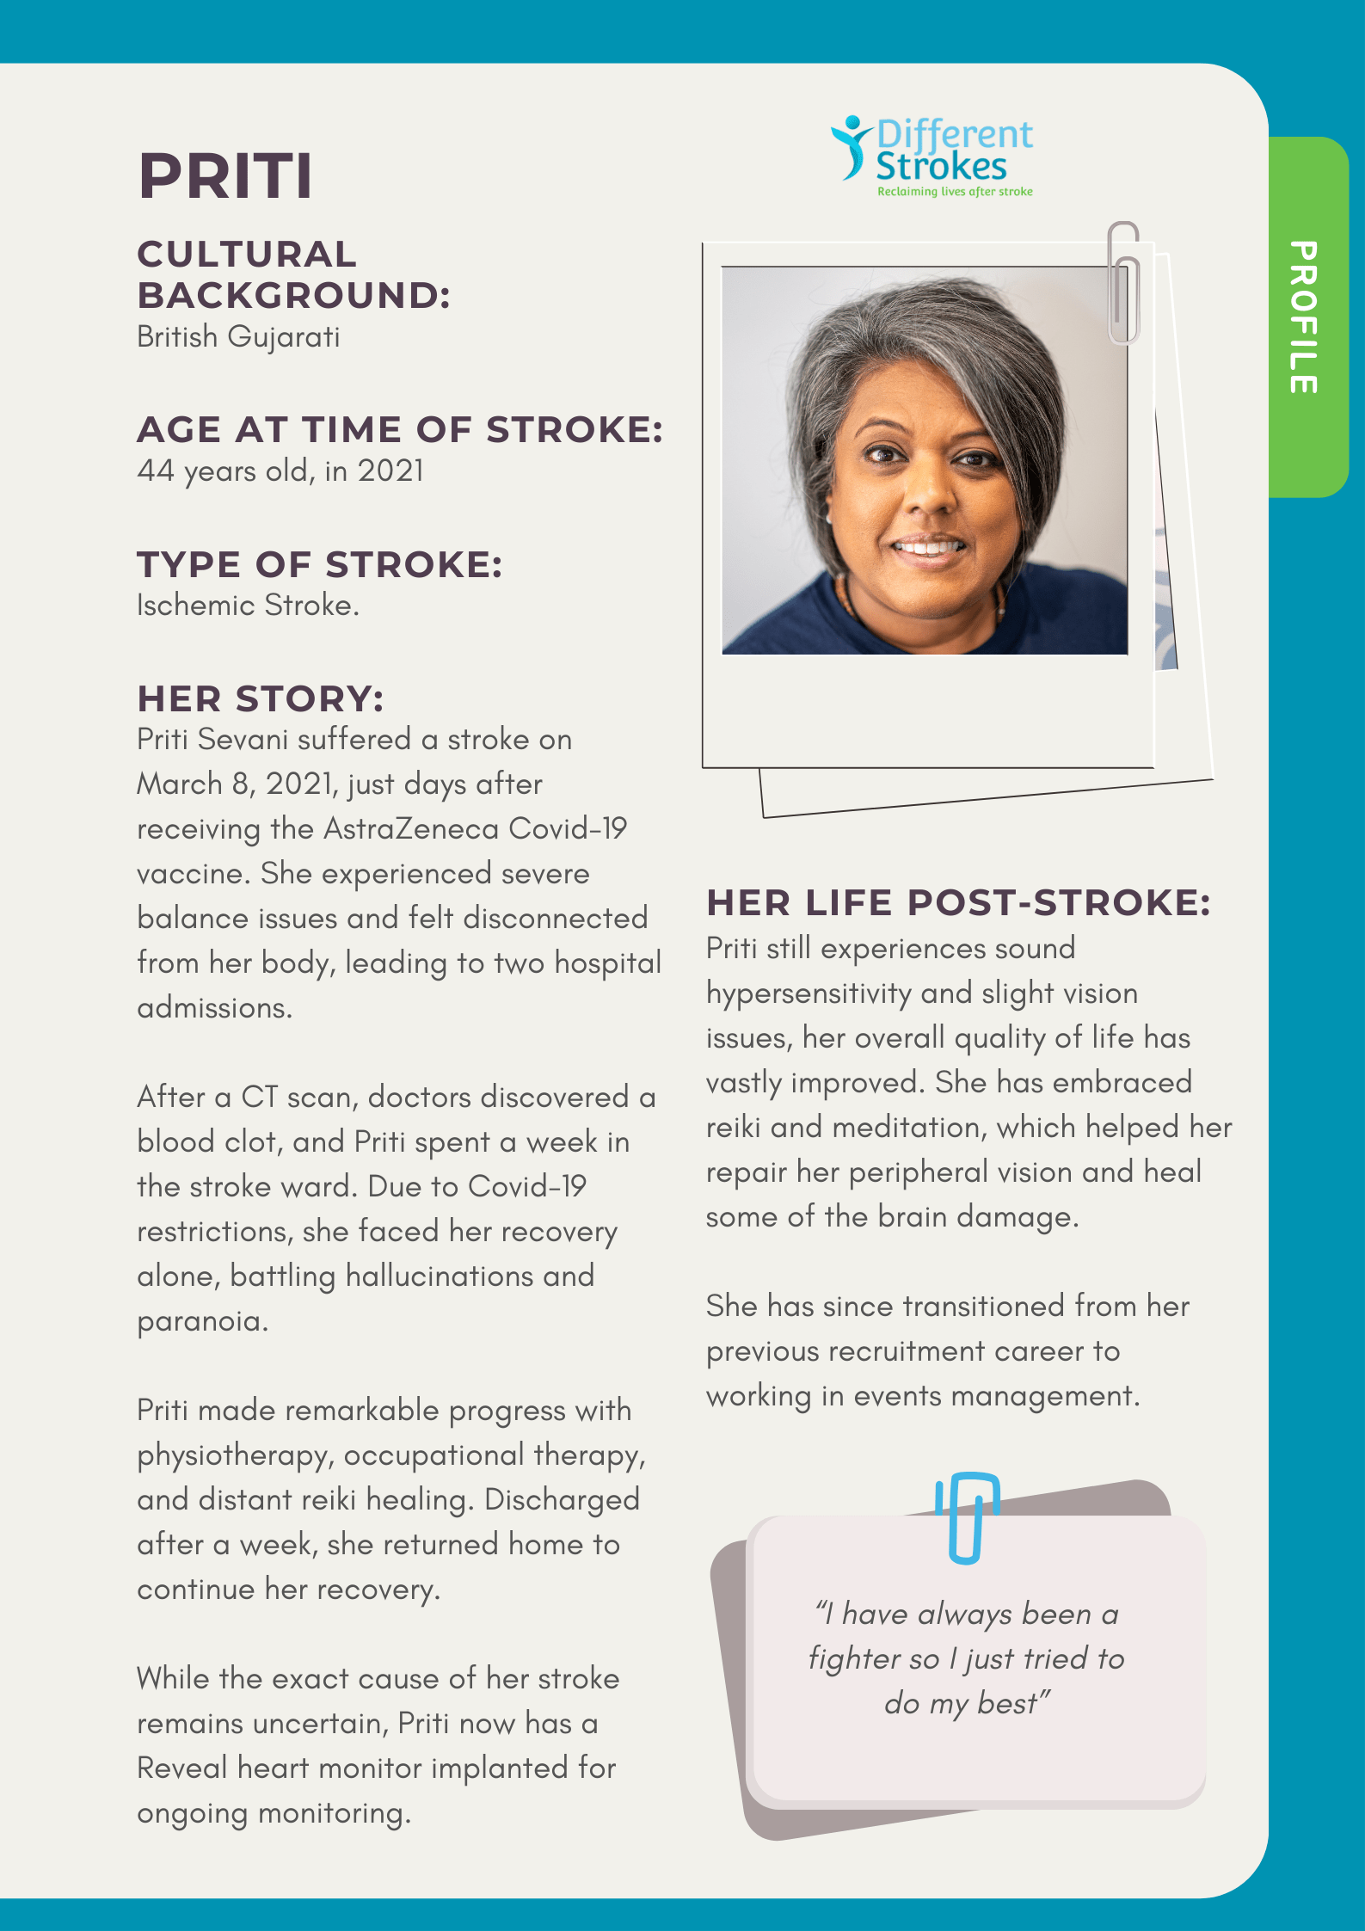

FOR MORE INFORMATION
Where To Get Help (UK Stroke Support)
- The NHS Provides ongoing medical support and rehabilitation.
- They can also signpost you towards different kind of support.

www. Nhs.uk/ conditions/stroke
Trusted UK organizations:
• Stroke Association
Website: www.stroke.org.uk
Provides support, recovery advice, and helplines for stroke survivors across the UK.
• Different Strokes
Website: www.differentstrokes.co.uk
Offers peer support especially for younger stroke survivors and ethnic minority communities.
• InterAct Stroke Support
Website: www.interactstrokesupport.org
Provides emotional and cognitive support through interactive rehabilitation programmes.
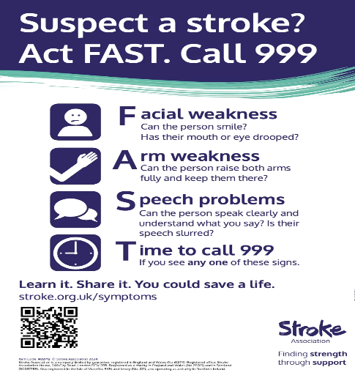

Reference list
- Acton, EK, Abbasi, MH & Kasner, SE 2022, ‘Evaluating Age, Sex, Racial, and Ethnic Representation in Acute Ischemic Stroke Trials, 2010 to 2020: A Systematic Review and Meta‐Analysis’, Journal of the American Heart Association, vol. 11, Ovid Technologies (Wolters Kluwer Health), no. 8, viewed 16 February 2026, https://www.ahajournals.org/doi/full/10.1161/JAHA.121.024651.
- Al-Batat, A. L., Pana, T. A., Mamas, M. A., Kontopantelis, E., & Myint, P. K. (2025). Sex and Ethnic Disparities in Stroke Revascularisation Treatments and Post-Stroke Outcomes in Patients with Heart Failure: A
- National Inpatient Sample Study. Journal of Clinical Medicine, 14(23), 8354. https://doi.org/10.3390/jcm14238354
- Aparicio, H. J., & Springer, M. V. (2025). Racial and Ethnic Disparities in Stroke Incidence and Outcomes. Current Cardiovascular Risk Reports, 19(1). https://doi.org/10.1007/s12170-025-00766-9
- Bonnechère, B., Liu, J., Thompson, A., Amin, N., & van Duijn, C. (2023). Does ethnicity influence dementia, stroke and mortality risk? Evidence from the UK Biobank. Frontiers in Public Health, 11. https://doi.org/10.3389/fpubh.2023.1111321
- Clery, A, Bhalla, A, Rudd, AG, Wolfe, CDA & Wang, Y 2020, ‘Trends in prevalence of acute stroke impairments: A population-based cohort study using the South London Stroke Register’, in JZ Willey (ed.), PLOS Medicine, vol. 17, Public Library of Science (PLoS), no. 10, p. e1003366, viewed 16 February 2026, https://journals.plos.org/plosmedicine/article?id=10.1371/journal.pmed.1003366.

- Diaz, MA & Rosendale, N 2023, ‘Exploring Stroke Risk Factors and Outcomes in Sexual and Gender Minority People’, Neurology Clinical Practice, vol. 13, Ovid Technologies (Wolters Kluwer Health), no. 1, viewed 16 February 2026, https://www.neurology.org/doi/full/10.1212/CPJ.0000000000200106.
- Emmett, ES, O’Connell, MDL, Pei, R, Douiri, A, Wyatt, D, Bhalla, A, Wolfe, CDA & Marshall, IJ 2025, ‘Trends in Ethnic Disparities in Stroke Care and Long-Term Outcomes’, JAMA Network Open, vol. 8, American Medical Association (AMA), no. 1, p. e2453252, viewed 16 February 2026, https://pubmed.ncbi.nlm.nih.gov/39786777/.
- Fayed, M., Peng, T. J., Skolarus, L. E., Sheth, K. N., Wong, K.-H., & de Havenon, A. (2025). Racial and Ethnic Disparities in Ischemic Stroke Severity in the National Inpatient Sample Between 2018 and 2021. Stroke. https://doi.org/10.1161/strokeaha.124.048532
- Fluck, D, Fry, CH, Gulli, G, Affley, B, Robin, J, Kakar, P, Sharma, P & Han, TS 2023, ‘Adverse stroke outcomes amongst UK ethnic minorities: a multi-centre registry-based cohort study of acute stroke’, Neurological Sciences, vol. 44, Springer Science and Business Media LLC, no. 6, pp. 2071–2080, viewed 16 February 2026, https://link.springer.com/article/10.1007/s10072-023-06640-z.
- Frisullo, G., Scala, I., Giovanni, J. D., Rizzo, P. A., Bellavia, S., Aldobrando Broccolini, Monforte, M., Franceschi, F., Gasbarrini, A., Carbone, L., Paolo Calabresi, & Covino, M. (2024). Racial and ethnic differences in access to care and treatment in patients with suspected acute stroke: A retrospective, observational, cohort study. Journal of the Neurological Sciences, 466, 123225–123225. https://doi.org/10.1016/j.jns.2024.123225
- Gardener, H, Sacco, RL, Rundek, T, Battistella, V, Cheung, YK & Elkind, MSV 2020, ‘Race and Ethnic Disparities in Stroke Incidence in the Northern Manhattan Study’, Stroke, vol. 51, Ovid Technologies (Wolters Kluwer Health), no. 4, pp. 1064–1069, viewed 16 February 2026,

https://www.ahajournals.org/doi/full/10.1161/STROKEAHA.119.028806.
- Green, T. L., Singh, P., & King-Shier, K. (2019). The impact of ethnic/racial status on access to care and outcomes after stroke: A narrative systematic review. Journal of Vascular Nursing, 37(3), 199–212. https://doi.org/10.1016/j.jvn.2019.07.002
- Ikeme, S, Kottenmeier, E, Uzochukwu, G & Brinjikji, W 2022, ‘Evidence-Based Disparities in Stroke Care Metrics and Outcomes in the United States: A Systematic Review’, Stroke, vol. 53, Ovid Technologies (Wolters Kluwer Health), no. 3, pp. 670–679, viewed 16 February 2026, https://www.ahajournals.org/doi/full/10.1161/STROKEAHA.121.036263.
- Kamtchum-Tatuene, J, Yiin, GSC, Li, L & Rothwell, PM 2025, ‘Ethnic Contrasts in Stroke Risk Factors and the Atrial Fibrillation Paradox in the United Kingdom’, Neurology, vol. 105, Ovid Technologies (Wolters Kluwer Health), no. 8, viewed 16 February 2026, https://www.neurology.org/doi/full/10.1212/WNL.0000000000214178.
- King, D, Wittenberg, R, Patel, A, Quayyum, Z, Berdunov, V & Knapp, M 2020, ‘The Future incidence, Prevalence and Costs of Stroke in the UK’, Age and Ageing, vol. 49, no. 2, pp. 277–282.
- Levine, DA, Duncan, PW, Nguyen-Huynh, MN & Ogedegbe, OG 2020, ‘Interventions Targeting Racial/Ethnic Disparities in Stroke Prevention and Treatment’, Stroke, vol. 51, Ovid Technologies (Wolters Kluwer Health), no. 11, pp. 3425–3432, viewed 16 February 2026, https://www. ahajournals.org/doi/10.1161/STROKEAHA.120.030427.
- Marshall, IJ, Wolfe, C, Emmett, E, Wafa, H, Wang, Y, Douiri, A, Bhalla, A & O’Connell, MD 2023, ‘Cohort profile: The South London Stroke Register – a population-based register measuring the incidence and outcomes of stroke’, Journal of Stroke and

Cerebrovascular Diseases, vol. 32, Elsevier BV, no. 8, p. 107210, viewed 16 February 2026, https://www.sciencedirect.com/science/article/pii/S1052305723002331.
- Metcalf, D & Zhang, D 2023, ‘Racial and ethnic disparities in the usage and outcomes of ischemic stroke treatment in the United States’, Journal of Stroke and Cerebrovascular Diseases, vol. 32, Elsevier BV, no. 12, p. 107393, viewed 16 February 2026, https://pubmed.ncbi.nlm.nih.gov/37797411/.
- Mital, R, Bayne, J, Rodriguez, F, Ovbiagele, B, Bhatt, DL & Albert, MA 2021, ‘Race and Ethnicity Considerations in Patients With Coronary Artery Disease and Stroke’, Journal of the American College of Cardiology, vol. 78, Elsevier BV, no. 24, pp. 2483–2492, viewed 16 February 2026, https://www.jacc.org/doi/epdf/10.1016/j.jacc.2021.05.051.
- Nanavati, HD, Andrabi, M, Arevalo, YA, Liu, E, Shen, J & Lin, C 2024, ‘Disparities in Race and Ethnicity Reporting and Representation for Clinical Trials in Stroke: 2010 to 2020’, Journal of the American Heart Association, vol. 13, Ovid Technologies (Wolters Kluwer Health), no. 6, viewed 16 February 2026, https://www.ahajournals.org/doi/full/10.1161/JAHA.123.033467.
- Owolabi, M, Sarfo, F, Howard, VJ, Irvin, MR, Gebregziabher, M, Akinyemi, R, Bennett, A, Armstrong, K, Tiwari, HK, Akpalu, A, Wahab, KW, Owolabi, L, Fawale, B, Komolafe, M, Obiako, R, Adebayo, P, Manly, JM, Ogbole, G, Melikam, E & Laryea, R 2017, ‘Stroke in Indigenous Africans, African Americans, and European Americans’, Stroke, vol. 48, Ovid Technologies (Wolters Kluwer Health), no. 5, pp. 1169–1175, viewed 16 February 2026, https://pmc.ncbi.nlm.nih.gov/articles/PMC5404953/.
- Pantoja-Ruiz, C, Khanolkar, AR, Ismail, I, Almirova, A, Lim, E, Soley-Bori, M, Kalansooriya, W, Emmett, ES, Douiri, A, Wyatt, D, Wang, Y, Chowla, R, Bhalla, A, Rudd, AG, Wolfe, CDA, O’Connell, MD &

Marshall, IJ 2026, ‘Widening Ethnic Inequalities in Stroke Incidence: A 30-Year Population-Based Analysis of the South London Stroke Register’, openRxiv, viewed 16 February 2026, https://www.medrxiv.org/content/10.64898/2026.01.13.26343995v1.full.
- Peters, SAE, Carcel, C, Millett, ERC & Woodward, M 2020, ‘Sex differences in the association between major risk factors and the risk of stroke in the UK Biobank cohort study’, Neurology, vol. 95, Ovid Technologies (Wolters Kluwer Health), no. 20, viewed 16 February 2026, https://www.neurology.org/doi/full/10.1212/WNL.0000000000010982.
- Qian, N., Lu, C., Wei, T., Yang, W., Wang, H., Chen, H., Li, J., Zhu, S., Wang, W., & Shao, N. (2025). Epidemiological trends and forecasts in stroke at global, regional and national levels. Journal of Stroke and Cerebrovascular Diseases, 34(8), 108347. https://doi.org/10.1016/j.jstrokecerebrovasdis.2025.108347
- Razieh, C, Zaccardi, F, Miksza, J, Davies, MJ, Hansell, AL, Khunti, K & Yates, T 2022, ‘Differences in the risk of cardiovascular disease across ethnic groups: UK Biobank observational study’, Nutrition, Metabolism and Cardiovascular Diseases, vol. 32, Elsevier BV, no. 11, pp. 2594–2602, viewed 16 February 2026, https://www.sciencedirect.com/science/article/pii/S0939475322003295.
- Ryan, T 2010, ‘Stroke awareness among British ethnic minorities’, British Journal of Community Nursing, vol. 15, Mark Allen Group, no. 8, pp. 381–384, viewed 16 February 2026, https://www.magonlinelibrary.com/doi/abs/10.12968/bjcn.2010.15.8.71946.
- Shiekh, SI, Forbes, H, Mathur, R, Smeeth, L, Pearce, N & Warren-Gash, C 2019, ‘Ethnicity and risk of diagnosed dementia after stroke: a cohort study using the Clinical Practice Research Datalink’, Journal of Epidemiology and Community Health, vol. 74, BMJ, no. 2, pp.
114–119, viewed 16 February 2026, https://jech.bmj.com/content/74/2/114.
- ‌ Smith, RW, Barnes, I, Green, J, Reeves, GK, Beral, V & Floud, S 2021, ‘Social isolation and risk of heart disease and stroke: analysis of two large UK prospective studies’, The Lancet Public Health, vol. 6, Elsevier BV, no. 4, pp. e232–e239, viewed 16 February 2026, https://www.thelancet.com/journals/lanpub/article/PIIS2468-2667(20)30291-7/fulltext.
- Trimble, B & Morgenstern, LB 2008, ‘Stroke in Minorities’, Neurologic Clinics, vol. 26, Elsevier BV, no. 4, pp. 1177–1190, viewed 16 February 2026,
- https://www.sciencedirect.com/science/article/abs/pii/S0733861908000698.
- Venketasubramanian, N. (2025). Stroke: Risk Factors, Mechanisms, Outcomes and Ethnicity. Journal of Cardiovascular Development and Disease, 12(6),199. https://doi.org/10.3390/jcdd12060199
- https://www.trihealth.com/services/trihealth-neuroscience-care/stroke-center/what-is-a-stroke
- https://www.bordeclinicpune.com/wp-content/uploads/2023/10/Understanding-Stroke2.jpg

