Name: Jennarong Trongklang

Student number: 1902236

Programme of Study: Outdoor Adventure Education

Module: Business Inquiry and Research

Tutor: Dr Roisin Mullins

Date: 23-04-2021, by 3pm

Introduction
I have written a report that presents my study of how the Covid-19 pandemic has affected the way people have undertaken outdoor activities. Covid-19 has given us many challenges such as not being able to see loved ones, however for people who enjoy using the outdoors for their leisure time, have struggled to keep up with their normal routine due to restrictions that the government have placed and complications of travelling to these outdoor areas. My Epistemology is to use a positivist approach where I will gather quantitive data; data that is known. We explored the epistemology and spoke about “interpretivism being part of epistemology in exploring qualitative research but for quantitative research the Epistemology is positivism” ( Mullins, 2021). Positivism is explained as not being about capturing the emotions, or feelings for deeper understanding ( Mullins, 2021), so that is why I chose to create a survey which captures factual data rather than an interview. Furthermore, positivists believe that the best way to observe the world is through objective methods, which means that the research captured is quantifiable ( Mullins, 2021). The ontology will be addressed through an objective understanding, so outside the individual (the researcher) ( Mullins, 2021).

My methodology used was the quantitive research approach which meant that my approach is structured; with questions that result in data which I can use to assess in a quantitative way. In quantitative research the approach to the study is to use methods to be as objective as is possible ( Mullins, 2021). Factual. For this instance I created a survey which consisted of 10 questions with predefined answers, so for example I asked what was their age and there was a list for the participants to choose from. Another example would be their gender, so they were given the choice of male, female and other so, these answers can be converted into a number for analysis later on. My participants will vary in types because this survey will be posted on a social media platform such as Facebook, so this sample size will only be limited to my friends list. This will affect my results when I am analysing my data because the sample size will be limited and only focused in a small area whereas a better sample would include a wider range of participants and random compared to using my social media friend list.

I chose to study this topic of the changes the Covid-19 pandemic has forced upon outdoor practitioners because I, myself, consider to be an outdoor practitioner and I have experienced the challenges faced when trying to undergo my regular outdoor activities. My University course also explores how outdoor practitioners are finding ways to still be active in the outdoors but using the local environment. Although the recent travel restrictions stopped many from taking unnecessary journeys, adventure travel; “travel to undertake novel, physically challenging activities in remote natural environments” became more popular and in demand ( Mackenzie & Goodnow, 2020, p. 1). There is a new concept created for this and it is called “microadventure”. “It still captures the essence of big adventures, the challenge, the fun, the escapism, the learning experiences and the excitement” (Humphreys, 2014, p. 14). So this would be a solution for the restricted, long distance, travel rules and also can be better for the environment because there will be less emissions produced by cars and planes. Whereas Microadventures require less distance to travel, because it involves adventure in local areas, and people can become more connected with their local natural environment. Market Research (2018) and WTO (2014) stated that, pre-pandemic, adventure travel was experiencing a significant growth globally. It grew by 195% from 2010 to 2014 and was expected to raise by 33% by 2023 (Allied Market Research, 2018; WTO, 2014).

Data Presentation and Findings

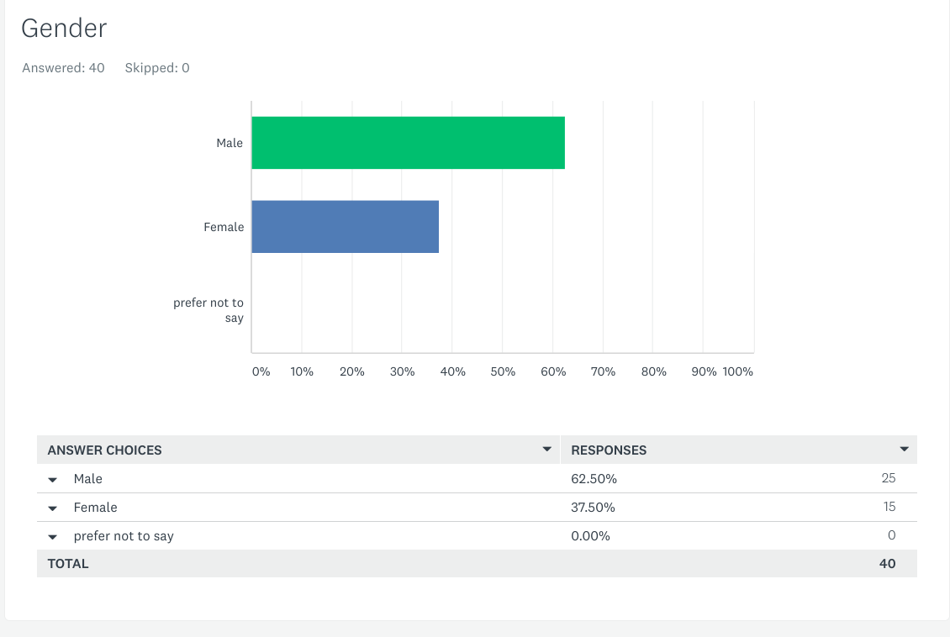

From my survey, there were a total of 40 participants altogether. This was because the survey app that I used was the free version of SurveyMonkey so they only allowed a maximum of 40 participants. Out of these 40 participants, 25 participants were male and 15 of the participants were female. I can already see that over 60% of my participants who enjoy taking part in outdoor activities were male. This can be seen when Davis (2018) states that “Adolescent girls and young women are less likely to engage in heart-rate raising recreational activities than their male peers, and when they do keep at it for shorter periods of time, research has revealed”. This suggests that there were more males who took part in the survey however, this result could be different if my sample size was bigger and more random whereas most of these participants were my friends.
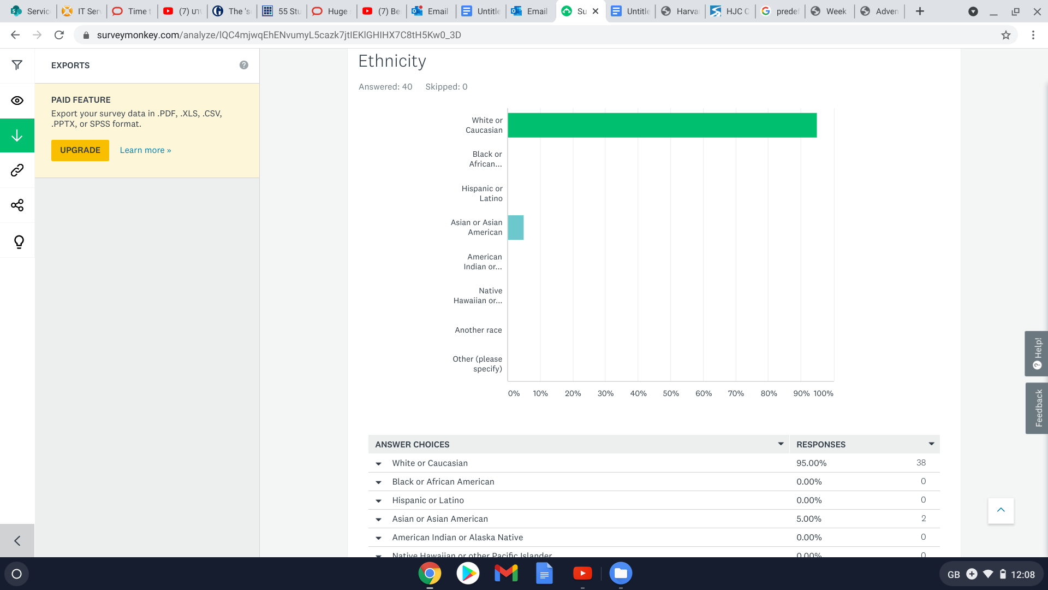

From this survey I can see that 95% of my participants were classed as white or caucasion. So this can suggest that more white/caucasion people have more access to the outdoors or that Asian/ Asian American people do less outdoor activities. Like mentioned above, if my sample size was bigger, then I could get a better picture of the ratio between the different ethnicity between my participants and link it to their usage of the outdoors.
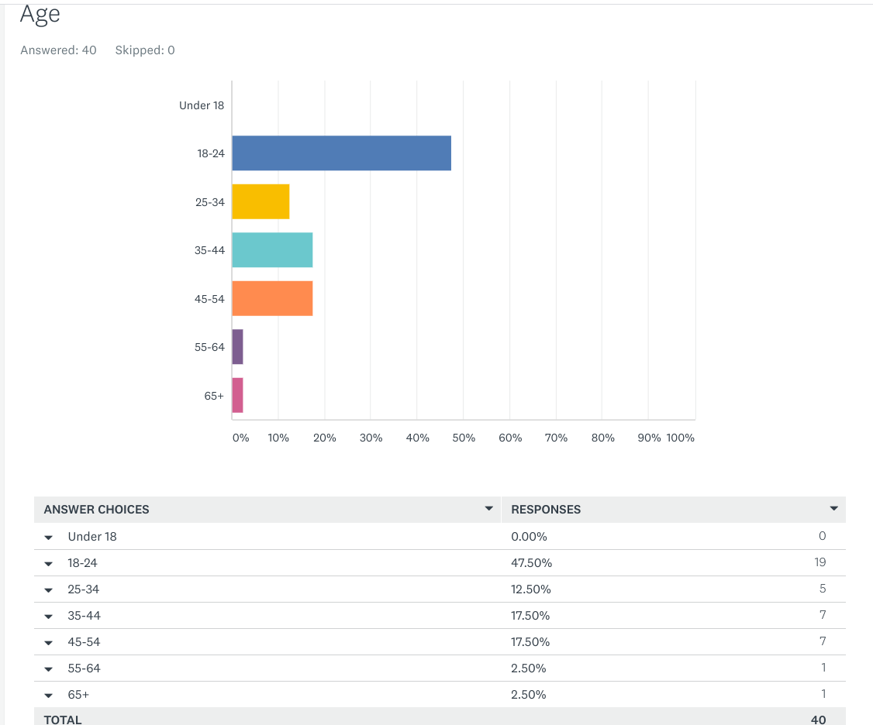
I can see that the majority of my participants were between the age of 18-24 so this suggests that the younger of the participants were more active. However, realistically, because of my age and due to the fact that most of the participants were my social media friends then they would be all around my age. This makes the survey data unreliable if I were to create factual statements from this research.

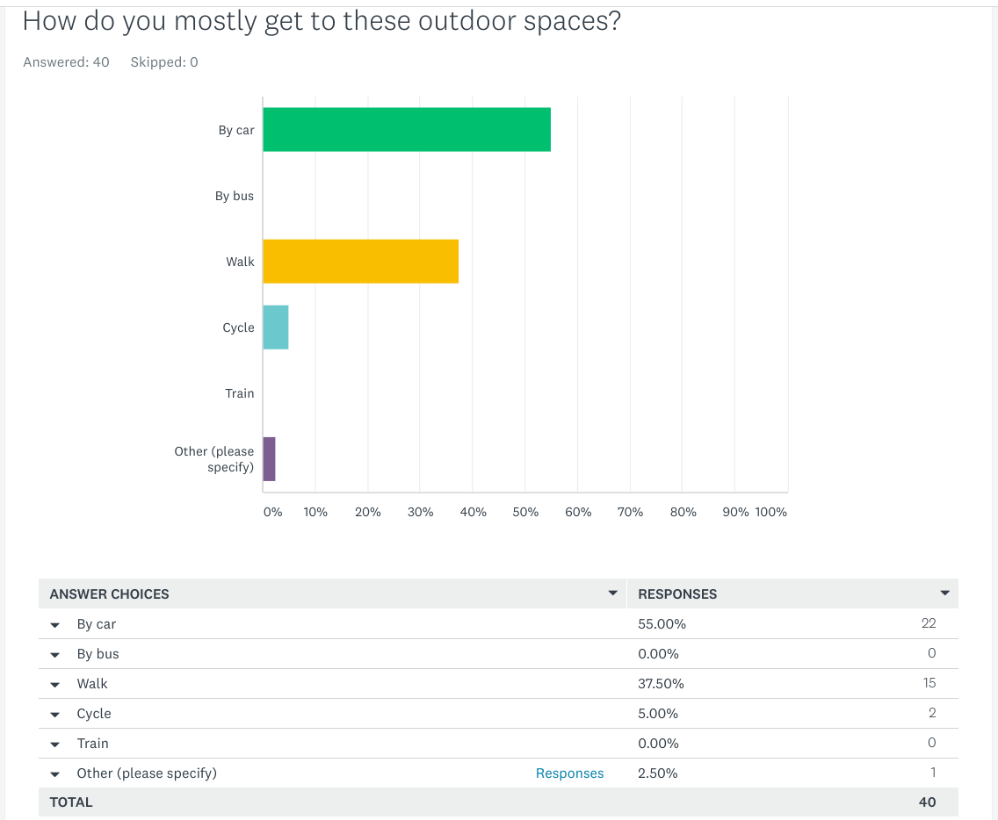
It seems that just over half of the participants used cars as a means of transport to get to the outdoor areas. This is either because it would be too far or too difficult to walk or it is much easier to take a car. Although taking a car is better than flying and travelling abroad, it would be better if they kept it local and travelled closer; complying with the Covid-19 travel restrictions. The second highest score of my graph above was that 15 out of the participants walk to the outdoor spaces. Only 2 participants cycled and 1 participant used other ways of travelling.
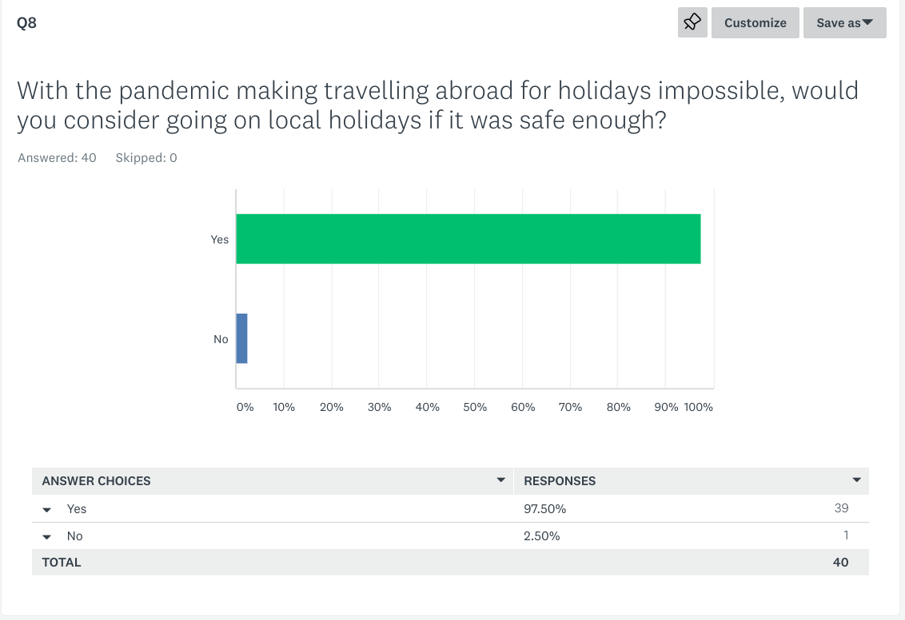
This graph shows that almost all, but 1, were willing to choose local holidays when holidays or travelling abroad were restricted. This suggests that they are willing to adapt and comply with the travel restrictions.

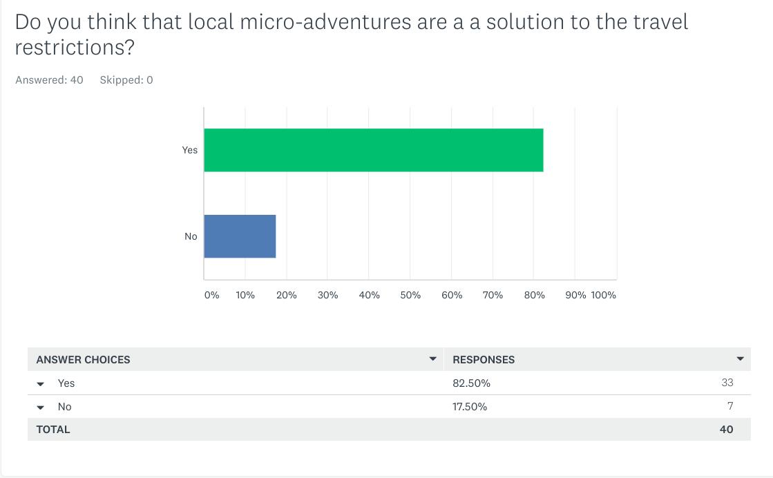

This question was asked to see whether the participants were willing to give this “microadventure” concept a chance and it could be the way forward for adventure participants for a while. Until the pandemic is over. This graph shows that over 80% were willing to adapt and that this would be a solution to the current conditions.
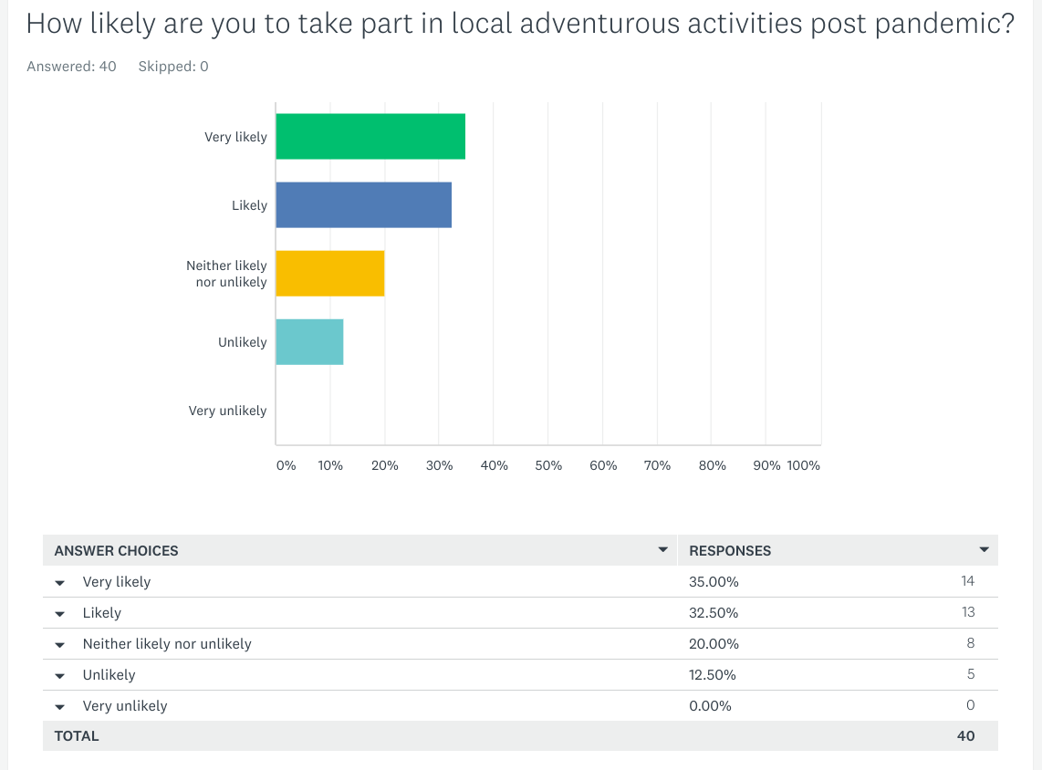
The answers from this question were mainly positive towards the idea of changing their regular outdoor activity schedules to using more local areas and travelling less distance which will benefit local communities aswell as the environment.

Conclusion/Reflection
To conclude, this method of research worked quite well because it was quicker to get answers from participants whereas the qualitative research style required timely interviews which meant that there were less participants involved. So a quantitive study makes it easier to gather more data and the data can be used to create graphs for further analysis. Creating the survey was relatively easy because SurveyMonky had templates and suggestions in place to help create the survey. SurveyMonkey also turned the answers into graphs ready to be anylised. If I were to do this study again I would like SurveyMonky to allow more participants to take part in my survey or use other ways to get more participants because this study only allowed me to have a limited participant population and they were mostly my social media friends. This was due to SurveyMonky only allowing me to share the survey on Facebook. I would also use other methods of data analysis tools such as excel or SPSS to analyse my data because the graphs from SurveyMonky limited what I could analyse. I could not link the data and compare them with each other.

Word count: 1357

References:

Humphreys, A. (2014). Microadventures: Local discoveries for great escapes. Williams Collins

Mullins, R. (2021) ‘Quantitive research’ [PowerPoint presentation]. Module code: Business inquiry and research BMSP5007. Available at: https://moodle.uwtsd.ac.uk/pluginfile.php/484073/mod_resource/content/1/Week%206%20Quantitative%20Foundations%206.0.pptx (accessed: 23/04/21).

Susan Houge Mackenzie & Jasmine Goodnow (2020): Adventure in the Age of COVID-19: Embracing Microadventures and Locavism in a Post-Pandemic World, Leisure Sciences, DOI: 10.1080/ 01490400.2020.1773984

World Tourism Organisation (WTO) (2014). Global report on adventure tourism. Retrieved from https://www.unwto.org/archive/middle-east/publication/global-report-adventure-tourism

