

MBA LCMB7024: MARKETING MANAGEMENT PORTFOLIO ASSIGNMENT
TITLE:- BRAND EXTENSION STRATEGY FOR CHANEL: LAUNCH OF CHANEL SKINSENSE - A HIGH-TECH SKINCARE LINE
STUDENT NAME:- NASIRBHAI MANUBHAI RATHOD
STUDENT ID:- 2412816
MODULE CODE:- LCMB7024
LECTURER:- TUSHARA BALENDRAN
THE WORD COUNT:- 2378
SUBMISSION DATE:- 28TH APRIL 2025

Index
1. Introduction 2
2. Overview of the brand extension: Chanel SkinSense 3
3. Segmentation, Targeting & Positioning (STP) 7
4. Customer Persona Development 8
5. Marketing Mix (7Ps) 10
6.Conclusion 12
7. References 13

1. Introduction
Founded by Gabrielle "Coco" Chanel in 1910, Chanel is a globally recognized French luxury fashion house known for elegance, timeless style, and high fashion. Through the decades so Chanel expanded beyond haute couture and became a leader in beauty, fragrances, accessories and skincare. Its emphasis on quality, innovation and subtle branding has helped make it a household name among prosperous consumers. But Chanel No. 5 is still one of the world’s most iconic perfumes, and its fashion lines are still among the benchmarks for luxury and elegance.
Chanel’s beauty business — especially its skincare and makeup lines — has come a long way over the past 20 years, thanks to R&D-led product development and a hard focus on luxury experiences. Luxury brands are challenged to innovate, without diluting their core values, as consumer preferences swing towards personalised wellness and tech-boosted beauty regimes. Given the proliferation of tech-enabled skincare and demand for data-driven, tailored solutions, Chanel is also uniquely positioned to engage in a tech-forward brand extension that is modern yet retains exclusivity.
Brand extensions are strategic vehicles that firms use to capitalize on their existing brand equity to enter new product categories, whether similar or completely different. Successful brand extensions can solidify market leadership for luxury brands like Chanel while aligning with changing consumer trends. The following document introduces a brand extension strategy for Chanel by establishing Chanel SkinSense, an exclusive high-tech skincare line that incorporates AI skin diagnostics alongside individualised skincare products. The portfolio consists of a brief summary on the extension, segmentation and targeting approaches, developed customer persona and an adapted 7Ps marketing mix. that enable companies to use their established brand equity to launch new products in closely-related or entirely new categories. For luxury fashion houses, like Chanel, a successful brand extension can reflect its dominance in the market and align with changes in consumer trends. In this report, we will use this information to work alongside their existing model to deliver a brand extension strategy which involves launching Chanel SkinSense - a luxurious high-tech skincare line that seamlessly marries AI skin diagnostics with personalised skincare products. This portfolio comprises an outline for the extension, segmentation and targeting strategies, a created customer persona, and a customized 7Ps marketing mix approach.

2. Overview of the brand extension: Chanel SkinSense
Table1 : Critical Features and Strategic Fit

Feature | Strategic Benefit
AI-powered skin diagnostics | Personalisation, tech appeal
Serum & skincare subscription | Recurring revenue, convenience
Clean, sustainable packaging | Aligns with green beauty trends
In-store personalised service | Reinforces luxury experience
Figure 1: Global AI Beauty Market Growth (USD Billion, 2020–2025)
Year | Market Size (USD Billion)
2020 | 2.1
2021 | 2.8
2022 | 3.6
2023 | 4.3
2024 | 5.1
2025 | 5.9 (projected)

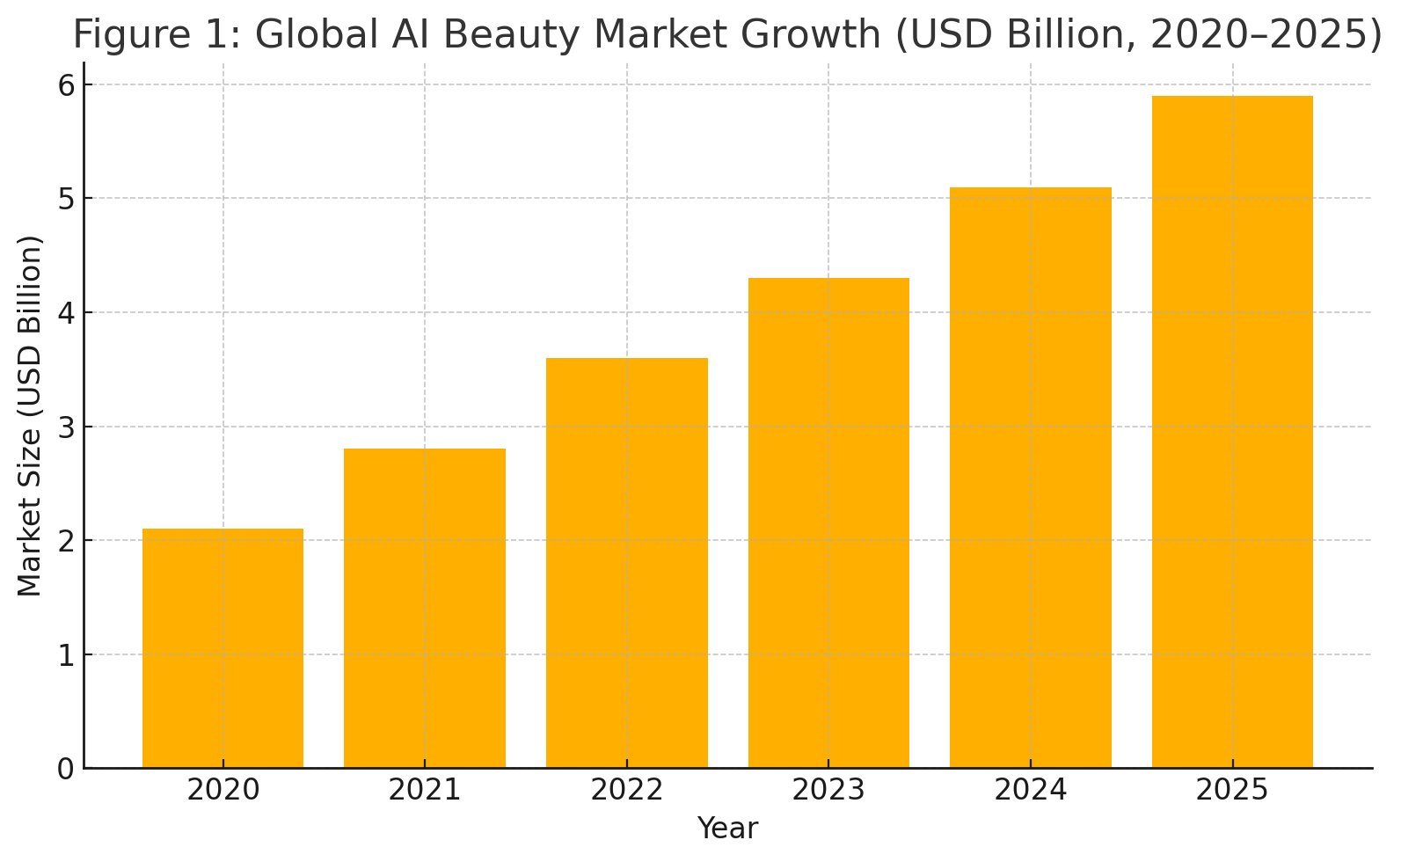
Source: Statista, 2024
Technology adoption sustainability is fettering the beauty industry, as demonstrated by the chart above, which shows tremendous growth in the global artificial intelligence beauty market and consumers' issues regarding tech-based skincare products. Several factors drive this trend, including growing consumer demand for personalisation, advances in AI and biotechnology, and a move towards proactive skin health management.
Consumers are demanding more re-usable and refillable products, and they are increasingly educated about the science of ingredients and technologies used to obtain pertinent results, favoring brands known to deliver hard-hitting results. Singh says: “The rise of AI-enabled applications like skin analysers and diagnostic apps is putting the onus in the hands of the consumer to understand their skin conditions and find tailored solutions.
Chanel’s SkinSense is perfectly suited to meet these changing perceptions in this arena. The expected increase from USD 2.1 billion in 2020 to nearly USD 6 billion in 2025 is also a lucrative opportunity. This growth not only reinforces a sound revenue model from product sales, but also enables the deployment of digital ecosystems, subscription models, and lifetime relationships with its customers.
In addition, the luxury skincare market is primed for innovation. Wealthy shoppers want high performance as well as premium experience. Chanel SkinSense leverages on this by fusing laser-precise focus with luxury service, offering something beyond what is capable for mass market offerings and proving Chanel's continued leadership in innovation and exclusivity. This growth underpins Chanel's timely entry into personalised skincare with the SkinSense brand extension.

Table1: Chanel, famed around the world for haute couture and legendary perfumes, including Chanel No. 5, has made strides in beauty and skincare. This brand extension is Chanel SkinSense, a tech-enabled smart skincare solution that fuses luxury with innovation and personalisation to make it possible to respond to evolving needs for individualised beauty experiences.
Rationale for Extension:
- Emergence of AI and bespoke beauty tech (Statista, 2024)
- Growing demand for science based non-invasive skin care
- The heritage of Chanel in skincare and beauty innovation
Market Snapshot The global AI beauty market was valued at USD 1.2 billion in 2019 and is expected to generate USD 13.3 billion by 2025, growing at a CAGR of 54.18% during the forecast period.
A bar chart here would show a rise from USD 2.1 billion in 2020 to an à USD 5.9 billion forecasted for 2025 — reinforcing why Chanel SkinSense is today and tomorrow.
(Chart Source: Statista, 2024)
Chanel, world famous for haute couture and its classic perfumes like Chanel No. 5, has made strides in beauty and skincare. So to answer the rising demand for personalised and tech-integrated skincare, this extension introduces Chanel SkinSense, a smart skincare solution that embodies the luxury, innovation, and personalisation of a solution like Chanel.
Key Features:
- AI-Driven Skin Scanner (app/device)
- Subscription for personalized serum and skin-care products
- Where do we go from here? Diagnostics in store and bespoke experiences
- Packaging and clean formulations driven by sustainability
Rationale for Extension:
- AI and personalised beauty tech on the rise (Statista, 2024)
- Rising demand for evidence-based and non-invasive skincare
- Chanel’s history with skincare and beauty innovation
Global AI Beauty Market Growth (USD Billion, 2020–2025) {Figure 1}
A bar chart here would show an increase from USD 2.1 billion in 2020 to an anticipated USD 5.9 billion in 2025, supporting why Chanel SkinSense is current and forward-looking.
—— Chart Source: Statista, 2024. —–
Chanel, a household name all over the world for haute couture and classic fragrances such as Chanel No. 5, has also been doing well in beauty and skincare. With the growing demand for personalized and technological skincare solutions, this extension suggests Chanel SkinSense – an intelligent skincare solution commanded by luxury, innovation and personalisation.
Key Features:
AI Skin Scanner (app/device)
Subscription of personalised serum and skin-care product
In-store diagnostics and personalized experiences
Packaging focused on sustainability and clean formulations
Rationale for Extension:
AI and personalised beauty tech taking off (Statista, 2024)
Rising preference towards science-based, non-invasive skincare
Chanel’s legacy of skincare and beauty innovation

3. Segmentation, Targeting & Positioning (STP)
In order for Chanel SkinSense to be successful, it’s important to understand and identify the right market segments. The systematic STP framework enables Chanel to identify its most promising consumer segments and develop a precise brand message that complements their values and preferences. Our segmentation strategy was multi-faceted, taking demographic, psychographic and behavioural aspects to encapsulate the modern luxury skincare consumer.
Segmentation:
Targeting Countries: Given the nature of the brand, we would recommend considering particular countries to target, based around communicated income levels and packed with a target demographic often most accessible to brands, as follows: Demographic: Similar to Chanel's existing offerings, the main target for Chanel SkinSense is women ages 25-45, predominantly city professionals and entrepreneurs with middle to high disposable income. This cohort is usually financially-self-sufficient, career-driven and investing heavily in self-care.
Geographic: Targeting metropolitan in the UK, Europe and key overseas luxury markets coordinated where Chanel has both retail and digital presence.
Psychographic: These consumers seek an aspiration and pay attention to health and appearance. They are seeking out premium lifestyle experiences and care about innovation and brand reputation.
Behavioural: Target consumers are loyal to luxury brands, frequently pay for high-end skincare, and are early adopters of beauty tech. They are also open to digital experiences such as virtual consultations and subscription services.
Targeting Strategy:
Chanel will adopt a differentiated marketing strategy that will target the niche of high-end skincare purchasers who would be more willing to use a technology-based clinical remedy. The target audience includes:
Wealthy millennial and Gen Z consumers
People already involved with Chanel’s beauty or fragrance products
Tech-savvy customers who demand and appreciate personalisation and AI-driven solutions
Marketing will be centered on digital channels, luxury fashion media, and select influencer partnerships to maintain relevance and aspirational positioning.
Positioning Statement:
“Chanel SkinSense delivers AI-personalised skincare for the modern woman who loves precision — all supported by Chanel’s legacy of luxury, innovation and elegance.”
Notably, this positioning sets Chanel SkinSense apart from a crowded field of generic skincare products, introducing an interesting mix of AI technology, intimate customisation, and the established luxury of the Chanel name.
Target Audience: Urban professionals, women, 25–45, middle to high income
Psychographic: Health-conscious, tech-savvy, brand-driven, focused on quality and prestige
Behavioural: Convenience-seeking, personalised care, loyalty to luxury brands
Targeting Strategy:
Marketing with differences aimed at urban millennial and Gen Z professionals with different self care, innovation and brand equity priorities
A positioning statement should read something like this: “For the contemporary woman who craves precision in her skincare, Chanel SkinSense; AI-personalised skincare that is a marriage of Chanel’s unrivalled tradition of luxury, innovation and sophistication.

4. Customer Persona Development
Table 3: Customer Persona – SkinSense by chanel

Attribute | Detail
Name | Sophia Laurent
Age | 32
Location | London
Occupation | Fashion Marketing Executive
Income | £65,000 annually
Interests | Skincare, technology, wellness, luxury brands
Pain Points | Time-poor, needs smart solutions
Media Consumption | Instagram, fashion blogs, skincare forums
Purchasing Habits | Online subscriptions, boutique visits

Sophia embodies the perfect Chanel SkinSense consumer: high interest in technology and indulgence, high purchasing power and lifestyle fit.
- Name: Sophia Laurent
- Age: 32
- Occupation: Fashion marketing executive
- Location: London
- Income: £65,000 annually
Demographics:
Single, resides in a city apartment
Post Grad, shops online like everyday
Psychographics:
Keeps up with beauty trends, spends money on self-care and wellness
Follows influencers — and keepers of skin.
At Harrods, Selfridges, and luxury beauty e-commerce sites
Motivations:
Values leading technology in beauty
Wants results-driven skincare
Faithful to brands rooted in luxury and innovation
Challenges:
Time-constrained lifestyle
Adjusting to skincare products that work with her evolving skin concerns

5. Marketing Mix (7Ps)
Table 2: Chanel SkinSense – 7Ps Marketing Mix Overview
Element | Strategic Focus
Product | AI diagnostics, customised skincare, premium design
Price | Premium, value-based tiers
Place | Online, Chanel boutiques, luxury counters
Promotion | Influencer marketing, digital campaigns, exclusive launch events
People | Expert advisors, AI chatbot support
Process | Seamless AI onboarding, refill logistics
Physical Evidence | Luxury packaging, in-store experience, personalised notes
Below each element of the mix is explained further;
Product
- That is, AI-based diagnostic type app/device
- Personalised skincare subscription box (cleansers, serums, moisturisers)
- Feeling good about using packaging that is high-quality and eco-friendly
- Design premium in sync with Chanel’s DNA
Price
- Premium price point (entry kit £180; monthly refils £90)
- Storytelling Ads with a premium pricing that allows for customisation
- Diagnostic use only versus full product use tiered pricing
Place
- Boohoo Man: boohooman.com Uk-based Boohoo Man’s offering is for the stylish and trendy man on a budget.
- Online Chanell and in-app subscription
- online exclusive enter occult with in-store skin analysis
Promotion
- Paired V with influencer collaborations and beauty tech events
- Digital ads tailored for skincare and technology fans
- Product education and how-to email campaigns
- Sampling at expensive events and spas
People
- In-store trained skin consultants
- Online support team and virtual skincare advisors
- Artificial Intelligence-based chatbot for app-to-user engagement
Process
- Smooth App/Device Onboarding
- AI analysis of skin in real-time and recommending products
- Quick delivery and tailored refill management
Physical Evidence
- Sophisticated minimalistic package and unique unboxing
- Personalized thank you notes and made-to-order refill bottles
- Store layouts at upscale stores displaying Chanel's brand DNA

6.Conclusion

Chanel SkinSense seems to provide a moment of opportunity that is both timely and strategically sound, offering the brand a way to extend its skincare portfolio in a manner that is true to its luxury legacy while also allowing it the freedom to innovate. Chanel is also positioned to take advantage of a beauty industry that is increasingly influenced by the intersection of technology and consumer demand for hyper-personalised solutions, supported by its reputation for elegance, quality and consumer trust. By integrating artificial intelligence with personalised skincare regimens, Chanel SkinSense both caters to the emerging consumer preference for custom skincare in the luxury market, as well as helps the brand to differentiate itself from traditional skincare offerings in that same space.
By employing a targeted segmentation, targeting, and positioning strategy, Chanel SkinSense makes certain that it caters to the specific preferences of modern, digital-native, and health-conscious individual who pays particular attention to precision and efficiency in their personal-care practices. By outlining a detailed customer persona of a consumer who matches all of these criteria, the brand can get a better sense of who their ideal customer is, what they want, and why they are motivated to buy, which can lead to better messaging and product offering. By maintaining the complete marketing mix (all 7Ps) for this extension, it exclaims closely with Chanel’s original core values, whilst demonstrating practicality and innovation within their product delivery and customer experience areas.
In addition, this diversification provides Chanel an opportunity to fortify its foothold in the already competitive skincare landscape, while paving the way for later, tech-infused wellness product innovation. However, it is the strategic opportunities for cross-category synergy — where fashion meets fragrance and where technology-enhanced beauty products intersect with new fashion and lifestyle formats — that could lead to more integrated brand storytelling channels, opening up opportunities for long-term customer loyalty. The inherent sustainability component of Chanel SkinSense also speaks to the changing role of luxury brands and their responsibility to behave responsibly and sustainably, with that increasingly factoring into purchase decisions among younger demographics.
All in all, Chanel SkinSense is a prime example of how the brand is not only solidifying its top dog status in the market but also re-defining boundaries when it comes to luxury innovations. It also shows that heritage brands can evolve in a way that makes sense, by bringing creativity, technology and insight into its consumer into its response to market trends. With a well-engineered plan the move from fashion to beauty with a tech edge can set the bar yet again in luxury tech as beauty becomes skindeep. because the booming personalised skincare market, employing technology, sustainability and luxury appeal, was the next frontier for the brand. The extension preserves the brand identity of Chanel, while catering to modern consumer needs, through well-defined STP, a clearly articulated customer persona, and a strategically aligned 7Ps marketing mix. One, the alignment of AI and skincare – this caters to the surge in demand for data-based, ritualized offerings, positioning Chanel as an innovator beyond fashion and into beauty-tech.

7. References
Chandon, P., Wansink, B., and Laurent, G. (2021). Brand Extension Strategies in the Luxury Market. Journal of Brand Management, 28(2), pp.175–194.
Kapferer, J.N. and Bastien, V. (2012). The Luxury Strategy: Break the Rules of Marketing to Build Luxury Brands. 2nd ed. London: Kogan Page.
Statista (2024). Global AI Skincare Market Value. [online] Available at: www.statista.com [Accessed 10 Apr. 2025].
Kotler, P. and Keller, K.L. (2022). Marketing Management. 16th ed. Harlow: Pearson.
Euromonitor (2023). Personalised Beauty: Global Industry Trends and Forecasts.

