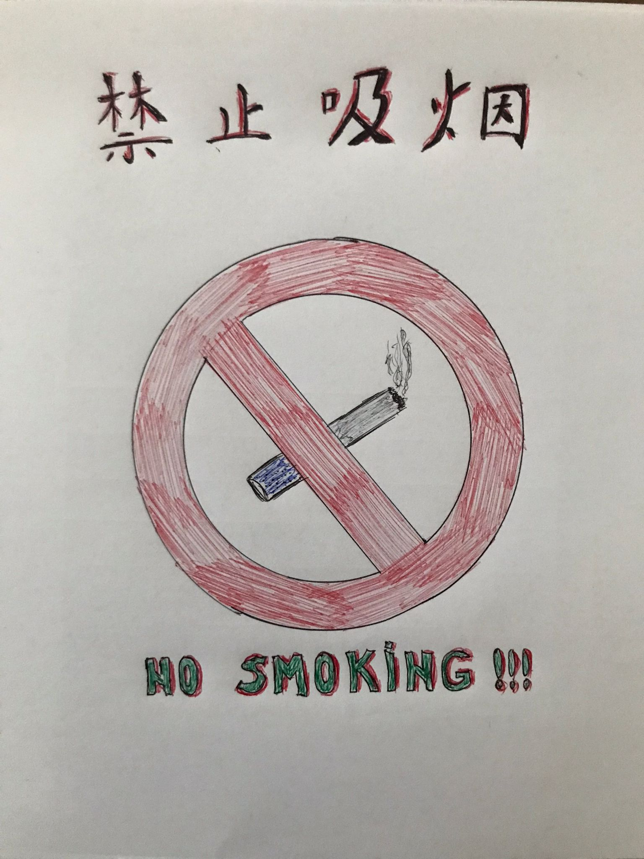

Hello, Li laoshi ! This is the assignment number 4, and I choose the “NO SMOKING” sign for a hotel ! hope this is well. Thank you very much,
Kind regards,
Mihai-Andrei Matei (2021030)

