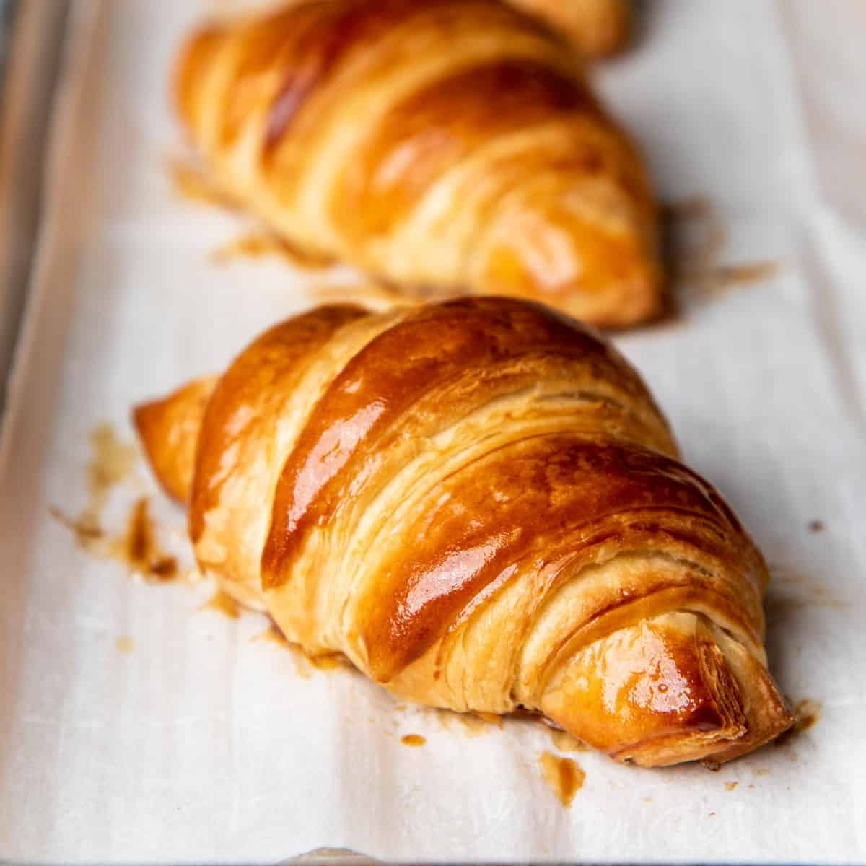
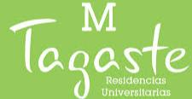
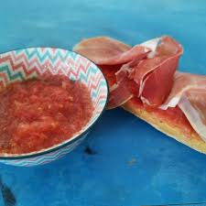
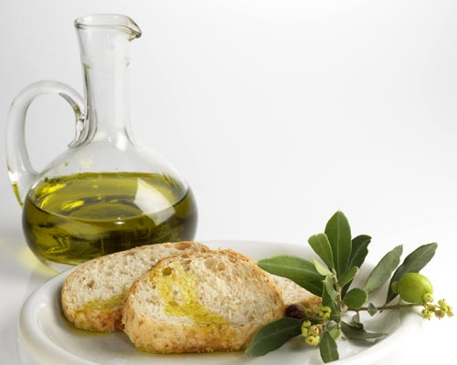


CAFE+TOSTADA CON QUESO VIEJO
(COFFEE+TOAST WITH OLD CHEESE)
1,50 euros (SOCIOS/STAFF)
2,00 euros (NON-SOCIOS/GUEST)

CAFE O COLACAO Y BOLLERIA CON MERMELADA Y MANTEQUILLA
(COFFEE OR & CROISSANT WITH BUTTER&JAM)
3,00 euro (SOCIOS/STAFF)
3,50 euros (NON-SOCIOS/GUEST)

Tabla de desayuno
Breakfast board
6.00 am- 10.00 am

CAFE+TOSTADA CON ACEITE Y TOMATE
(COFFEE+TOAST WITH OLIVE OIL AND TOMATOES)
3,50 euros (SOCIOS/STAFF)
4,00 euros (NON-SOCIOS/GUEST)

CAFE+TOSTADA CON JAMON+ZUMO DE NARANJA
(COFFEE+TOAST&HAM+ORANGE JUICE
4,50 euros (SOCIOS/STAFF)
5,00 euros (NON-SOCIOS/GUEST)

CAFE+TOSTADA CON ACEITE
(COFFEE+TOAST WITH OLIVE OIL)
2.00 euros (SOCIOS/STAFF)
1.70 euros (NON-SOCIOS/GUEST)

