

International Business Consultancy Report on Unilever PLC: Strategic Expansion, Cultural Alignment and Operational Adaptation in India

Master of Business Administration (International Business)
Module: LCMB7034 – International Business Concepts
Student Name: Alexandru Netoi
Student ID: 2026780
Lecturer Name: Babar Syed
Date: 22 November 2025

Table of Contents
1.Introduction 2
2. Benefits and Challenges of International Operations 2
2a. Unilever as an MNC/TNC 2
2b. Nature of Global Operations and Value Chain 3
2c. Entry Modes Used by Unilever 4
2d. Key Benefits from International Operations 5
2e. Challenges of International Operations 6
3. OLI Factors and Their Impact on Market Entry Mode 7
Ownership Advantages 8
Location Advantages 9
Internalisation Advantages 9
Integrated OLI Assessment and Entry Mode Implications 10
4. Cultural Differences and Their Implications 11
Impact on Market Entry Strategy 13
Effects on Organisational and Managerial Practices 14
Influence on Consumer Behaviour and Marketing Strategy 14
Cultural Distance and Operational Challenges 15
Implications for Unilever’s Potential for Success 15
5. Recommended Adjustments to Unilever’s SOPs 16
5.1 SOP Adjustment 1: Culturally Adaptive Marketing and Communication Practices 16
5.2 SOP Adjustment 2: Localised Human Resource and Leadership Development Structures 18
5.3 SOP Adjustment 3: Strengthened Inclusive and Sustainable Supply-Chain Procedures 19
6. Conclusion 21
References 22

1.Introduction
Unilever PLC is one of the world’s largest and most globally integrated fast-moving consumer goods (FMCG) corporations, with operations spanning more than 190 countries and a diverse portfolio of brands shaping daily consumption worldwide (Unilever, 2023). As global markets become increasingly interconnected, multinational enterprises such as Unilever must navigate complex institutional environments, competitive pressures, and cultural variations. Analyzing Unilever’s international business practices therefore provides valuable insights into contemporary global strategy. Grounded in international business theory, particularly Dunning’s OLI paradigm, the report examines how ownership advantages, locational factors and internalization benefits underpin Unilever’s international expansion (Dunning & Lundan, 2008). Additionally, the report evaluates how cultural dimensions influence managerial decision-making, operational models, and market success in emerging economies (Hofstede, 2011). By assessing Unilever’s global value chain, entry modes and cross-cultural challenges, the report offers evidence-based recommendations to strengthen the company’s strategic and operational effectiveness in a selected emerging market.

2. Benefits and Challenges of International Operations

2a. Unilever as an MNC/TNC
Unilever PLC can be classified as both a multinational corporation (MNC) and a transnational corporation (TNC) due to its global reach, decentralised organisational capabilities, and integration of worldwide operations. Operating in more than 190 countries, Unilever demonstrates the defining characteristics of MNCs: geographic dispersion, multi-country operations, and significant cross-border flows of capital, goods, and knowledge (Dunning & Lundan, 2008). Beyond this, Unilever also matches Bartlett and Ghoshal’s (1989) conceptualisation of a transnational organisation, which emphasises a balance between global efficiency, local responsiveness, and international learning. The company’s dual-headquarters structure (in London and Rotterdam prior to unification), regional innovation centres, and localised brand strategies reinforce its transnational identity. Unilever’s ability to coordinate global brand portfolios—such as Dove, Knorr, and Lifebuoy—while adapting them to cultural and market-specific requirements further strengthens its position as a TNC. Its governance reflects a globally integrated network rather than a hierarchical multinational model, enabling seamless knowledge sharing and value creation across markets.

2b. Nature of Global Operations and Value Chain
Unilever’s value chain reflects a sophisticated and globally integrated system designed to enhance competitiveness, reduce cost, and support sustainable long-term growth. The company’s research and development (R&D) network is dispersed across major global hubs, including the United Kingdom, India, China, and the United States. This distributed innovation model allows the firm to leverage global knowledge pools while tailoring innovations to regional and local needs (Grant, 2016). For instance, its R&D centres in emerging economies support the development of low-cost, high-impact innovations such as single-use sachets and water-efficient hygiene products.

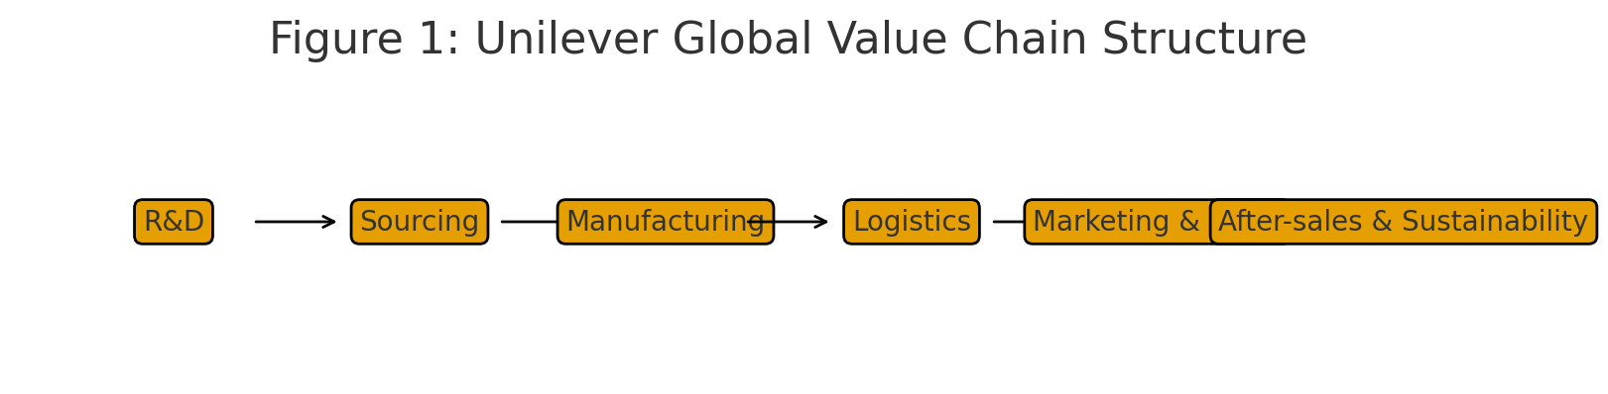

Sourcing activities are central to Unilever’s value chain. The company works with thousands of suppliers across multiple continents and maintains extensive partnerships with smallholder farmers in Africa and Asia. Unilever’s Responsible Sourcing Policy ensures compliance with environmental, labour, and ethical requirements, thereby reducing reputational and supply-chain risks (Unilever, 2023). This global sourcing strategy enables the company to take advantage of regional efficiencies, maintain flexibility, and minimise dependency on specific markets.
Manufacturing capabilities are equally international, with more than 280 factories worldwide. Unilever follows a regional production model, establishing manufacturing facilities close to raw material sources or large consumer markets to reduce logistics costs and adapt quicker to market fluctuations (Hill & Hult, 2020). Additionally, the company has invested significantly in sustainable manufacturing practices, including reducing carbon emissions, improving water efficiency, and promoting circular packaging initiatives.
Distribution and logistics combine global coordination with local responsiveness. The company uses digital technologies such as integrated enterprise resource planning (ERP) systems and predictive analytics to manage inventory, forecast demand, and optimise transportation routes. Partnerships with both international logistics firms and local distributors help Unilever reach remote and underserved areas, particularly in emerging markets.
Marketing and sales strategies follow a glocalisation approach, blending global brand identity with local adaptation. For instance, while Dove’s global brand message focuses on natural beauty and empowerment, campaigns are tailored to cultural norms in different countries. Similarly, food products under the Knorr brand are adapted to local taste profiles in Asia, Africa, and Latin America.
Financing operations are centralised to achieve global cash pooling, manage exchange-rate exposures, and allocate capital efficiently. This structure supports Unilever’s ability to invest in R&D, make strategic acquisitions, and enter emerging markets.
Collectively, Unilever’s value chain illustrates its commitment to operational excellence, global integration, and local market relevance.

2c. Entry Modes Used by Unilever
Unilever employs multiple entry modes to establish and strengthen its presence in international markets. Foreign direct investment (FDI) is the dominant mode, particularly through wholly owned subsidiaries. Examples include Hindustan Unilever Limited (HUL) in India and Unilever Nigeria, which allow full control over production, marketing, and strategic decisions. The company’s preference for FDI aligns with its need to safeguard proprietary technologies, brand reputation, and supply-chain standards (Dunning, 1993).

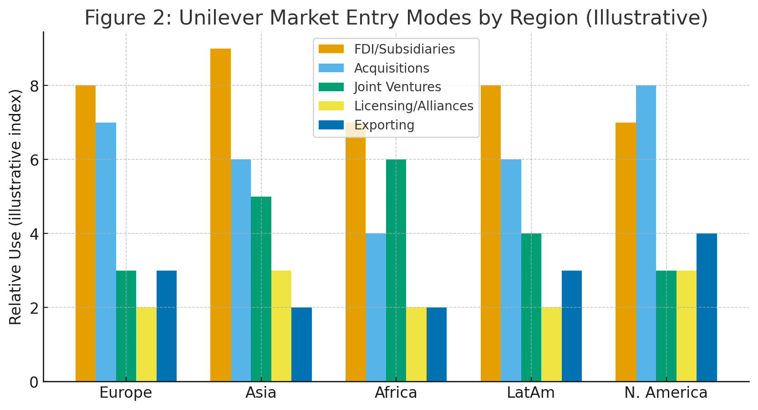
Acquisitions represent another significant entry mode. By acquiring successful local firms, Unilever gains immediate access to established brands, validated supply chains, and deep market insights. Acquisitions such as Dollar Shave Club (USA), T2 Tea (Australia), and various regional beverage and food companies highlight its strategy of leveraging existing brand equity and distribution networks for rapid market entry (Johnson et al., 2020).
Joint ventures (JVs) are used selectively in markets with restrictive foreign ownership regulations or where local expertise is crucial. For example, Unilever has used JVs in parts of the Middle East and Africa to navigate regulatory landscapes and cultural complexities.
Licensing and strategic alliances support product diversification and distribution expansion in specific contexts, though they are not Unilever’s primary entry modes.
Finally, exporting plays a minor role, typically reserved for premium or niche products that require specialised production facilities.
Overall, Unilever’s predominant reliance on FDI and acquisitions reflects its emphasis on control, long-term market commitment, and efficient global coordination.

2d. Key Benefits from International Operations
Unilever’s extensive international operations generate numerous benefits that contribute to its competitive advantage and long-term sustainability. One of the primary benefits is access to diverse consumer markets. Emerging economies such as India, Brazil, Indonesia, and Vietnam have increasingly contributed to Unilever’s revenue growth due to rising disposable incomes and demographic expansion (Unilever Annual Report, 2023). This geographical diversification reduces dependency on mature markets where growth has plateaued.
Economies of scale also play a crucial role in Unilever’s global success. High production volumes, centralised procurement systems, and integrated logistics networks enable the company to achieve cost efficiencies and maintain price competitiveness (Kotabe & Helsen, 2020). These scale advantages extend into marketing, where global brand campaigns can be adapted and reused across markets.
Another major benefit derives from knowledge transfer and innovation. Unilever’s global network allows successful innovations from one market to be adapted for others. For example, the affordability-focused innovations developed in India’s rural markets—such as small-sachet packaging—were later introduced in Africa and parts of Latin America, supporting inclusivity and market penetration (Prahalad, 2004).
International operations also enhance risk management and resilience. Economic downturns, currency volatility, or political instability in one region can be offset by stability or growth in another, allowing Unilever to maintain steady performance (Rugman & Verbeke, 2004).
Brand equity is strengthened through global visibility and local relevance. Unilever’s ability to maintain consistent global messaging while tailoring products and campaigns to local cultural norms enhances consumer loyalty and trust.
Finally, international operations support Unilever’s sustainability objectives. By engaging multiple markets in the Sustainable Living Plan, collaborating with global NGOs, and partnering with local communities, the company amplifies its environmental and social impact.
These combined benefits reinforce Unilever’s position as a global leader in the FMCG sector and support its continued growth in established and emerging markets.

2e. Challenges of International Operations
Despite its global success, Unilever faces multiple challenges:
Institutional Complexity: Emerging economies such as India present regulatory inconsistencies, bureaucratic delays and institutional voids, increasing transaction costs.
Cultural Distance: Significant differences in communication styles, power distance, and consumer behaviour require constant adaptation of HR practices and marketing strategies.
Supply-Chain Vulnerability: Infrastructure gaps, fragmented agricultural systems and high informality in supplier networks create sourcing risks.
Political and Economic Volatility: Currency fluctuations, policy shifts and geopolitical instability affect pricing, investment decisions and operational continuity.

Sustainability Pressures: Rising environmental expectations require ongoing investment in ethical sourcing, waste reduction and carbon management. These challenges emphasise the need for flexible strategies and strong local embedding.

3. OLI Factors and Their Impact on Market Entry Mode
The Ownership–Location–Internalisation (OLI) paradigm developed by Dunning (1980; 2000) provides a comprehensive analytical framework for assessing the determinants of foreign market entry modes. Applying the OLI framework to Unilever’s international operations—particularly in relation to entry into an emerging economy such as India—offers valuable insights into why the company prefers specific modes such as wholly owned subsidiaries, acquisitions, and joint ventures. The following analysis critically examines each of the OLI dimensions and illustrates how these factors influence Unilever’s strategic decision-making.

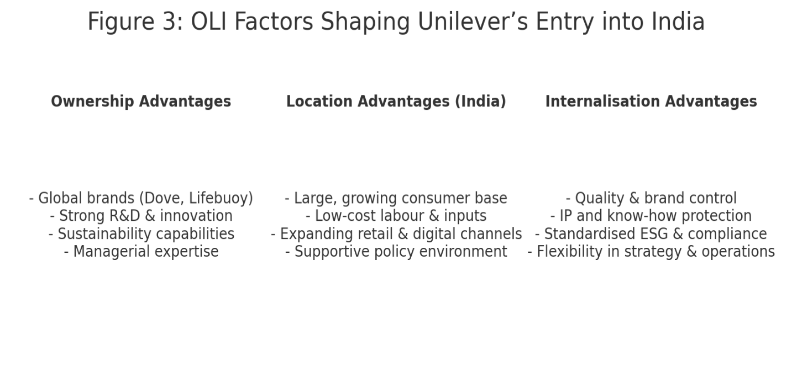

Ownership Advantages
Ownership advantages refer to firm-specific assets that confer competitive superiority in foreign markets, including brand equity, proprietary technology, managerial capabilities, and organisational culture (Dunning & Lundan, 2008). Unilever possesses substantial ownership advantages, with globally recognised brands such as Dove, Lifebuoy, Surf Excel, and Knorr. These brands benefit from strong reputational capital, high customer loyalty, and consistent quality standards worldwide. Protecting such intellectual property and brand integrity is essential, especially in emerging markets where risks of imitation, counterfeit products, and weak regulatory enforcement are more prevalent (Kotabe & Helsen, 2020).
Additionally, Unilever’s R&D capabilities constitute a major ownership advantage. Its extensive global innovation network provides advanced product development capabilities and supports the company’s ability to adapt formulations to local preferences. Such proprietary knowledge—encompassing packaging innovations, sustainable supply-chain processes, and digital marketing expertise—necessitates high levels of control and consequently favours entry modes with strong ownership stakes, such as wholly owned subsidiaries (Grant, 2016).
Managerial expertise also strengthens Unilever’s ownership advantages. The company has developed a distinctive organisational culture characterised by global coordination, sustainability leadership, and rigorous operational standards (Unilever Annual Report, 2023). These capabilities enhance its ability to manage complex multinational operations and reduce uncertainties associated with entering culturally and institutionally distant markets.

Location Advantages
Location advantages refer to the host-country factors that attract foreign investment, including market potential, labour availability, infrastructure quality, institutional stability, and access to distribution networks (Rugman & Verbeke, 2004). Emerging markets such as India and Indonesia offer substantial growth opportunities due to their large populations, expanding middle classes, and rising consumer spending—factors that make them desirable destinations for firms like Unilever.
India, for example, provides notable location-specific advantages. Its large rural population, rapid urbanisation, and growing demand for affordable consumer goods align directly with Unilever’s strategic priorities (Prahalad, 2004). The availability of low-cost labour, diverse raw material sources, and an increasingly supportive regulatory environment further justify Unilever’s commitment to localised production. Hindustan Unilever Limited (HUL), Unilever’s Indian subsidiary, extensively leverages these location advantages by establishing manufacturing facilities close to supply bases and distribution centres.
Infrastructure improvements in emerging markets—such as enhanced digital connectivity and transportation networks—also contribute to more efficient production and distribution systems. Furthermore, the presence of well-established retail networks and traditional distribution channels facilitates rapid market penetration and enables Unilever to reach consumers in remote or underserved areas.
However, location advantages in emerging economies can be accompanied by challenges. Regulatory complexity, political risks, and institutional voids may increase transaction costs (Khanna & Palepu, 2010). These conditions often lead Unilever to choose entry modes that offer greater control over operations, enabling it to mitigate risks, enforce compliance with corporate standards, and maintain brand reputation.

Internalisation Advantages
Internalisation advantages explain why firms prefer establishing internal operations rather than relying on external market mechanisms such as licensing or partnerships. These advantages arise from the need to reduce transaction costs, protect intellectual property, and maintain quality control (Buckley & Casson, 2010).
For Unilever, internalising activities through wholly owned subsidiaries or acquisitions is often preferable due to the need to protect proprietary technologies, sensitive market knowledge, and supply-chain processes. Licensing—while offering lower initial risk—would expose Unilever to potential imitation, inconsistent product quality, and reputational harm, particularly in markets where enforcement of intellectual property laws may be weak.
Internalisation also supports Unilever’s sustainability agenda. The company has stringent environmental, social, and governance (ESG) standards that require systematic implementation across its value chain. By internalising production and distribution, Unilever ensures compliance with its Sustainable Living Plan, maintains ethical sourcing practices, and enforces labour standards that may not be prioritised by external partners (Unilever, 2023).
Additionally, internalisation allows Unilever to maintain strategic flexibility in responding to market changes. Emerging markets often experience rapid fluctuations in consumer demand, regulatory shifts, and competitive pressures. Internalised operations provide the agility to adapt marketing strategies, modify product formulations, and restructure supply networks more efficiently than if such activities were outsourced.

Integrated OLI Assessment and Entry Mode Implications
The interplay between ownership, location, and internalisation advantages strongly supports Unilever’s preference for foreign direct investment (FDI) in emerging markets. The company’s substantial ownership advantages—ranging from brand strength to R&D capabilities—combined with the considerable market potential in emerging economies, make FDI a strategically sound choice. Furthermore, internalisation advantages reinforce the need for control to maintain product quality, safeguard intellectual property, and uphold sustainability commitments.
In India, the synergy of OLI advantages is clearly demonstrated through Hindustan Unilever Limited (HUL), one of the most successful subsidiaries in Unilever’s global portfolio. The company benefits from strong brand equity (ownership), access to an expansive consumer base (location), and the ability to manage operations internally (internalisation). This configuration has allowed Unilever to achieve extensive market penetration, innovate locally relevant products, and build competitive resilience.
In contrast, in markets with higher regulatory constraints or greater institutional uncertainty, Unilever may opt for joint ventures. These arrangements allow it to access local knowledge and mitigate risks while still retaining sufficient influence to ensure strategic alignment. For example, joint ventures in parts of the Middle East and Africa help navigate cultural complexities, regulatory limitations, and distribution challenges.
Licensing and exporting remain less prominent due to their limited ability to safeguard ownership advantages and ensure operational control. These modes are generally unsuitable for Unilever’s mass-market approach, where supply-chain integration, brand reputation, and quality consistency are critical.
Through the application of the OLI paradigm, it becomes evident that Unilever’s choice of market entry mode is shaped by the strength of its ownership-specific assets, the attractiveness of host-country locations, and the benefits of internalising key operations. In emerging economies such as India, where both market potential and institutional challenges coexist, the combined OLI advantages strongly favour foreign direct investment as the dominant entry strategy. This approach provides Unilever with the control, flexibility, and strategic alignment necessary to ensure long-term success.

4. Cultural Differences and Their Implications
Cultural differences represent a major determinant of international business success, influencing organisational practices, consumer behaviour, managerial decision-making, and overall market performance. For a global corporation such as Unilever, whose operations span mature Western economies and diverse emerging markets, understanding cultural distance is essential. This section critically evaluates how cultural differences between Unilever’s home-country context (the United Kingdom/Netherlands heritage) and a selected emerging economy—India—affect its market entry strategy and subsequent potential for long-term success.
Cultural Differences through Hofstede’s Dimensions
Hofstede’s cultural dimensions provide a structured framework for examining the cultural distance between countries (Hofstede, 2011). The UK and India demonstrate significant contrasts across power distance, individualism–collectivism, uncertainty avoidance, long-term orientation, and masculinity–femininity. These differences create implications for Unilever’s marketing communication, organisational relationships, human resource management, and consumer engagement.
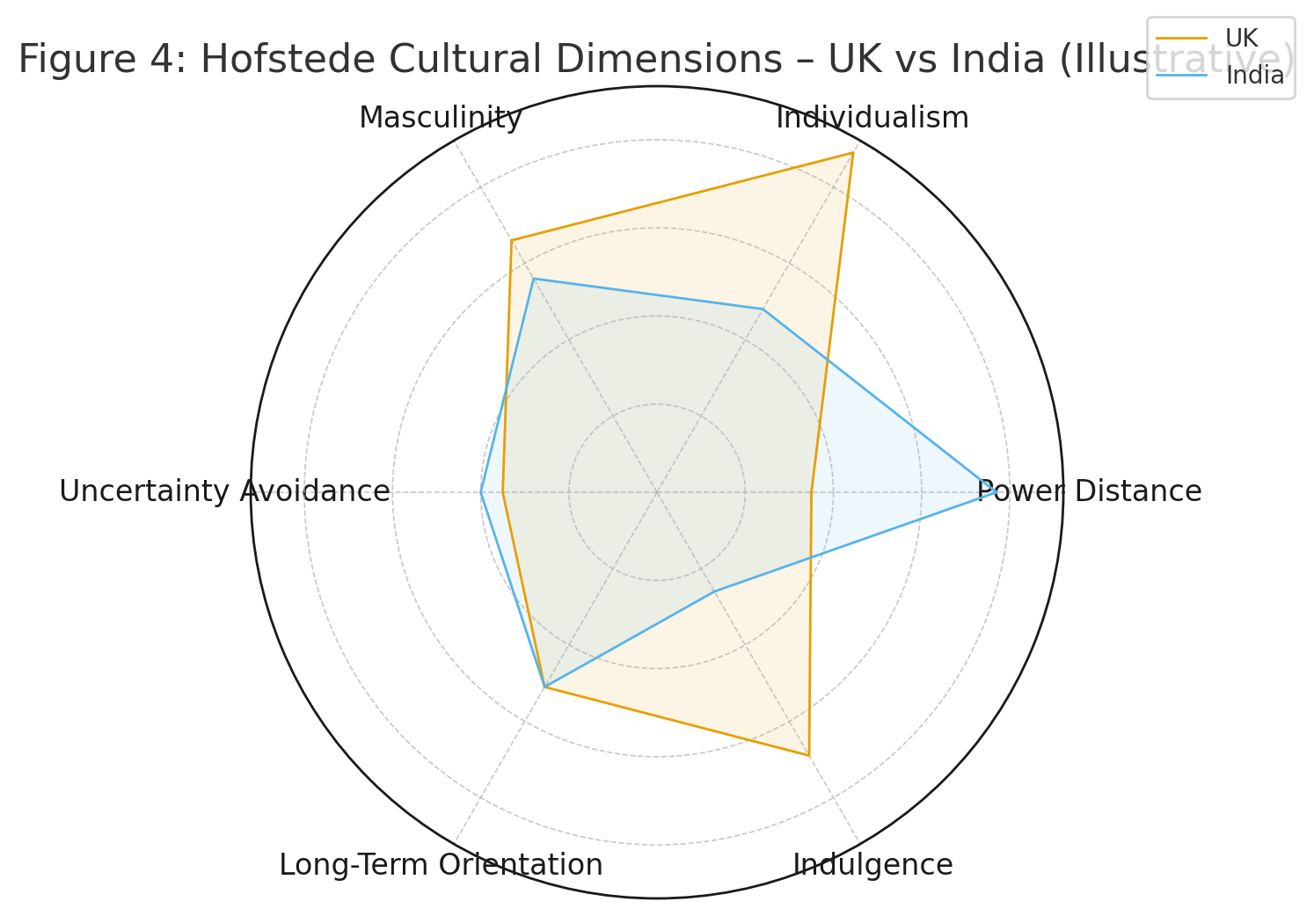

India’s high power distance indicates a hierarchical social structure where authority is respected, and decision-making tends to be centralised (Hofstede Insights, 2023). In contrast, the UK has relatively low power distance, emphasising flatter organisational structures and participatory decision-making. Unilever must therefore adjust leadership styles, managerial communication, and workplace expectations when operating in India. Local managers may expect clearer authority lines, while employees may rely on top-down direction. Failure to adapt to these expectations can result in misunderstandings, lower productivity, and misalignment between corporate norms and local expectations.
In terms of individualism versus collectivism, the UK scores highly on individualism, emphasising autonomy, personal achievement, and self-expression. India, however, reflects collectivist tendencies, prioritising community ties, family influence, and group loyalty (Hofstede, 2011). For Unilever, these cultural dynamics shape marketing strategies, particularly in product positioning and brand messaging. Campaigns that highlight individual freedom or Western-style self-improvement may not resonate as strongly as family-centric or community-orientated narratives. Unilever’s successful localisation of advertising—for instance, Lifebuoy’s health-focused campaigns targeting family hygiene—illustrates its ability to tailor communication to collectivist contexts.
Uncertainty avoidance levels also differ between the countries. India exhibits moderate uncertainty avoidance, with consumers often relying on established brands and socially validated choices to reduce risk (Schmidt & Engelen, 2020). This cultural trait benefits Unilever, whose strong brand equity and long-standing presence in India (through Hindustan Unilever Limited) help reduce perceived risk and support consumer trust. British consumers, by comparison, may be more open to experimenting with niche or challenger brands. The implication is that Unilever’s product diversification strategy in India may require a stronger emphasis on trust-building, consistency, and safety messaging.
Long-term orientation is another dimension where differences matter. India demonstrates a strong long-term orientation, valuing perseverance, frugality, and future-oriented decision-making. This cultural tendency aligns positively with Unilever’s sustainability messaging and long-term business strategies. Sustainability-focused initiatives, such as water-saving products and environmentally conscious packaging, align with cultural values and enhance brand legitimacy.

Impact on Market Entry Strategy
Cultural differences influence the selection and effectiveness of market entry modes. In markets like India with complex cultural and institutional environments, Unilever benefits from establishing wholly owned subsidiaries or majority-owned local entities. This approach, exemplified by Hindustan Unilever Limited, enables deeper cultural understanding, stronger control over brand messaging, and alignment with local workforce expectations (Khanna & Palepu, 2010).
Joint ventures or licensing arrangements may limit the firm’s ability to align operations with cultural norms because local partners may operate under different organisational assumptions. Given the cultural distance between the UK and India, wholly owned subsidiaries provide Unilever with the strategic control required to adapt HR practices, customise marketing messages, and implement culturally sensitive supply-chain strategies.
Furthermore, collectivist cultures emphasise relationship-building and trust, making long-term corporate presence more effective than transactional or short-term entry modes (Meyer et al., 2020). Unilever’s historical presence in India, dating back to the 1930s, has cultivated trust and deep market knowledge, reinforcing the appropriateness of high-commitment entry modes.

Effects on Organisational and Managerial Practices
Cultural differences also influence Unilever’s management strategies. Hierarchical expectations in India require managers to demonstrate authority, offer structured guidance, and maintain clear role definitions. British management approaches that favour egalitarianism and employee autonomy may require adjustment to avoid cultural dissonance.
Communication styles differ significantly as well. The UK’s communication culture tends to be low-context, valuing clarity and directness, whereas India leans towards high-context communication, where meaning is conveyed through social cues, relationships, and implicit understanding (Hall, 1976). Unilever’s managerial practices in India must therefore integrate culturally aware communication approaches, particularly in negotiations, team management, and performance evaluation.
Human resource management is similarly affected. Recruitment strategies that emphasise individual achievement in the UK may need to account for family expectations, community obligations, and more hierarchical career progression paths in India. Leadership development programmes must also integrate local cultural values, ensuring that managerial training addresses hierarchical norms and collectivist motivations.

Influence on Consumer Behaviour and Marketing Strategy
Unilever’s success in India depends significantly on its ability to navigate culturally shaped consumption patterns. Cultural norms influence preferences for product attributes, advertising messages, price sensitivity, and brand loyalty.
India’s collectivist orientation creates strong family influence on purchasing decisions, making household-oriented marketing particularly effective (Prahalad, 2004). Unilever leverages this by positioning brands such as Surf Excel and Lifebuoy around family care and community wellbeing. Similarly, the country’s diverse cultural makeup requires hyper-localisation—adapting messages to regional languages, festivals, and traditions.
Price sensitivity is also culturally embedded. In many Indian communities, frugality and value optimisation are prioritised, creating demand for affordable pack sizes and budget-orientated products. Unilever’s sachet innovation aligns with these cultural and economic realities, supporting widespread penetration in low-income and rural markets.
Values related to health, beauty, and social identity differ as well. In India, beauty norms are often influenced by social status and cultural expectations. Products aligned with skincare, grooming, and hygiene require culturally sensitive positioning to avoid ethical criticism while meeting consumer expectations (Nagar, 2018). Unilever’s adjustment of messaging around beauty products demonstrates the need to incorporate cultural nuance in product marketing.

Cultural Distance and Operational Challenges
Cultural distance can create operational challenges, particularly in supply-chain coordination, conflict resolution, and employee motivation. In a high power-distance context, employees may hesitate to report problems or challenge managerial decisions, potentially slowing down organisational learning (Schneider & Barsoux, 2014). Unilever must therefore implement systems that encourage upward communication without violating cultural norms.
Additionally, collectivism may create expectations for more relational and personalised interactions with suppliers, distributors, and retail partners. Transactional approaches typical of Western business environments may not be effective. Unilever’s long-term partnerships with rural distributors and local entrepreneurs demonstrate how relationship-based business models can overcome cultural barriers.

Implications for Unilever’s Potential for Success
Understanding and adapting to cultural differences significantly enhances Unilever’s potential for success in India. Culturally sensitive marketing strengthens brand loyalty, culturally aligned management practices improve workforce productivity, and culturally informed entry strategies support long-term market penetration. Unilever’s long-standing presence and deep cultural embedding—achieved through HUL—position it competitively against both global rivals and strong domestic FMCG firms.
However, continued success depends on ongoing cultural learning. Market dynamics in India are evolving rapidly due to rising urbanisation, digitalisation, and shifting social norms. Unilever must continuously update its cultural insights and adapt its strategies to emerging cultural trends, including increasing individualism among urban youth and growing environmental awareness.

5. Recommended Adjustments to Unilever’s SOPs
Building upon the OLI framework and the cultural analysis presented earlier, it is clear that Unilever must adapt aspects of its Standard Operating Procedures (SOPs) to enhance strategic fit, operational efficiency, and cultural responsiveness within India. While Hindustan Unilever Limited (HUL) is already one of the most successful subsidiaries in Unilever’s global portfolio, the dynamic nature of India’s institutional environment—combined with shifting consumer expectations, technological evolution, and sustainability pressures—requires continuous procedural refinement. This section critically expands on three major SOP adjustments: (1) culturally adaptive marketing and communication; (2) localised human resource and leadership development; and (3) strengthened inclusive and sustainability-focused supply chain procedures.
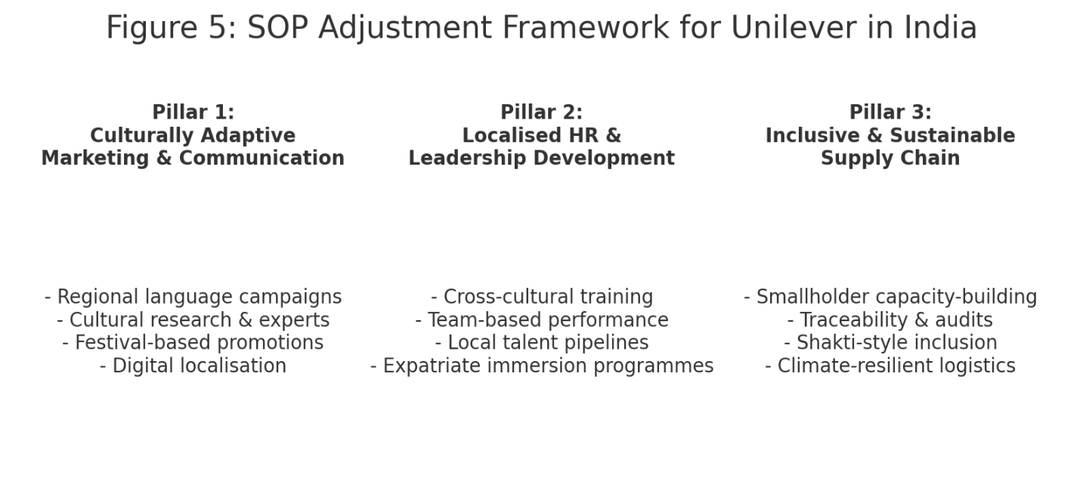

5.1 SOP Adjustment 1: Culturally Adaptive Marketing and Communication Practices
India’s cultural landscape is one of the most diverse and complex globally, characterised by variations in language, religion, regional identity, and socio-economic stratification (Hofstede, 2011). For Unilever, marketing success depends on its ability to reflect these cultural nuances within its brand positioning and communication strategies. Although Unilever already engages in marketing localisation, its SOPs should formally institutionalise deeper cultural embedding.
A revised SOP should require robust cultural research prior to campaign development. This research must examine culturally specific values—such as family orientation, community identity, respect for tradition, and symbolic meaning in colours and imagery. For example, Unilever’s successful Lifebuoy campaigns have relied on culturally resonant messages about family health and shared responsibility, illustrating how culturally grounded narratives improve engagement (Nagar, 2018). Similarly, Dove’s beauty campaigns in India should integrate local beauty norms while ensuring ethical sensitivity.
To operationalise this culturally adaptive approach, SOPs should be expanded to include:
- mandatory regional linguistic adaptation for all major campaigns;
- structured consultation with local cultural experts, sociologists, and anthropologists;
- adoption of high-context communication methods such as allegory, symbolism, and emotional storytelling (Hall, 1976);
- guidelines for integrating festivals, regional celebrations, and local customs into promotional strategies.
Digital localisation must also become a formal SOP requirement. With over 750 million smartphone users in India and the rise of regional-language digital platforms, marketing strategies must prioritise mobile-first content and influencer partnerships (Kantar, 2023). SOPs should embed digital consumer segmentation, regional-language content creation, and partnerships with micro-influencers—especially in Tier II and Tier III cities.
Furthermore, marketing SOPs should institutionalise mechanisms for continuous cultural scanning. India’s rapid socio-cultural evolution—shaped by urbanisation, global media exposure, and shifts in gender roles—requires Unilever to constantly reassess cultural relevance. Embedding cultural monitoring protocols ensures that marketing strategies remain up-to-date with emerging values and generational differences.

5.2 SOP Adjustment 2: Localised Human Resource and Leadership Development Structures
Human resource management is deeply influenced by cultural values, and Western-derived HR practices do not always translate effectively in emerging markets (Schneider & Barsoux, 2014). India’s cultural profile—marked by high power distance, collectivism, and relational communication—requires SOP modifications that support culturally attuned leadership and workforce management.
First, leadership development SOPs must explicitly incorporate cultural competencies relevant to India. Employees often expect leaders to provide authoritative guidance, structured directions, and a formalised hierarchy. Therefore, leadership programmes should include modules on hierarchical decision-making, relational authority, and high-context communication norms. For expatriates, understanding the expectations surrounding seniority and social status is essential to establishing credibility.
Second, communication SOPs must be adapted. In the UK, communication tends to be direct and explicit; in India, communication often relies on implicit meaning, contextual cues, and relationship-building (Hall, 1976). SOPs should require:
- cross-cultural communication training for managers;
- structured conflict-resolution training based on relational norms;
- guidelines for culturally appropriate feedback delivery.
Third, performance management SOPs should be revised to incorporate team-based metrics. In collectivist cultures, team outcomes are often valued more than individual achievements (Hofstede, 2011). Unilever’s SOPs must therefore formalise balanced performance scorecards that measure collaboration, group innovation, and collective problem-solving.
Fourth, SOPs should mandate culturally responsive recruitment and retention strategies. India’s labour market is shaped by regional disparities, strong community networks, and family influence. Therefore, recruitment SOPs should expand to include partnerships with regional universities, community-based hiring initiatives, and inclusive hiring frameworks that account for socio-economic diversity.
Fifth, talent development SOPs should include structured career pathways, mentoring programmes, and family-supportive HR policies such as extended leave arrangements and flexible working options. These policies align with collectivist expectations regarding work-life balance and familial responsibilities.
Finally, SOPs should institutionalise cultural immersion programmes as mandatory for expatriate leaders. Research shows that cultural intelligence significantly improves expatriate performance, organisational integration, and local team trust (Ang & Van Dyne, 2015). These programmes may include language familiarisation, cultural workshops, and structured exposure to local communities.

5.3 SOP Adjustment 3: Strengthened Inclusive and Sustainable Supply-Chain Procedures
India’s supply-chain ecosystem is characterised by institutional voids, fragmented agricultural networks, infrastructural inconsistencies, and widespread informality (Khanna & Palepu, 2010). While Unilever’s global Responsible Sourcing Policy is rigorous, additional localisation is necessary to address India-specific challenges.
First, SOPs must allocate greater resources to capacity-building for smallholder farmers and rural suppliers. Many suppliers lack technological capabilities, financial literacy, or knowledge of sustainable farming practices. Revised SOPs should mandate structured training programmes in:
- climate-resilient agriculture;
- digital supply chain documentation;
- ethical labour standards;
- water conservation and soil management.
Second, monitoring and compliance SOPs must be strengthened. Given inconsistent regulatory enforcement across Indian states, Unilever cannot rely exclusively on external regulation. SOPs should require:
- digital traceability systems across the supply chain.
- third-party audits at regular intervals.
- grievance mechanisms accessible to workers and local communities.
- partnerships with NGOs and local cooperatives for monitoring rural suppliers.
Third, distribution SOPs must prioritise inclusivity. India’s retail landscape is dominated by small Kirana stores and informal channels. The Shakti programme—which trains and employs rural women as micro-entrepreneurs—has proven highly effective (Prahalad, 2004). Embedding this model into SOPs enhances both distribution efficiency and social impact.
Fourth, risk management SOPs require enhancement. India’s logistical and environmental risks—such as monsoon disruptions, volatile commodity prices, and infrastructure gaps—necessitate formalised contingency planning. SOPs should include:
- decentralised inventory hubs;
- multimodal logistics partnerships.
- predictive analytics to forecast disruptions and prepare mitigation strategies.
Fifth, sustainability-focused procurement must be central to revised SOPs. Growing environmental awareness among Indian consumers and regulators means that Unilever must prioritise:
- recyclable and biodegradable packaging.
- renewable energy usage in factories.
- low-carbon logistics.
- circular economy initiatives.
These changes enhance Unilever’s alignment with its Sustainable Living Plan (Unilever, 2023) while reinforcing consumer trust.

6. Conclusion
Unilever’s international expansion demonstrates the strategic complexity associated with operating across diverse institutional and cultural contexts. The analysis presented in this report highlights how the company’s extensive ownership advantages—such as strong global brands, advanced R&D capabilities, and operational expertise—combine with the location-specific benefits of emerging economies like India to support long-term competitiveness (Dunning & Lundan, 2008). Internalisation advantages further reinforce Unilever’s preference for high-control entry modes, enabling the organisation to safeguard brand integrity, ensure quality standards, and fully implement sustainability commitments.
Cultural analysis based on Hofstede’s dimensions demonstrates that significant cultural distance exists between Unilever’s home-country culture and the Indian market. These differences affect consumer behaviour, managerial expectations, communication practices, and workforce dynamics (Hofstede, 2011). As a result, the company must remain proactive in adapting its global strategies to local cultural norms.
The recommended SOP adjustments—culturally adaptive marketing, localised HR and leadership development, and strengthened inclusive supply-chain systems—address these complexities by embedding cultural responsiveness, operational resilience, and sustainability into Unilever’s organisational processes. Collectively, these adjustments support stronger competitive positioning, deeper market penetration, and enhanced long-term alignment with India’s socio-economic environment.
Overall, the report demonstrates that Unilever’s success in emerging markets hinges on its ability to integrate international business theory with culturally informed operational practice. Continuous adaptation, strategic localisation, and culturally grounded management will remain essential for sustaining growth in India and other emerging economies.

References
Books & Edited Volumes
Ang, S. and Van Dyne, L. (eds.) (2015) Handbook of cultural intelligence. New York: Routledge.
Bartlett, C.A. and Ghoshal, S. (1989) Managing across borders: The transnational solution. Boston, MA: Harvard Business School Press.
Buckley, P.J. and Casson, M. (2010) The multinational enterprise revisited: The essential Buckley and Casson. Basingstoke: Palgrave Macmillan.
Grant, R.M. (2016) Contemporary strategy analysis. 9th edn. Chichester: John Wiley & Sons.
Hall, E.T. (1976) Beyond culture. New York: Anchor Books.
Hill, C.W.L. and Hult, G.T.M. (2020) International business: Competing in the global marketplace. 13th edn. New York: McGraw-Hill.
Johnson, G., Whittington, R. and Scholes, K. (2020) Exploring corporate strategy. 12th edn. Harlow: Pearson.
Khanna, T. and Palepu, K. (2010) Winning in emerging markets: A roadmap for strategy and execution. Boston, MA: Harvard Business Press.
Kotabe, M. and Helsen, K. (2020) Global marketing management. 8th edn. Hoboken, NJ: John Wiley & Sons.
Prahalad, C.K. (2004) The fortune at the bottom of the pyramid: Eradicating poverty through profits. Upper Saddle River, NJ: Wharton School Publishing.
Schneider, S.C. and Barsoux, J.L. (2014) Managing across cultures. 3rd edn. Harlow: Pearson.

Journal Articles
Dunning, J.H. (1980) ‘Toward an eclectic theory of international production’, Journal of International Business Studies, 11(1), pp. 9–31.
Hofstede, G. (2011) ‘Dimensionalizing cultures: The Hofstede model in context’, Online Readings in Psychology and Culture, 2(1), pp. 1–26.
Meyer, K.E., Oestrin, S., Bhaumik, S.K. and Peng, M.W. (2020) ‘Institutions, resources, and entry strategies in emerging economies’, Strategic Management Journal, 41(3), pp. 680–709.
Nagar, N. (2018) ‘Cultural relevance in marketing communications in India’, Asian Journal of Marketing, 12(3), pp. 45–58.
Rugman, A.M. and Verbeke, A. (2004) ‘A perspective on regional and global strategies of multinational enterprises’, Journal of International Business Studies, 35(1), pp. 3–18.
Schmidt, S. and Engelen, A. (2020) ‘Uncertainty avoidance and brand trust in international marketing’, International Marketing Review, 37(2), pp. 203–226.

Company & Industry Reports
Kantar (2023). Digital consumer landscape in India. London: Kantar.
Unilever (2023) Unilever annual report and accounts 2023. Available at: https://www.unilever.com (Accessed: 21 November 2025).

