MARKETING PLAN FOR

Ritz Carlton Hotel Brand
______________________________

STUDENT NAME

SYED SHAHED AHMED
_________________________

STUDENT ID NUMBER

2210199
___________________

MARKETING ESSENTIALS BMIH4005

Total Word Count: 703 words.
Submission Date: 26/05/2023
Component 2 (50%) Marketing Plan (1250 words)

Contents

INTRODUCTION 3
SITUATION ANALYSIS 3
CUSTOMERS 3
COMPETITORS 4
COLLABORATORS 4
CLIMATE 4
OBJECTIVES 5
STRATEGY 5
TACTICS 5
ACTION 6
CONTROL 6
CONCLUSION 6
FURTHER READING 7
APPENDICES 9
APPENDIX 1 10
APPENDIX 2 11

INTRODUCTION

- This marketing plan is prepared for the Ritz Carlton hotel brand, with the aim of developing effective strategies to enhance its market position and customer satisfaction. The plan is being prepared for the management team of the Ritz Carlton, providing a comprehensive roadmap for achieving marketing objectives. The key frameworks used in this plan include SOSTAC (Situation Analysis, Objectives, Strategy, Tactics, Action, and Control) (Please see Appendix 1) , Marketing Mix, Bowmans Strategy Clock, and RACE (Reach, Act, Convert, Engage) communications mix.

SITUATION ANALYSIS

- SWOT Analysis:

- Strengths: Strong brand reputation, exceptional customer service, luxurious facilities.
- Weaknesses: High price point, limited market presence in certain regions.
- Opportunities: Growing demand for luxury travel, expanding into emerging markets.
- Threats: Intense competition, economic downturns impacting travel industry.

CUSTOMERS

- Segmentation and Targeting: The Ritz Carlton targets affluent individuals seeking luxury accommodations and personalized experiences. Using SimilarWeb, it was identified customer segments such as high-net-worth individuals, business travellers, and luxury tourists.

COMPETITORS

- Perceptual Positioning Map: A perceptual positioning map will be created to compare the Ritz Carlton with its competitors based on attributes like price, luxury, service, and location. This will help identify the Ritz Carlton's unique selling proposition.

COLLABORATORS

- The Ritz Carlton has established valuable B2B relationships with travel agencies, airlines, and corporate event planners. These collaborations enhance the brand's exposure and attract potential customers.

CLIMATE

- Climate (PESTLE):
- Political: Changes in travel policies and regulations.
- Economic: Fluctuations in currency exchange rates and disposable income.
- Social: Changing travel preferences and increasing emphasis on experiences.
- Technological: Technological advancements in the hospitality industry.
- Environmental: Growing awareness of sustainable practices.
- Legal: Compliance with labour laws and regulations.

- Marketing Mix
- Product: The Ritz Carlton offers luxurious accommodations, personalized services, fine dining, and exclusive amenities, providing a unique value proposition.
- Price: Premium pricing strategy to reflect the luxury and exclusivity of the brand.
- Place: Strategically located hotels in key destinations globally, targeting high-end markets.
- Promotion: Integrated marketing communications approach, including digital marketing, PR, and partnerships to showcase the brand's exceptional offerings.

OBJECTIVES

- The SMART target for this marketing plan is to increase website traffic by 20% and social media followers by 15% within the next six months. Key performance indicators (KPIs) will include website analytics, social media engagement, and conversion rates.

STRATEGY

- The Ritz Carlton will focus on enhancing its value proposition by leveraging its exceptional customer service and creating unique experiences for guests. The strategy aligns with the market penetration strategy from Ansoff's matrix, aiming to increase market share through existing products in the current market.

TACTICS

- The RACE communications mix will be used to address identified issues. Tactics will include:
- Improving online reputation through targeted social media campaigns, influencer collaborations, and online review management.
- Enhancing customer experience by personalizing services and providing tailored recommendations based on preferences.
- Leveraging digital channels to engage with customers and share compelling stories about the brand and its destinations.

ACTION

- A marketing channels schedule has been created using a Gantt chart to outline the timeline for each tactic. Channels include social media platforms, hotel website, email marketing, and online advertising. Metrics and KPIs, such as website traffic, social media engagement, and conversion rates, will be measured and monitored as recommended in the Gantt table included in Appendix 2.

CONTROL

- Success will be measured through metrics such as increased website bookings, positive customer sentiment, and improved financial performance. KPIs include website conversion rate, customer satisfaction scores, and revenue generated through online channels. Regular monitoring and analysis of these metrics will provide insights for further adjustments and improvements.

CONCLUSION

- By implementing the proposed strategies and tactics, the Ritz Carlton can strengthen its market position, attract and retain affluent customers, and enhance brand reputation. Continuous monitoring and adaptation will be essential to ensure the marketing plan's success. Further recommendations include conducting regular customer surveys, exploring partnerships with luxury lifestyle brands, and expanding digital marketing efforts to target specific customer segments.

FURTHER READING

- Ritz-Carlton (2023). Available at: https://www.ritzcarlton.com/en/about/history (Accessed on: 05 February 2023)
- The Luxury Travel Expert (2018) Top 10 best Ritz-Carlton Hotels & Resorts in the world. Available at: https://theluxurytravelexpert.com/2018/10/08/top-10-best-ritz-carlton-hotels-world/ (Accessed on: 05 February 2023)

- Robert R, Forbes (2009). How Ritz-Carlton Stays At The Top. Available at: https://www.forbes.com/2009/10/30/simon-cooper-ritz-leadership-ceonetwork-hotels.html?sh=6c89c37d10b1 (Accessed on: 06 February 2023

- Ritz-Carlton Leadership Center (2023) Embark on Your Journey to Excellence. Available at: https://ritzcarltonleadershipcenter.com/ (Accessed on: 07 February 2023)

- Ritz-Carlton (2023) Gold Standards. Available at: https://www.ritzcarlton.com/en/about/gold-standards (Accessed on: 07 February 2023)

- PR Smith (2022) SOSTAC & Planning.
Available at: https://prsmith.org/sostac/
(Accessed: 02 December 2022)

- Porter, Michael E., Competitive Strategy: Techniques for Analyzing Industries and Competitors (1980). University of Illinois at Urbana-Champaign's Academy for Entrepreneurial Leadership Historical Research Reference in Entrepreneurship, Available at SSRN: https://ssrn.com/abstract=1496175 (Accessed: 03 December 2022)
- Investopedia (2022) Porter's 5 Forces Explained and How to Use the Model. Available at: https://www.investopedia.com/terms/p/porter.asp (Accessed: 03 December 2022)
- HotelTechReport (2022) 3 Examples of SMART Goals in the Hospitality Industry. Available at: https://hoteltechreport.com/news/smart-goals (Accessed: 06 December 2022)
- Lucidity (2022) Introduction to Bowman’s Strategy Clock. Available at: https://getlucidity.com/strategy-resources/introduction-to-bowmans-strategy-clock/ (Accessed: 07 December 2022)
- David Bojanic. 11 Apr 2008, Hospitality marketing mix and service marketing principles from: Handbook of Hospitality Marketing Management Routledge Accessed on: 08 Dec 2022 https://www.routledgehandbooks.com/doi/10.4324/9780080569437.ch3
- Swan, S (2022) How to use the SOSTAC® planning model and the RACE Framework. Available at: https://www.smartinsights.com/digital-marketing-strategy/sostac-plan-example/ (Accessed on: 08 December 2022)
- Kotler, P., Keller, K. L., Koshy, A., & Jha, M. (2016). Marketing management: A South Asian perspective. Pearson Education.
- Lancaster, G., & Massingham, L. (2011). Essentials of marketing management. Routledge.
- Armstrong, G., & Kotler, P. (2015). Marketing: An introduction. Pearson Education.
- Proctor, T. (2014). Strategic marketing: An introduction. Routledge.
- Jobber, D., & Ellis-Chadwick, F. (2016). Principles and practice of marketing. McGraw-Hill Education.
- Hanlon, A (2021) The Ansoff Model. Available at: https://www.smartinsights.com/marketing-planning/create-a-marketing-plan/ansoff-model/ (Accessed on: 21 May 2022)

- Contributor, P. (2023). What is PESTLE Analysis? An Important Business Analysis Tool. PESTLE Analysis. Available at: https://pestleanalysis.com/what-is-pestle-analysis/(Accessed on: 21 May 2022)

- Website Traffic - Check and Analyze Any Website | Similarweb. (n.d.). Similarweb. Available at: https://www.similarweb.com/ (Accessed on: 20 May 2022)

APPENDICES

APPENDIX 1

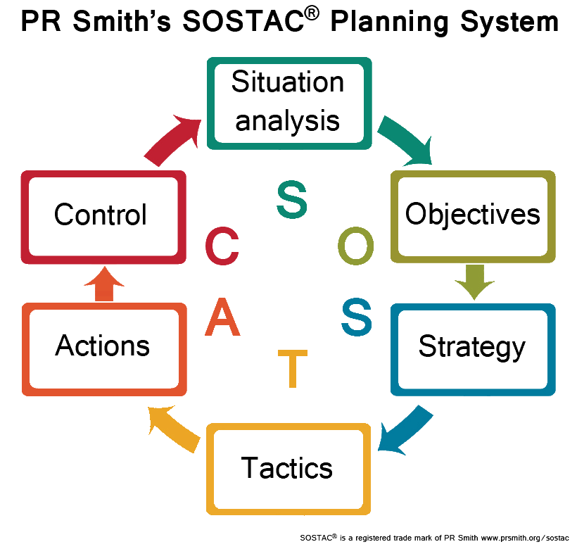

APPENDIX 2

GANNT CHART

Marketing Activities | Months | KPIs/Metrics
Social media campaigns | Month 1-2 | Increase in social media followers by 15%
Online review management | Month 2-4 | Improved online reputation scores and ratings
Influencer collaborations | Month 3-5 | Increased brand visibility and engagement
Personalized services | Month 1-6 | Improved customer satisfaction scores
Digital marketing | Month 1-6 | Increase in website traffic by 20%
Email marketing | Month 2-6 | Higher open rates and click-through rates
Online advertising | Month 3-6 | Improved conversion rates and ROI

END OF MARKETING PLAN ASSIGNMENT

PRESENTATION

Component 1 (50%) Presentation

Presentation slide and script screen shots attached as requested to the end of the marketing plan word document.

SLIDE 1 AND SCRIPT

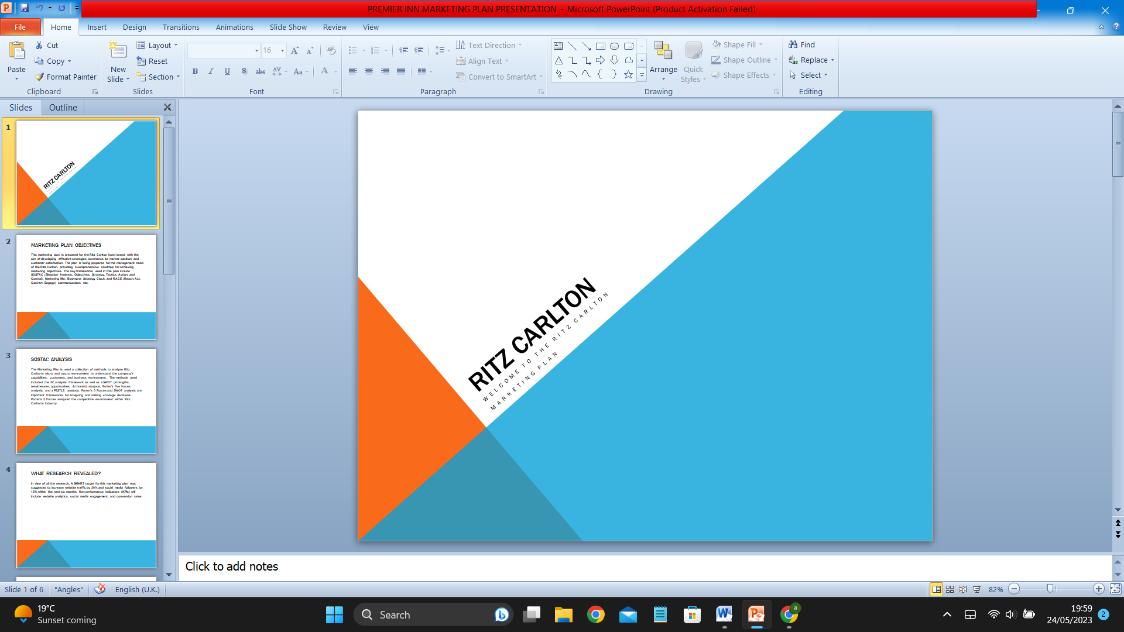

RITZ CARLTON
WELCOME TO THE RITZ CARLTON
MARKETING PLAN

SLIDE 2 & SCRIPT

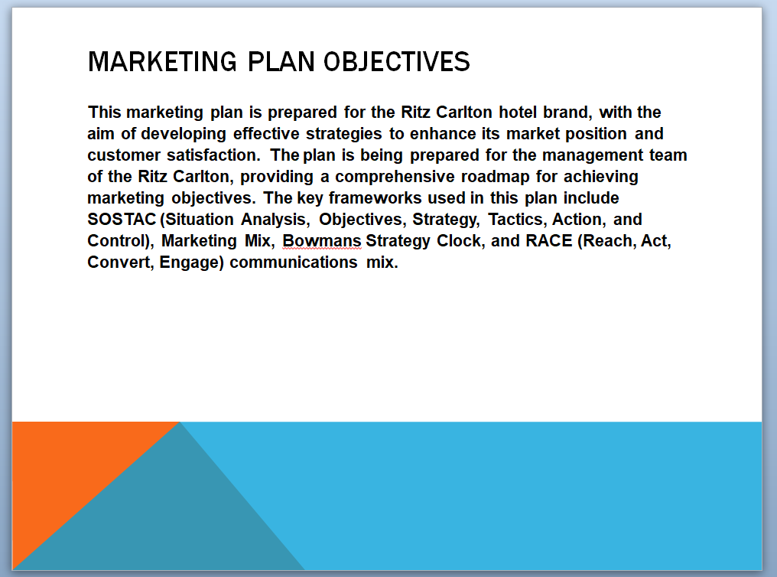

SLIDE 2 SCRIPT

MARKETING PLAN OBJECTIVES

This marketing plan is prepared for the Ritz Carlton hotel brand, with the aim of developing effective strategies to enhance its market position and customer satisfaction. The plan is being prepared for the management team of the Ritz Carlton, providing a comprehensive roadmap for achieving marketing objectives. The key frameworks used in this plan include SOSTAC (Situation Analysis, Objectives, Strategy, Tactics, Action, and Control), Marketing Mix, Bowmans Strategy Clock, and RACE (Reach, Act, Convert, Engage) communications mix.

SLIDE 3 AND SCRIPT

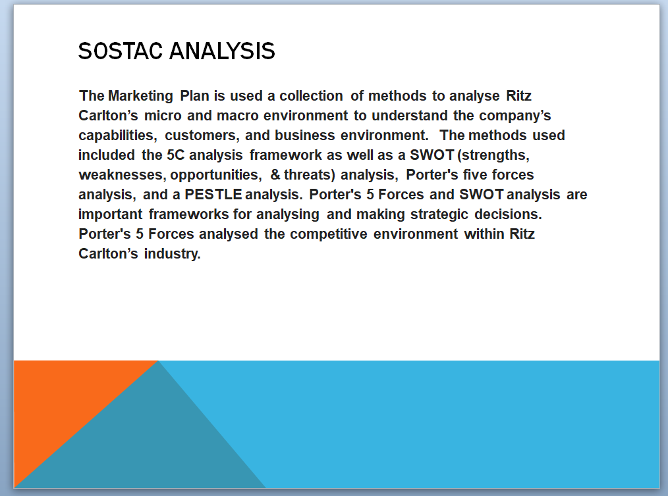

SLIDE 3 SCRIPT

SOSTAC ANALYSIS

The Marketing Plan is used a collection of methods to analyse Ritz Carlton’s micro and macro environment to understand the company’s capabilities, customers, and business environment. The methods used included the 5C analysis framework as well as a SWOT (strengths, weaknesses, opportunities, & threats) analysis, Porter's five forces analysis, and a PESTLE analysis. Porter's 5 Forces and SWOT analysis are important frameworks for analysing and making strategic decisions. Porter's 5 Forces analysed the competitive environment within Ritz Carlton’s industry.

SLIDE 4 & SCRIPT

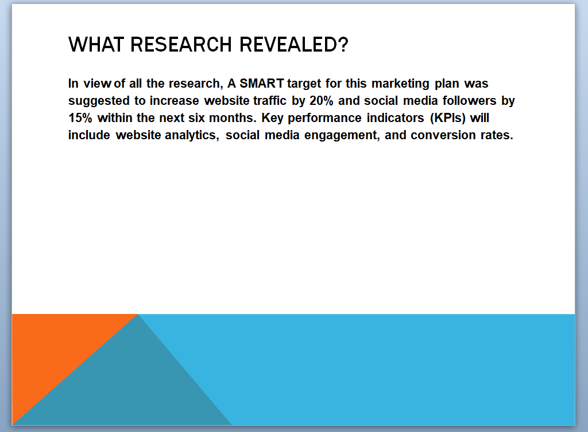

SLIDE 4 SCRIPT

WHAT RESEARCH REVEALED?

In view of all the research, A SMART target for this marketing plan was suggested to increase website traffic by 20% and social media followers by 15% within the next six months. Key performance indicators (KPIs) will include website analytics, social media engagement, and conversion rates.

SLIDE 5 & SCRIPT

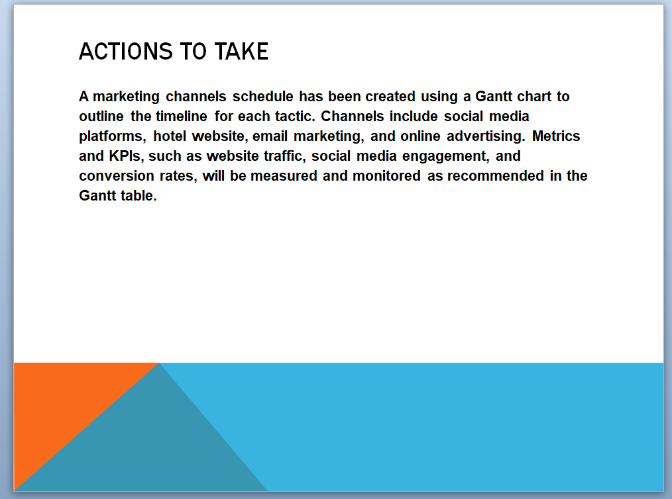

SLIDE 5 SCRIPT

ACTIONS TO TAKE

A marketing channels schedule has been created using a Gantt chart to outline the timeline for each tactic. Channels include social media platforms, hotel website, email marketing, and online advertising. Metrics and KPIs, such as website traffic, social media engagement, and conversion rates, will be measured and monitored as recommended in the Gantt table.

SLIDE 6 & SCRIPT

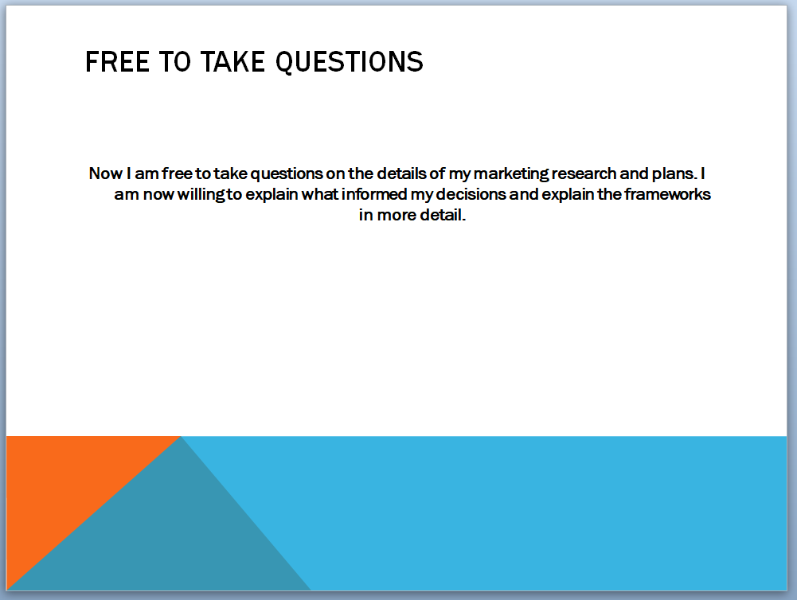

SLIDE 6 SCRIPT

FREE TO TAKE QUESTIONS

Now I am free to take questions on the details of my marketing research and plans. I am now willing to explain what informed my decisions and explain the frameworks in more detail.

