Davion Linton Gowie (2216147)
2216147@student.uwtsd.ac.uk
Abstract
Student ID:2216147
Student Name: Davion Linton Gowie
Student Name: Renuga Jayakumar
Module code: ACCA6020
DeadLine: 02/04/2026
BSc Applied Computing L6
Blockchain | Music-Smart

Table of Contents
Abstract 2
Introduction 3
Problem statement 4
Purpose of the literature review 5
Project Title: Blockchain Music Smart 6
Aim: 6
Research Objectives 6
Scope of the Review 6
Project Timeline (10 February 2026 – 14 August 2026) 7
Gantt Chart 7
Blackchain Music Smart Storyboard: 7
1. Understanding the Domain: Looking at and analysing how blockchain can be used in the music business 9
2. The tools you must use to make your project idea happen 9
3. Creating the Functional Music App and Designing It 10
4. Using smart contracts to split up royalties 10
5. Adding a digital wallet for safe transactions. 11
6. Making a decentralised storage system 11
Current Gaps: 12
Proposed Solution 12
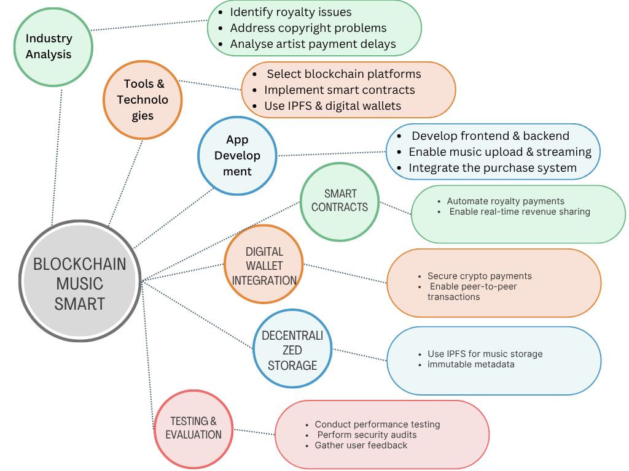 13
Significance of the Proposed Idea 13
Future developments 14
Conclusion 14
References 15
Appendix 16

Abstract
The research aims to create Music Smart, a blockchain-based music streaming and buying platform Addresses industry issues like copyright management, artist payments, and royalty transparency. Decentralised technologies: Blockchain smart contracts automatically distribute royalties.
Digital wallets for secure payments, IPFS for decentralised music and metadata storage. The system architecture combines frontend, backend, and blockchain layers for simplicity and efficiency. Testing includes checking its speed, security, usability, and effectiveness. Finds scalability, user adoption, and integration issues. Says blockchain can make music distribution open, fair, and safe.

Introduction
The music business around the world has changed quickly because of digital technology. It used to be based on physical sales, but now it's mostly based on online streaming. Streaming apps and other services make things easier and more accessible for a lot of people, but they also make it harder to share money, enforce copyrights, and be open about things. This means that many artists have less control over their money and intellectual property rights.
With the digital world changing all the time, new technologies like blockchain offer new ways to get around these problems. Blockchain can change the way music is shared and paid for by making transactions decentralised, open, and safe. It can also make copyright tracking easier, automate royalty payments, and build trust between artists, consumers, and platform providers.
[1] [2] [3] [4] [5] [6] [7] [8] [9] [10] [11] [12] [13]

Problem statement
Despite the rapid growth of digital music streaming services, artists still face unfair revenue sharing, late royalty payments, and financial transparency issues. Middlemen manage music licensing, payments, and distribution on traditional music platforms. This structure can reduce efficiency and artist control over money and IP. Centralised digital music storage may have security issues and hinder business. Decentralised blockchain technology could simplify, automate, and secure royalty payments and transactions. Blockchain music streaming services require more research and development.
The remaining issues include unfair royalty distribution, Delayed payments to artists, and a lack of financial transparency. Traditional systems rely on centralised intermediaries, limiting artist control over their work and earnings.

Purpose of the literature review
Blockchain technology and its use in the music industry are the focus of this literature review. The review investigates how blockchain can solve royalty management, copyright tracking, and secure digital transactions. It also examines smart contracts, decentralised storage systems, and digital wallets used to create blockchain-based apps. The literature review examines academic studies and field research to theoretically support this project. It also highlights research gaps and technological constraints that must be considered when creating a blockchain-based music streaming and buying platform.

Project Title: Blockchain Music Smart

Aim:
- To develop a blockchain music platform that enables streaming and purchasing, enabling fans to invest in their favourite songs as well as to integrate fair, secure & transparent royalty distribution.

Research Objectives
- To critical evaluations and analyses of blockchain use case scenarios in the music industry, and the toolset available to implement the project idea.
- To implement blockchain-based smart contracts to automate music royalty distribution and ensure transparency in transaction processing, and integrate a digital wallet system that enables secure peer-to-peer payments and cryptocurrency transactions, as well as to develop a decentralised storage mechanism (for example: IPFS) to securely store music files and metadata.
- To ensure transparent and fair royalty distribution and reduce reliance on intermediaries, and to develop a functional blockchain, streaming, purchasing and investing music platform, as well as testing and evaluating a blockchain system’s performance, security, and usability through user testing and technical analysis.

Scope of the Review
Define boundaries of research:
- Time frame (10th, 02 2026 – 14th, 08 2026)
- Geographic focus (global / EU / UK / US)
- Industry focus (music, publishing, digital media)
- Type of sources (peer-reviewed journals, conference papers, reports)

Project Timeline (10 February 2026 – 14 August 2026)

Gantt Chart

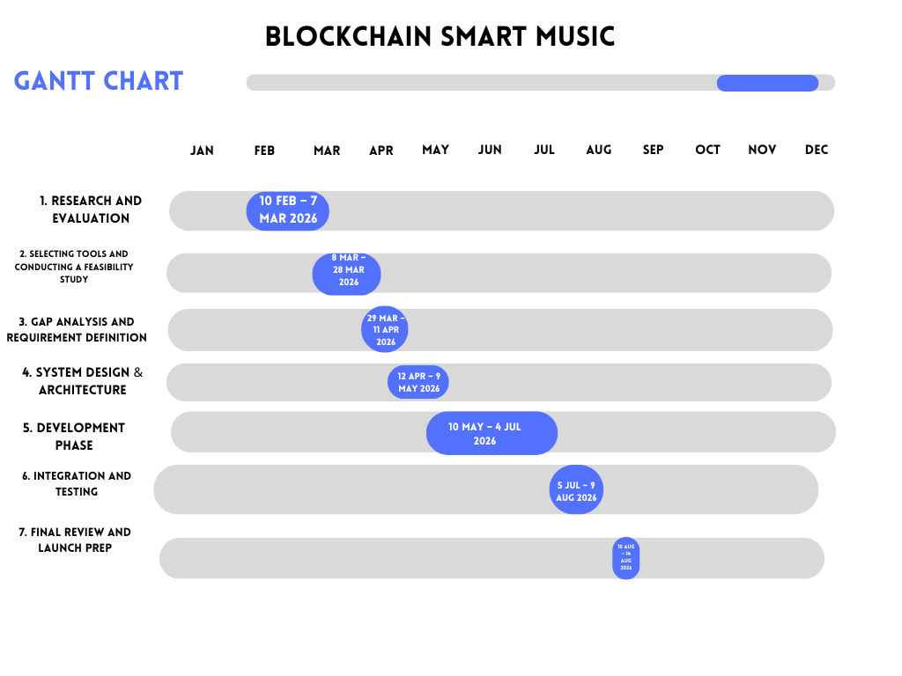

Blackchain Music Smart Storyboard:

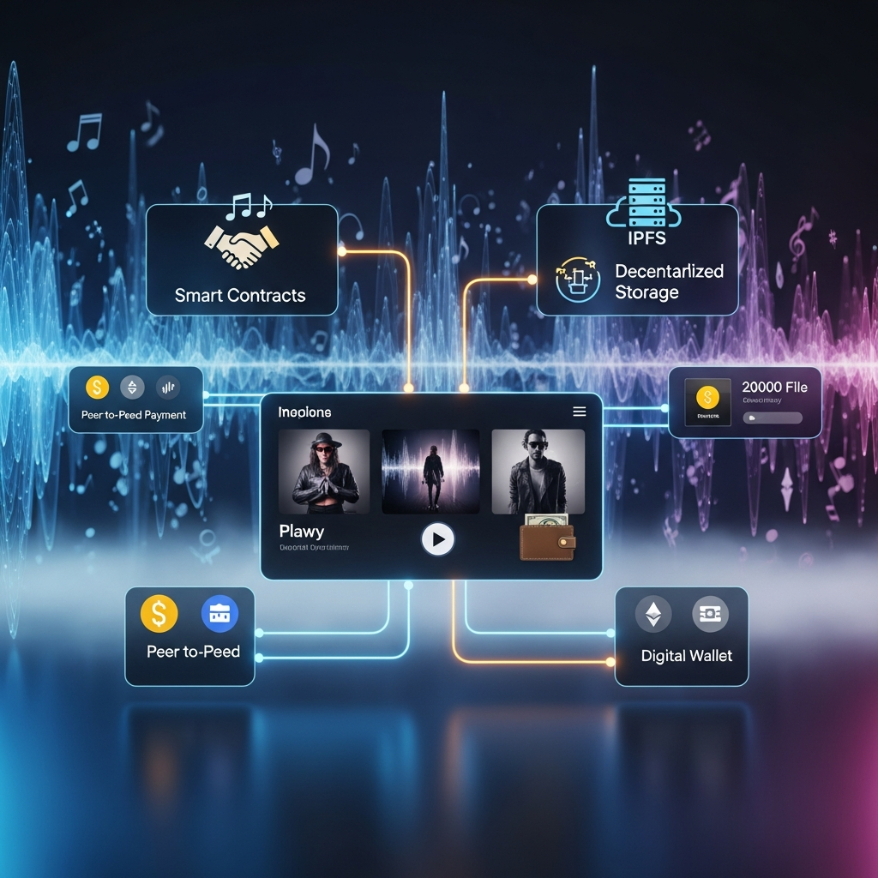

1. Understanding the Domain: Looking at and analysing how blockchain can be used in the music business
• A blockchain-based music streaming and purchasing platform requires blockchain tools, web technologies, and decentralised storage systems.
Blockchain platforms like Ethereum allow decentralised apps and smart contracts. You can write Solidity smart contracts and deploy them with frameworks like Hardhat, The Truffle Suite
• These tools simplify contract creation, deployment, and testing. • Build the web app front end with modern technologies: • React • HTML5 • CSS3 JavaScript • React creates music browsing, streaming, and shopping interfaces. • Frontends can communicate with blockchain networks using Web3.js or Ethers.js • Peer-to-peer storage systems like Interplanetary File System can store music and metadata without central servers for copyright control purposes. • Connecting your digital wallet to MetaMask lets you manage cryptocurrency accounts and approve blockchain transactions. Node.js and Express.js can build backend services for: • Application logic • Metadata management Communication via APIs • These technologies are said to create a safe, growing, and decentralised music platform.
[1]
2. The tools you must use to make your project idea happen
• A blockchain-based music streaming and purchasing platform requires blockchain tools, web technologies, and decentralised storage systems. Blockchain platforms like Ethereum allow decentralised apps and smart contracts. You can write Solidity smart contracts and deploy them with frameworks like Hardhat
The Truffle Suite
• These tools simplify contract creation, deployment, and testing.
• Build the web app front end with modern technologies:
• React
• HTML5
• CSS3
JavaScript
• React creates music browsing, streaming, and shopping interfaces.
• Frontends can communicate with blockchain networks using Web3.js or Ethers.js.
• Peer-to-peer storage systems like Interplanetary File System can store music and metadata without central servers for copyright control purposes.
• Connecting your digital wallet to MetaMask lets you manage cryptocurrency accounts and approve blockchain transactions. Node.js and Express.js can build backend services for:
• Application logic
• Metadata management
Communication via APIs
• These technologies are said to create a safe, growing, and decentralised music platform.
[2]
3. Creating the Functional Music App and Designing It
• A blockchain-powered music app needs a well-organised system architecture with simple web interfaces and decentralised backends. The platform lets users browse music. Online song play. Buy songs. Artists upload and track music ownership. There are three main application architecture layers: Frontend and backend layers. Layer of blockchain • Frontend users can sign up and log in, find new music, View artist profiles, create playlists, and buy music. • Interfaces are simple and look like modern streaming services, but they use blockchain. Backend layer handles: Metadata and indexing of Frontend-blockchain messaging, Verifying users and platform analytics • The backend of decentralised storage systems like the InterPlanetary File System stores music file references. • The blockchain layer handles payment, music ownership, and licensing smart contracts. When musicians upload songs, a blockchain record includes: Artist information, Ownership percentage, License information, IPFS storage hash • System design emphasises fast transactions, Effective streaming, Easy to buy • Decentralised infrastructure and modern web technologies create an open, easy-to-use platform.
[3]

4. Using smart contracts to split up royalties
• Smart contracts automate royalty payments and clarify financial transactions. • A smart contract is a blockchain program that performs its stated tasks under certain conditions. • Each song has a smart contract governing ownership and royalties. • When a song is streamed or bought, the smart contract automatically pays stakeholders like: A artist Creator songwriter, record label. • Artist gets 70% of royalties, 20% producer, 10% songwriter • Participants' blockchain wallets receive payments automatically, reducing manual accounting and delays. • Blockchain records show your earnings in real time, making collaboration more transparent. Testing smart contracts during development is crucial for security. Code audits: Avoiding weaknesses like re-entrancy. • Well-designed smart contracts ensure safe, reliable, automatic royalty payments.
[4] [5]
5. Adding a digital wallet for safe transactions.
. • A digital wallet lets music platform users securely pay each other. • Keep cryptocurrency, approve transactions, and use smart contracts. • Login users link their wallet (like MetaMask) to the platform. • The wallet is the user's identity and payment method. When users buy music or stream premium content, the wallet checks the payment. • Blockchain tracks transactions, and smart contracts execute them. • Listeners can directly support artists with peer-to-peer payments. Giving artists tips is an example. Buying exclusive music or digital collectibles Security measures include not storing private keys on the platform and approving transactions through wallets. API security and encryption. • Digital wallets enable new revenue streams like subscription content. Few music releases o Token-based fan experiences. • This system gives artists more freedom and simplifies fan interaction.
[6]

6. Making a decentralised storage system
• Traditional music streaming services store and send files on centralised servers. • Centralised storage can cause data loss Possible censorship. High infrastructure costs. • The peer-to-peer Interplanetary File System stores files in a decentralised. • Different nodes store smaller music files. • Each file has a permanent cryptographic hash. When musicians post songs online, IPFS receives the file and metadata. The blockchain smart contract stores the hash. • The stored hash receives and plays network music. • Decentralised storage improves: o System reliability, Censorship and inability to descend Artists' digital asset control. • Metadata may include song name Artist name Information about the album, and royalty percentages. • Blockchain and decentralised storage create a secure, tamper-proof music management system.
[7]
7. Checking and testing the system's performance, security, and ease of use:
Blockchain-based music platforms need rigorous testing, which includes: Functionality and performance testing A security analysis Usability testing. Functional testing ensures feature functionality: Posting music online Playing music online Buy things Smart contract royalty distribution. The automated frameworks act like blockchain transactions. • Performance testing evaluates a system's ability to handle more users and respond quickly: Many users and transactions. Measures transaction completion, streaming latency, and data retrieval from storage. • Security testing protects funds: Smart contract audits, testing backend and web app security • Usability testing involves real users: Easy to use and navigate Getting musician and fan feedback • Technical analysis tools monitor blockchain transactions Network performance Storage efficiency • Technical metrics and user feedback ensure a safe, effective, and easy-to-use system. [8]

Current Gaps:
- Most blockchain research focuses on theoretical frameworks, not music platform implementation.
• Research on decentralised music streaming apps' performance, growth, and usability is scarce.
• Blockchain and decentralised storage technologies like the Interplanetary File System are still difficult to integrate.
- Decentralised infrastructure for large-scale streaming isn't well-studied.
• Communication barriers. • Many platforms have complicated interfaces for non-techies. [9] [10] [11] [12]

Proposed Solution
For a fair royalty distribution, real-time statistics and payments to artists, reduction in Lock of transparency, I will integrate a decentralised platform to cut out the middleman management of artists' accounts, instead of centralised intermediaries, which limit artist control over their work and earnings.

[12]

Significance of the Proposed Idea
The importance of this project lies in its potential to:
- Empower artists financially by ensuring fair and real-time royalty payments and increasing transparency in music ownership and revenue distribution.
- Reduce dependency on intermediaries, lowering costs and inefficiencies, and enhance trust between artists, producers, and listeners through verifiable blockchain records.
- Promote innovation in digital music consumption through decentralised technologies.
[13] [14]

Future developments
Artist and fans interaction (communication).

Conclusion
In conclusion, blockchain technology has the potential to significantly transform the music industry by addressing long-standing challenges related to transparency, copyright management, and royalty distribution. Traditional music platforms often rely on centralised systems that obscure financial flows, delay payments, and limit artist control. By contrast, blockchain introduces a decentralised and immutable infrastructure that ensures trust, traceability, and efficiency.
Using smart contracts, this project demonstrates how royalty payments can be automated and distributed instantly among stakeholders, eliminating intermediaries and reducing disputes. In addition, decentralised storage systems such as IPFS enhance the security and availability of music assets, while digital wallets enable secure peer-to-peer transactions between artists and listeners.

References

[1] | giovanna centorrino, valeria naciti, daniela rupo, “A new era of the music industry? Blockchain and value co-creation: the Bitsong case study,” emerald.com, no. dec 20, 2022, pp. https://www.emerald.com/ejim/article/26/7/65/26135/A-new-era-of-the-music-industry-Blockchain-and, 2022.
[2] | fran casino, thomas k. dasaklis, constantino's patskis, “A systematic literature review of blockchain-based applications: Current status, classification and open issues,” sciencedirect.com, vol. 36, no. march 2019, p. https://www.sciencedirect.com/science/article/pii/S0736585318306324, 2019.
[3] | constantine, “How to Build a Blockchain Music App: 9 Steps,” devteam.space, pp. https://www.devteam.space/blog/how-to-build-a-blockchain-music-app/.
[4] | blockchainusecases, “Smart Contracts in Blockchain-Based Music Streaming and Royalty Distribution,” blockchainusecases.com, no. oct 29, 2024, pp. https://blockchainusecases.com/gaming-entertainment/smart-contracts-in-blockchain-based-music-streaming-and-royalty-distribution/, 2024.
[5] | vartika, “Improving Royalty Contracts with Blockchain Deployment,” nadcab.com, no. 5 jan, 2026, pp. https://www.nadcab.com/blog/royalty-contract-in-smart-contract, 2026.
[6] | vishvabodh sharma, “Blockchain Music Platform Development: A Comprehensive Guide,” ideausher.com, pp. https://ideausher.com/blog/blockchain-music-platform-development/.
[7] | b. technologies, “How Web3 Storage Platforms Are Redefining Data Ownership and Security in 2026,” linkedin.com, no. march 17, 2026, pp. https://www.linkedin.com/pulse/how-web3-storage-platforms-redefining-data-ownership-security-kn2pc/, 2026.
[8] | thinksys, “blockchain testing,” thinksys.com, pp. https://thinksys.com/blockchain/blockchain-testing/.
[9] | Mohit Mitta, Khandakar F. Rahman, C. K. Jha, Vikram Bali, Tejaswi Khanna., “A Blockchain Enabled Solution for Royalty Tracking in Movies and music industry,” scitepress.org, p. https://www.scitepress.org/Papers/2024/132378/132378.pdf?.
[10] | Harshali Mane, Harshali Mane., “Music Streaming Decentralized App using blockchain,” ijcrt.org, vol. 12, no. sep 9, 2024, p. https://www.ijcrt.org/papers/IJCRT2409675.pdf?, 2024.
[11] | Rendrikson Soares, André Araújo., “Towards a New Business Model for Streaming Platforms Using Blockchain Technology,” mdpi.com, no. 13 june 2024, pp. https://www.mdpi.com/1999-5903/16/6/207?, 2024.
[12] | Julio C. Mendoza-Tello, Jonathan J. Sánchez-Lucas, Juan G. Orosco-Pantoja., “A Model to Support the Music Streaming ServiceUsing Blockchain-Based Smart Contracts,” researchgate.net, pp. https://www.researchgate.net/publication/380996114_A_Model_to_Support_the_Music_Streaming_Service_Using_Blockchain-Based_Smart_Contracts.
[13] | Y. Jiang, S. Matsumoto and T. Bischof, “ Towards a blockchain-based music royalty system,” inderscience.com, vol. 2, no. 2024, p. https://www.inderscience.com/info/inarticle.php?artid=142533, 2024.
[14] | Vendrell Mendonca, Ashwin Pillai, Elbin Thomas Abraham, Kyle Crasto, Annies Minu. , “Decentralized Music Marketplace: A blockchain based right management approach,” ijfmr.com, p. https://www.ijfmr.com/papers/2024/2/19080.pdf?.

Appendix


