
Leading and Implementing Workplace Change

June 25, 2021
Samantha Davis
1812476

Executive Summary
The following report is going to be addressing the changes and processes Morrisons followed to implement their zero-waste management initiative. The change was brought to the forefront of their strategic planning due to the global pandemic Covid-19.
The report will focus on the findings of a micro/macro environment and the influences these analysis’s have identified to help/hinder the change processes. There will be findings also based on the importance of the cultural influences that will impact the change process and the need for leaders and change agents in this process. The author will also be identifying the different change theories and models that will help introduce and promote the step-by-step processes to incorporate the changes.
The report will have a conclusion and will also introduce a recommended improvement plan to the managers of Morrisons.

Contents
Executive Summary 1
Task 1 3
a. Brief background of Morrison's to demonstrate its development 3
b. Overview of the products and services it currently offers 4
c. Current market position of the company 4
d. Description of the change which was implemented 7
Task 2 9
SWOT Analysis 9
PESTEL Analysis 10
Task 3 12
Impact of “Cultural influences” of Morrisons on the change process 12
Task 4 14
An area of "complex change" the organisation faced. 14
Role of leaders in supporting/ hindering the change process 14
Role of change agents in supporting/ hindering the change process 14
Task 5 16
Critical understanding and knowledge of various change models/ theories 16
Task 6 20
Conclusion 20
Improvement Plan 20
References 21

Task 1

a. Brief background of Morrison's to demonstrate its development
Morrison's is one of the largest retailing organisations in the United Kingdom. In the year 1899, the organisation was established in Bradford, United Kingdom. The founder of this organisation is William Morrison, who is one of the famous businessmen of that age. This organisation was established for providing necessary products such as food products and dairy products to the local organisations in the country. The organisation had no proper shop when it was established. Ken Morrison, the son of William Morrison, took over the country in the year 1952 (Morrisons PLC, 2021). During his time, the organisation had expanded its business activities at a constant rate. After Ken Morrison had taken over the company, the first town-centre shop of Morrison was established in the year 1958. After that, Ken Morrison had made this firm a public company and more than 80,000 investors were directly involved in the organisation in 1961.
After the organisation had become a public company, it has constantly improved its current financial and managerial activities over the years. From 2000 onward, Morrison had acquired numerous companies such as Safeway and created partnerships with Amazon to expand its business all around the country (Morrisons PLC, 2021). After the demand for online services grew in the market, the management of Morrison's could capture that demand, and they could implement online retailing services to the customers. This is extremely essential for the management as the chance of financial risks can be mitigated. In addition to that, with the assistance of online services, the business could improve its business growth and could expand the potential number of customers.
In respect to the above details of Morrison, the organisation has managed to improve its business performance over the years. Currently, Morrison's has been conducting its business activities for over 122 years. The main reason for the survival capability of the company is adopting new and advanced technologies and business ideas. During the time of William Morrison, the company growth was slow as the owner could not be capable of implementing new strategies. However, Ken Morrison could understand the changes in the market and customer behaviour over the years. Based on the changes in market behaviour, new and advanced technologies, business mergers and partnership were considered by the CEO. After that, the organisation was able to maintain constant development over the years. The current CEO of Morrison, David Potts, has also supported technological advancements that have helped the organisation expand its financial performance over the years.

b. Overview of the products and services it currently offers
It is mentioned in the above section that the organisation was established to provide food and dairy products to local customers. However, as the company expanded and it increased its profitability rate, the company offered new products and services. Currently, Morrison's offers food and beverages, groceries, clothing, florist, fuel, book, magazines, homecare products and health and beauty products. With respect to that, it can be clearly seen that the organisation's product range has expanded over the years. With respect to that, this can be clearly mentioned that the company has been capable of generating a massive amount of profit over the years. In addition to that, Morrison's sells its products to numerous countries in the international market. This has also helped to increase the number of global customers in the market. On that basis, the potential profitability rate of the company can be expanded over the years.

c. Current market position of the company
to analyse the current market position of Morrison, the financial position of the company needs to be explored:
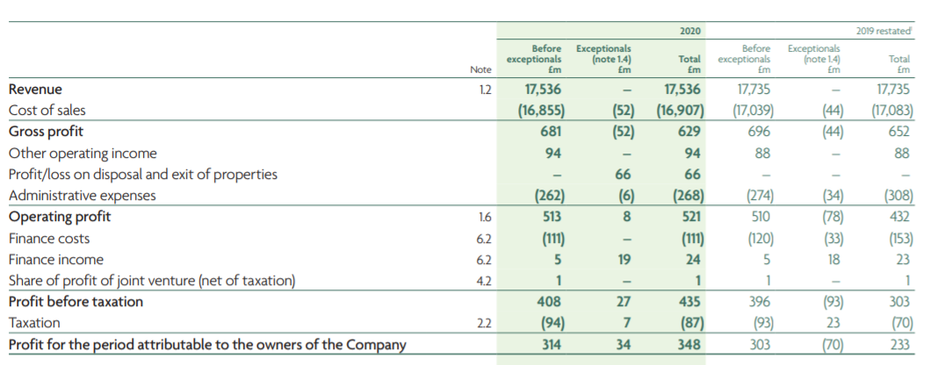
Figure 1: Income statement for the year 2020
(Source: Annual report, 2020)
With respect to the current figure, it has been clearly seen that the organisation decreased its revenue in 2020 compared to 2019. In the year 2019, the revenue of Morrison's was £17,735 million, and it declined to £17,536 million in 2020. This can be clearly stated that due to the Covid-19 impact in the year 2020, the organisation has decreased its profitability. However, even in the pandemic situation, the organisation has not faced any losses, and the revenue has decreased slightly compared to 2019. On that basis, it can be stated that the management activities of the company are stable. However, due to the Covid-19 pandemic, the profitability growth of the company has decreased. In addition to that, the above financial statement shows that even though the organisation has failed to collect a high amount of revenue in 2020, it has increased its net income. In 2019, the net income of Morrison's was £233 million, and it has expanded to £348 million, which is beneficial for the company. Based on the pandemic situation, the organisation was able to reduce its unnecessary cost, which has allowed them to mitigate the current financial risks in 2020.
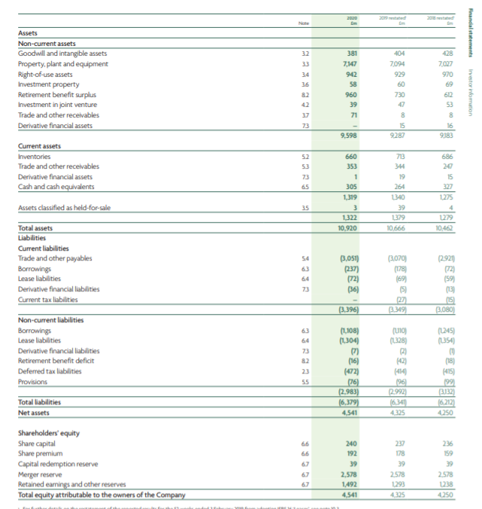
Figure 2: Balance sheet statement for the year 2020
(Source: Annual report, 2020)
The balance sheet statement has shown that the organisation was able to expand its assets amount in 2020 compared to 2019. High assets amount is essentially beneficial for the management as it helps to improve its current financial position in the market. In addition to that, with the assistance of high assets, the organisation will not face the probability of bankruptcy. Moreover, it is seen that the liabilities of Morrison's decreased in 2020 compared to 2019. This is extremely beneficial as the management will not face high cash outflows compare to cash inflows. Therefore, the potential profitability rate of the company can be expanded over the years.
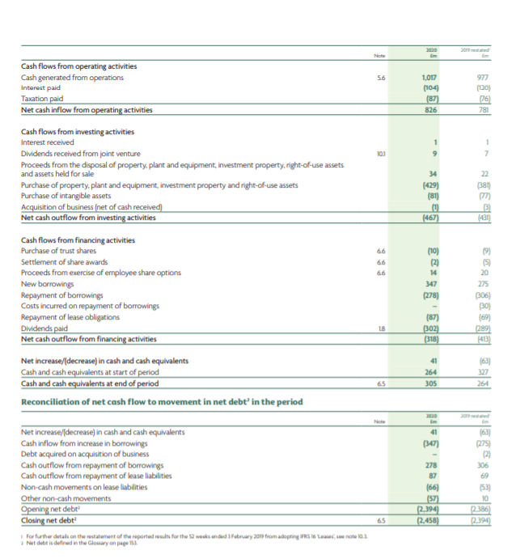
Figure 3: Cash flow statement for the year 2020
(Source: Annual report, 2020)
The cash flow statement has clearly shown that net cash flow from operating expenses is only in a positive range. However, net cash flows from investing and financing activities have decreased to a negative range. Decrement of net cash flows in a negative capacity is not beneficial for the organisations due to the decrement of net cash flows. The management can be capable of avoiding the chance of financial risks over the years. Moreover, the management may not be capable of expanding the positive cash variable in the upcoming years. On the other hand, it is seen that compared to 2019, net cash flow from operating expenses expanded in 2020. Therefore, the management needs to reduce the wastage of cash regarding financial and investing activities to improve its financial position in the market.

d. Description of the change which was implemented
After the Covid-19 impact in 2020, Morrison's had implemented zero waste management in which they focused to reduce wastage of products. In addition, Morrison has taken a green management strategy into consideration, which is extremely beneficial for the organisation (Miller, 2021). Based on the green management strategy, all collected waste from the shop had recycled by the management. In addition, the organisation had compromised with soft and hard plastic, food waste, green waste, and other types of waste in the management. If this change management activity is successful in the current times, the management will include renewable energy in the future. The main reason for implementing the change is to improve the environment after the impact of Covid-19. Due to the Covid-19 impact, the immunity of many people was affected, so the organisation focused on reducing waste and avoiding health issues recognised from pollution. On that basis, the potential health improvement for the customers can be identified. This will also allow the management to understand the current financial performance by analysing the social benefits generated from the current strategy.

Task 2
To understand the nature of the chance, proper SWOT analysis and PESTLE analysis needs to be conducted in the study.

SWOT Analysis
The SWOT analysis of Morrison's is presented below:
Strengths  - Effective supply chain management  - Brand image  - High market share  - Expansion of online retailing and shopping | Weakness  - Limited geographical reach  - Past issues regarding farmers rights
Opportunities  - The growing market for organic products  - International expansion  - Rising demand for service  - Acquisition of the small company | Threats  - Massive competition  - Increment of tax and changes in government policy  - Rise of eCommerce business affecting retail stores.

In respect to the above SWOT analysis, this can be clearly seen that the organisation has been capable of expanding its strengths compared to its weaknesses. It is essential for the management to increase the strengths to survive in the market. Based on the current brand image and high market share, the organisation has been capable of implementing the waste management strategy in the market. In the opinion of Chaouk et al. (2020), the company needed to implement a unique social strategy that could help to mitigate the past issue with the farmer's rights. In this respect, the requirement for the green management strategy had developed for the organisation. This green management strategy aimed to reduce waste in the locality to develop a healthy lifestyle. On that basis, the social benefits of the company had expanded at a constant rate. With respect to the collected social benefits, the past issues recognised by the company will be ignored, and the business will be capable of avoiding the chance of unnecessary business risks.
In addition to that, SWOT analysis has stated that Morrison's has opportunities regarding international expansion and acquisition of small companies. Based on that, the business can implement the waste management strategy in the global market to expand the number of international customers in the future. Based on this method, the management can be capable of expanding the foreign cash flow in the market. This is essential for the direction as the potential profitability rate can be improved in the future. The opportunity of Morrison's will help the business to avoid the risk regarding the massive competition. On that basis, the quality of the business performance can be conducted in the future years.

PESTEL Analysis
The PESTEL analysis is considered below:
Political factor: It has been identified that the political factor of the UK is stabilised. However, due to the Brexit impact, political stability was corrupted. As per the views of Mir and Mir (2019), even though the Brexit implications, the government has supported the companies of the UK and appropriate taxation policies were implemented by the management. On that basis, Morrison had received government support regarding the current change management. Based on that, benefits from the change management activity had been collected. The government support had helped the business to receive tax benefits which may reduce the unnecessary cost of the company. On that basis, the benefits had been expanded, and the profitability of the company had been stabilised.
Economic factor: Economic stability in the United Kingdom has decreased in the year 2020. The inflation rate had been reduced to -9.8, which has reduced the purchasing power of the company (Data Worldbank, 2021). This is not beneficial for the management as they cannot be capable of expanding the profitability rate to implement the current management activities. In addition to that, the business had not been capable of maintaining the cost regarding the waste management strategy in the industry. This may create a gap. However, the inflation rate of the UK is 0.85 per cent which is extremely low (Statista, 2021). On that basis, the potential additional cost of the company can be mitigated. As a result, even after collecting a low amount of profit, the management can reduce the extra cost to expand its profitability. This is essential for the management for conducting business-related activities in the future years. Finally, the company had found highly skilled employees in the country who can complete the waste management activity.
Social factor: Social factors such as requirements of society regarding waste management have played an essential role in the operation. The management of Morrison's had evaluated the social need of the society members and implemented them in the business operation. Based on this strategy, the business was able to complete the change management activity without any errors. This is an essential factor for the organisation as it expands the social benefits. Moreover, educational aspects of society have also affected the activities of the current operation. With the assistant of educational level development in the community, the requirement for waste management and green management had expanded in the market. Hence, the company had captured the demand and increased its social benefits.
Technological factor: The technological market of the United Kingdom is large, and there are many new and advanced technologies included market of the United Kingdom. With the assistance of this strategy, the management had been easily implemented advanced technologies in the current change management activity. According to Castañeda-Ayarza and Godoi (2021), based on this strategy, the wastes in the stores had been easily recycled by the management. On that basis, the unnecessary risks can be expanded, and the financial performance of the organisation can be improved in the future years. The technological aspects had helped the business to reduce the operation cost of the change management strategy. On that basis, the quality of the change management operations can be conducted in a proper way. Automation technologies have been included in the change management operation, which will allow the business to mitigate the financial risks in the upcoming times.
Environmental factor: The whole change management activity is based on the environmental factor in the UK market. The organisation had evaluated the environmental law of the UK and followed its rules to implement the waste management strategy in the past times. Valente (2018) stated that by following the environmental laws properly in change management, a professional relationship with the government agencies was established by the management. This had also helped the business to collect government financial supports regarding the change management strategy. Therefore, the organisation could maintain efficiency in the business. Based on that, the success rate of the change management strategy had improved, and the management could achieve the expected outcome from the project.
Legal factor: The legal factor of the United Kingdom is extremely strict. This had directly affected the progress of the change management strategy. It had been seen that the management of Morrison's was forced to follow corporate law, consumer law, environmental law and accounting law while conducting the waste management activity. Based on that, the quality of the change management strategy had been implemented in the past years. On that basis, the financial risks of the organisation had decreased, and the quality of the project activities had improved. Based on the macro and microenvironment analysis, this can be overall concluded that the business had a beneficial situation that helped to complete the project in a proper manner. As a result, the unnecessary risk had been reduced, and the management success rate had increased over the years.

Task 3

Impact of “Cultural influences” of Morrisons on the change process
While discussing the impact of “cultural influences” of Morrisons on the change process, it has been observed that the corporate strategy and values of the entire organisation are strongly involved with its cultural aspects. The organisational culture of Morrisons influences the company to become more competitive, and for this, it has implemented and has been making changes to become the first "zero waste” supermarket chain of the whole UK. Diverse ranges of employees from diverse cultural backgrounds work with Morrisons, which has made the culture of the company diversified. This aspect has been enabling the employees to speed up and simplify the whole change process along with the establishment of culture based on teamwork (Morrisons PLC, 2021). Morrisons also maintains a hygiene culture, which has been helping the organisation to implement the change of becoming a "zero waste” supermarket in the UK.
In this context, Sîrbu and Rosca (2010) stated that both organisational change and cultural influences play a crucial role in developing the economic performances of business organisations. A diverse cultural scenario has been helping the employees of Morrisons to work collaboratively with Nestle for recycling and collecting all types of “hard-to-recycle” soft plastic materials for the very first time within the entire UK. Within most of the stores in the UK, Morrisons has already been offering recyclable and reusable paper bags to the customers after their purchasing. Moreover, employees from different cultural backgrounds have been spreading awareness to the customers by talking with their preferable languages so that the rate of greenhouse gas emissions can be lowered. The strong culture of Morrisons has also been protecting the organisation from the current environmental changes, which have occurred due to the pandemic situation of Covid-19.
Environmental or climate change is one of the most important reasons, due to which Morrisons has been implementing the changes of “zero waste” during the pandemic situation of Covid-10 without considering its current market position. The CEO of the company, David Potts, strongly believe that such an initiative will increase the profits of the company considerably as, by this, the business will become more sustainable. In this context, Smith (2019) believed that when many people are involved within the change process, the condition becomes more complex than normal, although the support of the employees depends on their common attributes towards organisational changes along with new things and innovative ideas. While making this change process successful, Morrisons has also been shedding light on the budget as it is one of the greatest concerns, which can impact the change process. While doing so, Morrisons has been capable of reducing plastic packaging of its branded products within 498 stores since the year 2017, and the net amount is 8,000 tonnes (Miller, 2021).
On the other hand, Aguirre, and Post (2013) opined that organisational culture is one of the most important aspects compared to organisations' operating models and business strategies. Due to this reason, Morrisons has always been focusing on its corporate culture by aligning it to its values and business strategies so that more relevant results can be acquired.
Lastly, the significance of “cultural influences” in terms of the organisational change process of Morrisons can be depicted. The corporate culture of Morrisons is important enough as it helps to define the external and internal identity of the organisation along with the adoption process of the changes (Moseley, 2019). As one of the core values of Morrisons to serve the customers better along with greater availability of products is related to its corporate culture, the current change process to develop the concept of a "zero waste” store has been maintained smoothly by all its employees collaboratively. Additionally, the diversified organisational culture of Morrisons has been helping the employees to transform themselves into critics or advocates. Another important cultural influence of Morrisons is to provide equal respect to all its employees, and by considering this, Morrisons has recently announced “Boxing Day off” for hard work and excessive contribution of all employees during the Covid-19 pandemic (McCoid, 2021). The provision of such facilities has been influencing the employees of Morrisons to adopt the current organisational change smoothly.

Task 4

An area of "complex change" the organisation faced.
Along with the initiative to develop “zero waste” stores by the end of 2025, Morrisons has already implemented some changes within its business structure. The organisation has been aiming to recycle all unsold food and packaging by 2025 so that more sustainable business activities can be commenced. The company has already started its trial to recycle the products of the customers like face masks, empty packets, wrappers, coffee pods and film (Boneham, 2021). In this context, the strategic technical manager of WRAP, Helen Bird, said that the design of the packets during packaging and collection of the packets are also required to be considered during recycling (Miller, 2021). All the employees of Morrisons have been providing training on how to sort the waste in the storerooms after collecting those.
Climate change is one of the key areas of "complex change” which Morrisons has faced during the last years, and due to this reason, the organisation has been preparing all its employees to make the trial of "zero waste store” successful. According to this trial initiative, which has been developed by Morrisons, the wastes within the stores of the company consists of cardboard, plastics, green waste, food waste, foils, cans, tins, and PPE (Barker, 2021). The employees of the stores will sort the waste within the warehouse, and then, specialist waste partners will collect the different ranges of wastes for recycling within the UK.

Role of leaders in supporting/ hindering the change process
While describing the role of leaders in supporting/ hindering the change process, it has been found that the leaders of Morrisons are extremely talented, skilled, knowledgeable, and experienced, who are working collaboratively for making the change more successful. The leaders of Morrisons help to drive corporate governance, which in turn facilitates prudent, entrepreneurial, and effective management. Such aspects of corporate governance also help the leaders of Morisons to deliver long-term success. Leaders of Morrisons operate within the already established values for determining strategies as parts of daily operational management (Morrisons, 2021). In terms of this change process, the leaders of Morrisons have been offering sustainable solutions throughout various ranges.
Additionally, female employees within the leadership team of Morrisons has increased to 33% from 17%. The proportion of female managers within the stores of Morrisons increased to 20% from 7% (Morrisons, 2021). Increasing numbers of female employees within the leadership team of the organisation has been developing the concept of equality and diversity, due to which they can support their followers effectively. Additionally, the senior leaders of Morrisons have been sponsoring and supporting the events of the organisation, and in this context, this change process is one of the most important events. Furthermore, the company has recruited the most talented employees within the retail team of the organisation so that it can develop its current market position (Morrisons PLC, 2021). In this aspect, the leaders of the business firm maintain effective communication and relationship with the employees for making the change process successful enough.

Role of change agents in supporting/ hindering the change process
Dalton Philips, who is the prior change agent of Morrisons, was extremely brave, whose footsteps have been followed by the current change agents of the organisation. He was also the previous CEO of the company, who left Morrisons when ten stores, which was making a loss, were closed (Jones, 2015). Although, he fought bravely for causing the condition suitable for conducting all types of business activities. Currently, the organisation does not have such a change agent within the organisation, and due to this reason, it may require hiring a change agent from outside of the company if a critical situation arises within the change management process.
According to the opinion of Lunenburg (2010), one of the most visible and effective roles of change agents while supporting the entire change process is to coordinate, facilitate and stimulate the efforts of the employees for adopting organisational change. In this aspect, the relationship between the decision-makers and change agents is very important as they collaboratively increase the workability and quality of the change efforts. Another primary role of change agents in supporting the change process is to investigate the entire scenario of the organisational change by advocating the actions of the employees. Lastly, it can be said that the change agents also motivate or encourage the employees for adopting the change.

Task 5

Critical understanding and knowledge of various change models/ theories
While depicting the necessary understanding and knowledge of different change models/ theories, the following models/ theories can be illustrated:
1. Lewin’s Change Management Model
As Kurt Lewin was the inventor of this model, it is known as “Lewin’s Change Management Model”, which was developed in the year 1950s. Kurt Lewin divided the entire change procedure into three phases such as unfreeze, change, and refreeze. Unfreeze is known as the preparation phase, in which all the employees of the organisations understand the necessity and requirement of organisational changes (Sarayreh, Khudair and Barakat, 2013). Change is the execution step, in which changes are required to be put into practice along with the provision of support for the staff involved. The last step is refrozen, in which strategies are developed for reviewing the new procedures. While dealing with the change, Morrisons can apply this model, in which the management of the organisation can get the employees prepared for the change within the unfreeze phase, whereas the activities of change can be put into practice within the change phase. In the refreeze phase, the employees need to get back to their normal activities by adopting the current change.
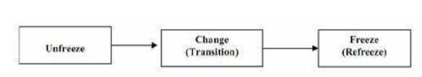
Figure 4: “Lewin’s Change Management Model”
(Source: Sarayreh, Khudair and Barakat, 2013)
2. Kotter’s Change Management Model
John Kotter developed this change management model, which mainly sheds light on the individuals involved within the entire change procedure consisting of eight crucial steps. The first step is to establish a sense of urgency, which Morrisons can apply for motivating the employees so that they can understand the necessity of the change effectively. The second step is to establish the change team of the organisation, in which Morrisons has already developed a team with the employees from different departments and staff of the stores for dealing with the change. It is commonly known as a "guiding coalition" with the change agents and leaders from different departments (Rajan and Ganesan, 2017). Within the third step, Morrisons has developed strategic visions, which are to make the concept of a "zero waste store” successful. By considering the fourth step, Morrisons has been developing effective communication with all the employees regarding the change vision. Moreover, Morrisons has also been dealing with the problems of recycling and packaging within the UK within the fifth phase by identifying roadblocks. One of the most effective short-term goals of Morrisons is to make the change trial effective. Lastly, for keeping up the momentum, Morrisons is continuously working with Nestle so that the current and future implementation of the organisational changes can become successful.
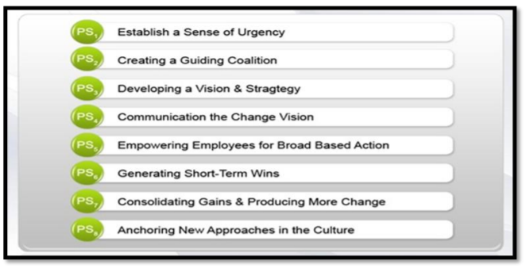
Figure 5: “Kotter’s Change Management Model”
(Source: Rajan and Ganesan, 2017)
3. ADKAR Change Management Model
Jeff Hiatt was the founder of this model, which consists of five major goals for basing the entire change management procedure. ADKAR, the abbreviated form of awareness, desire, knowledge, ability, and reinforcement, is based on three consecutive steps such as current, transition and future. Awareness and desire are considered in the current phase, whereas ability and knowledge are considered in a transition phase, and reinforcement is considered in the future stage (Tang, 2019). For the past 3-5 years, Morrison's goal has been to establish awareness of the requirement to change so that the concept of “zero carbon emissions” can be developed. The management of the organisation has been working hard for fostering the desire of the employees to make the change successful. Within the third stage, Morrisons has been offering information or knowledge to the employees by involving them within the change process. For making the fourth goal effective, the company has been ensuring the abilities of the employees for making the changes so that the current change can be reinforced effectually.
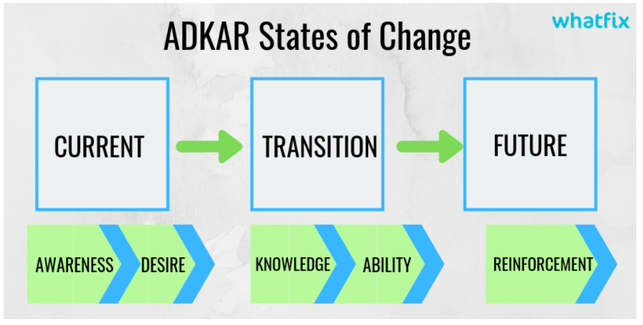
Figure 6: “ADKAR Change Management Model”
(Source: Malhotra, 2019)
4. Kubler-Ross Change Management Framework
Elisabeth Kübler-Ross was the inventor of this model, which described the experiences of the employees during the organisational changes. Understanding this model can be helpful in addressing the responses of the employees during organisational changes. The five responses of the employees are denial, anger, bargaining, depression, and acceptance. As developing 498 stores of Morrisons as “zero waste store” is a huge change, the employees firstly refused to adopt this change. As it is totally an unwanted change for all the employees, some of them can feel angry while the change is being forced on them (Hicks, K., 2021). In the bargaining phase, the employees of Morrisons may try to avoid the acceptance of the new changes. In the fourth phase of this model, some employees of Morrisons can enter the depression phase when they are unable to adopt the change. Finally, all the employees of the company have embraced the change while identifying that there is no way to avoid it.
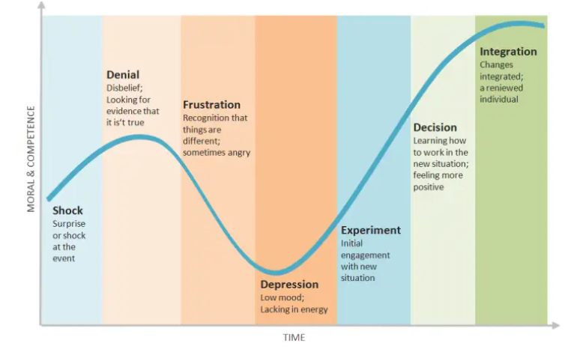
Figure 7: “Kubler-Ross Change Management Framework”
(Source: Belyh, 2020)
5. The McKinsey 7-S Model
McKinsey & Company consultants developed this model, which consists of seven different components related to the change management process. Strategy, structure, shared values, systems, style, staff, and skills are the seven various components of this model. Amongst all these components, systems, structure, and strategy are the hard elements, whereas staff, style, skills, and shared values are the soft elements. During organisational change, Morrisons has currently organised accountability relationships and chain of command as a new organisational structure. For making the trial and future change successful, Morrisons has already developed a well-structured business plan, including step-by-step activities. Within this change process, all the employees of the company from different departments are involved by applying their personal skills and shared values aligning those to the strategies of the company. While maintaining the systems of the fundamental change, the senior managers, and leaders of Morrisons have been helping the employees along with the establishment of the "Code of Conduct”.
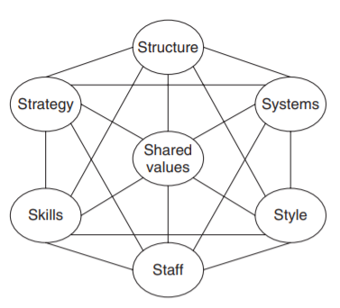
Figure 8: “The McKinsey 7-S Model”
(Source: Channon and Caldart, 2015)

Task 6

Conclusion
It can be concluded that the cultural influences of Morrison’s are also important parts of its leadership agenda, which has been allowing the leaders of the company to increase awareness of its employees for adopting the current organisational changes. This change process has been helping Morrison’s to cut the additional costs of exporting materials from other countries as the organisation has decided to recycle the materials within the country.

Improvement Plan
Strategies  (what) | Actions  (how) | Priority  (L/M/H) | Period  (when) | Responsibility  (who) | Performance indicators  (measurements)
Presentation of the capabilities of HR | The number of recruitments needs to be more | M | 1-2 weeks | The CEO | By measuring the engaged qualities
Addressing gaps between present capabilities and future requirements | The potentialities need to be found through the effectiveness | H | 2-3 weeks | The management bodies | HR should attend performance appraisal
Sharing and monitoring the plans and programmes | Human resources should be responsible for getting associated with the engaged plans for development | L | 3-4 weeks | The managers | HR must be involved in the upgrading criteria of the respective profession.

References
Aguirre, D. and Post, R., 2013. Culture’s Critical Role in Change Management. [online] strategy+business. Available at: <https://www.strategy-business.com/blog/Cultures-Critical-Role-in-Change-Management> [Accessed 10 November 2021].
Annual report, 2020. Annual report 2020. [online] sec. Available at: <https://sec.report/nsm/Morrison-Wm-Supermarkets-P-L-C/Portal/NI-000003677> [Accessed 10 November 2021].
Barker, M., 2021. Morrisons launches 'zero waste' store trial. [online] Fruitnet.com. Available at: <http://www.fruitnet.com/fpj/article/186292/morrisons-launches-zero-waste-store-trial> [Accessed 10 November 2021].
Beth, A., 2020. Understanding the Kubler-Ross Change Curve. [online] Cleverism. Available at: <https://www.cleverism.com/understanding-kubler-ross-change-curve/> [Accessed 10 November 2021].
Boneham, I., 2021. Morrisons is launching six ‘zero waste’ stores in the UK in huge recycling push. [online] Nationalworld.com. Available at: <https://www.nationalworld.com/news/morrisons-to-launch-6-zero-waste-stores-in-uk-in-push-to-recycle-all-packaging-by-2025-3382140> [Accessed 10 November 2021].
Castañeda-Ayarza, J.A. and Godoi, B.A., 2021. Macro-environmental influence on the development of Brazilian fuel ethanol between 1975 and 2019. Renewable and Sustainable Energy Reviews, 137, p.110457.
Channon, D.F. and Caldart, A.A., 2015. McKinsey 7S model. Wiley encyclopaedia of management, pp.1-1.
Chaouk, M., Pagliari, R. and Moxon, R., 2020. The impact of national macro-environment exogenous variables on airport efficiency. Journal of Air Transport Management, 82, p.101740.
Data Worldbank, 2021. GDP growth (annual %) - United Kingdom | Data. [online] Data.worldbank.org. Available at: <https://data.worldbank.org/indicator/NY.GDP.MKTP.KD.ZG?locations=GB> [Accessed 8 November 2021].
Hicks, K., 2021. Organisational change management: 8 proven models to navigate change. [online] Zendesk. Available at: <https://www.zendesk.com/blog/change-management-models/> [Accessed 10 November 2021].
Jones, K., 2015. Morrisons' Dalton Philips was a 'brave change agent' - but his time was up. [online] Campaignlive.co.uk. Available at: <https://www.campaignlive.co.uk/article/morrisons-dalton-philips-brave-change-agent-time/1329192> [Accessed 10 November 2021].
Lunenburg, FC, 2010. Managing change: The role of the change agent. International journal of management, business, and administration, 13(1), pp.1-6.
Malhotra, G., 2019. What Is ADKAR Model for Change Management? (2021). [online] The What fix Blog | Drive Digital Adoption. Available at: <https://whatfix.com/blog/adkar-model-what-is-it-and-how-to-use-it/> [Accessed 10 November 2021].
McCoid, S., 2021. Morrisons make huge change to benefit every staff member. [online] Liverpool Echo. Available at: <https://www.liverpoolecho.co.uk/news/uk-world-news/morrisons-make-huge-change-benefit-21282213> [Accessed 10 November 2021].
Miller, R., 2021. Morrisons announces major changes for customers in some stores - effective immediately. [online] Express.co.uk. Available at: <https://www.express.co.uk/life-style/food/1490416/Morrisons-supermarket-change-zero-waste-recycling-system> [Accessed 10 November 2021].
Miller, R., 2021. Morrisons announces major changes for customers in some stores - effective immediately. [online] Express.co.uk. Available at: <https://www.express.co.uk/life-style/food/1490416/Morrisons-supermarket-change-zero-waste-recycling-system> [Accessed 10 November 2021].
Mir, FA and Mir, MA, 2019. Macro-Environment Analysis of the Tourism Industry of Kashmir. E-Commerce for Future & Trends, 6(1), pp.65-76.
Morrisons PLC, 2021. Company History - Morrisons Corporate. [online] Morrisons. Available at: <https://www.morrisons-corporate.com/about-us/company-history/> [Accessed 10 November 2021].
Morrisons PLC, 2021. Morrisons announces new retail leadership. [online] Morrisons. Available at: <https://www.morrisons-corporate.com/media-centre/corporate-news/morrisons-announces-new-retail-leadership/> [Accessed 10 November 2021].
Morrisons PLC, 2021. Strategy | Morrisons Corporate. [online] Morrisons. Available at: <https://www.morrisons-corporate.com/about-us/strategy/> [Accessed 10 November 2021].
Morrisons, 2021. Wm Morrison Supermarkets Plc | Corporate Responsibility Report 2019/20. [online] Morrisons-corporate.com. Available at: <https://www.morrisons-corporate.com/globalassets/corporatesite/corporate-responsibility/23783_morrisons_cr_2019_interactive.pdf> [Accessed 10 November 2021].
Moseley, C., 2019. 7 reasons why organisational culture is important. [online] Blog.jostle.me. Available at: <https://blog.jostle.me/blog/why-is-organizational-culture-important> [Accessed 10 November 2021].
Rajan, R. and Ganesan, R., 2017. A critical analysis of John P. Kotter's change management framework. Asian Journal of Research in Business Economics and Management, 7(7), pp.181-203.
Sarayreh, B.H., Khudair, H. and Barakat, E.A., 2013. Comparative study: The Kurt Lewin of change management. International Journal of Computer and Information Technology, 2(4), pp.626-629.
Sîrbu, M. and Rosca, D., 2010. The Impact of Culture and Organizational Change on The Economic Performance of Companies. Business & Leadership, pp.103-110.
Smith, C., 2019. How Does Organizational Culture Affect Change?. [online] The Change Management Blog. Available at: <https://change.walkme.com/how-does-organizational-culture-affect-change/> [Accessed 10 November 2021].
Statista, 2021. United Kingdom - Inflation rate 2026 | Statista. [online] Statista. Available at: <https://www.statista.com/statistics/270384/inflation-rate-in-the-united-kingdom/> [Accessed 8 November 2021].
Tang, K.N., 2019. Change management. In Leadership and Change Management (pp. 47-55). Springer, Singapore.
Valente, R., 2018. The influences of a macro-environment and work and firm organisation changes. An analysis of Italian productive decentralisation in the 1970s. Nauki o Zarządzaniu, 23(4), pp.48-68.

