

BA Leadership and Management Skills for the Workplace

Organisational Culture

Organizational Culture in Emirates Airlines

Module Code: LCLM 5005
Module Name: Organisational Culture
Student Name: Joao Carlos Jovo Teixeira
Student Number: 2327733
Lecturer Name: Toyin Adisa
Submission date: 9th December 2025

Table of Contents
Abstract 70 words 3
Introduction to the Emirates Airlines 3
Organisational culture company structure + decisions 4
Types of culture 4
Organisational structure external environment Pestel Analysis 4
Organisational culture, barriers to effective functions 4
Organisational culture Organisational performance 4
Recommendations 4
Reference List 4

Abstract 70 words

Introduction to the Emirates Airlines

Emirates is a multicultural company with people from over 160 different nationalities, each contributing with their knowledge and experience, resulting in a strong organizational culture.
Emirates Airline is currently one of the largest and best airlines in the world, flying to more than 130 countries globally and is focused on the well-being of its employees and passengers. In addition to being known as one of the airlines with the best aircraft in the world, such as the newest Boeing 777, it also has in its fleet the Airbus A380, which is currently the largest commercial aircraft in the world.
Emirates Airlines began its history in the 1980s. It was precisely in 1984 that the plan to form an airline was born. At that time, the Minister of Defence, Sheikh Mohammed bin Rashid, requested the possibility of creating an Airlines and start study tis plan, and in December of that same year, the name Emirates was chosen. Five months later, in 1985, Maurice Flanagan, who was the general director of Dnata, (Dubai National Air Travel Agency) received the mission to create the airline, and October 1985 the new airlines was born, named ‘Emirates’. Since Emirates didn't have their own aircraft, they had to charter two planes from the Pakistani airline: a Boeing 737 and an Airbus A300B4. It was in 1987 that Emirates bought its first aircraft, an Airbus A310-304 (Emirates, 2025).

Organisational culture in Emirates structure & decisions
Organisational culture refers to the shared values, believe, customs and behaviours that shapes how members of an organisation behave, make decision, interact and collaborate which one another. According to Shein, 1992 culture can influence, attitude toward power, uncertainly individualism versus collectivism and long-term orientation of factors with important implications for organisational structure and governance.
In the Emirate airline as in any organisation an employee's responsibilities are dictated by their position, their immediate supervisors and the manager and anyone above them in the hierarchy. This suggests that all organisation, even those unaware of it, naturally poses an organisation structure. An organisation structure is determined by the distribution of the relationships and the authority within it (Organimi, 2017).
In this way. The skilled and committed team which is made-up of individuals from more than 160 different country brings their variety of knowledge and experience to provide the best goods and services to the a broad spectrum of client worldwide. Every employee at Emirates contribute to the success of the company (Emirates, 2025).
Generally speaking, the United Arab Emirates is a hierarchical society where leaders hold all the decision-making power. Similarly, at Emirates Airlines, hierarchy always prevails when it comes to organizational culture. This means that the most senior and experienced employees occupy the highest positions and are responsible for decision-making. Employees with little influence are those at lower hierarchical levels, meaning they don't have much decision-making power (Hough, 2022).
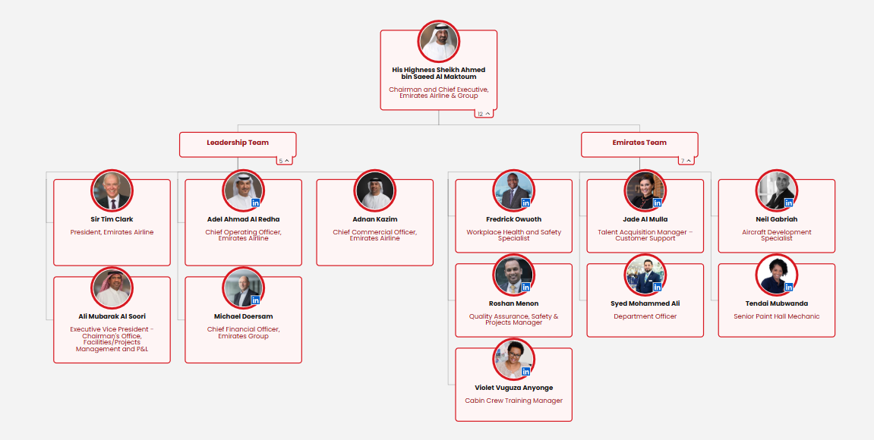

Source: Organimi

Types of culture in Emirates Airlines
If we delve a little deeper into the studies of the types of culture that exist at Emirates Airlines, we end up discovering that, in addition to having a Hierarchical organizational culture, which is the predominant one in this organization, in which operational leaders guide all communication and communication between employees, which prevents some institutional changes from being made.
We must also consider that there are other types of organizational culture models, such as the Clan model, where the feeling of sharing and values ​​and knowledge are promoted by employees who, in turn, are encouraged by leaders. A company that fosters a familial environment is said to have a "clan culture." The ancient Scottish Gaelic word "clan," which means "offspring" or "family," is the source of this relatively modern late middle English phrase. Based on this model, workers or employees demonstrate a sense of unity and top-down vertical collaboration. This leadership model makes employees feel part of the organization and thus contribute more efficiently to the company's growth.
A work environment that values ​​cooperation, consensus, and the opinions of all employees is characterized by a clan culture. This is also the case at Emirates Airlines. Supervisors and managers choose to offer practical mentoring to new hires during the onboarding process in order to foster this organizational culture. In an environment that promotes teamwork, all employees feel valued because their opinions are important to the company's operations; in other words, workers have opinions and are heard (Indeed Editorial Team, 2025).
By providing service excellence and operational quality, Emirates employees play a crucial role in boosting performance, innovation, and customer satisfaction. Because they embody the company's values through training, motivation, and culture, employees deliver excellent customer service, which enhances Emirates' reputation internationally.
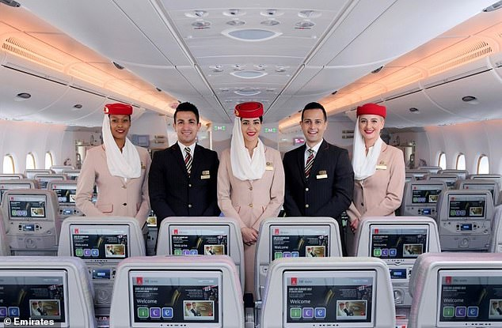
Source: dailymail

Organisational structure external environment Pestel Analysis
According to Oxford College Marketing, Pestel analysis Is a strategic tool used to assess the broad external condition that may influence company or industry, the term PESTEL represent six major categories.
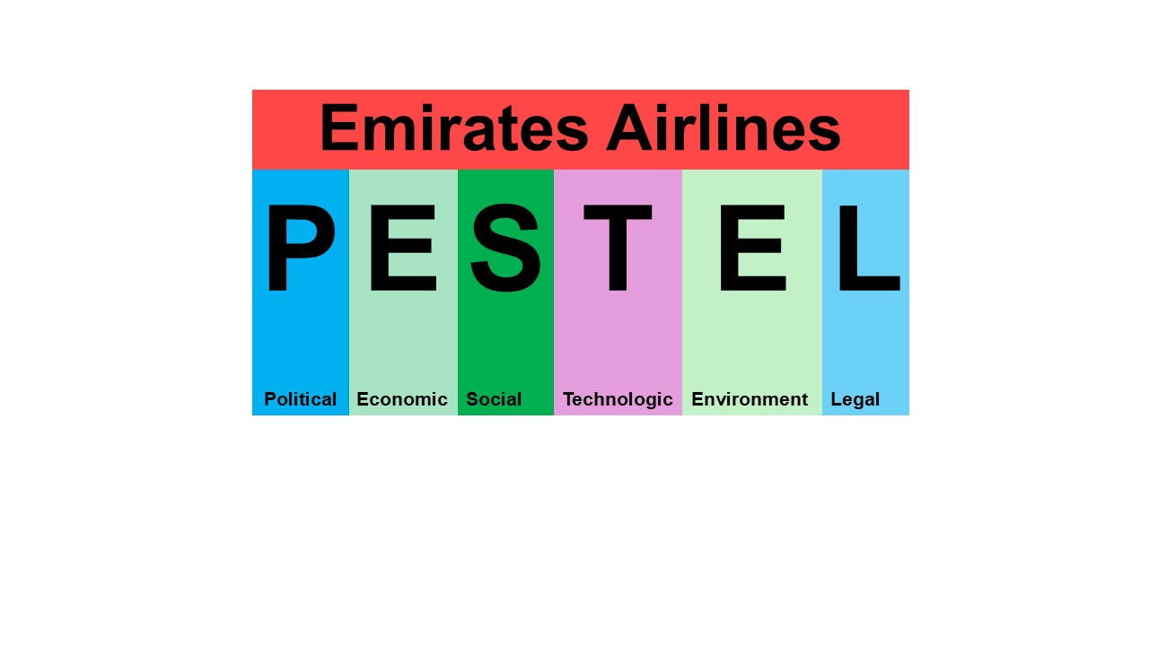

Source: Joao Carlos Jovo Teixeira

Political
As a stable monarchy, the UAE provide a conducive, political environmental for businesses like. Emirates Airline. Political stability in a country is crucial as it ensure consistent policies, giving businesses confidence in their long-term planning. The ability of the emirates to fly from and to different country around the world depends on the air service agreement that the UAE government has negotiated with other countries. Any changes or restrictions on theses agreement could impact Emirates route network. Political issue in the Middle East or surrounding the regions can influence Emirates operations, for instance, conflict in neighbourhood county or tensions, which Qatar can affect airspace rights, flight, routes and passenger demand, for example this year when Iraq attacked Qatar, or when Israel dropped bombs on Qatar to annihilate terrorist. Like any airline, Emirates is subject to the global threat of terrorism. Increased concern may lead to stricter security measure, raising operations cost and influencing passenger travel decisions.
In other hand, competing airlines frequently accuse Emirates of benefiting from government subsidies. While Emirates denies these accusations, such perceptions can create political challenges in countries where the airline seeks to expand its operations, and changes in global aviation policies or regulations in the countries where Emirates operates can impact its business. For example, stricter emissions regulations can influence operating costs.
Economical
Economic conditions play a key role in Emirates Airlines' performance. Strong global economic growth typically stimulates demand for international travel, tourism, and cargo services, thus increasing the airline's revenue potential. However, Emirates remains highly sensitive to fluctuations in fuel prices, as fuel represents one of its largest operating costs; sudden increases can compress profit margins unless offset through pricing strategies or fuel hedging mechanisms. Operating in diverse international markets also exposes Emirates to currency volatility, which can influence both profits and expenses. For example, an appreciation of the UAE Dirham could reduce the affordability of travel to Dubai for foreign customers. Furthermore, variations in interest rates affect the airline's financing costs, particularly for fleet expansion, while inflation can increase operating expenses and influence consumer behaviour. Economic trends in key business sectors, such as energy, finance, and technology, further influence the demand for Emirates' premium and corporate travel services (The Strategy Story, 2023).
Social
Sociocultural dynamics are increasingly shaping consumer expectations in the aviation sector, and Emirates Airlines needs to adapt to this reality. The evolution of travel habits, such as the growing interest in ecotourism, experiential travel, and solo travel, requires the airline to identify and serve new market segments. As an aside, most of my trips are solo. Serving a global and diverse customer base also demands a strong commitment to inclusion, which includes offering culturally appropriate dining options and a wide variety of in-flight entertainment. As an airline positioned in the premium market, Emirates also needs to address the different cultural interpretations of luxury and service quality in each region, ensuring its offerings align with or exceed these expectations. Increased public awareness of health and well-being, intensified by the COVID-19 pandemic, continues to influence passenger priorities regarding hygiene and safety standards. Furthermore, growing societal concern about environmental sustainability is putting additional pressure on airlines with a high carbon footprint, leading Emirates to improve its environmentally responsible practices in response to consumer sentiment.
Technological
Technological innovation continues to play a central role in defining Emirates Airlines' competitive positioning. Modern passengers increasingly expect sophisticated digital experiences on board, including advanced entertainment options and reliable internet access. Emirates has been a leader in this area through its ICE system, but maintaining this advantage requires continuous upgrades in line with constantly evolving technological standards. The broader digitalization of air services, such as online booking, mobile check-in, and app-based boarding has become equally essential to increasing customer convenience and loyalty. With the innovation of online check-in, passengers can check in 48 hours before boarding directly from their devices such as laptops, computers, and even smartphones, and can download their digital boarding pass directly to their device. In the case of smartphones, you can also add or download your boarding pass to the Wallet app (Emirates 2025).
Advances in aeronautical engineering also offer strategic benefits, as new models provide greater fuel efficiency and a lower environmental impact. Investment in these technologies supports long-term cost reduction and sustainability goals. Similarly, innovations in maintenance and safety—particularly predictive systems driven by artificial intelligence and the Internet of Things enable the early detection of technical problems, improving operational reliability. More broadly, AI and automation can optimize flight planning, customer service, and baggage handling, increasing organizational efficiency. Furthermore, biometric technologies are transforming airport security and boarding procedures, speeding up passenger processing and reinforcing security measures.
Environmental
Environmental considerations increasingly influence strategic decision-making in the aviation sector, and Emirates Airlines is subject to growing expectations regarding sustainable operations. Carbon emissions remain the most critical issue, as global pressure for airlines to reduce their environmental impact increases through more fuel-efficient aircraft and the exploration of alternative or sustainable aviation fuels. Noise pollution represents another concern, particularly for airports located near residential areas, requiring compliance with regulatory limits and the adoption of quieter technologies during take-off and landing (Everllence 2022). Airlines also need to manage the substantial amount of waste generated during flights, including disposable plastics and food scraps, driving a shift towards recycling initiatives and less reliance on disposable materials. Water consumption associated with aircraft cleaning and in-flight services further necessitates efficient conservation strategies. Furthermore, advances in sustainable aviation fuels (SAF) offer long-term potential for emissions reduction, motivating airlines to participate in research partnerships and initial investments. Finally, aviation activities can affect local ecosystems and biodiversity airport operations, wildlife risks, and habitat disruption require collaborative efforts between airlines and airport authorities to ensure environmentally responsible infrastructure and practices
Legal
Legal and regulatory frameworks play a decisive role in shaping Emirates Airlines' global operations. Bilateral air services agreements determine route access, flight frequency, aircraft capacity, and market rights between nations; any renegotiation of these agreements can directly influence the airline's network strategy. Emirates must also meet stringent safety standards set by international aviation authorities such as the FAA in the United States, EASA in Europe, and the GCAA in the United Arab Emirates, which govern aircraft maintenance, crew training, and operational procedures (ICAO, 2022).

Labor regulations in different jurisdictions also affect Emirates, given its multinational workforce and global presence. Consumer protection laws impose additional obligations, particularly regarding compensation for delays, cancellations, lost baggage, and overbooking. Environmental regulations are becoming increasingly important as governments introduce stricter rules related to emissions, noise, and waste management. Furthermore, competition and rivalry laws must be considered when forming alliances, partnerships, or codeshare agreements. Tax policies, both national and international, also influence financial decisions, including pricing structures and aircraft leasing contracts. Finally, the expansion of digital services requires airlines to adhere to robust data protection standards such as the EU's GDPR to safeguard passenger information and ensure regulatory compliance (European Commission, 2021).

Organisational culture, barriers to effective functions

Organisational culture Organisational performance

Recommendations

Reference List
Emirates (2025). History Timeline | About us | Emirates United Kingdom. Available at: https://www.emirates.com/uk/english/about-us/timeline/. (Accessed 28 November 2025).
Emirates. (2025). About Us, Our People. Available at: https://www.emirates.com/uk/english/about-us/our-people/ (Accessed 29 November 2025).
Hough, M. (2022). Global Business Culture. UEA Business Culture. Available at: https://www.globalbusinessculture.com/cultural-awareness/business-culture-of-the-uae/ (Accessed 03 November 2025).
Indeed Career Guide. (2025). What is clan culture? (With definition and pros and cons). Available at: https://uk.indeed.com/career-advice/career-development/clan-culture, (Accessed 03 November 2025).

https://www.organimi.com/organizational-structures/emirates/

https://www.organimi.com/organizational-structures/emirates/
https://www.dailymail.co.uk/lifestyle/article-7783841/Emirates-flight-attendants-takes-job-airlines-cabin-crew-named-best-world.html
The Strategy Story (2023). Emirates Airlines PESTEL Analysis. Available at: https://thestrategystory.com/blog/emirates-airlines-pestel-analysis/. (Accessed 04 November 2025).
MBA Skool (2020). Emirates PESTLE Analysis. Available at: https://www.mbaskool.com/pestle-analysis/companies/18058-emirates.html. (Accessed 04 November 2025).
https://www.organimi.com/organizational-structures/emirates/
https://www.emirates.com/us/english/manage-booking/online-check-in/
https://www.everllence.com/industries/campaigns/sustainable_aviation_fuel?utm_medium=sea&utm_source=google&utm_campaign=campaign_ft_pcd_power-to-liquid_e_251001&utm_term=pcd&utm_content=link&gad_source=1&gad_campaignid=23264376221&gbraid=0AAAABCC_F8e0HXO-ysA1jzt0HZtqXfN02&gclid=EAIaIQobChMI27u_6a2qkQMVaZpQBh3yLQLKEAAYASAAEgL5bvD_BwE

