The document chosen for this assignment relates to the early nineteenth century, last will and testament of Thomas Couling of Middlesex London, the details of which were downloaded from the records of the National Archives website. It is important to note though, that neither the original will and testament, nor a copy were available to view. Rather the document transcribed, is a reproduction of a page taken from a register of wills containing details of Couling’s last wishes. Although the purpose of this assignment is to attempt a transcription of the chosen text, this task cannot be carried out without taking into account other important considerations including historical and social factors which will be discussed later.
The guidance provided by The National Archives website proved a practical starting point, particularly the section entitled ‘Palaeography’ which provided a useful overview of how to approach the task of transcription. Although the primary source chosen was written in English, the document contained several versions of letters that had been in use since at least the previous century and at times proved difficult to decipher. The ‘Alphabet Document 2’, on The National Archives website contained both capital and lower-case examples of the alphabet dating to 1722 and this source was used to as a quick reference when transcribing the document. As recommended by Grannum and Taylor, a printed copy of the source was used for transcription and though time-consuming, used in conjunction with a magnifying glass it was possible to decipher most of its contents. Each line of the document was numbered as suggested by the authors, thus simplifying the process and ensuring that sections of the text were not omitted. Additionally, when words appeared indecipherable, decoding other legible words letter by letter sometimes proved useful and it was possible to return to the document later to attempt a further transcription.
The obligation on dying ‘men’ to make a will to make amends for their ‘sins’ was regularly reinforced by the clergy and this was common practice until at least the nineteenth century. Indeed, those making a will were encouraged to include stipulations regarding unpaid tithes and to allocate donations from their estate for those in the parish who were financially destitute. Records indicate that the majority of registered wills were written by men. Women had very few rights in common law and until the twentieth century required their husband’s permission to make a will, consequently, most female testators tended to be either spinsters or widows. As Roger Turvey notes, originally the last will and testament were two separate legal documents but by the early sixteenth century, both terms became interchangeable. Technically a will was the term used to describe a written statement by a dying property owner or alternatively for individuals who intended undertaking a long and often hazardous journey. It was a way of ensuring that a person’s last wishes with regard to the disposal of their land and property would be carried out according to common law after their death. A testament meanwhile, was drawn up beforehand and dealt with personal goods, debts and burial.
The vast majority of wills that survive today are copies made by ecclesiastical clerks who worked in the diocese in which the testator lived, or if they owned property in more than one diocese, in the Prerogative Court of Canterbury. Wills were no longer written in Latin by about the sixteenth century though probate annotations continued to be entered in Latin until 1733. The preservation of public records including the ecclesiastical registers of wills, has occurred since the middle-ages, in part to maintain an accurate record of what was owed to church authorities in taxes and services. Jurisdiction of wills by ecclesiastical courts was established under Henry II and until 1858, it was the responsibility of the ecclesiastical courts to grant probate, a process whereby a will is ‘proved’ or accepted as valid, thereby entitling the executor to carry out the wishes of the testator.
In England alone there were more than 200 church courts dealing with probate issues, this though was not a coordinated process, each court kept its own separate register of wills, a situation that remains to this day. Access to the information contained in wills made up until the mid-nineteenth century, is generally provided through the enrolled copies of ecclesiastical court registers. When probate was granted by the court, a copy was given to the executor with annotations stating when probate was granted and to whom. Details of the will were then entered into the probate register, a large bound ledger and it these that ledgers that were microfilmed instead of the original wills and held in various archives. The contents of individual wills, were displayed on the recto of each leaf of the register, accompanied by a stamped typographical number entered in the upper right-hand corner of the page. From 12 January 1858 the state took over probate with the establishment of a new court of probate based in London. Consequently, much of the jurisdiction of the ecclesiastical courts was removed, especially the responsibility over tithes, probate and matrimonial causes leaving their authority confined to dealing with clergy.
For many historians the ‘reconstruction of a story from documents’ is key to their research methodology yet the transcription of a text is merely one step in the process of understanding its significance. The literal meaning of a document, in this case a record of the contents of a will, written at the beginning of the nineteenth century cannot be taken at face value. As Karin Dannehl notes, documents are objects that relate to the social world in which they were created and as such they need to be subjected to the process of interpretation. Indeed, the transcription of any document must include a consideration of the historical and cultural context in which it was produced and the manner in which it was preserved. For this reason, wills and probate records can provide a rich source of data about the economic, social and religious states of society through the ages and some historians have employed imaginative approaches in their research methodology. Maragaret Spufford for instance, used the evidence from wills containing dedicatory clauses, to pinpoint the religious beliefs of early seventeenth century residents in Cambridgeshire. Further, assessing the authenticity of a written document is critical. Examining the original source and cross-referencing the details of the author, the wording and the date it was written, should highlight any incongruencies in the text. Legal documents including wills were often forged, especially during the Middle Ages, sometimes to replace authentic ones that had been lost, particularly when a benefactor stood to gain financially.
At the time Thomas Couling made his will, he was living at 7 Framework Knitters Alms-Houses, Kingsland Road, Shoreditch London. One of twelve cottages, it was built in 1734 following the death of Thomas Bourne, a wealthy merchant and philanthropist. Bourne’s will of 14th August 1727, contained a number of bequeaths, one of which provided for the ‘erection and maintenance’ of an alms-house ‘for 12 poor freemen of the Framework Knitters Company or part freeman and other part-freemen’s widows.’ It can be deduced therefore that Couling was provided with the accommodation because at some time he had been employed as a framework knitter himself. Couling like his fellow workers were skilled operators of their home knitting frames, yet they were poorly paid and would have lived and worked in wretched conditions.
While it has been possible to identify Couling’s occupation and address at the time he made his will, details of his life and death remain elusive. A search of the newspaper archives failed to find any reference to Couling and it might be presumed that he was not well known or a man of property. Historical data relating to the Frame Knitters of London is held by organisations including The Framework Knitters Company, but unfortunately the information is only available to view in person. A more in-depth study, could make use of birth, marriage and death registers to provide a detailed account of Couling’s life and to place his last will and testament in context.
As already mentioned, it was not possible to access the original will for this assignment and only a microfilm version of the ecclesiastical register was available for inspection. There is no visible evidence of any numbering on the top right-hand corner of the copy of the register, which may be an omission due to the microfilming process but there is numbering on the left-hand side, though what this represents is unclear. As the original will was not available for inspection, it cannot be determined whether Thomas Couling wrote the will himself, or whether the clerk entering the details into the register changed any of the spelling or wording of the will. In accordance with the usual format for last will and testaments, in his opening statement, Couling states his name and address and pronounces that he is of sound mind and memory. There is no religious preamble to the will, this practice had become less popular since about the mid-sixteenth century, though it continued well into the eighteenth century. Couling appoints his ‘beloved wife’ Sarah to be the executor of all that he possessed and to distribute his belongings according to the instructions in his will, though there is very little to indicate what Couling’s possessions consisted of. He was living in an alms house at the time he made the will and it is not clear whether his wife and any dependent children would have been allowed to remain there after his death. The will is signed and dated by Couling on 18 January 1805, witnessed accordingly and indicates that it has been ‘proved’ by Samuel? , Parson, Doctor of Laws. The last line of the will contains the letters Exd. which may be an abbreviation of executed, to show that the paperwork associated with the process of granting probate has been dealt with.
On the next page is the microfilmed copy of the ecclesiastical ledger containing details not only of Couling’s will, but that of Stephen Cole. For the purposes of this assignment, only the contents of Thomas Couling’s last will and testament will be transcribed.
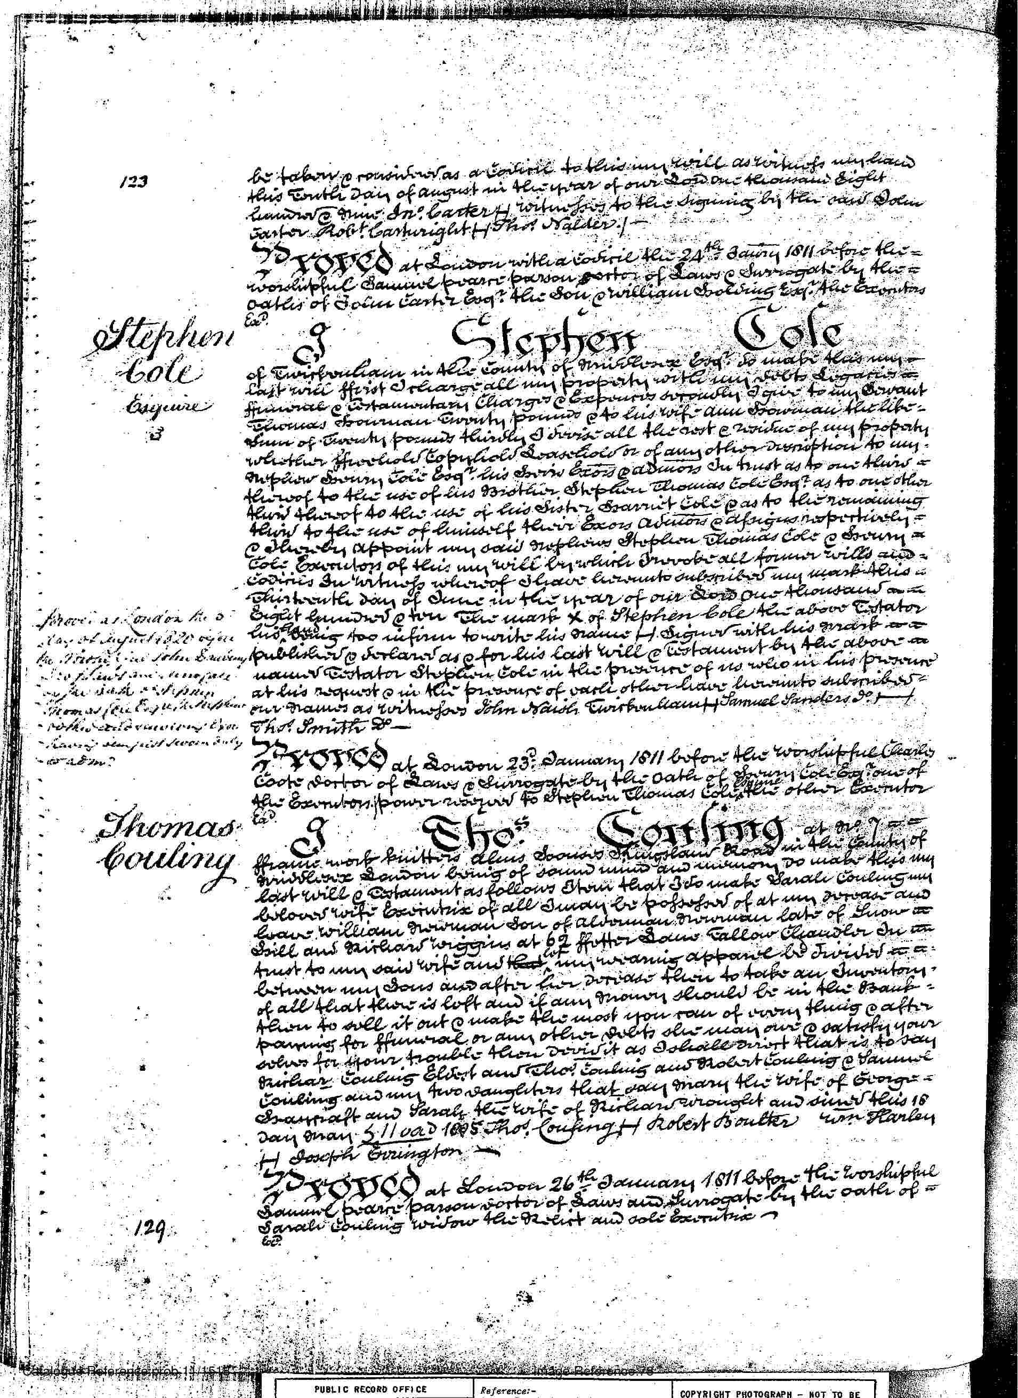
Transcription
Thomas
Couling I Thos. Couling at no. [number] 7 [illegible]
Frame work knitters alms Houses Kingsland Road in the county of
Middlesex London being of sound mind and memory Do make this my
last will [&] Testament as follows stru? that I do make Sarah Couling my
beloved wife Executrix of all I may be possessed of at my d…… [departure?] and
grant William [Nairmon?] son of alderman [Nairmon?] late of Snow [illegible]
Hill and Richard Wiggins at 62 Fuller Gdns. sons Tallow Chandler do [illegible]
trust to my said wife and [crossed out] my remaining appariel be divided [illegible]
between my sons and after their d…. [departure?] then to take an inventory
of all that there is left and if any money should be in the bank
then to [sull?] it out [&] make the most you can of every thing [&] after
paying for funeral or any other debts that may occur. [&] satisfy your
selves for your trouble then divid (divide) it as I should wish that is to say
Richard Couling Eldest and Thos. Couling and Robert Couling [and] Samuel Couling and my two daughters that ? Mary the wife of George [illegible mark]
? and Sarah the wife of Richard? and sinned [signed] this 18
Day jnary. [January] 5 .11 vaD 1805 Thos. Couling [I—I?] Robert Boulter Wm. Harley
[I—I?] Joseph Ernington [mark illegible].
PROVED at London 26^{th.} January 1811 before His worshipful
Samuel [poasrt?] parson doctor of Laws and surrogate by the oath of [mark illegible]
Sarah Couling widow the [niert?] and sole Executrix [mark illegible]
ExD.

Using a microfilm copy of a probate record raises several issues. As John Tosh notes, primary sources can be thought of as ‘contemporary with the event’, which in the case of this particular document, certainly fulfils the criteria. Nevertheless, the document is one step removed from the original will, the details of which have been entered by a clerk of the ecclesiastical court. The obvious disadvantage is that errors or omissions may have occurred not only by the clerk transcribing details of the will into the ecclesiastical record, but also during the microfilming process. The digitisation of historical documents has revolutionised the way in which researchers access primary sources, both geographically and in the ease of using online databases, though as Tosh notes, these records may not always be the most comprehensive or accurate. Additionally, as already noted, original documents provide ‘a connection to the past’ that digitised copies cannot, and academics argue that the very ‘physicality’ of primary sources is an integral part of material culture.
The Ministry of Justice recently revealed its plans to digitise approximately 100 million British last will and testaments, dating back more than 150 years, in order to save an estimated £4.5m a year. Original wills will be destroyed after 25 years and a digital copy retained, though the original wills of those they define as ‘famous’ people will still be preserved. Historians understandably have grave reservations about the plan and the increasing risk posed to digitised data by cyber-attacks, recent incident affecting the British Library website. Financial cut backs may in the future affect other preserved texts and as a consequence, directly impact the methodology and quality of historical research.

Bibliography
Bird, Jannes, ed, ‘Framework Knitters’ Alms-houses’, in Survey of London: Volume 8, Shoreditch (London 1922), British History Online, https://www.british-history-ac.uk/survey-London/vol18
Booth, Robert, ‘Ministry of Justice plan to destroy historical wills is insane’, The Guardian, Mon 18 December 2023, https://www.theguardian.com/society/2023/dec/18/ministry-of-justice-plan-to-destroy-historical-wills-is-insane-say-experts
Brougham, Henry ‘The Ecclesiastical Courts’ (HL Deb 10 February 1857) vol 144 cc422-51
https://www.hansard.uk/Lords/1857-02-10/debates
Dannehl, Karin, ‘Object biographies’ in History and Material Culture ed by Karen Harvey, (London: Routledge, 2009).

Farge, Arlette, ‘The Allure of the Archives’, Yale University Press https://jstor.org/stable/j.ctt5vm50t.3
Grannum, Karen and Nigel Taylor, ‘Wills and Other Probate Documents’ The National Archives, 2nd edition, 2004, https://nationalarchives.gov.uk/help-with-your-research
Haertle, Eugene A. ‘The History of the Probate Court’, Marquette Law Review, vol 45 issue 4 Spring 1962 Art. 7 http://scholarship.law.marquette.edu/mulr/vol45/
Helmholz R. H., ‘Testimony, Law and Probate Jurisdiction’, The Oxford History of the Laws of England: The Canon Law and Ecclesiastical Jurisdiction from 597 to the 1640s (Oxford, 2004 online edition, Oxford Academic 22 March 2012, https://doi.org/10.1093/acprof:oso/9780198258971.003.0007
Lewis, Mary ‘Frame Knitting’, May 24 2021, The Framework Knitters Company, https://www.frameworkknitters.co.uk/about/company-heritage

Macdonald, Keith and Colin Tipton, ‘Using Documents’ in Researching Social Life, ed by Nigel Gilbert (London: Sage, 1993).

‘Palaeography’, The National Archives, ,https://www.nationalarchives.gov.uk/palaeography

‘The Prerogative Court of Canterbury and Related Probate Jurisdictions’, The National Archives, https://discovery.nationalarchives.gov.uk/details/record?catid=10909&catln=3

Tosh, John, The Pursuit of History, (London: Routledge, 2015).

Turvey, Roger, ‘Until Death Do Us Part: The Last Wills and Testaments of a Husband and Wife in Early Sixteenth Century Pembrokeshire’, Pembrokeshire Historical Society, https://www.pembrokeshirehistoricalsociety.co.uk
‘Will of Thomas Couling of No 7 Framework Knitters alms Houses Kingsland Rd London’, The National Archives, PROB 11/1518/387, [26 January 1811].

‘Wills and Administrations before 1858’, The National Archives https://www.nationalarchives.gov.uk

Will of Thomas Couling of No 7 Framework Knitters alms Houses Kingsland Rd London’, The National Archives, ‘PROB 11/1518/387, [26 January 1811], accessed 19 December 2023.
‘Palaeography,’ The National Archives, https://www.nationalarchives.gov.uk/palaeography [accessed 21 November 2023].
Ibid.
K. Grannum and N. Taylor, ‘Wills and other Probate Documents’, The National Archives, https://www.archive.gov.uk/help-with-your-research[ [accessed 22 November 2023] p.6.
ibid
ibid
‘Wills and administration before 1858’, The National Archives, https://www.nationalarchives.gov.uk [accessed 22 December 2023].
Roger Turvey, ‘Until Death Do Us Part: The Last Wills and Testaments of a Husband and Wife in Early sixteenth Century Pembrokeshire’, Pembrokeshire Historical Society, https://www.pembrokeshirehistoricalsociety.co.uk [accessed 16 December 2023].
Ibid.
Ibid.
Ibid.
‘The Prerogative Court of Canterbury and Related Probate Jurisdictions’, The National Archives, https://discovery.nationalarchives.gov.uk/details/record?catid=10909&catln=3 [accessed 6 January 2024].
Tosh, John, The Pursuit of History, (London: Routledge, 2015), p.88.
Karen Grannum and Nigel Taylor ‘Wills and other Probate Documents’, The National Archives, https://www.archive.org/details/willsotherprobate0000gram/ [accessed 22 November 2023] p.6.
‘Wills and administration before 1858’
Turvey
ibid
Grannum and Taylor, p.18.
‘The Prerogative Court’
R. H. Helmholz, ‘Testimony Law and Probate Jurisdiction’, The Oxford History of the Laws of England: The Canon Law and Ecclesiastical Jurisdiction, from 597 to the 1640s (Oxford, 2004 online edition, Oxford Academic 22 March 2012, https://doi.org/10.1093/acprof:oso/9780198258971.003.0007 [accessed 21 November 2023].
John Cannon ed, The Oxford Companion to British History, (Oxford: University Oxford Press, 1997), p.321
Karin Dannehl, ‘Object biographies’ in History and Material Culture ed by Karen Harvey, (London: Routledge, 2009), p.130.
ibid
Keith Macdonald and Colin Tipton, ‘Using Documents’ in p.197 in Researching Social Life, ed by Nigel Gilbert (London: Sage, 1993), p.197.
Roger Turvey, ‘Until Death Do Us Part: The Last Wills and Testaments of a Husband and Wife in Early sixteenth Century Pembrokeshire’, Pembrokeshire Historical Society, https://www.pembrokeshirehistoricalsciety.co.uk [accessed 4 January 2024].
Tosh, p.112.
Tosh, p.102.
Jannes Bird, ed ‘Framework Knitters’ Alms-houses’, in Survey of London: Volume 8, Shoreditch (London 1922) pp. 132-133, British History Online, https://www.british-history-ac.uk/survey-London/vol18 (accessed 14 December 2023).
Mary Lewis, ‘Frame Knitting’, May 24 2021, The Framework Knitters Company, https://www.frameworkknitters.co.uk/about/company-heritage
Tosh, p.112.
ibid
ibid
Robert Booth, ‘Ministry of Justice plan to destroy historical wills is “insane” say experts,’ The Guardian, https://theguardian.com/society/2023/dec/18/ministry-of-justice-plan-to-destroy-historicalwills-is-insne-say-expert Monday 18 December 2023
Ibid.
Ibid.
Ibid.

