Assessment Title: Research skills for healthcare
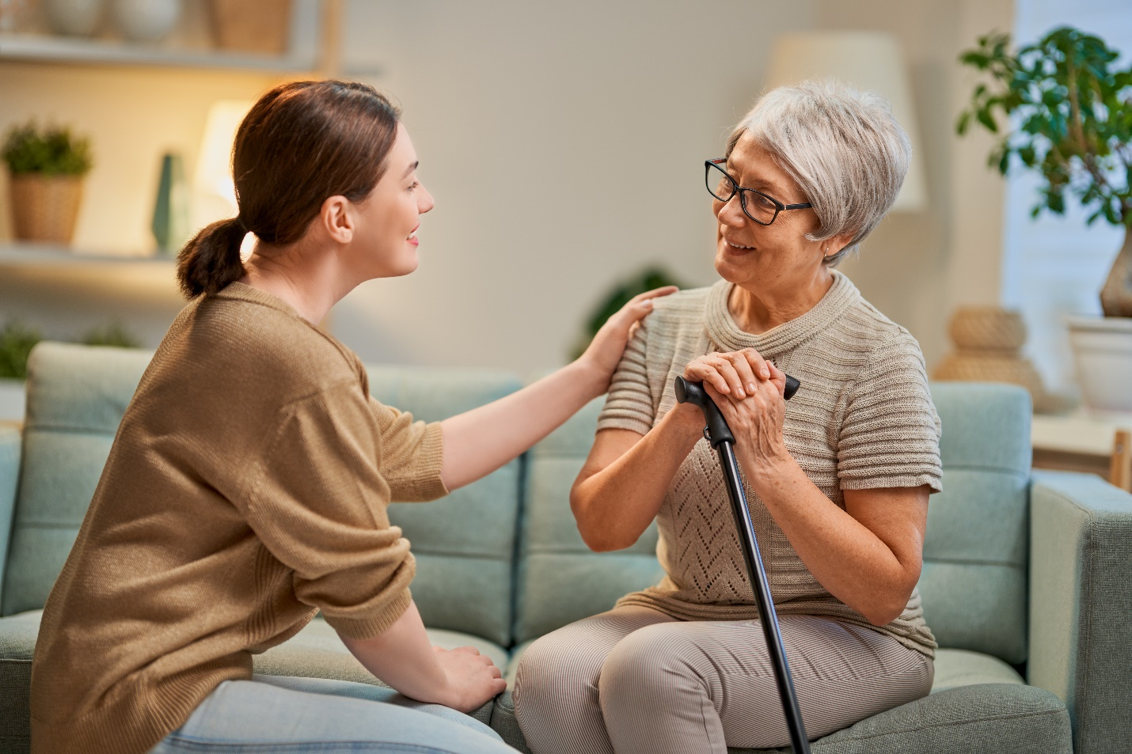
Student Name: Suraiya Amin
Student ID: 2028701
Module: Digital Skills and Research Methods
Module Code: BMSW4003
Module Teacher: Joy Botu

Contents
Introduction 2
Assessment: Research skills for healthcare 2
You are required to conduct a secondary research on the use of technology in the modern healthcare workplace (Care homes, Hospital, GP surgery, Day Centres, Nurseries, Nursing homes, Rehabilitation Centres etc). Explore the technology and communications systems that are used within your chosen healthcare settings. Your report should show your understanding and awareness of relevant legal, ethical and Healthcare settings. 7
Conclusion 8
Reference 9

Introduction
Health care is arguably the most significant of all the industries helped by technological adoption. So, in this report I will discuss about how technology is helping the healthcare industry and also why is it so important to use technology in the health sector also I will show a secondary research on the use of technology in the modern healthcare workplace.

Assessment: Research skills for healthcare

You are required to conduct secondary research on the use of technology in the modern healthcare workplace (Care homes, Hospital, GP surgery, Day Centers, Nurseries, Nursing homes, Rehabilitation Centers etc). Explore the technology and communications systems that are used within your chosen healthcare settings. Your report should show your understanding and awareness of relevant legal, ethical and security issues.

Secondary research or desk research is a form of study involving the use of existing data. In order to improve the overall efficiency of research, existing data are summed and collected. Many companies and organizations prefer the secondary research method because this research method is cost-effective (Morilla, Sans, Casasa, & Giménez, 2017). Not every organization can afford primary research method because in this case the company have to collect the data and the research it thoroughly. But in case of secondary research the data can be gained only by sitting behind a desk that’s why this research is also called the desk research. An organization can collect their data from many sources for the secondary research. Organizations can collect data from the internet, government or non-government websites, public libraries etc. In this assessment we will conduct secondary research on the use of technology in the modern healthcare workplace.

Introduction
Internet and technology play an important role in the field of healthcare. High technologies are really helping to improve the quality of the health care. Moreover, healthcare practitioners can gain their knowledge by using digital literacy. For the digitized system medical assistants, nurses can update patient records with diagnosed code. Patients may not only get their documents by clicking a button, but also guarantee that errors are discovered faster (Katsaliaki, & Mustafee, 2011). Technologies like EHRs provide invaluable data to clinical researchers and it also helps to advance the medical knowledge. So, ICT is really important in the medical field. It is quite impossible to cure diseases and big medical issues without the help of technology.
Research objectives
The objectives of the research define what we expect a project to achieve. The main objective of this research is to know how technology is helping the healthcare sector. In this research we will get to know how professionals use technologies to improve the quality of the care also how technologies can satisfy the patients. The objectives of this project are given below
- To know how technology is helping the healthcare sector
- To know how technology helps to train the healthcare practitioners
- In this project we will also know how can patients and doctors can communicate with the help of technology
- To know why is it important to use high technologies in the healthcare sector
- To know why practitioners and professionals should know about digital literacy
Literature review
In order to make research interesting and helpful, a literature review is necessary to improve the acceptability of study. The review of literature is very important as it reports to the research audience. In the literary review the references from the writers from a different standpoint may also be prevented through undesirable copying (Bloom, Garicano, Sadun, & Van Reenen, 2014). There is a famous care home organization named Excel care. They provide really high quality of care. In Leigh, you can always provide them confidential and unbiased advice on your needs, so that you are never left alone. In addition, alongside one of our professional care coordinators, they can organize a free consultation at your own home at any time. These organizations use technologies to promote their service quality. These technologies also increase the social engagement in care homes. They use technology to monitor health, to prevent delirium and also it to reduce unnecessary hospital admission. They promote the physical exercise in care homes by using technologies. There are many reasons for using technology and they go far beyond security, but may include:

Increase participation, promote independence via many mechanisms (memory push, orientation, motor capabilities support), allow proactive health monitoring and prevention, increase well- being in several areas (including promoting exercise) and alleviate stress in healthcare providers. The organizational advantages might also include better focusing on human resources, supporting team-wide communication, supporting compliance and safeguarding through improved monitoring and reporting (Mettler, 2016, September).
Secondary Research Methodology
In this research only the secondary research will be done. Also known as desk research is secondary quantitative investigation. Researchers employ the existing data, sometimes referred to as secondary data, in this study approach. Not every organization can afford the primary research so secondary research is cost-effective (Kumar, 2011). Primary research requires many things like researcher have to collect all the data by themselves and then they will research through it. Secondary research is comparatively simple. In this research we just have to collect information from internet and articles. We can use internet, social apps, and other media to collect data. Secondary research leverages the available data. This technique of study comprises the collection of information from the Internet, public papers or resources, libraries and other research carried out.

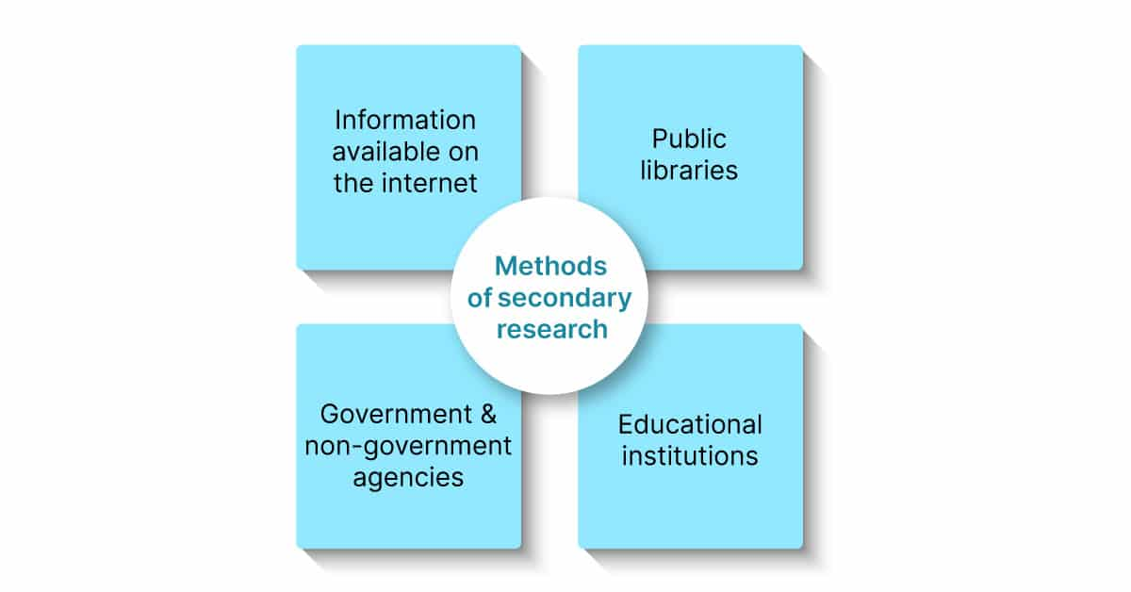
The internet is the most useful source to collect data for secondary research. So, we will mainly use the internet for our secondary research because all the data is accessible and can be easily downloadable with just one click.
Secondary Research Data Collection and Analysis
As it is secondary research, to collect data we have used Google, social media etc. The things that we have found from this research is given below.
- Hand-held, software-compatible mobile devices might let personnel to update care or information they wish to record on someone 'in real time' rather than add it to the paper notes at the conclusion of a shift.
- Modern healthcare workplaces use technologies in order to fasten their data entry
- Acoustic listening devices that can be turned on at night it helps staff to keep an ear if there is any noise or any kind of problem in the patient’s room. Of course, if the patient is okay with it
- The central holding of digital records allows management to analyze the data that workers submit to validate. As an example, if a patient has received his/her medications or not
- Staffs can check on the patient’s heart rate, blood pressure, diabetes. Also, the technology helps to identify if there is any change in patient’s mobility, sleeping, eating or using the toilet.
- In response to complaints and events, technology may expedite corporate procedures such as employee-specific SMS communication in different sections of the house and automatically organizing meetings between staff and management.
- In care homes they use digitized locking system that really ensures the security of the patient.
- Technologies like telemedicine help residents and healthcare workers manage long-term illnesses without leaving the house. Video consulting with local hospitals and experts can be a great approach to obtain services and advice from specialized facilities.
- A decent Wi-Fi infrastructure enables workers to obtain dementia material and to stay up with the newest thoughts.
From this information we can see that services like care homes are totally impossible nowadays without technologies (Vermeir et al. 2015). We can see that it makes everyone’s life easier and healthier. We can see that technology plays an important role in the health sector. Nurses and other practitioners can always communicate with the professionals immediately if something goes wrong. We can also see that the technology also increases the mobility of modern health care services. There are an estimated 318,500 mobile health apps with the expanding smartphone market that helps all kind of the health industry. We can also see that these gadgets and programs can enhance the efficiency, service and living circumstances of people.
Research Conclusion
We can come to this conclusion that technologies; digital literacy is really an important aspect in the field of healthcare. If we compare this day with a day which is 50 years ago, we can see the difference. We can now cure many diseases which was incurable 50 years ago. In a very short time, we have achieved which was once impossible to even think. The use of technology has enhanced providers' skills and patient access, while enhanced some patients' quality of life and saved others' lives.

For the purpose of exploring the technology and communication system I have chosen a well-known healthcare in my country named Boots. In United Kingdom Boots is a famous healthcare which provides the best healthcare service in this region (Foronda, MacWilliams, & McArthur, 2016). Now let’s talk about the healthcare settings of the Boots. First of all, we have to know about the healthcare settings.
Healthcare settings
The word health care encompasses a broad range of services, and includes acute care, urgent care, rehabilitation, nursing homes and other long-term care, specialist ambulatory services (e.g., hemodialysis, dental, podiatrist, chemotherapy, endoscopic and pain management), and ambulatory care facilities (Martin, Charlesworth, & Henderson, 2010). Some health services are also available in private offices or residences.
The technology and communication system that are used on my chosen healthcare settings
Here we will briefly talk about the technology and communication system that are used on my chosen healthcare settings. As an example, if we talk about a patient named Patrick, he is 85 years old who was having a sudden breathing problem. And the he immediately calls his personal caregiver and the caregiver emergency department of the healthcare. The emergency department gets an online application instantly and prepares for the arrival of the patient while the ambulance is on the way. Paramedics uses interoperable communication technologies which enable them to communicate on the one hand with fire and police agencies and hospitals on the other. It was an incident of yesterday on my chosen healthcare (Weaver, Lindsay, & Gitelman, 2012). Moreover, the healthcare uses tablet PC to beam into the hospital database using a wireless network. In this medical center the doctors and the staffs are highly skillful on digital literacy and IT. All the workers in the health care can use the technologies and they communicate using them. There is electrical health record in this healthcare. The healthcare has the telemedicine system and they have the access to communicate with the patients online. The healthcare has certified HER system, technologies for the surgical and service line, Telehealth tools, smartphones for communication, social media, websites, hybrid operating rooms, infection detecting technologies, use of CCTV cameras for the safety, ultra sound imaging devices etc. Their communication system is remarkable which satisfies the patients.

Conclusion
From this report we get to know that technology and digital literacy is really important for the health practitioners and professionals. We have seen that how technology and better communication system can help the healthcare practitioners. The report is significant because it offers extensive information on the relevance of information technology implementation to health organizations and healthcare providers.

Reference
Katsaliaki, K. and Mustafee, N., 2011. Applications of simulation within the healthcare context. Journal of the operational research society, 62(8), pp.1431-1451.
Bloom, N., Garicano, L., Sadun, R. and Van Reenen, J., 2014. The distinct effects of information technology and communication technology on firm organization. Management Science, 60(12), pp.2859-2885.
Mettler, M., 2016, September. Blockchain technology in healthcare: The revolution starts here. In 2016 IEEE 18th international conference on e-health networking, applications and services (Healthcom) (pp. 1-3). IEEE.
Kumar, R.K., 2011. Technology and healthcare costs. Annals of pediatric cardiology, 4(1), p.84.
Vermeir, P., Vandijck, D., Degroote, S., Peleman, R., Verhaeghe, R., Mortier, E., Hallaert, G., Van Daele, S., Buylaert, W. and Vogelaers, D., 2015. Communication in healthcare: a narrative review of the literature and practical recommendations. International journal of clinical practice, 69(11), pp.1257-1267.
Foronda, C., MacWilliams, B. and McArthur, E., 2016. Interprofessional communication in healthcare: An integrative review. Nurse education in practice, 19, pp.36-40.
Martin, V., Charlesworth, J. and Henderson, E., 2010. Managing in health and social care. Routledge.
Aveyard, H., 2018. Doing a literature review in health and social care: A practical guide.
Zain, A., Nadeem, M. and Aqil, S.B., 2010. Information and communication technology in healthcare management systems: Prospects for developing countries. International journal of computer applications, 4(2), pp.27-32.
Mamlin, B.W. and Tierney, W.M., 2016. The promise of information and communication technology in healthcare: extracting value from the chaos. The American journal of the medical sciences, 351(1), pp.59-68.
Weaver, B., Lindsay, B. and Gitelman, B., 2012. Communication technology and social media: Opportunities and implications for healthcare systems. Online J Issues Nurs, 17(3).
Morilla, M.D.R., Sans, M., Casasa, A. and Giménez, N., 2017. Implementing technology in healthcare: insights from physicians. BMC medical informatics and decision making, 17(1), pp.1-9.
Picture: https://elements.envato.com/elderly-patient-and-caregiver-P9F3N7A

