UNIVERSITY OF WALES TRINITY SAINT DAVID
LONDON CAMPUS
Assignment 2
Learning in the Digital Era
Video Link: Assigment 2 LDE
Presentation Assigment 2 (1)

Module Name: Learning in the Digital Era
Module Code: ACCA 4025

Student Name: Nikodem Walkowiak
Student ID: 2508837
Group: 1

Lecturer’s Name: Koushik Modak

Table of Contents
Introduction 2
Main Body 2
Conclusion 9
References 9

Introduction

Main Body
Video Link: Assigment 2 LDE

Slide 1 COVER PAGE
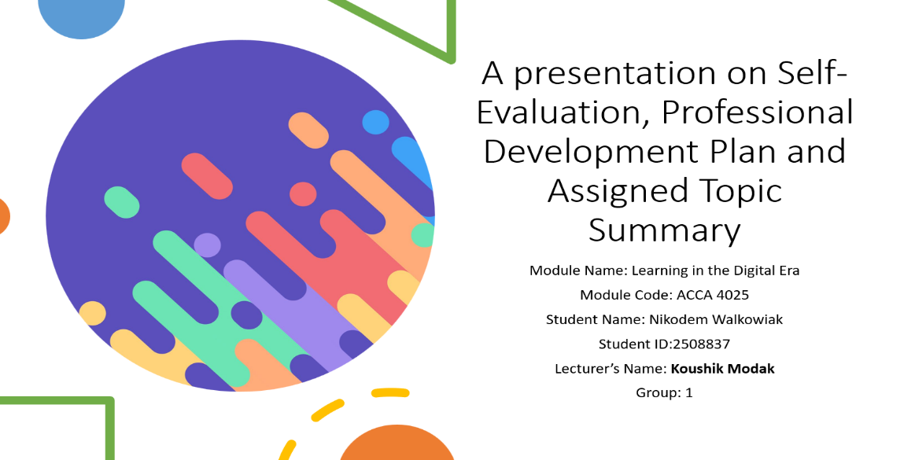
Slide 2 CONTENTS

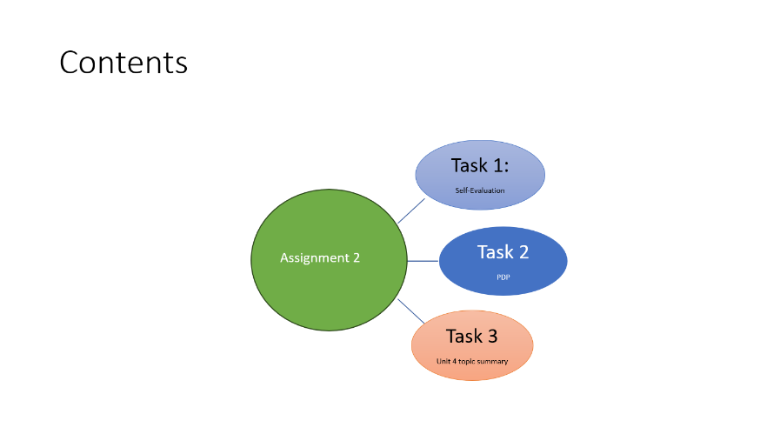

Slide 3 INTRODUCTION
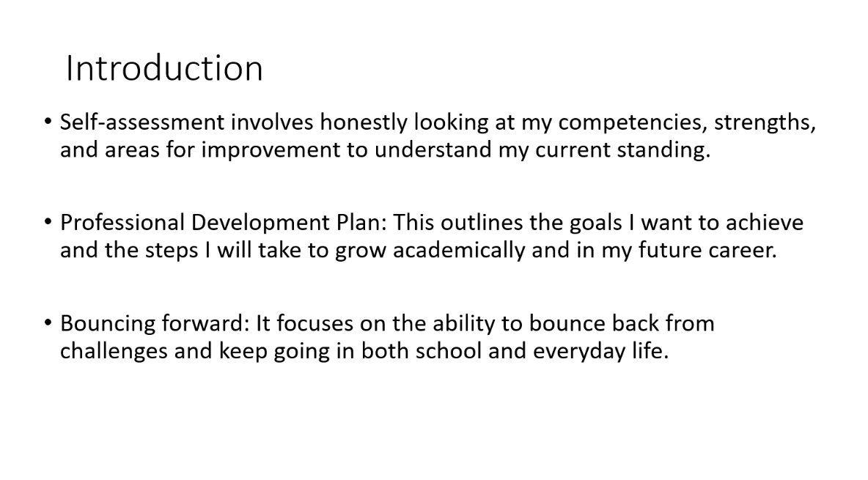

Slide 4 MAIN BODY
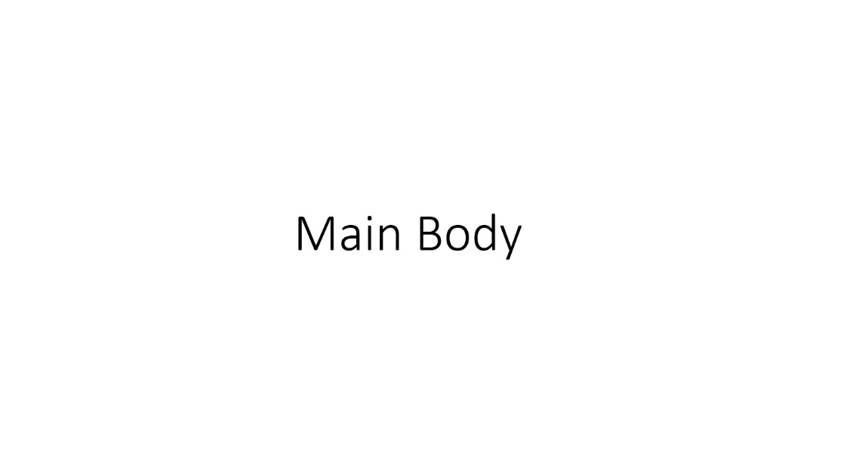

Slide 5 GIBB’s REFLECTIVE MODEL

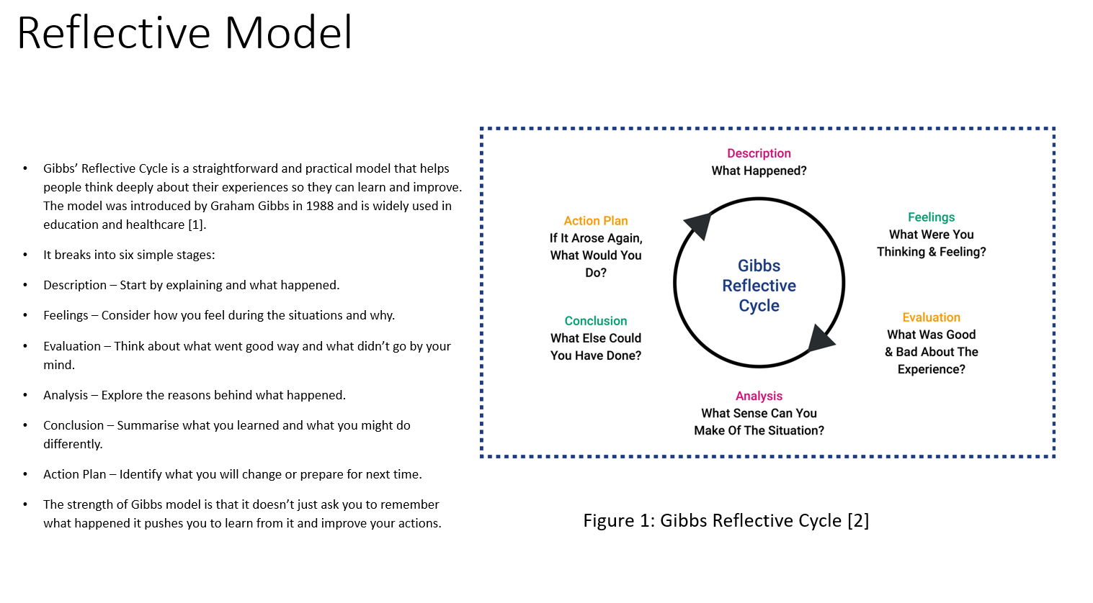
- Brief explanation : Gibbs’ Reflective Cycle is a straightforward and practical model that helps people think deeply about their experiences so they can learn and improve[1].
- It breaks into six simple stages:
- Description – Start by explaining and what happened.
- Feelings – Consider how you feel during the situations and why.
- Evaluation – Think about what went good way and what didn’t go by your mind.
- Analysis – Explore the reasons behind what happened.
- Conclusion – Summarise what you learned and what you might do differently.
- Action Plan – Identify what you will change or prepare for next time.
The strength of Gibbs model is that it doesn’t just ask you to remember what happened it pushes you to learn from it and improve your actions

Slide 6 TASK 1: SELF EVALUATION
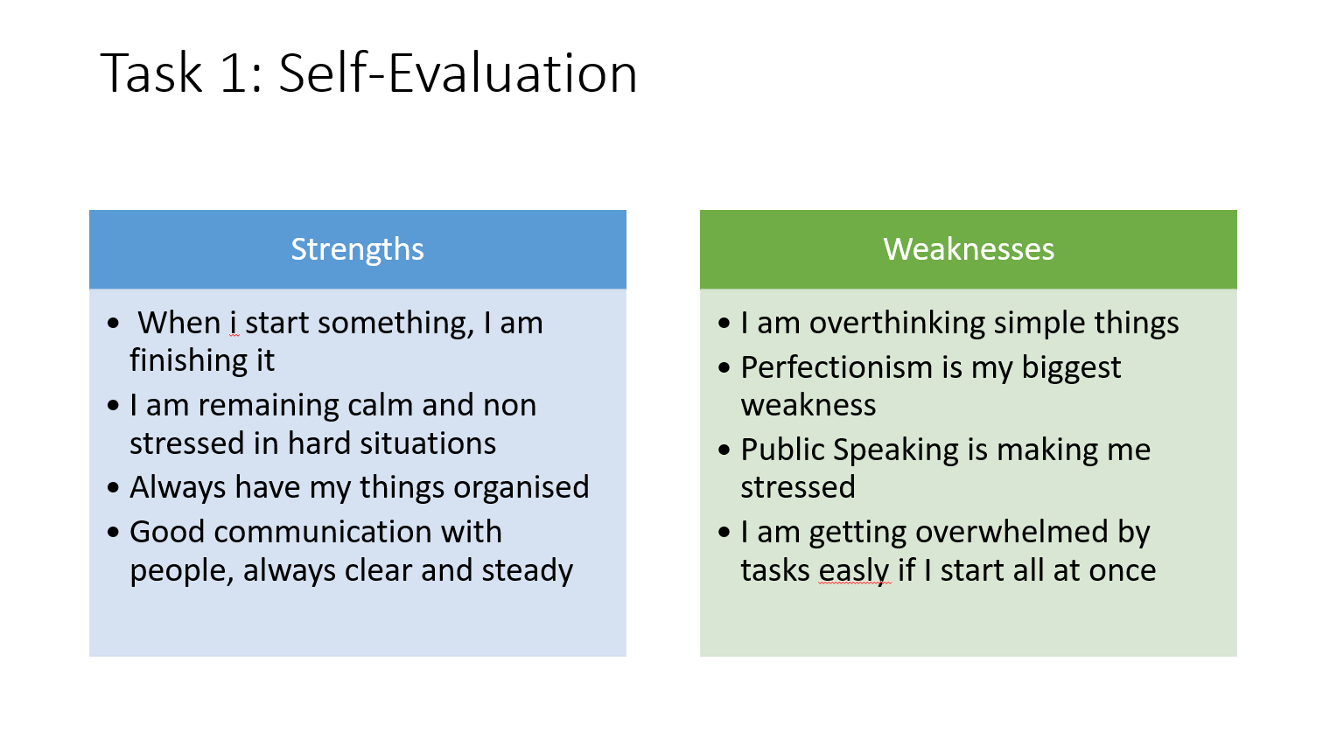
Brief explanation: Discuss your strengths and weaknesses based on your individual SWOT analysis. One Strength and one weakness are provided as example. Please feel free to remove them if that does not apply to you.
Slide 7 TRAITS GAINED FROM THE SELF EVALUATION
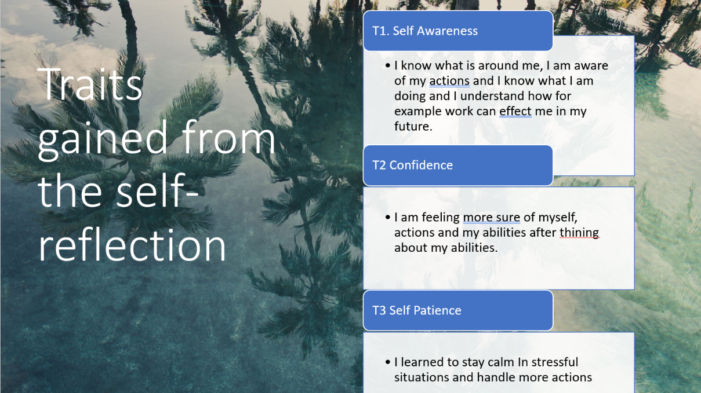
Brief explanation:

Slide 8 PROFESSIONAL DEVELOPMENT PLAN
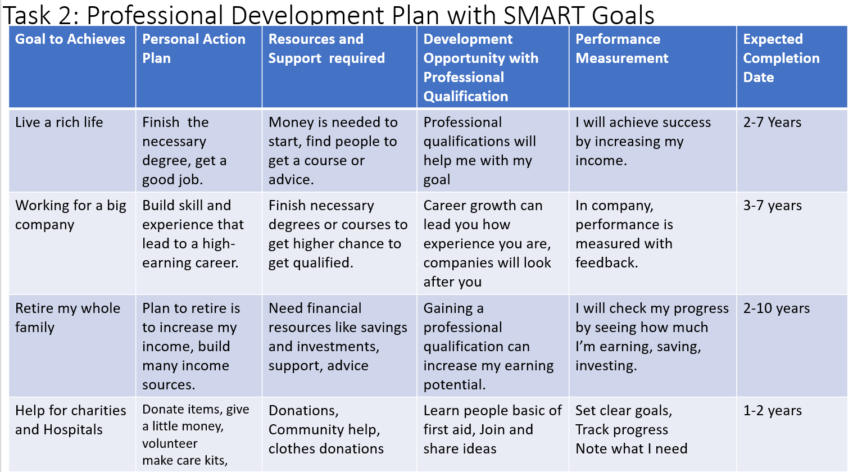

Brief explanation:

Slide 9 UNIT 4 TOPIC SUMMARY
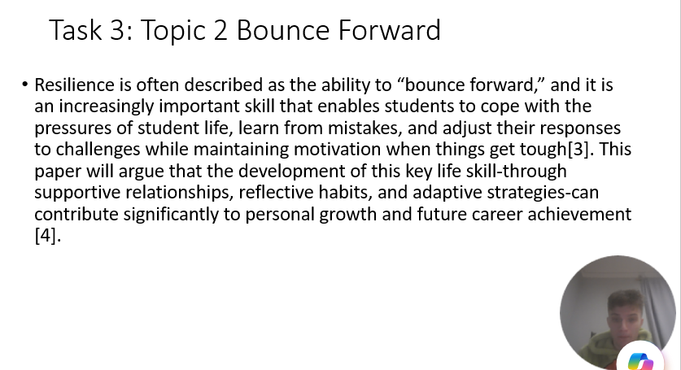

Slide 10 CONCLUSION

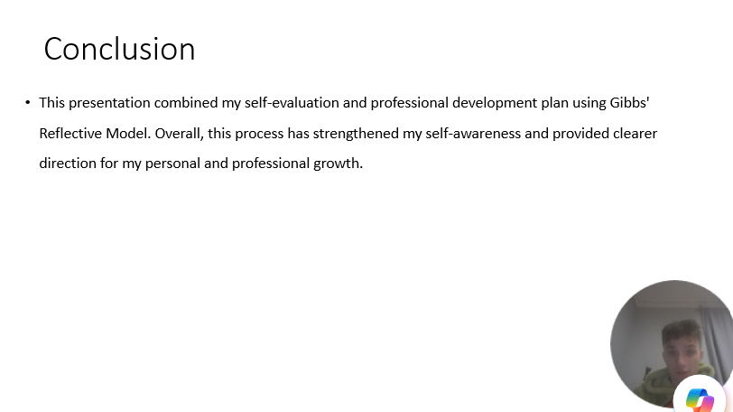

Brief explanation:

Slide 11
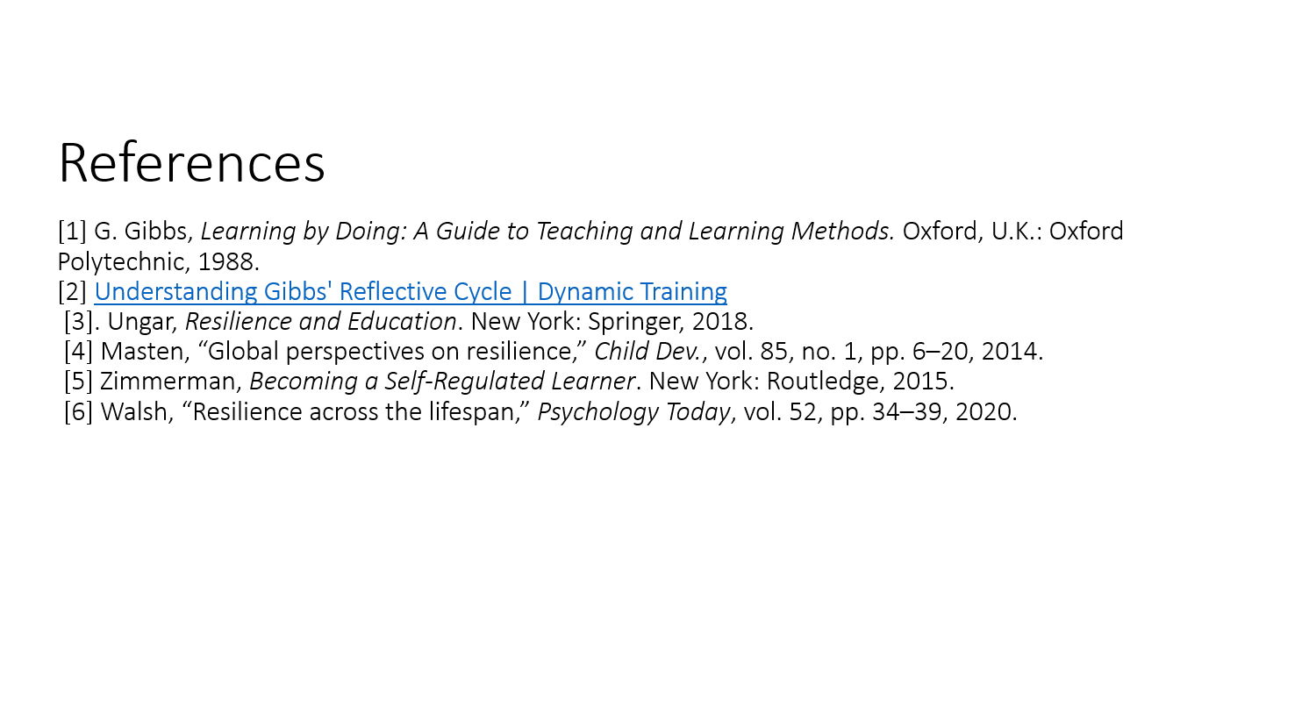
Conclusion

References
[1] G. Gibbs, Learning by Doing: A Guide to Teaching and Learning Methods. Oxford, U.K.: Oxford Polytechnic, 1988.
[2] Understanding Gibbs' Reflective Cycle | Dynamic Training
[3]. Ungar, Resilience and Education. New York: Springer, 2018.
[4] Masten, “Global perspectives on resilience,” Child Dev., vol. 85, no. 1, pp. 6–20, 2014.
[5] Zimmerman, Becoming a Self-Regulated Learner. New York: Routledge, 2015.
[6] Walsh, “Resilience across the lifespan,” Psychology Today, vol. 52, pp. 34–39, 2020.

