Automated Timesheet Management System
Research Proposal
Rachid Aboulachouaq
University of Wales Trinity Saint David
Industrial Research Project Proposal
Word Count: 3330
Module Code: ACCA6029

Contents
Figures 2
1. Introduction 5
2. Background to the Proposed Research 5
Data Quality 5
Automation (In payroll and ERP Systems) 7
Business Process Management 7
Conclusion 7
3. Aim & Objectives 8
Research Problem 8
Aim 8
Research Objectives 8
4. Methodology 8
4.1 Research Methodology 8
4.1.1 Philosophy 8
4.1.2 Approach 9
4.1.3 Strategies 9
4.1.4 Risks & Limitations 10
4.1 5 Ethical Issues 10
4.1.6 Validity, Reliability & Generalisability 10
4.1.7 Data Evaluation Methods 11
4.2 Development Methodology 11
4.2.1 Software Development Methodology 11
5 Resources and Planning 13
5.1 Hardware Resources 13
5.2 Software Resources 13
5.3 Information Resources 13
5.4 Human Resources 13
5.5 Project Plan 14
6. To Conclude 16
7. Reference List 16

Figures
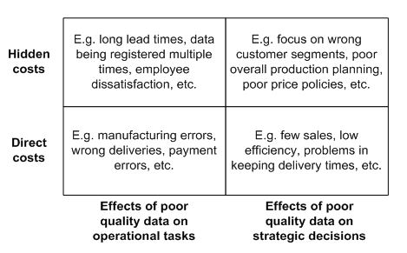
Figure 1: Costs of Poor Data Quality [1]

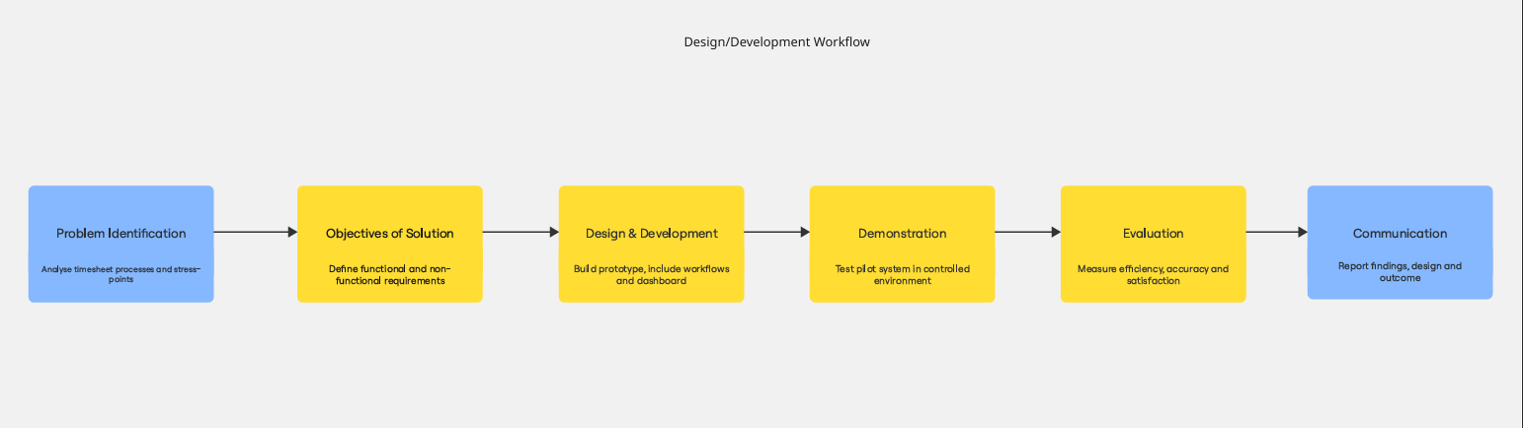
Figure 2: Simple Workflow Created with Miro
URL: https://miro.com/app/board/uXjVJMUJcXg=/?share_link_id=613652531175

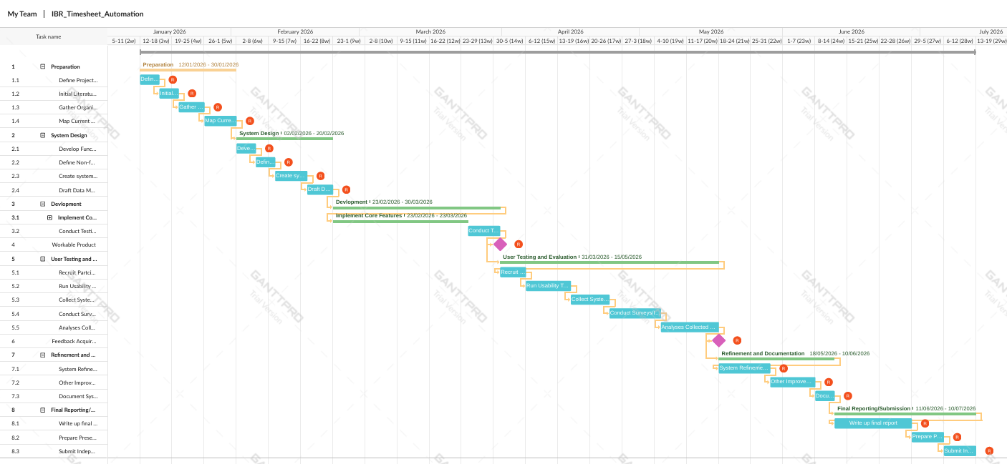
Figure 3: Gantt Chart Created with GanttPro
URL: https://app.ganttpro.com/shared/token/9ee71933593d361e32b4f91963129b899707a5b6acf2d234ebf16355d314d29e/1916421

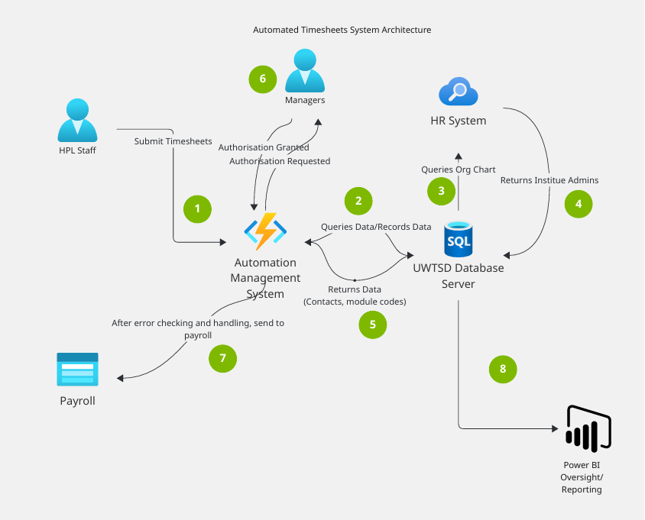
Figure 4: Initial System Architecture Diagram Produced with Miro
URL: https://miro.com/app/board/uXjVJLjWrEE=/?share_link_id=394752282644

Introduction
The industrial partner in this context is the University of Wales Trinity Saint David (UWTSD), a higher education institute with several campuses located across the UK, as such management systems for the university should be robust and scalable so that efficiency of its functions is maintained to provide the best service to its staff and pupils.
In a cursory review of aspects of the university systems, an issue that was brought to attention was the use of multiple timesheets in a workflow for payroll processes regarding hourly-paid lecturers (HPLs). The issue is that activities have different pay rates and approval is needed form various departments to sign off on this, and the current system in use by the University relies heavily on excel spreadsheets and email for tasks such as data entry, summarisation, authorisation etc. Such a workflow process is prone to problems; duplicate timesheets submitted, inaccuracies in manual data entry, conflicting/inflated claims and delays at each stage.
The cost in time for the administration of the process and the errors that may occur can manifest itself in multiple ways, and essentially compromises organisational efficiency, leading to costly mistakes financially and reputationally [1]. The growth of automation offers opportunities to address these challenges. Cloud-based workforce management systems, integrated payroll solutions, and intelligent process automation have shown significant potential in reducing errors and streamlining workflows [3][8].
As such this project aims to review the current system in place and design a comprehensive timesheet management system that minimizes manual errors and enhance the overall efficiency of the process through automation.
By utilising knowledge of digital skills such as software development and by drawing upon existing literature of automation tools and their applications, the impact on the university should be noticeable.

2. Background to the Proposed Research
This literature review seeks to explore the background of current literature and the themes related to the project to be undertaken. As such, the literature has been organised thematically to maintain a linear structure that will demonstrate the links to the current proposal. The themes include data quality, as a main problem identified was the quality of data in terms of manual errors and duplication, and automation, as this aims to solve the problems previously mentioned, particularly in a business centric approach.

Data Quality
Data has steadily become more prevalent and indeed valuable to society as the years have gone by, with some dubbing the current era the “Information Era”. This is due to the holistic impact of data being recognised on society, business and organisations. A key principle of UWTSD is being data-driven, as indeed it is with decisions being made almost daily based upon considerations of students, staff and the public. With this in mind, data quality is important.
Data quality is the measure of how suitable data is for its intended purpose. High-quality data is accurate, complete, consistent, timely, valid, unique, and reliable, ensuring that it can be trusted and effectively used. Good data quality supports better decision-making, improves efficiency by reducing errors, builds customer trust through accurate information, and helps organizations meet compliance requirements [12].
In contrast, poor data quality can have detrimental effect on businesses as the opposite of the benefits and has been identified as costly barrier to organisational efficiency [1]. Haug et al. provide a framework on the negative consequences of poor data quality, in economic terms, categorised by their ‘visibility’ (direct, hidden) itself being based on Eppler and Helfert’s (2004) cost taxonomy.
Figure 1: Costs of Poor Data Quality [1]
This also highlights how data quality is not just a technical concern, but also strategic, that has far reached consequences. It would be prudent to note that some of the concerns brought up in the research problem can be applied to the framework and additional issues identified, as such the solution provided in the proposal can satisfy the criteria of the project. However the methodology for this is based on conceptual and theoretical analysis and may lack real world results and applicability, and a wider literature should be viewed to obtain a more robust understanding.
Subsequent literature can be found advancing this perspective by linking data quality further to enterprise systems alongside other technologies. More and Mucherla emphasise the importance of master data management (MDM) within enterprise resource planning (ERP) [6]. Enterprise resource planning is a business management software solution that integrate core functions of a business, such as finance, HR, manufacturing etc [13]. As such data quality is a key consideration in this research, with More and Mucherla seeking to use AI in an automation process to deal with data duplication, inconsistencies etc. The results of the integration of AI automation into these management systems are positive, with improvement in processing speed and data accuracy [6]. This study illustrates how data quality and business processes can be enhanced through the process of automation, which is applicable to the problem identified for this process.
Similarly, Amgad et al explore the digitisation of medical data using large language model (LLM)-based systems. Their work demonstrates the potential of AI for cleansing and visualising datasets, thereby improving healthcare analytics and decision making [7].Their work involved the use of system design and development, as such the results are based on a relevant context and adds validity to their findings. Collectively, these studies underscore that improving data quality not only reduces operational costs but also enables more effective automation and further innovation in business functions.

Automation (In payroll and ERP Systems)
In the field automation, payroll systems provide a useful context for exploring the benefits that automation can provide. Aggarwal et al. provide a review on the design and implementation of payroll management systems and emphasise how automation of certain processes reduces manual errors, enhance compliance of the organisation and increases overall efficiency of the process [3] which align with the research goals.
This is supported by Then et al. wherein a case study on the development of web-based payroll system demonstrated the benefits of a digital platform compared to a manual process in terms of accessibility and accuracy [5]. The benefits are further evidenced in wider industries also. Bao et al. also proposed a software management system to assist in the construction industry. It again highlights the use of automation in managing workflows and reduction in human error in complex processes. Their work also demonstrates that automation is not confined to office functions but extends to project management and operational processes in larger scale industries. This shows the versatility of automation solutions across sectors [2].
In the wider scope of automation, it increasingly enabled by robotic process automation (RPA) and intelligent process automation (IPA), which is automation enhance through the use of AI technologies. Lubis and Sembiring argue that RPA enhances efficiency by eliminating repetitive manual tasks, reducing errors, and supporting scalable business processes [4]. Cascais Brás et al. further support this by examining how intelligent automation contributes to business continuity and scalability, especially digital businesses. By mapping automation standards, they demonstrate how automation not only supports efficiency but also compliance and resilience in operations [9].
From a technological standpoint, platforms supporting automation must exhibit scalability, flexibility, and integration capacity. Uskenbayeva et al. evaluate properties of platforms for process transformation, stressing that their design affects adoption success [10]. These works collectively indicate that automation tools are not isolated tools but integral to organisational resilience, transformation, and competitive advantage.

Business Process Management
Process management systems enhance workflow efficiency, with Bartlett et al. stressing the need for both technological and organisational redesign through virtualisation and work design [8]. As such, having this adaptability will be useful to UWTSD in streamlining their processes. Moreira et al identify barriers such as limited resources and resistance to change, though they also note gains in efficiency and competitiveness [11]. As such, there is notable increase to department efficiency when taking the cost of automation into account.

Conclusion
Across the reviewed studies, several themes emerge. For one, data quality is foundational to effective automation. Poor data quality undermines efficiency, while automation-driven solutions demonstrate significant promise for improving accuracy and decision making. Second, automation in payroll and enterprise systems is well-established, with growing applicability in industry-specific contexts such as construction.
However, there are gaps, few of the studies integrate data quality frameworks directly with automation platforms, leaving questions about how organisations can holistically manage both simultaneously.
This review establishes the foundation for investigating how data quality management and process automation can be jointly harnessed to increase efficiency and satisfaction in an organisation complex.

3. Aim & Objectives

Research Problem
Organisations often rely on manual or semi manual timesheet process that are inefficient and error prone. Processes such as these can create bottlenecks in the university, taking valuable time away from all those involved in the process

Aim
To design a new comprehensive management system for timesheet submission that utilises automation to streamline workflow, verification and oversight.

Research Objectives

- Investigate current system and identify challenges in submission and authorisation processes
- Identify areas where automation can be implemented to reduce manual workload, data entry errors and delays in the workflow
- To design a system architecture that uses automated submission, verification and notification processes
- To implement a prototype system that satisfies core automation requirements

4. Methodology

4.1 Research Methodology

4.1.1 Philosophy
The chosen philosophy for this project will be pragmatism. This is because the project will be focusing on solving a real-world issue and generating practical results. This philosophy will give flexibility when it comes to methods, as such a combination of quantitative and qualitative techniques will be used. This can be applied through Boolean unit testing as well as end-user interviews.
Some challenges may be the standard of quality of research or researcher bias. To combat this, a clear requirements list can be agreed on prior to development and development can adopt an agile method with the client, ensuring user needs are satisfied.

4.1.2 Approach
A deductive approach will be adopted for this project, as there is wealth of knowledge on automation, data management and system design which can be implemented in design. Certain aspects will adopt an inductive approach as development stages. This allows for iterative improvement of the product and aligns with the agile method of development.

4.1.3 Strategies

4.1.3.1 Literature Review
A systematic review of relevant academic and industry sources identifies gaps in timesheet management, challenges in automation adoption, and best practices in system design. This provides the theoretical foundation for the system requirements. This focuses on three main areas applicable to timesheet management and automation.
Data quality is essential for mitigating negative impact of poor data and automation can boost the benefits of good data quality [1][6], which establish the need for verification and validation of data in requirements.
Automation in payroll and enterprise systems are well documented and existing research details how design of these systems enhances accuracy, reduces errors and increases accessibility across different functions. These studies identify design and technical features such as web-based access, modular integration etc that can be adapted for timesheet submission systems [2][3][5].
Research on process management systems (Bartlett et al., 2023; Moreira et al., 2024; Uskenbayeva et al., 2019) provides insights into organizational design, system scalability, and adoption challenges that may arise over the course of the project. This will help anticipate challenges such as resource limitations and integration (with existing system) complexity [8][10][11].
The collected literature uses a wide range of methodologies. For example, Haug et al. used a conceptual approach and is an analysis of existing literature that they applied theory to [1], whereas Bao et al. utilised a case study application of their research to propose a software system by presenting architecture and its implementation in that specific context [2].

4.1.3.2 Software Development Strategy
A prototype system will be designed using modular architecture principles to produce a minimum viable product. Key features include automated submission validation, rule-based verification, escalation workflows, and oversight reporting dashboards. Agile development principles will guide iterative development and improvement.

4.1.3.3 Action Research
The prototype will be evaluated through an action research strategy. This will be achieved through:
- Usability testing
  - A sample of users will be used to assess the efficiency, accessibility and user experience of the product
- Performance metrics
  - Quantitative metrics to measure product performance
  - Reduction in approval time, error rates, compliance with GDPR
- Feedback
  - Feedback through short interviews and surveys

4.1.4 Risks & Limitations
One such limitation of the project may be integration challenges. As authorisation is needed from individuals in multiple departments, the data needed for automation may face technological and functionality constraints due to legacy systems.
Another limitation is the challenge of integrating user feed back alongside quantitative methods.
A risk may be that user feedback is influenced by the product, and its full potential may not be realised. As mentioned previously, there are no clear quality standards for the system and novelty may affect that.
Time constraints may also be a factor as there would be a single researcher working on the project. This can be mitigated with proper planning and scheduling of the project

4.1 5 Ethical Issues
Consent for usability testing and interviews will be obtained from all participants, and they will be made aware of their right to withdraw.
As the timesheet system will be dealing with sensitive data, any data that can be anonymised will be and mock data will be used in the initial stages.
As sensitive data will be handled, compliance with GDPR and organisational guidelines of UWTSD will be observed and ethics guidelines will be observed.

4.1.6 Validity, Reliability & Generalisability

4.1.6.1 Validity
Internal validity will be ensured through clear alignment between research objectives, system features, and evaluation measures. Consideration of literature, system metrics, and user feedback will strengthen construct validity.
Content validity will be maintained in the study. This can be ensured by liaising with the supervisor for the project to ensure that methods and techniques are correct.

4.1.6.2 Reliability
A consistent evaluation protocol (standard usability tasks) will ensure reliability. The rules and workflows used in the system will be documented to allow replication, and existing systems will not be tampered with.

4.1.6.3 Generalisability
The generalisability of the project may be limited due to context-specific testing. However, the underlying architecture and principles of the system can be adapted across industries and other business functions, such as contracting, providing external relevance.

4.1.7 Data Evaluation Methods

4.1.7.1 Data Collection
Data for this project will be taken from both primary and secondary sources. The primary sources include system logs generated during prototype testing capturing metrics such as submission time, approval latency, exception flags and error rates. Using a sample group of 4 from the target department (IICL, Payroll etc), user feedback will also be collated through surveys and semi-structure interviews alongside the usability tests, which will provide deeper insight.
As UWTSD utilise MS Teams, short interviews and feedback will be relatively easy to obtain as distance/location is not an issue.
Secondary data will be utilised in the development of the product from existing organisational records and historical timesheet data, which will provide a baseline for comparison.

4.1.7.2 Data Evaluation
Data collected will be evaluated by using a mixed methods approach. Quantitative data from system logs can be analysed with descriptive and comparative statistic methods which will identify improvements in efficiency, accuracy etc. This can be made into a visualisation for identifying trends in the development. Measure of central tendency (i.e. mean, median, mode values) can be applied to quantitative results to produce an overview of the results.
Qualitative data from interviews will be analysed according to theme (e.g. UI, ease of use) to capture user perspectives, highlighting opportunities and challenges that may not be visible in quantitative measures. Results from both methods will be combined to provide an evaluation of system performance and user acceptance.

4.2 Development Methodology

4.2.1 Software Development Methodology
Agile was selected due to its flexibility, its emphasis on continuous feedback, and capacity for iterative improvement, features that are critical in both a software development and industrial development environment. In contrast to more traditional approaches, Agile enables the rapid creation of a working prototype (minimum viable product), which can then be tested with users and refined based on insights gained from collated data. This also suits the size of the workforce of this project as it is a method that can suit a single employee project.
As such, being able to plan workload and provide updates on the project with the industrial supervisor is a key aspect in this project. This means feedback can be given and received regularly to continue iterative improvements, which satisfies the research inductive approach and satisfies the research philosophy.
Figure 2: Simple Workflow Created with Miro
URL: https://miro.com/app/board/uXjVJMUJcXg=/?share_link_id=613652531175

5 Resources and Planning
Resources used in this project will be minimal and will consist of open source tools and software appropriate for the task, and software and tools that UWTSD already have licenses/subscriptions of.
As such, the highest cost associated with this project will be the actual development time involved.

5.1 Hardware Resources
Development and testing will be conducted on a provided institute work laptop (MS Surface Pro) with access to the organisation network and internet. This will also need access to database servers, cloud resources and be able to run the various software that will be utilised during this project.
Access to existing systems (i.e. HR information, Academic departments) for data extraction and workflow implementation.

5.2 Software Resources
Development environments will be needed to produce the prototype:
- SQL Server Management Studio (SQL and data extraction)
- Microsoft Visual Studio 2022+ (C# development)
- Microsoft Fabric (Workflow engine for managing workflow and automation)
- Power BI (Visualisation and reporting dashboards)

5.3 Information Resources
Current internal timesheet policies and procedures from UWTSD.
Historical Timesheet data (anonymised) for testing automation and verification.
Academic and industry literature, already identified in review, to assist in guiding best practice

5.4 Human Resources
A sample group of four employees should be sufficient to test the prototype product. These participants can be identified through the UWTSD organisation chart and can be contacted via company email or through MS Teams to take part in the testing, and feedback can be submitted the same way.
This can include:
- Two from the finance/Payroll department
- Two managers from various related departments to trial workflow authorisation

5.5 Project Plan
Figure 3: Gantt Chart Created with GanttPro
URL: https://app.ganttpro.com/shared/token/9ee71933593d361e32b4f91963129b899707a5b6acf2d234ebf16355d314d29e/1916421

Figure 4: Initial System Architecture Diagram Produced with Miro
URL: https://miro.com/app/board/uXjVJLjWrEE=/?share_link_id=394752282644

A Gantt chart has been provided detailing the project timeline and task workflow. A preliminary time period of roughly 6 months has been allocated to this project:
- Preparation & Foundations (3-4 Weeks)

- System Design (3 Weeks)

- Development (4- 5 Weeks)

- Testing (2 Weeks)

- Refinement & Documentation (3 Weeks)

- Final Reporting & Submission (4 Weeks)

Write the final dissertation/report.

Prepare presentation materials for viva.

Submit final project report.

Deliver viva presentation.

Along with that, a simple system architecture diagram to visualise the components and workflow that the proposed product would perform.
The structure of this plan outlines the tasks to be taken over the six-month period, from the initial requirements gathering and automation development through to the submission of the final report. Key milestones have also been added to ensure steady and tangible progress, as well as a phased approach so that the stage of the project is clear. By following and completing these tasks systematically, it demonstrates the viability of the proposed project as well as it a clear path to satisfying the objective of this research.

6. To Conclude
The successful implementation of the proposed automation this timesheet management system will provide significant benefit to UWTSD. By streamlining submission, authorisation and oversight, the system will yield boons in terms of reduced manual workload, reduction in errors and by the acceleration of approval processes, increasing overall department efficiency. Ultimately, the project not only addresses existing faults with the current system but also seeks to create lasting value in the process as a whole.

7. Reference List

- [1] A. Haug, F. Zachariassen and D. Van Liempd, "The costs of poor data quality," Journal of Industrial Engineering and Management (JIEM), vol. 4, no. 2, pp.168–193, 2011.
- [2] X. Bao, et al., "A Software Management System Solution for Digitalization and Automation in Construction Sector," 2023 IEEE 15th International Conference on Humanoid, Nanotechnology, Information Technology, Communication and Control, Environment, and Management (HNICEM), 2023. doi: 10.1109/HNICEM60674.2023.10589122.
- [3] T. Aggarwal, et al., "Design and Implementation: A Review of Payroll Management System," 2022 4th International Conference on Advances in Computing, Communication Control and Networking (ICAC3N), 2022. doi: 10.1109/ICAC3N56670.2022.10074240.
- [4] L. S. Lubis and D. E. Sembiring, "Driving Digital Transformation: Leveraging Robotic Process Automation (RPA) to Enhance Business Process Efficiency and Reducing Manual Errors," 2023 IEEE International Conference on Data and Software Engineering (ICoDSE), 2023. doi: 10.1109/ICoDSE59534.2023.10291662.
- [5] H. J. Then, et al., "Analysis, Design and Implementation of a Web-Based Payroll Application Software," 2009 International Conference on Computer Technology and Development, 2009. doi: 10.1109/ICCTD.2009.112.
- [6] S. More and S. K. Mucherla, "Enhancing Master Data Management Within Enterprise Resource Planning Systems Using Artificial Intelligence for Optimized Business Processes," 2025 International Conference on Visual Analytics and Data Visualization (ICVADV), 2025. doi: 10.1109/ICVADV63329.2025.10961191.
- [7] M. Amgad, et al., "Digitization of Medical Data: LLM-Based Data Entry, Cleansing, and Visualization Solutions," 2025 22nd International Learning and Technology Conference (L&T), 2025. doi: 10.1109/LT64002.2025.10940243.
- [8] L. Bartlett, M. A. Kabir and J. Han, "A Review on Business Process Management System Design: The Role of Virtualization and Work Design," IEEE Access, vol. 11, pp.116786–116819, 2023. doi: 10.1109/ACCESS.2023.3323445.
- [9] J. Cascais Brás, et al., "Understanding How Intelligent Process Automation Impacts Business Continuity: Mapping IEEE/2755:2020 and ISO/22301:2019," IEEE Access, vol. 11, pp.134239–134258, 2023. doi: 10.1109/ACCESS.2023.3337159.
- [10] R. K. Uskenbayeva, et al., "Properties of platforms for the transformation and automation of business processes," 2019 19th International Conference on Control, Automation and Systems (ICCAS), 2019. doi: 10.23919/ICCAS47443.2019.8971550.
- [11] S. Moreira, H. S. Mamede and A. Santos, "Business Process Automation in SMEs: A Systematic Literature Review," IEEE Access, vol. 12, pp.75832–75864, 2024. doi: 10.1109/ACCESS.2024.3406548.
- [12] M. Knight. "What Is Data Quality? Dimensions, Benefits, Uses." https://www.dataversity.net. https://www.dataversity.net/what-is-data-quality/
- [13] The Investopedia Team. "Enterprise Resource Planning (ERP): Meaning, Components, and Examples." https://www.investopedia.com. https://www.investopedia.com/terms/e/erp.asp

