Assignment
Software engineering principles and testing
BSc Computing (Games Development)
Jarrad Scott (2404449)
2026
Table of Contents
1. Introduction 3
2. Design Evaluation 3
2.1. Design Process and Evaluation 3
2.2. Strengths and Weaknesses 5
3. User Stories & CRC Cards 5
3.1. User Stories 5
3.2. User Story Map 7
3.3. CRC Cards 7
4. Software Testing 8
4.1. Importance of Software Testing 8
4.2. Black Box & White Box 9
4.3. Testable Code 9
5. Tests 10
5.1. Black Box Tests 10
5.1.1. Player shooting an enemy ship. 10
5.1.2. Player shooting an empty square. 10
5.1.3. Player destroys all enemy ships. 11
5.1.4. Player uses a special drop bomb. 11
5.1.5. Player places ship in valid position. 11
5.2. White Box Tests 12
5.2.1. Player shoots an enemy ship. 12
5.2.2. Player uses a special drop bomb. 12
5.2.3. Player places a ship. 12
5.2.4. Player destroys a ship. 13
5.2.5. Player shoots / uses their turn. 13
6. Unit Testing 14
7. Conclusion 15
8. Figures 15
9. References 15

1. Introduction
This document will cover the evaluation of the group produced design for a battleships type game. It will cover the design, with a focus on user stories and CRC cards, then focus on software testing, discussing black and white box testing, along with delving into the tests for the produced design.

2. Design Evaluation

2.1. Design Process and Evaluation
In a group, a design was produced utilizing agile methodology for a battleship type game, to make the collaborative aspects easier and provide a more flexible workflow. The agile methodology utilized for this design has various stages throughout to aid the design process, beginning with user stories. These user stories intend to present ideas and design pieces from the perspective of different users, traditionally following the format “As a [USER], I want [THING], so that [BENEFIT]” so that the stories focus on the benefits of certain features to users of the implementation. These stories are developed as a group, gathering many stories relating to various aspects of the project.
Stories are then made into a user story map, where a backbone of more general task / features is created, which gets broken down into individual steps. Stories can then be assigned to these steps, usually split into segmented blocks based on importance, with the closest to the step being must haves, stories relating to the core pieces of the project, then a secondary block for should haves, which are important to the project but not critical, and a tertiary block for could haves, such as optimizations or future ideas.
Utilizing the user's stories, Class, Responsibility, Collaborator (CRC) cards are created to better define classes and their responsibilities within the software. The user stories should be analysed to be able to define different parts of software from what type of noun they are. This would include classes from things, objects from names, variables / attributes from properties of something, variables value from data, states from different conditions of things, operations from events or occurrences.
Once these were defined, CRC cards are made up of the class name, the responsibilities of the class, and the other classes it collaborates with. The responsibilities are the things the class must know and do, while collaborators are the other classes that provide methods used by the class.
Upon completion of the CRC cards, class diagrams will be created. These class diagrams would take the information from the CRC cards and use Unified Modelling Language (UML) to display a class and its structure, including both its attributes and methods. These diagrams help to define the structure and parts of a class in an approach more in line with how it would look in code.
Finally, sequence diagrams are created using all the prior information, identifying actors and objects involved within the various scenarios. These diagrams arrange interactions with a timeline, showing how messages pass, and objects interact with each other to give a better understanding of the systems.
This process was followed as a group, creating these elements to produce a design for the battleships game idea. This began with the group creating user stories, compiling all stories into one area so that the group could review them, and reduce duplication or unsuitable stories, etc. This could allow for further discussions about stories and if there were any issues or changes. One issue did crop up, in that a story mentioned preventing players from attacking a square they attacked previously, which conflicted with the counter move action, which could have moved a ship to a space where the player shot prior. This resulted in a small discussion, where it was decided that the ships counter move could only be done to spaces that had not been shot before, and keeping the restriction to not shoot the same tile twice.
Once the stories were reviewed and refined, they were then categorised under various sections and organised into a story map, included the backbone of the main tasks, the individual steps, then the stories, organised by must haves, should haves, and could haves. Once the story map was fully arranged, the group moved onto the creation of CRC cards. Initially, the CRC cards created directly linked to user stories, and did not encapsulate the correct formatting, so as a group the cards were reworked to better reflect the desired outcome, where an initial 10+ classes that were more akin to methods were shrunk to be closer to classes with attributes and methods as responsibilities. The final cards created sufficiently captured the core classes needed for the development of the project, including a ship class, a game class, a board class, and an actions class, where each class contains its own responsibilities. While no explicit acceptance criteria were defined within the user stories, they meet the implied responsibilities that the stories set out.
After reviewing the CRC cards, class diagrams were created matching the new CRC cards, where the responsibilities of each were expanded with UML into attributes and methods. For example, the ship CRC card states that the ship must handle the ships position coordinates, so within the class diagram, the ship class is given coordinates as an attribute. Whilst a sequence diagram was intended to be finalised for the design process, it was not completed within the timeframe, with only the beginning portion of the work for a diagram being completed.

2.2. Strengths and Weaknesses
This design approach brought various strengths and weaknesses to the table for the group during the designing of the project. One such strength is how the collaborative nature provided by the agile approach allows for the group to work together, bringing varied opinions and ideas to each stage of design that may otherwise have not been thought of. This collaborative nature also allowed issues to be flagged that may have been missed by others, providing a stronger end design for the project.
Due to the communication focused approach, some weaknesses were introduced. A primary weakness of this approach is that those who are weaker in terms of communication and/or socialisation are often at a disadvantage in terms of voicing both their ideas and opinions, potentially being overlooked or talked over as a result. This can result in some people not feeling heard, along with potential harm to the design. Another weakness is that, due to the reliance on group working, if members are unavailable for any reason, it may result in reduced work and potentially other issues down the line, including lower quality or unfinished work.

3. User Stories & CRC Cards

3.1. User Stories
For the user stories portion of the design work, a variable host of stories were created within the group and reviewed to make a list of different stories that were applicable and suitable for the project design. This list is shown in Figures 1 and 2 below.
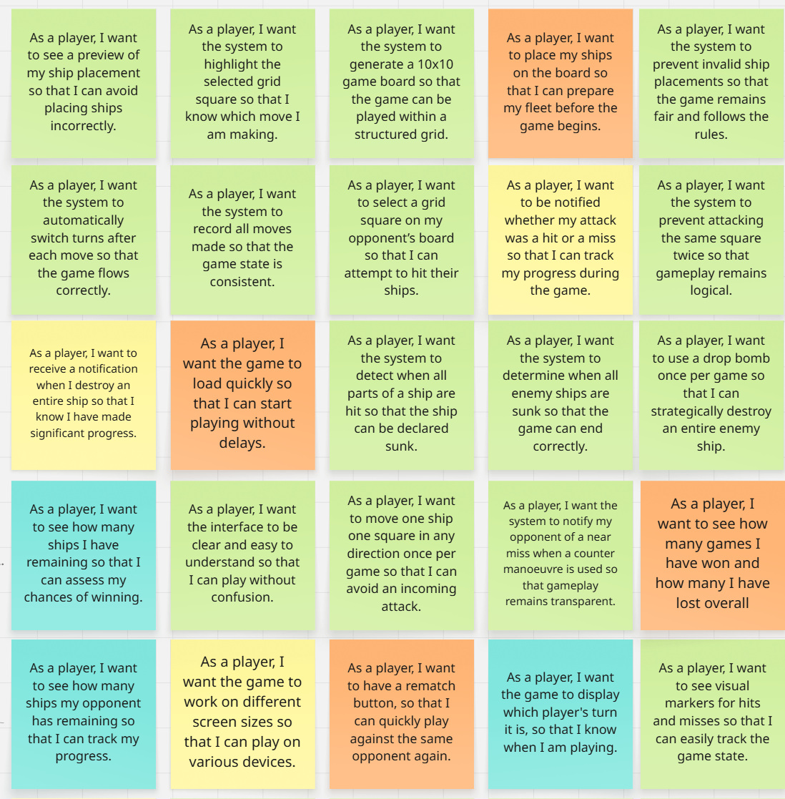
Figure 1. User Stories (1/2)
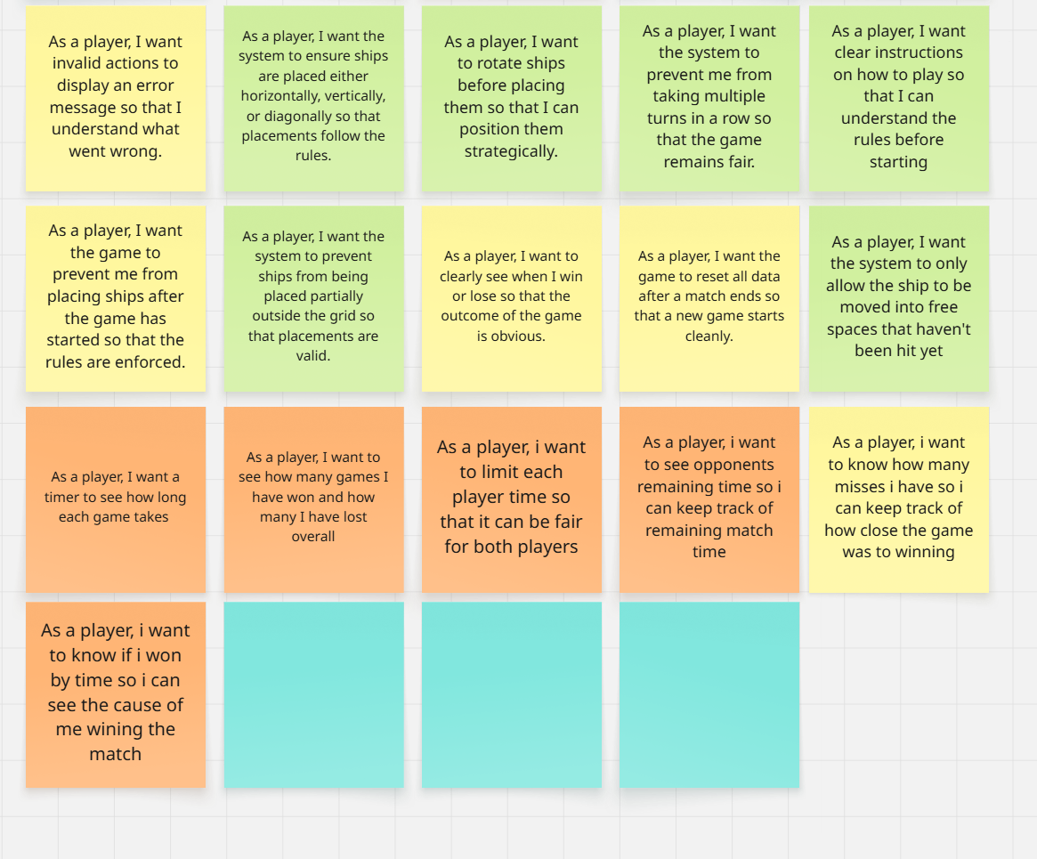
Figure 2. User Stories (2/2)
All stories created contributed meaningfully to the design of the project, but some are worth noting for analysis of the benefits of user stories. One primary example would be the user story “As a player, I want the system to prevent attacking the same square twice so that gameplay remains logical”, which stipulates that the players should be prevented from targeting a tile that has previously been targeted so that a player can not mistakenly shoot the same tile for a second time. The reason this story is worth analysing is not just because of its explicit meaning for the design, but because of a discussion that sprouted from it. Initially, the counter manoeuvre available to ships only stated that a ship could be moved once per match, notifying the enemy player of a near miss. However, one oversight was how would the board handle displaying a near miss, as there were a few options. If it cleared or updated the tiles in any way it would reveal either the placement of the ship, or similar. As such, after short debate, it was decided to update the counter manoeuvre mechanic so that it would only allow moving a ship to places that were not yet hit. This highlights the benefits of user stories on multiple levels, both in terms of outlining features and functionality allowing for more thought, but also in enabling discussion between group members around the stories and other decisions.
Other stories worth mentioning could include “As a player, I want to be notified whether my attack was a hit or a miss , so that I can track my progress”, which has the benefit of being in the place of the player, and thinking about what players may feel or want in features, as opposed to adding features for features sake. Another option that demonstrates this would be “As a player, I want to see a preview of my ship placement so that I can avoid placing ships incorrectly”.

3.2. User Story Map
The user stories created within the group were organized by priority levels of “MoSCoW”, meaning Must Haves, Should Haves, Could Haves, Would Haves, where each bracket is lower priority, but the highest would be the Minimum Viable Product. Using this, the backbone was created to contain general categories for the stories, then the backbone was split into individual steps required to be completed. Following this the stories were mapped into a proper user story map, including layer-based prioritization and segmenting the stories based on their task. Figures 3 and 4 displays the completed user story map.
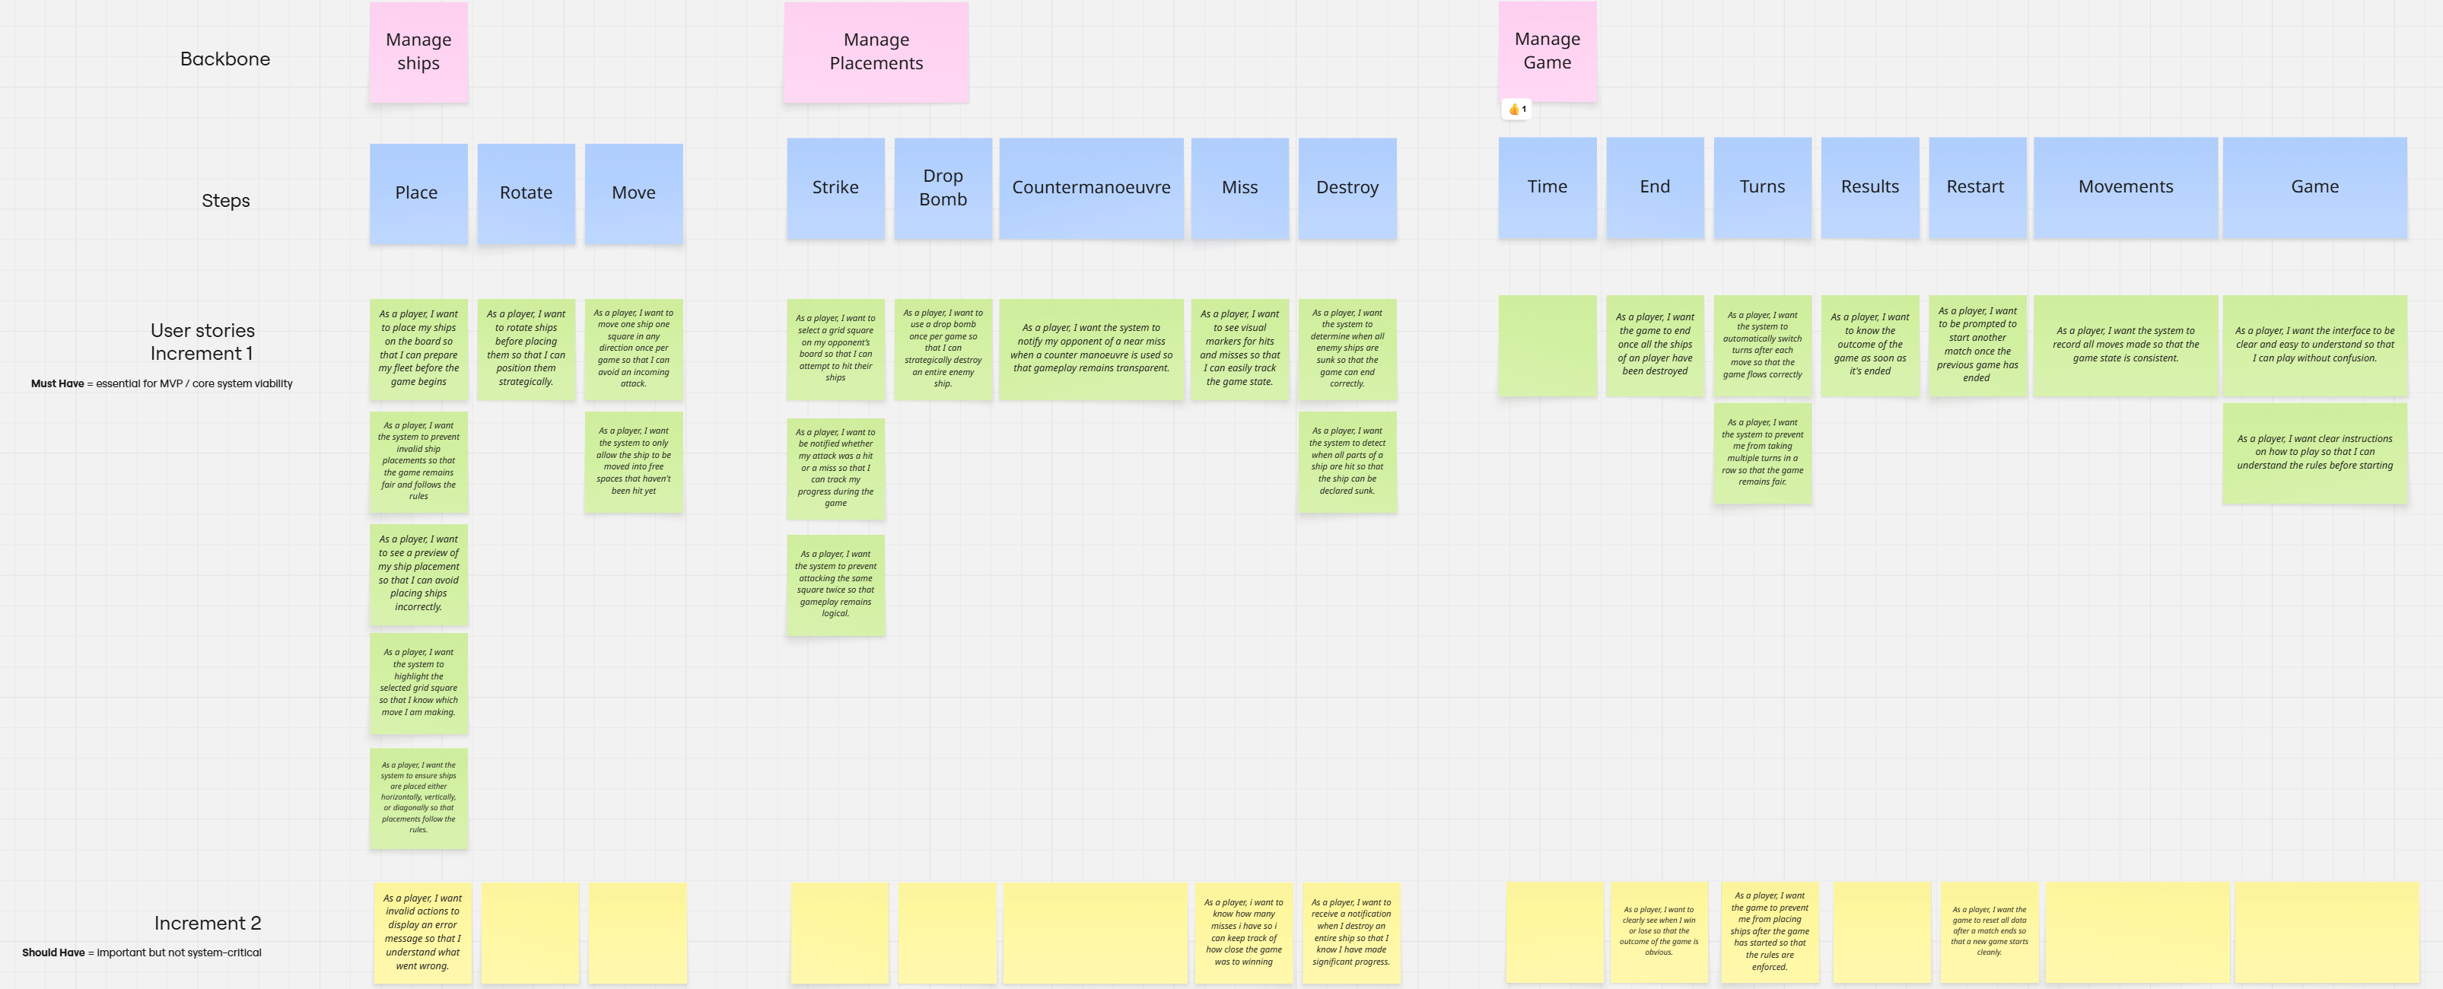
Figure 3. User Story Map (1/2)

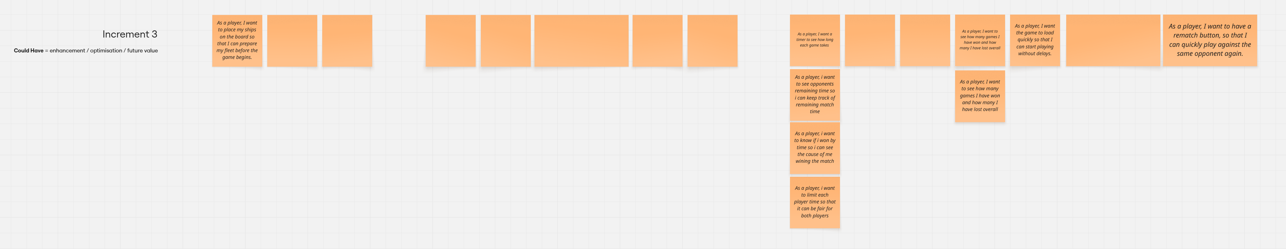
Figure 4. User Story Map (2/2)

3.3. CRC Cards
The CRC cards were created and refined utilizing the user stories map above to provide more design of how the practical implementation could be handled. This resulted in four classes being created, consolidating their responsibilities and collaborators within each card. This approach is beneficial both in terms of developing a design and is useful when it comes to developing the project practically also. Below, figure 5 showcases the CRC cards created.
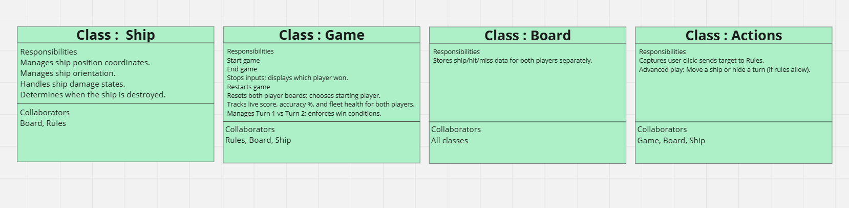
Figure 5. CRC Cards
The cards shown include the details from the user stories in the form of responsibilities per class, choosing to have four main classes, these being the ship, game, board, and actions. The ship class holds all responsibilities tied to the ship, including managing its position, orientation, health / damage states, and the destruction of the ship. The game class is the heaviest, handling most of the game processing, including starting and ending the game, along with restarting it, but also things such as tracking the score. The lightest class is the board class, which could potentially be expanded to include responsibilities such as handling the board size, etc. These classes overall include enough detail to enable the implementation of the code within a practical setting.
In terms of testing, the CRC cards generally aid with determining how the practical implementation of the code would be tested, as they showcase what the class is meant to do. Whilst they are useful in this case, the lack of explicit acceptance criteria within the user stories stage could have harmed the outcome, along with the thin detailing for the board class, where more defined responsibilities could aid the planning and performing of testing later down the line.

4. Software Testing

4.1. Importance of Software Testing
Software testing is a crucial component in software development that cannot be ignored, as it is only through testing that software can reach a high quality and have proper functionality. It must be considered early in the development life cycle to be as effective as possible. One key reason why software testing is important is because it identifies any flaws or issues early into development prior to release, and since these issues are caught earlier in development, it is cheaper and easier to implement fixes or changes that address said issues [1]. Fixing these issues early on can help both speed up development and reduce risks or costs that may occur because of the issues down the line for the project. Another aspect is that if the issues are unresolved at time of release, there is potential for extreme consequences as a result, with a notable case being from 2024, where a software update from a company called CrowdStrike resulted in systems crashes across Windows platforms, including severe impact for companies like Delta Air Lines, which suffered over $500 million in losses as a result [2]. As a result of these high risks, software testing is crucial, to reduce the chances of any issues arising post release. Additionally, something to consider about software testing is that it does have its own costs, in both the time taken to plan out and engage in testing, but also any extra resources required to facilitate it. However, these costs are outweighed both in the benefits of testing, and in the costs that it may save as a result [2]. Another factor is client satisfaction, where people want systems to work, and work well, and nobody wants to receive a product that either does not work, is not reliable, or is not what they were told they would get. Testing helps to eliminate this by checking if the product works correctly and is what the user expects [3].

4.2. Black Box & White Box
There are two main types of testing that can be completed in relation to software testing, these being black box and white box testing. Black box testing would be the testing of inputs and comparing outputs to the expected output values and thus is referred to as data-driven testing. Contrastingly, white box testing focuses more on internal logic and code of the software, examining the software to allow for precise and targeted testing [4]. For example, within the context of the project, a black box test that could be completed would be that, when Player 1 destroys all of Player 2’s ships, a win screen showcasing that Player 1 wins displays. This could be described as the expected input being Player 1 destroys every ship, and the expected output being the win screen displaying Player 1 wins. This would satisfy the more data-driven approach with no knowledge of the logic or code that black box testing is. Alternatively, a white box test could be to check that when a ship is destroyed, does it correctly flag as destroyed, and do the appropriate subsequent events and logic trigger correctly. This would suit the more logical side of white box testing, requiring knowledge of how the system handles these events to be able to test them.

4.3. Testable Code
Code testability refers to how completely or efficient aspects of software can be tested. Some factors that can make code easier to test would be controllability and observability, where controllability allows for the application of set inputs to test specific code, where aspects linked to things such as system time or dates would not be controllable and thus harder to test as a result. Observability would allow for the viewing of the outputs / states after a test run, making it easier to verify the outcomes of a test than if these aspects were hidden [5]. The testability of code is highly important and can influence the quality of the product [3], as if code is hard to test then it can both take longer to test areas of the code or become impossible for some areas. As such, writing code with testability in mind will aid both testing the code to ensure functionality, and result in a better end product, but if it is not taken into account, the difficulty of testing increases, making the test process difficult, time-consuming, and potentially introduces risks into the software as a result. These two factors can be applied to some tests within the project, for example, if a test involved the turn system, the turn system would need to allow a tester to set the turn of the player prior to running the test, making it controllable. Another example would be showing explicitly which player’s turn it is to easily verify if the turns are swapping correctly, making it observable.

5. Tests

5.1. Black Box Tests
Black box tests were created for the project to test the functionality from a data-driven perspective, with no knowledge of the internal workings of the systems.

5.1.1. Player shooting an enemy ship.
Pre-conditions:
The game is running and both players have placed their ships, and it is Player 1’s turn.
Inputs:
Player 1 targets and shoots a tile containing an enemy ship.
Expected Outputs:
The game correctly displays the notification indicating Player 1 hit the enemy ship.
Description:
This test would ensure that the game recognizes and informs the player of when their shots hit a ship, ensuring that the player is not misinformed on their progression.

5.1.2. Player shooting an empty square.
Pre-conditions:
The game is running and both players have placed their ships, and it is Player 1’s turn.
Inputs:
Player 1 targets and shoots a tile not containing any ships.
Expected Outputs:
The game correctly displays the notification that the shot missed and no ships were hit.
Description:
This test aims to ensure the game recognizes shots that do not hit targets correctly, so that the player knows that tile does not contain an enemy ship.

5.1.3. Player destroys all enemy ships.
Pre-conditions:
The game is running and both players have placed their ships. Additionally, Player 2 only has one ship remaining, that is one shot away from being destroyed. It is Player 1’s turn.
Inputs:
Player 1 targets and shoots the tile containing the final ship part.
Expected Outputs:
The game ends, displaying that Player 1 wins the game.
Description:
This tests that the game can be won and displays so correctly upon all a player’s ships being destroyed.

5.1.4. Player uses a special drop bomb.
Pre-conditions:
The game is running and both players have placed their ships, and it is Player 1’s turn.
Inputs:
Player 1 uses the special drop bomb when selecting to target a tile with an enemy ship.
Expected Outputs:
The game displays that the enemy ship is destroyed, regardless of how many times it was hit before.
Description:
This test checks the special drop bomb attack available to players, ensuring that it properly shows that the enemy ship is completely destroyed.

5.1.5. Player places ship in valid position.
Pre-conditions:
The game is running, and Player 1 is about to place their ships.
Inputs:
Player 1 places their ship in a valid position on the board.
Expected Outputs:
The game places the ship correctly and displays the placed ship to Player 1.
Description:
This test ensures that the placement of ships displays and works correctly.

5.2. White Box Tests
White box tests were devised to ensure that not only does the game work from a user perspective, but that all code and logic work as intended, with no backend issues that could otherwise go unnoticed.

5.2.1. Player shoots an enemy ship.
Pre-conditions:
The game is running and both players have placed their ships, and it is Player 1’s turn.
Inputs:
Player 1 targets and shoots a tile containing an enemy ship.
Expected Outputs:
The ship flags that section / tile as shot correctly.
Description:
This test would ensure that when a ship is damaged, the damage is tracked correctly within the ship object and not incorrectly tracking where / how it is damaged.

5.2.2. Player uses a special drop bomb.
Pre-conditions:
The game is running and both players have placed their ships, and it is Player 1’s turn.
Inputs:
Player 1 uses the special drop bomb and targets a tile containing an enemy ship.
Expected Outputs:
The ship is destroyed, and the game flags that Player 1 used their drop bomb, disabling it for the rest of the match.
Description:
This test would check the functionality of the special action, ensuring that it does not allow for multiple in one game, and that it correctly destroys the entire ship.

5.2.3. Player places a ship.
Pre-conditions:
The game is running and Player 1 is still placing their ships.
Inputs:
Player 1 attempts to place a ship in any position.
Expected Outputs:
The correct validation checks are run, and if valid, the ship is placed.
Description:
This test aims to check the ship position validation system, and ensure that checks are run properly and accurately, giving the correct determination for the validity of a ship placement, and preventing invalid ship positions.

5.2.4. Player destroys a ship.
Pre-conditions:
The game is running and both players have placed their ships, it is Player 1’s turn and Player 2 has a ship with only one hit left.
Inputs:
Player 1 targets the final tile for Player 2’s ship and shoots it.
Expected Outputs:
The ship gets correctly flagged as destroyed, and any subsequent code or functionality runs correctly.
Description:
This test would ensure that ship destruction is handled correctly, flagging the ship as destroyed and trigging all functionality that comes after ship destruction properly without fault.

5.2.5. Player shoots / uses their turn.
Pre-conditions:
The game is running, both players have placed their ships, and it is Player 1’s turn.
Inputs:
Player 1 selects an empty tile, shooting and using their turn.
Expected Outputs:
The turn system properly swaps all flags and runs the operations necessary to change the turn to be Player 2’s.
Description:
This test would aim to ensure that the turn-based system is accurately tracking the player the turn belongs to, and swaps the turns as and when necessary, so that gameplay functions properly.

6. Unit Testing
Within software testing, there is a type known as unit testing. This unit testing refers to testing the smallest testable parts of a software in isolation from the rest of the system [3]. These parts are referred to as units, and this testing would typically be done by developers as opposed to testers. In unit testing, each unit must be tested independently to ensure proper functionality prior to being integrated with other systems. An example for something to test could include a door, for a door, these units could be open, close, lock, and unlock. In unit testing, a unit could be as small as a class or a function / method.
As defined by Robert C. Martin, there are five core principles for unit testing, forming the F.I.R.S.T principles [6]. These principles would be Fast, Independent, Repeatable, Self-Validating, and Timely. Fast would refer to how tests should be fast and run quickly, so that they may be run frequently. Tests need to be fast, as slow tests will mean they cannot be run as frequently, resulting in issues not being caught as quickly. Independent refers to how tests should not be dependent on any other test, and one test should not set conditions for another. This is key, as if tests rely on each other or use each other’s data, then a failure in one can then impact the other tests that depend on it, making identification of problems harder. Repeatable states that tests should be able to be repeated in any environment, so that if an environment is not available, you can still run them, with no excuse for why they fail. This is crucial, as if tests produce different results in different test environments, then the issue could be either a bug or as a result of the environment, giving unreliable hard to analyze results. Self-validating states that tests should have a Boolean output of pass or fail, and that you should never manually compare results or logs to determine the outcome of a test. This is a key point as manually interpreting results not only slow down the testing process but introduces more human error into the testing process. Timely states that tests should be written just before the code that passes them, as if the tests are written after the code, the code may be harder or even impossible to test, where writing the tests first is likely to result in testable code.
These principles / form of testing can be applied to some of the previously listed white box tests, for example, ship destruction and turn change tests. Both can easily meet all the principles. They would be fast tests to run due to the simpler nature of them, where the ship destruction test simply needs a ship to run the destruction test on, which would be lightweight, and then an automated check for if the test was successful. For the change turns, all that would be needed is to set it to a player’s turn, then run the required code, and automatically check if it was successful. They are both independent of any other tests, not relying on one to set up any data for the other, and would not affect or edit shared data or stated that could impact other tests. They can be repeatable in release, development, and testing builds, either through normal gameplay tests where they would be applied naturally, through a dedicated environment for testing where the bare minimum is set up and ran through, or developer settings hidden in all builds to instantly access the unit test functions, such as a keypress to destroy a targeted ship or swap turns to the other player. They could be set up for self-validation via automatic checks of flags or states with the expected outcomes for the test, giving a simple pass or fail outcome for each test run. They could be considered timely if they were written prior to the code.

7. Conclusion
This document covered the design process and an evaluation of a design for a project for a battleships like game, including focus on the user stories and CRC cards. It further covered software testing, including black box and white box testing, their differences, and some examples of them relating to the project. It also touched upon unit testing and how its principles could apply to some of the prior white box tests mentioned. Overall, the design and testing processes covered throughout the document aid to provide a stronger overall design for the project, and would aid in its implementation, resulting in a stronger end product.

8. Figures
Figure 1. User Stories (1/2) 4
Figure 2. User Stories (2/2) 5
Figure 3. User Story Map (1/2) 6
Figure 4. User Story Map (2/2) 6
Figure 5. CRC Cards 7

9. References
[1] "The Importance of Software Testing." IEEE Computer Society. Accessed: May 1 2026. [Online]. Available: https://www.computer.org/resources/importance-of-software-testing
[2] S. Susnjara and I. Smalley, "What is Software Testing? | IBM." Accessed: May 1 2026. [Online]. Available: https://www.ibm.com/think/topics/software-testing
[3] A. Uddin and A. Anand, "Importance of Software Testing in the Process of Software Development," pp.2321–0613, -01-01 2019, Accessed: May 1, 2026. Available at: https://www.researchgate.net/profile/Abhineet-Anand/publication/331223692_Importance_of_Software_Testing_in_the_Process_of_Software_Development/links/5c6d13464585156b570ae061/Importance-of-Software-Testing-in-the-Process-of-Software-Development.pdf.
[4] A. Verma, A. Khatana and S. Chaudhary, "A Comparative Study of Black Box Testing and White Box Testing," vol. 5, no. 12, 31 December 2017, Accessed: May 1, 2026. Available at: https://www.researchgate.net/profile/Sarika-Chaudhary/publication/325816726_A_Comparative_Study_of_Black_Box_Testing_and_White_Box_Testing/links/5d289f29458515c11c2a99b6/A-Comparative-Study-of-Black-Box-Testing-and-White-Box-Testing.pdf?__cf_chl_tk=_s9qf8v556Po2FFJ.eo58DDpBWYIx5JzgTvx2b9dcBk-1739317740-1.0.1.1-QsT9_qJZeok1LY33B.7q3ZNArMO__g0TyjhmRgX9a9E.
[5] P. Schrammel. "How Testable is Business Software?" Accessed: May 1 2026. [Online]. Available: http://arxiv.org/abs/2011.00630
[6] R. C. Martin, Clean Code: A Handbook of Agile Software Craftsmanship, Upper Saddle River, NJ, United States: Prentice Hall PTR, 2008. doi: 10.5555/1388398[Online]. Available: https://dl.acm.org/doi/book/10.5555/1388398

