Scaffolding for peer assessment.



By Aled Williams

Introduction

The school in question that I will be writing about, which I will call school X is located in a known deprived area that has a challenging community especially in the last few months. All though school X my be in a deprived area it is the only school with in the whole county that is a Welsh medium school and because of this comprehensive is the only welsh medium school it takes in learners from all different and diverse areas and backgrounds of the county. From the privileged to the deprived and there for is diverse in culture. There are many challenges to school X such as behaviour management, getting the learners to critically evaluating their work and evaluating their peers. That is why for my research I chose to, and I will focus on giving the learner the scaffolding for peer assessment to see what impact it had on the learner and their progress of understanding and learning pre and post of the assessment and how affected it can be. It is crucial that the learner understands the reason on why peer assessments can be critical to their learning and to build up a culture of independent learning, that takes away the pressures and complex archetypes in the classroom for the facilitator/teacher.

Lit review

The way I will be breaking down the literary review is by examining a few documents. The first is ‘Self- and peer-assessment and taking responsibility: the science student’s role in formative assessment’ by Paul Black and Christine Harrison. Now it maybe science related but a lot of the techniques may or may not be transferable. This is a collective of teachers who tried similar and different techniques with different outcomes.

1.1
“Most pupils are honest in their own assessment for most of the time. Some, especially the less able, don't like to admit that they are not coping and sometimes say they understand when they do not. Teachers try to help by emphasising to each pupil that the record is a private document between the two of them and what matters is that the teacher can see where the pupil has problems so that help can be given where needed. There are likely to be variations in standards between pupils in filling in the boxes, but this doesn't matter very much—the main value comes from the combination of the box data and the pupils' comments: these together provide starting points for useful dialogue with teachers. Pupils have got noticeably better at their own assessment during the year. Many at the start write very few, and very vague, comments, but during the year these change and become more explicit and perceptive and so more useful (p. 15).”

What I can review from this is what self-assessment was not the indeed endgame, the importance on the needs of the learner to develop an overview of their work and their understanding of the subject. It is an essential element to self-assessment. The person goes on to theories that feedback in learning has to have very clear goal. Make sure the learner is aware of where they are in relation to the endgame of the task. This should be able to make them take action and become a more independent learner and to aim and reach fro the goal. In relation to peer assessment how a learner needs to be aware of what the goal is and how to explain to their peer.

1.2
“One technique has been to put the students into small groups and give each student a small part of the unit to explain to their colleagues. They are given a few minutes preparation time, a few hints, and use of their exercise books. Then each student explains their chosen subject to the rest of their group. Following the explanation, each of the other students then gives the speaker a ‘traffic light’ mark — Green means it was explained better than they could have done so themselves. Amber means it was explained at about the level they would have been able to do, and red means that they feel it was not explained as well as they feel they could have explained it. Students are very honest in doing these, and in doing the follow up, where all those who gave a green or a red mark justify their ‘score’. Here students are quick to point out things such as, “I thought that the examples you chose to explain were very good as they were not ones in our books, so I don’t think I would have thought of those.” Or, “I expected you to mention particles more when you were explaining the difference between liquids and gases.

These sessions have proven invaluable — not only to me, in again being able to discover the level of understanding of some students, but to the students too. Given the opportunity to comment freely on what they felt about the sessions, almost without fail the comments were, “They help me to realise the parts I need to revise more. “, or, “Explaining to other people and listening to their explanations really helps me to understand it much more than just reading it at home” So, revision homework has actually started to mean something to the students —now if that isn’t success what is?”

Philip, Century Island School”

To contextualize this there are two elements that are brought up here. The first is the peer assessment. The result of working in a group. One must think of the greater value of peer assessment as referred before hand it is to set a common goal for one another. However he could suggest that as the learners are in control of their assessment their use of language would naturally come across, also the learner takes on the mantel of the teacher/ facilitator and examiners each others work. This should bring focus on their work and establish preciousness over it.

1.3
“Pupils also mark their end of module tests without mark schemes using their exercise books, textbooks and each other. This had a bit of a bumpy start with pupils comparing answers and marking them as correct only when they had the same answer. By training them to use the textbooks and discuss what they think the answer is has helped the process. It is also improved by concentrating on only two or three questions at once and by giving a set amount of time to complete the marking in.

Susan, Waterford School”

In this there is a suggestion of insuring that there are set assessment frame works or ‘success criteria’s’. In the context of art and design as GCSE and ALEVEL are the endgame pulling from what makes a successful piece or body of work from there own marking criteria and develop it so its malleable for KS3 students would insure success when coming to examination but also a training of there ability to be critical and independent thinking which is reflective of the art world.

1.5
“Now, the papers are returned, and students work in small groups to agree on answers — in effect coming up with their own mark scheme. This works best in practice, I have found, if only a few questions are tackled at a time, then the class 4 share information, and make sure that they are in agreement with the official mark scheme, then on to the next few questions. Initially, this tended towards, “I must be wrong because I’m the only one who has that answer.” And that is still a problem with lower ability students, who lack confidence. Quickly, however, the middle ability and more able pupil is able to realise that the best answer is not necessarily the majority’ one, but the one that can be best justified;

Philip, Century Island School”

Again similar however the learner is critically evaluating their own works against others compare and contrasting and think critically about if it works or not. Debating what is successful and creating a success criteria could be another form in which peer assessment can be fruitful. If were to reflect the real world it would be successful for them to create there own success criteria as that would create a very democratic approach to peer assessment. However one would have to scaffold there thought process and show them way in critical thinking. Everyone has different idea of what is successful. How do we agree on a consensus on what is successful and what isn’t?

Methodology & Ethics

Of the core policies school X has, there is one element school X wished to improve on. School X believed that the learners did not have enough empathy and with the thought of that from our currant social political landscape that social media has consumed the learners thought process and ideologies. There for they wished to strategized ways of developing empathy into the work, and perhaps to ensure the learners understood and grew critical of their thought process and ability to process.

From that to compare and contrast the questions of various teachers I may suggest to question many ways in which we can use peer assessment to allow space for the learner to critically evaluate them self’s an others with meaning and heart. However how much handholding must there be in the peer assessment? Is it possible for students to critically evaluate them self’s, in which would be effective in their learning? What might be the restrictions? One would have to consider how the differentiation would work in this case. With what Philip from century Island school (3.1) Suggest is if the pupils were to create the criteria for marking then would that create a better form of success? Is what the learner’s ideology of success different to the teacher’s ideology of success? What paradigms do we use to measure? Is crude to say how can one measures success? In the context of art can we say for certain there are measures for success? Does the peer have more influence over the teacher when success is needed? “Now, the papers are returned, and students work in small groups to agree on answers — in effect coming up with their own mark scheme. This works best in practice, I have found” (1.5) Susan from Watford school maybe approaching the idea that it does have an impact in some way. That the peer may have a greater influence on another rather then the teacher, but I still question how does a peer recognize success and can confidently assess it for another peer?

From this the methods I will use to create my scheme of work for the experiment will be the as suggested in 1.2 where I will get the learners to sit in groups “One technique has been to put the students into small groups and give each student a small part of the unit to explain to their colleagues.” Instead of explaining to their peers I will ask the learners to break down subject information that then should build the idea of the peer working collectively and support them in the further progression of their work for the end product. This should lead to what 1.1 is suggesting in that “Many at the start write very few, and very vague, comments, but during the year these change and become more explicit and perceptive and so more useful (p. 15).” Suggesting more they work on a particular way of assessing the more confident and a potential for depth in their writing will improve.

1.3 is the method I wish to use as the end assessment for the body of work that I will design for the experiment “Pupils also mark their end of module tests without mark schemes using their exercise books, textbooks and each other. This had a bit of a bumpy start with pupils comparing answers and marking them as correct only when they had the same answer.” This perhaps may have in interesting dynamic that I wish to see if it may become successful or not. That the learner will to assess and have an open critic on there peers work. That it doesn’t become a tick box exercise but might reflect the professional art worlds approach to critically talking and evaluating worth of a body of work. The quote also does state that It might not be as effective since there may not be as much structure and that might tamper with the quality of the outcome and the assessment.

A method as to be put forth that will engage the learners in critical thinking from 1.5 -“Now, the papers are returned, and students work in small groups to agree on answers — in effect coming up with their own mark scheme.” Depending on the time I may allow the learners to create a marking criteria but the idea is that the learner needs to be able to engage with there peer and critically evaluate their work. This maybe problematic as state before “Many at the start write very few, and very vague, comments” and that I do worry that the learners may not answer or evaluate there peer with gust and depth to there peer assessment. How might we solve that? How might the learners be shown an expectable assessment example with out feeding too much to the learner? Might we simple show an example? Or create one, as a class so there would be a consensus on is ‘success’. The end assessment maybe problematic indeed and working to scaffold the learner will be the next step to creating a possible successful outcome.

Evaluation

After conducting a control experiment at school X to see how and why scaffolding learners for peer assessment can be critical to their development and learning, and how it might grow a culture of independent learners with in the content of secondary education. I’ve chosen for the learner to partake in is a peer assessment of an outcome of a particular unit that I have designed myself for the experiment. It seeks to look at the impact a learner might achieve and possibly help the learner critically think about their work and the consequences of an outcome.

What we may know about Key stage 3 year 9 either from our own experiences in school that the learner is at the foreshore of the begging of their GCSE. Some schools may begin earlier and some school don’t. The learner lives in limbo until they can partake in their GCSE’s. That mixed with their minds and bodies changing, it is challenging for them as a learner as they begin to question why for many elements of the work but may lack the strength to thinking critically for them self’s why.

From this I designed a unit that looks at an end piece as a situation that creates dramatic ‘consequence’ for the learner. So they have more of an ability to show their skills and understanding off to their peers but also give the learner and ability to conduct them self’s in way that they understand with life comes consequences and maybe whether those consequences are taken seriously or as part of a teenage culture not to bother and overthink it.

How to deal with them for further progression in their work. This may or may not diminish their questioning on why? This may or may not give the learner the ability to think critically and independently. However hopefully it starts a dialogue on consequences and maybe an ability to think for one self. This may be problematic with a few learners.
To give context I will briefly explain the scheme of work I gave to two different Key stage 3- year 9 classes. As part of my separate research into developing my own schemes of work for Key stage 3 around the idea of industry and activism. I took an aspect what I am developing, an element I briefly touched on in my research from my first assignment (ECSP6001). In that I stated “The creative industry is the second largest industry in the UK contributing £92bn to the UK economy in the last year and according the GOV.UK the creative industry is growing twice the rate of the economy.” From this I seek to design a scheme of work around the six artistic practises that make up the most lucrative, viable and profitable elements that contributes to the British economy through the arts industry. Fashion, film and television, product design, architecture and fine art. This my be what is culturally significant now as this report is from 2017 but with our rapid culture growth and globalization some subject may change depending on education, accessibility and culture.
As time was factor and I only had 4 weeks to conduct this experiment. I focused on one of the practises and one element with in it. Fashion as this is the most lucrative but also universal in understanding as we do all wear garments, being at the age that the learners were they may have an interest or they may not but thought provoking about it.
British Fashion specifically to be more fine about it I create a unit on a British designer called Vivienne Westwood. Arguably a dynamic and progressive designer of fashion “largely responsible for bringing modern punk and new wave fashions into the mainstream.” Vivienne Westwood is also is an activist for slow and sustainable fashion so is a sensible option for students to learn as it may add an element of civic duties. However her work maybe is questionable in taste as she does push gender normative ideologies and provokes with crudeness.



The learners were introduced to her as an artist, a design or maker. Questions were raised as a few learners questioned “but that’s fashion sir”. This was great response as the learner began to critically think what is an artist and what is the difference as a fashion designer. There isn’t a straightforward answer; one would suggest there isn’t a difference. One would suggest one is design another an expression. None the less the learner began to crucially think about the difference and its practice.
The learners then created an artist page about Vivienne Westwood. This would be a culmination of various facts about her. It was then on the learner to find two other facts about Vivienne Westwood which they did. Another example of their critical thinking. They researched specific elements to her as a designer. Perhaps this may have been problematic as a few learners copied one another, other simple focused on the crudeness.
Inspired by Vivienne Westwood’s early work the learner then had been given a task to think about how would they recreate Vivienne Westwood’s work in the same context. Vivienne Westwood was known for her outrages and politically motivated t-shirts that had an element of protest to them being that her style was post punk. Post punk being “Post-punk has traditionally been described as a genre to rise out of the first wave of the punk rock movement in the late 1970s. The genre is stylistically diverse; this diversity is due to re-examining and challenging the formal strictures of the punk orthodoxy.”

The learner engaged and created a slogan of text that reflected their feelings or frustrations deriving from a previous project, again another use of their critical thinking by reflecting. Perhaps the challenge with this is that learners are sometime reluctant to be open and share raw emotions with their peers, as the social dynamics don’t work. Some needed to be encouraged but once explained again, the learner came up with interesting pieces.

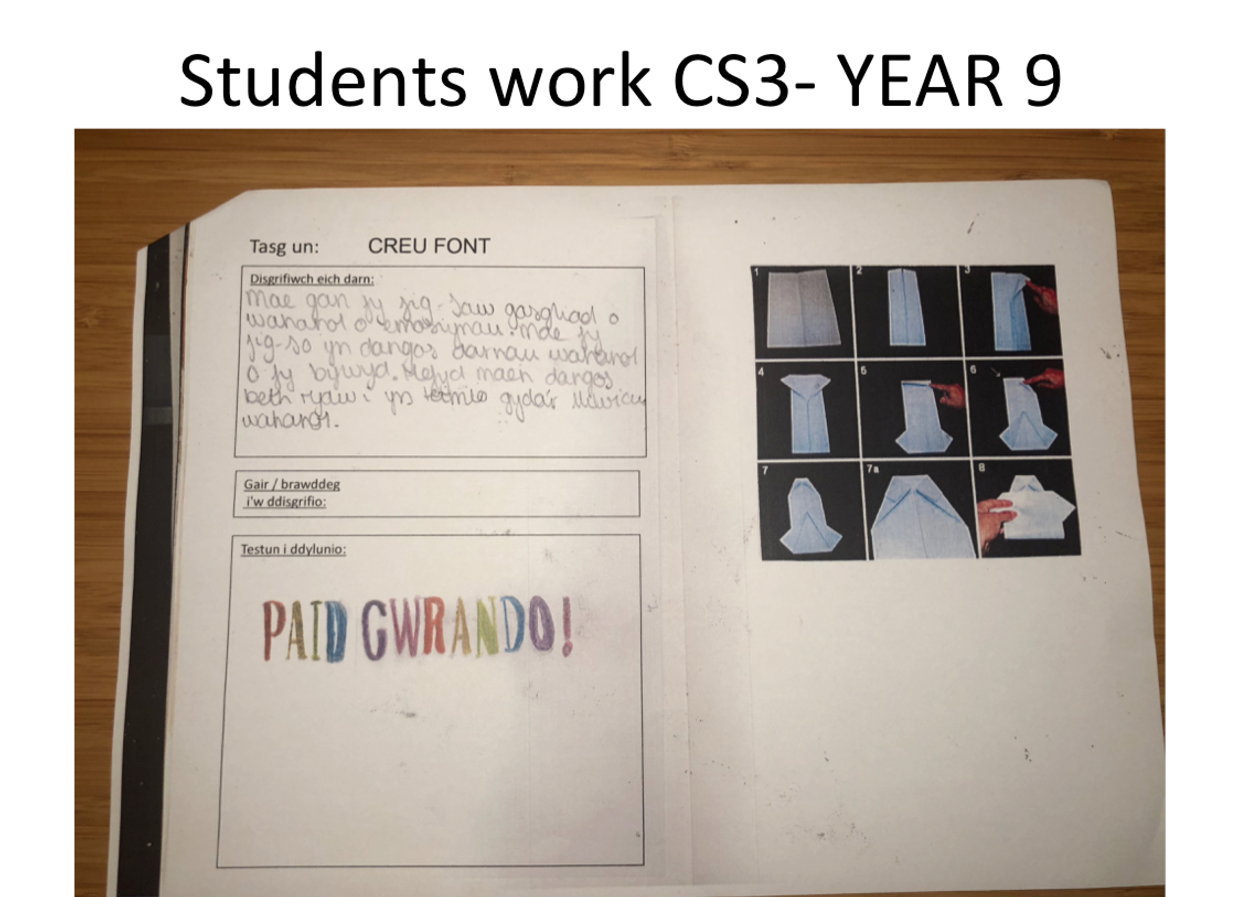
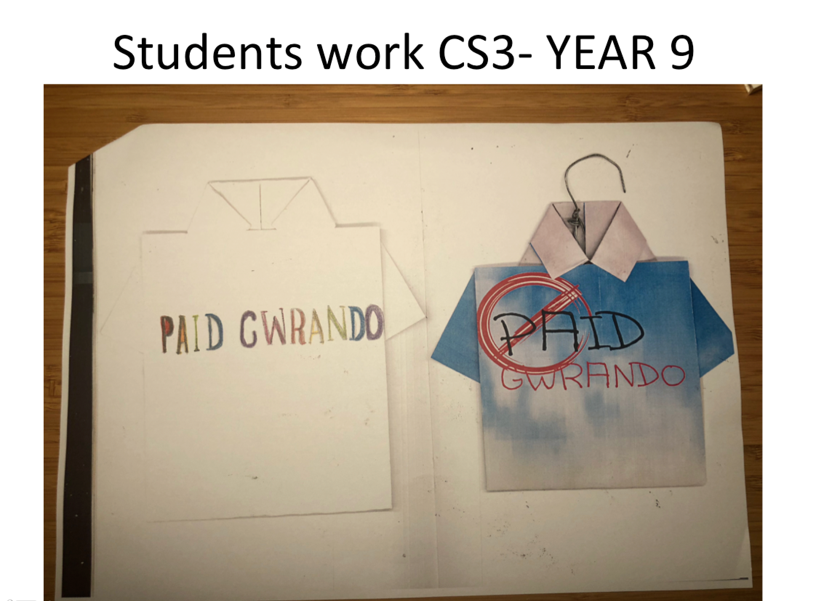
They later created a typography that visually reflected that emotion or ‘rant’ if you wish. I call this ‘Context and Form’ a philosophy from Central Saint Martins, fitting as Vivienne Westwood also trained at this institution. What it means that what ever the ‘context’ of the piece is saying or meant to be saying that it should inform the ‘form’ of the piece. The learners later went on to create an origami t-shirt and transcribed their text onto the t-shirt. We later furthered and experimented with a digital element to see whether it can enhance the piece or distract
The unit finished with the final assessment. Three questions were asked. “Were they happy with the final outcome and why” I’m paraphrasing a little. “How much would they want to sell they’re piece for?” then they asked a peer “how much would they buy it for” and “what was the difference in price? And why?” So they might suggest elements of the garment might be better in some places and some other places might be worst.
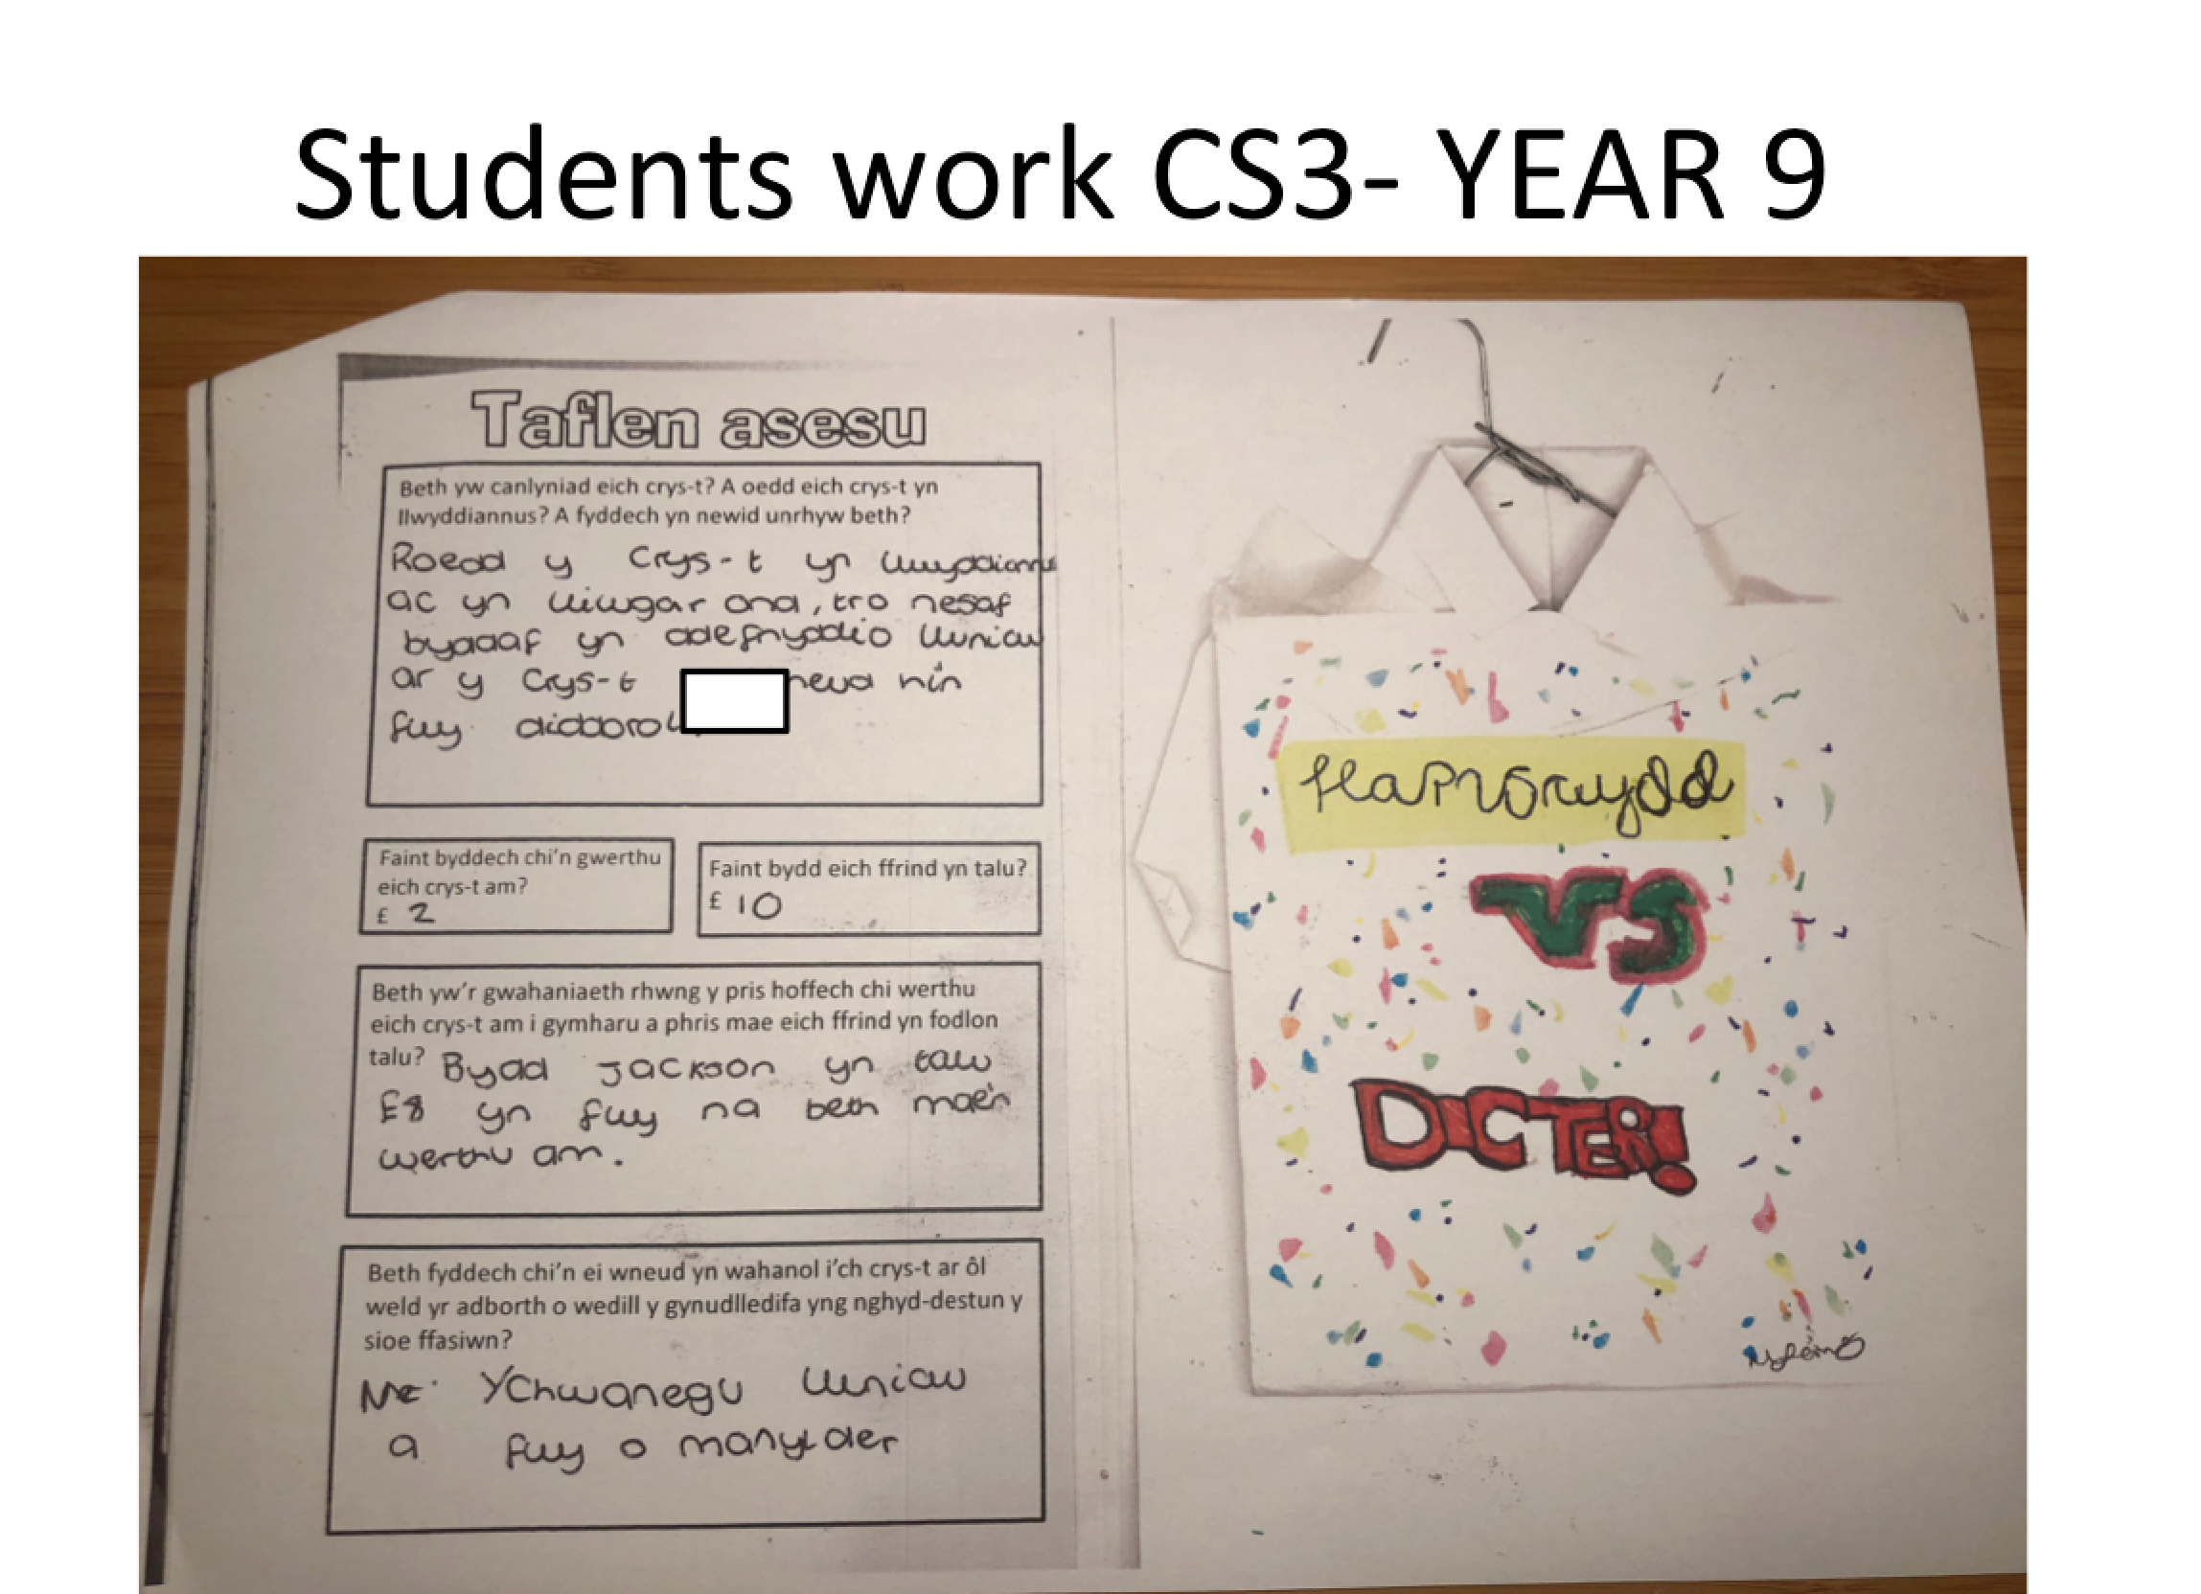

Then we had a fashion show to see the piece in context (context and form) for them to answer the last question “After seeing the show what would they do different next time?” This was final element of their critical thinking as we had a critique of the show after so a heavy influence on peer assessment and class assessment was clear and the idea of consequence beginning to come to fruition.
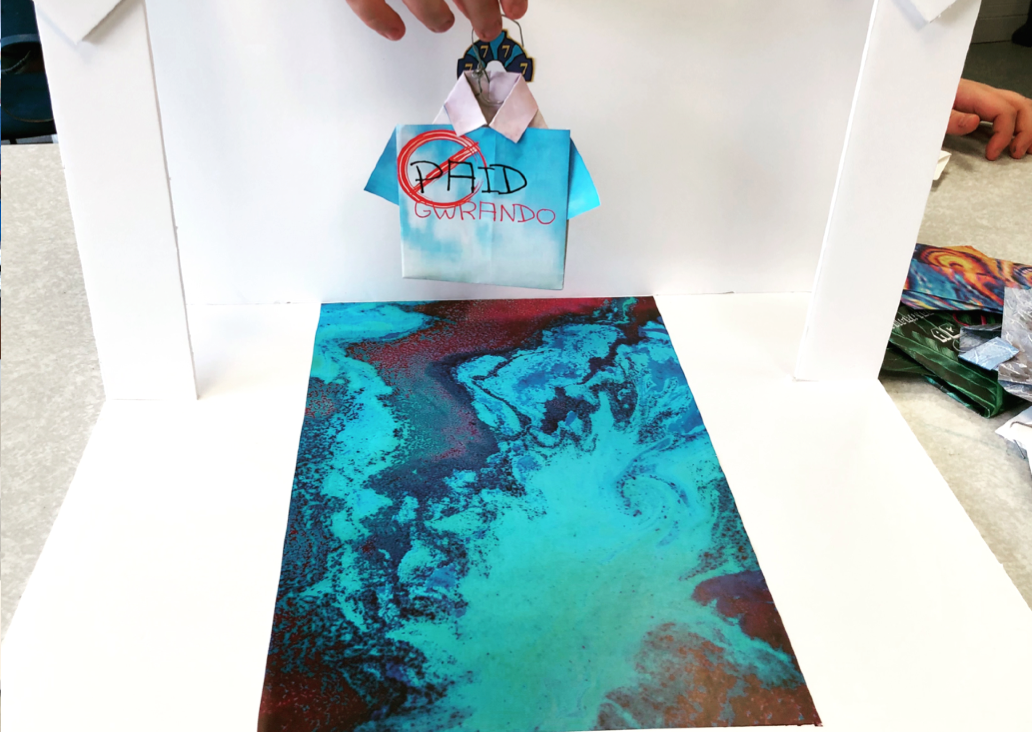

Following back to the comment made by Susan from Waterford School “Pupils also mark their end of module tests without mark schemes using their exercise books…this had a bit of a bumpy start with pupils comparing answers and marking them as correct only when they had the same answer.” This issue did arise a lot in the assessment where one or two students would make a lack of effort on their piece and gave a very surface level answer to their assessment which plagued a few in the class. Or students wouldn’t answer the questions with critical understanding but more of a passive comment.

However having the fashion show put a spotlight on the learner and their work, since the majority of them have seen each other’s work the emphasis on consequence was very clear and the reaction for some were obvious, for other it took time when writing each others feedback to think objectively and critically, whether it had impacted or not maybe still up for debate, perhaps a follow up class assessment to see if the learner achieved what was set out.

Most students were happy with the out come but a majority were displeased and in the final question of ‘what the would of done differently’ a clear case can be made that the student had learned and successfully critically evaluated their work and understood what they could of done differently to have a better or more successful outcome.

Again to reiterate from what Philip from century island school suggest that the students benefited from creating their own marking criteria that’s what might work more effectively for school X. However what to look out for in criteria for marking is questionable. The learner would need prior knowledge of what success is. How do we create that? Through creating our own work as an example? Is that to derivative? Can we teach the learner to spot success in works like Vivienne Westwood? There is that question of what is success?

They knew what was successful and what wasn’t by visual seeing in its context (fashion show) and critically thought of how to improve, but is that enough? Is that just a reaction the learners had maybe from years of conforming to a white heteronormative paradigm? What would have been even more beneficial or may have been more beneficial is if the learners prior to the final assessment were able to make their own marking criteria as a class. However I felt that the experience was interesting pulling on raw emotions and experiences, it may have had the learner think and shape their idea of what is success is future projects.

Conclusion

What I was able to deduce from my research was that there were successful elements and there were rooms for improvement. Setting up the learner for success was incredibly important and vital for the body of work to have been ‘successful’. Though we may not know what success maybe in this context giving the learner a set of standards, rules or criteria for success depending on your terminology would have been a lot more beneficial to the learner. Now that also maybe problematic as the learner does not know what the end piece will be and because of the context of the experiment it may not have been accessible to have a broad success criteria, something that would of been a standard for the academic year. School X did have a success criteria, however it was only somewhat compatible with the body of work designed for this experiment. Small and sharp success criteria’s were created as a way to sustain success. For examples, examples were shown on what is successful, what is acceptable and what isn’t acceptable.

What was a success were more the content and how it was consumed. How a subject that may seem foreign to them intrigued the learner to go further with its understanding. More of the political engagement that sparked much debate in class. That challenged their idea of art, of what is acceptable in the context of what they know e.g. an image of Vivienne Westwood wearing a t-shirt with a swastika on it. This I would wasn’t as transferable to their own work as the tasks were designed to encourage their own expression of their own identity and emotions. To create a more empathetic learner is School X was the task at hand for this academic year something they wished to work on, challenging as it was a difficult process to get the learner to open up and be more connected to delve deeper into their emotions. That said when questioned the learner was able to clearly and critically think in a more concerning way to there emotions, and might think of the causalities to them.

Condensing stylisation of Vivienne Westwood’s work proved a lot more challenging then progressive. Her work has depth and strong values to meaning passing that on and allowing the student to think if the learner can or cannot create this was challenging.

The final assessment. As stated in 1.5 -“Now, the papers are returned, and students work in small groups to agree on answers — in effect coming up with their own mark scheme.” After using this methodology allowing the learners to assess their peer on the standard of their outcome was a problematic as foreseen and said in the quotation.

The learner did not engage as much by writing as much about their work, the lack of depth to the resulting piece was shocking to say the least. However the last question of the assessment was “After seeing the fashion show with the garment in context what were your thoughts?” This sparked a contrast from the rest of the assessment as the learner engaged not just as individuals but also as peers with more depth and idea of consequence, which was an intention for the scheme of work.

Overall the learners were able to communicate effectively how their peer could improve next time but the only element a lot of the learners could not achieve was ability to extend their language and extend the question to suggested how they could of done better to have had a better successful outcome. Still a very surface level language and ideas but a step in a successful direction to critical thinking and are able to perform better with peer and peer assessment for future development.

Limitations and future development

There are many varying factors to limitations I had with School X. Limitations to experiment was the time. Trying to sequence effective lessons that work with my intended time frame as well as what the learners time frame maybe as art isn’t the only subject they will par take in one day. With the intensions of breaking down barriers and getting the learners to think there a generational problematic issues with social anxiety was in issue, “1/6 young people will experience an anxiety condition” that from anxiety UK and from what I have witnessed at school X is and was a growing concern and created an issue when we needed to work with peers to assess one another.

The transference of the style of work and the content to the learner was problematic at times given it was a new artist/designer to be introduced to and there for had issues with the learner empathising with the work. Again because of the complexity of the sequence of work the learners who missed a lesson or two would be out of sequence and would be hard to work to conduct a fair experiment as some learners had more time with the work and more time to understand the work.

With the context of year 9 some learners will not be progressing on with art & design this challenge was to create a body of work that interested all was dynamically difficult. It may not have come to fruition but after reflecting there could be many areas of improvement to be able to engage with the learner.

In terms of the assessment what may have limited the assessment process and I wish to progress with next time is that the learner should create a success criteria as peers. So that the learners are collectively deciding there own success, which is a great attitude to use in real life. This should alleviate issues like why they might not have been so successful as they determine the success. What may need to happen is to scaffold the learner I will need to set out the six elements that reflect professional and development practise so it my reflect better to the body of work that we study. The Five development areas being 1) Reflective recording 2) personal development 3) critical analysis 4) presentation 5) progression.

I would say that the assessment format I created was a success for me as the teacher as it identified what was successful. The learner created a body of work that was reflective of Vivienne Westwood’s practice. The identified what need improvement; some identified how to improve it. What I would do to improve my professional development for the future is to study more the cultural impact of social anxiety with in this generational issue. It is an issue that is begging to affect the standard and quality of the learner with in the context of art, from secondary to high education. One needs to identify the issue that it is causing to then strategies on how to over come these issues and successful support the learner for a successful future.

Aled Williams

Bibliography

Black, P. and Harrison, C., 2001.
Self-and peer-assessment and taking responsibility:
The science student's role in formative assessment.
School Science Review, 82, pp.43-50.

Article title: | Vivienne Westwood
Website title: | En.wikipedia.org
URL: | https://en.wikipedia.org/wiki/Vivienne_Westwood

Article title: | What is Post-Punk?
Website title: | Play Alone Records
URL: | https://playalonerecords.com/pages/what-is-post-punk

Article title: | hong kong scaffolding - Google Search
Website title: | Google.co.uk
URL: | https://www.google.co.uk/search?q=hong+kong+scaffolding&safe=strict&source=lnms&tbm=isch&sa=X&ved=0ahUKEwiY78u66q7iAhViTBUIHQfDAD4Q_AUIDigB#imgrc=w_Ji1SWqPNe5WM:

Article title: | Young People and Anxiety - Anxiety UK
Website title: | Anxiety UK
URL: | https://www.anxietyuk.org.uk/get-help/anxiety-information/young-people-and-anxiety/
Article title: | Creative industries’ record contribution to UK economy
Website title: | GOV.UK
URL: | https://www.gov.uk/government/news/creative-industries-record-contribution-to-uk-economy
Article title: | ASESORA de IMAGEN
Website title: | by VERO CARRANZA
URL: | https://byverocarranza.portfoliobox.net/asesoradeimagen
Article title: | vivienne westwood demand the impossible
Website title: | ET CAETERA ET CAETERA ET CAETERA ET CAETERA ET CAETERA ET CAETERA ET
URL: | https://www.et-caetera.com/vivienne-westwood-demand-the-impossible/

