Module Title: Food & Beverage Operations
BMIH4002
Assignment Title: Menu Engineering Assignment
Student Name: Claudia Butnariu
Student ID: 2239415
Word count: 754

Table of Contents
Part 1: Restaurant Concept 3
Introduction 3
Restaurant Idea 4
Target Audience 5
The Reasoning behind the Menu Choice 6
Part 2: Menu Design 7
Menu 7
Conclusion 9
References 10

Part 1: Restaurant Concept

Introduction
The menu engineering assignment will provide a practical restaurant business concept that will help in understanding the various aspects of the food business. The target audience and the reasoning behind the menu planned will also be discussed here in this menu engineering assignment. Further, a Special Dining Experience Menu for launching the restaurant will also be created here in this menu engineering assignment.

Restaurant Idea
The restaurant that will be established under the Hotel Trinity chain needs a detailed plan and strategies to develop its customer base. Planning a menu, designing the restaurant’s decor and developing a serving method is a crucial factor when laying the initial plan for the restaurant. The new restaurant named, Trinity Food Hub will be mainly dealing with seafood and will give the customers an authentic taste of the seafood of England. The food will be unique with a taste of traditional recipes of the UK (Brown et al., 2013). Along with that, the pricing strategy will be focused on the target audience, transportation costs, and inventory costs. Skilled employees will be hired who will manage the restaurant business with efficiency and effectiveness. Hence, the chef and other cooks will be hired based on their experiences with seafood as cooking is the most essential in a restaurant business. The design of the interior of the restaurant will be based on seafood and the UK’s traditional cooking methods that will be done by expert designers as the customers will only be attracted to a well-maintained and hygienic place (Cousins et al., 2011). Along with that, skilled managers and servers will be hired to provide seamless services to the guests. The restaurant will provide car parking services and the restaurant will look after the security of the cars belonging to the guests. The restaurant will focus on the finances so that the business will not fail due to lack of money. The budget will be maintained and the local supply chain will be used to prevent the transportation cost. It will also help in giving fresh food to the customers. Further, a feasibility study will be conducted after the implementation of this concept to ensure the effectiveness of the concept and the status of profit and loss (Foskett et al., 2021).

Target Audience
The UK is famous for seafood and with 19,500 miles of coastline UK citizens prefer seafood more than anything else. The target audience of the restaurant will be all young to old-generation people of Salisbury, UK who have steady earnings and have time to spend in a restaurant and taste the authentic recipes of the UK. The tourists to this place will also be targeted to boost sales and profit (Boussard, 2021).

The Reasoning behind the Menu Choice
The rapid development of trawl fishing and railways that connected the ports has increased making it available for the people and fish become a highly preferable food choice for UK citizens. Fish, Sushi, white fish, salmon, crab, Abalone and many other seafood are daily consumed by UK citizens and other travellers making it the highest-ranked food choice (Walker, 2017).

Part 2: Menu Design

Menu

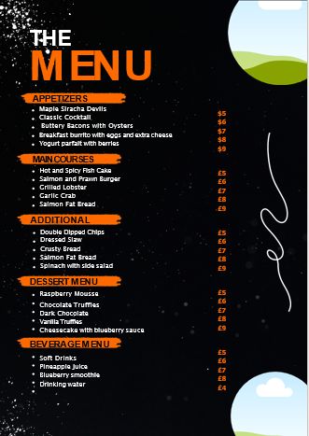
(Source – Author)

Conclusion
The above menu engineering assignment has discussed the business concept of the new restaurant Trinity Food Hub under Hotel Trinity. In this context, the travellers and working-class people of Salisbury, UK have been portrayed as the target audience due to their preference for seafood making it the main theme of the menu in this restaurant. Moreover, the special menu for the hotel launch event has been created too in this menu engineering assignment.

References
- Boussard, S (2021) Food and Beverage Management in the Luxury Hotel Industry. New York: Business Expert Press**
- Brown, D. R., TotalBoox and TBX (2013) The Restaurant Manager’s Handbook : How to Set Up, Operate, and Manage a Financially Successful Food Service Operation. 4th Edition. Atlantic Publishing Group*
- Cousins et al. (2011) Food and beverage management: For the hospitality, tourism and event.
- Foskett, D. et al. (2021) The Theory of Hospitality and Catering. 14th Edition. London: Hodder Education Group.* industries. 3rd ed. Oxford: Goodfellow.
- Walker, J (2017) Introduction to Hospitality. Harlow: Pearson Education Limited.*

