

Masters of Business Administration

The Influence of Sustainable Marketing Strategies on Consumer Trust and Purchase Intentions in the UK Fast-Food Industry
Dissertation - Proposal
Module code: LCMB7035

Student Name: Md Mahtabur Rahman Tarek
Student ID: 2504937
Submission Date: 31 July,2026
Lecturer Name: Jean Wang

Table of Contents
INTRODUCTION 2
RATIONAL OF THE STUDY 2
PROBLEM STATEMENT 3
AIM 3
RESEARCH OBJECTIVES 3
RESEARCH QUESTIONS 3
LITERATURE REVIEW 4
Sustainable Marketing Strategies in the Fast-Food Industry 4
Consumer Perceptions and Behavioural Responses 4
Research Gap 5
Conceptual Framework 5
Research Methodology 6
Research Onion 6
Primary Research 7
DATA COLLECTION AND ANALYSIS 7
DATA COLLECTION METHOD 8
RESEARCH ETHICS 9
RESOURCES AND PLANNING 9
REFERENCES 10

INTRODUCTION

The fast-food industry faces increasing pressure to adopt sustainable business and marketing practices as environmental concerns influence corporate strategies and consumer expectations. Sustainable marketing involves creating and communicating value while considering environmental, social and economic responsibilities, including sustainable sourcing, eco-friendly packaging, waste reduction and transparent communication (Kotler, Kartajaya and Setiawan, 2021). Within the fast-food sector, sustainability initiatives have become increasingly prominent, although their influence on consumer perceptions, trust and purchasing decisions remains uncertain. While consumers may respond positively to environmental initiatives, factors such as price, taste, quality and convenience can also influence purchasing decisions (Neacsu and Tulbure, 2023). Existing literature identifies several sustainable marketing dimensions, but further research is required to determine which strategies most significantly influence consumer responses in the UK fast-food industry. Consumer trust may also determine whether positive sustainability perceptions translate into purchase intentions (Martey et al., 2024). Therefore, this study will examine sustainable marketing strategies, consumer trust and purchase intentions within the UK fast-food industry.

RATIONAL OF THE STUDY

Sustainability has become an important priority for organisations across various industries as businesses increasingly integrate environmental and social responsibility into their marketing practices while creating value for customers (Kotler, Kartajaya and Setiawan, 2021). Growing public awareness of environmental issues has encouraged organisations to adopt initiatives such as sustainable sourcing, waste reduction, environmentally friendly packaging and transparent sustainability communication (Neacsu and Tulbure, 2023). However, implementing sustainable marketing strategies does not always result in favourable consumer responses, as purchasing decisions are often influenced by factors including price, quality, convenience and personal preferences. In addition, consumer trust plays a significant role in determining whether sustainability claims are viewed as credible and influence purchasing behaviour (Martey et al., 2024). Therefore, this study seeks to examine the relationship between sustainable marketing strategies, consumer trust and purchase intentions, contributing to both academic knowledge and practical business decision-making.

PROBLEM STATEMENT

The growing emphasis on environmental sustainability has encouraged fast-food companies to implement sustainable marketing strategies such as eco-friendly packaging, responsible sourcing, waste reduction and sustainability communication. However, the extent to which these initiatives influence consumer trust and purchase intentions remains uncertain, as purchasing decisions are also affected by factors such as price, taste, quality and convenience. While previous studies have explored sustainable marketing, there is still a need to identify the strategies most relevant to consumers in the UK fast-food industry and examine how they influence consumer trust and purchase intentions through a focused conceptual framework.

AIM
To examine how sustainable marketing strategies influence consumer purchase intentions in the UK fast-food industry, with particular focus on the role of consumer trust in sustainability claims and to assess its mediating effect in this relationship.

RESEARCH OBJECTIVES

- To identify and critically evaluate the sustainable marketing strategies most relevant to the UK fast-food industry based on existing literature.
- To examine UK fast-food consumers' perceptions of sustainable marketing strategies and their trust in sustainability-related claims.
- To investigate the influence of sustainable marketing strategies on consumers' purchase intentions in the UK fast-food industry.
- To assess whether consumer trust mediates the relationship between sustainable marketing strategies and consumer purchase intentions.

RESEARCH QUESTIONS
- What sustainable marketing strategies are most significant in influencing consumer responses within the UK fast-food industry?
- How do UK fast-food consumers perceive sustainable marketing strategies and sustainability-related claims?
- To what extent do sustainable marketing strategies influence consumer purchase intentions in the UK fast-food industry?
- Does consumer trust mediate the relationship between sustainable marketing strategies and consumer purchase intentions in the UK fast-food industry?

LITERATURE REVIEW

Sustainable Marketing Strategies in the Fast-Food Industry
Sustainable marketing has become increasingly important as businesses respond to environmental concerns, changing consumer expectations and pressure to demonstrate corporate responsibility. It incorporates environmental and social considerations into the creation, communication and delivery of value (Peattie and Belz, 2010). In the fast-food industry, sustainable strategies may include eco-friendly packaging, responsible sourcing, waste reduction, sustainable products and transparent communication. These initiatives can influence consumer perceptions of corporate responsibility. However, their effectiveness may depend on credibility and visibility. While green marketing can improve attitudes and purchase intentions, consumers still consider price, taste, quality and convenience (Neacşu and Tulbure, 2023). Therefore, this study examines selected strategies and their influence on consumer trust and purchase intention.
H1: Sustainable marketing strategies have a significant positive influence on consumer purchase intentions in the UK fast-food industry.

Consumer Perceptions and Behavioural Responses
Consumer perceptions significantly influence how sustainable marketing strategies are evaluated. Consumers may respond positively to companies demonstrating environmental and social responsibility, particularly when sustainability initiatives reflect their personal values and expectations. Green marketing can encourage favourable attitudes by communicating organisational commitment to environmental protection and responsible practices (Hermanto et al., 2024). However, positive sustainability attitudes do not necessarily result in purchase intentions, as consumers may prioritise price, convenience, taste and quality. The credibility of sustainability communication is therefore important. Genuine, transparent and evidence-based claims may strengthen positive perceptions, whereas exaggerated or misleading claims can create scepticism. Thus, sustainable marketing may influence purchase intention through consumer trust.
H2: Sustainable marketing strategies have a significant positive influence on consumer trust in sustainability claims.
Consumer Trust in Sustainable Marketing
Consumer trust is a central concept in sustainable marketing and differs from customer loyalty. It refers to consumers' perceptions that a company's sustainability claims and practices are credible, honest, reliable and genuine. Trust is particularly important because consumers may lack the information or expertise needed to verify environmental claims independently. Therefore, they often depend on perceptions of organisational credibility when evaluating sustainability information. Clear evidence of responsible sourcing, sustainable packaging and waste reduction may reduce uncertainty and strengthen trust. In contrast, vague or exaggerated claims may increase scepticism. Consequently, positive attitudes towards sustainability may not be sufficient to influence purchase intention unless consumers believe that sustainability claims made by fast-food companies are trustworthy.
H3: Consumer trust in sustainability claims has a significant positive influence on consumer purchase intentions.
H4: Consumer trust in sustainability claims significantly mediates the relationship between sustainable marketing strategies and consumer purchase intentions.

Research Gap
Existing research shows that sustainable and green marketing can influence consumer perceptions and behavioural intentions, but several gaps remain. Previous studies have examined strategies such as green products, sustainable packaging, promotion, responsible sourcing and waste reduction, yet limited clarity exists regarding which strategies most effectively develop consumer trust in the UK fast-food industry. Research has also focused more on green attitudes, purchase intentions and loyalty than on consumer trust in sustainability claims. Furthermore, the mediating role of trust between sustainable marketing and purchase intention remains insufficiently understood. Finally, findings from other industries and countries may not directly apply to UK fast-food consumers. This study addresses these gaps by examining these relationships in the UK context.

Conceptual Framework

Independent variables showed a connection towards dependent variables because fast food establishments practise sustainable packaging, responsible sourcing, waste reduction and sustainability communication. Customers identify and advocate for reusable packaging, shopping locally, controlling garbage and spreading sustainability (Neacşu and Tulbure, 2023).
Hermanto et al. (2024) found that sustainable marketing methods affect buying decisions. Green marketing increased the likelihood of buying green items among fast-food customers. Their study also found an indirect channel via green attitude, supporting the premise that the research should not assume sustainability activities lead to purchase intention without testing a mediating mechanism. For this reason, consumer trust is chosen over green attitude, because it is about whether or not individuals believe that sustainability promises are true, honest, trustworthy and real.
Martey et al. (2024) reported that green marketing increased fast food customer image and loyalty. This indicates that consumers’ actions are influenced by their view of the sustainability activities of an enterprise. Even though their technique did not specifically analyse customer trust, it enables analysing the consumer process. H1 displays the direct association between sustainable marketing strategies and buying intention. H2 indicates the relationship with customer trust. H3 indicates the relationship between consumer trust and buying intention. H4 indicates the indirect influence. The Theory of Planned Behaviour holds that intention drives behaviour (Ajzen, 2020). This is why purchasing intention is the major consequence.
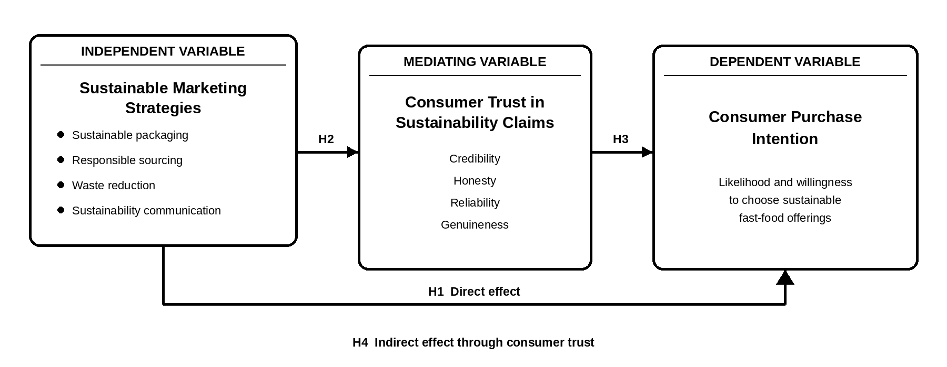
Figure 1: Proposed Conceptual Framework (Source: Author, 2026)

Research Methodology

The positivist approach has been employed in this study as sustainable marketing, consumer trust, and purchase plans are measurable. To test literature and conceptual framework assumptions against first-hand facts, a logical technique will be employed. The research will make use of a one-method quantitative cross-sectional survey. A questionnaire will be designed in Microsoft Forms. The objective of this approach is achieved through systematic measurement and comparison of the predicted associations of fast food consumers in the UK (Saunders et al., 2019).

Research Onion
The research onion framework provides a structured approach to designing and conducting research by guiding researchers through key methodological stages, including research philosophy, approach, strategy, methods, time horizon, and data analysis. This framework supports a systematic investigation of sustainable marketing strategies and consumer behaviour in the UK fast-food sector (Saunders et al.,2007). For this study, the selected layers are positivism, a deductive approach, a mono-method quantitative design, a survey strategy and a cross-sectional time horizon.
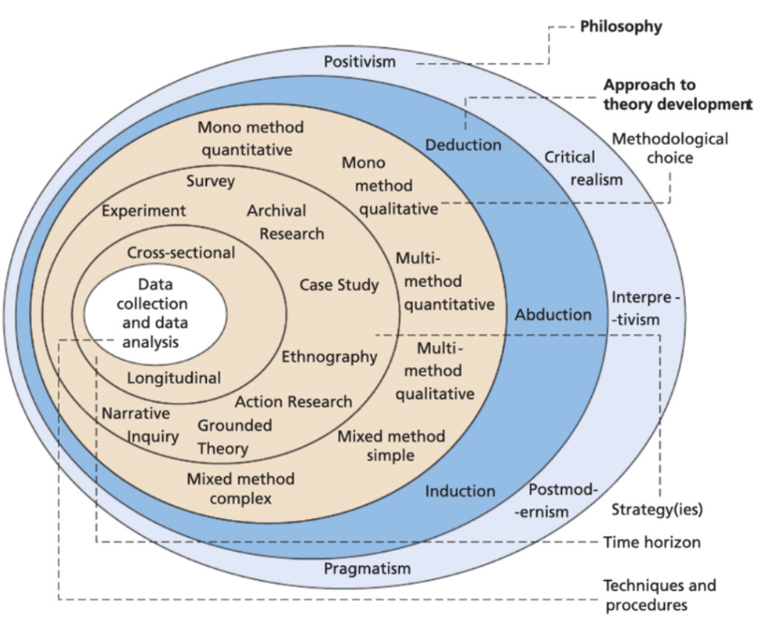

Figure 02: Research Onion (Saunders et al.,2007)

Primary Research
Primary research involves collecting original data directly from individuals or other relevant sources to address specific research objectives (Yin, 2018). In sustainable marketing research, primary data is essential for understanding consumers’ responses to sustainability initiatives and generating relevant insights. By collecting information directly from the target audience, organisations can better tailor their marketing strategies to consumer preferences. Various techniques can be used to gather primary data, with surveys being one of the most common methods. Accordingly, this study will collect primary data through a structured survey questionnaire.

DATA COLLECTION AND ANALYSIS
Sampling
Sampling can be described as the method of choosing a portion of individuals or objects from a broader population to draw conclusions or generalise about the population as a whole, utilising the characteristics of the selected sample (Saunders et al, 2019).
Sample Size
This research will involve a sample size of 100 individuals, possessing diverse backgrounds, who are consumers of UK’s fast food industry and have purchased within the past six months. McDonald’s will serve only as the contextual setting for data collection, while the study examines the wider UK fast-food industry.
Sample Type
Sampling is an essential research technique that entails the selection of a smaller group of individuals or entities from a larger population for the purpose of study. Researchers may employ sampling methods to align the demographic makeup of their sample with that of the population they are studying, taking into consideration factors such as age, gender, income, and education. Likewise, in terms of geography, they may opt to select samples of individuals or entities based on their geographic position or proximity to specific areas of concern (Groves et al, 2009). Participants from both genders, between the ages of 18 and 60, who reside in the United Kingdom will be selected for the presented study on the influence of sustainable marketing strategies on consumer behaviour.
Sampling Method
The present study will employ convenience and snowball sampling methods. According to Saunders et al (2019), with convenience sampling, a sample is chosen based on the ease of access and availability of participants. Research findings can provide valuable insights into consumer behaviour, although this method may limit generalisability to the broader population. Alternatively, snowball sampling is a methodology in which existing participants recruit additional participants from their networks. This technique proves to be advantageous in cases where accessing specific consumer groups is challenging or when researching niche populations with specific characteristics.

DATA COLLECTION METHOD
The data will be collected using an online questionnaire created with Microsoft Forms. The questionnaire will be shared through social media, email, and messaging apps. It will include 15-20 closed-ended questions about participants' background, views on sustainability, trust in sustainability claims, and buying intentions. Responses will use a five-point Likert scale. The survey will take about 5–10 minutes to complete, and it will be tested with a small group before the main data collection over four weeks. Microsoft Forms will ensure consistent presentation of the survey items and support anonymous, efficient collection of the 100 responses.
Data Analysis
The collected quantitative data will be analysed using Microsoft Excel. Descriptive statistics, such as frequencies, percentages, and averages, will be used to summarise the findings. Simple correlation analysis may be used to examine relationships between key variables. Finally, the results will be presented using tables, bar charts, and pie charts to make the findings easy to understand and clearly show patterns and trends in the data.

RESEARCH ETHICS
Research ethics ensures the protection of participants' rights and welfare throughout the study (Saunders et al., 2023). This research will adhere to ethical guidelines by obtaining informed consent from all participants before data collection. Participants will be clearly informed about the study's purpose, their voluntary participation, and their right to withdraw at any time without penalty. All responses will remain anonymous and confidential, with no personal information collected. Data will be stored securely on a password-protected computer and used solely for academic purposes. The research will be conducted honestly and transparently, following the University of Wales Trinity Saint David's ethical approval procedures.

RESOURCES AND PLANNING

This research will require limited resources, including a laptop, internet access, Microsoft Forms for questionnaire distribution, and Microsoft Excel for data analysis. The study is expected to be completed over approximately four months, covering questionnaire design, data collection, data analysis, and report writing. Regular meetings with the supervisor will support progress and ensure academic quality. A Gantt chart will be used to plan and monitor the research timeline, helping to organise key activities and complete the project within the planned schedule (Geraldi & Lechter, 2012; Saunders et al., 2023).

Fig 03: Personal Gantt Chart (Self-Prepared,2026)

REFERENCES

Ajzen, I., 2020. The theory of planned behavior: Frequently asked questions. Human behavior and emerging technologies, 2(4), pp.314-324.
Arseculeratne, D. and Yazdanifard, R., 2014. How green marketing can create a sustainable competitive advantage for a business. International business research, 7(1), p.130.
Creswell, J.W. (2014) Research Design: Qualitative, Quantitative, and Mixed Methods Approaches. 4th edn. Thousand Oaks, CA: Sage Publications.
Dawson, C. (2017) Introduction to Research Methods: A Practical Guide for Anyone Undertaking a Research Project. 5th edn. London: Robinson.
Eneizan, B., 2016. Effects of green marketing strategy on the financial and non-financial performance of firms: A conceptual paper. Arabian Journal of Business and Management Review.
Geraldi, J. and Lechter, T. (2012) ‘Gantt charts revisited: A project management perspective’, International Journal of Managing Projects in Business, 5(4), pp. 578–594
Groves, R.M., Fowler, F.J., Couper, M.P., Lepkowski, J.M., Singer, E. and Tourangeau, R. (2009) Survey Methodology. 2nd edn. Hoboken, NJ: John Wiley & Sons.
Hermanto, H., Astuti, W., Sugito, P. and Triatmanto, B. (2024) 'Can green attitude complement the influence of green marketing on green purchase intention for fast food products?', Journal of Economics and Management, 46, pp. 584-612.
Kotler, P., Kartajaya, H. and Setiawan, I. (2021) Marketing 5.0: Technology for Humanity. Hoboken, NJ: John Wiley & Sons.
MARTEY, E.M., LARBI, R.R., SIAW, G.A. and ADDO, R.A., 2024. Green marketing orientation and sustainable practice in fast food vendor’s management in Ghana. Quantum Journal of Social Sciences and Humanities, 5(SI1), pp.154-166.
Menguc, B., Auh, S. and Ozanne, L., 2010. The interactive effect of internal and external factors on a proactive environmental strategy and its influence on a firm's performance. Journal of business ethics, 94(2), pp.279-298.
Neacşu, N.A. and Tulbure, A., 2023. Quality and sustainability strategies implemented by fast food restaurants. In Proceedings of the International Conference on Business Excellence (Vol. 17, No. 1, pp. 1559-1568). Bucharest University of Economic Studies.
Peattie, K. and Belz, F.M., 2010. Sustainability marketing—An innovative conception of marketing. Marketing Review St. Gallen, 27(5), pp.8-15.
Saunders, M., Lewis, P. and Thornhill, A. (2007) Research Methods for Business Students. 4th edn. Harlow: Pearson Education.
Saunders, M., Lewis, P. and Thornhill, A. (2019) Research Methods for Business Students. 8th edn. Harlow: Pearson Education.
Saunders, M., Lewis, P. and Thornhill, A. (2023) Research Methods for Business Students. 9th edn. Harlow: Pearson Education.
Solomon, M.R. (2020) Consumer Behavior: Buying, Having, and Being. 13th edn. Harlow: Pearson
Yin, R.K. (2018) Case Study Research and Applications: Design and Methods. 6th edn. SAGE Publications

