

Title: Assessment component 2:
Marketing Portfolio

Student Name:
Chiya Feyzullah

Student ID:
2208596
Module:
LCMB70024 Marketing Management

Name of Lecturer:
Ejike Udeogu (Birmingham)
Internal verifier:
Vasilios Tavlaridis Hoang Dang Nguyen

Portfolio Brand Development
Nokia Vitals Smartwatch
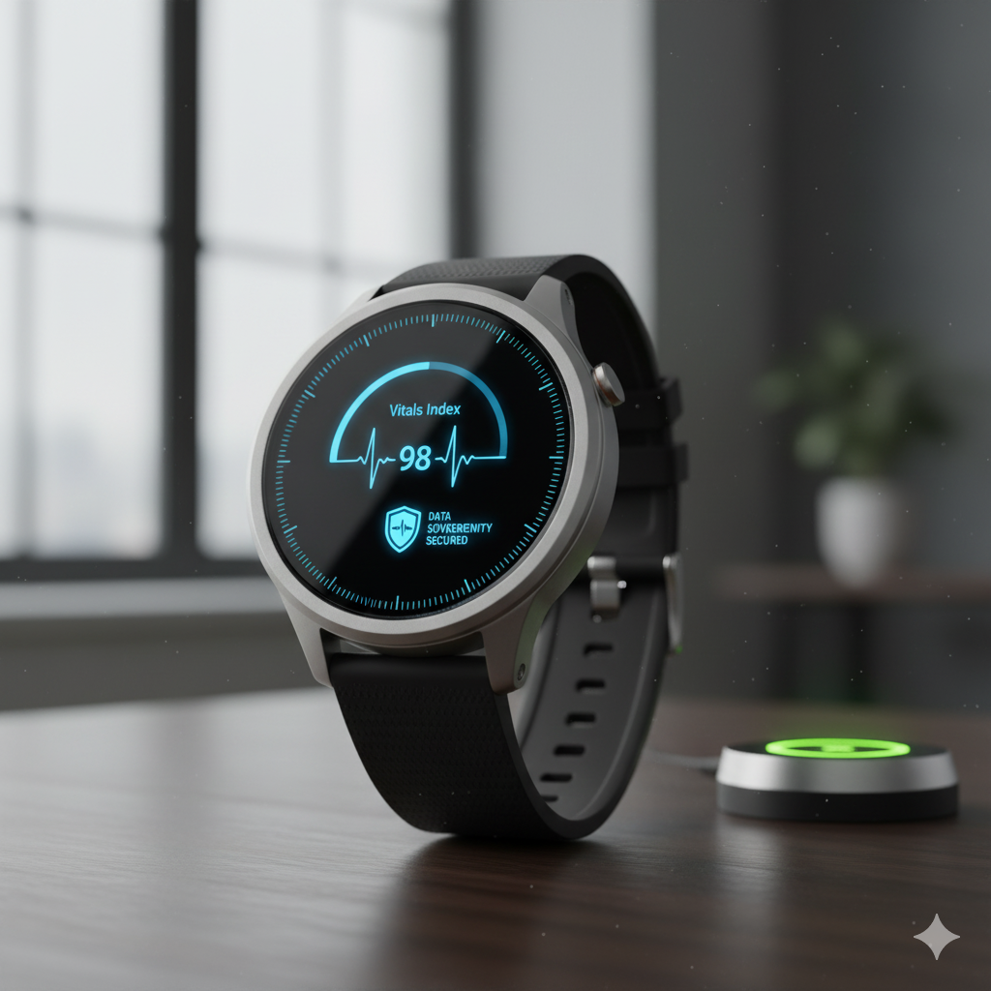

Contents
1. Nokia Vitals Segmentation, Targeting, Differentiation, and Positioning (STDP) Analysis 1
1.1 Introduction 1
1.2 New Brand Concept- Nokia Vitals 1
1.3 Segmentation Analysis 2
1.4 Targeting Analysis 2
1.5 Differentiation Analysis 3
1.6 Positioning Analysis 3
2. The Marketing Mix (4Ps) Analysis 4
2.1 Product 4
2.2 Price 5
2.3 Place (Distribution) 6
2.4 Promotion 7
3. The Marketing Strategy Pitch 9
4. Reflection 9
5. Conclusion 10
References 11
Appendix-I The Marketing Strategy Pitch 13

1. Nokia Vitals Segmentation, Targeting, Differentiation, and Positioning (STDP) Analysis

1.1 Introduction
Nokia, a name synonymous with unparalleled durability and reliability in the mobile phone industry, possesses a heritage of trust that few brands can match. Since Nokia 3310 is considered a classic and Nokia has made itself strong, user-friendly, and ethically responsible; the brand is considered a strong brand (NOKIA, 2025). However, nowadays, its market share has decreased significantly in favour of smartphone and wearable technologies. The proposed analysis suggests a strategic re-entry into the high-growing wearable market by launching a new sub-brand of the smartwatch: Nokia Vitals.

1.2 New Brand Concept- Nokia Vitals
The Nokia Vitals is based on the concept of a smartwatch that is aimed at the same purpose to track fitness, but it should also be a holistic, clinically oriented, and privacy oriented health and wellness platform (Hosseini et al., 2023). In a marketplace full of devices that are mostly focusing on lifestyle and connectivity, Nokia Vitals would use the brand trust as a primary positioning strategy in letting the brand be seen as a health guardian. The device would incorporate state-of-the-art biometric sensors such as ECG, SpO₂, stress, and sleep analytics into a user-friendly interface that would focus on charging data, long battery life, and, most importantly, data privacy and security, which is increasingly becoming a concern among consumers.
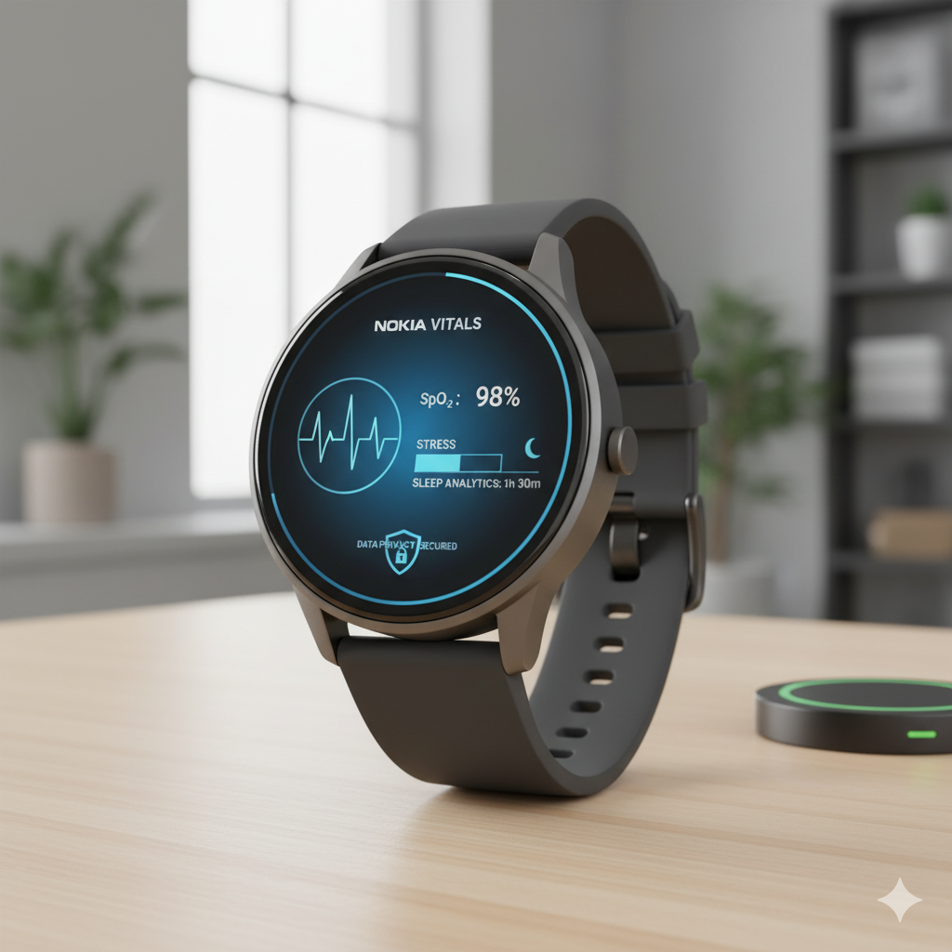
In line with the Trends and Consumer Behaviour. The Nokia Vitals brand offered is designed to take advantage of some of the strong emerging trends. The major force is the massive consumer behavioural change toward preventive health. According to Wareable (2025), in the modern context, health and fitness tracking is becoming a key buying decision for 83 per cent of consumers, who are no longer content with simple step counts: instead, they are expecting to receive features like ECG monitoring and improved sleep analytics.

1.3 Segmentation Analysis
The market of smartwatches can be divided by a variety of dimensions relevant to Nokia Vitals:
Demographic: Adults between the ages of 35-65 and with the existence of mid- to high-disposable income (Chandrasekaran, Sadiq T and Moustakas, 2025).
Psychographic: Healthconscious people, proactive patients, individuals with a family history of chronic diseases (e.g., hypertension, heart disease), and those who use technology and prioritise substance and reliability over fashion, thus enhancing health and wellbeing through Health Care Smartwatches (Almuwais, and H.Alharbi, 2022).
Behavioural: Customers who are interested in a long-term health tracker, The accuracy of data, the durability of the device, and privacy. They are poorly affected by the app ecosystem and better by fundamental health features.

1.4 Targeting Analysis
The explicit target of Nokia Vitals will be the Proactive Health Guardian. This is not the segment of high-profile athletes but is made up of average people who are highly committed to the management of their long-term health. Included in the typical demographics are ages 40-60, people with emerging health issues, or family history of cardiac or metabolic problems, and those whose responsibility increases because of their parents getting older (Zhang, K., et al., 2023). This group does not trust in the fast obsolete of technology and doubts the approach of big tech to personal data. They are not interested in notifications or music control: they want to invest in a health guardian. They appreciate clarity, precision and practical knowledge, like an exact ECG they are comfortable in telling a doctor about, or the result of a stress test that actually matches their physical condition.
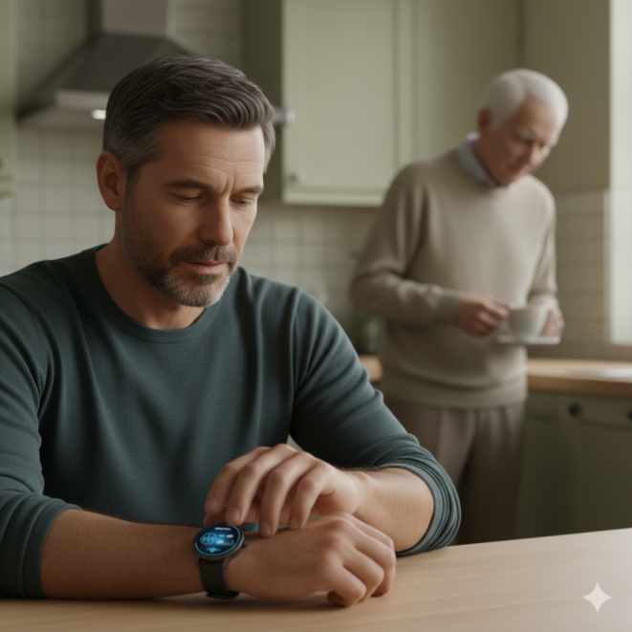
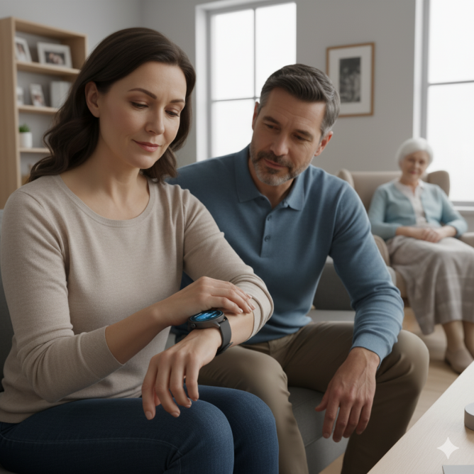

1.5 Differentiation Analysis
Nokia Vitals should position itself differently on a number of key dimensions to compete with the more senior players like Apple Watch and Fitbit:
Medically-Quality Accuracy and Ease: As much as the Apple Watch has FDA-approved functionalities, its interface may be complicated (Jena et al., 2025). Nokia Vitals will also distinguish itself based on its collaboration with health institutions to certify its sensors and introduce the information to users using an uncomplicated, intuitively designed interface, making it more medically friendly than complicated.
The Durability and Longevity Guarantee: Nokia Vitals will be promoted as a product with outstanding quality of construction, being waterproofed, and resistant to scratches (Nokia, 2017). Better still, it will ensure long term software support and security patches, which will oppose the proposed obsolescence in the industry.
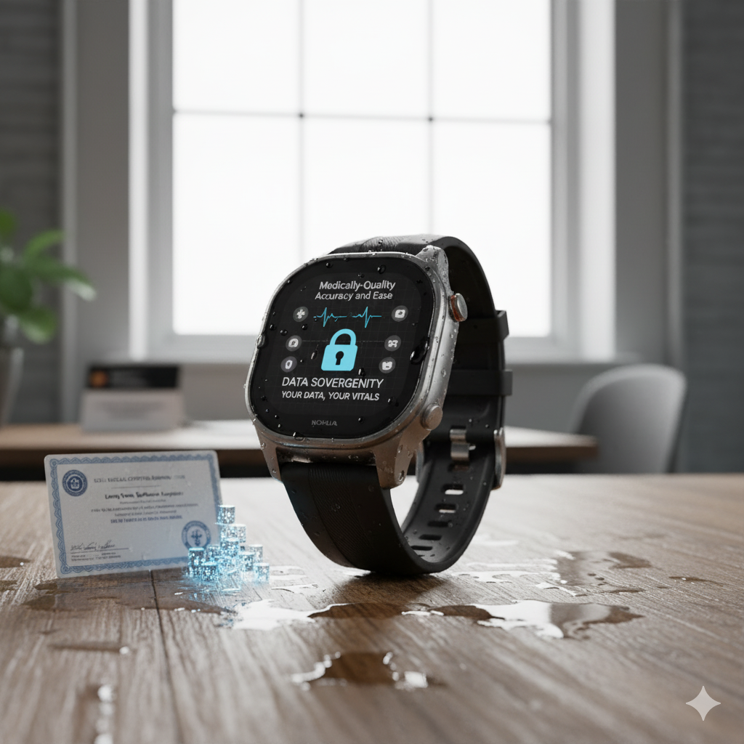
Extremist Privacy and Data Sovereignty: A fundamental point of distinction. Nokia will become a transparent company with a policy of Your Data, Your Vitals. Any health information shall be encapsulated end-to-end and data storage and sharing shall be controlled explicitly. Health data will not be used to advertise or be sold to third parties, and it will directly resolve a major issue that consumers have.

1.6 Positioning Analysis
The desired positioning for Nokia Vitals is "The Trusted Guardian for Your Long-Term Health" (Köhler, C., et al., 2024). This positions the brand as a serious, reliable, and private The positioning Nokia Vitals would like to have is The Trusted Guardian to Your Long-term Health (Kohler 0. C., et al., 2024). This makes the brand a sober, trusting and intimate companion in the health process of the user and not just a fashionable technological device. The perceptual map can be visualised to have two major axes, namely: Lifestyle Gadget vs Health Tool and Data-Exploitative vs Privacy-Focused.
Apple Watch is positioned in the Lifestyle Gadget category and is to some extent privacy focused but is a part of a larger ecosystem that takes advantage of user data (https://facebook.com/ParolaAnalytics, 2025).
Scores of Android watches in the lower tier are seen as lifestyle devices that are more data-exploitative. Niche medical devices are in the same category, only they are not smart (Health Tool). Nokia Vitals is intended to become the leader of the intersection of the categories of Health Tool and Privacy-Focused, which is not currently addressed by the leading brands. Marketing messages will always focus on the sense of trust, reliability, clinical cooperation, and respect to the user.

2. The Marketing Mix (4Ps) Analysis
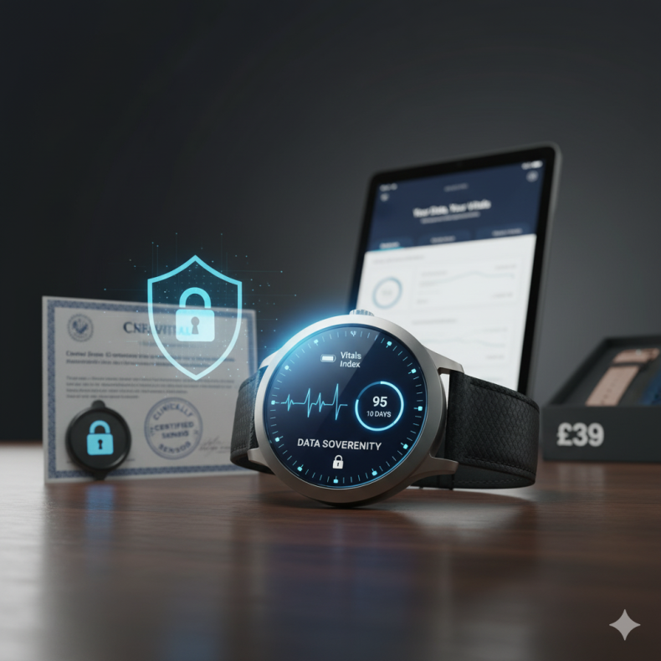
Marketing mix that Nokia Vitals has will be carefully designed to transform the STDP strategy into a concrete and convincing market presence.

2.1 Product
Kohler et al. (2024) argue that there are three essential functional areas that smartwatches can be used in: monitoring, nudging, and predicting. Nokia Vitals product is not just a smartwatch, it is a complete health assurance system. The product vision is a gadget with a simple device that has advanced software and services capable of delivering the promise of confident, long-term health tracking.
Core Product: Proactive health monitoring, and data sovereignty is the key advantage of peace of mind.
Actual Product (Device):
Design: The gadget is designed in a minimalist timeless way with brushed titanium and sapphire glass thus conveying the message of durability and classiness instead of trendiness. It will come in various sizes and replaceable bands (leather, recycled silicone) to suit the professional and casual environment.
Features & Technology:
Advanced Sensors: With more detailed physiological data, advanced sensors, such as medical-grade ECG, continuous SpO 2, skin-temperature sensing, and an optical heart-rate sensor (Jeeva, G., Mahalakshmi, P. and Thenmalar, S., 2025) are offered.
Proprietary Health Algorithms: Proprietary health algorithms also provide the Vitals Index, which is a composite measure comprising of sleep quality, stress, activity level, and heart rate variability metrics to reflect systemic readiness. Similarly, the battery life is one of the most important differences, and the estimated range is 7-10 days in one charge.
Augmented Product (Services & Software):
The Vitals app is a clean, ad-free and user-friendly mobile app that displays the data in clinically-inspired charts, including trends over time and practical information (e.g., Your resting heart rate has increased by 5 BPM in the past month). Think of talking to your doctor about this. Nokia Health Lock is a system bedrock that ensures the encryption of all health data in the device, and optional cloud backup to a personal, user-favoured vault (Islam, M., 2025). An easy-to-understand privacy dashboard also allows the user to view and manage exactly what is shared, and by doing so, the privacy promise of the brand is fulfilled.

2.2 Price
Nokia Vitals pricing strategy will be based on Premium Value Based Pricing model, which will demonstrate the high value perception of the clinical grade of reliability, data privacy, and durability. The retail price will range between PS349 and PS399, which will position it slightly higher than the mainstream pricing in the fitness bands (e.g. Fitbit Charge, around PS130) and at the same time, lower than the Apple Watch series (PS379-PS479+) but strategically.
Pricing Rationale:
Value based: The cost is supported by the differentiated value propositions: the data privacy, unmatched (Health Lock), software support on a long-term basis, and clinically tested sensors. Customers do not just buy hardware but they are putting money on trust and future.
Cost-Based: The increased price is justified by the use of superior material (sapphire glass, titanium) and a significant amount of expenditure on security systems and clinical validation (Chopra, G., Ahmed, S. & Gupta, S., 2025).
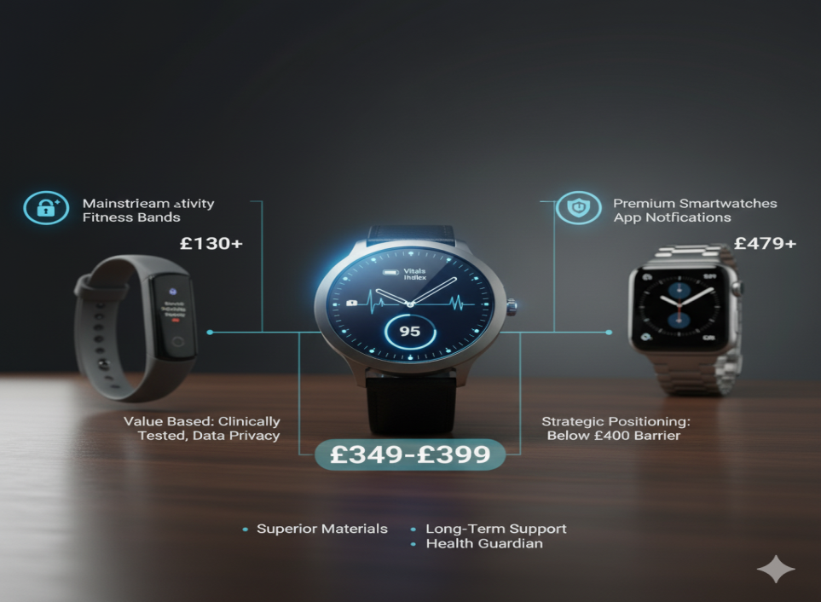
Psychological Pricing: The PS 349-PS 399 range will not go beyond the PS 400+ psychological barrier, leaving the product as a thoughtful, high-end investment, but not a crazy halo product.

2.3 Place (Distribution)
The distribution strategies of omnichannels have been driven by globalisation, technology and market expansion (Belu & Marinoiu, 2014). Therefore, the Nokia Vitals distribution strategy will utilise an Omni-Channel Selective Distribution model, which is intended to guarantee the accessibility and maintain a luxury brand experience.
Direct Channels:
Nokia.com/Vitals: is the main channel, where Nokia will be able to shape the narrative, develop a direct rapport with the customers, and present the functionality of the product and its privacy philosophy in their fullness. Product promotions such as pre-orders and special bundle packages will be introduced here.
Indirect Channels:
High quality electronics outlets such as Currys PC world and John Lewises in the UK have trained personnel who have the capability of informing the technical and health benefits of the device effectively. The opportunities to offer the watch with data plans to its connectivity capabilities are provided through the selected mobile network operators (MNOs) e.g., EE or Vodafone, hence, accessing their customer base. Specialised health and wellness retailers Boots or Holland & Barrett offer strategic partnerships, so that Nokia Vitals will be placed in the context of health, directly at the Proactive Health Guardian in their wellness shopping process (Miao, Wu and Yang, 2023). There is a possibility of in-store kiosks that are manned by certified product specialists. This discriminatory strategy prevents dilution in supermarkets or discount electronic shops, so that the product will be on hand where the targeted group are making purchases, online to make it convenient and in the real world where the premium construction can be tried and advice will be given by the experts.
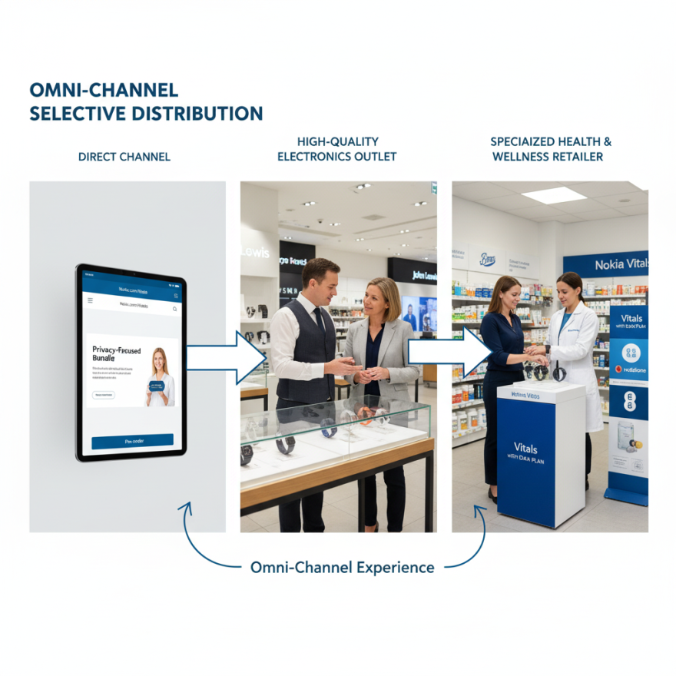

2.4 Promotion
Content marketing has become a key to the product promotion (Quinn, C., 2025). There will be a special blog and a video series called Nokia Vitals Journal, articles are to be written by cardiologists, sleep scientists and fitness experts on issues like Understanding Your Ecg Reading and The Connexion between Sleep and Heart Health. This makes Nokia an authority and the organic search traffic is drawn to the company by health-conscious consumers. Without needing to mention, the collaboration may be initiated with medical institutions (e.g., British Heart Foundation) to conduct research or awareness campaign and give third-party confirmation and support the clinically based positioning. Public Relations campaign will focus on the privacy aspect of Health Lock and this will create news to the media including The Guardian, Wired, and Wareable (Djakeli, K., 2024).
Digital Advertising: Digital advertisement will capitalize on highly targeted LinkedIn and Facebook campaigns that target people aged forty years and above that show interest in health insurance, preventive medicine, and certain medical conditions. The aesthetic content will be creative following a clean, information-oriented vision, preempting the product distinction like a long battery life and strong privacy protection.
Influencer Marketing: Influencer marketing will seek partnerships with influencers of senior-age and respected medical experts on YouTube, avoiding traditional technology reviewers, to deliver authoritative and familiar testimonials.
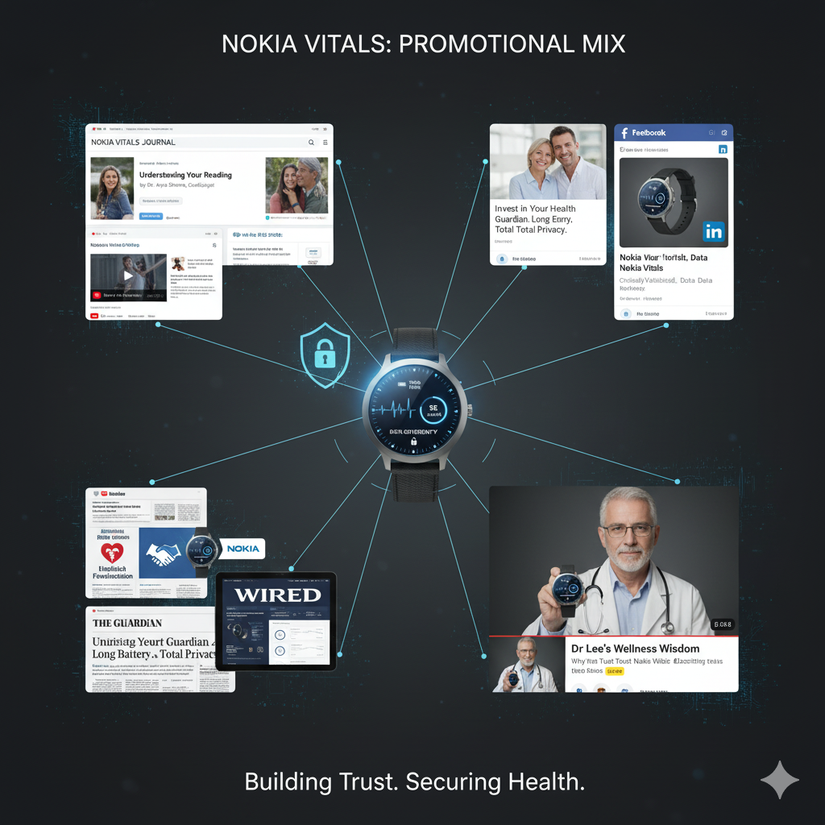
This form of promotional mix has always relayed the essence of strategic message of the STDP framework, informed the intended audience and created confidence, as opposed to simply promoting a consumer device.

3. The Marketing Strategy Pitch
The strategic marketing pitch is presented in appendix-I. Smart watch market is saturated with gadgets that are focused on lifestyle and connections. Nevertheless, a large and growing group of consumers, the so-called Proactive Health Guardians, also show desire to have a long-term wellness companion. Nokia Vitals is the answer to this desire, but it will not be a device, but rather a part of a vital health guaranteeing product.
The Segmentation, Targeting and Positioning analysis has found the core to be the adult segment between the ages forty and sixty who actively take care of their health, usually in reaction to the growing health issues in their lives or in their families. These people are sceptical of the obsolescence and data culture of mainstream technology brands that are obsolescent at such a rapid rate. Thus, Nokia Vitals is branded the Reliable Protector of Your Long-term Health, which is supported by all the marketing mix elements. The 7-P marketing mix will achieve this promise. The product also brings on board medical-grade sensors, seven-day battery life, and a durable design, but substantive values are the augmented Vitals application and the new Nokia Health Lock service, which ensures end-to-end encryption and leaves responsibility of sensitive health information with users.

4. Reflection
The creation of a brand concept and marketing strategy to be used by Nokia Vitals was a deep integration of the theoretical marketing models and strategic and real world implementation. The exercise was beyond the abstract learning and it faced the reality in building up a coherent and powerful market offering at the base level. One key lesson was the need to understand that a customer-centered base is the essential factor. This first STDP analysis was not just a form of exercise but the fundamental framework over which all other decisions were based. Each component of the marketing mix could be purposefully aligned by initially defining the 'Proactive Health Guardian' and stating their essential requirements namely trust, accuracy and privacy. Examples include the premium pricing strategy and the Health Lock feature that were a direct conversion of the psychographic profile of the target customers, as opposed to the design decisions being random. This experience strengthened my understanding that strong, intuitive positioning statement is used as the guide in all tactical marketing processes. The ability to simplify complicated information into a compelling story was also refined during the process of writing the marketing strategy pitch and presentation of the proposal. The issue was to reduce a 1000-word plan, with a lot of detail, to a brief one-hundred and eighty-word pitch that retained its strategic core. To achieve success, it was necessary to identify and prioritise the most impressive value propositions, namely, clinical-grade features and data privacy, and to contextualise them in the context of documented trends in the market (Wareable, 2025; Statista, 2024). The experience underscored that an effective pitch is not a mere enumeration of features, but a cogent argument that links a validated market need to a unique and credible solution. In future undertakings, I will improve on it by using more stringent financial modelling and contingency planning. Although the strategy outlined a pricing and promotional strategy, a closer examination of the unit economics, break even, and clear budget of the intended marketing efforts will further reinforce the viability of the strategy. Moreover, performing a pitch in front of a non-specialist audience would be absolutely essential in enhancing my capacity to explain complex concepts clearly and effectively to ensure that the strategy would not appear one-sided. This, in the end, was key in the process of making the marketing theory a practical and practical business plan.

5. Conclusion
This study has clearly shown that the Nokia Vitals smartwatch could be a viable product in the market as a new entry. With the legacy of trust Nokia has built over the years and taking direct measures to meet the unmet needs of the unnamed market opportunity, the brand is positioned in an excellent place to win over a rich market segment. The overall STDP analysis provided a solid base of a differentiated positioning of trusted guardian, which was translated into the actual marketing mix where each decision- making (product features to advertising messages) supported the main idea of clinical-grade insight, superior durability and uncompromising data privacy. The plan presents a powerful, consumer-focused roadmap Nokia should take to redefine itself as a relevant and powerful player in the wearable technology industry.

References
- Almuwais, N. and H. Alharbi, Z. (2022). The Effectiveness of Wearable Devices on the Users’ Health: The Case of Saudi Arabia. SAR Journal - Science and Research, pp.149–158. doi:https://doi.org/10.18421/sar53-06.
- Chandrasekaran, R., Sadiq T, M. and Moustakas, E. (2025). Usage Trends and Data Sharing Practices of Healthcare Wearable Devices Among US Adults: Cross-Sectional Study. Journal of Medical Internet Research, [online] 27. doi:https://doi.org/10.2196/63879.
- CHOPRA, G., AHMED, S. and GUPTA, S., 2025. Smart Patient Monitoring using Wearable Devices: Applications and Future Scope. Driving Innovation through AI and Digital Twin for 6G Powered Sustainable Ultra Smart Cities, pp.211-236.
- Djakeli, K., 2024. Healthcare marketing, meaning, historical development, applications, and current status. In Modern Healthcare Marketing in the Digital Era (pp. 1-25). IGI Global Scientific Publishing.
- Hosseini, M.M., Hosseini, S.T.M., Qayumi, K., Hosseinzadeh, S. and Tabar, S.S.S. (2023). Smartwatches in Healthcare medicine: Assistance and monitoring; a Scoping Review. BMC Medical Informatics and Decision Making, 23(1), p.248. doi:https://doi.org/10.1186/s12911-023-02350-w.
- https://facebook.com/ParolaAnalytics (2025). From 0 to 10: Apple Watch’s evolution through the patent lens - Parola Analytics. [online] Parola Analytics. Available at: https://parolaanalytics.com/blog/apple-watch-series-patents/ [Accessed 13 Nov. 2025].
- Islam, M., 2025. Healthcare on the Move: The Evolution and Future of Wearable Health Tech. In Remote Monitoring and Wearable Devices in Healthcare (pp. 187-207). Cham: Springer Nature Switzerland.
- Jena, N., Singh, P., Chandramohan, D., Garapati, H.N., Gummadi, J., Mylavarapu, M., Shaik, B.F., Nanjundappa, A., Apala, D.R., Toquica, C. and Lapsiwala, B., 2025. Wearable Technology in Cardiology: Advancements, Applications, and Future Prospects. Reviews in Cardiovascular Medicine, 26(6), p.39025.
- Jeeva, G., Mahalakshmi, P. and Thenmalar, S., 2025. Advancements in Smart Sensor Technology for Enhanced Health Monitoring in Smart Watches. Advanced Computing Solutions for Healthcare, pp.88-105.
- King, B., Lark, A., Lightman, A. and Rangaswami, J.P., 2016. Augmented: Life in the smart lane. Marshall Cavendish International Asia Pte Ltd.
- Köhler, C., Bartschke, A., Fürstenau, D., Schaaf, T. and Salgado-Baez, E. (2024). The value of smartwatches in the healthcare sector: Monitoring, nudging, and predicting (Preprint). Journal of Medical Internet Research, [online] 26(39356287). doi:https://doi.org/10.2196/58936.
- Köhler, C., Bartschke, A., Fürstenau, D., Schaaf, T. and Salgado-Baez, E., 2024. The value of smartwatches in the health care sector for monitoring, nudging, and predicting: Viewpoint on 25 years of research. Journal of Medical Internet Research, 26, p.e58936.
- Mihaela Belu and Marinoiu, A. (2014). A new distribution strategy: The omnichannel strategy. [online] XVII(52), pp.117–134. Available at: https://www.researchgate.net/publication/388830993_A_new_distribution_strategy_The_omnichannel_strategy.
- Miao, X., Wu, Y. and Yang, Z. (2023). From Rise to Fall: A Study of Nokia’s Strategic Partnerships and Market Positioning. Advances in Economics Management and Political Sciences, 49(1), pp.312–318. doi:https://doi.org/10.54254/2754-1169/49/20230535.
- NOKIA (2024). We are Nokia | Nokia. [online] Nokia. Available at: https://www.nokia.com/we-are-nokia/.
- Nokia (2017). Transforming Today for Tomorrow: Nokia innovations in health, virtual reality, and phones. [online] YouTube. Available at: https://www.youtube.com/watch?v=hrRSjYZgLi4 [Accessed 13 Nov. 2025].
- MobiHealthNews (2024). Fitbit's focus on wellness scores and patient-generated health data. [online] Available at: https://www.mobihealthnews.com/ [Accessed 20 October 2025].
- Quinn, C., 2025. The Future of Digital Marketing for Medical Practices. In The Digital Practice: Proven Marketing Tactics for Today’s Physician (pp. 195-210). Cham: Springer Nature Switzerland.
- Statista (2024). Share of consumers who consider health and fitness tracking features an important smartwatch function worldwide from 2021 to 2025. [online] Available at: https://www.statista.com/forecasts/ [Accessed 21 October 2025].
- The Verge (2023). How the Apple Watch changed the world. [online] Available at: https://www.theverge.com/ [Accessed 21 October 2025].
- Wareable (2025). The best smartwatch 2025: Reviews and buying advice. [online] Available at: https://www.wareable.com/smartwatches/best-smartwatch-reviews-compared-8286 [Accessed 21 October 2025].
- Zhang, K., Ma, Y., Luo, Y., Song, Y., Xiong, G., Ma, Y., Sun, X. and Kan, C., 2023. Metabolic diseases and healthy aging: identifying environmental and behavioral risk factors and promoting public health. Frontiers in public health, 11, p.1253506.

Appendix-I The Marketing Strategy Pitch



