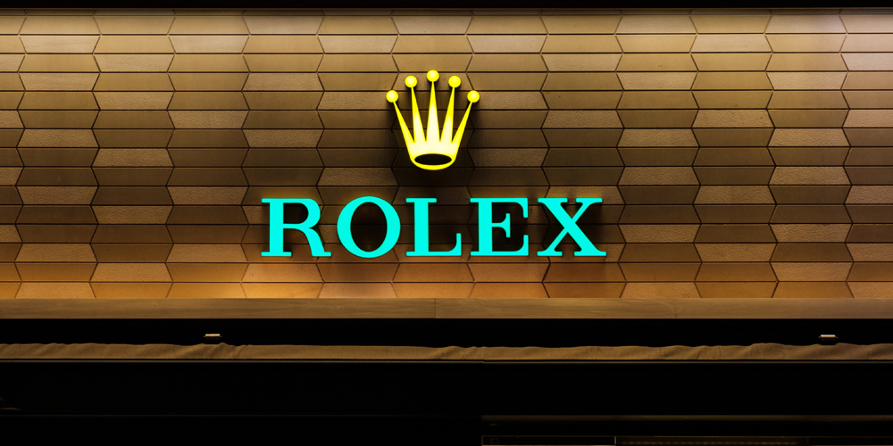

India and UK - passion for luxury

by Ionela Madalina Saiz

Student id: 1605699
Course: International Marketing (LCMB7006)
Lecturer: Tushara Balendran

April 2021

Table of Contents
I. Introduction 3
Background of Rolex Brand in UK and India 4
II. Forces of the Macro Environment 6
Culture Dimension Model of Hofstede 7
III. SWOT Analysis of Rolex Brand 12
The advantages of Swot analysis 15
The disadvantages of Swot analysis 15
IV. Market Segment Strategy (STP Model) 15
Brand perception – Brand loyalty 17
V. Rolex Market Mix Strategy 18
VI. BCG Matrix 22
VII. Rolex Product Life Cycle 24
VIII. Recommendations 25
IX. Conclusion 26
References 27

Introduction
International marketing is the need of a fast-moving world of innovation and technology. Global marketing is the principal deal with the strategies necessary to run a business in different parts of the world. Marketing on a worldwide scale has different reconciliation strategies like operational differences, similarities, and opportunities at large extend for international growth. No doubt, international marketing provides a high standard of living, ensures rational and optimum utilization of resources, facilities culture exchange, better utilization of surplus production, enhances the foreign exchange, and become the basis of creation of harmony and peace among different nations of the world (Samee, 2020).

Different ways are required to improve international marketing strategies involves the research of new territories, focus of opportunities areas, occasionally checking of prices of the product and services in comparison with the competitors, learning of local customs and adjustment of marketing media mix plays important role in the success of international marketing. Some factors are of immense importance are tariff barriers, political instability, culture diversity, variation in exchange rates, ethical challenges, terrorist, and racism. Some barriers like language, cultural diversity, servicing customers, and intellectual property theft must be kept under consideration while doing international business (Rana, 2020).

International marketing depends highly upon export research, planning, and expansion of international business from a broad perspective. In this report, the Marketing strategies used in the sale of Rolex in the UK and India will be elaborated with a wide vision, and the impact of various forces must be kept under consideration for improving strategies for enhancing future sales. The report also emphasis on the similarities, difference, and opportunities the brand has in different countries due to difference of geographical, political and cultural values and perspectives.

Background of Rolex Brand in UK and India

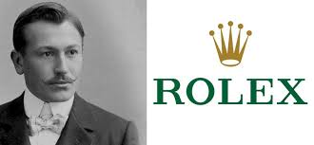
Figure 1: Hans Wilsdorf Rolex Founder
Source: (Gisbert Brunner,2017)

Rolex’s story began in 1905, when its founder Hans Wilsdorf at the age of 24 years started a company in London in distributing the timepieces known for their reliability and elegant factor. Hans Wilsdorf created the first waterproof wristwatch “the Oyster” and developed it into a range of timepieces that have become icons of watch making. According to the latest statistics Rolex Company introduce 700,000 mechanical chronometers in the world. The annual turnover of the company is USD 4.7 billion and about 2800 people are associated with the great luxury item brand (Uggla, 2020).
According to one research of 2011, luxury products have increased the global sales volume by over one trillion. Many rich people have excess to buy luxuries items and this reason has increased the demand for the luxury’s products. Rolex is a Swiss luxury watch and its manufacturing unit is in Geneva Switzerland. The company registered its name as Rolex as a brand name in 1908 and become Rolex Co.Ltd.in 1915.
It is considered one of the prestigious watch brands in the market. Celebrates are highly attracted to this unique and high-quality brand. Rolex is a brand known for its durability and robustness. No doubt, the brand is presenting an incremental and aesthetic design with innovations. The brand is known for providing strict adherence for decades.
The brand was previously produced in the UK. The heavy tax moves the production towards Geneva Switzerland. The retail demand for Rolex watches is too high in the UK. The opportunity of employment in Rolex increased due to its high demand and reduces employment rate in the hotel, stores, and tourism sector.
At present, people in the UK are more indulging in buying luxury items especially watches instead of tourism activities. The buying capability and value of Rolex watches are increasing day by day due to the strengthening of GBP with time. People finding the price of Rolex cheaper in the UK compared to other countries of the World. One can find the cheapest Rolex watch in the UK at the price range of 3000 to 4000 pounds.
According to the statistics, instead of Covid-19 during the start of 2020, the demand for the Rolex watch is better in the UK. The company is holding the best retailer activities in the UK and expected the forecast sales value of 900 to 925 billion pounds in 2020, highly surprising by knowing the actual demand for the luxury product in the market share.
The demand anticipated in the last Christmas holiday period and the stock rose to 10%. The Rolex watches are resold, and, in this way, many people earn great profit by using this strategy. The Rolex Sportswear is in great demand in the UK due to its unique features that provide ease of use in technology during exercising and warming up give attraction towards this durable and reliable luxury item.
The companies of watches knew the high demand of watches and invested in huge volume in this sector to enhance its potential in the positive mean in the market. The forecasted demand for Rolex in India shows a rise of 20.3% till 2025. The people in India are highly focused on luxury items especially watch. Although the prices of watches are high in India instead of the UK due to the sports, fitness, and heath sensors adaption provides people addicted to the use of these luxuries in an effective way. According to the survey, it has been disclosed people aged 18 -25 are more attracted to sports and fitness watches. Another study revealed that ladies are more conscious about watch selection in India comparatively gents. Lower-priced to mid-priced watches are in high demand in India. People in India are buying watches online as well as offline platforms.
One research was conducted in 2017 regarding the pricing of Rolex in comparison in the UK and India. It is revealed that the luxury brand is less expensive while buying from the UK than in India. The reason is no tax implementation on luxury items in the UK as well as Brexit causes the price reduction with pounds value increase. People of India are attracted to highly lucrative and technology-based watches. The market strategies of Rolex have shown potential growth from the forecasted figures. The important market strategy involves the innovation of watches, improvement of distribution channels, and the branding of watches through the platform of social media (Sengabira, 2020).

Forces of the Macro Environment

The business is not alone in its environment and surrounded by various forces which are responsible for the growth and decline of any company at large and collectively these forces are known as “Macro Environment” by marketing and strategic planning professionals. No doubt, these forces create a positive as well as a negative impact on the Rolex business values in countries UK and India based on how they are approach and handled. One can create great business opportunities by understanding and implementing these forces correctly towards business growth (Jelassi, 2020).

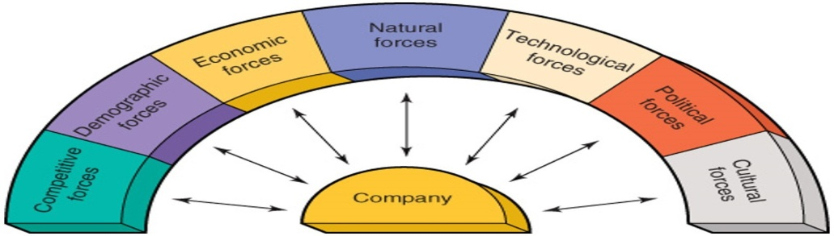
Figure 4: Forces of Macro Environment
Sources: (Jelassi, 2020)
It is important to have brief look at each of the macro-environment force's impact on company growth in different countries. The seven forces that are impacting the business towards opportunities and threats are as follows:
It is related to all the competitors working towards the same niche and all firms within the market niche are striving to increase market share, profit, and revenue effectively. Both UK and India are big business markets and are surrounded by many competitive forces. Rolex-sounding competitors in India are Titan, Swatch, and Timex. Similarly, in the UK, the various competitive watches are available in fronting Rolex includes Graham, Farer, Rover Smith, and Omega are some of them. While visualizing the competitive forces that affect direct, indirect, and substitute product competitors must be kept under consideration(Isabelle, 2020).
Rolex Cultural Forces
It defines the culture and moral values of the people living in the specific territory. The cultural values of the UK are quite different than those of India. For instance, in UK, cultural forces are favourable, Rolex is precepted as the image of wealthiness, superiority and prestige. The cultural forces for India are unfavourable, the behaviour of the costumer is shaped by their religion. The selection criteria of watches are quite different in both countries. Rolex Company offers different designs and features in UK and India according to the consumer need and choice.

Culture Dimension Model of Hofstede
The culture dimension model of Hofstede defines the culture force's impact on the environment. This model relates the different country's cultural values of 6 dimensions based on the values of its members (Jackson, 2020).
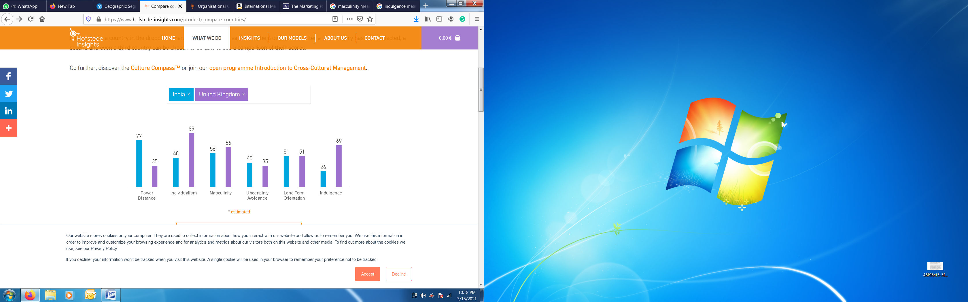
Figure 3: Culture Dimension Model of Hofstede
Source: (hofstede-insights.com, 2021)

- Power Distance
It measures the culture view power between people(Dhaundiyal, 2020).Also states that power should be equally distributed among all people living in the common society. The thing should be kept under consideration that different countries offering different power distances to their individuals. The score of the UK in the PDI is 35, which emphasizes that less imbalance present in the society and centralization of power among the individuals living as a community. In contrast, the score of India is high in the PDI is 77 which determines the great power distance is present in the society and power is not centralized (hofstede-insights.com, 2021). Organizing is the key element for the people of India to run uniformity among the civilians for the long run (Dhaundiyal, 2020).
- Masculinity
Masculinity also plays an important role in the marketing placement of any brand country-wise (Adam‐Troian, 2020). The masculinity PDI value in India is 56 which show success-driven compared to UK who is more towards masculinity and Its PDI value is 66 (hofstede-insights.com, 2021).
- Uncertainty Avoidance
It states that how many risky activities are avoided by different countries (Yang, 2021). The India PDI value is 40 which shows that they workout less regarding risk management compared to the UK. The PDI value for the UK is 35 which show that highly focused on doing various activities regarding risk management (hofstede-insights.com, 2021).
- Long Term Orientation
It states a person's basic attitude, beliefs, or feelings concerning a particular perspective or subject (He, 2020). The PDI value of India is 51 and similar is observed in the UK. The orientation PDI value defines the operating level in both countries (hofstede-insights.com, 2021).
- Indulgence
It states one's desire towards goals (Purevdorj, 2020). The PDI value of indulgence in India is 26 which show less motivation towards goals. The indulgence PDI value of the UK is 69 and it is quite high compared to India and showing a more active role of individuals towards the desirable attributes and goals (hofstede-insights.com, 2021).
- Individualism
It states the independency of a person towards performing any task (Zheng, 2021). The PDI value of individualism in India is 48 which is very less showing the independency is not too high in the country. On the contrary, the PDI value of individualism in UK is 89 means great independency and freedom is present among people to work and express them according to their own desires (hofstede-insights.com, 2021).
- Demographic Forces
It determines the population based on age, sex, gender, and race. India is considered the second largest populated country with a population of 1366 billion according to the statistics of 2019. The UK population is 66.65 million and comparatively varies less than India. The people's preference and need for watches are more in India compared to the UK. A large majority of people residing in India making a great number of consumers for the Rolex brand and therefore the demand for watches will be high in India. Business expansion is needed for fulfilling increasing population needs. India has the largest population, resulting a higher power of buyers and UK consumers are driven by value and their ego needs. Resulting demographic forces favourable for both countries.

Rolex Economic Forces
It defines the consumer purchasing power and also the stability of the business. Rate of inflation, level of interest rates, stock market trends, tax policies, and the fiscal policies of the federal government are the key factors keep in consideration during viewing the impact of the economic forces on business. The UK economic condition is unstable and fluctuating with time. The economic forces for UK are unfavourable for the moment, with Brexit changes, people think twice before purchasing a high value product. India is showing high growth towards GDP in recent years, resulting a favourable economic force.

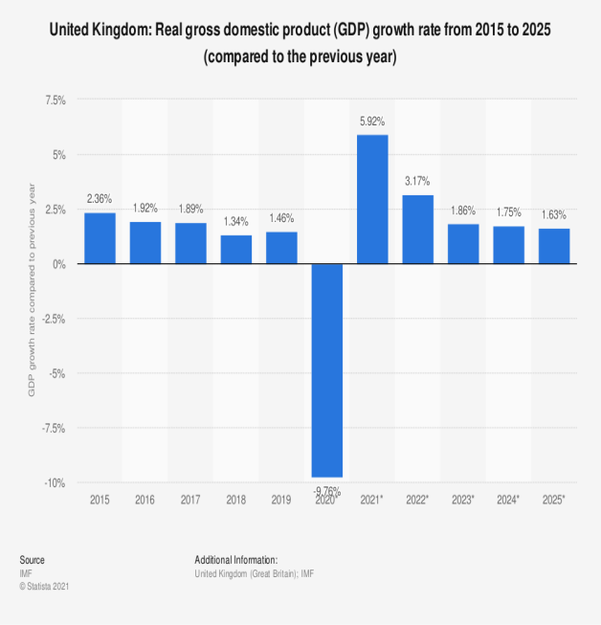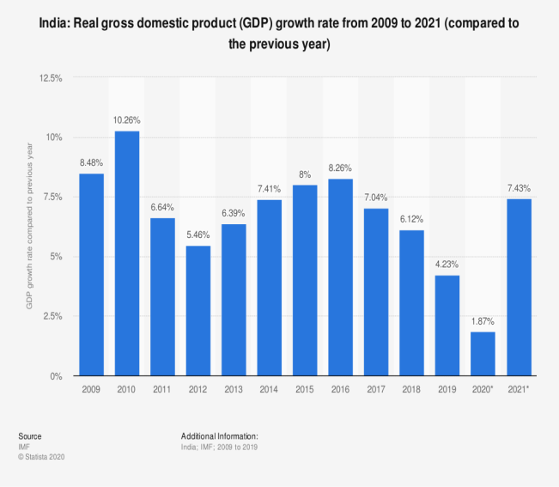
Figure 4: UK GDP Growth Rate (2015 to 2025) and India GDP Growth Rate (2019-2021)
Sources: (H. Plecher, 2020 &2021)

Rolex Natural Forces
It also impacts the business growth since the usage of natural resources is becoming an integral part of any production line proceedings. India is more sounding in natural resources compare to the UK. The impact of natural forces includes the shortage of natural and renewable resources and higher authorities of each country are very much concerned regarding this issue. Since this factor is playing a great role in the business growth of any country. The lack of resources and increased production cost of Rolex watch manufacturing move to Switzerland from the UK. Thus, UK has unfavourable natural forces. India is importing Rolex instead of manufacturing due to the lack of production lines over there. Despite the fact that India has favourable natural forces, they are not producing the watches.
Rolex Political Forces
It defines the political impacts on the growth of the product and services largely. The UK economy is highly unstable for the last 5 years due to Brexit as well as trade wars are creating great hurdles for the business growth of Rolex. The trade policies of the European Union during the period of 2017 to 2019 created a great negative impact on luxury product business growth along with essential domestic items. Political risk and uncertainties decrease business growth in any country. Resulting for UK, unfavourable political forces. India on the other hand face a political stability and its economic growth drive people to spend more on luxury products. Thus, India has a favourable political force.

Rolex Technological Forces
It defines the country's growth by creating new strategies towards innovation and the advancement of technology. The UK and India both are growing continuously in the innovation of technology, so both have favourable technological forces. The UK technology industry is worth over 184 billion pounds and growing rapidly and a similar case is observed in India, the global digital talent is growing rapidly and reaches up to 75% global digital talent of the world. India's digital growth is expected to reach up to 350 billion dollars in 2025. The Rolex brand watches business will positively be impacted in India and UK due to technology advancement in both countries.
Porter’s five forces
The significant marketing framework determining the present scenario of the business and analysis the competitors present in the market. It also provides guidelines regarding improvement strategies towards future growth. This model deals with five forces that include competitive rivalry, power of suppliers, power of customers, threats of substitute products, and the threat of new entrants. The level of forces Rolex must deal with while carrying out its operations in UK and India are demonstrated below (Khurram, 2020):
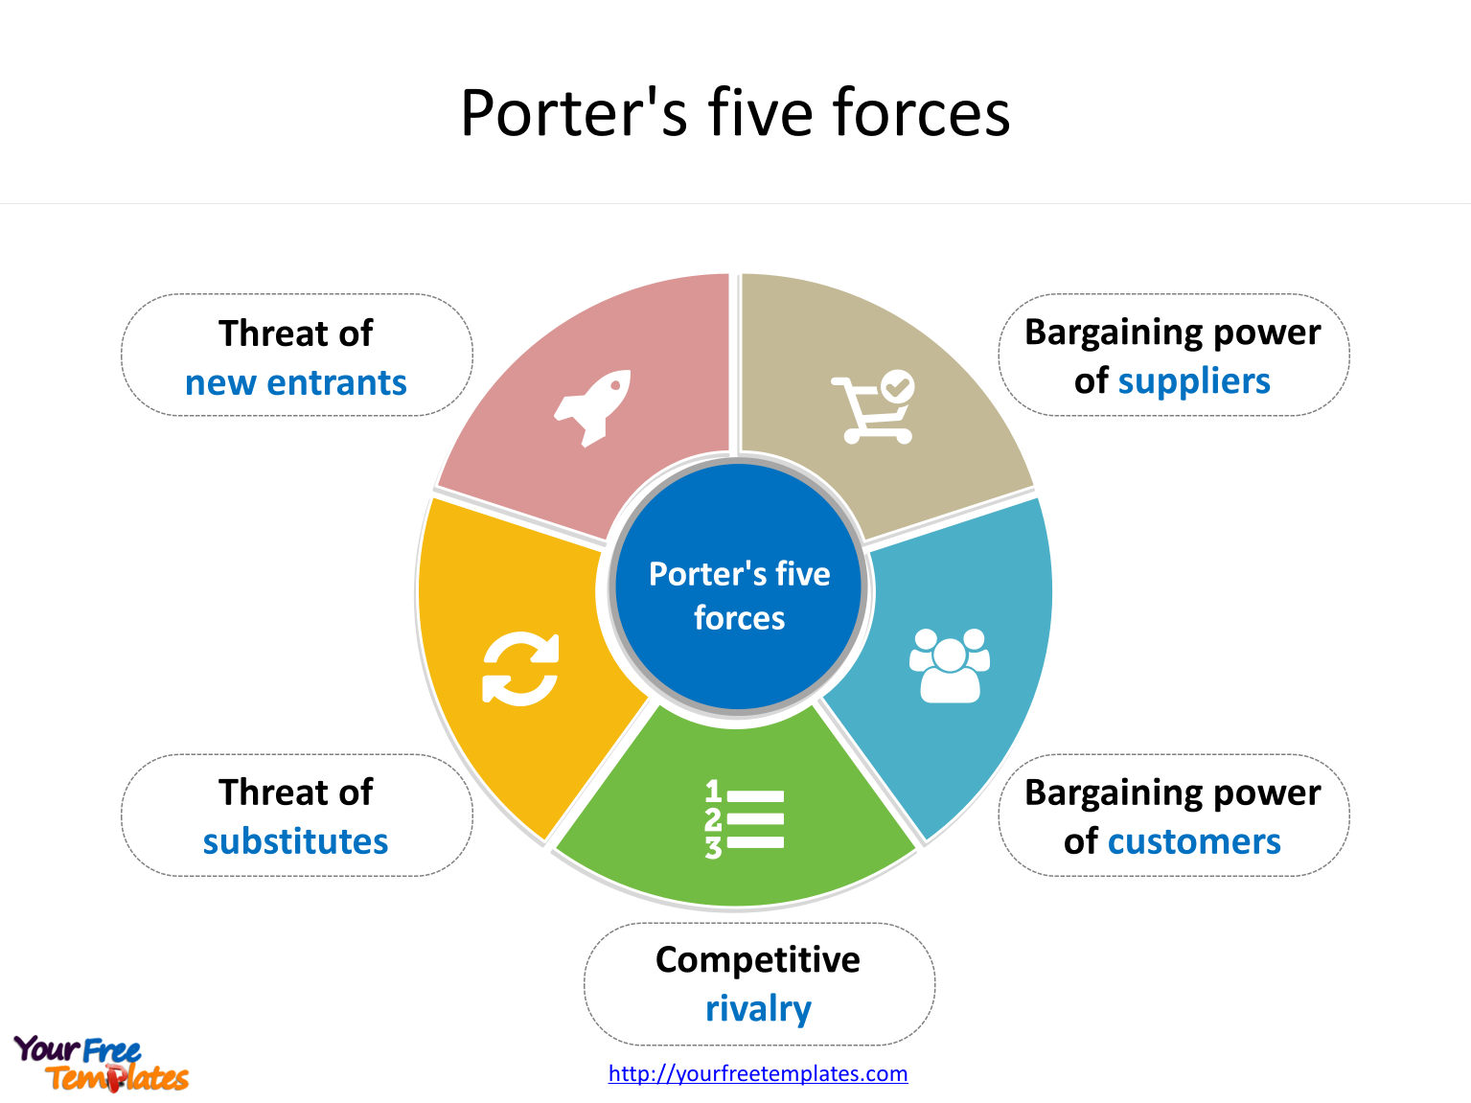
Figure 5: Porter’s Five Forces
Source: (Michael E. Porter, 2008)

- Competitive Rivalry
It defines the presence of competitors in the market selling the same product and services and reduces the market attractiveness (Porter, 2008). The Rolex has huge marketing competitors in the UK includes Hublot, Omega, Breitling, Longinus, and Patek Philippe. All these brands are providing good quality watches in the UK market and giving huge competition to Rolex.
The Rolex competitors in India include Titan, Omega, Fossil, Swatch Group, and many others. These brands are providing great competition to Rolex in sustaining its position in India. Thus, Rolex has a hight competitive rivalry in both countries.
- The threat of New Entry
The Rolex must strengthen its position in both countries the UK as well as India to resist the new entrant by strong and durable barriers of entry. It helps in enjoying a favourable position in the marketplace. The threat of new entry is medium for UK due to manufacturing cost, distribution channel, brand heritage and customers brand loyalty. In India, the threat of new entry is high due to the fact that they don’t have a very strong competition, also strong barriers for new entrants are in place ( economy of scale, manufacturing costs, brand name, distribution channel).
- Power of Buyers
The buyers put the prices of the product and services down by its buying power of an alternate brand; therefore, keeping this point in view Rolex is offering its watches at optimum prices in both UK and India to attract a large buying market. Before purchasing a watch, a few criteria determine the decision-making process: the style, the price, the quality and the size. In UK, the power of buyers is medium, a huge market variety and political instability, such as Brexit, and recently the Covid 19 pandemic situation influences the power of buyers. For India the power of buyers is low, customers also have a heavily influence of their culture, economic situation, income and social status.
- Power of Suppliers
The suppliers also have a strong potential of increasing prices of supplies therefore the brand has to maintain the number of suppliers to tackle this situation in case of need. The Rolex watches source supply is coming from Switzerland and having huge supply chain of trustworthy supplier providing best quality from decades. The power of suppliers is high for India and UK because the watches are produces in Switzerland and they can influence prices depending on availability and natural factors. The bargain power of suppliers is diminishing over watch brands.
- Threats of Substitute Products
The brands must build strong links with the customer to avoid their vision towards substitutes. The Rolex brand must bring more innovations towards its services. The Omega is a substitute brand available all over the world and especially in India offering the competitive path to Rolex. Similarly, in the UK, the Cartier brand and Tag Heuer are offering similar features at competitive prices than the Rolex brand. UK faces a hight threat level regarding substitute products. The substitutes offer lower price, sometimes better quality, better performance, also coming in a big variety of colours and sizes and a variety of styles. Another biggest threat come from digital watches which offers even more features and they attract more and more costumers in comparison with old-school watches. In India the threat of substitute products is low, its economy grows at slow pace and to establish a new business requires significant financial resources, market research and technology to start.
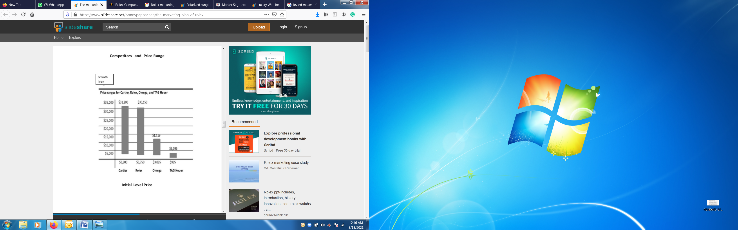
Figure 6: Price Range of Cartier, Rolex, Omega &TAG Heuer
Source: (Gilbert Brunner,2017)
The correct usage of the Porter five forces model determines the Rolex brand's better pathway to be followed to increase its profitably and efficiency with potential growth.

SWOT Analysis of Rolex Brand
It is marketing strategy helps in determining the business opportunities, threats, weakness, and strength in a sounding manner. Further provides opportunities based on data analysis. The correct formation of a business model for future growth helps in taking correct decisions for long-term business sustainability (Elavarasan, 2020).
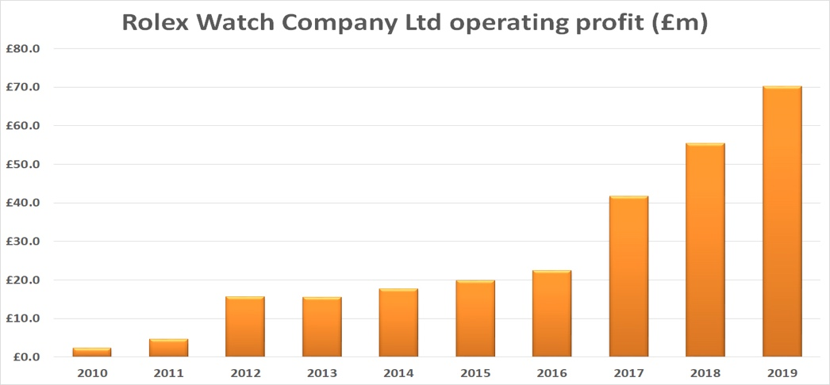
Figure 7: Rolex operating profit
Source: (watchpro.com, 2021)
- Strength
The major strength of the Rolex brand is providing value-added designs with time. The superior quality leads the customer to invest largely in this brand. The unique features and sophisticated design give the symbol of status. Strong history, global presence, product quality, and product development brings attraction to the brand at large. With a highly skilled workforce and the latest technology onboard, Rolex never remains behind surprising people with their new and luxurious avatars of the watches.
- Weaknesses
The high pricing is the weak area of the brand. The only elite class can buy luxury watches easily. Rolex must put a keen focus on introducing such products which are easily accessible to the other classes of the society too. Image management is another key area brand must work out by using marketing mix strategies for running long term in this business.
- Threats
It refers to the factors in the environment affecting the growth of the business. A large number of competitors present in the marketplace giving threats to Rolex. The major competitors are Tissot, Patek Philippe, Omega, and Panera.
- Opportunities
The favourable features of the environment bring opportunities towards the brand. The upper class of the society is potentially spending in buying expensive watches to maintain their social stratum. Rolex should start the precious jewellery line over the world. Since Rolex can produce jewellery with its precious techniques.

SWOT Analysis Rolex UK
Strength | Weaknesses
- Research and innovation | - High price
- Global distribution network | - Low volume production
- Loyal Customers | - Image management
Opportunities | Threats
- Elite Class value added design | - Brexit
- Expansion of luxury brand | - Culture diversity  - High taxes
Table 1: SWOT Analysis Rolex UK

The above SWOT analysis strategy of UK defines the areas required to be workout for improvement in future performance of the brand in an effective manner. Price reduction of watches needed so every class of the society can have the opportunity to wear these luxuries watches.
SWOT Analysis Rolex India
Strength | Weaknesses
- Manage demand | - High Manufacturing Cost
- Large market of buying | - Low volume production
- Unique designs | - Limited designs
 | - Online networking
Opportunities | Threats
- Future in Jewellery line | - Market uncertainty
 | - High–end competition
Table 2: SWOT Analysis Rolex India

The above SWOT analysis strategy of Rolex in India defines the weak areas to be a workout as the reduction of manufacturing cost by eliminating the unnecessary working steps and overheads. According to the UN, the population of India is 1.38billion in 2020. To meet the requirement of a large population the Rolex Company should increase its production volume and design as well as digital network enhancement for further growth (Longhurst, 2020).
No doubt,

The advantages of Swot analysis
SWOT analysis provides a pathway to the brand for improving its services for long term. Rolex is expanding its services in bringing better and improve output in the form of watches in the market by defining its strength, weaknesses, threats, and opportunity incorrect manner by using strategically sounding skills.
This frame work helps Rolex to identify its undeveloped areas, offer a better understanding of the current situation regarding company relationships with suppliers and distributors, its current situation of employer’s performance within organisation.

The disadvantages of Swot analysis
Cannot provide long term solution and its strength points can be imitated by competitors, transforming them in weaknesses. Also, not offer a good understanding for the economy of scale and a view towards financial resources of the company.
Can be impacted by economical and natural factors and has limited view towards leadership, management and pricing strategies of the company.

Market Segment Strategy (STP Model)
Segmentation: Marketing segmentation divides its customers base in groups with distinctive need and behaviours, in order to create different and appropriate marketing proposition. Rolex is divided in key areas: demographic, geographic, socio-economic data, psychographic and behavioural.
Demographic segmentation: Rolex started its business in 1905, in London in distributing the timepieces known for their reliability and elegant factor. The segmented market of Rolex is the rich and wealthy male consumers highly attracted by the unique and quality watches. The brand is created for those who have enough money to spend on luxuries and most of the consumers are of age 30 above. Mostly celebrities and sports figures are the targeted consumers of the Rolex brand. Rolex is a Sweden brand known for its quality and designs all over the world and has a market share of 50% in the US, Hong Kong, China, France, and Singapore. The Rolex remaining 50% share resides in European and South Asian Countries (Kalam, 2020).

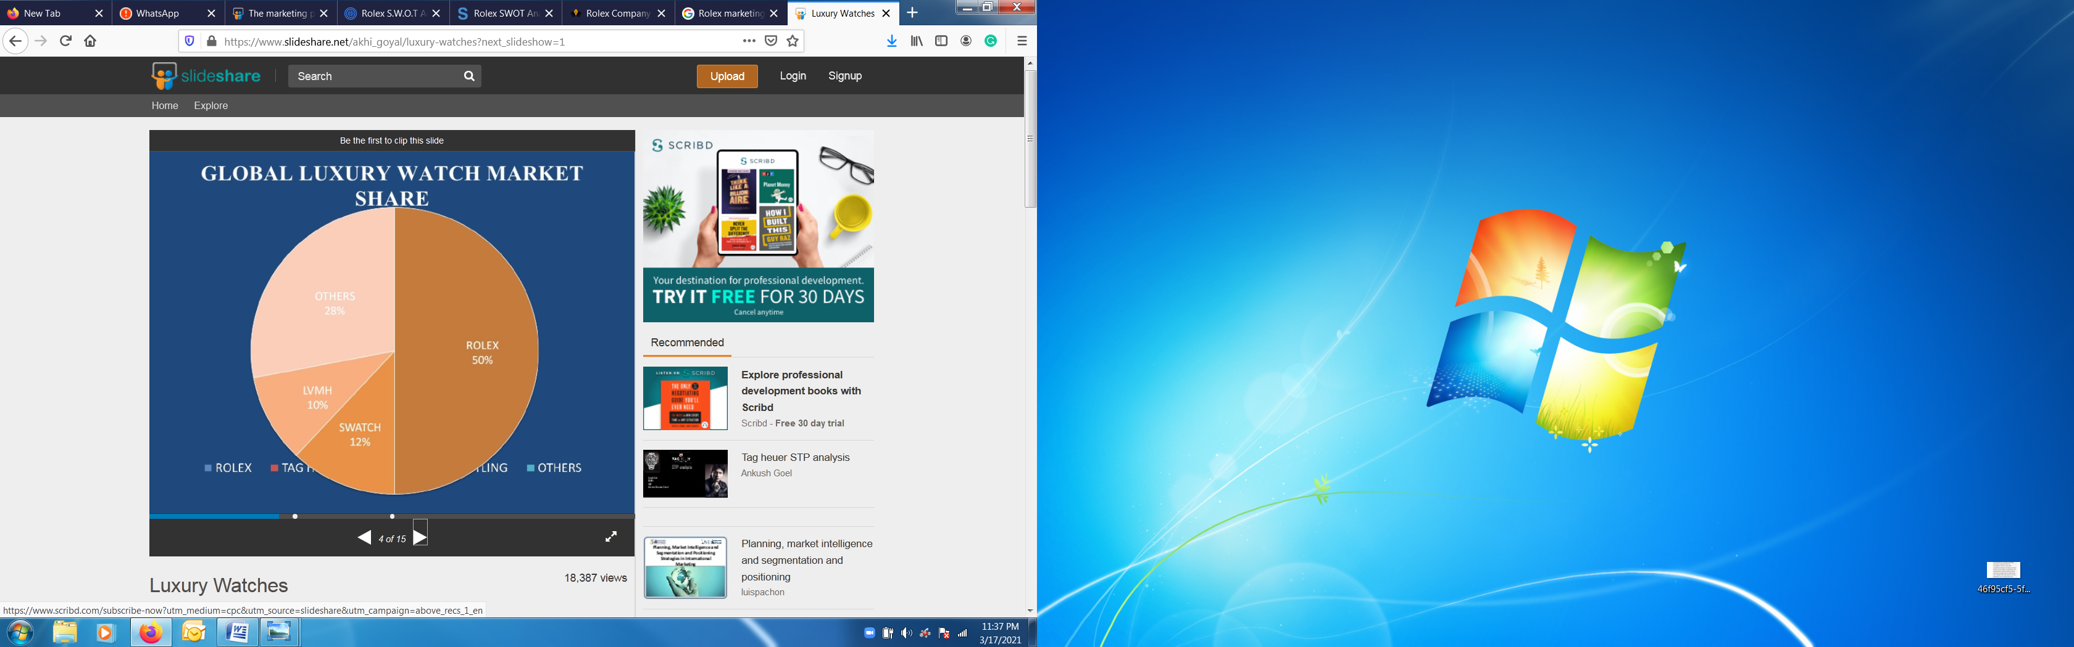
Figure 8: Global Luxury Watch Market Share
Source:(Pierre-Yves Donzé,2017)
Targeting
It is defined as the group of potential customers to whom company wants to sell its product and services(Asrari, 2021).The Rolex brand has applied the differentiated segment strategy to target the correct market for achieving the desired goal of the brand. The target market of Rolex is divided into three parts:
- Current Market
The rich upper class is forming the main present market of the Rolex brand attracted towards luxuries and attractive watches.
- Market Segment
The brand is focusing on the age group of 21 years to 39 years having a good life, better credit, and permanent jobs to be their targeted consumers of the future.
- Secondary Market Segment
The parents and grandparents are creating the secondary market of this international brand. Usually, elders buy the watches as a gift for their children or grandchildren on certain occasions to make them happy (Ahokangas, 2020).
Rolex India & UK similarities:
- Targeting the rich upper class
- Focusing on young age people
- Separate offers for premium customers
- Premium plans for professional and business executives
- Offering special collections on special events (Hasan, 2014)
Rolex India & UK differences:
- The customers power of buying is higher in UK
- Different website page
- Different customers uniforms
- Different promotions and advertising

Positioning
The Rolex brand positions its market by developing an attractive design and fashion watches as a status symbol for upper-class consumers. It is also designed as a fashionable cell phone use to tell time. In the above-defined STP Model, the segment for Rolex under consideration is the upper class of India and the UK. The target audience is the people of age 21 years to 39 years living in both countries and the positioning is the unique design features of highly expensive and luxuries watch as a symbol of status.

Brand perception – Brand loyalty
Rolex maintains its competitive advantage on the market despite the interference of new technologies, which affecting directly watch customers perception. Maintaining high standards and excellent quality products, helps the company to target more customers, even now from middle class or low-income people. Precepted as a luxury product, and wearing a Rolex watch empower the carrier, giving a note of superiority and wealthiness.

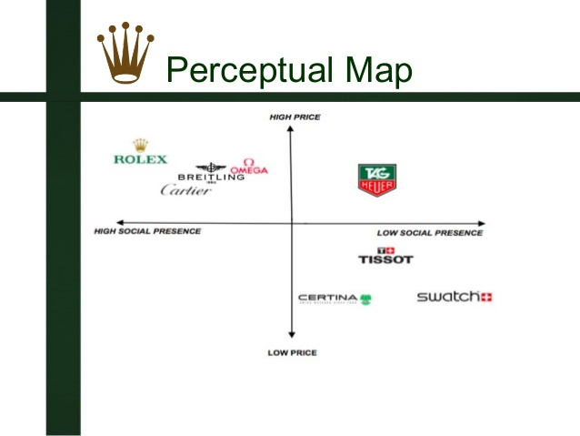
Figure 9: Perceptual Map of Rolex
Source: (Richard R, 2014)

Rolex Market Mix Strategy
Rolex target a specific category of customers by choosing the upper class and the business class people who can afford to buy their products and offer exclusive customer services, high quality products and value. Market mix strategy of marketing provides the online (indirect market) and offline (direct market) campaign platform to the brand for improvement by monitoring it from time to time. The main key elements of a marketing mix strategy are people, place, pricing, product, process, physical evidence and promotion (Sivakumar, 2020).
Nowadays, many countries around the world agreed to a tax-free trade process, known as globalization. Whit its manufacturer based in Switzerland and tariff exemptions for imports and exports, Rolex had to lower its actual products prices.
The brand address to a niche segment by offering its luxurious products at premium prices, exclusive watches for wealthy class of people, watches priced based on its own products, and not in order to made them competitive.
In order to maintain its competitive advantage, Rolex committed to offer both in India and UK, same quality services and luxurious products. To be able to maintain its high standards in India, the company limited retailers to sell the most two watches per year for same customer, to maintain its brand image and wealthier status.
Without owning its own distribution channel, Rolex use same strategy to distribute its high-end products in UK and India, by carefully selected certified dealers. UK has a large distribution network, more selected stores and showrooms compared to India, because the brand wants to avoid any chances of counterfeit watches (marketing91.com).

Price
The watches industry reaches higher competition levels and Rolex its pushing to its limits to maintain competitive advantage by offering to its customers unique luxury products. In UK market, Rolex is percept as an accessible product, despite its high price. People in UK are more intended to afford a Rolex watch in comparison with India’s people where their income and social status represent an impediment in achieving a Rolex watch.
Covid 19 pandemic situation impacted the watches industry, among all brand names, Rolex was impacted by this crisis and in 2021 registered significant price drop both in India and UK (https://thetruthaboutwatches.com/2020/04/coronavirus-watch-11-rolex-prices-dropping/).
The Rolex Company should look towards the value pricing strategy to gain more customer attention towards the brand and put consideration in keeping the prices near to the consumer willing to buy it or we can say the price that reaches the consumer buying capability of the customer.
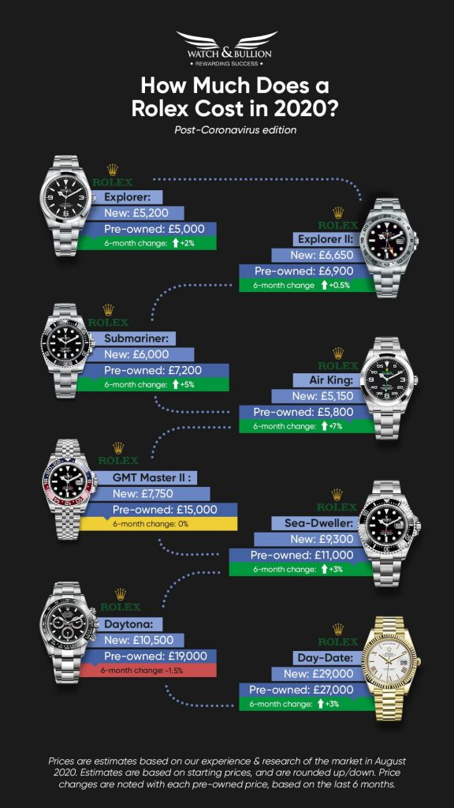
Figure 10: Rolex in 2020
Source: (watchandbulion.com, 2020)
Promotion
Rolex brand is using different promotion strategies for promoting company name and products. Some effective strategies include advertisement, sales promotion, and public relations. These marketing strategies provide the consumer with better information regarding the brand and its market position. The advertisement is considered one of the best promotion strategies and it gives awareness to all groups of people belonging upper to lower class. Advertisement not only gives awareness about any brand product and services. It can also be used as an effective platform for the introduction of any new product and services to the consumers.
Another strategy regards pre-owned watches who are selled at lower prices because of their preowned condition.
Place
The Rolex brand is expanding its business in different countries of the world. The major sell generating company is China Gang Dong Market. Apart from China Company is also trying to penetrate Europe and various South Asian Countries. Its high focus is promoting the product and services towards the wealthiest neighborhood. The retailer as well as wholesalers of Rolex are present in UK and India, who are effectively performing distribution services (Donndelinger, 2020).
Market Entry Methods
The brand licensed its products in order to avoid any counterfeit chances and to maintain its competitive advantage on the market. To distribute its products, Rolex does not have an own distribution channel, a selective certified dealer is used both in India and UK. It allows its products to be distributed only in certain areas of UK and India, especially in big cities where its product line can be accessed by a particular uber rich demographic area, in order to conserve brand value and maintain competitive advantage.
The company sell its high-end products only on Rolex website and certified outlets and retailers, both in India and UK, and its being well know its aggressive promotion of watches. In online are not allowed any sales offers, they are done only in certain selected stores in major cities from India and UK.

People
Rolex must offer high orientation marketing programs for attracting and retention of existing consumers. The program will strengthen the customer loyalty factor and help in building a strong connection with the customer. The program uses social networking for easy communication with the customer and helps in keeping updated to the customer regarding the present brand scenario.
Rolex aims to convince customers that their watch is ‘the one’ and only this watch suits them perfectly. Just one of the reasons of being selective in their brand name association with certain events and celebrities, such as “Wimbledon”, “Australian Open”, “U.S. Open”, “The Open Championships”, “The Senior Open Championship”, “Rolex Sports Car Series” and “24 Hours of Daytona”. Rolex stared in 2001 to be the timekeeper for Le Mans motor racing and in 2013 for the Formula 1.
Also choosing certain celebrities to associate with, starting in early 1968 with Sir Jackie Stewart, as a brand ambassador, and continuing with huge names in sports like Roger Federer, Michael Schumacher, Daniel Craig, Cristiano Ronaldo.

Product
Rolex brand is using a recognizable product for decades without changes because it believes in maintain heritage values. This is the reason the brand is selling limited design watches for consumer end usage. The market mix strategy helps the brand in improving its custom value with time. It also helps in improve slowly and gradually towards the target goals for future success.
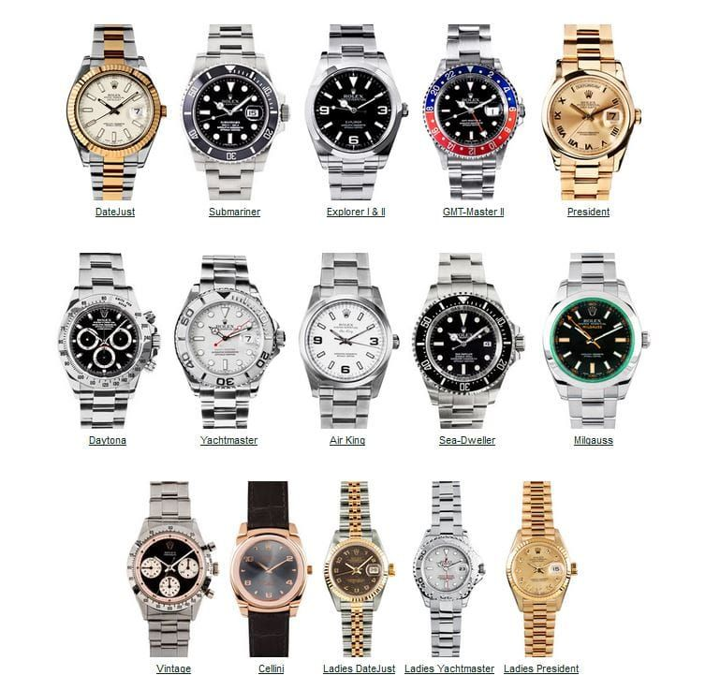
Figure 11: Rolex watches
Source: (pinterest.com, 2021)

BCG Matrix
It is the strategic management tool for defining the position of the business in its working environment. The matrix has four classifications and two-dimension. One dimension defines the business nature, and the second dimension defines the business growth or profitability. The BCG matrix of Rolex determines which marketing strategy should be applied to business growth and development. Rolex is marketing its product in more than 100 countries. The main thing required to identify is the position of Rolex in the BCG matrix. (Husain, 2020)

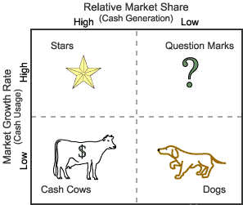
Figure 12: BCG Matrix
Source: (Husain, 2020)
- Stars
It is defined as a product or service in a business having strong market share and generates the most cash (Kader, 2020). The financial unit of the Rolex Company is the potential area of generating a high amount of revenue and acting like a star. Rolex should integrate other firms as a supply chain unit as this sector has great potential of earning a huge amount of revenue. The Rolex comes in the star category of the BCG matrix since acquired its position and uniqueness in the luxury market.
- Cash Cows
The supplier management unit in the BCG Matrix acts as cash cows. It has been in operation for decades and the company earning huge profits. All over the progress of the company is high, but the company is running its supplier management system whose sale is declining and the suggestion according to the matrix positioning is to stop investing in this business unit and keep it running up till it is generating profit.
- Question Marks
The local food business is the question mark in the strategic business of Rolex. The company has a low share in the food business and to grow in this business company has to start innovative marketing strategies. Rolex must invest more in research and development of marketing of local foods for earning profit remarkably.
- Dogs
The plastic bags strategic business is a dog in a BCG matrix of Rolex. The Company is facing losses for the last 5 years in this unit sector and is required to improve its business strategies to overcome the decline occurring in this unit of Rolex for future success (Kader, 2020).
- VRIO Framework
It is considered the strategic business tool which identifies company internal strength and resources that can be used as an additive advantage for company growth.

Rolex Product Life Cycle
The product life cycle determines the stages in which the product generates revenue. The four stages of a product life cycle include Introduction, Growth, Maturity, and Decline (Pieroni, 2020).
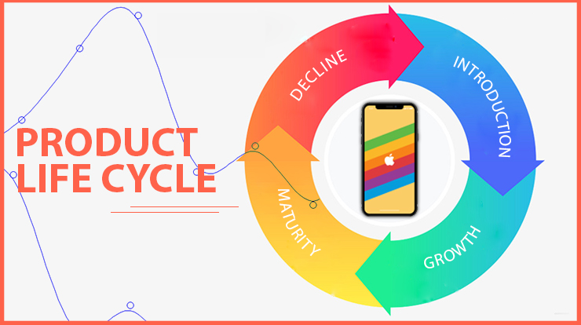
Figure13: Product Life Cycle
Source: (Peroni, 2020)
In this stage, Rolex creates awareness to the customer regarding the unique features of the watches as well as the main theme for buying them. Rolex spends a large amount on marketing for creating awareness regarding the product for expanding sale which increases the profit margin. The product is introduced at this stage in the market (CATTIN, 2020).
Growth
The demand for the product accelerates in this stage and the market starts expanding for further growth. This stage is also known as the takeoff stage. Rolex put great efforts in this stage for enhancing the sales of the product effectively.
Maturity
At this stage Rolex products reach their equilibrium means the product demand and customer need then the price will be defined by the market forces. Such a state is known as the equilibrium or maturity state of the product.
Decline
At this stage, the sales drops and profitability decline, and companies prefer to stop the further production of the product. The product decline started due to two factors, firstly the rate of change of consumer taste and secondly the new product enters the market.
Like in the Rolex case if any new product introduces by the company or the competitors so the consumer will be more attracted towards the new product and services entered the market instead of giving attention to the previously introduced items.

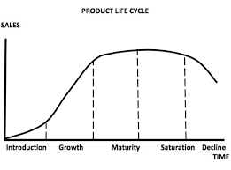
Figure 14: Product Life Cycle Graph
Source: (CATTIN, 2020).

The above life cycle defines how each product of Rolex entered the market from the development to decline stage and experiences the customer reactions towards the sales and rejections platform. Since the Rolex products are precious, unique, and highly admirable by the customers so always get positive impacts from the marketplace (Longwe, 2020).

Recommendations
Rolex must implement new programs which can offer high orientation towards marketing programs for attracting and retention of existing consumers. This will strengthen the customer loyalty factor and help in building a strong connection with the customer. Rolex must improve communication with its customers on social media and can use it more efficiently to promote its products among young generation, instead of targeting business class people or wealthiest customers.
A higher amount must be invested in research and development in order to offer variety of colors and styles.
Rolex need to focus more on developing and marketing of local foods for earning quick profit and to increase growth. The company should focus more on building a stronger strategy for pre-owned watches which can be revitalized and can bring a significant income.

Conclusion
This report highly focused on the Rolex brand marketing strategies implementation in India and UK for the selling of luxuries watches. It also determines the brand market value, position, and demand in a broad spectrum. The report further determines the country-wise importance of sales and profitability. The usage of different marketing strategies such as Culture Dimension Model of Hofstede, Porter Five Forces, SWOT Analysis, STP Model, Marketing Mix, BCG Matrix, and product life cycle of Rolex for improvement of product sales and profitability in long term for business progress. The company is tremendously ethically designed and fulfilling customer demand at the utmost level. The company is previously following the heritage-specified view design for its large sales market. Rolex is now putting efforts towards research and development of new innovative designs for customer attraction to expand its market profoundly. The sales of Rolex are gradually increasing in both countries UK and India, but the potential of growth is more in the UK compared to India due to certain resistance factors of resources, high duties or taxes, skilled manpower, and research and development needs.

References

- Adam‐Troian, J. W. P. M. M. A. T. I. R. Z. F. K. O. B. M. B. A. B. M. a. B. N., 2020. Investigating the links between cultural values and belief in conspiracy theories: The key roles of collectivism and masculinity. Political Psychology.
- Ahokangas, N., 2020. Digital Marketing Plan for a Mobile Application.
- Asrari, A. A. M. K. J. a. C. V., 2021. A Remedial Action Scheme for Cyberattacks Targeting Market Retailers in Smart Distribution Systems. IEEE Transactions on Industrial Informatics.
- CATTIN, N., 2020. Stratégies des entreprises et réseaux sociaux numériques: attention, engagement et besoins des internautes. Analyse de cas: Rolex & Greenpeace.
- Dhaundiyal, D. C. R. a. N. J. A., 2020.: Generational Evolution of Power Distance and Masculinity in UK in Popular Literature. In IndiaHCI'20: Proceedings of the 11th Indian Conference on Human-Computer Interaction (pp. 1-11).
- Dhaundiyal, D. C. R. a. N. J. A., 2020. Generational Evolution of Power Distance and Masculinity in UK in Popular Literature. In IndiaHCI'20: Proceedings of the 11th Indian Conference on Human-Computer Interaction (pp. 1-11).
- Donndelinger, J. a. F. S., 2020. present, and future of market-driven engineering design. Journal of Mechanical Design, 142(6).
- Elavarasan, R. A. S. V. R. S. U. a. N. M., 2020. SWOT analysis: A framework for comprehensive evaluation of drivers and barriers for renewable energy development in significant countries. pp. 1838-1864.
- He, J. a. S. L., 2020. Does continuity matter? Developing a new long-term orientation structure in a cross-cultural context: A study on supply chain relationships. Industrial Marketing Management, 88, pp.186-194.
- Hossain, H. a. K. M., 2020. An Analysis on BCG Growth Sharing Matrix. International Journal of Contemporary Research and Review, 11(10).
- hofstede-insights.com, 2021. country comparison India and UK. Available at: https://www.hofstede-insights.com/country-comparison/india,the-uk/ [Accessed on 2nd April 2021].
- Isabelle, D. H. K. M. S. a. P. C., 2020. s Porter's Five Forces Framework Still Relevant? A study of the capital/labour intensity continuum via mining and IT industries. Technology Innovation Management Review, 10(6).
- Jackson, T., 2020. The legacy of Geert Hofstede.
- Jelassi, T. a. M.-L. F., 2020. External Analysis: The Impact of the Internet on the Macro-environment and on the Industry Structure of e-Business Companies. I. In: In Strategies for e-Business (pp. 49-95). Springer, Cham.
- Kader, M. a. H. H., 2020. An Analysis on BCG Growth Sharing Matrix. International Journal of Economics, Business and Accounting Research (IJEBAR).
- Kader, M. a. H. H., 2020. International Journal of Economics, Business and Accounting Research (IJEBAR), 4(01).
- Kalam, K., 2020. Market Segmentation, Targeting and Positioning Strategy Adaptation for the Global Business of Vodafone Telecommunication Company. International Journal of Research and Innovation in Social Science (IJRISS), 4.
- Khurram, A. H. S. a. K. S., 2020. Influence of Non-Governmental Organizations on Competitive Rivalry in Various Economic Sectors.
- Longhurst, G. S. D. D. K. S. D. C. T. a. S. C., 2020. Strength, weakness, opportunity, threat (SWOT) analysis of the adaptations to anatomical education in the United Kingdom and Republic of Ireland in response to the Covid‐19 pandemic.
- Longwe, B. a. S. K., 2020. Reassessing the Core Product’s Relevance: Balancing Heritage against Modern Needs.
- www.marketing91.com, 2021. Rolex Strategy. Available at: https://www.marketing91.com/ [Accessed on 16 April 2021].
- Pieroni, M. M. T. a. P. D., 2020. From theory to practice: systematizing and testing business model archetypes for circular economy. Resources, Conservation and Recycling, 162, p.105029.
- pinterest.com, 2021. Rolex. Available at: https://www.pinterest.co.uk/rolex/ [Accessed on 2nd April 2021].
- Purevdorj, N. B. A. a. K. A., 2020. An Investigation of Mongolian National Cultural Values using the Hofstede 6-D Model.
- Rana, S. P. S. B. M. a. H. A., 2020. Determinants of international marketing strategy for emerging market multinationals. International Journal of Emerging Markets.
- Samiee, S., 2020. International marketing and the internet: a research overview and the path forward. International Marketing Review.
- Sengabira, C. S. F. a. N. G., 2020. the effects of frequency of corporate donations on luxury brand evaluations. Asia Pacific Journal of Marketing and Logistics.
- Sivakumar, G., 2020. Challenges and Strategies of Global Branding in Indian Market.
- Uggla, H., 2020. Research Challenges for Brand Authenticity. IUP Journal of Brand Management. IUP Journal of Brand Management, 17(1)., Volume 1, p. 17.
- Wang, J. a. W. Z., International Journal of Environmental Research and Public Health, 17(7), p.2235. Strengths, weaknesses, opportunities and threats (SWOT) analysis of China’s prevention and control strategy for the COVID-19 epidemic.
- watchpro.com, 2021. Rolex new offers. Available at: https://www.watchpro.com/news/uk/ [Accessed on 2nd April 2021].
- watchandbulion.com, 2020. Rolex rivals. Available at: https://watchandbullion.com/tag-heuer-carrera-chronograph-2020/ [Accessed on 2nd April 2021].
- Yang, S. I. S. a. R. T., 2021. Uncertainty Avoidance as a Moderating Factor to the Self-Congruity Concept: The Development of a Conceptual Framework. Sage Open, 11(1), p.215.
- Zheng, X. G. K. L. H. P. X. H. E. J. L. a. W. C., 2021. Individualism and Nationally Determined Contributions to Climate Change. Science of The Total Environment, p.146.

