

Applied Leadership and Management in the Workplace
Module Assignment Submission
Student Name: | Jennifer Parmenter
Student Number: | 2238431
Module No: | BMSK4013
Module Title: | Management Communication

Statement of Confirmation of Authenticity
By the act of making this submission, the student declares that this is the work of the student named above. The work has not, in whole or in part, been knowingly presented elsewhere for assessment, or where assessment has been built on a previous assessment, this has been identified. Where materials have been used from other sources it has been properly acknowledged. If this statement is untrue, the student acknowledges that an assessment offence has been committed.
Attention is drawn to the plagiarism and unfair practice policies of both the University and of ILM.

​​

Contents

Introduction 3
​Communication Cycle 3-4
Berlo’s SMCR model 4-5
Shannon-weaver mathematical model 5
Schramm’s model of communication 6-7
​Tone, Language and Formality 7-9
Range of verbal and written communication with in the workplace 9-10
​Motivation Theories 10-12
​Factors that affect motivation 12
​Conflict 13
​References 14
​Appendix A - Personal Development Plan 15

​​

Introduction
Effective communication is vital for success in the workplace. Over the years, various communication models have been developed to understand and improve the ways in which information is exchanged. This assignment explores several key communication models. By looking at these models, we can learn important things about how communication works with in the workplace.
Communication Cycle
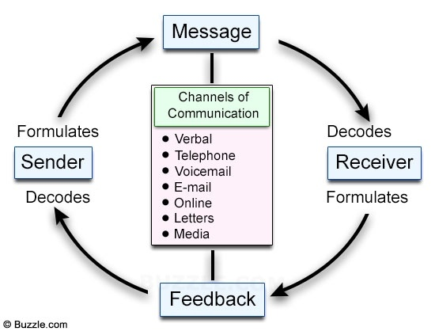
The communication cycle is a process that describes the stages involved in effective communication between individuals. This process ensures that the intended message is accurately received and understood by the recipient.
Recognizing the key elements and stages of the communication cycle, individuals can enhance their communication skills, minimize misunderstandings, and have more effective and meaningful interactions with others.
Manager (Sender): You, as the manager, want to inform your staff about a new salon procedure for booking appointments.
Message: You verbally explain the new booking procedure during a staff meeting.
Encoding: You break down the procedure into simple steps and use clear language to ensure understanding.
Medium: You use a face-to-face staff meeting to deliver the message, as it allows for immediate interaction and clarification.
Staff (Receiver): Your staff listens attentively to the explanation.
Decoding: They process the information, understanding the steps involved in the new booking procedure.
Feedback: After your explanation, you ask if there are any questions or concerns. A few staff members ask for clarification on certain steps, which you address.
Noise: While explaining, you ensure the salon environment is relatively quiet to minimize distractions.
This simple example illustrates how a manager in a salon can effectively use the communication cycle to give important information to their staff about a new procedure.
Advantages and disadvantages of the model
The communication cycle, as a model for understanding the process of communication, has several strengths and weaknesses. The cycle provides a clear structure for understanding how communication works. It breaks down the process into steps, making it easier to analyse and improve communication. By highlighting each stage of communication, the cycle helps individuals understand where misunderstandings or breakdowns may occur, so you can make needed improvements. The cycle also includes feedback as a crucial step. This ensures that communication is not one-sided. It highlights the importance of confirming understanding and adjusting messages as needed. Disadvantages could be that it oversimplify human communication. Real-life interactions often involve overlapping stages and are influenced by emotions, contexts, and culture that the model doesn’t fully capture. The cycle also suggests a linear process, which may not always reflect reality. Communication is often dynamic and interactive, with feedback occurring continuously rather than at certain stages.
In summary, while the communication cycle is a solid structure, it wouldn’t work with in a Salon. The cycle would need to be adapted to handle the fast-paced, dynamic environment of a busy salon. With proper training and strategies in place, the communication cycle could enhance the overall client experience but the fast-paced environment increases the risk of misunderstandings also immediate feedback is important to ensure that the client’s needs are met accurately. This can be as simple as confirming a haircut preference before starting. Staff need to be trained to recognize and address any confusion/ problems quickly.

Berlos SMCR model of communication

(Communication Theory, 2014)
Berlos Model of communication, also known as the SMCR model, was created by David Berlo in 1960. This model displays the importance of the individual components involved in the communication process and focuses on how each part contributes to effective communication. SMCR stands for Source, Message, Channel and Receiver.
For example, in a busy call centre, the project manager (source) sends and email (channel) to the sales team (receivers) informing them about the new deadline and target on sales (message).
The effectiveness of this communication depends on the project manager's ability to encode the message clearly and the team's ability to decode and understand the message accurately. If the message is clear and the team is receptive, they will understand the new deadline and adjust their work plans accordingly.
This example demonstrates how each component of Berlo's Model of Communication -Source, Message, Channel, and Receiver plays a crucial role in ensuring effective workplace communication.
Advantages and disadvantages of the model
Berlo's model is straightforward and easy to understand. It breaks down the communication process into four basic components: Source, Message, Channel, and Receiver. This simplicity helps in clearly identifying and analysing each part of the communication process.
However, the model is linear and does not account for the dynamic, two-way nature of communication. It assumes a one-way process from sender to receiver, which neglects the importance of feedback and interaction in effective communication. Berlo's model does not explicitly include feedback, which is a crucial component of communication. Without considering feedback, the model fails to address how the receiver's response can influence the sender and the overall communication process.
Berlo’s Communication Model, which emphasizes the Source-Message-Channel-Receiver structure, can be effective in a busy call centre. However, similar to any communication model, it needs to be adapted to the specific challenges of a call centre environment. Berlos provides a clear structure for agents to follow, ensuring that all essential parts of communication are covered. The model also emphasizes the importance of encoding and decoding messages clearly, which is crucial in a call centre where misunderstandings can lead to customer dissatisfaction. In summary, Berlo’s Communication Model can work well in a busy call centre with appropriate training and adjustments to handle certain challenges in a call centre environment.

The Shannon-weaver mathematical model 1949
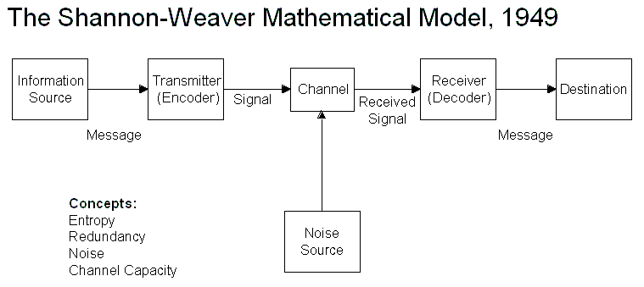
(Donohue, 2017)
The Shannon-Weaver model of communication is a clear and structured way to understand how information is sent and received. It was created by Claude Shannon and Warren Weaver in 1948. The model is often referred to as the "mathematical model of communication" due to its technical and systematic approach. Here are the key components and concepts of the Shannon and Weaver model:
Sender (Information Source) is the person or thing that wants to share information. For example, a friend who wants to tell you something. The Encoder (Transmitter) is the tool or method used to turn the message into a signal. In our example, this could be your friend's voice turning words into sound waves. The Channel is the medium through which the message travels. This could be the air carrying the sound waves, a phone line, or even the internet. The Decoder (Receiver) is the tool or method used to turn the signal back into a message. This could be your ears and brain interpreting the sound waves into words. The Receiver (Destination) is the person or thing that receives the message. In this case, it’s you, the listener. And finally the Noise is anything that interferes with the message as it travels through the channel. This could be static on a phone call, background noise in a room, or a bad internet connection.
Imagine you’re having a phone conversation:
Sender: Your friend wants to tell you about their day.
Encoder: They use their voice to speak into the phone.
Channel: The phone transmits the voice as electrical signals.
Noise: There might be static or background noise during the call.
Decoder: Your phone converts the electrical signals back into sound.
Receiver: You listen to the sound and understand what your friend is saying.
The Shannon-Weaver model helps us see the steps involved in sending and receiving messages, highlighting how important it is to minimize noise and ensure clear channels for effective communication.

Schramm’s model of communication
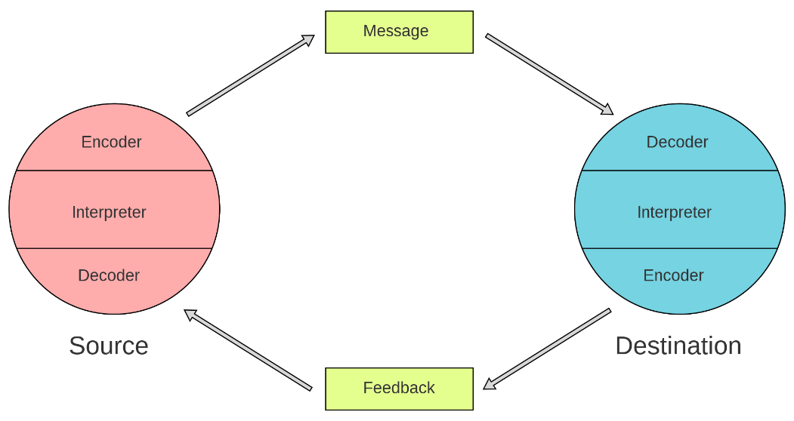
(Wikipedia Contributors, 2022)
Schramm's model of communication, developed by Wilbur Schramm in 1954. Schramm's Communication Model explains how communication is a two-way process where both the sender and receiver exchange messages and feedback. It highlights that both parties need to share some common understanding or experiences to effectively communicate. One advantage of this model is that it emphasizes interaction and feedback, making sure that messages are understood correctly and can be adjusted if needed. However, a disadvantage is that it assumes both parties have a similar background or experience, which might not always be the case, leading to misunderstandings. Additionally, it can be less effective in situations where immediate feedback isn't possible.
In a salon, Schramm's Communication Model would be very effective. The hairstylist and client exchanging messages and feedback during the haircutting process. The hairstylist asks the client about their desired hairstyle, and the client responds with their preferences. The hairstylist then uses their skills to create the hairstyle, while continuously checking with the client to ensure they are satisfied. If the client wants any adjustments, they provide feedback, and the hairstylist makes the necessary changes. This back-and-forth interaction ensures that both parties understand each other, leading to a successful haircutting experience. Schramm's model helps in creating a comfortable environment where communication flows easily, and both the hairstylist and client can work together to achieve the desired result.

Tone, Language and formality
Tone, language, and formality are important in the workplace because they affect how people feel and understand each other. Our tone id about how we say things. A kind and respectful tone helps people feel valued and happy, while a harsh tone can make them upset or angry. Language would be using clear and simple words helps everyone understand each other better. It's important to avoid using complicated words or slang that might confuse people. Being formal or informal depends on the situation. Being too formal can make people feel distant, but being too casual might not be appropriate either. Finding the right balance helps everyone feel comfortable and respected. By paying attention to these things, we can create a workplace where people communicate well, feel appreciated, and work together effectively.
Different modes of communication
Different modes of communication in the workplace are super important because they help people connect and share information in different ways. For example, face-to-face communication lets us see each other's facial expressions and body language, which can help us understand each other better. Written communication, like emails or messages, is great for sharing detailed information or keeping records. Phone calls can be useful for quick conversations or clarifying things in real-time. Each mode has its strengths and weaknesses, so it's important to choose the right one for the situation. For instance, while face-to-face communication is great for building relationships, it might not always be possible or practical, especially in remote work situations. So, having different modes of communication available helps ensure that everyone can stay connected and informed, no matter where they are or what they're doing.
n a salon, various methods of communication are crucial for maintaining smooth operations and delivering exceptional customer service. Direct interaction, known as face-to-face communication, is fundamental as it allows salon staff to grasp clients' preferences. Phone communication serves as a valuable tool in salons for scheduling appointments, confirming bookings, and providing timely updates to clients.
Formality
Formality in the workplace can be both helpful and challenging. On one hand, it's important because it shows professionalism and respect for others. When we use formal language and behavior, it helps people feel valued and understood. Formality also creates clear rules and structures for how we communicate, which can prevent misunderstandings. However, being too formal all the time can sometimes make people feel uncomfortable or distant from each other. It might even get in the way of creativity and teamwork because people might be afraid to speak up or share new ideas. So, while formality is important for showing respect and professionalism, it's also important to find the right balance so that people feel comfortable and can work together well.
An example of formality in the workplace is addressing colleagues or superiors using their titles and last names, such as "Mr. Smith" or "Ms. Johnson," instead of using their first names. This form of address is commonly used in more formal work environments, particularly in professions like law, finance, or academia. This use of formal titles demonstrates respect and professionalism, particularly when interacting with individuals of higher authority or seniority within the organization.
In a salon, an example of formality might involve the receptionist addressing clients using polite and respectful language, such as "Good morning, how may I assist you today?" This formal greeting demonstrates professionalism and shows respect for the client.
Language
Language in the workplace is super important because it's how we communicate with each other. When we use clear and respectful language, it helps everyone understand each other better and work together well. For example, if someone gives instructions using confusing words or slang that others don’t understand, it can cause problems and mistakes. However, it's also important to remember that using too formal or complicated language all the time can make communication hard too. People might feel distant or intimidated, and they might not feel comfortable asking questions or sharing their ideas. So, while language is crucial for effective communication, finding the right balance between clarity and friendliness is key to creating a positive and productive workplace environment.
In a salon, appropriate language is important because it helps create a comfortable and welcoming environment for clients. For example, hairstylists might use friendly and polite language when greeting clients, such as saying "Hello, welcome to our salon!" This kind of language makes clients feel valued and relaxed. When discussing hair preferences or treatments, using clear and descriptive language is key to ensuring that clients get the style they want. For instance, a hairstylist might ask, "Would you like a trim or a complete restyle today?" This helps avoid misunderstandings and ensures that clients leave the salon happy with their new look. Overall, using appropriate language in a salon contributes to a positive experience for clients and builds trust between them and the salon staff.
Structure
Structure in the workplace is super important because it helps everything run smoothly. When there's a clear structure, everyone knows what they're supposed to do and when they're supposed to do it. For example, having set working hours and schedules helps people plan their day and make sure they're available when needed. Structure also helps people understand who they report to and who they can go to for help. However, being too rigid with structure can sometimes be a problem. It might make people feel stuck or like they can't be creative or flexible. So, while structure is important for keeping things organized, it's also important to have some flexibility to adapt to changes and new ideas. Finding the right balance is key to creating a positive and productive work environment.
In a salon, structure is important to ensure that everything runs smoothly and clients receive the best service possible. For example, having a set appointment schedule helps organize the day and ensures that each client is seen in a timely manner. This structure allows the salon to manage their time effectively and prevents clients from waiting too long or overlapping appointments. Additionally, having designated stations or areas for different services, such as haircuts, colouring, and washing, helps streamline the workflow and ensures that each stylist has the necessary tools and space to work efficiently. Overall, structure in a salon ensures that operations are organized, clients are served promptly, and the salon runs smoothly, providing a positive experience for both clients and staff.
Content
Content in the workplace is super important because it helps people know what's going on and how to do their jobs well. For example, it can be used for sharing important information like company policies or updates on projects. Good content also helps people learn new things and stay motivated. However, too much content or content that's hard to understand can be overwhelming and make people feel stressed. So, while content is important for keeping everyone informed and engaged, it's also important to make sure it's clear, relevant, and easy to access. Finding the right balance is key to creating a positive and productive work environment.
Tone
The importance of tone in the workplace is huge because it affects how people feel and understand each other. When we use a friendly and respectful tone, it helps create a positive and supportive work environment where everyone feels valued and appreciated. This can boost morale, teamwork, and productivity. However, using a negative or harsh tone can make people feel upset or discouraged, leading to conflicts and misunderstandings. So, while tone is important for effective communication and building relationships, it's crucial to be mindful of how we speak to others and to choose our words carefully to create a positive atmosphere in the workplace.
An example of tone in a salon might be when a hairstylist greets a client with a warm and welcoming tone, saying something like, "Good morning! Welcome to our salon. How can I help you today?" This friendly tone helps clients feel comfortable and valued, setting a positive tone for their salon experience. It shows that the hairstylist cares about their clients and wants to make them feel at ease. A welcoming tone also encourages clients to open up and communicate their preferences, which helps the hairstylist understand their needs better and provide excellent service. Overall, tone in a salon is important because it creates a welcoming and positive atmosphere that enhances the client experience and builds rapport between the hairstylist and the client.

Range of verbal and written communication with in the workplace
Verbal communication | How is it used ? | Advantages | Disadvantages
Client Consultations | hairstylists discussing clients' preferences, hair goals, and concerns before starting a service | Allows hairstylists to understand clients' needs and expectations | Time-consuming, especially for detailed consultations
Team Meetings | The manager conducts regular team meetings | - Ensures all staff members are informed and aligned on salon objectives and expectations. | Can be time-consuming if not efficiently organized.
Performance reviews | The manager conducts performance reviews with salon staff to provide feedback on their performance | Provides constructive feedback to staff to improve performance and achieve career growth. | Requires preparation and time.

This table provides an overview of verbal communication in a salon workplace from the perspective of a manager, highlighting its usage, advantages, and disadvantages.

Written communication | How is it used? | Advantages | Disadvantages
email | The manager uses email to communicate with salon staff | Provides a formal and documented means of communication for conveying important information to salon staff. | May be less immediate than verbal communication for urgent matters.
Work contracts, policies and procedures | The manager develops and maintains written policies and procedures manuals outlining salon rules. | Provides clear and consistent guidance to salon staff on salon operations, policies, and procedures. | Requires regular updates and revisions to reflect changes
Client Communication social platforms | social media posts, to communicate with clients regarding appointments and promotions | Allows for personalised communication with clients regarding their appointments | Requires time and resources to develop and manage client communication materials effectively.
This table provides an overview of written communication in a salon workplace from the perspective of a manager, highlighting its usage, advantages, and disadvantages in various managerial contexts.
Motivation Theory
Motivation is that internal energy that drives us to act and pursue our goals and objectives (worksheetsplanet, 2024). Motivation is like a fuel that keeps people going towards their goals. In the workplace, it's what makes employees excited to do their job well. Motivation in the workplace is a massive deal. Employers often try to keep their employees motivated by offering rewards, like bonuses or promotions, or by creating a positive work environment where people feel valued and supported. They might also provide opportunities for training and development, so employees can learn new skills and grow in their careers. When employees are motivated, they're more likely to be productive, happy, and do well.
Intrinsic motivation is when you do something because you find it personally rewarding. You do it because you enjoy it or because it gives you satisfaction. For example, you might paint because you love being creative, or you might volunteer because it makes you feel good to help others.
Extrinsic motivation, on the other hand, is when you do something to earn a reward or avoid punishment. It's about external factors, like money, praise, or avoiding criticism. For example, you might work overtime to earn extra money, or you might revise hard to get good grades and avoid disappointing your parents.
So, intrinsic motivation is about doing things because you want to, while extrinsic motivation is about doing things because you have to or because you'll get something out of it.
There are 4 theories of motivation
Herzberg's Two-Factor Theory:
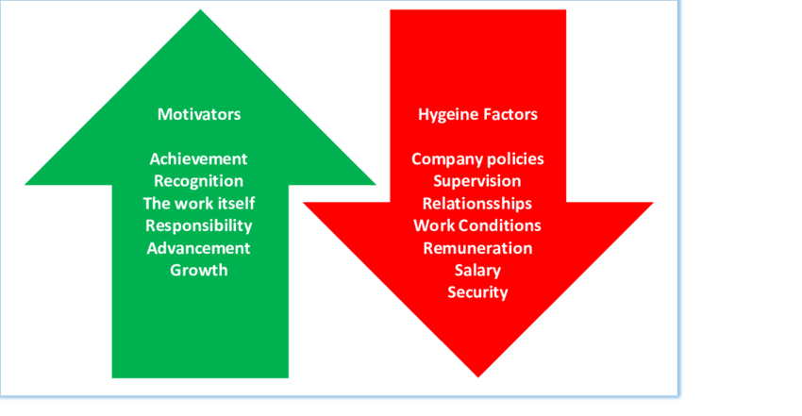
(MacPherson, 2021)
Herzberg suggests that there are two types of factors that affect job satisfaction and dissatisfaction. Hygiene factors are things like salary, work conditions, and company policies. Motivators are factors like recognition, responsibility, and achievement. If you have a good salary and decent working conditions, it might prevent you from being unhappy, but it won't necessarily make you happy. To be really satisfied with your job, you need things like recognition for your work or opportunities to grow.
While this theory helps us understand what makes people satisfied or dissatisfied at work, it might not capture all the factors that matter, like workplace culture or relationships with colleagues.

Maslow's Hierarchy of Needs:
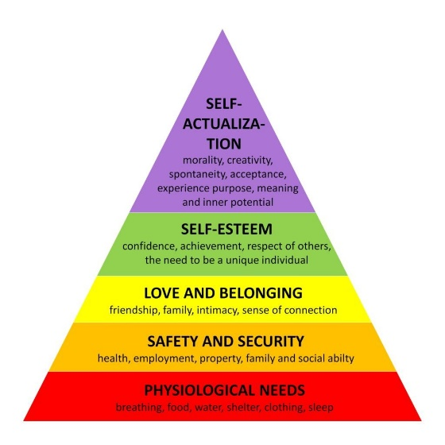
(McLeod, 2024)
Maslow suggests that people have different levels of needs, and they must satisfy lower-level needs before moving on to higher ones. The hierarchy includes basic needs like food and shelter, safety needs like job security, social needs like friendships, esteem needs like recognition, and self-actualization needs like personal growth. If someone is struggling to pay their bills, they might not be able to focus on things like career advancement. But once their basic needs are met, they might seek out opportunities for personal development and fulfilment. While this theory helps us understand what drives human behaviour, it's been criticized for thinking of individual differences and cultural variations in how people prioritize their needs.
These theories offer valuable insights into what motivates people in the workplace, but they each have their limitations and may not apply universally to all situations or individuals in the UK or elsewhere.
McGregor's Theory X and Theory Y:
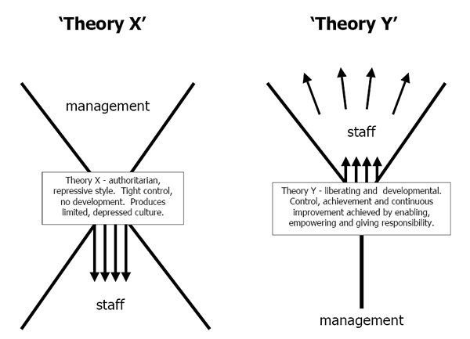
(Dudovskiy, 2013)
McGregor describes two different attitudes managers can have toward their employees. Theory X managers think employees are lazy and need to be closely controlled, while Theory Y managers believe employees are self-motivated and responsible. In the UK, a Theory X manager might micromanage their team because they don't trust them to work independently. But a Theory Y manager might give their team more freedom and responsibility, trusting them to do a good job.
This theory highlights how different management styles can influence employee motivation, but it might oversimplify the complexity of human behaviour in the workplace.
Theory X:
In a Theory X management style, the salon owner or manager might believe that employees are lazy and need to be closely monitored and controlled. They might think that without constant supervision, employees will slack off or make mistakes. In a salon with a Theory X manager, employees might have strict schedules and rules to follow. The manager might closely monitor their work and provide detailed instructions for every task. There might be little room for creativity or autonomy, as the manager believes that employees can't be trusted to make good decisions on their own. While this approach might ensure that tasks are completed according to the manager's standards, it can lead to demotivation and resentment among employees. They may feel micromanaged and undervalued, which could ultimately affect the quality of service they provide to clients.
Theory Y:
In contrast, a Theory Y management style assumes that employees are self-motivated, responsible, and capable of making a good contributions to the salon. Managers who subscribe to Theory Y trust their employees and believe that they will excel when given the opportunity. In a salon with a Theory Y manager, employees are given more. They might have input into decision-making processes, opportunities for training and development, and flexibility in how they approach their tasks. This approach fosters a positive and supportive work environment where employees feel valued and empowered. They are more likely to take ownership of their work and go above and beyond to satisfy customers.
In summary, applying McGregor's Theory X and Theory Y to a salon environment can have significant implications for employee motivation, job satisfaction, and overall salon performance. A Theory Y approach, which shows trust, empowerment, and is likely to result in happier employees, better customer service and a more successful salon.

Factors that affect motivation
Supportive and positive Environment (Intrinsic & Extrinsic): Having supportive colleagues and managers who listen and help can boost motivation. A supportive and positive work environment, good relationships among colleagues, fair treatment, and effective communication, can be both intrinsically and extrinsically motivating, as it contributes to overall job satisfaction.
Recognition and Rewards (Extrinsic): Getting praised or rewarded for good work can make people feel valued and motivated to keep doing well. When salon owners or managers recognize employees' hard work, talent, or creativity, it can boost motivation. This could be through verbal praise, employee of the month awards, or bonuses.
Clear Goals: When people know what they're working toward and understand the steps to get there, they're more likely to stay motivated. Providing clear pathways for career progression.
Work-Life Balance(extrinsic): Feeling balanced between work and personal life can help maintain motivation and prevent burnout. Offering flexible working hours or the ability to balance work and personal life commitments can be an extrinsic motivator, as it provides employees with a sense of control and autonomy over their time.
Interest and Passion: When people enjoy what they're doing and feel passionate about it, they're naturally more motivated to put in effort.
Feedback: Constructive feedback helps people understand how they're doing and where they can improve, which can keep them motivated to grow.
These factors can vary from person to person and situation to situation, but they all play a role in influencing motivation.

Conflict

Conflict in the workplace happens when people disagree or have problems with each other. It can be about different ideas, ways of doing things, or even personal issues. Conflict can make the workplace uncomfortable and affect how well people work together.

As a salon manager, conflict in the workplace can arise when stylists or staff members have disagreements about client appointments, scheduling, or salon procedures. For example, there might be tension between two stylists over who getting more work or both stylist wanting the same day off preferences. Resolving these conflicts requires effective communication, empathy, and a willingness to listen to everyone's concerns. By addressing conflicts quickly and finding solutions that accommodate everyone involved, a salon manager can keep a positive work environment.

References

Communication Theory. (2014, July 10). BERLO’S SMCR MODEL OF COMMUNICATION. Communication Theory. https://www.communicationtheory.org/berlos-smcr-model-of-communication/

Donohue, M. (2017, January 24). Shannon-Weaver Model of Communication. Medium. https://medium.com/design-theory-critical-thinking/shannon-weaver-model-of-communication-ce9ca9c14741

Dudovskiy, J. (2013, March 21). Theory X and Theory Y - Research Methodology. Research-Methodology. https://research-methodology.net/theory-x-and-theory-y/

MacPherson, A. (2021, January). Fig 4 -Herzberg’s Two Factor Theory (EPM, 2018) Herzberg’s Two factor... ResearchGate. https://www.researchgate.net/figure/Herzbergs-Two-Factor-Theory-EPM-2018-Herzbergs-two-factor-theory-shown-in-fig-4_fig3_348555191

McLeod, S. (2024). Maslow’s hierarchy of needs. Simply Psychology. https://www.simplypsychology.org/maslow.html

Wikipedia Contributors. (2022, November 1). Schramm’s model of communication. Wikipedia; Wikimedia Foundation. https://en.wikipedia.org/wiki/Schramm%27s_model_of_communication

worksheetsplanet. (2024, February 11). What is Motivation | Definition of Motivation. Worksheets Planet. https://www.worksheetsplanet.com/what-is-motivation/

Appendix A – Personal development plan
Areas for development | Strengths | Weaknesses | Action plan
Communication Skills | Excellent verbal communication skills I am able to give instructions and information Comfortably to staff and clients | struggles with written communication provide timely updates or feedback | Set reminders to provide regular updates and feedback to staff
Leadership | Strong leadership presence. I can motivate and inspire salon staff  Effective at delegating tasks and responsibilities | I need to be more authoritative at times Tends to micromanage certain tasks | Practice delegating tasks without micromanaging to empower staff
Time Management | Capable of prioritizing tasks effectively Manages salon schedules efficiently Able to handle multiple responsibilities simultaneously | Sometimes struggles with delegating tasks, leading to feeling overwhelmed Occasionally procrastinates on administrative tasks | Implement a time management system or tool to track tasks and deadlines  Delegate non-essential tasks to capable staff members to free up time for essential duties

