Project Planning and Management in the Workplace

Ranu Begum 1710178

Table of Contents
Introduction 3
Critical Assessment of Project Management Tools and Techniques 3
Various Tools and Abilities to Plan and Implement Project within the Workplace 7
Organisation Overview and Tools used for the Project 8
Communication and Implementation of the Project Plan 9
Critical Evaluation 10
Evaluation of Personal Abilities 10
Future Recommendation 10
Personal Development Plan 10
References 12

Introduction
Project management is one of the most critical aspects of the modern era, which helps the organisation to manage the overall activities appropriately. The ideology of project management can be defined as a systematic approach followed by the organisation to manage any particular task with initiation, planning, execution, control and closure to achieve a specific business goal within an allocated timeframe and budget Thayer (2018).
The chosen organisation for this task is Sort Your Future as the report will critically review and analyse about various project management tools and techniques used by the organisation to manage its project successfully.

Critical Assessment of Project Management Tools and Techniques
Quad Chart: These documents are termed as Quad charts as there are four different quadrants associated with it which are presented in a landscape manner.
According to the analysis of Thayer (2018), the Commerce’s National Oceanic and Atmospheric Administration (NOAA) department in the USA prepares Quad Chart. The focus behind the development of this dashboard is to improve budget management and project planning. Generally, the Quad Chart associated with the project is a technical documentation, which is used by the command team as COP or common operating picture to manage the overall project is helpful in managing the command staff, running estimate associated with budget, manage culture and develop a proper prototype, which is necessary to cater a detailed dashboard. (Alperen, 2011)
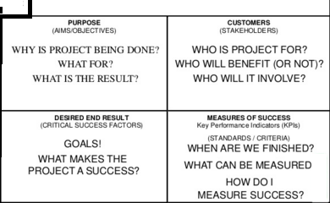
Figure 1: Sample QUAD Chart
(Source: Thayer, 2018)
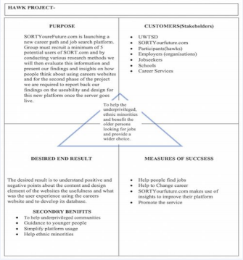
Figure 2: Quad Chart of the Sort Your Future’s Project
(Source: Created by Learner)
Iron Triangle:
The Iron triangle associated with project management refers to the relationship between three different parameters namely scope, scheduling and cost associated with the project (Wysocki, 2011). The iron triangle is often known as the flexibility matrix as well. These three are the basic factors that the project manager must consider while designing any project plan. Scope associated with the total volume of tasks, the cost is associated with the budget allocated and schedule is the estimated time for the same (Wysocki, 2011).
The scope of the project is to develop software to support job search for the students as well as employers and consultancy group, which will help in accessing the right candidate (Moustafaev, 2014). These three factors interlinked and lead to the quality of the project.
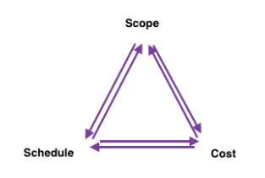
Figure 3: Iron Triangle of Project
(Source: Created by Learner, influenced by Wysocki, 2011)
Gant Chart: According to Mubarak (2015), a Gantt is a specific bar chart that appropriately replicates the overall project schedules with the establishment of the internal relationship between different tasks. Here are the advantages and disadvantages associated with the process.
Advantages
- Helps the project manager to organise the overall planning associated with the project and allocated schedule accordingly
- It is helpful to demonstrate the fact that the project manager is clear in his or her thoughts about what they need to perform. (Mubarak, 2015)
Disadvantage
- If the number of tasks is high with a greater degree of interdependency, the Gantt chart can be very complex to discuss and demonstrate.( Mubarak, 2015)
- The volume of work associated with the task never indicates by the Gantt chart; therefore time management in between the project, especially for long ones can be misleading based on Gantt chart (Mubarak, 2015).

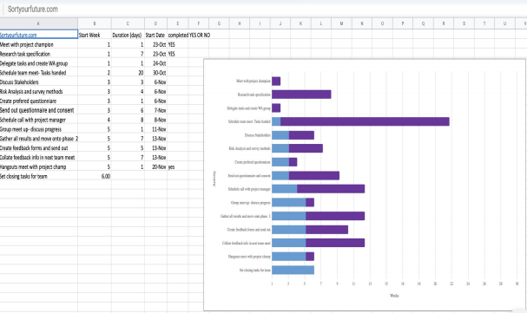
Figure 4: Gantt chart of the Project of Sort Your Future
(Source: Created by the Learner)
Stakeholders: The stakeholders are any individual or group of individual or organisation as well who are directly or indirectly associated with the overall project and someway or others influenced by the outcome of the project also (Schibi, 2013). There are broadly 2 types of project stakeholders, namely, internal and external (Roeder, 2013). The internal stakeholders are from inside the organisation that gets affected by the project process and outcome. This group includes employees, management, project team, project managers. External customers are from outside the organisation who are mostly get affected by the overall outcome of the process. This group includes suppliers, sponsors, government, consumers, local authorities and do on (Schibi, 2013).
Risk Analysis: It is helps project manager to identify different factors, which will negatively affect the overall performance of the project and design appropriate strategies to mitigate those challenges (Hopkin, 2013). The risk management plan is associated with every project to downplay the chances of outcome quality being affected. The overall process involves the following stages, namely identification, evaluation, mitigation planning and evaluation of the plan followed by implementation. (Hopkin, 2013)
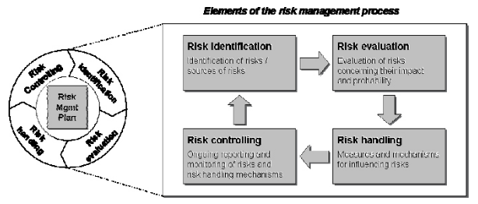
Figure 5: Risk Management in Project
(Source: Lavanya and Malarviz, 2018)
WPBS: One of the major success tool associated with project management is the development of a proper work breakdown structure. It is a delivery oriented hierarchical task to break down the process, which is important for the project team to execute appropriately. WBS (work break down structure) is helpful for the project manager to identify, scheduling and estimate all the tasks (Cobb, 2011).
There are different benefits associated with this tool about the project such as
- It helps in developing productivity
- Mention all the stages in detail associated with project management
- This tool helps in improving the level of transparency and accountability (Cobb, 2011).

Various Tools and Abilities to Plan and Implement Project within the Workplace
The overall project is aiming to develop a model to find out a project champion among all the participants. The organisation Sort Your Future is focusing on identifies the fundamental issues associated with the selection process and Career education. The focus of the firm is to ensure that everyone gets the best opportunity and able to choose the right career path. The firm organises different job types depending on the strength and interest of the candidates so that the organisation can make it easier (Sort Your Future, 2019). To manage this project appropriately, the organisation designed a QUAD chart which is helpful for the understanding of what the organisation is planning to achieve (new career path and job search platform) (Patel, 2019) and who will be the potential customers (Stakeholders) for the same. These two factors are discussed in the top two quadrants. The bottom two quadrants represent what the organisation is expecting from the project (Desired Outcome) and how the same will be measured. At the centre, the focus of the organisation has been represented to make it linked with all the 4 quadrants (Patel, 2019). Use of risk analysis tool is necessary for the project manager in this case because the entire process is dependent on the market survey and gathered information through a survey (Patel, 2019). Different mitigating actions are necessary which will support the successful completion of the project in that scenario. The stakeholder analysis helps categorise all the stakeholders associated with the task based on their priorities (high, low and medium) and their perspectives associated with this project are discussed to understand their expectations (Hillson, 2012). This analysis is helpful to design a proper action plan for the researcher, which is mentioned at the end. In this project, the organisation is using WBS in detail possible manner so that all the activities associated with four different phases of the project life cycle can be managed properly (Wysocki, 2010). The WBS simplifies the overall task flow and helps the project manager to continuously check how all tasks are moving as there is the number of activities interlinked. The project manager prepares a detail Gantt chart where the start and end date of all the tasks are mentioned which will be helpful to manage the project flow appropriately. All the tools used in this project are therefore important to help the project manager complete the project to achieve the desired outcome, (Wysocki, 2010)

Organisation Overview and Tools used for the Project
As a career development and recruitment solution providing organisation, the focus of Sort Your Future is to develop such a website which will not only help the students but at the same time; it will help the institutes as well as the career service providers, employers as well (Sort Your Future, 2019). Keeping their broad perspective in mind the organisation conduct a survey, as well as secondary research as both, are helpful to develop that model of the website and do necessary risk analysis associated with the same. The focus of the organisation is to manage and tackle challenges associated with career planning and management that the students are facing and design appropriate solution for the same. At the same time, the organisation is focusing on giving proper services to institutes, companies as well as consultancies an application which is helpful to choose right people for various roles (Sort Your Future, 2019)
The tools like stakeholder analysis and risk management, along with QUAD model, plays a vital role in the initiation only. The WBS, Gantt chart where the pre-approved software development flowchart developed by the project manager and allocates the job to various resources along with the schedule (Hill, 2013). The communication model, correlation between tasks mentioned in the Gantt chart as well as well-planned WBS is very much important here. The last phase is the evaluation where the project manager has done a detail evaluation by comparing the outcome with the main objectives. (Hill, 2013)

Communication and Implementation of the Project Plan
Project communication plan is helpful for the project manager to communicate all relevant development and progress (as well as limitations) associated with the project to all the concerned people (Binder, 2016). To achieve success, designing a proper communication plan at the very beginning is necessary because it decreases the chances of miscommunication within the project team, with top management as well as with the stakeholders.
To implement the communication plan in this project, Sort Your Future will follow four different forms such as team meeting, stakeholder update, the management or board meeting and designing newsletter and follow a structured policy for successful implementation of the same:
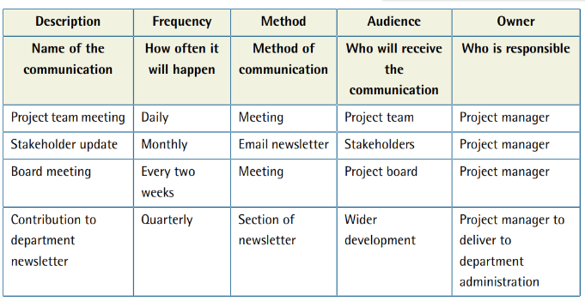
Figure 6: Communication Model for Sort Your Future
(Source: Lynch, 2019)

Critical Evaluation

Evaluation of Personal Abilities
A critical review of my abilities associated with overall project management reveals that my understanding of basic project management tools and their uses are clear with how and where those can be implemented. However, there are opportunities to gain more in-depth knowledge about the same to make sure that the proper implementation of those tools can be done. Secondly, project management required proper coordination among team members while working and designing any plan to manage the project successfully and take responsibility for certain parts of the study (Gudda, 2011). As an individual, I can manage the same with my in-depth understanding associated with some of the parts like risk management and stakeholder review.

Future Recommendation
- To improve my knowledgebase with project management, I focus on
- Work on various projects and use different tools in detail to understand how those can be effectively managed.
- Design a variety of project management plans for a single project and analyse which one will be better to achieve maximum success at the shortest possible time.
- Improve my understanding of the tools and techniques associated with worth with project management.

Personal Development Plan
Goals | Action | Measures | Time
Improve knowledge about project management tools | Undergo different courses to strengthen project management skills. | Ability to implement the key tools in a logical manner, Keep regular contact with manager | 20 weeks
Improve understanding of the logic behind project planning | Analyse difference business scenario from secondary research associated with the project and try to implement the right approach | Design and develop a project management plan which is important for project success appropriate to my learning or future goals. Keep simple but clear | 15 weeks
Improve project measurement approach understanding | Working with senior team members and learn how to measures project success. Use enhanced Gants and flow charts more effectively. | Able to manage proper review technique which helps in understanding whether stakeholder’s demand is meet or not | 21 weeks

Table 1: Personal Development Plan
(Source: Created by learner)

References
Binder, J. 2016. Global project management: communication, collaboration and management across borders. London: CRC Press
Cobb, A.T. 2011. Leading project teams: the basics of project management and team leadership. Sage.
Guddas, 2011. A guide to project monitoring and evaluation. London: Author House
Hill, M.G. 2013. The complete office management project handbook. London: CRC Press
Hillson, D. 2012. Managing risk in project. London: Gower Publishing Ltd.
Hopkin, P. 2013.Risk management. Kogan page publishing.
Lavanya, N. and Malarvizhi, T. 2018. Risk analysis and management: a vital key to effective project management. [Online] Pmi.org. Available at: https://www.pmi.org/learning/library/risk-analysis-project-management-7070 [Accessed 7 December 2019]

Lynch, W. 2019. Project management — communication plan template and example. [online] Medium. Available at: https://medium.com/@warren2lynch/project-management-communication-plan-template-and-example-5f86590b5900 [Accessed 7 Dec. 2019]
Moustafaev, J. 2014. Project scope management: a practical guide to requirements of engineering, products, construction, IT and enterprise projects. London: CRC Press.
Mubarak, S.A. 2015.Construction project scheduling and control. New Jersey: John Wiley & Sons.
Patel, n. 2019. Practical project management for engineers. Artech House
Roeder, T. 2013. Managing project stakeholders: building a foundation to achieve project goals. New Jersey: John Wiley & Sons.
Schibi, O.2013. Managing stakeholder expectations for project success: a knowledge integration framework and value focused approach. J. Ross Publishing
Sort Your Future. 2019. Talent is equally distributed, opportunity is not. [online] Available at: https://www.sortyourfuture.com/about [Accessed 7 December 2019]
Thayer, M.K. 2018. Quad chart: the executive leadership dashboard. [online] Rally point. Available at: https://www.rallypoint.com/status-updates/3726502 [Accessed 7 December 2019]
Usmani, F. 2019. Stakeholders in project management. [online] PM Study Cycle. Available at: https://pmstudycircle.com/2012/03/stakeholders-in-project-management-definition-and-types/ [Accessed 7 December 2019]
Wysocki, R.K. 2010. Effective software project management. New Jersey: John Willey & Sons.
Wysocki, R.K. 2011. Effective project management. New Jersey: John Wiley & Sons.

