ASSIGNMENT 2
The Impact of Digital Twins
Exploring the cultural and workforce factors that contributes to successful adoption of digital twins. And identifying the potential economic and societal benefits from a successful implementation.
Author: Chun Ho
Student ID: 2237975
Module Course: Industry 4.0 Advanced Manufacturing
Date: 22nd September 2023

Contents

Summary 3
1.0 Introduction 4
2.0 What is a digital twin? 5
3.0 Tools enabling digital twin 6
4.0 Human factors to consider 9
5.0 Economic and societal benefits 11
6.0 Case study: HS2 13
7.0 Conclusion 17
References 18

Summary

An exploration of the technological tools that enables digital twins such as internet-of-things (IoT) sensors, software and services from technology providers (such as Unity), advancements in immersive technology (such as affordable mixed reality (MR) headsets).
Via a case study, this document investigates a successful design and implementation of a digital twin by the HS2 project. Understanding how they identified their challenges (eg. the requirement to share data across the whole project) and produced solutions (web-browser based collation, processing and presentation of data).
Cultural and workforce factors identified within this document that contribute to a successful implementation of digital twins:
- The general acceptance of Gen Z age group who are generally more acceptance of technology when compared to their older colleagues.
- A lack of experience and expertise within an enterprise can lead to an unsuccessful implementation of industry 4.0 technologies. Therefore, creation of new roles and training are important considerations.
The economic benefits of successful implementation of industry 4.0 such as digital twins can potentially help to redevelop a manufacturing industry as the government of Hong Kong is trying to achieve via investments in technology parks and support from local Universities through the development of metaverse digital twin versions of campuses.
There are societal benefits from the implementation of digital twins eg. UK government funded services such as the Smart Manufacturing data Hub (SMDH) was formed to help small and medium sized enterprises (SMEs) to implement IoT sensors to their existing manufacturing workspace. This allows machine learning to analyse data such as energy usage to identify periods of energy waste. When shared with other manufacturing enterprises, this sharing of data can lead to a reduction of carbon footprint produced the manufacturing industry.

Introduction

This document aims to explore the cultural and workforce factors that contributes to a successful implementation of a digital twin. Additionally, this document aims to identify the potential economic and societal benefits that can come from digital twins.
This will be achieved by understanding what is a digital twin and the tools that enables the technology. As well as the services from technology companies and UK government funded initiatives that help SMEs to realise their implementation.
Finally, this document aims to study a real case of a successful digital twin implementation that provided a solution to specific challenges.

2.0 What is a digital twin?

Broadly speaking, a digital twin is a representation of an object or system that is updated from real-time data, and it may use simulations and machine learning to facilitate decision-making at different levels (IBM, n.d.).
Digital twins can help organisations to simulate real situations to produce data for analysis by machine-learning processes. With the aim to facilitate better decision making (McKinsey & Company, 2023). Within the manufacturing space, this can lead to:
- More effective research & development projects eg. data and insights from product simulation can help to refine the design prior to production.
- Greater efficiency during the production process eg. arrays of sensors across a production line can prompt when to restock raw materials to ensure a continuous production.

3.0 Tools enabling digital twin

3.1 Internet of things (IoT) sensors
A digital twin uses data from interconnected sensors to form the bigger picture of the state of the physical counterpart. The vast array of sensors, referred to as internet-of-things (IoT) are placed across the physical infrastructure and their purpose is to measure specific indicators of the health of components and performance. Data collected includes temperature and humidity of machine parts, stock levels of raw materials.
The benefits of smart sensors in a supply chain of a manufacturing business includes (Deloitte, n.d.):
- Increase operational efficiency through the automation of operations.
- Reduce costs in repairs and maintenance via better monitoring.
- Perform real-time inventory tracking.
- Inform product development through automated data feedback.
- Enhanced customer experience.
Soft sensors are software-based that uses algorithms to process hundreds of measurements simultaneously. Within a smart factory, soft sensors can be implemented in physical environments where hardware sensors would be impractical such as chemical processing or combustion environments (Ernst & Young Global Limited, 2019).

3.3 Software
An example of software tools and services that enables the realisation of digital twins is offered by Unity Technologies, providers of the popular Unity game engine which powers many mobile and console games.
Unity Technologies has expanded upon their Unity game engine to offer a suite of software and services for businesses and developers to help them to realise digital twin ambitions (Unity Technologies, n.d.).
Developers can leverage Unity’s existing capabilities to provide 3D, augmented reality (AR), virtual reality (VR) development platforms to be delivered to end users via mobile, desktop and web-browser. Developers and 3D designers can build digital replicas machines or a whole production process and add realistic simulation that adheres to real-time physical laws such as gravity and Newtonian forces.
Unity Technologies’ expansion from the gaming industry to the manufacturing sector (via the Unity Industry) allows for game developers to expand their skills as game developers to producing digital 3D assets for a wider range of businesses. Therefore, allowing developers greater job opportunities previously limited to gaming companies.

3.4 The industrial and enterprise metaverse
The industrial and enterprise metaverses are described as a ‘highly immersive and connected virtual and physical reality enabling never-before-seen levels of connectivity and data analytics’ (World Economic Forum, 2023). They share similarities to the consumer metaverse.
As the time of writing the metaverse is still at a nascent stage that lacks definition. However, it is generally agreed that the underlying technologies enabling the industrial metaverse are IoT, artificial intelligence, cloud and edge computing, extended reality (XR), 5G networks and robots.
There are opportunities that comes from the connection of a digital twin to the industrial metaverse. For example, workers will be able to perform operations, diagnose or solve problems remotely. Additionally, the vast array of sensors can be analysed by machine learning to optimise how much effort is required for tasks which, in turn, can raise safety standards.
The interconnectivity of the production process via the industrial metaverse can provide other benefits too eg. suppliers of raw materials can automatically send warnings to vendors to prepare for disruptions and adjust production capabilities or find alternative suppliers (McKinsey & Company, n.d.).

3.5 Presentation of a digital twin to an end user
Use of immersive technology for presentation of data
Currently, the definitions and abbreviations for immersive technology terminologies are inconsistent and contested amongst hardware providers, academics and other stakeholders (Rauschnabel, et al., 2022; Milgram, et al., 1995). However, for the purposes of this document the author uses the following abbreviations: extended reality (XR), virtual reality (VR), augmented reality (AR) and mixed reality (MR) and the following definitions (The International Organization for Standardization, n.d.). The ISO does not currently have a definition for extended reality however, it is generally defined as an umbrella term for AR, VR and MR (Qualcomm, 2017).
Virtual Reality (VR) | Mixed Reality (MR) | Augmented Reality (AR) | Reality
Artificial virtual environment | Physical and virtual objects co-exist and interact | Reality has virtual information | Real physical environment
Figure 1 ISO’s definitions of VR, MR, AR and reality
Data from a digital twin can be presented to an end user via AR, VR or MR. Hardware facilitating these features include the Microsoft Hololens, Meta Quest Pro, Apple Vision Pro, AR capable mobile phones and tablets. Continuous improvements in this field such as video passthrough features on the Meta Quest and Apple Vision Pro (Meta, n.d.) devices also facilitate the presentation of data to end users.
The use of immersive technology to present data from a digital twin to an end user has many advantages eg.:
- An accurate 3D model can improve collaboration during the research and development phase of a product by allowing team members to have a spatial awareness of the final product. Decisions can be made by team members at different geographical locations.
- Planning and layout of large machines can be made collectively as different teams and departments can have their say and voice concerns.
- Experts can remotely provide guidance to troubleshoot issues and thus reducing travel cost and increased efficiency. Step-by-step maintenance would be easier for machine operators to perform even if they are unfamiliar with the machine.
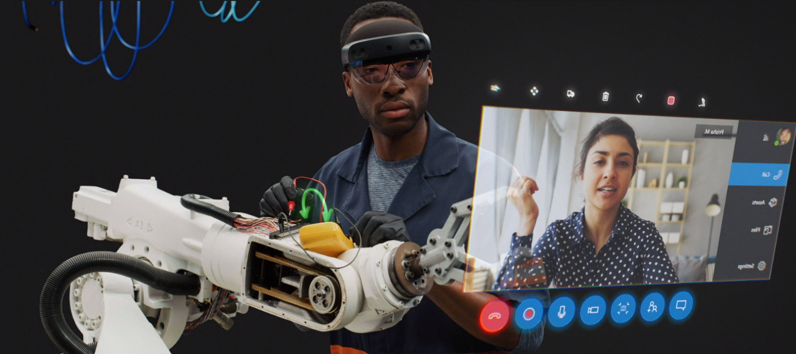
Figure 2 An intended use of the Microsoft Hololens where a machine operator receives help from a remote expert (Microsoft, n.d.)

Use of web-browser for presentation of data
There are also non-immersive methods of presenting data to the end-user as this was utilised by the High Speed Two (HS2) project (see the case study at section 6 of this document). One of the aims of the HS2 digital twin project is to make data accessible to different teams and departments across the project. And by making the data available via a web-browser, end-users can collaborate and make decisions based on IoT sensor data and analytics without the need to install specialist software or plugins. Data made available includes CAD models, BIM files, databases, schematics, spreadsheets etc (iTwin.js, n.d.).
Advancements in webGL technology facilitates these features eg. Google model-viewer allows for browser based 3D content which is accessible via mobile devices and and desktop computers (Google Inc, n.d.). Web-browser based 3D model viewers are windows within a webpage that displays 3D models (eg. a digital version of a machine) and make it interactive via programming languages such as javascript.

4.0 Human factors to consider

4.1 Cultural factors
As Gen Z age group enters the workforce, we may see a shift in the general attitudes and acceptance of industry 4.0 related technologies such as the metaverse and digital twins. Generally defined as born between mid-to-late 1990s and early 2010s, people from this generation sees the metaverse as a new frontier for them (Nokia and Ipsos, 2022).
Gen Z’s willingness to adopt new technologies are reflected by universities around the world who creating digital twin versions of their campuses. For example, two of Hong Kong’s universities have metaverse counterparts which are aimed at students to learn, rather than for the purposes of operational maintenance. In July 2022, The Hong Kong of University Science and Technology (HKUST) announced MetaHKUST, a ‘twin campus in metaverse’ (HKUST, n.d.). Whilst in May 2023, the University of Hong Kong (HKU) announced the ‘HKU Campusland’ (The University of Hong Kong, n.d.).
The MetaHKUST campus aims to link the university’s Hong Kong and Guangzhou physical campuses to allow for students to attend the same lectures as the geographical distance would make it impractical to attend every lecture. Physical infrastructures were in place to facilitate the teaching. XR classrooms were kitted out with sensors, cameras, and VR harnesses for lecturers.
This cultural change is supported by a particular finding where 77% of the region’s population have an awareness of the metaverse and 82% have an awareness of extended reality (Lo, 2022). This high awareness of the metaverse and web 3.0 technologies could lead to a skilled workforce equipped with knowledge to develop a smart manufacturing industry.

4.2 Workforce factors
An important factor to consider when adopting a digital twin is the acceptance and availability of skilled workforce. The Metaverse at Work Report (Ernst & Young and Nokia, 2023) finds that 32% of companies surveyed identifies ‘reluctance to adopt’ as a primary challenge to implementing the industrial metaverse and its related technologies. And the same survey identifies 47% of companies identifies a ‘lack of expertise’ as the primary challenge.
The Sensors as Drivers of Industry 4.0 report (Ernst & Young, 2019) suggests that many companies will need to invest vast sums of money to adopt new technologies in their factories. Employees will need to have ‘a flexible outlook, engage in active learning, and have high cognitive skills’. New job roles suggested includes robot coordinators, industrial data scientists, supply chain coordinators, simulation experts and digitally-assisted service engineers.
As mentioned previously, workers are able to work and diagnose issues remotely using industry 4.0 technology (World Economic Forum, 2023). Additionally, workers can learn remotely via immersive technology such as virtual reality (VR) eg. Linde Virtual Academy allows operators to gain machine operation skills (Linde Virtual Academy, n.d.).
However, a drawback of digital, but non-VR training, sessions is that it doesn’t provide engaging practical hands-on training to operate machinery. VR allows trainees to receive a sense of spatial awareness like a practical hands-on training. VR allows trainees to receive a sense of spatial awareness like a practical hands-on training. Immersive technology can contribute to a positive training experience by creating a ‘sense of presence’ that other digital training methods cannot provide (Garnham, August 2021). A sense of spatial presence adds value by providing simulated physical control and its impact is greater for customers who prefers verbal rather than visual information (Hilken, et al., 2017).
Training takes place in VR and trainees can start and complete each module to suit their schedule as long as they have the hardware specified on their website: a VR capable computer and a VR head-mounted display.

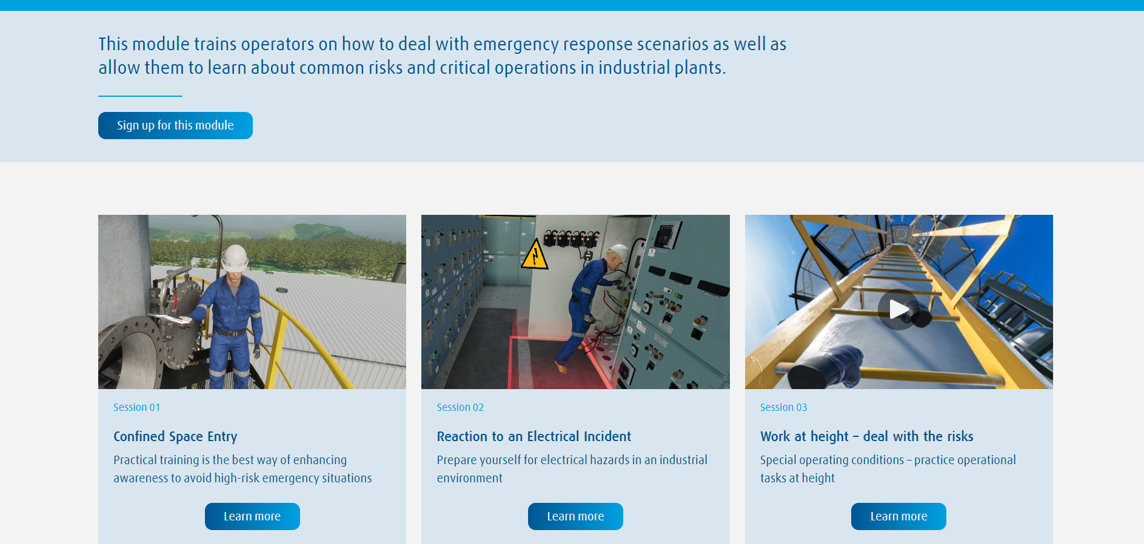
Figure 3 Courses and modules offered by the Linde Virtual Academy (Linde Virtual Academy, n.d.)

Workforce engagement allows a company to ensure successful adoption of new technologies. McKinsey & Company lists five areas manufacturers can engage with the workforce so to ensure a smooth transition to industry 4.0 (McKinsey & Company, 2022):
- Learning and development – new technologies require new skills to operate.
- Empowerment and ownership – encouraging workers to make their own decisions. Eg. utilising AI to analyse data for a worker to make decisions based on analysis
- Collaborations and connections – creating a network of peers to share knowledge and skills
- Impact and recognition – recording achievements and highlighting successes
- The voice of the worker – using digital channels to allow feedback from the workforce

5.0 Economic and societal benefits

Economic benefits
Industry 4.0 technologies such as digital twins are key to many government’s plans to develop industrial sectors. For example, of the 7,906 manufacturing enterprises in Hong Kong, most are SMEs and accounts for 0.1% of the GDP; and 2.2% of the total employment (The Government of HKSAR, n.d.).
To revitalise the manufacturing sector (which has been in decline from 24% in 1980 to 1% in 2020) the Hong Kong Legislative Council introduced a ‘re-industrialisation’ initiative which was launched in 2016 aiming to generate new potential areas for economic growth (Research Office, Legislative Council Secretariat, 2022). This initiative focuses on developing high-end and low land/labour intensive manufacturing industries whilst capitalising on industry 4.0 technologies.
Government support is provided via its Hong Kong Science and Technology Parks Corporation (HKSTP) which is upgrading existing industrial estates for the innovation industries. Eg. The Tseung Kwan O Industrial Estate will have an Advanced Manufacturing Centre to support innovative companies.

Societal benefits
The Smart Manufacturing Data Hub (SMDH) is an initiative funded by the UK Government to incentivise small and medium sized enterprises (SMEs) across the UK to adopt IoT sensors, machine learning and other industrial 4.0 technology to factory production lines. This allows data to be collated, analysed and viewed readily via a ‘Virtual hub’ dashboard. These data are then shared with other manufacturing spaces to share best practice of production and energy saving (Smart Manufacturing Data Hub, n.d.).
Another benefit to society comes in the form of upskilling existing workforces. As repetitive tasks are performed by automated robots and sensors, the human machine operators can become decision makers eg. when a machine has a malfunction, IoT sensors on the machine can relay the problem to the human machine operator visually via a mixed reality (MR) headset. This allows the human operator to repair the machine themselves, or ask for advice and guidance from a remote expert, or make the decision to request a repair service.
This would justify paying for training for the human operator to upskill them. And collectively this divides knowledge more evenly amongst different levels of workers. This is backed up by the Future of Jobs Report 2023 (World Economic Forum, 2023) which finds that ‘employers estimate that 44% of workers’ skills will be disrupted in the next five years’. Cognitive skills are reported to be growing in importance most quickly…’
Digital representations of the factory floor became very useful and efficient when the Airbus factory in Broughton was temporarily converted from aircraft component manufacturer to hospital ventilators manufacturer during the early days of the COVID pandemic (Holmes, 2020). Figure 4 shows the tools (currently stored at AMRC Cymru) developed to facilitate the design of the optimal layout of the manufacturing space. Using the augmented reality (AR) features of the Unity game engine to place QR codes under a camera which translates to screen with scaled machinery.
Teams were then able to work collaboratively to efficiently fill the floor with ventilator producing machines whilst implementing the 2-metre spacing rule.
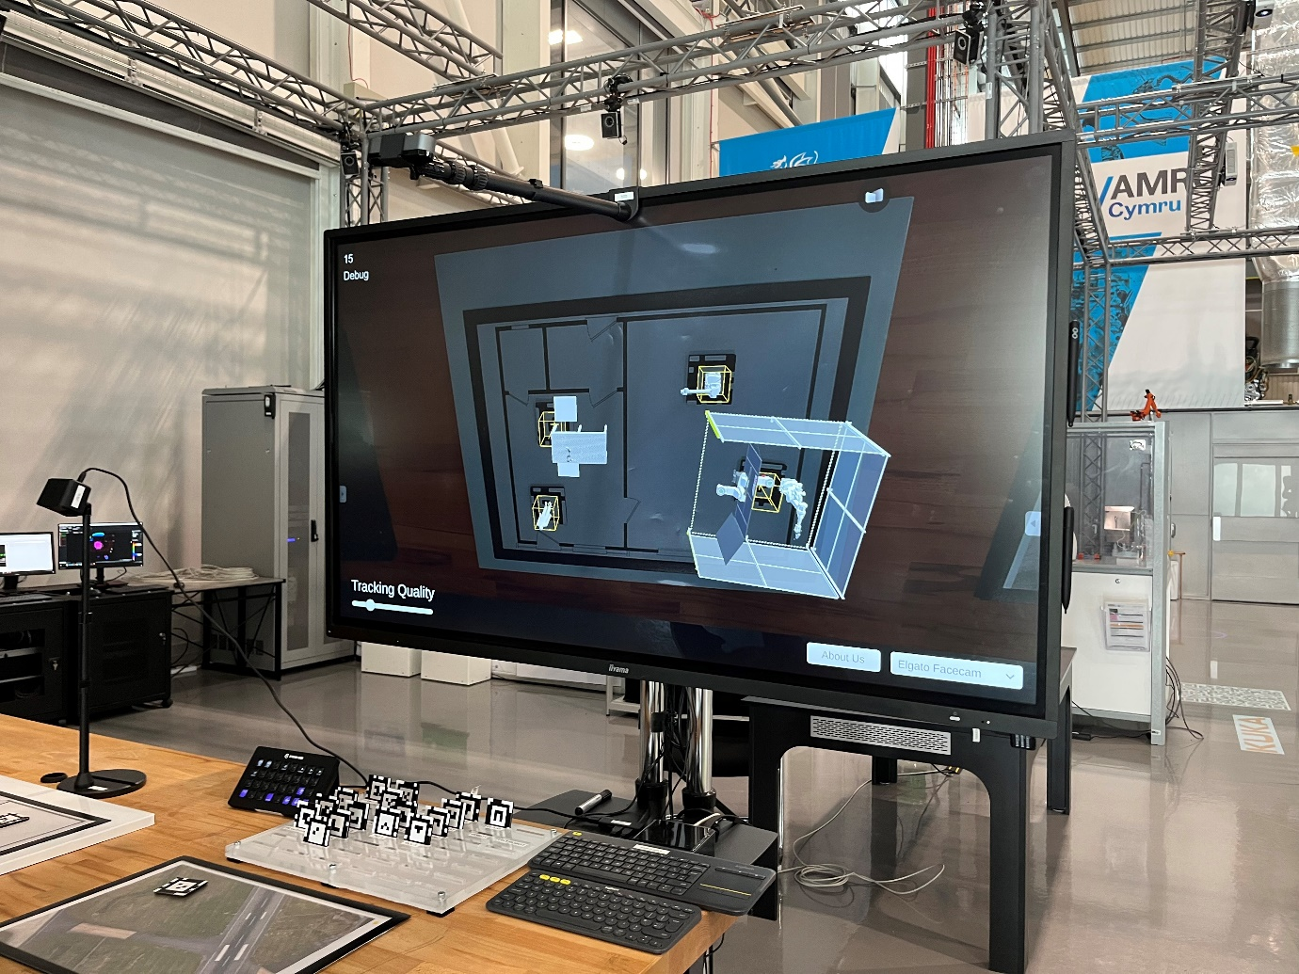
Figure 4 The AR interactive tool at AMRC Cymru which helped Airbus to turn their manufacturing space into a ventilator factory

6.0 Case study: HS2

About HS2 and its challenges
High Speed 2 (HS2) is a high-speed railway line currently in development. The line will run from the southern terminus in London to Manchester with stations in major cities such as Birmingham and Nottingham. It is described as a ‘transformative infrastructure programme’ with the aim of delivering economic, social and environmental benefits for the next century (High Speed Two Ltd, 2022).
The project is supported by 30,000 jobs and over 3,000 businesses with an estimated 400,000 contract opportunities (High Speed Two Ltd, 2023).
As Dr Sonia Zahiroddiny (Head of Digital Engineering at HS2 Ltd) states, the extensive number of contractors involved in the project presents challenges during the design phase where large volumes of data are hosted and ‘siloed’ on different specialist systems and in different formats (Bentley iTwin Platform, 2021). The means sharing of vital information between teams can be technically difficult if one party may not have required software and/or hardware to view the data from another party. Ultimately, this led to a slowdown in the decision making process (Bentley iTwin Platform, 2021).
Since 2019 a digital twin has been in development prior to the commencement of HS2’s construction phase. It was known internally as the ‘BIM (building information modelling) visualisation hub’. This would allow ‘digital railway during design and construction, with a view to hand over a digital twin of the built asset to operations and maintenance’ (Bentley iTwin Platform, 2021).

HS2’s vision and objectives
HS2’s ambition for its digital twin to run the railway virtually at least two years before running it physically. HS2 aims to achieve this by using sensors and machine learning to mimic, simulate and predict how HS2’s assets will perform in real life. The digital twin represents an integrated data and analyses, presents, and visualises the vast volume of data collected within this project (High Speed Two Ltd, 2022).
The objectives of HS2’s digital twin includes:
- ‘Reducing risk’ by virtually simulating safety and operational behaviours and using machine learning to provide in-depth insights.
- ‘Increasing productivity’ by combining diverse datasets of different formats from different systems to drive simulations.

Implementation of HS2’s digital twin
HS2 aims to achieve the development the digital twin in ‘small manageable steps, not one giant leap’. This approach allows HS2 to ‘de-risk’ the programme. The steps, called ‘horizons’, are:
- Enabling & finding
- Analyse, simulate & assure
- Predict, deliver & improve
Figure 5 shows an overview of how the data is collected from the array of data sensors across the HS2 infrastructure to the application programming interface (APIs) and several layers of data processing to be presented to the end users as mapping data, 3D simulations, CAD models, documentation such as health & safety or maintenance manuals.

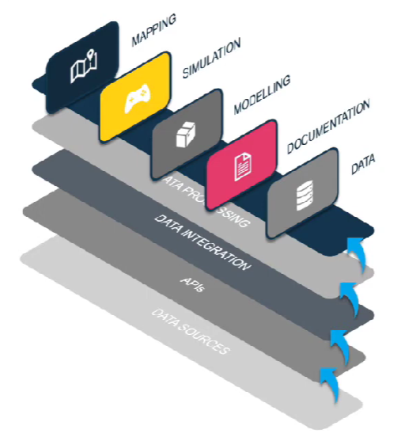
Figure 5 Overview of the journey of data from sensors to user (Bentley iTwin Platform, 2021)

Deployment
It was important for the visualisation of data to be readily available via a web-browser without the need to install a dedicated desktop app or plugins. Figure 6 shows a simple user interface to meet this requirement by sharing data easily across the infrastructure. Figure 7 and 8 shows webGL powered 3D model viewers to allow the navigation and viewing of 3D models within a web browser, ie. without the need to install costly and large specialist desktop applications.
The models can be imported from the Unity game engine to be presented to end users. A user can fly through 3D models and maps or search for specific assets to check its status.
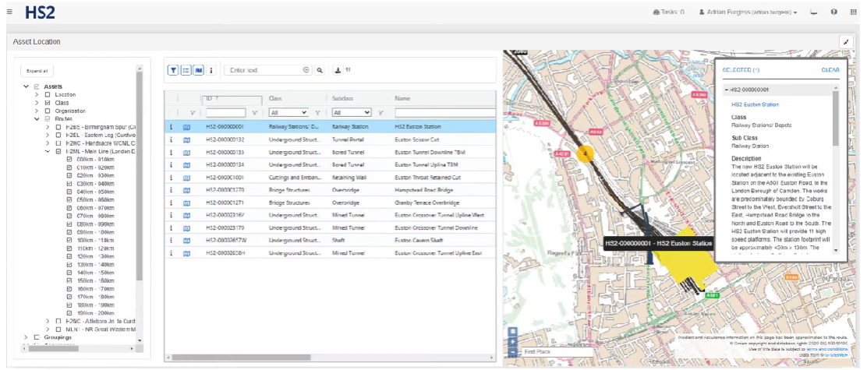
Figure 6 HS2 digital twin user interface (Bentley iTwin Platform, 2021)

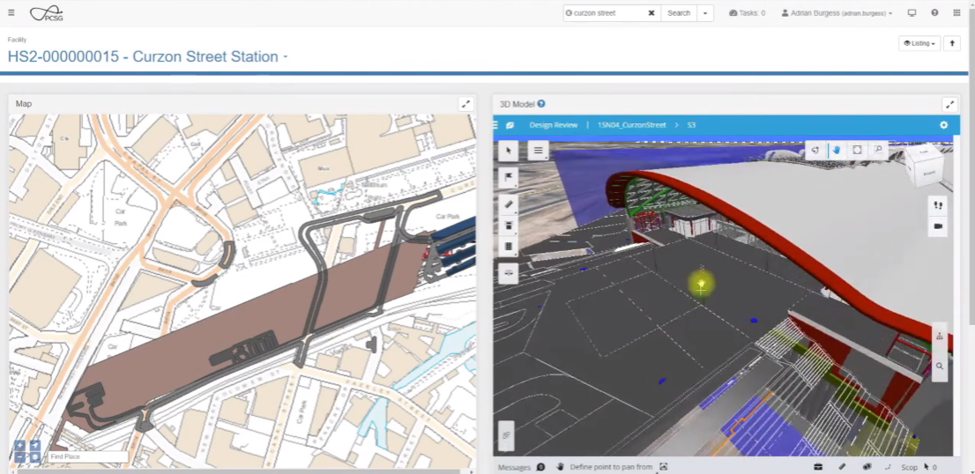
Figure 7 HS2 digital twin browser based 3D model viewer (Bentley iTwin Platform, 2021)

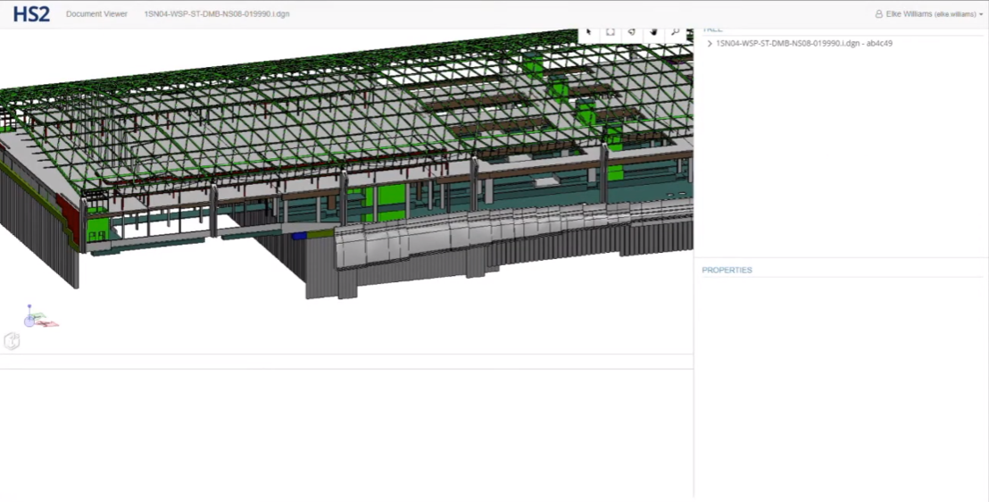
Figure 8 HS2 Detailed CAD drawings available to users (Bentley iTwin Platform, 2021)

End users
The intended end users at the design and construction phase of the digital twin are individual engineers and teams working within the infrastructure team who eg. requires ensuring the track junction fits with adjacent sections (High Speed Two Ltd, 2022).
Whilst the digital twin facilitates collaborative decision-making during the design and construction phase of HS2, the digital twin will be handed to operation and maintenance teams as this will allow engineers to check and pinpoint faulty assets.

Future developments for HS2
According to Dr Sonia Zahiroddiny (Head of Digital Engineering at HS2 Ltd), the next steps for HS2’s digital twin is to receive and store telemetry data from a vast of sensors with a view to provide live performance data from assets. This will allow a ‘micro and macro view of the HS2 infrastructure’.
The project also looks to the future development API framework and mobile application development (Bentley iTwin Platform, 2021) which would allow for greater opportunities for collaboration.

7.0 Conclusion

HS2’s digital twin is a good example of tailoring a solution to the needs and challenges the HS2 project required. The design and construction phase of HS2 involved and generates a vast number of datasets of different formats stored in different locations. The developed digital twin facilitates the sharing of readily available data with different teams by presenting the data via a web-browser user experience. Bypassing the need to install specific and costly desktop applications such as CAD viewing software. Therefore, the end user experience was an important factor when developing the digital twin.
A smooth running of the HS2 railway line is an example of how digital twin can contribute to the economic and societal benefits as promised by the High Speed Two Ltd (greater rail travel capacity, low carbon travel and better connectivity from the financial hub of London to the Midlands (High Speed Two Ltd, n.d.)).
Future developments of the digital twin may involve further integration of a digital manufacturing spaces to the industrial metaverse. This potentially allows for opportunities for workforces to perform tasks remotely and to provide expertise on machines from different geographical locations. This can lead to opportunities for individual jobseekers as well as reducing economic and environmental costs via reduced road travel.
Another example of societal benefits comes in the form of greater job opportunities for designers and developers eg. game developers who were previously limited to jobs within the gaming industry can adapt their 3D modelling skills to producing digital twin assets.
An example of societal benefit is the Smart Manufacturing Data Hub (SMDH)’s incentives to SMEs to adopt IoT sensors across their manufacturing infrastructure allows for shared data and analytics of power consumption which can lead to areas of improvement to reduce energy use. This is shared with other SMHD service users and encourages others to reduce energy consumption using the same method. Leading to a reduction of carbon emission.
However, new job roles and the upskilling of workforces are required for wider digital twins adoption especially for the adoption of the industrial and enterprise metaverses as suggested by findings from The Metaverse at Work Report (Ernst & Young and Nokia, 2023) which finds that 47% of companies surveyed claims a lack of expertise to be the primary challenge of implementing the metaverse.

References

Bentley iTwin Platform, 2021. Case Study: HS2's Digital Twin. [Online]
Available at: https://www.youtube.com/watch?v=qLi1fUHaK7A
[Accessed 14 September 2023].
Deloitte, n.d. Smart sensors and supply chain innovation. [Online]
Available at: https://www2.deloitte.com/us/en/pages/operations/articles/smart-sensors-and-supply-chain.html
[Accessed 22 July 2023].
Ernst & Young and Nokia, 2023. The Metaverse at Work, s.l.: EYGM Limited and Nokia.
Ernst & Young Global Limited, 2019. Sensors as drivers of Industry 4.0, s.l.: EYGM Limited.
Ernst & Young, 2019. Sensors as drivers of Industry 4.0, s.l.: EYGM limited.
Garnham, R., August 2021. Creating a Sense of Presence: The power of virtual and augmented reality. s.l.:Ipsos.
Google Inc, n.d. <model-viewer> Easily display interactive 3D models on the web & in AR. [Online]
Available at: https://modelviewer.dev/docs/#loading-attributes
[Accessed 22 September 2023].
High Speed Two Ltd, 2022. The Digital Twin: A vision for HS2, s.l.: High Speed Two Ltd.
High Speed Two Ltd, 2023. Supply chain. [Online]
Available at: https://www.hs2.org.uk/supply-chain/
[Accessed 20 September 2023].
High Speed Two Ltd, n.d. Why HS2?. [Online]
Available at: https://www.hs2.org.uk/why/
[Accessed 20 September 2023].
Hilken, T. et al., 2017. Augmenting the eye of the beholder: exploring the strategic potential of augmented reality to enhance online service experiences. Journal of the Academy of Marketing Science, pp. 884-905.
Hilken, T. et al., 2017. Augmenting the eye of the beholder: exploring the strategic potential of augmented reality to enhance online service experiences. Journal of the Academy of Marketing Science, pp. 884-905.
HKUST, n.d. HKUST to Launch World’s First Twin Campuses in Metaverse. [Online]
Available at: https://hkust.edu.hk/news/research-and-innovation/hkust-launch-worlds-first-twin-campuses-metaverse
[Accessed 29 May 2023].
Holmes, D., 2020. More than 550 Airbus engineers now making ventilators instead of wings. [Online]
Available at: https://www.cheshire-live.co.uk/news/chester-cheshire-news/more-550-airbus-engineers-now-18136669
[Accessed 21 September 2023].
HSBC, 2022. What does the Greater Bay Area and re-industrialisation mean for Hong Kong businesses?. [Online]
Available at: https://www.business.hsbc.com.hk/en-gb/insights/innovation-and-transformation/what-does-the-greater-bay-area-and-re-industrialisation-mean-for-hong-kong-businesses
[Accessed 29 May 2023].
IBM, n.d. What is a digital twin?. [Online]
Available at: https://www.ibm.com/topics/what-is-a-digital-twin
[Accessed 19 September 2023].
iTwin.js, n.d. What is iTwin.js. [Online]
Available at: https://www.itwinjs.org/
[Accessed 22 September 2023].
Linde Virtual Academy, n.d. Linde Virtual Academy - Courses. [Online]
Available at: https://vr.linde.com/courses/safe-operation/
[Accessed 29 May 2023].
Lo, A., 2022. The Metaverse Perception for Hong Kong. [Online]
Available at: https://www.ipsos.com/en-hk/metaverse-perception-hong-kong
[Accessed 29 May 2023].
McKinsey & Company, 2022. What are Industry 4.0, the Fourth Industrial Revolution, and 4IR?. [Online]
Available at: https://www.mckinsey.com/featured-insights/mckinsey-explainers/what-are-industry-4-0-the-fourth-industrial-revolution-and-4ir
[Accessed 29 May 2023].
McKinsey & Company, 2023. What is digital-twin technology?. [Online]
Available at: https://www.mckinsey.com/featured-insights/mckinsey-explainers/what-is-digital-twin-technology
[Accessed 21 September 2023].
McKinsey & Company, n.d. Digital twins: The foundation of the enterprise metaverse. [Online]
Available at: https://www.mckinsey.com/capabilities/mckinsey-digital/our-insights/digital-twins-the-foundation-of-the-enterprise-metaverse
[Accessed 21 September 2023].
Meta, n.d. Full-colour Pass-through on Meta Quest Pro. [Online]
Available at: https://www.meta.com/en-gb/help/quest/articles/getting-started/getting-started-with-quest-pro/pro-color-passthrough/
[Accessed 22 September 2023].
Microsoft, n.d. Microsoft Hololens 2. [Online]
Available at: https://www.microsoft.com/en-gb/hololens#layout-container-uid86be9
[Accessed 22 September 2023].
Milgram, P., Utsumi, A., Takemura, H. & Kishino, F., 1995. Augmented reality: A class of displays on the reality-virtuality continuum. Telemanipulator and Telepresence Technologies, pp. 282-292.
Nokia and Ipsos, 2022. Gen Z and the metaverse, s.l.: Ipsos.
Qualcomm, 2017. Extended reality: A convergence is coming. [Online]
Available at: https://www.qualcomm.com/news/onq/2017/05/extended-reality-convergence
Rauschnabel, P. A. et al., 2022. What is XR? Towards a framework for augmented and virtual reality. Computers in human behaviour, p. 133.
Research Office, Legislative Council Secretariat, 2022. Statistical Highlights: Re-industrialisation in Hong Kong, Hong Kong: Research Office, Legislative Council Secretariat.
Smart Manufacturing Data Hub, n.d. Manufacturing Smarter. [Online]
Available at: https://smdh.uk/
[Accessed 21 September 2023].
The Government of HKSAR, n.d. Hong Kong : The Facts - Trade and Industry. [Online]
Available at: https://www.tid.gov.hk/english/aboutus/publications/factsheet/factsheet.html
[Accessed 28 May 2023].
The International Organization for Standardization, n.d. ISO/TR 9241-380:2022(en): Ergonomics of human-system interaction — Part 380: Survey result of HMD (Head-Mounted Displays) characteristics related to human-system interaction. [Online]
Available at: https://www.iso.org/obp/ui/#iso:std:iso:tr:9241:-380:ed-1:v1:en
The University of Hong Kong, n.d. Connecting through Campusland. [Online]
Available at: https://bulletin.hku.hk/knowledge-exchange/connecting-through-campusland/
[Accessed 29 May 2023].
Unity Technologies, n.d. Digital Twins. [Online]
Available at: https://unity.com/solutions/digital-twins
[Accessed 21 September 2023].
World Economic Forum, 2023. Future of Jobs Report 2023, Cologny/Geneva Switzerland: World Economic Forum.
World Economic Forum, 2023. Future of Jobs Report 2023, s.l.: World Economic Forum.
World Economic Forum, 2023. The industrial metaverse and its future paths. [Online]
Available at: https://www.weforum.org/agenda/2023/01/davos23-indutrial-metaverse-future/
[Accessed 20 September 2023].

