Transitions into a flying start childcare setting:
The importance of effective communication.



(Source: Own Image,2021).
Handbook for Keyworkers

“When we give every child the best start in their early years, we give them what they need today. We also set them up with every chance of success tomorrow.” Welsh gov (2019).

Contents
Introduction 2

Aim of this Handbook 2

Transitions 3

Role of the Adult 4 - 7

The needs of the Child 8 – 11

Interventions 12 – 13

Proposed Outcomes 14

Introduction
“Childhood is not a race to see how quickly a child can read, write, and count. Childhood is a small window of time to learn and develop at the pace which is right for each individual child.” (Carton, 2014).

Aim of this handbook
This handbook will enable early years keyworkers to understand the importance of effective communication between practitioners, families, health visitors, and any other professionals involved in a child's life. keyworkers will promote a smooth positive transition from home into a flying start childcare setting, by planning the process will facilitate a positive transition. This handbook will look at transitions and its meaning, the needs of the child, role of the adult, interventions and outcomes that construct the basis to allow these transitions to happen. This handbook will also link theories throughout supporting transitions into a flying start childcare setting.
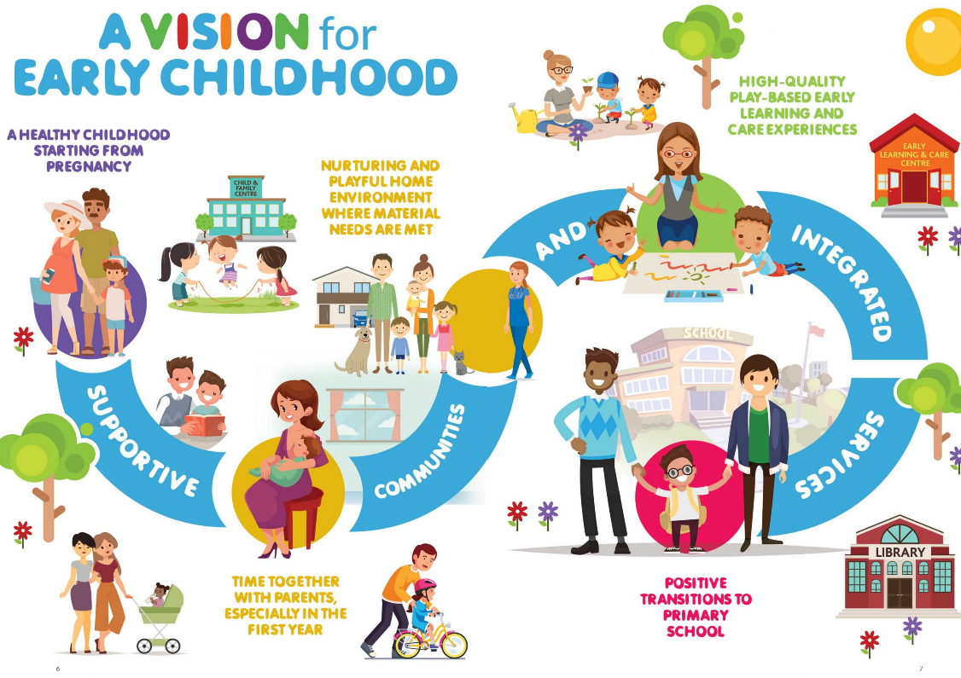
UNCRC (UN Convention on the Rights of the Child) article 3.1 states the best interests of the child should be carefully thought and article 3.3 states all involved in the child’s life professionally should adhere to national minimum standards, UNICEF (date unknown).

(Source: Linc, 2021).

Transitions
Transitions are a milestone in a young child’s life when there is a change - from home into a childcare setting. When a child goes to a childcare setting for the first time it is called a transition, transitions are a process, a process that will have effect on the child’s development, therefore it is paramount the child is central in planning and all involved ensure it is a positive experience for the child, this can be reached by effective communication and information sharing by all involved in the child’s life, family, keyworkers, health visitors and any other professionals involved in the child's life, keyworkers can implement this by keeping up to date with the ever-changing society, with qualifications, and training opportunities, the latest research available to them and follow policies and procedures in their practice, this will enable them to provide high quality care remembering the children’s needs, development and rights, children need to be central in all they do, (Brooker, 2021). Dewey states the child should be central in their learning, they learn by doing, being involved helps the child engage and become active while the keyworker guides and supports this learning style it allows the child to grow and develop using their own experiences and interests as an individual. (Aubrey and Riley, 2019, p.8).
When a child transitions from home into a childcare setting such as a flying start setting it is known as a vertical transition, this is because it is a considerable change to the child’s life, although horizontal transitions may also impact the child over a longer period, it may be their well-being that is affected due to the change in their environment or routine, they may feel insecure, therefore keyworkers need to consider both horizontal and vertical transitions when thinking about the expectations of the child, keyworkers and parents may have a difference of opinion on routines, boundaries, and acceptable behaviours this needs to be planned for during the settling in period. (Welsh Government, 2017, p.3)
When smooth transitions are done correctly it gives the child clear guidance about the expectations and routines of the setting, they enable children to feel comfortable and wanted by those around them.

Role of The Adult
Practitioner's/Keyworker
When children start a new setting, it may be overwhelming, using a keyworker system creates the foundation for positive relationships and effective communication, this in turn supports positive transitions.
keyworker's role in an early year’s setting requires understanding, knowledge, and skill to support transitions, by having these tools will enable them to provide positive smooth transitions and high-quality care, implementing these skills throughout the transition process allows the child to form attachments. According to Bowlby’s theory children form an attachment usually with the primary caregiver but suggests 2.5 years of age is a critical time for forming attachments, (Mcleod, 2017). Therefore, keyworkers can build strong relationships with the child entering the setting at 2 years of age, supporting attachments, and learning outcomes.
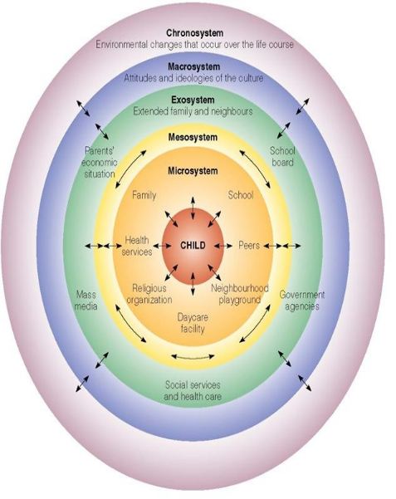
Bronfenbrenner suggests positive relationships with children and their families will have a beneficial impact on the child’s development and learning experiences, Bates, 2019, pp. 194- 195. Bronfenbrenner also states the importance of having the interests of the child at the forefront of working together this promotes a more holistic approach to the child’s development, (Aubrey, and Riley, 2016, p. 114).
(Source: Guy-Evans, 2020).
Here is Bronfenbrenner's Ecological model showing the child in the centre reinforcing the child is central to their learning and all decisions made. Equally as important to this model is Article 12 of the UNCRC (UN Convention on the Rights of the Child) states that a child has the right to form and express their own views in matters that affect them, UNICEF, (date unknown). keyworkers should always listen to the child, take cues from the child to show the child is being acknowledged and respected, be prepared to answer their questions, when doing this the child builds trust, relationships, and attachments which will have a positive effect on their development and learning outcomes.

Management
The setting manager has a duty to provide high quality care, this is done by ensuring all staff are qualified and up to date with mandatory training and research, the manager will book staff on to any flying start training that is offered to them, this is done using workforce development. The manager will also ensure all policies and procedures are in place and being followed correctly by the staff, this will fall in line with National minimum standards, these standards are in place and regulated by Care Inspectorate Wales to ensure appropriate care is being delivered in the childcare setting and the needs of the family and child are being met, (Care Inspectorate Wales, 2021). The manager will promote inclusion and diversity, so everyone feels welcome regardless of their background, ability, ethnicity, race, or religion. The manager will use the key worker system so that relationships between the child, family and practitioners can be formed, and communication is effective, supporting positive learning experiences and outcomes for the child. The manager will have a liaison meeting with the flying start health visitor before a child has an induction to get any relevant information needed and allow for the setting to plan for any support or adaptations needed for when the child comes into the setting, this supports inclusion and diversity from the very beginning of the child’s transition.

Multi Agency Working
Multi agency is all professionals involved in a child's life striving for the best outcomes for the child. keyworkers may have to work and communicate with these multi agencies to support the needs of the child and their families, they have a responsibility to share information, this is vital to ensure measures can be put in place making certain the well-being, needs and welfare of the child are being met. EVERYONE HAS A RESPONSABILITY AND EVERYONE HAS A ROLE! NSPCC, (2019).

Role Model’s
A role model for a child is usually the primary caregiver, the parent, but when a child forms a relationship and attachment to a keyworker these too will become significant role models in the child’s life, role models influence a child’s behaviour, decision making, and relationships with others. Vygotsky believed children need social interactions to develop and this is done with their families and adults around them, he suggested guided learning supported development and that adults interaction gives children the foundation to develop, McLeod (2020). Furthermore, Bandura states children use observational learning, they learn by what they see, and this influences their decision making and actions. (Aubrey and Riley, 2019, p.134-135). So, as keyworkers always lead by example, it is important to show respect to all, interact and engage in a positive manner, showing kindness and empathy, asking questions and actively listen to what the children have to say. Let the children have a voice. YOU ARE THE MORAL COMPASS IN THEIR LIVES.
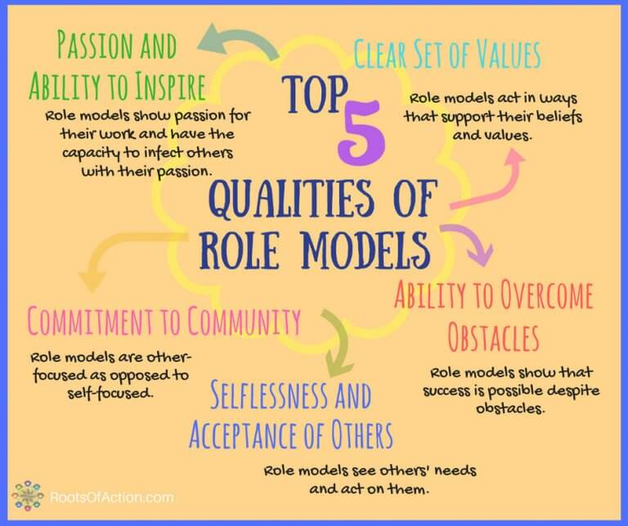

(Source: Price-Mitchell, 2017)

Effective communication
Effective communication improves a child’s learning outcomes, importantly those who are disadvantaged. When parents and keyworker share their knowledge about a child is supports the child’s individual needs and development. Bronfenbrenner supports this with his ecological theory, placing the child at the centre with everyone involved in the child’s life working together, showing respect, making the child central to all decisions made, impacts the child’s development positively, (Bates, 2019, pp. 194-195). Keyworkers should ensure effective communication and sharing of information is part of their daily practice, by doing this it will help to build trust and form relationships with the child and their families and will give the child The best experiences of learning that suit their own needs.
Keyworker must understand who they are communicating with and need to be inclusive and sensitive to all, families will come from all diverse backgrounds and cultures, sometimes an interpreter may be needed for the induction meeting, flying start can provide this service, this will allow the family to feel comfortable and included. A child may have additional needs that require a wheelchair, this may mean adapting the setting, so the child is included in all activities.

Working in partnership
Working in partnership is the principal for the national minimum standards in Wales. When the provision meets the child and parents for the first time it is essential to actively listen to the information the parents are offering regarding their child, the parent knows the child best and this is the starting point of building positive relationships, Pacey, (date unknown). According to Vygotsky children develop through social interaction, relationships, and learn from the adults around them and this considered provides greater learning opportunities for the child (Aubrey and Riley, 2019, p. 58-59). Keyworkers should work in partnership with parents not only to provide the best experiences and learning outcomes for the child but for the parents to feel included and involved in their child's experiences and progress.

The needs of the child
Erikson argues that children need consistent care to form relationships that develop continuously and learn new skills throughout a whole life span, consequently Freud claims development is mostly complete by the age of five, (Cherry, 2021). If keyworkers link these theories with practice both are relevant to support the child’s needs and development, to meet all the child’s needs they must have a competent understanding of child development and use a holistic approach to see the whole picture, this enables them to be successful in their relationship, planning, and outcomes for the child.
Montessori believes nature and nurture are needed to support a child’s development and suggests activities for children should reflect real life. (Aubrey and Riley, 2019). Montessori’s theory can be links to the flying start ethos of a home from home environment, giving children hands-on experiences, from chopping and preparing food to using real tools in the Construction area. Real experiences are how children learn.
The foundation phase framework has seven core aims,
- Have a flying start in life and the best possible basis for their future growth and development.
- Have access to a comprehensive range of education, training and learning opportunities, including acquisition of essential personal and social skills.
- Enjoy the best possible physical and mental, social, and emotional health, including freedom from abuse, victimisation, and exploitation.
- Have access to play, leisure, sporting, and cultural activities.
- Are listened to, treated with respect, and can have their race and cultural identity recognised.
- Have a safe home and a community that supports physical and emotional well-being.
- Are not disadvantaged by any type of poverty.
These aims have been used summarising the UNCRC. The foundation phase says practitioners and parents working together is vital to identify a child’s learning needs and will help children to feel safe and comfortable, it promotes children having a well-planned, rich, and stimulating environment where everyone feels included regardless of their ethnicity, culture, religion, home language, family background, special educational needs, disability, gender, or ability. (gov. Wales, 2015). Practitioners/keyworkers can link the foundation phase aims throughout their practice from the transition process, to planning, assessing, and observing, also when providing a nurturing environment and rich experiences through activities and play.

Maslow’s hierarchy of needs (1943) suggests all children’s basic needs need to be met to reach self-actualization, so an individual would start at the bottom of the pyramid building on their needs, building up to all needs being met to attain self-actualisation. McLeod, (2020).
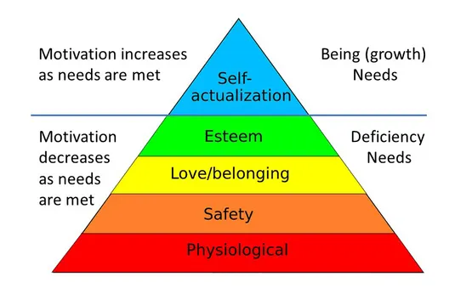
This theory links into transitions as a child needs to feel safe, wanted, listened to, comfortable and confident for smooth transitions and positive relationships and learning outcomes to take place.

(Source: Simply psychology 2020)

Keyworkers ensure children’s basic needs are met while in their care by providing children with a healthy snack and making sure they always have access to a drink during the session, incorporating a child centred environment where the children are included in the planning of their play and activities, they are actively listened to, and most importantly somewhere where they feel safe and happy. Using the observation process effectively in practice will ensure children's needs are met and are planned for appropriately for the individual child, allowing the keyworker to use continuous provision and change, adapt or enhance activities according to the child led play and engagement, observations will be taken once every term and will have evidence to reflect their role and responsibility to the child,

Vygotsky's scaffolding theory can be linked to today's practice as he suggested by offering support and resources a child is able to develop, and once the child becomes confident the support can be removed and the child is independent in their learning, McLeod, (2019).

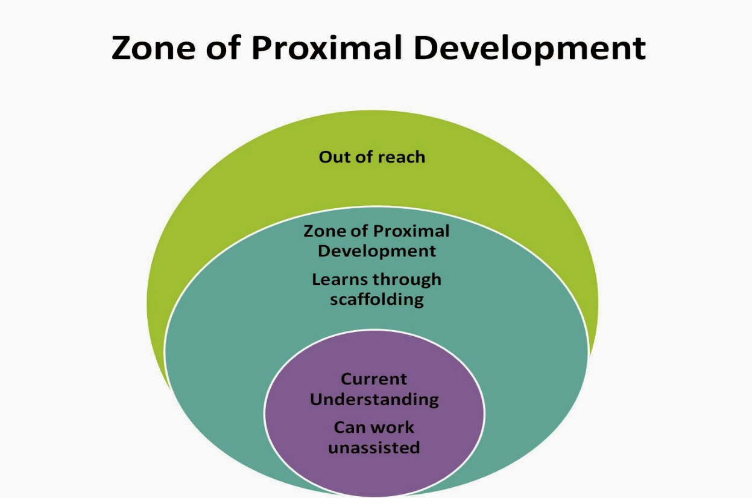

(Source: Meagor, 2014)

Keyworkers can use these theorists in today's practice to not only meet a child’s needs, plan effectively, build relationships but to support the importance of brain development. Using serve and return interactions with a young child, if they make a noise, eye contact, babble or cry it is vital for a response, this supports their neural connections, the serve and return engagement also impacts a child’s development positively (Harvard University, 2021).

Environment
Children need a caring, stimulating environment. The environment will be both indoors and outdoors; safe and secure, whilst being challenging; where children can be happy and feel valued as individuals. (Welsh Gov, 2014).
When children are going through the transition process the environment in which they learn and develop is a crucial factor. The Mcmillan sisters claimed giving children opportunity to an outdoor provision not only enhances a child’s learning and development, but it also has a positive effect on their health, they believed children learn through the freedom of play (Liebovich, 2018). Additionally, Froebel placed a significant importance on outdoor play to support children’s learning, he claimed space and natural light impact learning, he believed children need experience of the world to understand it and that they should be given the opportunity to play (Tovey, 2017). Keyworkers can link these theorists with today practice in a flying start setting when implementing the open-door policy, allowing the children to have choice in where they want to play, giving them a voice to be heard and be independent in their learning.
Pestalozzi believed every child has the right to an education (Smith, 1996, 2008). This links with article 28 of the UNCRC which states, children have a right to education based on equal opportunities (UNICEF, date unknown).
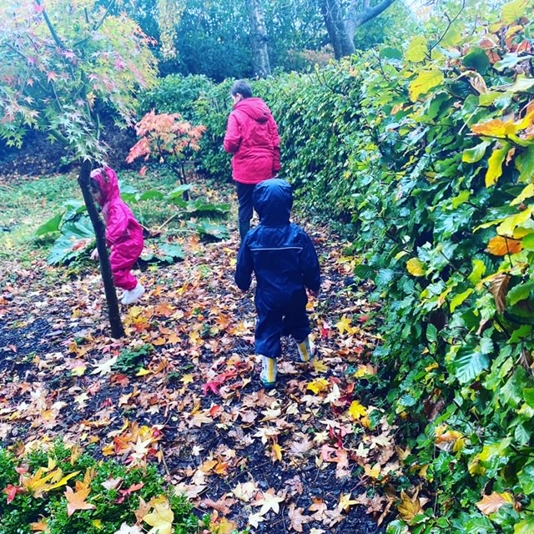
Play is so critically important to all children in the development of their physical, social, mental, emotional, and creative skills that society should seek every opportunity, children have a right to play, and it is central to their well-being (Wales.gov, 2014). This links with article 31 of the UNCRC which states, children have the right to relax and play (UNICEF, date unknown).

(Source: own image, 2020).

Interventions
Keyworkers will be part of the transition process from the day of the child’s induction, here they will meet the child and their family for the first time, this is the beginning of a new relationship and experience for the child, they may never have been away from their parents and may feel upset or overwhelmed, by offering engaging and stimulating activities may encourage the child to look around the setting at their new environment, but it also allows for the Keyworker to observe the child to see what interests them or what stage of development they are at. The parents can sit with the nursery manager and be given all the relevant information about the setting, the parents will be asked if there are any concerns or worries, this allows the interventions to be put in place to best support the child and their family, the family will be asked to fill out a ‘now I am 2’ form for the child, this will have all relevant information regarding the child, who lives in their family home, their likes/dislikes, things they may struggle with or need support with. By having this form allows the keyworker to plan accordingly for a smooth transition to take place. If a child is coming in to setting with additional needs, they too will be invited for an induction, but they will come with their family and team around the child, at a flying start setting this will be somebody from the inclusion team who knows the child and family and will be able to support them with giving the relevant information regarding the child’s needs and how best to support the child and their needs.
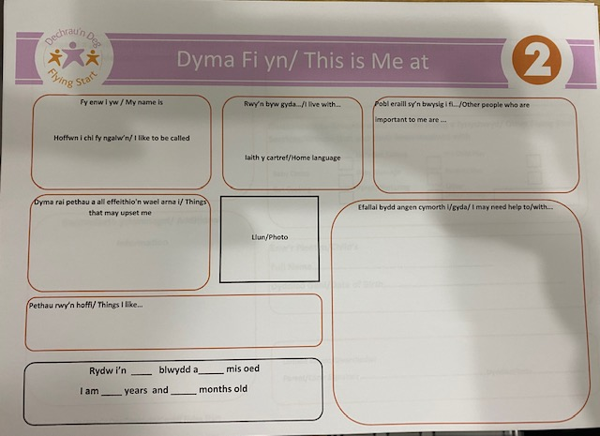
: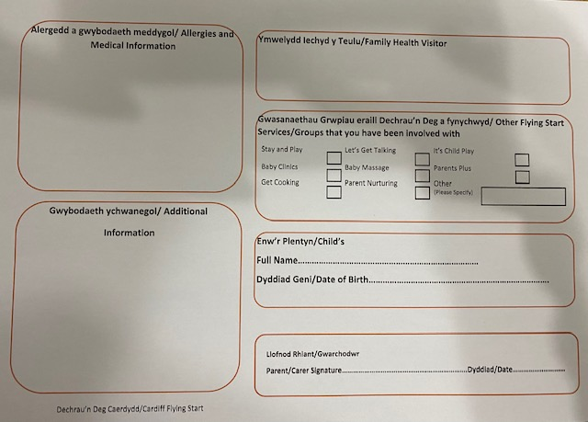
(Source: Flying start, date unknown).

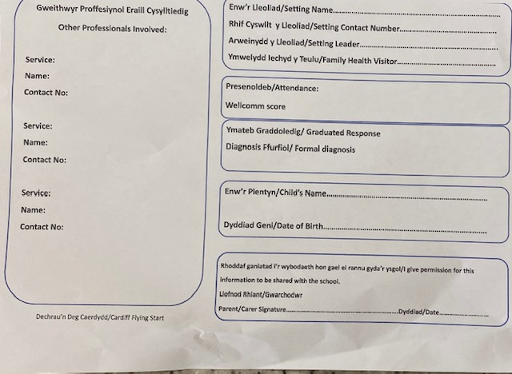
Children with additional needs will also have ‘this is me at’ sheet but they will also have all named professionals involved in providing care and support and their contact information on their sheet.

(Source: Flying start, date unknown).

In Wales, the government’s aim is to give every child the best start in life, early intervention and prevention is implemented as a way of working, it helps to build families well-being and resilience (Gov. Wales, 2017).
By using an induction meeting enables the keyworker to plan accordingly to meet the child’s needs, if they have shown a particular interest in something during their time at setting, the practitioner/keyworker can make sure that equipment/activity is set up for the child’s first day this allows for the keyworker to interact and engage with the child, it is the start of building trust and for the child to feel comfortable in the unfamiliar environment.

Proposed Outcomes
A child who is content, confident, able to make their own choices, resilient, be independent in their play and demonstrate a positive coping mechanism when dealing with their social & emotional needs, when a child displays the ability to do this the transition has been a positive experience for the child.
When keyworkers use the observation process it ensures the child’s needs are being met and planned for to move their development forward, giving them opportunity to grow. The sustained shared thinking theory support this stating it is interaction between two or more individuals (adults and children), it allows the adult to engage in a natural way and for the child to express themselves, the adult will guide the child using open-ended questions (Nursery story, 2021).
There is a significant importance for keyworkers to share what they know to support a child’s development and plan the next steps in their learning, this is a holistic approach that the child is always central in decisions and plans (Early years matters, 2021).

Reference list

Aubrey, K and Riley, A. (2016) Understanding & using Educational Theories. London: Sage publishing.

Aubrey, K, and Riley, A. (2019) Understanding & using educational theories. 2nd Edition. London, Sage publishing.

Bates, B. (2019) Learning Theories Simplified. 2nd Edition. London: Sage publishing.
Brooker, L 2008, EBOOK: Supporting Transitions in the Early Years, McGraw-Hill Education, Berkshire. Available from: ProQuest eBook Central. [2 November 2021].

Care Inspectorate Wales (2016). National minimum standards for regulated childcare for children up to the age of 12 years. Available at: National Minimum Standards for Regulated Childcare for children up to the age of 12 years (careinspectorate.wales) (Accessed: 17 November 2021).

Cherry, K. (2021). 7 major theories of child development. Explore psychology. Available at: 7 Major Theories of Child Development - Explore Psychology. (Accessed 24 November 2021).

Early years matters, (2021). Available at: Working in Partnership - Early Years Matters (Accessed: 15 November 2021).

Early years matters. (2021). Observation, assessment and planning. Available at: Observation, Assessment and Planning - Early Years Matters. (Accessed 26 November 2021).

Early years matters (2018) Transitions. Available at: https://www.earlyyearsmatters.co.uk/eyfs/positive-relationships/transitions/. (Accessed: 11 November 2021).

Flying start. (Date unknown). Other professionals. [Image]. Unpublished.

Flying start. (Date unknown). This is me at 2. [Image]. Unpublished.

Gov. Wales, (2015) Curriculum for Wales. Available at: foundation-phase-framework-revised-2015.pdf (gov.wales). (Accessed 23 November 2021).

Gov.uk. (2021) Development matters. Available at: Guidance overview: Development Matters - GOV.UK (www.gov.uk). (Accessed: 17 November 2021).

Guy-Evans, O. (2020) Bronfenbrenner’s ecological system theory. [Image]. Available at: Bronfenbrenner's Ecological Systems Theory | Simply Psychology. (Accessed: 16 November 2021).

Harvard University. (2021). Center on the developing child. Available at: Serve and Return (harvard.edu). (Accessed 25 November 2021).

Liebovich, B. (2018). The MacMillan sisters, the roots of the open-nursery, and breaking the cycle of poverty. Social and Education History, 7(1), 78-96. doi:10.17583/hse.2018.2925: Available at: http://dx.doi.org/10.17583/hse.2018.292.(Accessed (25 November 2021).

Linc, (2021) Supporting transitions from the home to the early learning and care setting-advice and best practice. [image]. Available at: In this edition of the LINC Programme blog we examine how early childhood teachers can ensure a smooth transition for children as they embark on their education journey. As we welcome children and families back to our Early Learning […] | Leadership for Inclusion, LINC Programme (Accessed: 15 November 2021).

McLeod, S. (2019). The zone of proximal development and scaffolding. Simply psychology. Available at: Zone of Proximal Development and Scaffolding | Simply Psychology. (Accessed24 November 2021).

McLeod, S. A. (2020) Maslow’s hierarchy of needs. Simply psychology. [Image] Available at: Maslow's Hierarchy of Needs | Simply Psychology (Accessed 23 November 2021).

McLeod, S. A. (2020) Maslow’s hierarchy of needs. Simply psychology. Available at: Maslow's Hierarchy of Needs | Simply Psychology. (Accessed 23 November 2021).

McLeod, S. (2020) Vygotsky’s sociocultural theory. Available at: Lev Vygotsky's Sociocultural Theory | Simply Psychology. (Accessed: 17 November 2021).

McLeod,S. (2017) Bowlby’s attachment theory. Available at: John Bowlby | Maternal Deprivation Theory | Simply Psychology (Accessed: 16 November2021).

Meagor, K. (2014). Dewey, Piaget, & Vygotsky on “Learner-Centred” Education. Team two blog [Image]. Available at: TeamTwo Blog: Dewey, Piaget, & Vygotsky on "Learner-Centered" Education (aasmith17.blogspot.com). (Accessed 24 November 2021).

Michael Carton (2014) Twitter.com"Childhood is not a race to see how quickly a child can read, write, and count..”. Available at: http://t.co/hBLPaMFSMg" / Twitter (Accessed: 14 November 2021).

NSPCC, (2019) multi-agency working. Available at: Multi-agency and interdisciplinary working | NSPCC Learning (Accessed: 15 November 2021).

NSPCC. (2019) Multi Agency Working. Available at: Multi-agency and interdisciplinary working | NSPCC Learning. (Accessed: 17 November 2021).

Nursery story. (2021). Introducing sustained shared thinking in early years. Available at: Introducing Sustained Shared Thinking in the Early Years (nurserystory.co.uk). (Accessed 26 November 2021).

Own image. (2021) sunset photograph. [Image]. Unpublished.

Pacey. (Date unknown) Working in partnership with parents. Available at: Working in partnership with parents - spotlight on | PACEY. (Accessed: 18 November 2021).

Price-Mitchell, M, (2017). What is a role model? Five qualities that matter. [Image]. Available at: What is a Role Model? Five Qualities that Matter to Youth | Roots of Action. (Accessed: 21 November 2021).
Smith, M. K. (1996, 2008). Johann Heinrich Pestalozzi: pedagogy, education and social justice, The encyclopaedia of pedagogy and informal education. Available at: https://infed.org/mobi/johann-heinrich-pestalozzi-pedagogy-education-and-social-justice/. (Accessed 25 November 2021).

Tovey, H. (2017). Outdoor play and exploration. Froebel Trust. Available at: Layout 1 (froebel.org.uk). (Accessed 25 November 2021).

UNICEF, (date unknown) Available at: UN Convention on the Rights of the Child (UNCRC) - UNICEF UK. (Accessed: 14 November 2021).

Welsh Government. (2014). Quality childcare guidance. Flying start-Annex. Available at: Flying Start childcare: guidance (gov.wales). (Accessed 25 November 2021).

Welsh Government. (2014). Wales-A play friendly country. Available at: Wales: a play friendly country (gov.wales) (Accessed25 November 2021).

Welsh Government. (2017) Flying Start-Annex, transition guidance. Available at: Flying Start parenting support: guidance (gov.wales) (Accessed: 15 November 2021)

Welsh Government. (2017). Families first. Available at: Families First: guidance for local authorities (gov.wales). (Accessed 26 November 2021).

