

Data Handling And Business Intelligence Assignment 2 LCBB5000
Name of student: Elena Miloshevska 2024564
Name of lecturer: Anupam Mazumdar

Date: 09.05.2022

PART#1
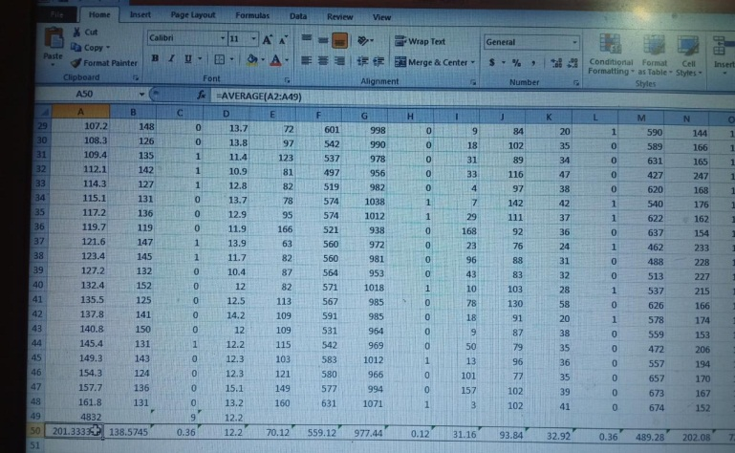
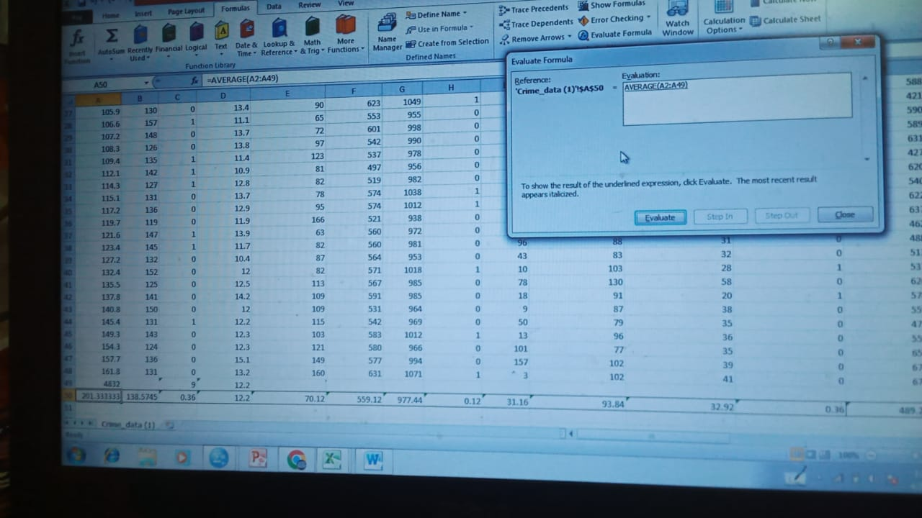
- Determine the crime rate (number of offences per million population), and evaluate the use of Excel for pre-processing, analyzing and visualizing the data.
“Information. The analysis, irrespective of whether the data is qualitative or quantitative, may:”
• “describe and summarise the data”
• “identify relationships between variables”
• “compare variables”
• “identify the difference between variables”
• “forecast outcomes”

The use of evaluate function in this example can help us with the walk into the real argument we faced while evaluating this feature could help in the fixing of the mistake if any of the mistake is caused in the overall evaluation and to test that how each formula is tested in the real visualizing of the data. firstly selected the cell I want to evaluate for the results.
The actual the evaluate formula when touched it displays the box it helps in breaking down the formula which work efficiently in the work of preparing the excel.

- To demonstrate how you can do this practically with the use of at least two of Excel functions such as: IF, LOOKUP, PIVOT TABLES, etc

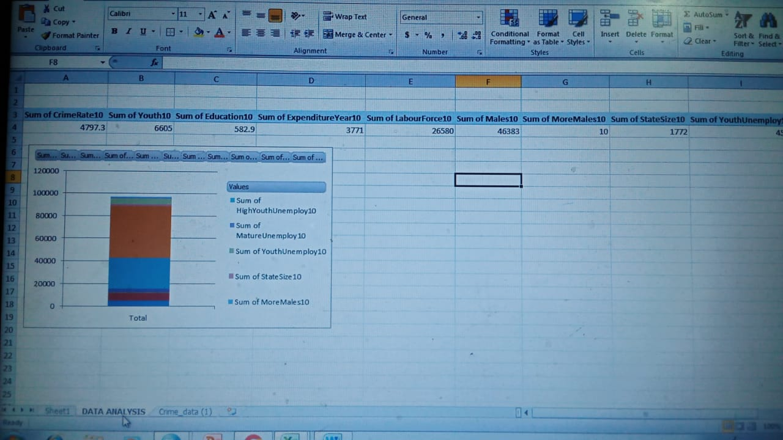
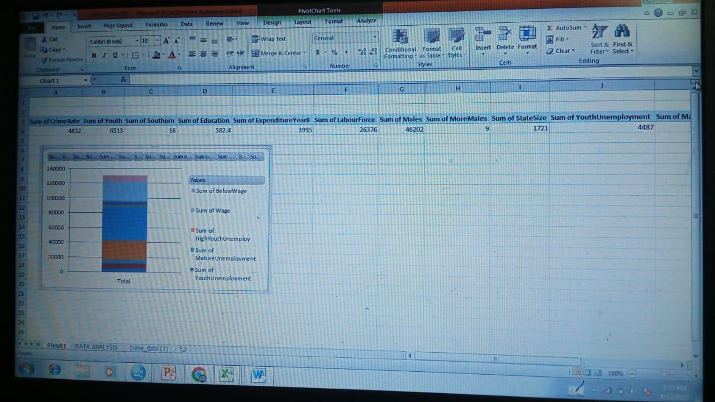

PART#2
- HOW MANY STUDENTS LIKE THE VANILA FLAVOR
As being a data analyst let’s consider the following preferred table of the ice-cream flavors that are from the 3 basic flavors of the chocolate, Vanilla & strawberry therefore this table is recommending the concised data derived from the collective data in other ways we can say that this is the overall conclusion for the
 | CHOCLATE | VANILLA | STRAWBERRY | TOTAL
MALE | 13 | 44 | 26 | 83
FEMALE | 39 | 43 | 25 | 107
TOTAL | 52 | 87 | 51 | 190

Hence the above findings show that chocolate flavor is mostly liked among the male students they are most fond of the vanilla flavor and the female were not much fond of the flavor therefore being the analysts that the most of the vanilla flavor is liked by male students of the campus female students are not likely to have the therefore it is being said that the female as per the data findings the most of the men that are most fond of the vanilla flavor following data is carried forward by the excel functions

- HOW MANY STUDENTS ARE MALE AND FEMALE
the findings shows that the campus contains more male than the female this table is also showing that the campus has more males than the females
- WHAT ARE THE MEAN MEDIAN OF THE PARTICIPANTSWHO LIKE CHOCHLATE STRABERRY FLAVOR

- Using the dataset Ice_cream_csv provided in conjunction with SPSS give a specific example of clustering (ex. K-means). Show your workings with screenshots and clearly explain your results.
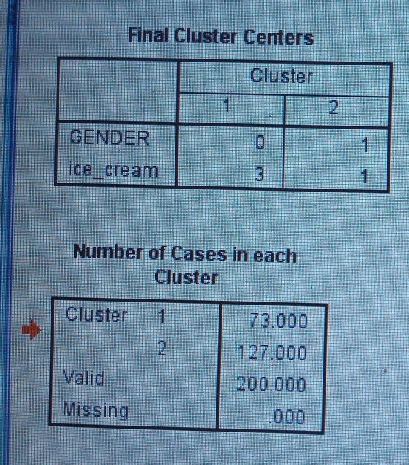
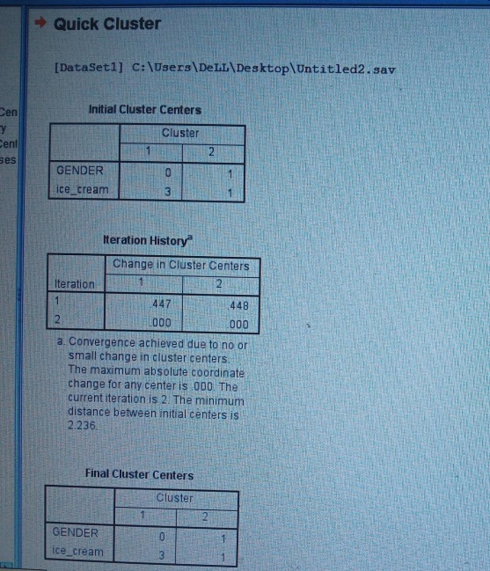

“Let’s kick things off with a simple example. A bank wants to give credit card offers to its customers. Currently, they look at the details of each customer and based on this information, decide which offer should be given to which customer.”
“Now, the bank can potentially have millions of customers. Does it make sense to look at the details of each customer separately and then make a decision? Certainly not! It is a manual process and will take a huge amount of time.”
“The groups I have shown above are known as clusters and the process of creating these groups is known as clustering. Formally, we can say that:”
“Clustering is the process of dividing the entire data into groups (also known as clusters) based on the patterns in the data.”
“Can you guess which type of learning problem clustering is? Is it a supervised or unsupervised learning problem?”
“Think about it for a moment and make use of the example we just saw. Got it? Clustering is an unsupervised learning problem!”

“predict the Item Outlet Sales based on outlets ize, outlet location type, etc. and in the loan approval problem, we have to predict the Loan Status depending on the Gender, marital status, the income of the customers, etc.”
“So, when we have a target variable to predict based on a given set of predictors or independent variables, such problems are called supervised learning problems.”
“Now, there might be situations where we do not have any target variable to predict.”
“Such problems, without any fixed target variable, are known as unsupervised learning problems. In these problems, we only have the independent variables and no target/dependent variable.”
“In clustering, we do not have a target to predict. We look at the data and then try to club similar observations and form different groups. Hence it is an unsupervised learning problem.”
“We now know what are clusters and the concept of clustering. Next, let’s look at the properties of these clusters which we must consider while forming the clusters.”
“For simplicity purposes, let’s say the bank only wants to use the income and debt to make the segmentation. They collected the customer data and used a scatter plot to visualize it:”
Having similar data points within the same cluster helps the bank to use targeted marketing. You can think of similar examples from your everyday life and think about how clustering will (or already does) impact the business strategy.
“in a particular cluster are not similar to each other, then their requirements might vary, right? If the bank gives them the same offer, they might not like it and their interest in the bank might reduce. Not ideal.”
“The data points from different clusters should be as different as possible. This will intuitively make sense if you grasped the above property.”
“Points in the 1st cluster are completely different from the customers in the blue cluster. All the customers in the red cluster have high income and high debt and customers in the blue cluster have high income and low debt value. Clearly we have a better clustering of customers in this case.
Hence, data points from different clusters should be as different from each other as possible to have more meaningful clusters.”
“one of the most common applications of clustering is customer segmentation. And it isn’t just limited to banking. This strategy is across functions, including telecom, e-commerce, sports, advertising, sales, etc.”

“So far, we have understood what clustering is and the different properties of clusters. But why do we even need clustering? Let’s clear this doubt in the next section and look at some applications of clustering.”
- Explain the most common data mining and text mining methods that can be used in business with real world examples
“Many people are confused about what type of analysis to use on a set of data and the relevant forms of pictorial presentation or data display. The decision is based on the scale of measurement of the data. These scales are nominal, ordinal and numerical.”
Nominal scale
“A nominal scale is where:the data can be classified into a non numerical or named categories, and the order in which these categories can be written or asked is arbitrary.”
Ordinal scale
“An ordinal scale is where: the data can be classified into non-numerical or named categories an inherent order exists among the response categories. Ordinal scales are seen in questions that call for ratings of quality (for example, very good, good, fair, poor, very poor) and agreement (for example, strongly agree, agree, disagree, strongly disagree).”

Numerical scale
“A numerical scale is: where numbers represent the possible response categories there is a natural ranking of the categories zero on the scale has meaning there is a quantifiable difference within categories and between consecutive categories.”
“When using a quantitative methodology, you are normally testing theory through the testing of a hypothesis. In qualitative research, you are either exploring the application of a theory or model in a different context or are hoping for a theory or a model to emerge from the data. In other words, although you may have some ideas about your topic, you are also looking for ideas, concepts and attitudes often from experts or practitioners in the field.”
“The data analysis that can be done depends on the data gathering that was done”
• “Qualitative and quantitative data may be gathered from any of the three main data gathering approaches”
• “Percentages and averages are commonly used in Interaction Design”
• “Mean, median and mode are different kinds of ‘average’ and can have very different answers for the same set of data”
• “Grounded Theory, Distributed Cognition and Activity Theory are theoretical frameworks to support data analysis”
• “Presentation of the findings should not overstate the evidence.

- Discuss the advantages and disadvantages of using SPSS and Excel using relevant practical examples and present your discussions in a table.
“In business, strategic planning is essential and requires valid information in order to make key decisions. Choosing the right tools for inputting, tracking, analyzing and storing data will help business owners and managers make the best choices for their company's business. One of the components within software productivity suites is the spreadsheet. Spreadsheets are popular among accountants and among those who like to collect and track data, yet there are some limitations, which may not make them the best choice for every office application.”
SPSS | EXCEL
For example if I were supposed to do analysis in an appropriate manner therefore I required to switch to a SPSS from Microsoft Excel and why it wins. | “Though Microsoft Excel and SPSS have a similar look and feel, with menus, spreadsheets and built-in statistical functions, SPSS is a definite winner when it comes to data analysis, as this software is especially designed for statistics.”
SPSS statistics is used to solve the statistics called premium statistics software that is duable for a large quantity of statistical analysis which may be known as the compilation of the data .Their preparation and good graphics analysis of modeling. | “Spreadsheets are frequently the go to tool for collecting and organizing data, which is among the simplest of its uses. Information can easily be placed in neat columns and rows and then sorted by information type. Although a large collection of data may be overwhelming to view in its raw state, tools within the program allow the user to create presentations where the data is analyzed and plugged into pie charts or tables for easy viewing and interpretation.”
Following software was used in 1968 it was the exact back then named as the statistical package for social sciences. | “However, the downside is that only the information that the user chooses for analysis is included in these presentations, and therefore, other pertinent information that may influence decision making might be excluded, unintentionally. To make reporting of data more user friendly and comprehensive, companies are choosing to use reporting tools such as Tableau and Qlik, instead of relying solely on the spreadsheet.”
And when it roses up it become one of the famous working statistical tool for the survey analyzations for the health care for the social sciences and you can name it. | “No one likes to spend all their time at work doing repetitive calculations. The great appeal of spreadsheets is that the program does all the math for the user. Once a formula is written and the program has a set command, complex calculations can easily be computed for the related data that has been input. This allows users to ask "what if" types of questions and to easily get the answers they need without the need to rework the calculations.”  “For example, if the spreadsheet is set up to calculate your gross profit, when any variable such as cost per unit, shipping costs, or sales discount are changed, the software automatically recalculates the new gross profit based on the new information.”
If any of the business is currently using the Microsoft excel to rely on for maket survey and researches they must needed to shift to the SPSS instead of the Microsoft Excel. It has very fast and easy to handle function itself. | “The difficult part for many users, is that the calculations must be entered into the spreadsheet as formulas. This requires learning the correct syntax for each type of calculation you wish to make. Although many classes are available to learn the skills necessary to use these formulas, many users still find them difficult. If the syntax is incorrect, the program will not return the correct information when the calculations are run. Additionally, if users input the wrong data, even in only one cell of the spreadsheet, all related calculations and cells will be affected and have incorrect data.”
The business those are running SPSS in stead of the Microsoft excel they are making their research excel in the analysis like ANNOVA,Cluster DISCRIMANAT,FACTOR and they would correlate valuably they can do the regression and descriptive source can also be find out through the software as well as the cross tabs and multi-Dimensional Scaling reporting and testing. | “In today's collaborative work environment, multiple users within an office often need access to the same documents. If using Microsoft Excel, the spreadsheets can be shared, but only one user can change data at a time. If local copies are made and updated, other users will not have access to the new data. Google Sheets offers the solution of file sharing and allowing multiple users to access and update a single form.”  “Be aware that, in both cases, there is no file history. Therefore, no matter who makes changes at any time, when any changes are made, the previous information history is lost.”
A thorough and easy work is a bit more quick and way too easy to be functioned like descriptive and the statistics | “Another spreadsheet disadvantage is the lack of security for your files. Typically, spreadsheets are not that secure and therefore are at greater risk for data corruption or mismanagement of information. Files that contain sensitive financial information may not be safe from hackers, even if password protected.”  “Other types of data collection software therefore may be a more suitable option. Access, Oracle or some other form of relational database has built in safeguards that protect data integrity and prevent the reorganization of information. For example, in a spreadsheet, a user might sort a column of information and may inadvertently cause related information, such as first and last name, to become out of sync. In contrast, a database will keep all parts of a record unified, thereby ensuring better data integrity.”
“A wide range of charts and graphs to choose from”
A good and speedy access test
“When it comes to organizing and managing your data, the SPSS software offers the user a lot of control. Since the software remembers the location of the variables and cases, it provides quicker and accurate data analysis.”
“With the wide range of graphs, methods and charts, you will find that any type of statistical analysis is a breeze. The techniques of screening and cleaning data within SPSS is great for future analysis”
“In SPSS, the output is usually kept apart from the data, by storing all the results in a separate file that is different from the file in which the data is stored. When you use SPSS, you will not have to worry about overwriting any other information by accident.”

“Even though Microsoft Excel is a good software to use for data organization, using a specially developed analysis and statistical software like SPSS can provide you with in-depth, faster and accurate data analysis.”
“IF our company looking for expert market research services or data analysis? If yes, then we at Outsource2india can assist you. Over the last couple of years, we have been successfully using the SPSS software to provide our customers with effective research services that helps them take the right decisions for their business. Find out how we can be of service to you by reading more about our market research”

References

(n.d.). Retrieved from https://cpb-us-e1.wpmucdn.com/wordpressua.uark.edu/dist/a/189/files/2020/07/HowTo_UCR_CrimeRatesCounty.pdf
(n.d.). Retrieved from https://www.customguide.com/excel/evaluate-formula-excel
(n.d.). Retrieved from file:///C:/Users/DeLL/AppData/Local/Temp/Rar$DIa5992.41081/Data%20Analysis,%20Interpretation%20and%20Presentation%20Example.pdf
(n.d.). Retrieved from https://blog.outsource2india.com/microsoft-excel-vs-spss-statistics-software-use-market-research/
(n.d.). Retrieved from https://www.examples.com/business/data-analysis-report-examples.html
(n.d.). Retrieved from https://smallbusiness.chron.com/turbotax-taxes-13771756.html
(n.d.). Retrieved from https://www.analyticsvidhya.com/blog/2019/08/comprehensive-guide-k-means-clustering/

