Computer History

Student: Bouaru Mihai Valentin

Student Number : 2323369

Teacher’s : Nathan Morgan and Mark Huntly

Module: Skills for Academic Success
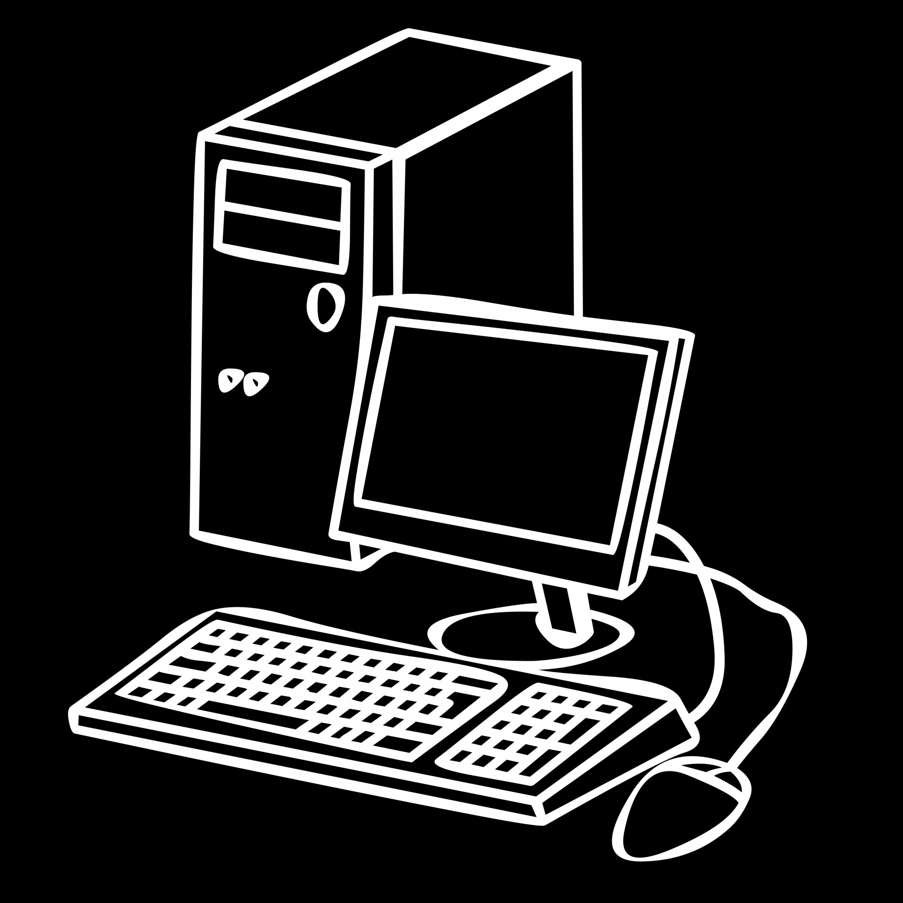



TABLE OF CONTENTS
Introduction……………………………….3
MainBody…………………………………….4
Apendix………………………………………12
Conclusion………………………………….18
References………………………………….19

INTRODUCTION | 
In this assessment we will be able to do a short walk through the process of developing computer’s from the first generation to the lastones availbe on the market and some of the history.
This will including a brief description of the computer technology and introduction abaut computers and is advancemet based on reserch on studies done by people, online website’s and some books abaut computer’s and his developments during the year’s.
From the beginning of the era of the computer’s being just some wooden racks to the micro parts and super coputers that we have today that we have today on the market .

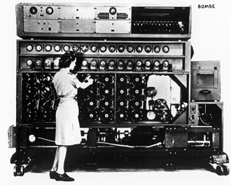
This Photo by Unknown Author is licensed under CC BY-SA

MAIN BODY

Computers are characterized as a tool that has helped automate operational procedures in which data acts as an input, is processed, and displays the outcome as a result. However, the device's process does not always need to be formed all at once, and it has evolved over time. The gadget has a long history that includes the introduction of many pieces of equipment, such as the Jacquard loom, the ancient Chinese abacus, Charles Babbage, and other individuals. Since the 1800s, all these kinds of equipment have been seen to appear gradually. Additionally, the architecture of mechanical, analogue, and digital computing schemes has undergone natural selection. Together, these factors have aided in the development of computers, which are widely used in today's world. The development of mechanical devices known as Marchant calculators, which were instrumental in devious activities, occurred in the 1960s. This trick can still be found in several scientific and engineering fields. There have been a variety of debates about the benefits that digital and analogue computers have brought to society during the earlier stages of computer development.
Analog computers were used in a few niche applications during the first part of the 1960s, but as the decade came to an end, digital computers became more and more popular because of their scalability and affordability for large-scale computations. Since then, digital technology and computing have taken over the world of computing and have been used in every field possible, ranging from supercomputers to distributed calculators.
Many unique computer models have developed over time, and they all differ in terms of functionality, cost, size, and other factors. The introduction of mainframe computers, which were very distinct and costly to run, marked the beginning of history. This was a large device that required added staff to handle the approach. This algorithm was put on hold and was replaced by the Minicomputer, which was unveiled with improvements to help it perform a variety of assigned tasks. This was an improved model that was less expensive and larger. Other device types, such as microcomputers, which appeared to be the more advanced model with microprocessors, came after this. Supercomputers, which are smaller in size but occasionally quite large and can be used for a variety of assigned tasks, are currently the most sophisticated type of device in use. The hardware and software intentions that are installed in the device intentions show the advancement.

After some time, with the development of computers, there have been two types of program growth, for instance, treat suits and apps. As a result, aside from their internal systems, both computers show natural selection. Generations of computers is a common term used to describe the evolution of computers seen in digital technologies. After some time, sixth-generation computers appeared, and each one has unique characteristics as well as improvements from earlier generations.
The ways that each generation has been built, the internal computing technique that has been used, and the installed programming languages are where the differences lie. Natural selection in computing is the result of each newly formed generation being perceived as a sophisticated model of its predecessors.

First Computers Generation

[1] [2] Initial Computer Generation These expensive, clunky computers were the largest of all the generations. Moreover, these computers were perceived as slow and could only handle a single problem at a time. Additionally, these computers were incapable of handling a complex mission at once or multitasking. The development of the theoretical rotating device was seen in 1937, during the era of the first generation of computers. Several other technologies appeared in the same year. John V. Atanasoff invented the first digital device. In addition to this, the first-generation device saw other advancements, such as electromechanical Z machines. Colossus, a device that combines digital numerical and other.
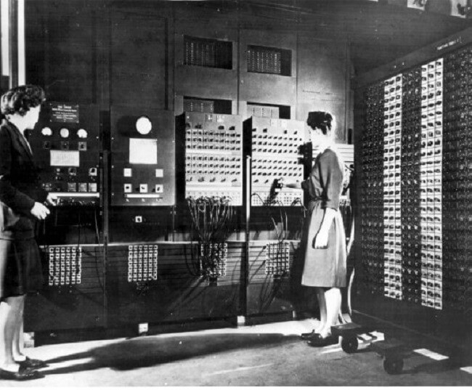

Second Computers Generation

[1] [2]In the real world, these new computer models are less costly and smaller than the ones from the first generation. These computers are designed to be more energy-efficient than their earlier model to help save a significant amount of power. However, this generation of computers occasionally turned out to be problematic when the transistors started to generate a significant amount of heat.
This era's digital switches used discrete diode technology, which had a 0.3 microsecond changeover time. Additionally, a few programming languages, such as FORTRAN, Algol, and COBOL, were introduced during the period when second-generation computers were introduced. Several proofs and constructs of the first two supercomputers that could be used for numerical processing applications were also seen in the second generation.
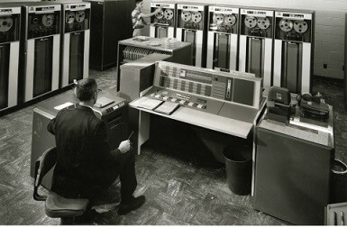

Computer Third Generation

[1] [2]In 1964, this generation was introduced to BASICS, which was created by Thomas Eugene Kurtz and John George Kemeny. After the development of a mouse prototype in 1963, computers were used in conjunction with mice for their first setup. The development of this generation continued after that, with the creation of a video show terminal, a color visual element adapter, and even better visual element connectors.
One of the most well-known companies at the time, IBM, contributed to giving the gadget holidays some color. It was seen that the computer monitors of the third generation used CRT technology, which was replaced by LCD displays in the 2000s.
The invention of the device keyboard, device storage devices like floppy disks, the first minicomputer, the PDP-8, the expansion of the ARPANET, and other innovations are also notable developments in this generation. As a result, the third-generation gadget gradually gathered the features found in modern computers worldwide. This also served as the foundation for various parallel processing types and the upcoming pipelining. 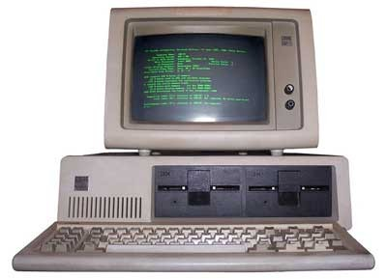

Computer Fourth Generation

[1] [2]A better computer model started to appear, such as the CRAY 2, which had a larger and better principal retention. Additionally, during this time, a variety of architectures that were more experimental with the natural world appeared. Microcomputers and workstations were introduced as alternatives to mainframe computers. The silicon chip that included this generation of device's microprocessor showed thousands of combined circuits. At that moment, everything that included the intention was Intel, and other industries were beginning to approach their computer systems. In 1984, Apple was the company that was determined to introduce the Macintosh, a customized device. By
this point, ingenuity had developed into a necessary aspect of people's lives across the United States, where 45 million computers were in use at the time.
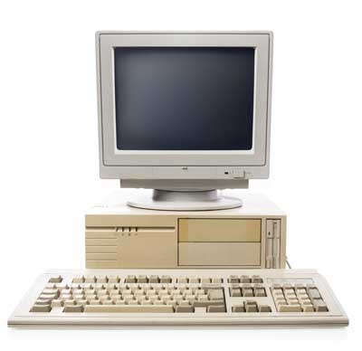

Computer Fifth Generation

[1] [2]This generation produced computers with multiple processors, each of which could handle different tasks within a single program with little difficulty. The deployment of single-user workstations and device networks was the most relevant and essential development of this generation. As a result, it was the first configuration that people learned about networks and their importance in managing things collectively.
The Ipsc-1 Named and "The Hypercube," which started using retention modules, are products of Intel research. With the help of networks, Intel was able to link each processor to its unique retention. The distributed retention architecture, which was used in this generation of Intel devices, needed an accumulation of larger methods because the retention that was used was no longer a bottleneck.
In addition, several significant advancements occurred that helped shape the current generation of computers that people use and helped advance computational capabilities with relatively inexpensive workstations and servers.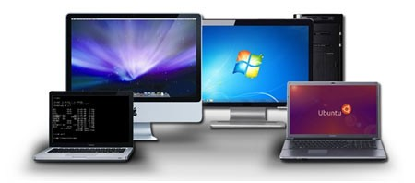

Sixth Generation Computer

[1] [2]After this final modification to the computing treat, the method of computing has been gradually upgraded. Significant changes in computing methods were seen prior to this generation. The primary feature of this generation of devices is parallel computing, which is clear in both the hardware and the algorithmic program's awareness. The algorithmic program made it possible to take advantage of various massively parallel computing architectures. The introduction of a broad place association is one of the most notable and dramatic changes seen in the sixth generation. Throughout this generation, there has been a noticeable increase in the contacts' bandwidth, which has continued to grow for many decades. These are the advancements that the device has experienced since its adaptation over the course of years, with significant advancements occurring in a variety of relevant areas, such as dimension, abilities, efficiencies, and cleverness.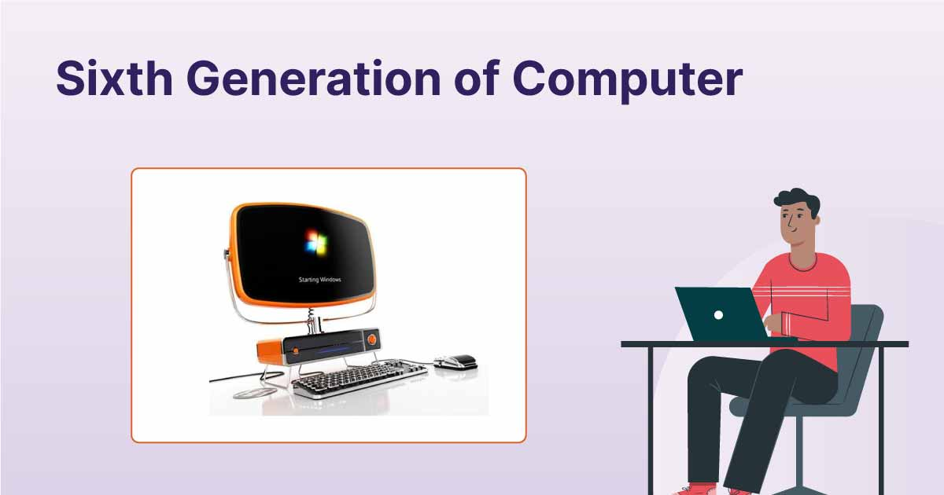

Appendix
[2] “The naive understanding of computation had to be overcome before the true power of computing could be realized. The inventors who worked tirelessly to bring the computer into the world had to realize that what they were creating was more than just a number cruncher or a calculator. They had to address all of the difficulties associated with inventing such a machine, implementing the design, and actually building the thing. The history of the computer is the history of these difficulties being solved.
1801 – Joseph Marie Jacquard, a weaver and businessman from France, devised a loom that employed punched wooden cards to automatically weave cloth designs.
1822 – Charles Babbage, a mathematician, invented the steam-powered calculating machine capable of calculating number tables. The “Difference Engine” idea failed owing to a lack of technology at the time.
1848 – The world’s first computer program was written by Ada Lovelace, an English mathematician. Lovelace also includes a step-by-step tutorial on how to compute Bernoulli numbers using Babbage’s machine.
1890 – Herman Hollerith, an inventor, creates the punch card technique used to calculate the 1880 U.S. census. He would go on to start the corporation that would become IBM.

Early 20th Century
1930 – Differential Analyzer was the first large-scale automatic general-purpose mechanical analogue computer invented and built by Vannevar Bush.
1936 – Alan Turing had an idea for a universal machine, which he called the Turing machine, that could compute anything that could be computed.
1939 – Hewlett-Packard was discovered in a garage in Palo Alto, California by Bill Hewlett and David Packard.
1941 – Konrad Zuse, a German inventor and engineer, completed his Z3 machine, the world’s first digital computer. However, the machine was destroyed during a World War II bombing strike on Berlin.
1941 – J.V. Atanasoff and graduate student Clifford Berry devise a computer capable of solving 29 equations at the same time. The first time a computer can store data in its primary memory.
1945 – University of Pennsylvania academics John Mauchly and J. Presper Eckert create an Electronic Numerical Integrator and Calculator (ENIAC). It was Turing-complete and capable of solving “a vast class of numerical problems” by reprogramming, earning it the title of “Grandfather of computers.”
1946 – The UNIVAC I (Universal Automatic Computer) was the first general-purpose electronic digital computer designed in the United States for corporate applications.
1949 – The Electronic Delay Storage Automatic Calculator (EDSAC), developed by a team at the University of Cambridge, is the “first practical stored-program computer.”
1950 – The Standards Eastern Automatic Computer (SEAC) was built in Washington, DC, and it was the first stored-program computer completed in the United States.Late 20th Century
1953 – Grace Hopper, a computer scientist, creates the first computer language, which becomes known as COBOL, which stands for COmmon, Business-Oriented Language. It allowed a computer user to offer the computer instructions in English-like words rather than numbers.

1954 – John Backus and a team of IBM programmers created the FORTRAN programming language, an acronym for FORmula TRANslation. In addition, IBM developed the 650.
1958 – The integrated circuit, sometimes known as the computer chip, was created by Jack Kirby and Robert Noyce.
1962 – Atlas, the computer, makes its appearance. It was the fastest computer in the world at the time, and it pioneered the concept of “virtual memory.”
1964 – Douglas Engelbart proposes a modern computer prototype that combines a mouse and a graphical user interface (GUI).
1969 – Bell Labs developers, led by Ken Thompson and Dennis Ritchie, revealed UNIX, an operating system developed in the C programming language that addressed program compatibility difficulties.
1970 – The Intel 1103, the first Dynamic Access Memory (DRAM) chip, is unveiled by Intel.
1971 – The floppy disc was invented by Alan Shugart and a team of IBM engineers. In the same year, Xerox developed the first laser printer, which not only produced billions of dollars but also heralded the beginning of a new age in computer printing.
1973 – Robert Metcalfe, a member of Xerox’s research department, created Ethernet, which is used to connect many computers and other gear.
1974 – Personal computers were introduced into the market. The first were the Altair Scelbi & Mark-8, IBM 5100, and Radio Shack’s TRS-80.

1975 – Popular Electronics magazine touted the Altair 8800 as the world’s first minicomputer kit in January. Paul Allen and Bill Gates offer to build software in the BASIC language for the Altair.
1976 – Apple Computers is founded by Steve Jobs and Steve Wozniak, who expose the world to the Apple I, the first computer with a single-circuit board.
1977 – At the first West Coast Computer Faire, Jobs and Wozniak announce the Apple II. It has colour graphics and a cassette drive for storing music.
1978 – The first computerized spreadsheet program, VisiCalc, is introduced.
1979 – WordStar, a word processing tool from MicroPro International, is released.
1981 – IBM unveils the Acorn, their first personal computer, which has an Intel CPU, two floppy drives, and a colour display. The MS-DOS operating system from Microsoft is used by Acorn.
1983 – The CD-ROM, which could carry 550 megabytes of pre-recorded data, hit the market. This year also saw the release of the Gavilan SC, the first portable computer with a flip-form design and the first to be offered as a “laptop.”
1984 – Apple launched Macintosh during the Superbowl XVIII commercial. It was priced at $2,500
1985 – Microsoft introduces Windows, which enables multitasking via a graphical user interface. In addition, the programming language C++ has been released.
1990 – Tim Berners-Lee, an English programmer and scientist, creates HyperText Markup Language, widely known as HTML. He also coined the term “WorldWideWeb.” It includes the first browser, a server, HTML, and URLs.

1993 – The Pentium CPU improves the usage of graphics and music on personal computers.
1995 – Microsoft’s Windows 95 operating system was released. A $300 million promotional campaign was launched to get the news out. Sun Microsystems introduces Java 1.0, followed by Netscape Communications’ JavaScript.
1996 – At Stanford University, Sergey Brin and Larry Page created the Google search engine.
1998 – Apple introduces the iMac, an all-in-one Macintosh desktop computer. These PCs cost $1,300 and came with a 4GB hard drive, 32MB RAM, a CD-ROM, and a 15-inch monitor.
1999 – Wi-Fi, an abbreviation for “wireless fidelity,” is created, originally covering a range of up to 300 feet.

21st Century
2000 – The USB flash drive is first introduced in 2000. They were speedier and had more storage space than other storage media options when used for data storage.
2001 – Apple releases Mac OS X, later renamed OS X and eventually simply macOS, as the successor to its conventional Mac Operating System.
2003 – Customers could purchase AMD’s Athlon 64, the first 64-bit CPU for consumer computers.
2004 – Facebook began as a social networking website.
2005 – Google acquires Android, a mobile phone OS based on Linux.

2006 – Apple’s MacBook Pro was available. The Pro was the company’s first dual-core, Intel-based mobile computer.
Amazon Web Services, including Amazon Elastic Cloud 2 (EC2) and Amazon Simple Storage Service, were also launched (S3)
2007 – The first iPhone was produced by Apple, bringing many computer operations into the palm of our hands. Amazon also released the Kindle, one of the first electronic reading systems, in 2007.
2009 – Microsoft released Windows 7.
2011 – Google introduces the Chromebook, which runs Google Chrome OS.
2014 – The University of Michigan Micro Mote (M3), the world’s smallest computer, was constructed.
2015 – Apple introduces the Apple Watch. Windows 10 was also released by Microsoft.
2016 – The world’s first reprogrammable quantum computer is built.”

CONCLUSION
The study's findings indicate that, in keeping with time, computers have advanced significantly. Vacuum tubes and

Microprocessors are among the components that have improved the efficiency and output of computers. Human life

has undergone a significant transformation because of modernization and digitization. The room-sized computers

had become tiny devices thanks to all these components. As a result, it has made it easier for humans to perform.

daily task It is difficult to imagine living in a world without technology.

We can se that since the beginig off the era off the computers we advance preaty much here a image seeing the progres untill 2015
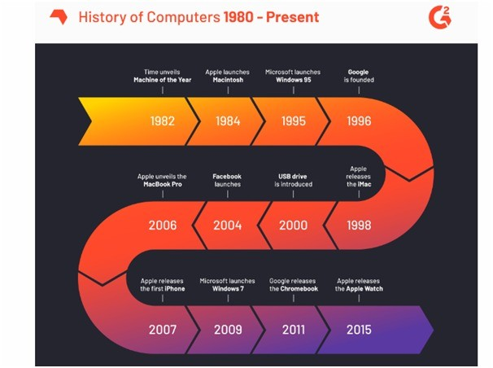

REFERENCES

[1] LinkedIn, “The history behind the generation wise evolution of the computers”, Aug. 4, 2021. [Online].
Available: https://www.linkedin.com/pulse/history-behind-generation-wise-evolution-computers-debalina-choudhury/

[2] toppr.com Available: https://www.toppr.com/guides/computer-aptitude-and-knowledge/basics-of-computers/history-of-computers/#:~:text=Early%20History%20of%20Computer&text=One%20of%20the%20earliest%20and,was%20a%20general%2Dpurpose%20computer “History of Computers”

[3] toppr.com. Available: https://www.toppr.com/guides/computer-aptitude-and-knowledge/basics-of-computers/generations-of-computers/ “Generations of computer “

[4] Philip Kotler, George Armstrong, Jon Saunders, Victor Wong, Howard Smith and Mark Jones, “Principles of Marketing”, published by Prentice Hall in London in 2000.

[5] Jack Moor “Can Cyberspace Be Just?”. Available:www.univ.trieste.it/~dipfilo/etica_e_politica/1998_2/moor.html [Accessed Nov.20, 2001]

