Project Planning and Management in the workplace
Module Code: BMSW5104
Student ID: 1709339
Student Name: Md Shahidur Rahman
Lecturer: Paul Ranson

Executive Summary
This report will define tools and techniques for developing a project by using a waterfall methodology. This report will also consist of reflection, recommendation, self-development plans, and conclusion.

Contents
Executive Summary 2
List of Table 4
Table of Figure 5
Introduction 6
The Organisation 6
Steering group 6
Risk Associate with this project 7
Tool and techniques 7
User Story 7
Project Prioritisation 8
Moscow technique 8
Scope and Estimation 9
Roberts Product Project Technique 10
Delphi Technique 10
The Iron Triangle 11
Microsoft Planner 12
Project Schedule 13
Stakeholder Communication Plan 14
Reflection and Recommendation 15
Conclusion 16
References 16

List of Table
Table 1: MoSCoW Technique for prioritizing needs. 8
Table 2: Communication plan for the project 14

Table of Figure
Figure 1: Steering group roles defined 6
Figure 2: The Roberts Product Project Technique 9
Figure 3: The Iron Triangle 10
Figure 4: Microsoft Planner 10
Figure 5: Microsoft Planner 11
Figure 6: The Gantt Chart 12
Figure 7: Project Price 16

Introduction
This report will introduce, the organisation this project is developing for, furthermore, it will discuss tools and techniques used for developing this project. this report will consist of risks that can accrue during this project and that would be the solution for those risks. A communication method and frequency of communication with stakeholders will be identified in this report. A reflection and the way future project that may conduct, also self-development plan as well as a conclusion.

The organisation
The Vintner is an antique shop within the family for the third generation, which is operating from Shirley. The landlord of Shirley shop offered them to buy the shop, but business is not great and has space issue in the shop but they also have warehouse in Sparkbrook witch has sufficient space but need lots of work needed because the warehouse was used only for storage and that’s why it has no essential facility that of needed for operating a store or office, the only thing it has is a brick wall and concrete floor.

Steering group
The project steering group will be accountable for the success and failure of the project (Roberts, 2012). They will be responsible for seeing if the project meets its purpose or not. So, unlike seven redline projects, the steering group must know what their role and argument are to support their point of view. According to Roberts (2012), steering should have some involvement towards the project at the beginning but not to make them committee or authority to intervene with the worker, because they can distract skills people performance where they are expert and senior people who can make their own decision.
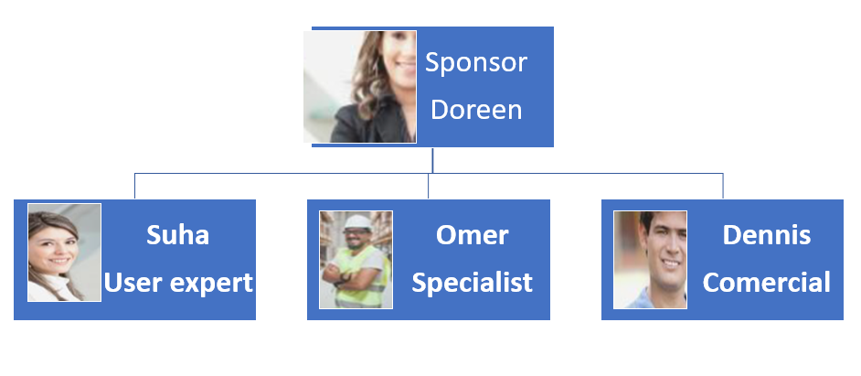
Figure 1: Steering group roles defined
(Source: Roberts, 2012)

Risk associated with this project
No one has seen the future and predicting can be difficult but useful to do so. The risk factor would be for this project, finance, recruiting new employees for project work, professionalism, and team coordination.
Managing risk is one of the popular topics for people who are involved in project management (Raz and Michael, 2001). To enhance the solution for these risk Boehm (1991) suggested to take those two steps, the steps would be, risk assessment, and risk control. Risk assessment is to think of possible risk might appear during the project and then analyse the problem and then prioritize by the possible impact of the risk. The second phase would be risk control, the risk can be control risk management planning, find the possible solution, and keep monitor the risk aspect and take corrective action when risk appears.
The finance crisis can make the project fail because the vintner family might have just enough for the project, if for some reason the project cost increase (natural catastrophe), they might not be able to continue the project. the possible solution would be asking for payment when the project archive a certain milestone. Because this is their first project, they might not take the project seriously and this may be a result of unprofessional practice such as not taking ownership of their responsibility. The solution would be, keep the communication regularly by using their chosen communication platform.

Tool and techniques
Some many tools and techniques have been applied in this project, such as User Story, Iron Triangle, Delphi and, Microsoft planner tools, product project technique, and Gantt Chart for structure for project scheduling.

User Story
A user story is the very first step of the waterfall methodology, without a user story, they are no project likewise user story is determined the need for the project. many organisations do not change when business demand change, nor they change when they have to change (Roberts, 2007, p. 44). That is the reason why many organisations fail. In the traditional method, the user story can be written on sticky notes and hand over to the project manager. The user story may consist, what and why they need certain things done. An example of a user story for this project would be, we need electricity, because of lighting, and for using the electronic appliance. User stories can be documented, and it could become a vital document during any point in the project life cycle. The two main crucial usefulness of user stories would be, a reminder for the project manager and when a dispute arises regarding task expectation, the user story can confirm how the task is agreed to carry out.

Project Prioritisation
User stories can lead to too many stories, the user stories are breaking down on big stories (Patton and Economy 2014). It is very important to identify a similar story or same story that is told differently and identify those incomplete stories and complete them and keep an eye on a fact that user stories are not shopping lists and it is a core aspect of the project. prioritising story is the key and fundamental aspect of the project as project cant have all the stories which are contradictory to other stories which are proposed, suppose if Doreen wants all the warehouse doors to be painted red and Omer want it black. The doors cannot be red and black at the same time.

Moscow Technique
The MoSCoW technique is tremendously helpful for prioritising the requirements of the project. the MoSCoW is an eco-name for Must, Should, Could, and will not (Hatton, 2008). By using this technique project manager can prioritise the requirement by asking the proposer to stick the sticky note to the column he or she think the story best fit. The manager can keep a record of the prioritisation document after it is approved by the organisation this project nominated for, before future references if any dispute arises. Some organisations might approve stories in must, should, and could categories, unlike others might decide to call for the project for Must categories stories only, it depends on organisation financial stability or time that in hand for them. it's distinct to organisation to organisation, in this case, the sale presentation speech was prepared by keeping this thought in mind (see appendix 1), the Vintner family were given choices over Must or Could and Must price as well as project lifecycle (time).

Must | Want | Nice
Planning | Advertisement screen | Coffee machine
Electrical installation | Kitchen facilities | Dining aria
Toilet facilities |  | Recreation room
Security system
Renovation
Table 1: MoSCoW Technique for prioritizing needs.
(Source: Marthasari, Suharso and Ardiansyah, 2018.)

Scope and Estimation
After prioritisation project manager know what is in stake in the project in another word project manager is know what is expected from the project. A project is like a boat that delivers things. The scope of the project determines the cost and time of the project. if the scope or task in hand is big or complex the time and cost and resources will require more, similarly, if the scope of the project is small, the cost, time, and resources will be minimum or less.

The project manager in this project appointed Mr. Jomir to have used some techniques to estimate the project. he has used Roberts Product Project Technique to identify the number of days an individual task may take. The second tool the manager has used is the ancient Greek Delphi Technique which is about 2000 years idea use for guessing. The future is unknown yet for project management better to have a plan or guess if someone wants to do a project and don’t know how much the project possible cost, that person wouldn’t go for the project. as for the project manager, the knowing project cost will help him or her to structure and distribute resources accordingly. The third tool is Iron Triangle, The Iron Triangle also known as Triple Constraint, consists of Scope and time and in the middle quality (Pollack, Helm and Adler, 2018).

Roberts Product Project Technique
The product project technique is a great way to find out how many days it will take to complete a task. all the numbers in the table are several days and on sideways the complexity of the task and column on the left has side is the size of the project. Hence, if the task size is small and complicity is hight, that task will take 5 days to complete. This can be disputed by the organisation, nevertheless, it can be solving by mutual understanding and from expert advice.

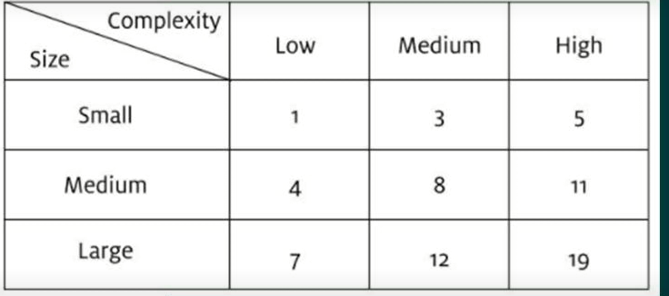
Figure 2: The Roberts Product Project Technique
(Source: (Roberts, 2012)

Delphi Technique
As mention above this technique or thought is 2000 years old, and people are still using this technique in today's time as well. The Delphi technique is taking people's opinions and guesses and the maid theology behind this thought is two heads are better than one head, regardless of personal competence (Dalkey and Helmer, 1963). This technique is also known as group communication, which aims to capture a real-world scenario (Hsu and Sandford, 2007). This technique functionality is, asking the opinion of other people on certain things such as, how much they think the electrical installation would cost according to their opinion. A large sum of people’s opinions is better for getting the most accurate guess. James Surowiecki wrote in his book, if organisation give authority to divers and a large group of people to make a decision on certain aspect or task, the group decision will be superior then an isolated individual (Surowiecki, 2005).

The Iron Triangle
To make the Vintner family aware of the cost, quality, and time dynamic is vital since this is their first project and may need to educate them without offending them. effective communication with the project sponsor and steering group can enhance the running of the project smoothly. The scope of the project is the size of the project, if the scope is small the project is small and if the scope is big the project is big. The time is the duration of the task and cost is the amount of financial capital required for completing the task. If one element has changed from the three in the Iron Triangle, the Iron Triangle will be broken or imbalance, therefore other two elements of the Iron Triangle must be adjusted, or else the quality of the product will have a negative impact and in most cases, the project will fail result of not taking or adjusting the triangle.
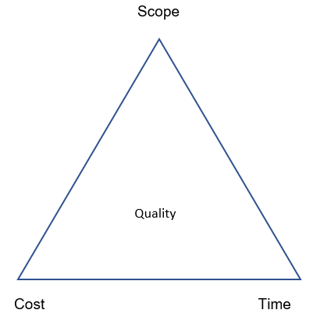
Figure 3: The Iron Triangle
(Source: Pollack, Helm and Adler, 2018)

Microsoft Planner
Microsoft Planner used to document this project early phase, it is a software that helps instore data, the information ineffective, and user friendly. The Team Spirit has stored all the user stories in this digital platform. It is very important to keep all the records and make them accessible to members who need them. This platform allows multiple guests to see this data plus it is efficient and time-saving when it comes to sharing. Sharing information is vital but sharing effectively will get a great response from the receiver.

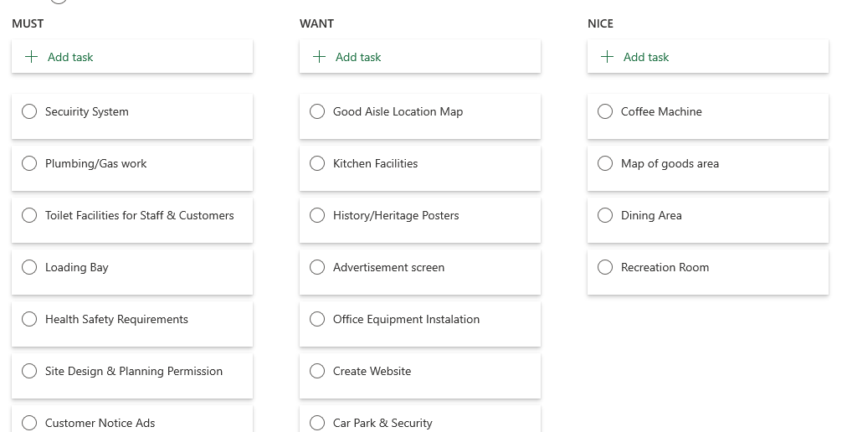
Figure 4: Microsoft Planner
(Source: Team Sprit)

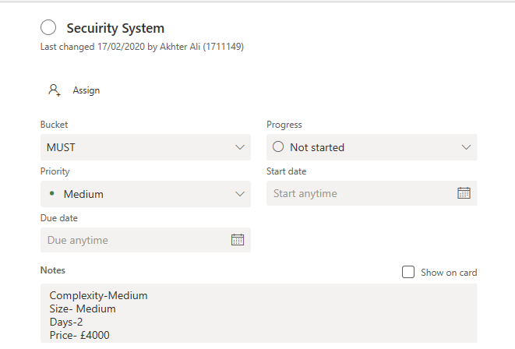
Figure 5: Microsoft Planner
(Source: Team Sprit)

Figure 5 is the result of using Robarts Product Project Technique, the complexity of the task was medium and the size of the task was medium as well, if the project manager went by Product Project Technique it would have allocated 8 days. The dispute appears and the team adapted the Delphi technique and came to a term 2 days.

Project Schedule
It was the early twentieth century when Gantt Chart was developed in the time of scientific management and associate of Frederick Wilson Taylor who is known as the father of Scientific Management who has transformed industrial revelation through his work. Yet the Gantt chart is in use with little adaptation across many projects (Wilson, 2003; Geraldi and Lechler, 2012).

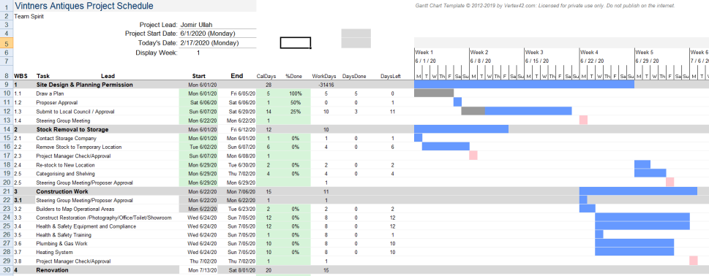
Figure 6: The Gantt Chart
(Source: Team Sprit)

Stakeholder Communication Plan
Stakeholders are those who have an interest in the organization (Friedman, Miles, 2006, p.5).
Stakeholders for this project. | Communication method. | How Often | Impact on the project.
Project Sponsor | Verbal and non-verbal,  business skype and e-mail. | One a week. Because the sponsor might be busy or has multiple projects. | Project Sponsor is the boss of the project and the person who has authority above all.
Project Steering group | Verbal and non-verbal, such as WhatsApp and e-mail. | Once a week. | The steering group can influence the goal of the project.
Public | Verbal and Non-verbal  Notice board and to inform what is happening and maybe the architecture of the end product in 3D image | Once a Month. | They must be heard and can responsible for the destruction of the project, by complaining to the local authority is seen suspicious. So better to tell or show the public what is the project outcome.
Government | Verbal and non-verbal, using, telephone, e-mail, and government websites to seek information. | Once a week foresee any changes in the regulation. For example, during COVID19, the law is changing, such as using a facemask, the age restriction for working from home, or can go to the workplace. | It is very important to see if there is any new regulation that may impact the working environment.

Table 2: Communication plan for the project
(Source: Project Manager, 2019)

Reflection and Recommendation
I would prioritise risk assessment and cost management as these are a very important aspect of the project. if the potential risk minimise and the project stay on budget, the project can become successful. Understanding which criteria project would be judge by (cost, quality, time) would determine the core point of the project. changing daily meeting time morning to afternoon will save time by not waiting for stakeholders who come late in the morning.

Self-development
I must learn more about the tools and techniques used in this project, this can accomplish by reading project management books and journals. take notes of good and bad experience of this project and use experience enhance from this project to future projects. I have to improve my communication skills, especially verbal and written communication, for this, I have to read more books and watch animation cartoons which can improve my English vocabulary.

Conclusion
This report discussed tools and techniques that helped to develop this project. Those tools and techniques can be useful for daily life as well, such as MoSCoW technique. It’s important to make right effort at right time, it is essential for success in a projects and life.

References
- Boehm, B.W., 1991. Software risk management: principles and practices. IEEE software, 8(1), pp.32-41.
- Friedman, A.L. and Miles, S., 2006. Stakeholders: Theory and practice. Oxford University Press on Demand.
- Geraldi, J. and Lechler, T., 2012. Gantt charts revisited: A critical analysis of its roots and implications to the management of projects today. International Journal of Managing Projects in Business, 5(4), pp.578-594.
- Hatton, S., 2008. Choosing the Right Prioritisation Method. 19th Australian Conference on Software Engineering (aswec 2008), pp.517–526.
- Hsu, C.C. and Sandford, B.A., 2007. The Delphi technique: making sense of consensus. Practical Assessment, Research, and Evaluation, 12(1), p.10.
- Marthasari, G., Suharso, W. and Ardiansyah, F.A., 2018. Personal Extreme Programming with MoSCoW Prioritization for Developing Library Information System. Proceeding of the Electrical Engineering Computer Science and Informatics, 5(1), pp.537-541.
- Pollack, J., Helm, J. and Adler, D., 2018. What is the Iron Triangle, and how has it changed?. International Journal of Managing Projects in Business, 11(2), pp.527-547.
- Project Manager (2019). What Is a Project Management Communication Plan? Available: https://www.projectmanager.com/blog/project-management-communication-plan. Last accessed 07th August 2020.
- Raz, T. and Michael, E., 2001. Use and benefits of tools for project risk management. International journal of project management, 19(1), pp.9-17.
- Roberts, P., 2007. Guide to project management: Achieving lasting benefit through effective change (Vol. 16). John Wiley & Sons.
- Surowiecki, J., 2005. The wisdom of crowds. Anchor.
- Wilson, J.M., 2003. Gantt charts: A centenary appreciation. European Journal of Operational Research, 149(2), pp.430-437.

Appendix 1

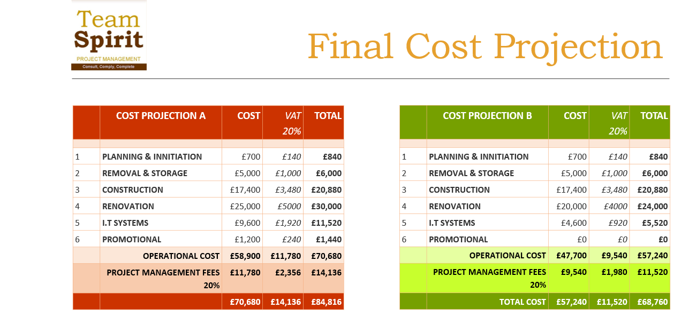
Figure 7: Project Price
(Source: Team Spirit)

