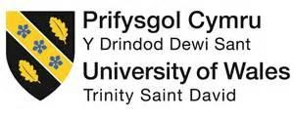
University of Wales Trinity Saint David
Swansea College of Arts

Project design and methodology- Research Portfolio
Investigating Performance
HPCP6004

Kiara Sullivan
1701519
29th November 2019

Research Question
Why should sixteen-year-olds within South Wales be allowed to vote in Parliament Elections?
Abstract for the Research Project
This research portfolio is built up on the foundation of an autoethnographic account of the researcher herself. She wants to find out if there are any sixteen-year olds within the Rhondda Cynon Taff that hold the same opinions as she held when she was sixteen years old that she still holds deeply today. That opinion is that sixteen-year olds should have the right to vote in elections run by the government. She believes that if you can get married, have children and fight for your country at sixteen years of age then you should also be able to have a say on how your country is run and who is best for that job.

Aims of the Research Project
- To empower young people from the South Wales Valleys to use their voice to speak out about the issues they want to change within and outside of their communities.
- To give power back to the young people within the South Wales Valleys to affect the change they want in their lives.
- To break the stigma on disadvantaged communities within the South Wales Valleys and show who they really are.
- To educate people on the importance of smaller communities within the South Wales Valleys and that people within those communities want to effect change within and outside of their communities.
Objectives of the Research Project
- To use Augusto Boal’s Forum Theatre to engage the young people within these communities.
- When using forum theatre, allowing everyone who has an opinion to use their voice to speak up and to encourage the young people to also use their actions to show us the change they want.
- To encourage the young people to write their stories down and to then get together to share those stories through Spoken Word.
- To record the Spoken Words to broadcast them for people further away to hear the voices of these young people within these communities.
Intended Outcomes of the Research Project
- The young people’s work creates a ripple effect within communities outside of their community which encourages more communities to create a positive change.
- The young people are empowered to use their voices after the project has finished to encourage the next generation to use their voices to create change.
- The young people are empowered to continue making changes within their lives to create a better future for themselves and their community.

Areas of Investigation
Youth Engagement and Participation Service (Yeps)
Yeps is a service that offers young people between the ages of eleven to twenty-five free activities during school, school holidays and also run extra provisions most evenings throughout the week. Yeps also runs alongside WICID.tv, which is a youth information and media website for young people and is run by young people. The website is maintained by Yeps in association with Rhondda Cynon Taf County Borough Council (Rhondda Cynon Taf, 2019).
In July 2019, Yeps held an RCT Youth Vote based off of statistics that came from the ‘Your Voice’ (WICID.tv, 2019) survey that was given out in 2018. ‘Your Voice’ survey was put into motion to find out the things that matter most to the young people of RCT. Almost five thousand young people got involved with the ‘Your Voice’ survey; the statistics that came from the ‘Participation and Rights’ section of the survey showed Yeps that:
76 % of you said that there’s not enough education or information on how to vote by the time you’re old enough to vote in local and national elections! 67% of you also felt that you would like to vote at the age of 16 (WICID.tv, 2019).
This led Yeps to create a project which would encourage young people to vote and allow them to tackle potential barriers that may arise when voting in future elections. Voters had the choice to vote for one of three projects, where Yeps would then run and fund the winning project with £10,000.
The three projects covered issues that were of concern within RCT. One project would tackle youth homelessness, another would explore knife crime, while the last project would raise awareness/ supporting positive mental health. The Youth Vote turned youth clubs and schools into polling stations from the eighth to the twelfth of July; twenty-two youth clubs took part while every school within the County Borough was given the opportunity to run a polling station (Rhondda Cynon Taf, 2019).
Three thousand, seven hundred and sixty-six votes were counted with only twenty-one spoiled votes. Raising awareness/supporting positive mental health project received one thousand, seven hundred and thirty-six votes, tackling homelessness project received one thousand, two hundred and thirty- nine votes leaving exploring knife crime project receiving seven hundred and ninety-one votes. Yeps are now preparing a project idea to be led by young people who are said to be involved within the whole process (Rhondda Cynon Taf, 2019).

Senedd and Elections (Wales Bill)
The Senedd and Elections Bill for Wales is run by The National Assembly for Wales.
The National Assembly for Wales is the democratically elected body that represents the interests of Wales and its people, makes laws for Wales, agrees Welsh taxes and holds the Welsh Government to account (National Assembly for Wales Commission, 2019).
This bill sets out to make many changes, to add duties and rules to the way the Assembly works. The one specific change that excites the researcher the most is that the Assembly wants to change the electoral law for people aged sixteen and seventeen to have the chance to vote in Assembly elections. Even though the change is not for all elections that are held, this is a step in the right direction. Allowing the young people of Wales to be able to have a say on the elections held by the National Assembly for Wales will show Parliament how much faith the Assembly has in their young people and it may spark an ignition within Parliament to make bigger changes within Parliament elections. (National Assembly for Wales Commission, 2019, p. 6-7).
YouGov
YouGov wanted to do a poll based on how people intend to vote in the upcoming election. They decided to do this so they could make relations between the different genders, age groups along with the educational background of the voters to determine how their votes will shape the election.
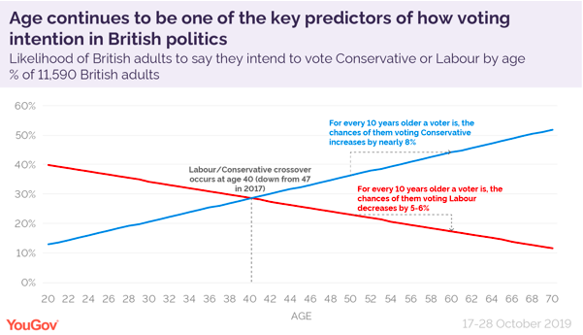
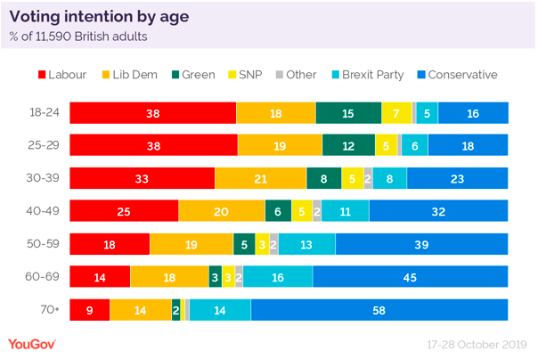
From the 2017 election, YouGov could see that there was a clear dividing line between the age of voters and who they voted for. The older the voter is most likely to vote for the Conservative party, whereas, the younger the voter is most likely to back the Labour party. From doing this poll, YouGov can still see that this is still the case when it comes to the age of the voter (YouGov, 2019).
Figure 1: (YouGov, 2019).
Figure 2: (YouGov, 2019).
When it comes the gender of voters, YouGov have found that there is a small difference in which gender votes for which party. The difference in this category does not have a significant impact on the election unlike the age of a voter which does have a significant effect on the election (YouGov, 2019).
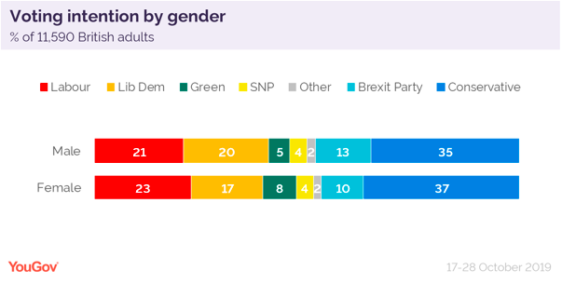
Figure 3: (YouGov, 2019).
Alongside the age of a voter to determine how the election may play out, education also plays as a big predictor and did so in the 2017 election. The Leave parties show that people who have lower levels of education are going to vote Conservative and Brexit parties. For the Remain side, people who have higher qualification and degrees, they seem to be wanting to vote for Labour and Liberal Democrats (YouGov, 2019).
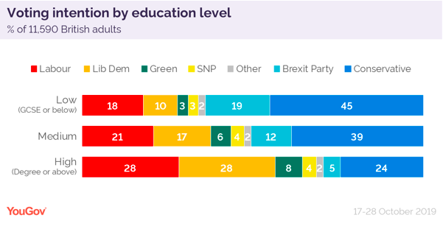

Figure 4: (YouGov: 2019).

Conclusion
By looking at this data, even though it is not reliable as the vote has not happened yet and these are predictions on what people have said, their minds can still change. But the researcher believes that if the voter age was dropped to sixteen years old, on the basis of this data, it shows that Labour would gain more voters because of their education status and the age of previous voters shows that the younger you are, the more likely you are to vote Labour.

Methodologies adopted for this study- Autoethnography
An autoethnography focuses on the manner in which people behave and impact the world around us. This is a study of society and is known as Social Science. Within an autoethnographic statement, you are re (presentation) the findings of the society you have studied, there is a three-fold process. This three-fold process includes a care for the audience, a care for the complexity and contextuality of the phenomena being expressed and that as a qualitative researcher, you care for your informant’s voice (Muncey, 2010, p. 27-49).
Within an autoethnography, the research process turns on an epistemological and ontological nexus. When writing an autoethnography, sometimes if you are attached strongly to the phenomena, you can be emotionally invested, not think logically or rationally about the phenomena. It is suggested that if that is the case, then that particular autoethnography could be better understood by someone who knows the person, story or phenomena more intimately than someone who does not (Muncey, 2010, p. 27-49).
An autoethnographic performance can provide a space for emancipation of the voice and body from homogenizing knowledge production and academic discourse structures (Spry, 2001, p. 727).
Autoethnographies are writings about yourself which can be intensely personal, it is not something someone can do, and it be perfect first time- they take practice. When you think you have finished an autoethnography writing, you can and will find yourself changing, editing and evolving it continuously. As humans we are constantly questioning the actions of others and trying to understand them, so we use our own experiences and actions to try and understand the actions of others (Muncey, 2010, p. 55).
Gray defines ethnography as a “study of culture, discovering the relationship between culture and behaviour, studying ‘sites’, as many informants as possible, use of observation, and some interviewing, use of analysis: event and reliability: triangulation” (Gray, 2014, pp. 25).
The researcher used this specific type of research methodology as her starting point. She had intimate knowledge and experiences of the topic she wanted to research. The autoethnography allowed her to put herself back in the place of her sixteen-year-old self and allowed her to gather qualitative research to allow quantitative research to take place to build on the foundation of the autoethnography and support it.

Practices for this study
Augusto Boal- Forum Theatre
A play or scene, usually indicating some kind of oppression, is shown twice. During the replay, any member of the audience (‘spect-actor’) is allowed to shout ‘Stop!’, step forward and take the place of one of the oppressed characters, showing how they could change the situation to enable a different outcome. Several alternatives may be explored by different spect-actors. The other actors remain in character, improvising their responses. A facilitator (Joker) is necessary to enable communication between the players and the audience.

The strategy breaks through the barrier between performers and audience, putting them on an equal footing. It enables participants to try out courses of action which could be applicable to their everyday lives. Originally the technique was developed by Boal as a political tool for change (part of the Theatre of the Oppressed) but has been widely adapted for use in educational contexts (Drama Resource, 2019).

The researcher has taken part in many forum theatre productions throughout her life and when being a part of them it is the most, she has ever felt liberated, free to say whatever she wants and feels empowered to change the protagonist’s outcome. The researcher would like to create scenes around discussions of people talking about why young people should not be allowed to vote. She is aiming that throughout the weekly sessions she will build trust within the group, that they feel like they can shout ‘stop’ and get up and persuade and change the outcome of other people’s views on why young people should be allowed to vote. Even if there is only one person who shouts ‘stop’ the first time they do forum, she hopes that this will empower other young people to get involved and use their voices and actions to step up and change the outcome.

People Speak Up
People Speak Up is a social arts and wellbeing enterprise. We connect communities through storytelling, spoken word, creative writing and participatory arts. We offer workshops, training, events, volunteering and conversations.
Through artistic exploration we aim to:
- Stimulate, engage and create
- Build confidence
- Cultivate intergeneration understanding
- Promote health and wellbeing through creative practice
- Generate workshops, performances and opportunities for individuals and communities
- Tackling loneliness and isolation
- Measure social impact in our local and wider community
- Investigate the gaps in provision within current arts and wellbeing practices in the UK and nationally (People Speak Up, 2019).

The researcher has taken part in some workshops run by Eleanor Shaw (Artistic Director) and has seen many of their Spoken Word events and has witnessed how liberating it is for the participants to tell their stories in front of their community. As the researcher has written an autoethnographic statement, she would like her participants to write their own and then share back using their own voices to empower them, allow them to feel liberated and to be listened to by their community. From first-hand witnessing the joy Spoken Word brings people, she believes that it will have the same impact on her participants and that this first experience of sharing their voices will be imprinted in them for future times where they may feel the need to use their voices again.

Research and Analysis of activities for the study
The researcher would like to run the project over fifteen weeks, starting from the 2nd September 2019 to the 9th December 2019. This being the period of time before the next election comes around. She would like to meet up with a group of fifteen sixteen-year-olds from the Rhondda Cynon Taff and run two-hour sessions every Monday with this group.
Within these weekly sessions, she wishes to explore the issues the young people face with voting. These may be that they are not educated early enough to know about the political parties and what they do, that they do not understand how the parties manifestos work, that they feel like they have to vote for who their families vote for and could be as simple as where their polling stations are and what you do at the polling stations.
Within exploring these topics, she would like to introduce them to forum theatre through simple exercises so when it comes to sharing what they have explored at the end of the project, they can do it through forum theatre and show how much power it gives you. The researcher believes deeply that forum theatre can be the most powerful tool to use to get people to listen, to get people to understand the protagonist and to understand that in situations there are solutions that can offer a better outcome.
She would also like to encourage them to write down any feelings, emotions, incidents that may have happened to them before they started the project and while doing the project. She would like them to do this because she would like them to hold a sharing within their community where they share back their stories to allow their voices to be heard. For some people, this may be the first time where their voices are actually heard by the people of their community and it can feel extremely liberating. The researcher would like to record this sharing to share it far and wide to other communities so they can hear and understand that the young people of their communities hold a lot of power and that they are the voices of their generation and they demand to be heard.
While going through this process, the researcher hopes to empower the young people, let them know that they have a voice and that they can use it and that it is okay if you do not follow in your family’s footsteps. She hopes through the process that she can develop a set of questions that she can give to the young people at the end of the process to also gather some quantitative research along with all the great qualitative observations she will collect.

Statement on Ethics
The researcher’s statement on ethics has been formulated from previous projects that she has delivered and her statement on ethics has been adapted from Stella Barnes’ ‘Core Principles’ (Rifkin, 2010, p. 18-20).
Choice
Allowing everyone within the space to have a choice, that it is not the job of the facilitator to dictate what they have to do. If someone needs time to themselves/ do not want to take part within the exercise/ have a difficulty with something, then they have the choice to do what is best for themselves. Not eliminating someone because they have a disability and are thought to not be able to take part but giving them the choice to take part.
Equality
Understanding that everyone is unique within their own way and allowing them to have a space where their needs can be nurtured and developed in a safe space. Everyone is reminded that what is said in the space, is kept in the space and does not leave the space to be used as a tool to hurt someone. Accepting each other for who they are and not making fun or upsetting one another.
Respect
Having the respect to listen to one another without judging/ ridiculing one another. Respecting that everyone has different opinions/views and that there is no right or wrong answer/opinion/view. Everything is never seen as a black and white and having the respect to try and understand someone’s opinion even if you do not believe in it yourself. That as a facilitator, you are not there to force your personal opinions or what you think the group needs on them, that you are there to listen and accept what they need and be able to deliver what they want/need.
Safety
Allowing positive and challenging behaviour to occur within the group but having boundaries within the space to keep the participants and the facilitator safe. Certain elements of risk are accepted within the group to allow individuals to develop both creatively and personally.
Competence
Being able to understand as a facilitator your own capacities and experiences to not throw yourself into something on your own that you have never done before. Knowing how to work and hold a group of participants and a theatre space. Being able to adapt and learn from your mistakes quickly.
Bibliography
Drama Resource (2019) Forum Theatre. Available at: https://dramaresource.com/forum-theatre/ (Accessed: 17th November 2019).
Gray, E.G. (2014) Doing Research in the Real World. 3rd edn. Washington DC: Sage Publications Ltd.
Muncey, T. (2010) Creating Autoethnographies. London: Sage Publications Ltd.
National Assembly for Wales Commission (2019) Senedd and Elections (Wales) Bill: Bill Summary. Available at: http://www.assembly.wales/research%20documents/19-042/19-042-web-eng.pdf (Accessed: 17th November 2019).
People Speak Up (2019) What We Do. Available at: https://peoplespeakup.co.uk/what-we-do.html (Accessed: 17th November 2019).
Rhondda Cynon Taf (2019) More than 3,700 young people engage in RCT Youth Vote 2019. Available at: https://www.rctcbc.gov.uk/EN/Newsroom/PressReleases/2019/July/Morethan3700youngpeopleengageinRCTYouthVote2019.aspx (Accessed: 17th November 2019).
Rifkin, F. (2010) The Ethics of Participatory Theatre in Higher Education. HEA: Palatine.
Spry, T. (2001) ‘Performing autoethnography: An embodied methodological praxis’, Qualitive Inquiry, 7 (6), pp. 706 – 732.
WICID.tv (2019) Youth Voting Project 2019. Available at: https://www.wicid.tv/info/have-your-say/voting-project/ (Accessed: 17th November 2019).
WICID.tv (2019) Your Voice 2018 Results. Available at: https://www.wicid.tv/info/your-voice/ (Accessed: 17th November 2019).
YouGov (2019) 2019 general election: the demographics dividing Britain. Available at: https://yougov.co.uk/topics/politics/articles-reports/2019/10/31/2019-general-election-demographics-dividing-britai (Accessed: 17th November 2019).
Appendix A- An Autoethnographic account of Kiara Sullivan
I grew up in the Rhondda Valleys, which is only one valley of three. The other two valleys are the Cynon Valley and the Taf Valley. From when I was born to five years of age, I lived in the Cynon Valley, I do not remember much between those ages. I then spent from age six to now, living within the Rhondda Valley. Although, from the ages of six to fourteen, I lived in Penygraig and studied there. Then at fourteen, me and my mam moved to Porth, but I still continued to study in Tonypandy Comprehensive School.
This is where it gets confusing. I moved from one school to another when in year four and when starting at my new school I did not make friends as easy as I would have liked too. I had one solid friend while others were still warming up to the new the kid, I did not have a voice in school. Yes, I liked to be the first one to answer a question or get involved in class discussions, but my voice was never heard by the others in my class. It did not change that much when I went to comprehensive, although I had one good thing on my side. Artworks. Artworks know known as Sparc is a charity that works with young people through the arts to allow them to be who they are in their truest form.
I started attending drama sessions at seven years of age, I was still new to Penygraig and finding out what happens in the area but one day when leaving afterschool club at Valley’s Kids, I bumped into Johnno, the Youth Development Worker at the time. He encouraged me and my friend to join along in the drama sessions. We turned up the week after and I never left. I felt that this was a turning point for me as even though my voice was not being nurtured in school it was in these drama sessions. People where actually listening to what I had to say. They helped me grow with confidence within the group and allowed me the space to thrive. In school, I was still being bullied but I was not scared to report the incidents to the teachers and even though the bullying still carried on, I never once allowed them the power to take away my voice, even if that meant standing up for myself and there being consequences. Cause there were times when teachers would not pay attention to the boys bullying me and where I would physically stand up and shout back because I could not handle them constantly belittling me, but then I would be in the wrong because I ‘caused a scene’ where in fact I was defending myself because no else would.
Within Sparc, I was constantly being challenged (in a good way) about what I thought needed to be changed within our community, how we as young people could create change and why we felt it was necessary that we do not conform to what is expected of us. We were always encouraged and empowered to use our voices where and when we could to question what was happening, why it was happening and what can we do to stop/change these from happening. From my experiences being with Sparc for thirteen years, I have first handily seen how my voice and the voices of the people around me have effected change in a positive way, I have also seen how there are still people within communities who do not know that they can use their voice to stand up for what they believe in as they are scared of the backlash that may come with them standing up.
As a sixteen-year-old, hearing about the Brexit vote and how we had the chance to stay or leave the European Union but not being given the chance to have my say was heart-breaking. As someone who comes from a background indulged within every art form possible and being given the chance to use my voice in any way I could, then being told that because I was sixteen and too young that I could not have a say in the general election crippled me. I and many people within Penygraig had created so much change within our community, I felt robbed that I could not use my voice for this decision. Many of my friends and I, have had the discussion of how we can fight for our country and the Army at the age of sixteen, how girls at the age of sixteen can legally have sex, become pregnant and start a family and that we can even get married at sixteen. How when our parents where sixteen they could smoke and buy cigarettes. So why is it that we cannot vote at the age of sixteen?

