

Postgraduate/Distance Learning
Assignment coversheet & feedback form

THIS SHEET MUST BE THE FIRST PAGE OF THE ASSIGNMENT YOU ARE SUBMITTING (DO NOT SEND AS A SEPARATE FILE)

For completion by the student:
Student Name: Ros Lund

Module code: HPCA7015  Module title: Foundations in Cultural Astronomy and Astrology | Student ID number:  2413112 |  |  | Educational support needs:  Yes/No
Module tutor: Dr. Nick Campion

Assignment due date: 28/11/2024
If your module has multiple submissions please indicate which piece of work this is.

1st 2nd ☑ 3rd 4th 5th 6th
I confirm that this is my original work and that I have adhered to the University policy on plagiarism.
Signed ……………………………………………………………
Email submission: if you are submitting this form via email, please tick this box ☑
(as a substitute for your signature) to confirm that you agree to the above declaration.
Assignment Mark
Final Mark | WILL BE GIVEN ON TURNITIN

NB. All marks are provisional until confirmed by the Final Examination Board.

PLEASE NOTE: ALL COMMENTS WIL BE POSTED ON TURNITIN

For completion by Marker 1 :
Comments:

Marker’s signature: |  |  | Date:
For completion by Marker 2/Moderator:

Comments:

Marker’s Signature: |  | Date:
AGREED INTERNAL MARK (where necessary):

Comment on process of arriving at agreed mark:

External Examiner’s comments (if relevant)

External Examiner’s Signature: |  | Date:

An essay based on a Sky Journal.
This essay considers the sky's relationship to landscape reflecting on literary critic Alexandra Harris's statement ‘to think is to walk among clouds’, referencing my Sky Diary and recorded in photographs, over a month in October and November 2024. When asked the best view in London by the BBC, travel journalist Clive James described my view (Fig. 1), "the Butler's Wharf area, looking down-river when it's full and flat. You can see Canary Wharf looming out of the mist."
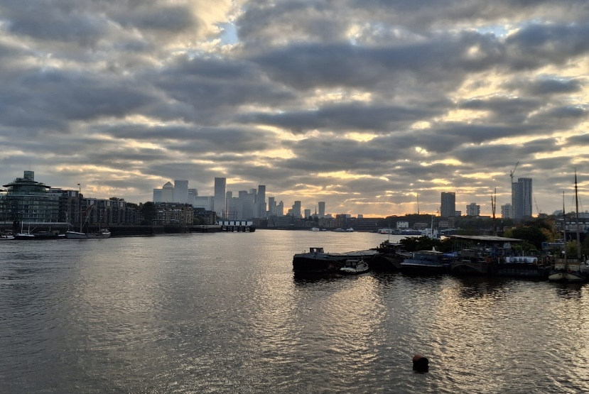
Figure 1: Ros Lund, Canary Wharf Looming, 24 October 2024. Photo: London.
Cultural theorist Adrian Ivakhiv in Engaging Images, commented that making sense of what we see is mixed with remembering. Humans see things through the lens of their backgrounds, upbringing and life experience. The author viewed the sky through the lens of her culture, defined by philosopher Eagleton as ‘whole way of life’, background, life experience and personality as a middle-aged English woman living nearby. The reader may have experienced different responses to the scene.
Cultural historian Nicholas Campion writes in ‘Skyscapes’ that understanding the world is fundamental to human existence and can be achieved by connecting with the sky;
Cultural perceptions of the sky are vital for fulfilling humankind's most basic need to comprehend the universe it inhabits, both from a modern scientific perspective and from countless other cultural standpoints, extending right back to early prehistory.
In the city the sky can remain unobserved and humankind’s most fundamental need unfulfilled. Rushing from place-to-place the city dweller looks downward to avoid other people and obstructions to progress, in some areas building density obscures the sky. Religious scholar Mircea Eliade recorded in ‘The Sacred and the Profane’ that a person observing the sky, ‘simultaneously discovers the divine incommensurability and his own situation in the cosmos.’ This essay recounts the author’s experience of observing changing skies over a month and the varying responses prompted. A vivid sunrise evoked a sense of Eliade’s transcendence, but at times the sunrise was obscured by cloud or mist inciting a feeling of abandonment, on other instances correlation was established between the spectator and the place of observation. This paper will consider in turn the arousal of hierophany, abandonment, connection to place, and assess the impact of sky observation over the period recorded in Sky Diary, it will also consider the influence of culture on those responses.
Hierophany
Arriving at the banks of the mighty Thames from the narrow side streets the view is open and the sky large, as Campion described in ‘Skyscape Archeology,’ ‘it is actually half of the natural environment, measured by the visual area it covers.' Looking up at the heavens on the first morning the sky appeared much larger than half the natural environment, dwarfing everything else in view, and summoning Eliade’s words that ‘contemplation of the celestial vault already provokes a religious experience….transcendence is revealed by simple awareness of infinite height.’

In harmony with Campion and Eliade the first diary extract documents the sky as a seemingly limitless space towering above the land and river scape, the fracturing stratus clouds facilitating a reflection of colourful luminosity on the water (Fig.2).
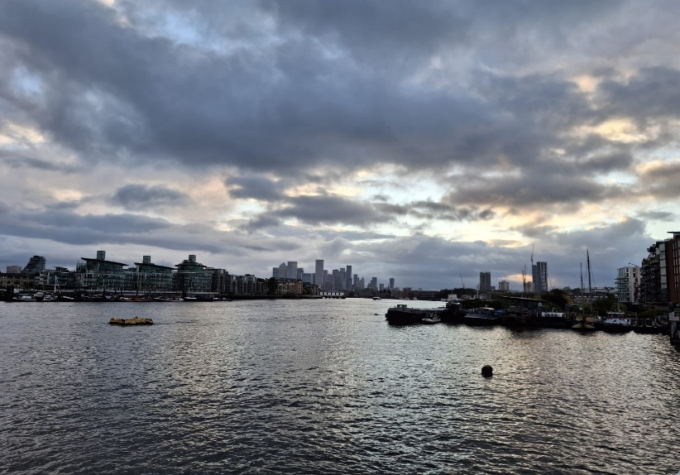
Figure 2. Ros Lund, Reflected Sky, 8 October 2024. Photo: London.
A towering bank of moody, magnificent rolling sooty grey hangs high above, pushed ever upwards by lighter clouds lit with reflected glow from the sun which, just rising in the East, has forced through chinks in the brooding mass. At first glance all looks grey, but brightness is breaking through, the glow of the sacred lighting the sky. The river gleams with iridescent apricot, gold, blue and grey stripes. Peace and hope are aroused in me.
The entry for 10 October documents a wall of grey with occasional glimpses of white cloud serving as a reminder that imminence floats just below the surface, concealed by the worries of life, but waiting for an opportunity to reveal itself, ‘the reflections of the sky on the water are faint this morning, but still exist to an observant eye.’ According to the Oxford Dictionary hierophany is a ‘manifestation of the sacred,’ and on these days there was an embodiment of sacred magnificence. Summer Allen of the Greater Good Science Centre in the executive summary of ‘The Science of Awe’ described how awe can bring about an awareness of beauty, reveal holiness, and make us feel part of something larger and even inspire kindness.
Awe experiences are self-transcendent. They shift our attention away from ourselves, make us feel like we are part of something greater than ourselves, and make us more generous towards others.
Awe is perhaps an overstatement but the sky on these day did engender an appreciation of beauty, a suggestion of hope and a momentary generosity of spirit which could be described as a hierographical, a fleeting but welcome respite from ego, albeit rapidly expunged in the bustle of city life and the stresses of the day ahead. On these days I experienced hierophany.
Abandonment
Several mornings, such as 15 October (Fig.3), revealed a bank of grey cloud and mist which made the sky appear gigantic and, without any sign of the sun, induced a feeling of abandonment, recalling the words of Christ crucified citing Psalm 22.1 ‘my God, my God, why hast thou forsaken me?’
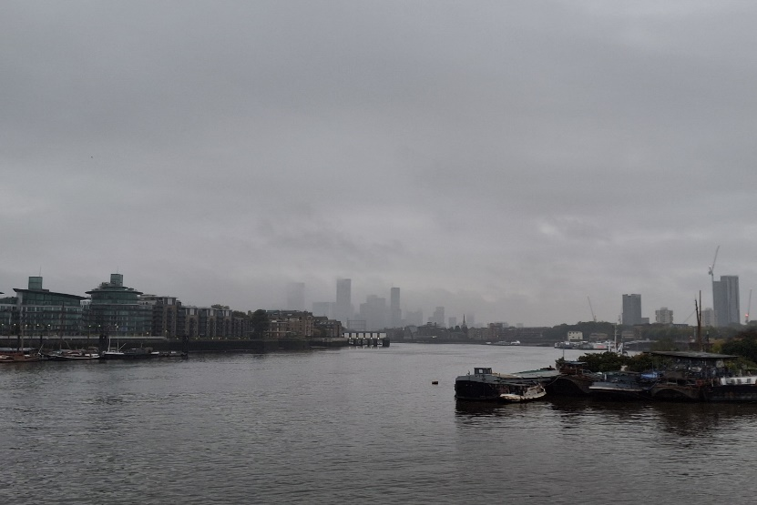
Figure 3. Ros Lund, Obscuring Sky, 15 October 2024. Photo: London.
It is raining this morning. Canary Wharf is hidden by mist like a ghostly apparition of standing stones surveyed at sunrise. The sun is obscured, the heavens angry and withholding the energy-giving light and warmth.
The dense clouds evoked Harris’s words, ‘to think is to walk among clouds’. I set out to examine sunrise but ended up inspecting clouds. Misquoting Descartes, I am, because I think about clouds - the heavy cloud elicited a strong consciousness of the reality of life. Across time and cultures multiple meanings have been assigned to clouds, thus Harris’s words may speak of transcendence, confusion, doubt, impermanence, sadness and anger. Life is not always comparable to a sunny day, on some days the clouds enveloped me obscuring the sun and creating shadows of sadness and doubt. In psychologist Abraham Maslow’s Hierarchy of Needs, self-realisation is the pinnacle of the five levels of motivation encompassing physiological, safety, love, esteem and finally self-actualisation. Maslow’s thesis notes that humans are stimulated to satisfy lower needs before seeking fulfilment of the higher more intellectual aspirations. During the writing period the diarist was burdened by life’s concerns imaginably resulting in a detachment from divinity.
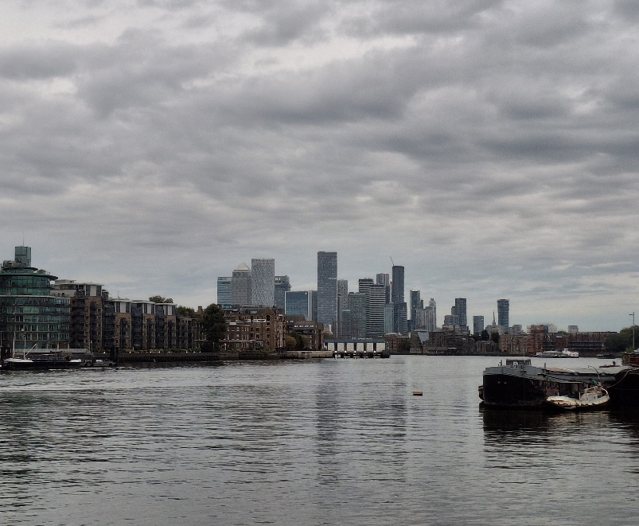
Figure 4. Ros Lund, Thin Veil, 12 October 2024. Photo: London.
12 October the sky was again grey with scattered light cloud and hints of blue sky (Fig.4), ‘the veil is thin, I must face the long shadows, do the work to enter the sanctuary’. In many religious traditions purification before admission to the holy place is required. In example anthropologist Babb described bathing for purification as an important part of Hindu ritual. Conceivably this was Allen’s meaning when writing of a ‘need for accommodation’. Transcendence demands an active mental response, ‘when a stimulus exceeds our expectations in some way, it can provoke an attempt to change the mental structure that we use to understand the world.’
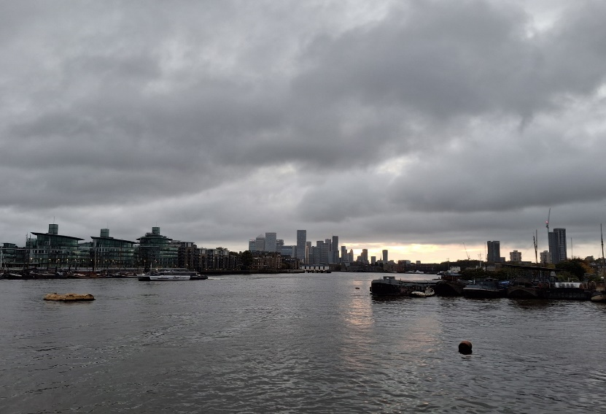
Figure 5. Ros Lund, Pocket Of Brilliance, 9 October 2024. Photo: London.
On 9 October the sky was similarly gloomy but shifting perspective eastward, a faint glow of light indicated the sun breaking through (Fig.5). My thoughts turned to seasonal affective disorder, I mused that an inheritance of ancestral fear that the sun will abandon the earth never to return could be cause. This dread is illustrated in Izzuddin and others ‘Cultural Myth of an Eclipse in a Central Javanese Village’ description of the belief of villagers that evil giants try to eat the sun during an eclipse and rituals required to appease those giants are expained. In Sky Diary an outlook change revealed flashes of gold and tangerine pushing through the gloom and lighting the river, ‘perhaps I am not forsaken surrounded by resplendent clouds and a glimpse of gold.’ Another of Allen’s accommodations, a conscious decision to change standpoint to transcend self and reframe desertion.

Connection to place
‘… we were standing by the banks of the Thames where the cold grey waters ripple in the misty morning light.’ In Misty Morning Albert Bridge punk band The Pogues describe the sky scape on 25 October (Fig.6). The lack of visible sun promoted a resonance with place.
There is no Canary Wharf today; it is completely obscured by fog. The feeling is eerie, still, calm and so quiet, the fog blanketing the sound. A strange ring of pink, green, and blue light is revealed in the middle of the sky attempting to break through the murk.
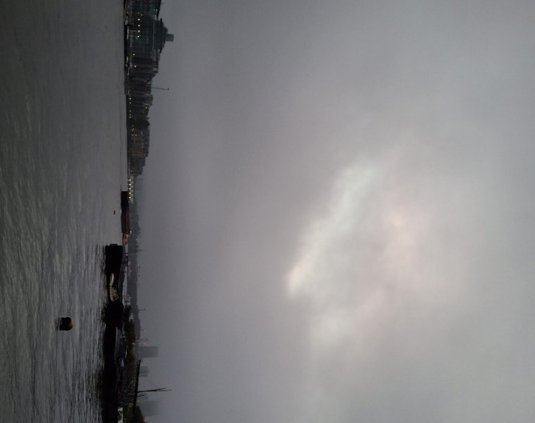
Figure 6. Ros Lund, Ring Of Light, 25 October 2024. Photo: London.
The obliteration of Canary Wharf transported me to a 1993 visit when the first tower was newly constructed, memories arousing reflection on the dichotomy of the ephemerality and continuity of life and summoning the statement by Ivakhiv that current reality is blended with past experience. My past blended with the history of the place on that day, the same but ever-changing sky bestowed a sense of continuation, grounding and calm.
The sky of 27 October summoned a strong link with the river on a gorgeous sunrise (Fig.7).
A new day, a blank page in a new note book, anything can occur. The Thames is smooth as a mirror, but a little boat is churning the water. The clippers zoom past in a rush to drop their passengers, creating large rapidly dispersing waves. The small, slow boat generates a sustained wave taking longer to subside and for the calm to return; resonance to life where small slights can cause greater disruption than large events, distorting peace and obscuring clarity. The river spoke to me of his history, how he expands with hope and vigour at each high tide and retreats in disappointment and fatigue at low tide, just as I do in my life.
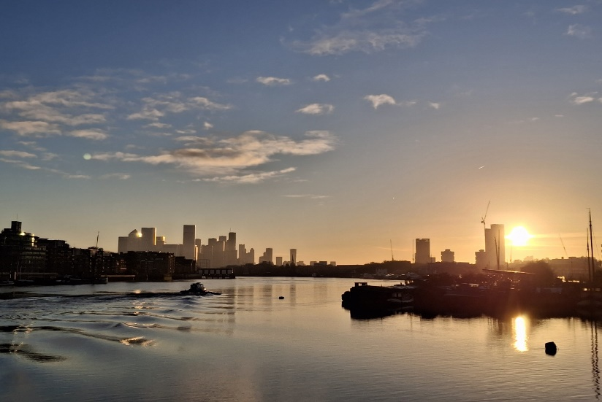
Figure 7. Ros Lund, New Day, 27 October 2024. Photo: London.
I would have expected such a stunning morning to arouse a sense of awe but the vista instead provoked memory of place and internal reflection. The sky was so perfect spirituality was almost superfluous, inducing the question of whether detriment is a necessity for divine experience. Conceivably the peace and connection to that location bestowed by the beautiful vision was in fact an experience of transcendence.
Conclusion
For a month I observed the morning sky looking across the Thames to Canary Wharf recording reflections and photographs. The sunrise proved elusive and Sky Diary became largely a record of clouds and the thoughts and responses provoked. Harris’s quote ‘to think is to walk among clouds’ conjured consideration of the unavoidable clouds of life and their influence on perception of cosmological grandeur. Extracts from Campion and Eliade promised encounters with the sky are essential and sacred, Allen added awe inspiring, beauty and generosity evoking. I felt my experience mundane, fleeting and insipid compared with the descriptions of the sources. Consequently I examined the impact of my culture, personal background and life experience as response moderators along with Maslow’s model of a needs hierarchy and Ivakhiv’s theory of the influence of memory, and reached a conclusion that sky response is situational, cultural and personal. Just as the reader’s responses may have differed, so may the diarists on another day.
In fact upon closer examination a sense of transcendence was apparent in all my sky observations, those where hierophany was obvious, when abandonment was felt, and when a connection was established with place. During the Sky Diary activity some kind of healing occurred, metaphorical clouds dispersed, thoughts and memories generated a greater acceptance of and satisfaction with my life. Setting out early and taking the time to stop and stare at the sky helped me to rise above some cares and process others. I will continue my morning pilgrimage and look forward to future revelations and healing.
Ending with one of two occasions when I saw the sun rise (Fig.8). ‘The sky is a magnificence of criss-crossing lines of contrails and distrails. The orange-yellow light illuminates a path across the river to me and I feel a surge of joy and peace.’
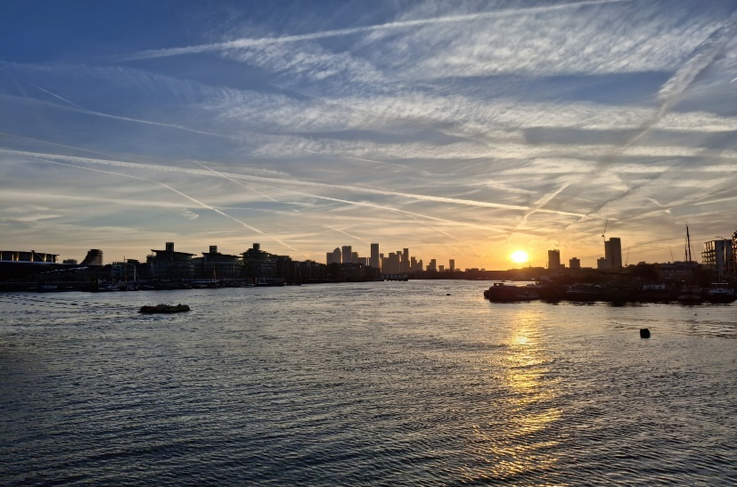
Figure 8. Ros Lund, Contrails And Distrails, 13 October 2024. Photo: London.

Bibliography
Allen, Summer, The Science Of Awe, The Greater Good Centre, UC Berkeley, 2018.
Babb, Lawrence A., The Food Of The Gods In Chhattisgarh: Some Structural Features Of Hindu Ritual,
Southwestern Journal of Anthropology, Vol. 26, No. 3 Autumn 1970, pp. 287-304.

Campion, Nicholas, The Value Of Skyscape Archeology, Journal of Skyscape Archeology, 2020, pp 94-97.
Dunlop, Storm, Weather, Collins Nature Guides, 2014.
Eagleton, Terry, Culture, Yale University Press, 2016.
Eliade, Mircea, The Sacred And The Profane, tr., Trask, Willard R., Harcourt, Brace and World, 1957.
Finer, Jeremy Max, Misty Morning Albert Bridge, Universal Music Publishing, 1989.
Harris, Alexandra, Weatherland: Writers And Artists Under English Skies, Thames and Hudson, 2019.
Ivakhiv, Adrian, Engaging Images: Building Common Worlds Shadowing The Anthrpocene, Eco Realism For
Turbulent Times, Puncture Books, 2018, pp. 151-222.

Izzuddin, Ahmad, and others, Cultural Myth Of Eclipse In A Central Javanese village: Between Islamic identity
And Local Tradition, AOSIS Publishing, 2022, pp 1-9.

James, Clive, Clive James’s London, BBC, 2009.
Stevenson, Angus ed., Oxford Dictionary Of English, Oxford University Press, 2010.
Silva, Fabio and Campion, Nicholas, eds., Skyscapes: The Role And Importance Of The Sky In Archeology,
Oxbow Books, 2015.
The Holy Bible, Authorised King James Version, Collins, 1949.

Alexandra Harris, Weatherland: Writers And Artists Under English Skies, Thames and Hudson, 2019, p. 201.
Clive James, Clive James’s London, BBC, 2009.
Adrian Ivakhiv, Engaging Images: Building Common Worlds Shadowing The Anthrpocene, Eco Realism For Turbulent Times, Puncture Books, 2018, p. 153.
Terry Eagleton, Culture, Yale University Press, 2016, p. 15.
Nicholas Campion, The Value Of Skyscape Archaeology, Journal of Skyscape Archaeology, 2020, p. 94.
Mircea Eliade, The Sacred And The Profane, tr., Willard R. Trask, Harcourt, Brace and World, 1957, p.119.
Campion, The Value Of Skyscape Archaeology, p. 94.
Eliade, The Sacred And The Profane, p. 118.
Angus Stevenson, ed., Oxford Dictionary Of English, Oxford University Press, 2010.
Summer Allen, The Science Of Awe, The Greater Good Centre, UC Berkeley, 2018, p. 1.
Matthew 27:46, The Holy Bible, Authorised King James Version, Collins, 1949, p.33.
Alexandra Harris, Weatherland, 2019, p. 201.
Renee Descarte, Discourse On Method, tr. John Veitch, J.M. Dent & Sons Ltd., 1912, p. 27.
Abraham Maslow, A Theory of Human Motivation, Psychological Review 50, 1943, pp. 396.
Lawrence A. Babb, The Food Of The Gods In Chhattisgarh: Some Structural Features Of Hindu Ritual, Southwestern Journal of Anthropology, Vol. 26, No. 3 Autumn 1970, pp. 287-304.
Ahmad Izzuddin, and others, Cultural Myth Of Eclipse In A Central Javanese Village: Between Islamic Identity And Local Tradition, AOSIS Publishing, 2022, p. 1.
Jeremy Max Finer, Misty Morning Albert Bridge, Universal Music Publishing, 1989.
Adrian Ivakhiv, Engaging Images, p. 153.
Alexandra Harris, Weatherland, p. 201.

