Effective Team Working and Communication (BMSW-4002)
Muntasir Reza Chowdhury (1916797)
Lecturer- Lloyd Beharry
Words - 2646

Table of Contents
Introduction 3
Models of communication 3
Shannon and Weaver (1948/49) 3
Schramm (1954) 5
Berlo (1964) 6
Communication skills 8
Refer to case studies 9
Examples of poor communication in the workplace 9
Suggestion for improving the poor communication 10
Conclusion 11
References 11

Introduction
Communication is the way of sharing information between person to person or one place to another place. Communication becomes effective when the receiver or receivers can comprehend the meanings of messages provided by the sender and provide feedback senders. Effective communication makes an organisation profitable in the marketplace and provides competitive advantages. It enhances employee engagement and productivity, provides organisational alignment, satisfies all parties in the organisation, lessens employee turnover, develops crisis management and workplace safety, enhances coordination among all departments, and increases efficiency and innovation in the workplace. There are some barriers that cause to make poor communication. These factors are communication skills and styles, physical barriers, disengagement of both parties, organisational structure, cultural variation, information overload, lack of trust, shortage of clarity, consistency and frequency, lacking active listening, wrong communication channels, and others that hinder to make the effective communication. Poor communication in the workplace produces several negative outcomes (Zambas, 2021). It enhances employee turnover and dissatisfaction, provides poor customer service, minimises shareholder returns, minimises employee productivity. As a result, a firm may lose its profitability in the marketplace.

Models of communication

Shannon and Weaver (1948/49)
American scholars Shannon and Weaver developed a model of communication for technical communication, especially in the telecommunication process. This mathematical communication is known as the Shannon and Weaver model of communication. The model focused on ensuring effective communication and barriers of communication that may occur while the communication process. It determined “noise” that causes the failure of ensuring effective communication.
The model is connected with several steps. These communication steps are dictated here.
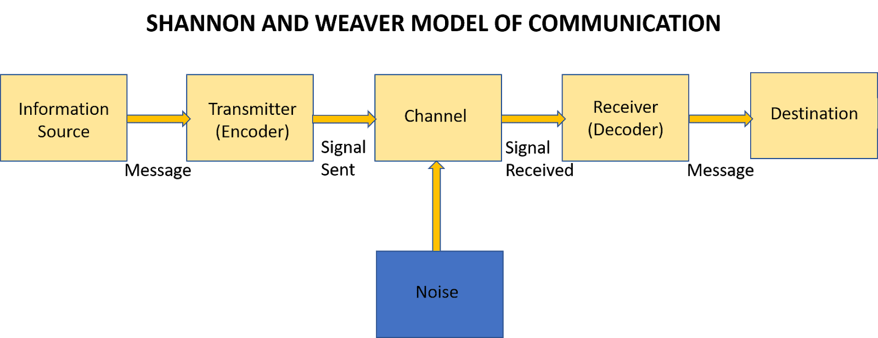

- Sender: A sender is a person who creates messages or generates an idea of sharing information.
- Encoder: An encoder is known as a transmitter that alters messages into binary signals. These signals are sent via cable or satellite platform. For example, in telecommunication platforms, sounds are altered into wave signals and sent via cable platforms.
- Decoder: Decoder is the platform that alters the signals into messages. Its function is just the opposite of encoder. It alters binary or waves data into communicable messages that are suitable for receivers.
- Receiver: The receiver is the person who accepts messages transmitted from the sender. He or she provides feedback based on decoded messages. The receiver may misunderstand and provide wrong feedback due to having noise in the communication.
- Noise: The model especially dictates external noises. Communication becomes a failure that may occur while sending messages via loud sounds, thunder, and physical noises (Al-Fedaghi, 2012). This model directly explained physical noises that hinder to make the effective communication. For example, mobile communication may go in vain due to having thunder while sharing information through cable platforms.

An example of the model
Robert is a marketing executive in a multinational company. He made called his assistant Max to attend the meeting on Thursday. Max only heard to attend the meeting. He didn’t hear the specific day due to loud traffic sounds while communicating with Robert.

Schramm (1954)
The model is called the Osgood-Schramm model of communication. The model is developed by Charles Osgood in 1954. According to Osgood, communication is a circular model, not a linear model. The model urges that communication is a two-way path where messages continuously transmit between sender and receiver. The main objective of this model is that both sender and receiver will figure messages fruitfully. On other hand, Shannon and Weaver model is a linear model of communication. Factors of this model are encoder/sender, decoder/receiver, message, and semantic noises (Wells, 2017). The model urges that there are required two elements known sender and receiver. The sender transmits messages to receivers while the receiver decodes the messages to figure out the meaning of messages. Then, the receiver will also send feedback that also known as messages. In that case, the receiver acts as the sender while the sender acts as the receiver. Under the model, it is assumed that communication is not effective unless the receiver provides feedback based on decoded messages.
Components of the model are discussed here.
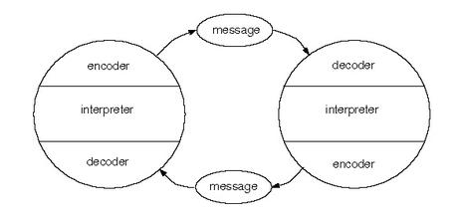
Figure: Schram model of communication
- Source: Sender is referred to as the source. He has the responsibility to ensure clarity, consistency and frequency of messages. He must provide clear and legal messages that are comprehensible to the receiver. He provides messages concisely based on the receiver point of view.
- Receiver: The receiver is the person to whom the sender provides encrypted messages. He decoded messages to figure out easily. To make the communication effective, it is essential to ensure that the receiver understands the messages. Therefore, some factor needs to be common –language, culture, and comprehending ability.
- Message: Messages are the main factor of communication. The receiver may provide messages both verbally and non-verbally. He may provide messages via audio, video, text messaging as well as other written forms, and oral messages. He also may provide messages via facial expression, gesture, bodily expression, eye contact, and other non-verbal ways. An interpreter may have in the communication to explain the meaning of messages towards the receiver or the sender. Based on interpreter skills, the communication also becomes effective.
- Feedback: Feedback is the most essential component of the model. Under the recipient understanding skill, he provides feedback. Communication becomes productive when the recipient meets all the criteria while providing feedback that satisfies the sender (Muyanga and Phiri, 2021). Feedback is essential to assume whether the recipient has understood or not. Under the feedback, the sender may also ask the receiver whether to explain more or not.
- Semantic noise: It is the factor that hinders understanding the message fruitfully.
An example of the model
A salesperson tells the customer of a 15 percent discount for the cheese product for the day. The customer heard only that the product has a 15 percent discount but he didn’t figure out the duration of the discount. The customer might ask the salesperson to know more.

Berlo (1964)
Berlo’s model of communication is also known as SMCR or Sender-Message-Channel-Receiver model of communication. Each component holds many elements. These components are dictated here.
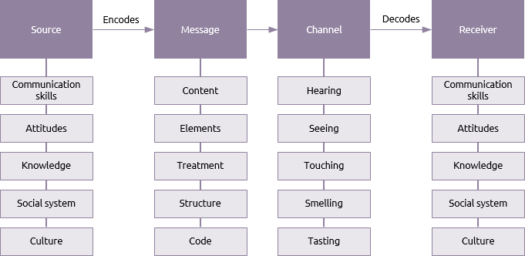
Figure: Berlo’s model of communication
- Source: The components contain various elements. The sender has to have effective communication skills including the capability to read, write, and actively listen. He needs to have a good attitude towards his audience. The sender must have specific and detailed knowledge of the subject. He needs to be conscious of beliefs, culture, religion, and other social factors while sending messages. He provides encrypted messages to the receiver.
- Message: Message consists of content, element, treatment, structure, and code. Content is the whole part of the messages known from the starting to the ending point. Element means language, body language, gesture, nonverbal clues, and others. Treatment is the way of conveying messages. The structure is the arrangement of messages where code is known as how the messages will be delivered.
- Channel: Channel is the media of sending messages. Under the communication model, there are five channels of communication. First is, hearing where the sender provides messages orally. Second, seeing where the sender delivers messages visually (Rizki, 2019). Third, touching where he sends messages like touching products. The fourth and fifth components are smelling and tasting.
- Receiver: The receiver also concentrates on the elements of sources, messages and channels to understand the messages and provide feedback.
The model is not designed for specific areas. It is a simple and general model of communication.

Communication skills
To make communication successful one have to possess some required communication skills. The most important skills are explained here.
- Active listening: The person has to become a receptive minded communicator to make the communication successful. He has to highly concentrate on other responses. He actively listens to other voices and removes himself from distractions like cell phones, laptops, and others.
- Communication mood: The person has to select suitable communication methods. There are numerous verbal and non-verbal communication methods. He may communicate through email, text messaging, instant messaging, letters, audio, visually, and other verbal and non-verbal ways. For example, he may communicate orally while supervising his subordinates.
- Friendliness: The person needs to be friendly while communicating with his subordinates. An autocratic mood of communication does not ensure effective responses from subordinates or colleagues. He may apply a delegative mood to communicate with them. He may show positive responses towards subordinates’ comments (Chairat, 2016). The person may provide space for them to comment and say something based on his ideas and messages.
- Confidence: The sender must have confidence while communicating with others. To raise his confidence, he may ensure eye contact and facial expression like smiling.
- Sharing feedback: The communicator accepts feedback and delivers a productive solution to the feedback. All person needs to deliver and accept feedback to become an effective communicator. The communicator has to provide an effective answer to asking questions by others.
- Clarity and sound: The sender must ensure the clarity of his messages. He needs to send clear and relevant messages that are comprehendible for receivers. He also needs to ensure a suitable volume of his speech while talking with others in the workplace. He must not always speak loudly or too slowly.
- Empathy: Empathy is an essential factor to make communication productive. The communicator has to show respect and value to other speeches even their speech is controversial to him. It means the communicator has to provide the value of other emotions even in an angry situation.
- Nonverbal cues: To make the communication, it is a good idea to use nonverbal cues in the communication process. He may use body language, facial expression, eye contact, gesture, and other nonverbal expressions to make the communication visual. These nonverbal communication cues influence receivers to pay attention to the speech of the sender.
- Open-mindedness: The communicator has to become an open-minded person. He needs to become a receptive and proactive minded person (Coffelt, Grauman and Smith, 2019). This quality inspires recipients to pay attention to the speech of the sender. The communicator has to determine to figure out other’s points of view.

Refer to case studies
The case study of Maria and Pedro is included in the Shannon and Weaver model of communication. Due to noise, Pedro didn’t figure it out fully. He might provide feedback to prevent misunderstanding. He might follow Schramm model of communication to reduce misunderstanding.
The case study of the professor and the village people are included in the Berlo model of communication. The professor didn’t analyse language and cultural variation (Eilers, 2021). He might use appropriate sentences based on the culture to get help from village people.
The case study of a day with the chief is included in the rumour that hinders to make the effective communication. Mark needs to develop some communication skills. He needs to improve his confidence level, open-mindedness, and active listening skills.

Examples of poor communication in the workplace
Poor communication is the communication process where different persons understand the different meanings of the same speech of the sender. It causes a failure of an organisation and loss of profitability. It increases the wastage of time and money in the organisation. In the training programme, if employees do not figure out the speech of the trainer, they will be demotivated that increases high employee turnover. Besides, bad communication between subordinates and seniors also increases employee turnover and loss of productivity (Effective Communication in the Workplace: How and Why?, 2021). Poor communication also increases the rate of missing deadlines of the projected mission of the organisation. Some examples of poor communication are given here.
Gossiping in communication is an example of poor communication. While the sender speaking in front of his subordinates, they may gossip about rumours. An executive is talking with subordinates about the organisational mission while someone is gossiping about their personal issues. As a result, they lost their attention and do not understand the speech.
Cultural and language variation is another factor of poor communication. For example, a marketing manager is talking speedy in English where numerous foreigners may exist. They have different languages. The speedy style of talking with subordinates also distract employees to figure out the speech properly.
Lacking nonverbal cues may also cause poor communication. An HR manager merely talking with subordinates without any body language and facial expression (Ramadanty and Martinus, 2016). As a result, employees may seem him as a rude and strict person that may cause the failure of effective communication.

Suggestion for improving the poor communication
There are some ways of ensuring effective communication. These ways are explained here.
In the organisation, there is needed to be set a standard of communication policies (Wells, 2017). The firm may write down communication principles and update the policies based on time and situation.
Before communicating with others, the communicator has to evaluate the culture of recipients. In an organisation, there are several employees who have diverse cultures and languages. Therefore, the firm has to apply a formal and cultural supportive method of communication approach.
The communicator has to ensure clarity of speech. As a result, the recipients will figure out the main objectives of the communication (Rittiman, 2021). He needs to prevent misunderstanding of messages through providing relevant and suitable messages.
The communicator must use facial expression, body language, and other non-verbal tools. Therefore, recipients will effectively the objectives and meaning of speeches. Besides, he also provides feedback on receivers’ questions.

Conclusion
Effective communication is required for all organisations. To make effective communication, scholars developed several theories of communication including Shannon and Weaver, Schramm, and Berlo model of communication (Sanmugam and Shamsudin, 2017). Communicators need to contain some skills to make the communication process productive. Poor communication can be reduced through taking some steps.

References
Al-Fedaghi, S., 2012. A Conceptual Foundation for the Shannon-Weaver Model of Communication. International Journal of Soft Computing, 7(1), pp.12-19.
Chairat, P., 2016. Communication Skills Used by English Major Graduates in the Workplace: A Case Study. International Journal of Languages, Literature and Linguistics, 2(1), pp.38-43.
Coffelt, T., Grauman, D. and Smith, F., 2019. Employers’ Perspectives on Workplace Communication Skills: The Meaning of Communication Skills. Business and Professional Communication Quarterly, 82(4), pp.418-439.
Eilers, C., 2021. Effective Communication Skills. [Blog] Zety, Available at: <https://zety.com/blog/communication-skills> [Accessed 30 August 2021].
Hrtechnologist.com. 2021. Effective Communication in the Workplace: How and Why?. [online] Available at: <https://www.hrtechnologist.com/articles/employee-engagement/effective-communication-in-the-workplace-how-and-why/> [Accessed 30 August 2021].
Muyanga, C. and Phiri, J., 2021. Assessment of Effective Communication in International Schools in Developing Countries Based on the Berlo’s SMCR Model. Open Journal of Business and Management, 09(01), pp.448-459.
Ramadanty, S. and Martinus, H., 2016. Organizational Communication: Communication and Motivation in The Workplace. Humaniora, 7(1), p.77.
Rittiman, E., 2021. Learn Effective Communication Strategies in the Workplace. [online] The Official Blog of CSU Global. Available at: <https://csuglobal.edu/blog/make-indispensable-5-workplace-communication-strategies> [Accessed 30 August 2021].
Rizki, M., 2019. PENGAPLIKASIAN MODEL KOMUNIKASI OSGOOD AND SCHRAMM OLEH PENGAJAR TK DALAM ACARA PARENTS WORKSHOP DI HIGHSCOPE BINTARO. Communicology: Jurnal Ilmu Komunikasi, 6(2), pp.69-83.
Sanmugam, S. and Shamsudin, S., 2017. The Use of Educational Research Findings to Develop Engineering Students’ Workplace Communication Skills. International Journal of Languages, Literature and Linguistics, 3(2), pp.49-52.
Wells, K., 2017. Effects of Poor Workplace Communication in Business. [Blog] FSD, Available at: <https://fsd.servicemax.com/2017/11/08/6-business-impacts-poor-communication/> [Accessed 30 August 2021].
Zambas, J., 2021. The Importance of Effective Communication in the Workplace. [online] Careeraddict.com. Available at: <https://www.careeraddict.com/the-importance-of-effective-communication-in-the-workplace> [Accessed 30 August 2021].

