The Repercussions of the First World War on European Art
By Isabelle Dufresnoy

I would like to take you on a journey back in time through my exhibition, exploring the change between the fast-soft strokes of the impressionists; attempting to catch the fleeting scenes of nature to the destruction and depravation of the first world war that led to such an uncensored emotional radical change. My aim is to conclude that modernism and its extreme relationship between art and audience was a product of the First World War 1914-1918. I decided to exhibit this part of art history because I believe it was the most influential time for art and it massively shaped how we use and perceive conceptual art in modern day.
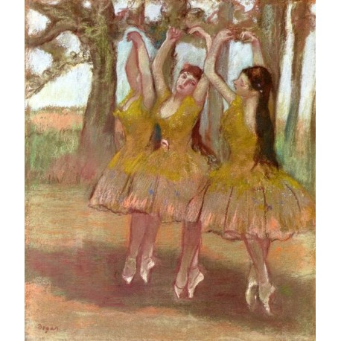
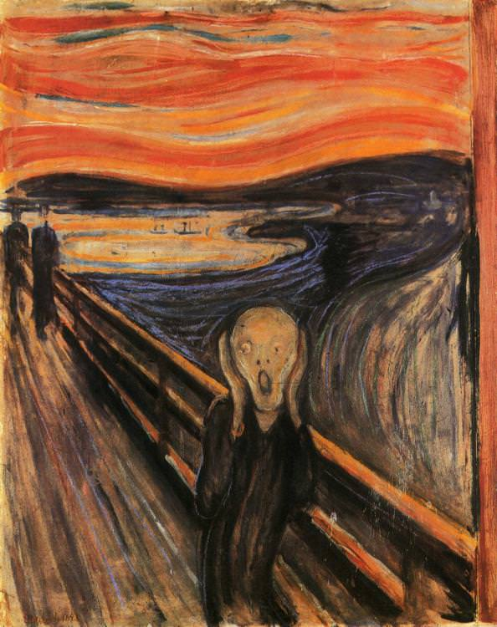
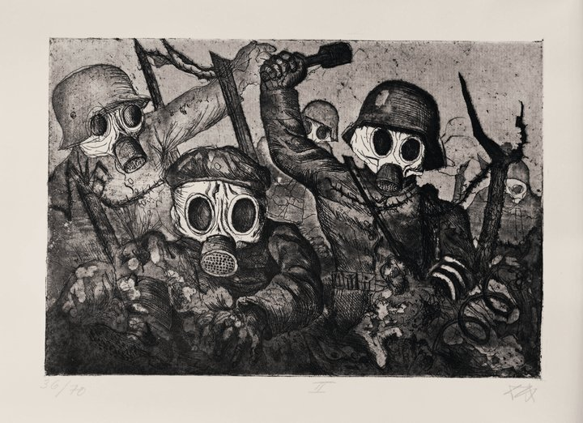
To begin my exhibition, I have chosen two pre-war impressionists to convey the venture between the movements. Edgar Degas, known as ‘one of the founders of impressionism’ is first with his painting ‘A Grecian Dance’ 1890. Art in Europe at this time still maintained influences of ancient Greek and Roman style in the form of classism, before the First World War art had been evolving at a cripplingly slow rate with no real ground-breaking changes in a century. However, my second artist Edvard Munch seemed to be one of the first artists to break out of this timid routine with his painting ‘The Scream’ 1893-1910, he seemed to prompt this rebellion against the gentle impressionists before him to create a post-impressionist movement with bolder colours and harsher strokes but still keeping an aspect of realism but slightly distorted or perhaps heightened but not in a completely abstract way similarly to Van Gogh, Gauguin and Cézanne’s art. This was occurring as tensions heightened in the western world with countries feuding and political relationships fraying.
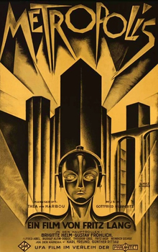
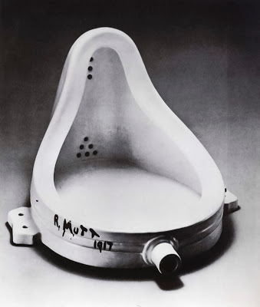
The First World War maintains a central position in cultural and historical setting in the modern world by shaping a lot of today’s art and literature, which brings me to my third artist Otto Dix who embodied new emerging concepts created by the trauma of was as depicted in his etching ‘Gassed’ 1916. I chose this image as the intermediate, this is an example of how our conceptual art changes for the darker and more real in the sense that there was no longer any restrictions due to the war destroying societies beliefs, social constructs and creative restrictions. The eeriness of the etching is a response to the destruction and chaos. This unprecedented loss of human life lead to degradation of social structures and depiction of violence death in the majority of art during this time. This idea of the deconstruction of society’s ways and perceptions is conveyed in my fourth piece of art, Marcel Duchamp’s ‘Fountain’ 1917. Duchamps art is original in the way that it was deemed the first piece of conceptual art. The breaking down of artistic norms by turning found objects into art, making his work an attack on what was the conventional understanding of art. Finally, my last piece of art is Fritz Lang’s ‘Metropolis’1927, World War 1 had taken its toll on Germany and in its bleak political crisis emerged this iconic silent film. It was an epic futuristic piece of visual art, with an undertone of reconciliation of the classes and radical social change.

I want my exhibition to be stimulating and thought provoking, because this is such an important part of our history; not just as artists but as human beings. Good curation is a massive part of exhibiting, if you curate badly then all of the influential art will lose some of its credibility and importance.
I will be exhibiting from left to right with the movements in chronological order, I’ve chosen to do this because the entrance will be on the left so as you enter you can read the free-standing plaque by the entrance with the title ‘The Yield of War’ and some information on the history and a brief explanation of my theory ‘Modernism is a product of the First World War, with movements such as Constructivism, Futurism and Dada stemming from the umbrella term”.
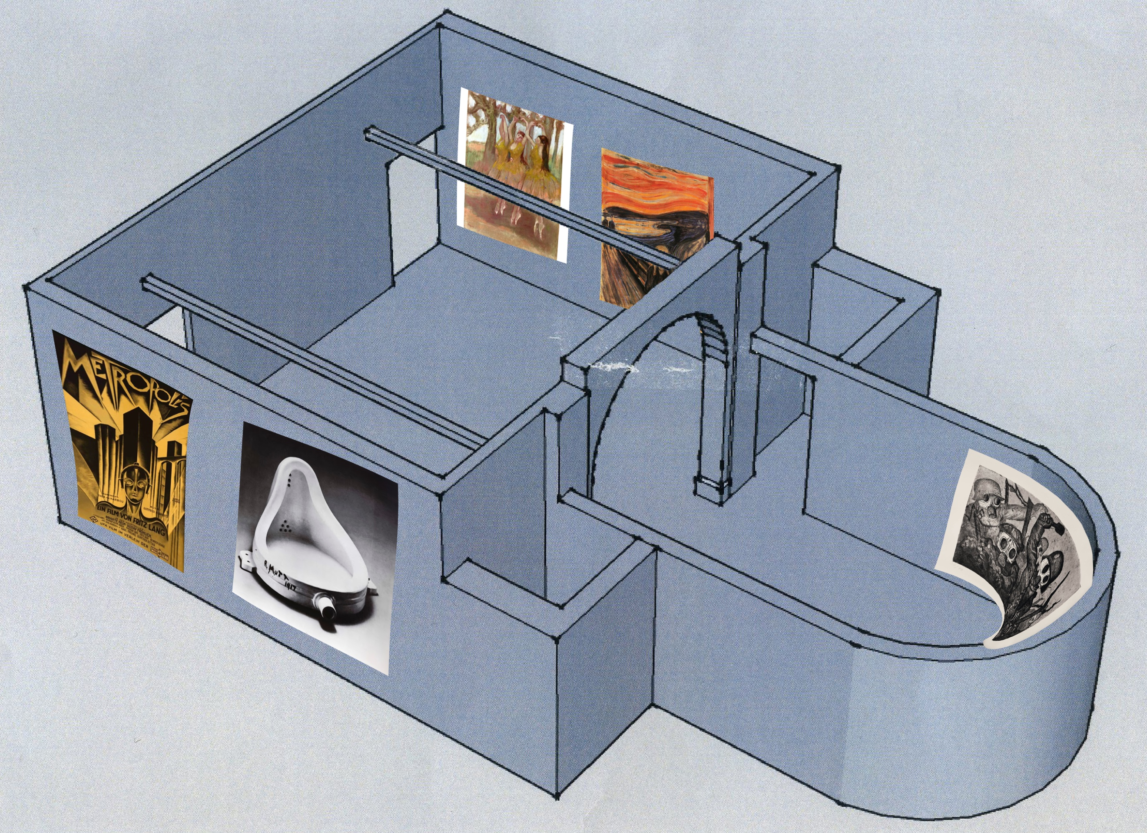
You then can begin reading and analysing in the right order and it will just strengthen my theory with the evidence in order, I’ve also done it so we have a clear comparison of the movements; before, during and after.
The left side of the room I would like well-lit up with upwards facing lights on the paintings which will be mounted perfectly straight at head height with hidden fixings and a small plaque on the left with the artists name and the year it was made. I would not like any windows or natural light as it can damage older paintings and cannot be controlled at all times.
In the centre curved wall, I would like the print of Otto Dix’s ‘Gassed’ printed very large, in extremely high quality and wrapping the curve of the wall, I would like this part of the gallery slightly darker with less lights to create a slightly darker atmosphere in comparison to the rest, I believe this is important when narrating such a journey with highs and lows that you don’t skip over emphasizing these emotional details, and it is beneficial when you create such an intimate and interactive gallery that it strikes something within you as the reader.
Now the right side of the gallery won’t be lit by free standing lights, Duchamps ‘Fountain will be on a white plinth with small LEDs lighting it up but not creating too much light leakage, the plinth will be about 3-foot-tall as I want it the height of a normal urinal just to emphasise Duchamps concept. Lastly, I would like Fritz Lang’s Metropolis on a loop being projected in the right-hand corner against a white wall, there will be a curtain over the exit so no light will leak in and spoil the picture, it will be quite large a few feet in width. There will be a couple of benches in front so viewers may sit and watch if they choose to do so and then exit out the door closest to them. There would also be a program outside of the exit with artists, their relevant history and I would also like to put in any additional reading or more artists of influence in the artistic venture they have just experienced in the gallery behind them, I understand its unconventional to the have the programme at the end but I feel like it’s over whelming being passed handfuls of documents upon entering a gallery.

To conclude, through my exhibition I hope to have proven that modernism as we know it today was an outcome of the First World War and that my gallery space and essay supports this statement and gives valid evidence for this.

By Isabelle Dufresnoy

References
Degas, E. (1890). A Grecian Dance.
Munch, E. (2018). The Scream. [oils, Pastels].
Dix, O. (1924). Assault Troops Advance under Gas.
Duchamp, M. (1917). Fountain.
Fussel, P. (1977). The great war and modern memory. Oxford: Oxford University Press.
Metropolis. (1927). [film] Directed by F. Lang. Germany.

