Dissertation Proposal
A Critical analysis of corporate social responsibility communication by global gambling operators; Commitment, initiatives and performance.

Introduction
Gambling has always been a prominent factor within society from the earliest forms of ancient civilisation (Dunlop, 2016), and through the advancements of technology within the millennium market, globalisation has been a catalyst for the exploitation of online gambling. Globalisation has powerful dimensions such as political, cultural, economic and social whereby organisations such as governments or business have significant international influences and operating scale (Wells et al., 2001). Over the last nine years, the growth of the online gambling industry has increased by $31.45 billion with a projection to grow a further $4.6 billion by the end of the financial year in 2019 (Statista, 2018). Online gambling involves activities such as casinos, sports betting, lotteries and bingo whereby every year, online gambling associations have seen an increase in users on online gambling platforms with an even more drastic increase in unregulated and emerging online gambling countries. Gambling is recognised for growing into being a core part for members within society (Reith, 2006), with (Casey, 2008) highlighting that this is driven by four different motives for gambling; economic capital, social capital, cultural capital and emotional capital. Due to the incremental growth of online gambling, it is ever more prominent for powerful global gambling operators to commit to positive CSR initiatives and to demonstrate positive and effective methods of CSR communication to stakeholders.
Research Rationale
The purpose for this research project is to critically evaluate whether corporate social responsibility communication is being delivered effectively by global gambling operators. CSR communication forms as a key strategy for organisations to effectively manage and meet stakeholders’ expectation (Pellinen, 2016). Based on carrying out a content analysis of annual reports and other published reports, the investigator can identify communication methods used by gambling associations to report commitment to CSR goals and whether specific initiatives are being undertaken to contribute to current gambling issues within society. The study will also highlight challenges global gambling operators face to communicate and practice CSR initiatives on an international scale. Some challenges operators may face such as a deregulated system within a country or the legalisation of gambling in emerging countries. Furthermore, the study will also the issues relating to CSR communication expressed by audiences why may take park in an arisen perspective of audiences through conducting a questionnaire.

Aims and Objectives
The aim of this study is to critically evaluate CSR reporting by global operating gambling associations and the commitment, initiatives those organisation have within the industry and how they are performing. Furthermore, an evaluation on an audiences perception on the issues within gambling along with their view on CSR reporting and communications led by these large organisations. The following objectives for this research project are;
- To undertake an extensive literature review in CSR communication within the global gambling industry.

- Evaluate the importance of CSR and CSR communication within the global gambling industry through conducting a content analysis.

- Evaluate gamblers opinions of CSR and CSR communication on online platforms.

Research Methodology
Jankowicz (2013) define research as a systematic investigation within a topic by using sources to discover and understand information to increase knowledge of the subject matter. Furthermore, Jankowicz suggests that effective methods for collecting, analysing, and evaluating research are important and should be executed by using an effective methodology. ‘The Research Onion’ demonstrated by (Saunders et al., 2009) highlights a process of research which within the layers represents a different stage of research by which the investigator should consider.
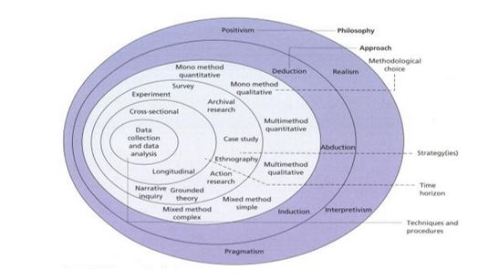
Saunders et al., 2012 – ‘The Research Onion’

This research project will be evaluated through undertaking a pragmatism philosophy whereby different methods of research will provide an interpretative view on the research field and will provide a reliable system for understanding, analysing and evaluating research (Burbules, 2004).
It is believed that using a mixed method approach within a research project will provide benefits such as adding more value and validity to the evaluation process within the project (Greene & Caracelli, 1997). This is done by incorporating both quantitative and qualitative research methods within the project as a source to gain a greater understand on interpretive perceptions and facts the subject matter (McKim, 2017). By utilising the triangulation method of research highlighted by (Creswell & Clark, 2009), integrating both methods of research will improve insight into understanding the data presented from the results along with providing strong evidence for conclusion.

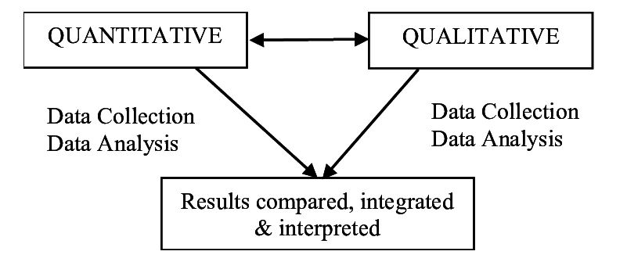
Creswell & Clark, 2009 – ‘The Triangulation Mixed Method’

The research methodology for this project will undertake cross-sectional research approach whereby the investigator will be utilising both quantitative and qualitative methods of research as a tool to evaluate and analyse data from target audiences and annual reports within a particular time frame (Lavrakas, 2008).
The research method will be sequential, firstly, a content analysis will be carried out by extracting information from annual reports presented by all organisations within the research project. This methodology is known as an inductive approach whereby data accumulated from annual reports and other reports will provide evidence on whether positive CSR practices are being implemented (Amaratunga et al., 2002). an online questionnaire will be carried out with the goal to achieve 200 respondents in order to increase the validity and value of the research project. This method is known as a deductive approach in which a hypothesis can be formed and theory created based on patterns which may emerge within the evaluation process of analysing questionnaire results.
Furthermore, an online questionnaire will be carried out with the goal to achieve 200 respondents in order to increase the validity and value of the research project. This method is known as a deductive approach in which a hypothesis can be formed and theory created based on patterns which may emerge within the evaluation process of analysing questionnaire results.
The findings from this research will both incorporate an interpretivism and positivist approach. The interpretivism approach will be concluded by evaluating annual reports evaluated with the positivist approach being the exploitation of online questionnaires to willing participants (Howell, 2012). By exploiting these methods of research, the outcome will result in a movement whereby a pragmatism philosophy is acknowledged as a tool to collate findings, ideology and shape the researches conclusion (Brinkmann, 2018). Furthermore, by adopting a pragmatism philosophy, the researcher can identify truth and reality which will shed light through conducting a mixed method research approach. Pragmatism gives freedom to “study what interests and is of value to you, study it in the different ways that you deem appropriate and utilised the results in ways that can bring about positive consequences within your value system” (Tashakkori and Teddlie, 2003, pg. 21).
Reliability
The reliability from the research projects results is amplified through using a comprehensive mixed method approach which provides a balanced and unbiased view of the study whereby one method may explain or examine findings of another if unexpected results were to occur (Tashakkori & Teddlie, 2003). However, it is also important to note that the researcher will be bearing in mind ethical considerations when designing an online questionnaire will through not manipulating the design of the questionnaire to influence a driven ideology and committing to university guidelines such as the British Psychological Society Code of Conduct, Ethical Practices and Guidelines.
The researcher will be publishing questionnaires on live forums which discuss a topic around CSR practices and the global gambling industry. The researcher views this as being a highly valuable tool to gain reliable and honest perspectives on CSR practices. Furthermore, questionnaires will also be published on social media platforms.
Validity
Publishing online questionnaires is a suitable method for gaining honest and valid research. The internet can increase the honesty levels of an individual when taking part in a self-case report resulting in greater validity and reduces social judgement and negative exposure (Joinson et al., 2010). The content analysis of the annual reports will be factual and will be published by BET365, Bwin and 888 Betting.

Resource and Time Management
Below is a constructed timeframe in which stages of the research proposal will be carried out and completed. The gantt chart is also designed for the investigator to monitor progress against the timeframe and project due date on the 21st of September 2018.
Stages | Project Name | May | June | July | August | September
 | Dissertation
1 | Proposal
 | Define research aims, objectives & methodology
2 | Literature Review
 | Carry out extensive research
 | Compile & send questionnaire
3 | Findings & Analysis
 | Analyse Questionnaire Results
 | Analyse Annual Reports
 | Collate & Analyse
 | Conclusion
4 | Submission Preparation
 | Consultation with Supervisor
 | Proof-read and editing
 | Binding
 | Submission

Bibliography
Amaratunga, D., Baldry, D., Sarshar, M., & Newton, R. (2002). Quantitative and qualitative research in the built environment: application of “mixed” research approach. International Journal of Productivity and Performance Management, 51(1), 17-31.
Brinkmann, S. (2018). Philosophies of Qualitative Research . Oxford: Oxford University Press.
Burbules, B. (2004). Pragmatism and Educational Research. Oxford: Rowman and Littlefield Publishers, Inc.
Casey, E. (2008). Working Class Women, Gambling and The Dream of Happiness. Feminist Review, 89(1), 122-137.
Creswell , J., & Clark, V. P. (2009). Designing and Conducting Mixed Methods Research. Organizational Research Methods, 12(4), 801-804.
Dunlop, S. (2016). The Earliest Forms of Gambling in Ancient Civilizations. Retrieved May 31, 2018, from DocumentaryTube.com: http://www.documentarytube.com/articles/the-earliest-forms-of-gambling-in-ancient-civilizations
Greene, J. C., & Caracelli, V. J. (1997). Advances in mixed-method evaluation: the challengesm and benefits of intergrating diverse paradigms. San Fransisco : Jossey-Bass Publishers.
Howell, K. E. (2012). An Introduction to the Philosophy of Methodology . London : Sage Publication.
Jankowicz, A. D. (2013). Business Research Projects (2nd ed.). Cleveland: Chapman and Hall.
Joinson, A. N., Reips, U.-D., Buchanan, T., & Schofield, C. B. (2010). Privacy, Trust and Self-Disclosure Online. Human-Computer Interaction, 25, 1-24.
Lavrakas, P. J. (2008). Encyclopedia of Survey Research Methods. London : Sage Publication.
McKim, C. A. (2017). The Value of Mixed Methods Research: A Mixed Methods Study. Journal of Mixed Methods Research, 11(2), 202-222.
Pellinen, K. (2016). CSR communication challenges: communication channels, sustainability reporting and stakeholder engagement. Bodo : Nord University .
Reith, D. (2006). Research on the Social Impacts of Gambling. Glasgow: Scottish Executive Social Research .
Saunders, M., Lewis, P., & Thornhill, A. (2009). Research Methods for Business Students (5th ed.). Harlow: Pearson Education Limited.
Statista. (2018, May 29). Size of the online gambling market from 2009 to 2020 (in billion U.S. dollars). Retrieved from Statista: https://www.statista.com/statistics/270728/market-volume-of-online-gaming-worldwide/
Tashakkori, A., & Teddlie, C. (2003). Handbook of Mixed Methods in Social and Behavioral Research. London: Sage Publications .
Wells, G. J., Shuey, R., & Kiely, R. (2001). Globalization . New York: Novinka Books.

