Manage and maintain Network resources, and its services applying suitable policies and drafting security and redundancy practices.
Author: Jonney Corner (1809784)
Network Operating Systems and Services (ACCA5023)
School of Applied Computing
Wales Institute of Science and Art
05/05/23 Date of Submission

Abstract
The purpose of this report was as a team to implement several device restrictions and security policies and explain their purposes and any additional features used within the group policy modeller. Another aspect covered in this report is guidance on how to setup an FTP server using IIS server roles which are installed through Windows programs and features. During this read you will be able to pick up how you can create or administer Group Policy objects and install server roles from screenshot and writeups we have provided as a team collaboratively.

Table of Contents
Contents
1. Task 1 4
1.1 Introduction 4
1.2 Mandatory Team Submission Details 4
1.3 Managing and maintaining Network Resources using Policy and Security (Screenshots) 5
NTFS 5
Share Permissions 7
Accessing the File share/server over the Network 9
1.4 Utilise Group Policy management Console to better facilitate network object Management (Screenshots) 10
Moderating Access to the Control Panel (GPO 1) 10
Removing Access to the Command Prompt. (GPO 2) 10
Restricting Access to Removable Media Drives (GPO 3) 10
Restricting Software Installs (GPO 4) 11
Enforcing Password Policy in the ‘accatask.msft’ domain (GPO 5) 12
1.5 Routing and Packet Filtering within core TCP/IP Services and Failover/Redundancy 13
Utilising ARP and Routing Tables 13
Deploy Core Services 13
Installing and Configuring the Routing and Remote Access Services 13
IP Packet Filtering – Filter 1 15
IP Packet Filtering – Filter 2 16
IP Packet Filtering – Filter 3 17
2. Task 2 19
2.1. Question i 19
2.2 Question ii 19
2.3 Question iii 19
2.4 Question iv 19
2.5 Reflection on Collaborative Work 20
3. References 21

Task 1

Introduction
The Purpose of this Task is to work as a team on the practical aspect of adding to the work completed within the first assignment of building, configuring, managing, and deploying a virtual network. The additional work undertaken in this assignment showcases the managing and maintaining of network resources using policies and other security practices. As a team we will collaborate on working through the requirements of the worksheet, this also includes routing and packet sniffing filtering, critical failover, and redundancy practices.

Mandatory Team Submission Details
Name of the Team: DMTJ
Team Members:
Student Name | Student ID
Dave Cornelius | 2023506
David Corner | 1809784
Dylan Thomas | 2014801
Morgan Combstock | 2014028
Team Evaluation (Self Evaluate your Team)
 | Student 1 | Student 2 |  | Student 3 |  | Student 4 |  | Student 5
Student 1 | X |  | 5 |  | 5 |  | 5 |  | X
Student 2 | 5 |  | X |  | 5 |  | 5 |  | X
Student 3 | 5 |  | 5 |  | X |  | 5 |  | X
Student 4 | 5 |  | 5 |  | 5 |  | X |  | X
Rate your Teams Contribution with a scale of 1 to 5 (1 No Contribution and 5 Excellent Contribution)
Add your comments on Team Evaluation: (Justify your evaluation)
Student 1: David glued every key aspect of the task together, by ensuring that all the formatting of the documentation was followed based on the spec and was always at hand to provide professional expertise in the event of any network-based issues within the task.
Student 2: I feel that I was able to assist extensively to the overall assignment implementing and advising on how the GPOs are setup and what evidence needs to be gathered to meet the assignment spec. Along side this I played a part with Dave into getting the formatting within the report and structure set accordingly.
Student 3: Dylan was always at hand to always assist with any queries who contributed a lot to how the document was set out and ensuring that we had sufficient evidence at hand to meet the specification.
Student 4: Dylan was a key member within the group as he was hosting the hypervisor off his own device for the whole team. He went up and beyond to provide all the screenshots and evidence we required and did a tremendous job in implementing a group policy security model and setting up the domain environment, all the way from Assignment 1 and was punctual and attending all classes and was available remotely out of hours to provide the evidence we need.

Managing and maintaining Network Resources using Policy and Security (Screenshots)

NTFS
Prior to making changes to the policy and security of a Network, we firstly as a group had to build the virtual network using a Type2 Hypervisor and apply the active directory services. This was completed within assignment 1 and provides the platform to showcase how to Manage and maintain Network resources.
Figure 1 – Create a Folder Share_ACCA5023 and File name Confidential File
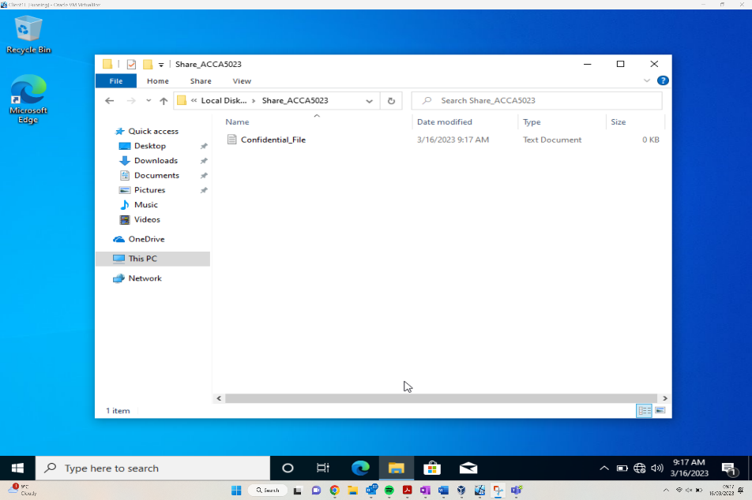
As can be seen from the above screenshot, the user is within the homepage of the Vitrual Network within the “Morgan Combstock” account, this account belongs to the Administrators group within the specified accatask.msft domain.
The folder has been renamed to Share_ACCA5023 as requested, and within this folder the file Confidential_File has been created.
Figure – Configure permissions for the file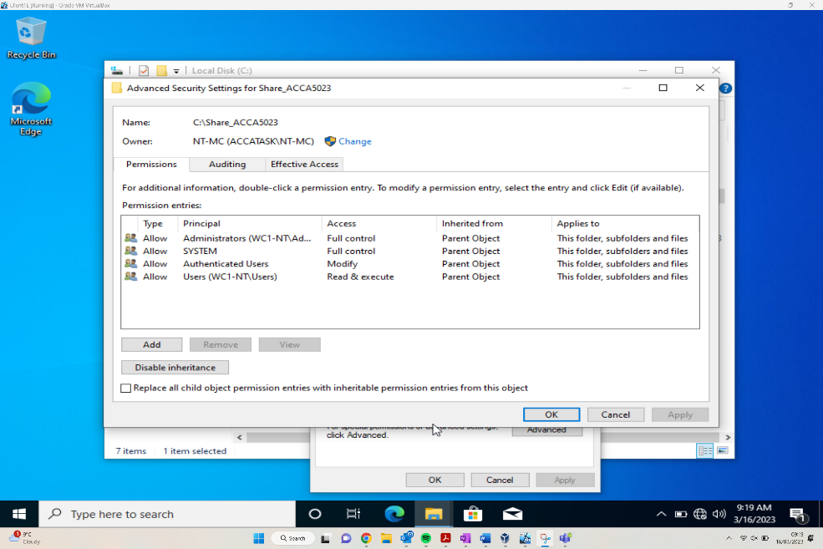
Following the creation of the folder and file, the file Confidential File requires the permissions to be amended. As can be seen from the above screenshot Principal column showing specific user groups, and the access column then shows what level of access they have for the file. This varies from Full Control, to Modify and Read + Execute. This is allowing certain groups certain CRUD access levels.
Following this, Inheritance needs to be disabled because of the following error message presented to the user:
“You can’t remover authenticated users because this object is inheriting permissions from its parent. To remove authenticated users, you must prevent this object from inheriting permissions.”
Figure – Morgan Combstock given full permissions to folder.
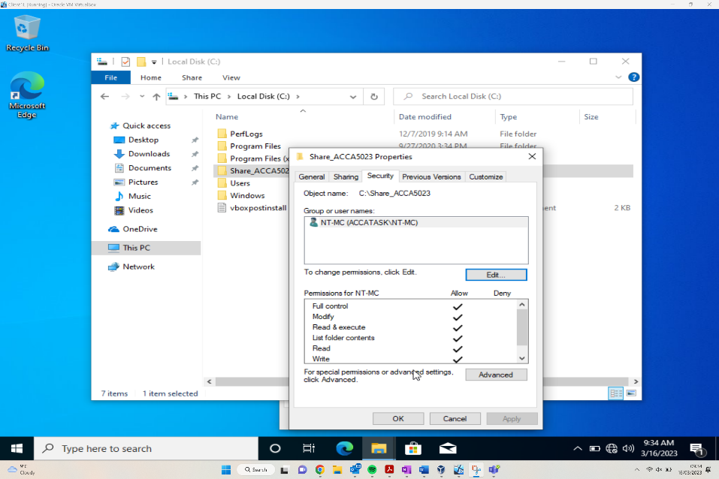
As can be seen from the above screenshot, the user has been added to the group NT-MC (ACCATASK\NT-MC), and within the share Properites window the Permissions for NT-MC section shows the CRUD functionality the user has. The Allow all shows the user has full functionality for this file.
Figure – Confidential file inheriting permissions from folder.
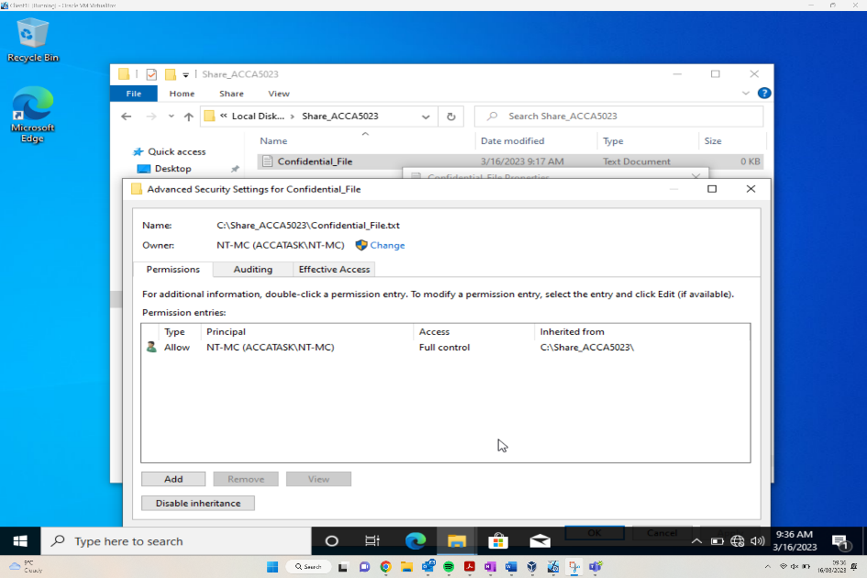
Following on from an earlier screenshot of the Advanced Security Settings for Confidential_File, this updated screenshot now shows that it’s only the NT-MC group that is allows access to the Confidential_File. Some of the original groups which had full access has now been removed from any levels of access.
Figure – Add another User to the folder “Security Group”.
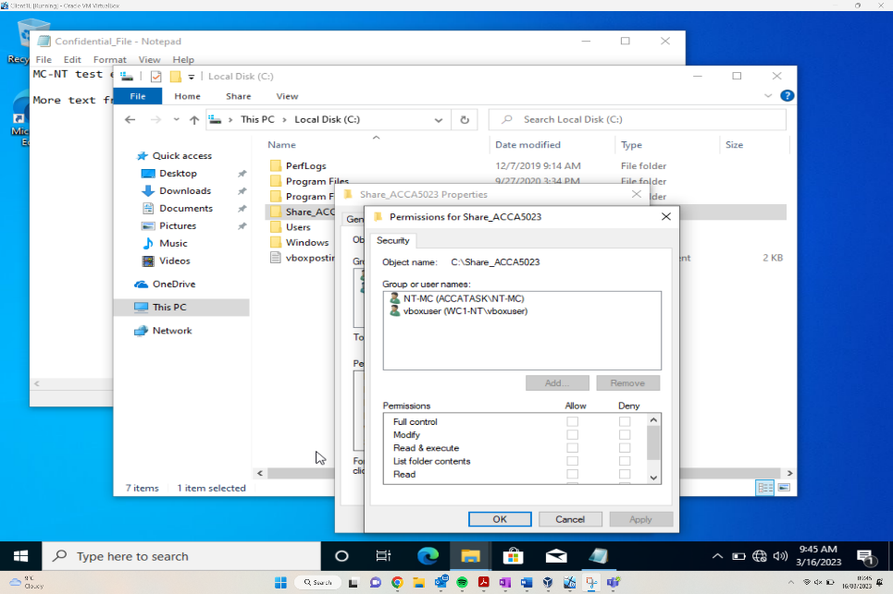
The above screenshot shows the addition of another user to the folder, the user has been labelled vboxuser. Following this screenshot the user was allowed full access credentials to the file, with the exception of the Delete functionality.
Following this functionality update the user “vboxuser” then accessed the file and added ‘more text from vboxuser’ to the document.

Share Permissions
After the NTFS work has been implemented, the share permissions can be implemented to have greater security of the resources. The share permissions can be accessed by entering ‘Server Manager’ in the search bar and then loading the Server Manager itself.
Figure – Checking other share options.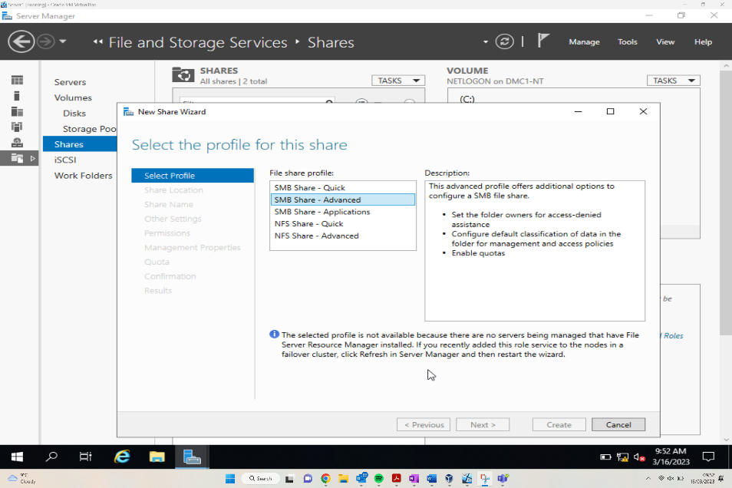
Once within the Server Manager, by selecting the file and storage services the user can then navigate to the new share wizard. There are various file share profile options to choose from, each providing differing levels of access.
Figure - Setting share name and noting path
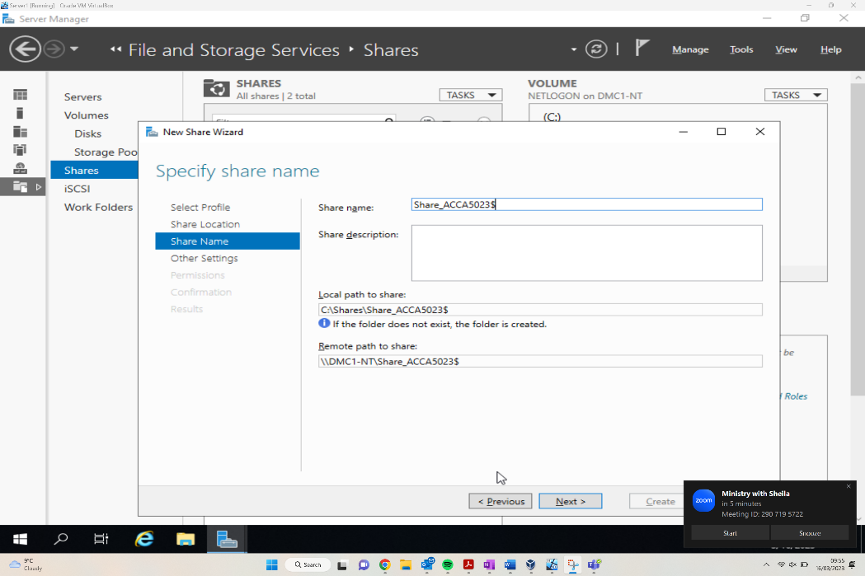
Once the share options are selected, the share name and path needs to be specified. As can be seen the name is set to “Share_ACCA5023$”, local path and remote paths have also been set.
Figure - Two users set up with read & execute permissions.
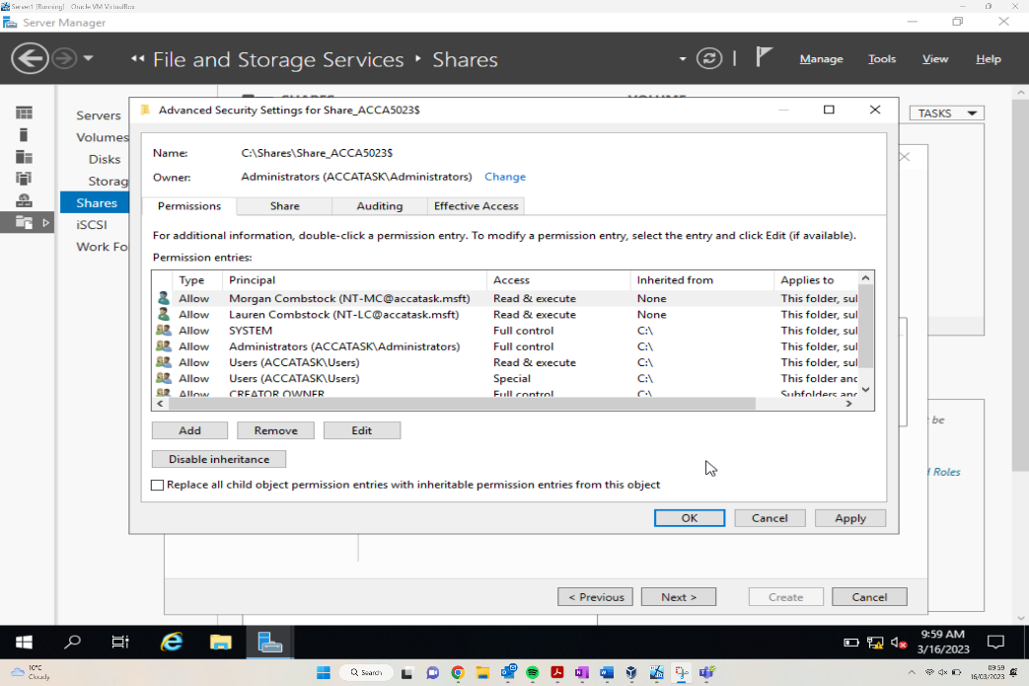
Following the setting of the file name, local and remote file share paths are set, two further users have been set up on the Advanced Security settings of “ACCA_5023$”. The users added to the permissions are “Morgan Combstock” and “Lauren Combstock”, these users have been granted Read + Execute access permissions.

Accessing the File share/server over the Network
Following the amendments to sharing permissions, the file then needs to be accessed by those users who need to access it. The file share paths have been set in the previous section, both local and remote, however the file should also be accessible via the File Explorer.
Figure - File is viewable from Client 1 when created in Server 1
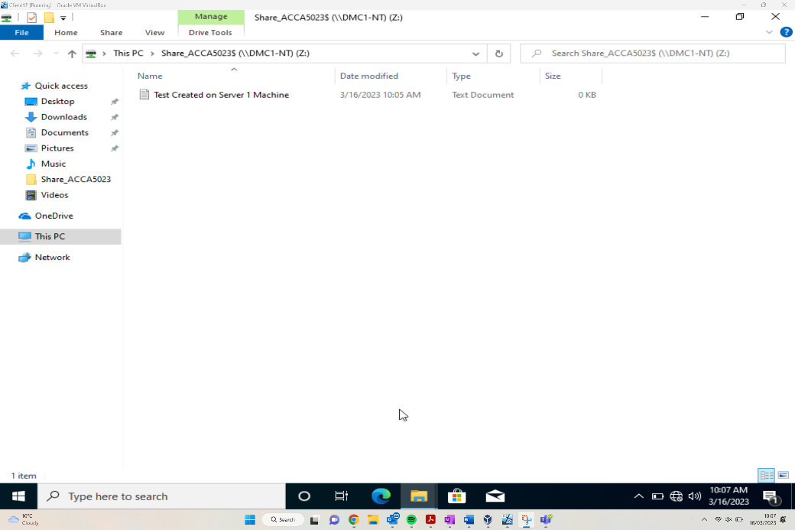
The above figure shows the user accessing the test created on Server1 document. This was accessed by searching the PC. As can be seen from the dollar sign at the end of the file, this shows the share feature of the file has been hidden or prevented due to security purposes.
Figure – Mapping the Network Drive
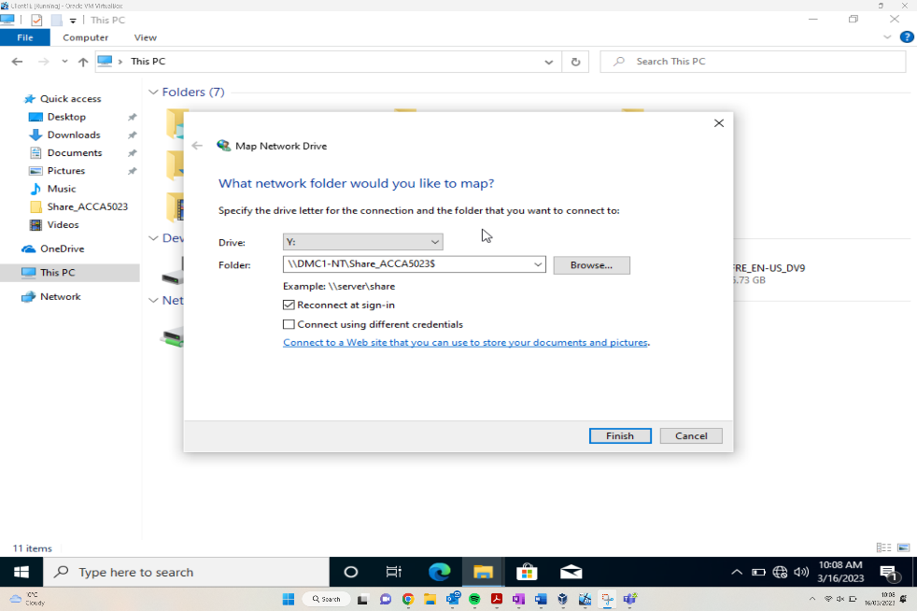
The above shows the mapping of a Network device. This helps specify which drive the folder should reside, along with the option to browse all files to select a location to store the file. There are other sign in options which the user can choose to fit their own use case.

Utilise Group Policy management Console to better facilitate network object Management (Screenshots)
According to Microsoft [], Group Policy is “an infrastructure that allows you to specify managed configurations for users and computers through Group Policy settings and Preferences”. The purpose of GP is to implement organisation wide settings, whether that’s Local policies that are manual configurations to a singular device, Site Policies that implements an Active directory which is applicable across multiple sites or Domain Policies that will be deployed across the organisation.
For this demonstration, Group Policy Objects will be created at an Organisational Unit level.

Moderating Access to the Control Panel (GPO 1)
Figure – New Organizational Unit
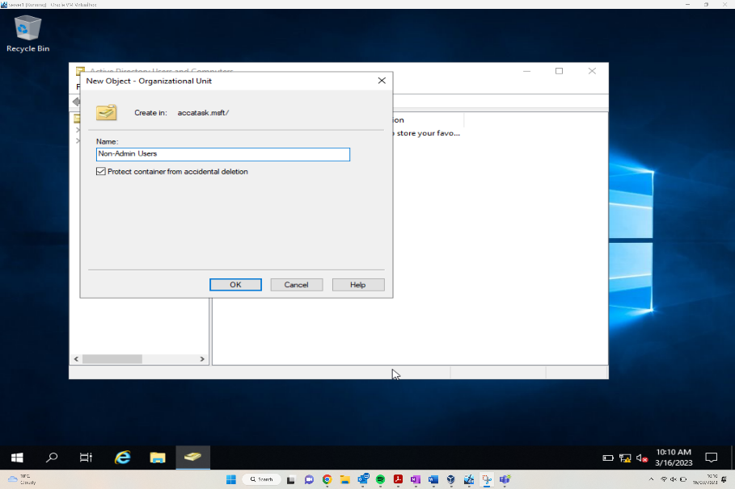

Before being able to apply group policy that can be deployed across the network first, we need to create a structure. The first part of a structure is an organization unit which the creation of has been demonstrated above,

Figure – Adding new user.
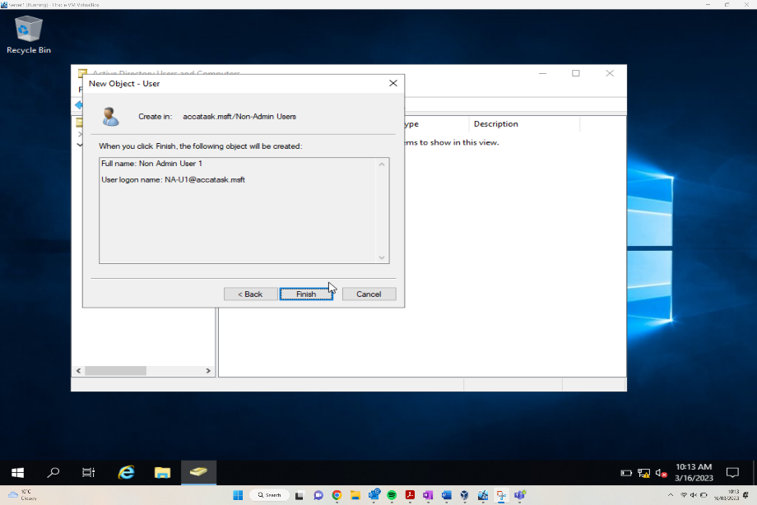
User added
username: NA-U1
password: P@ssword123
Figure – Adding a new GPO
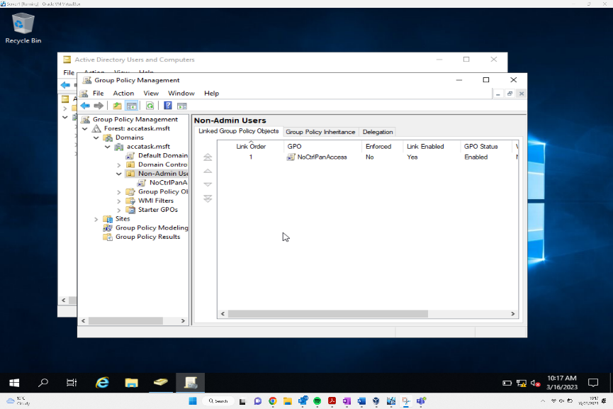
Figure – Enabled Control Panel Access Restriction (ix)

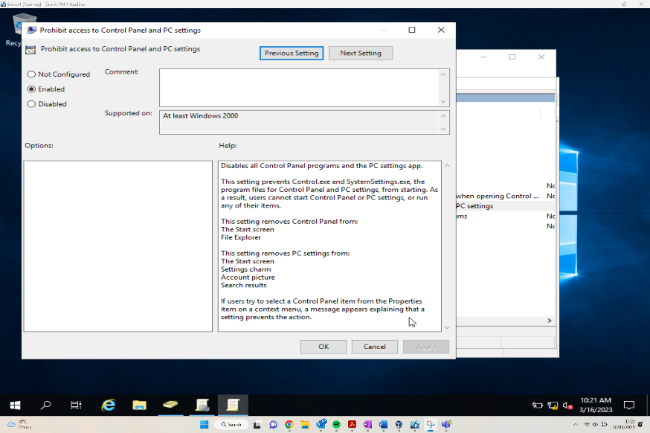

The above figures demonstrating the application and enabling of the first group policy which in this scenario is the denial of the control panel to non admin users. This is achieved utilising the inbuilt GPO GUI which allows for easy configuration of settings using the UI.

Figure – Command Prompt and Client 1 Machine signed in as NA-U1 can’t access control Panel

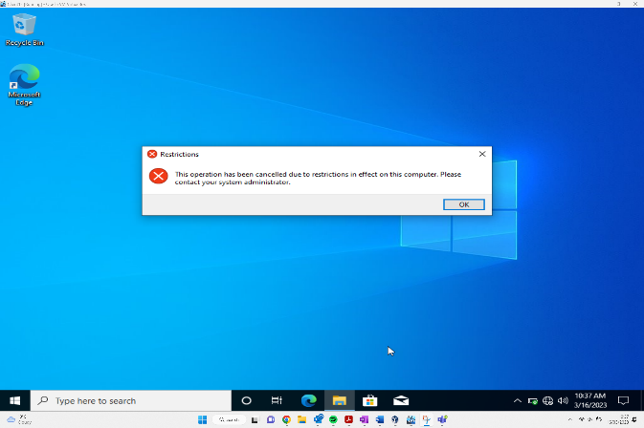
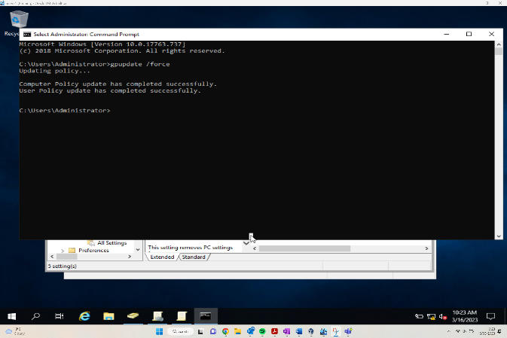

Demonstrating of the succesful denial of the control panel to a non admin user as stipulated by the Group policy previously show being enabled.

Removing Access to the Command Prompt. (GPO 2)
Most general users on the network wouldn’t know how to access the command prompt, let alone use it. However, for those with the knowledge, disabling the command prompt prevents those users the ability to run commands to override settings, especially those with hacking abilities.
The figure below shows a user within the network attempting to utilise the control panel, however the ‘Prevent access to command prompt’ GPO has been implemented meaning the user is unable to utilise as they will be greeted with a ‘The command prompt has been disabled by the admin’ message.
Figure – User unable to use command prompt.
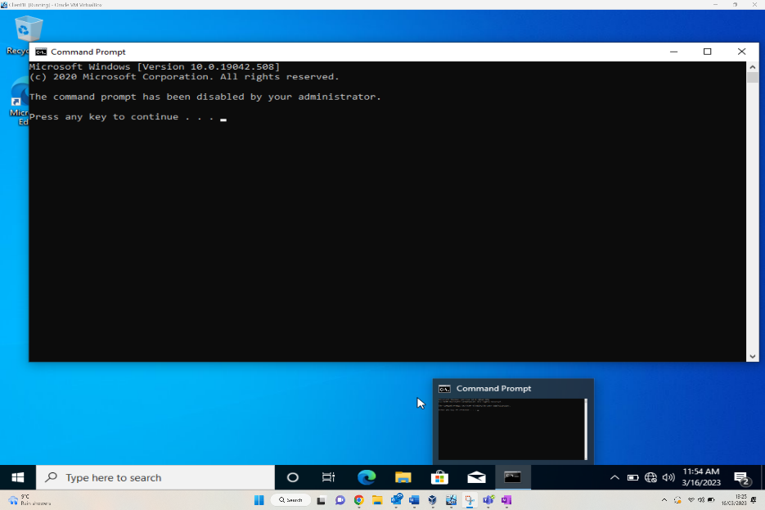

Restricting Access to Removable Media Drives (GPO 3)
Removable Media drives can be used by those with bad intentions towards the network to inject malware/malicious software into the network. By disabling the acceptance of removable drives to the network it prevents another access route to the network.
As can be seen from the figure below, the user has attempted to access a floppy disk and is greeted by an error message “Location is not available”.
Figure – User unable to access floppy disk Drive.
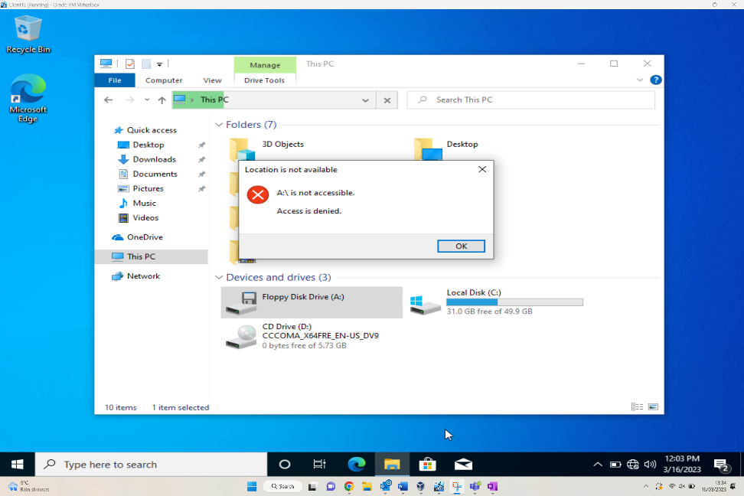

Restricting Software Installs (GPO 4)
Restricting users of installing software inside the network is a major security boost to the network. This prevents unauthorised software installations, which could be malicious software used by threats to infiltrate the network. By implementing a group policy restricting installation, only safe approved/acceptable software can be installed on the network.
Figure – Configuring Group Policy in Manager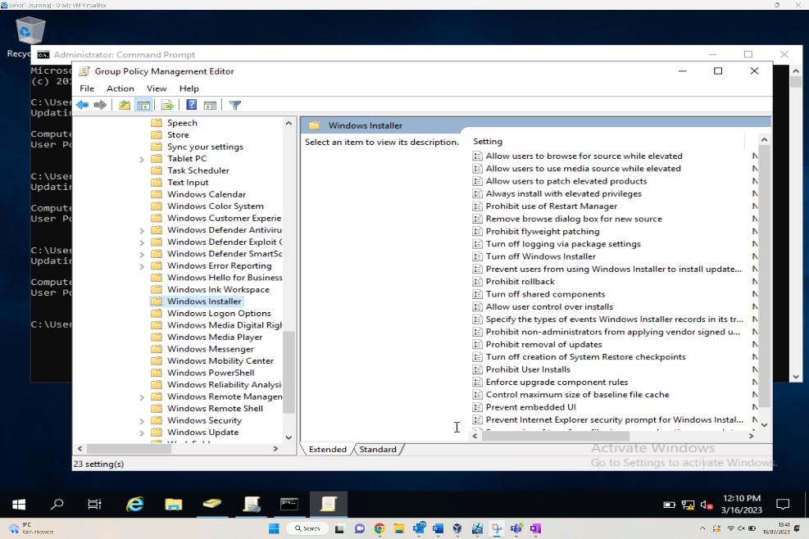
Once navigated to accatask.msft domain, the user must select new organisational unit and label it “NWClient Computers”. Within the Group Policy Management Editor, the Windows Installer screen allows the administrator to implement the security rules. As can be seen there are many security settings that can be turned on and off, one of which being turn off ability to install software.
Figure – Client1 user unable to install software.
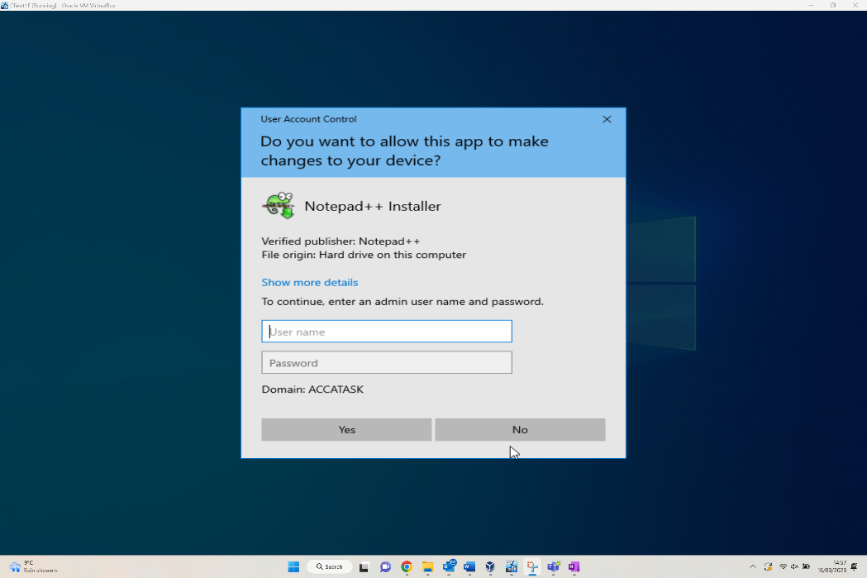
The above shows a user attempting to install Notepad++ to the ACCATASK domain. Unfortunately, the install ability for the domain has been restricted, so the user will not be able to download the software.

Enforcing Password Policy in the ‘accatask.msft’ domain (GPO 5)
Enforcing a password policy within a domain is an important aspect of securing the network. Like this scenario, adding requirements of the password set makes it harder to crack for any threats to the network. Even by having a simple password, this is still an additional barrier to slow down threats from accessing the data within the accatask.msft domain.
Figure – Unable to create a user with password failing Requirements.
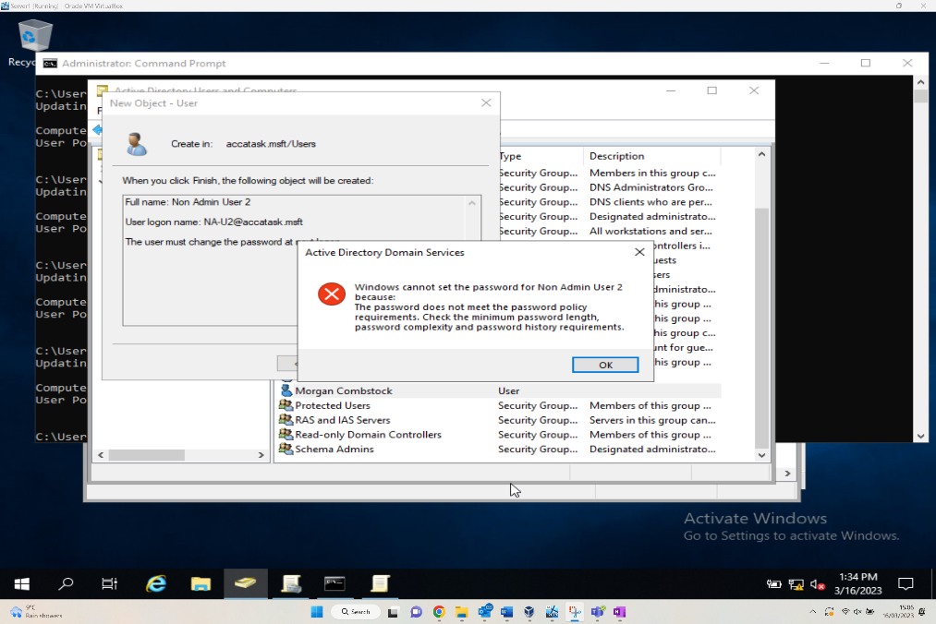
The above shows a user attempting and failing to create a user. The error screen is due to the user not meeting the required security standard. The predefined settings were changed as requested, so without meeting the following stipulations a user can’t be created,
Enforce Password History: | 3 Passwords
Maximum Password Age: | 2 Days
Minimum Password Age: | 1 Day
Minimum Password Length: | 7 Characters
Passwords must meet complexity Requirements: | Enabled
Store Password using reversible encryption: | Disabled

Routing and Packet Filtering within core TCP/IP Services and Failover/Redundancy

Utilising ARP and Routing Tables

Figure – ARP Table
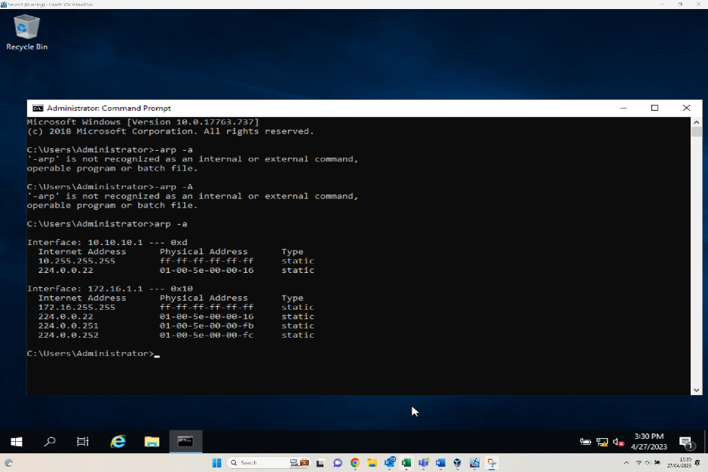
The above figure demonstrates the ARP Table on host ‘Server 1’ – ARP tables are utilised when trying to understand the Network topology and routing principles employed. The ARP table lists MAC Address bindings and their relational IP Address. ARP Tables are generally utilised when checking configurations or troubleshooting network connectivity issues.

Deploy Core Services

Figure – Added new user ftpuser in server Manager (xii)
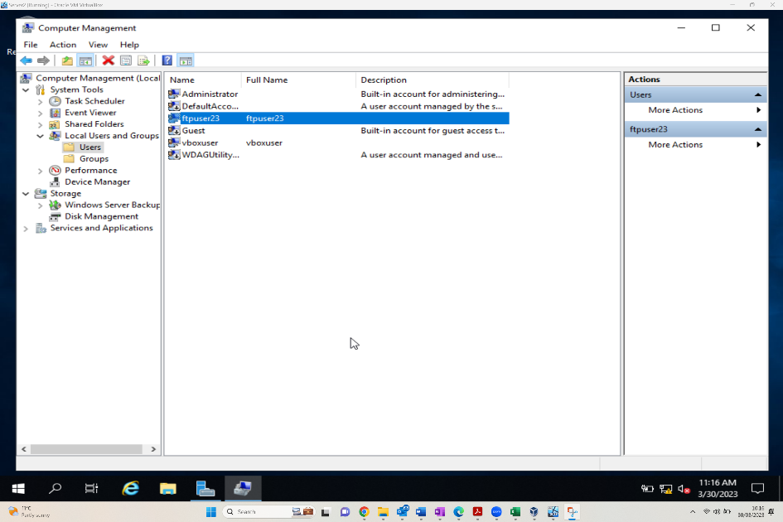
Creating a user which can be used to access the previously created FTP Site. Before access can be achieved however, authentication access will be required to be configured via IIS
Figure – Added FTP Site (xv)
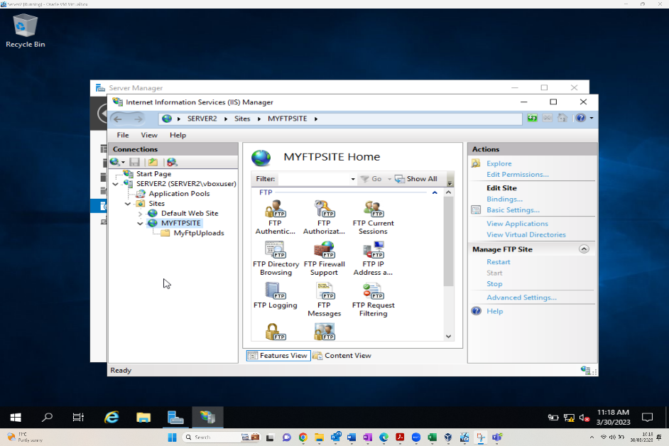
The above demonstrates the successful configuration of the FTP server within IIS. Now the site has been added further configurations can be considered such as transfer protocols, access ports and authentication.

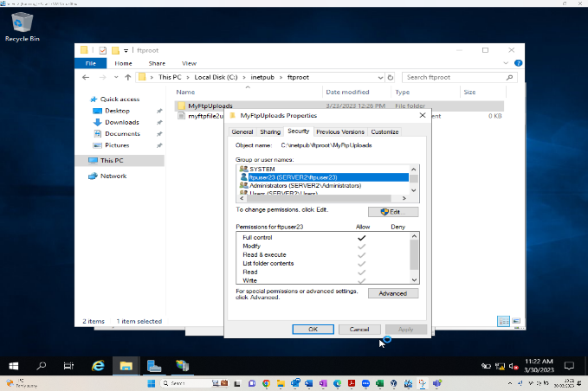
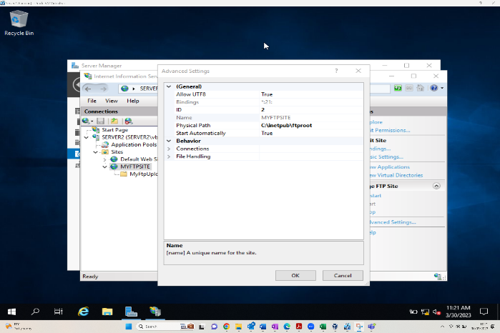
Figure – Root site Folder (xvii) and ftp Folder Security (xxxii)
Advanced configuration demonstrates the correct configuration of the SSL protocol. Followed by an authentication configuration utilising the in-built windows permissions manager. By setting the permissions as outlined in the screenshot we are granting our ftp user access to the newly configured ftp site.

Figure – Connecting to ftp via command prompt in client 2 (xliv)
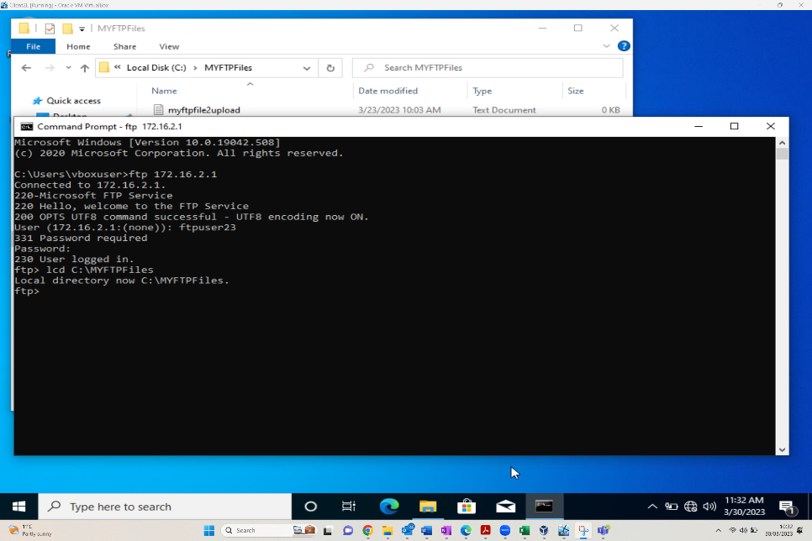
Now the FTP configurations have been completed and the user has been assigned the relevant permissions. We can attempt connection. The above screenshot demonstrates clearly a successful attempt indicating all configurations including authentication have been configured successfully

Installing and Configuring the Routing and Remote Access Services

Now the initial network design can be expanded, with the aim of connecting the two remote local area networks. Through deployment of software within the Windows server routing service, the two disconnected networks of PrivateNet1 and PrivateNet2 should be able to communicate.
Figure – Wizard to set up and start service.
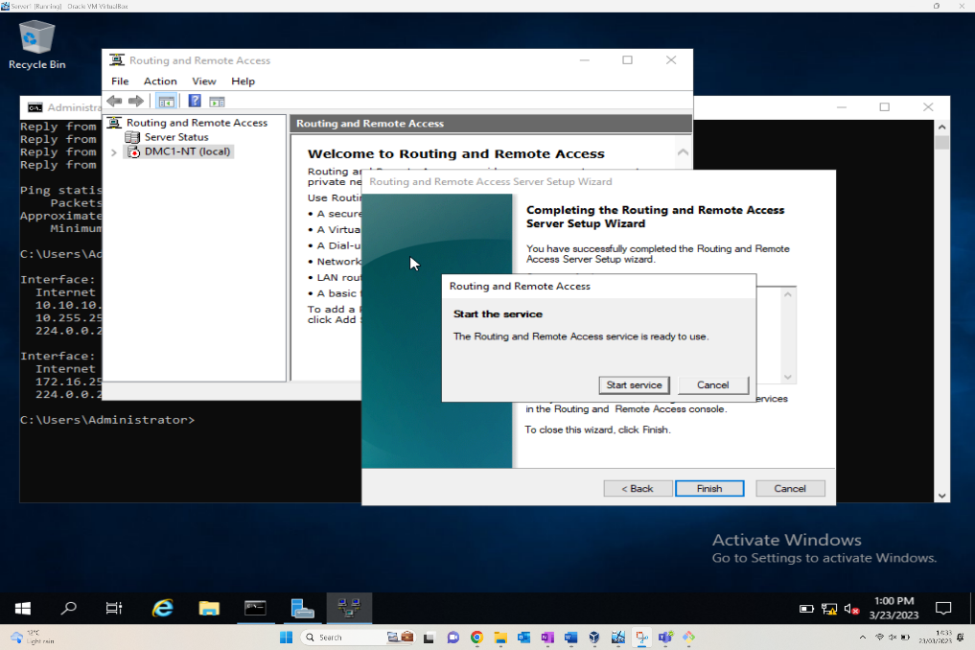
The figure above shows the Routing and Remote access screen on the specific server DMC1-NT, pre-requisite work of installation of the wizard and Deploy VPN only must be done. This wizard will allow the routing to be completed, and the two separate networks to finally communicate. For this task, a custom configuration of the LAN routing is required.

Figure – RIP 2
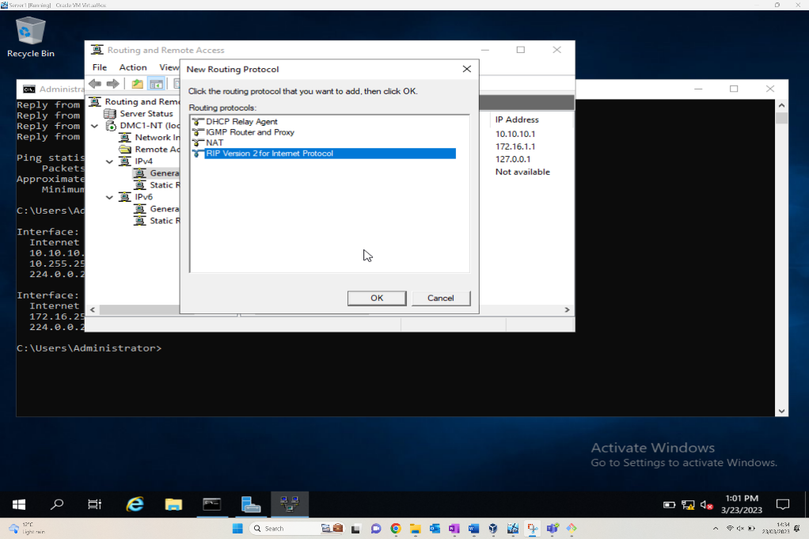
Following on from the Installation Wizard, Routing and networking protocols should be implemented, so that “learn about new networks” can be utilised via the WAN. Having selected the specific server, RIP v2 can now be selected as a new routing protocol option. This is then a repeatable action that needs to be implemented for Server 2VM. This can then be verified by attempting a ping on the PublicNet.

IP Packet Filtering – Filter 1
Packet Filtering is a service configuration of the firewall which can implement protocols to manage the inbound and outbound packets/messages of a network. It can filter the incoming messages for malicious software, as can the outbound filters look at any software or below par security. This function can restrict the flow, depending on if the traffic meets the set protocols or not.
Filter 1 is specific to anyone in PrivateNet1 pinging the firewall service.
Figure – ICMP Filter
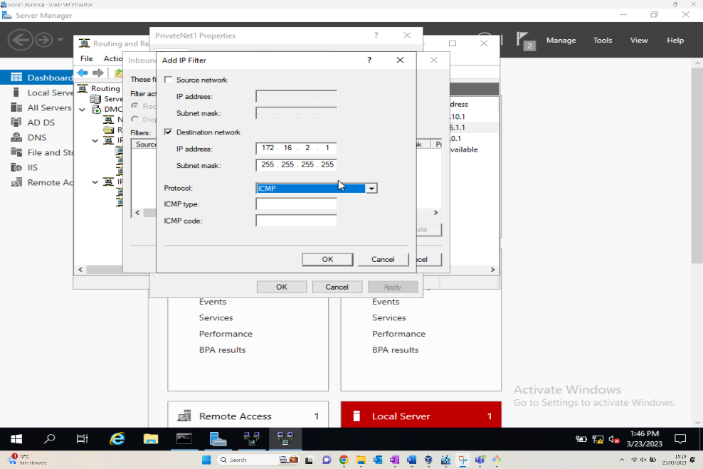
The above figure shows the IP filter configuration window. This is accessed via the server manager tools, routing and remote access. Within the PrivateNet1 connection interface properties the inbound filter requires amending. By adding the IP Filter the specific configurations of IP Address, Subnet Mask and protocols can be set as requested.
Figure – Successful Google ping, unsuccessful ping to 172.16.1.1
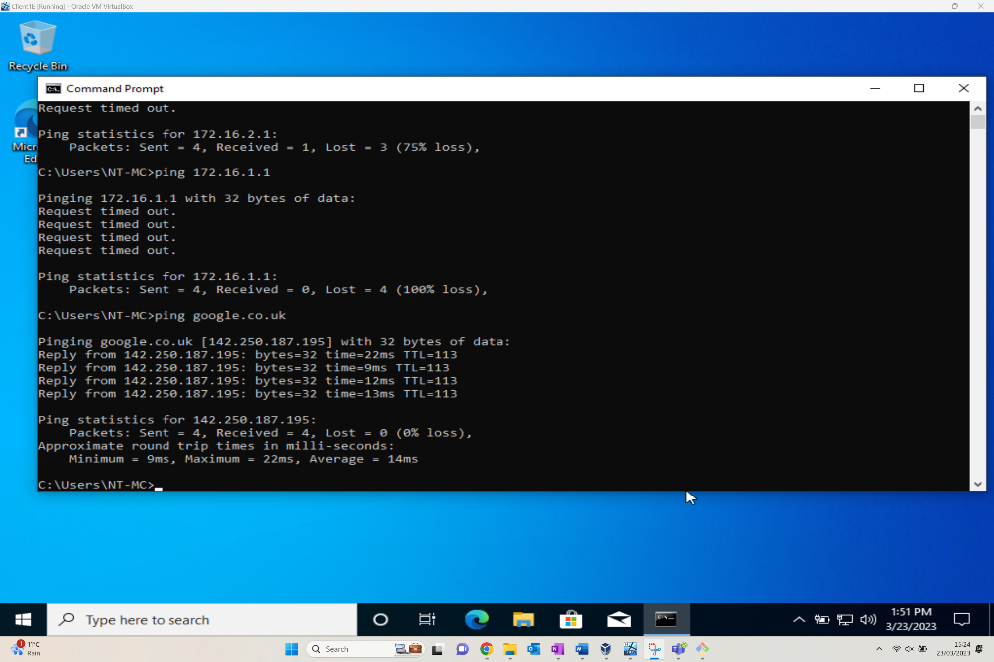

IP Packet Filtering – Filter 2

The second filter is to restrict access to the FTP Service on Server2, limiting it hosts in PrivateNet2 only. This is slightly less common, but the purpose of this filter is to restrict hosts on one network from accessing the FTP of another.
Figure – TCP Filter
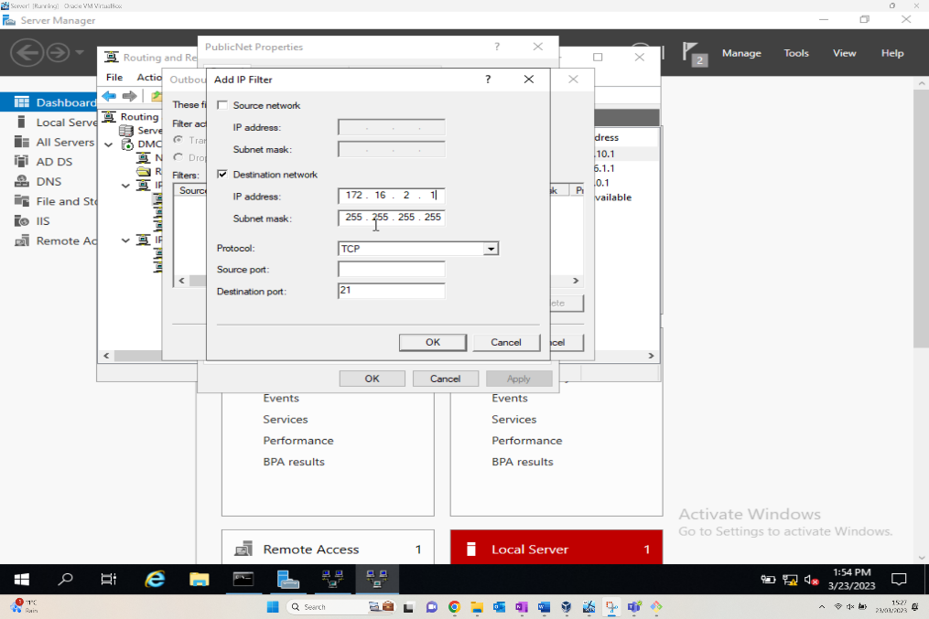
Similar to the first filter applied, the Filter window is accessed by the server manager tools, routing and remote access, via the IP Routing. This time an outbound filter is selected, and the required IP Address, subnet mask, and Protocol of TCP can be set.
Figure – Unable to connect to FTP
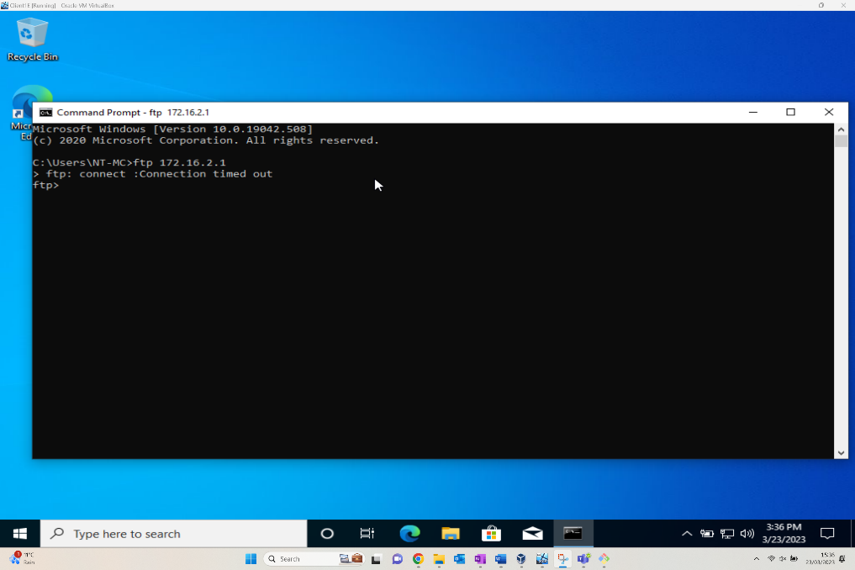

IP Packet Filtering – Filter 3

The third filter involves creating a rule as a group to restrict FTP access to everyone except Client1.
Figure – Adding new filter (Receive packets from 172.16.1.2 on PublicNet)
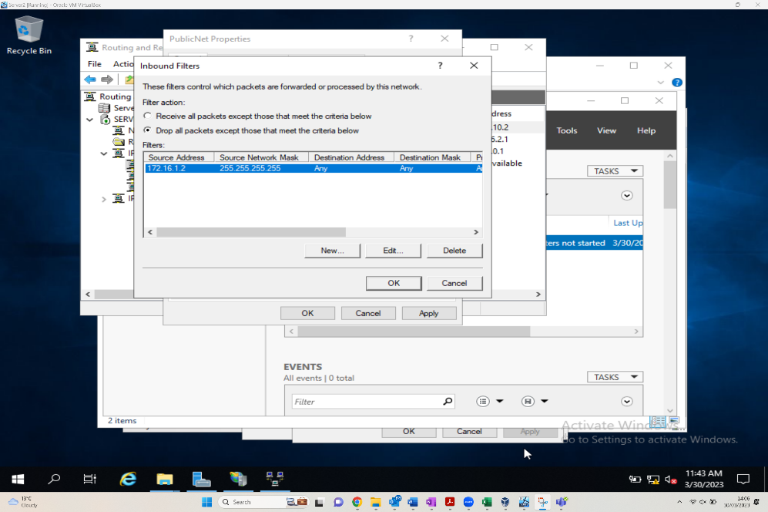
Like the other filters applied, the Filter window is accessed by the server manager tools, routing and remote access, via the IP Routing. This time an inbound filter is selected and provides the administrator with a couple of criteria options along with the Create, Edit and Delete functions of CRUD.
Figure – Inbound filter to drop packets from 172.16.1.2 on PrivateNet2
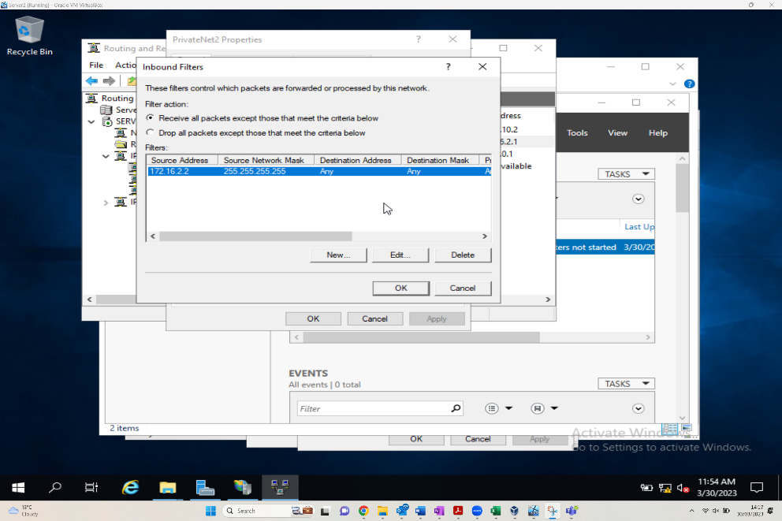
The above shows the administrator changing the selection of the Drop all packets except from those that meet the criteria below radio button to the Receive all packets except those the meet the criteria below. Having inputted the source IP protocols details, this can now be implemented.
Figure – Unsuccessful attempt to access FTP from 172.16.2.2
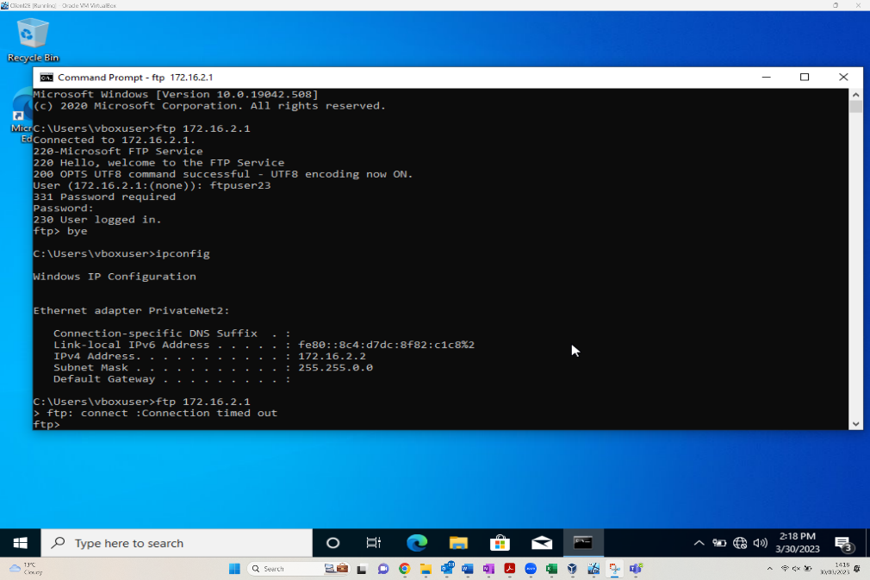

Task 2

2.1. Question i
SOHO Small Office/Home Network, if you want to consider enhancing security, what actions could you take? In your own words in the context of the worksheet activities to demonstrate security policies.
To harden the security in the SOHO network, there are further GPOs which can be applied to devices and users on the domain, these include:
Device Security Policies
Windows Defender Firewall rules – This is something we are able to set for all devices within the domain or for specific devices tied to groups, OUs, containers etc only. Within these Defender firewall rules we can allow/block specific ports from being accessed from the workstation level. There could be an instance where a specific application is not functioning correctly so adding it as a rule into the allow list would provide it the access required and aside from that ports could potentially be left open when the service is no longer required so rules to block that port number from no longer being used can be enforced.
AppLocker – This feature that can be configured through Group Policy modeller, which allows admins to restrict users executing specific applications based on their file hashes or even their format. When configuring AppLocker you can specify what you want to allow and block across the board if required. This feature assists the heightening of security as it could block out any malicious files being executed behind the scenes unexpectedly.
Screen Lock Timeout – This should be considered at least a basic security measure, as this mitigates the threat of someone using your account when logged into a machine which is left idle as the device will go to the lock screen after a specific period of time that has been set within the policy, so when the user abandoned their workstation, it would lock itself automatically if they have forgotten to do so.

User Security Policies
Account Password Policies - Setting these options within a group policy object will allow you to dictate the complexity of the passwords and additional security features related that users set on their domain accounts, this will mitigate simple passwords being created on accounts and any unsuccessful login attempts will enforce an account lockout, so an attacker is unable to access.
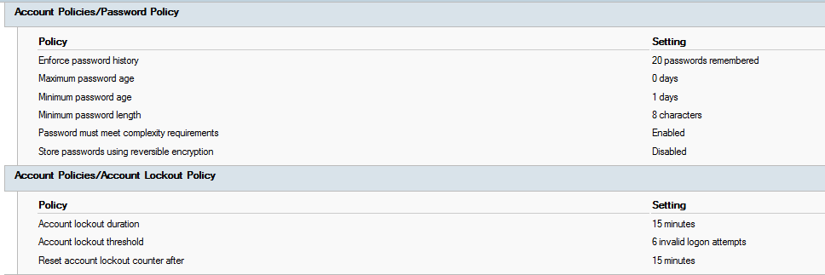
Within the password policies, you can also set a duration of when the password will expire and the user will need to set a new one, the more frequent the user changes their password the more secure their account will be from being compromised.

2.2 Question ii
Failover clustering for high availability systems/services. Explain the concepts that need careful consideration when considering usage of such a system.
Show a possible role within the Window Server OS environment that could provision the requirements.
There are several solutions that can be put into place for High Available (HA) systems to ensure business can carry on continuing, these solutions include:
Various database clusters – When utilising this, this will give us the ability to have a failover method in place for resilience where another DB cluster or server will carry the roles and do the heavy lifting to keep the HA services available during the time where the other is undergoing maintenance. Another
Orchestration groups – As a way to automate patching or any other maintenance tasks, we should be able to create orchestration groups which will know what stages to automatically carry out whilst this is being undertaken. I.e., when patching is applying to a particular SQL server, as part of orchestration it will know to enable services and other features on the other SQL server temporarily until the primary one has completed its maintenance to keep everything online during that task.
Database replication – Another solution for SQL servers which can be utilised would be to enable replication, where the data from one SQL server will be replicated to another SQL server, this will prevent data loss from lost databases and will fail over.

2.3 Question iii
Use your knowledge and understanding to draft a network policy for an Enterprise Network which can operate in multiple locations, considering critical business applications high availability practices and security practices. State all assumptions made.
A way to set the standard on how the network security is set on an organisational network and how as IT professionals you expect your clients/staff users to use it will be all included within several security policies. These include:
Email Security Policy – This policy is a set of rules created for how organisational email usage should be handled by all users.
Bring your own device policy – This sets the standards and highlights restrictions on how corporate resources can be access from employee’s personal devices.
Account Management Policy – This policy is in place for anything domain account related, such as the usage, creation, removal and even the administration.
Aside from various security policies published which users are expected to adhere to, a number of security barriers can be implemented across the board to mitigate any loopholes within the security, these include:
Multifactor Authentication – With this feature enabled against every active directory account, users will need to authorise their login following a successful authentication using their username and password, this is essentially an additional security barrier which will make it very difficult for malicious authentication to take place if details are compromised as the primary users themselves will need to authorise the access through the use of a one-time unique code.
Conditional Access Policies – These policies can work along side Multifactor authentication, where system administrators are able to set various conditions on how users are granted access to various systems or when Multifactor authentication gets triggered. For example you could create a conditional access policy which blocks any access being granted from any connections that come from outside the UK and Ireland, or even allow the access on condition that the user allows the access through Multifactor. With Conditional Access you also can create trusted locations by using static public IPs, so any connections that have that network address as a source will be allowed the access.
Enterprise level firewall – This could contain several counter measures such as data filtering policies which allow/block certain file types being downloaded from the internet based on user groups etc and even the ability to block malicious websites using web filtering measures and of course allow/deny access through ports on the network with advanced monitoring which should keep any bad from the outside from coming through to the network. Some high-level enterprise firewalls such as Palo Alto, have proactive security measures in place and can even apply countermeasures immediately after the CVE has been generically published to stop that attack from taking place.
Sys log servers – This will handle the entire network monitoring where any activity detected on network nodes will report back to this server via SNMP for further analysis. This server can also handle all the audit logs for user authentication/access and changes.
Another thing to consider to ensure business carries on as usual is to have good resilience, in practice this could entail factors such as ensuring that there are at least 2x PDUs in each data centre cab, so if there was a power failure on one the other would take over, there are 2x data centres in different geographical locations with two separate internet feeds so if one goes down the other one will continue to serve the feed to organisation. If you have multiple solutions of something you can be sure that there is resilience available following appropriate setup.

2.4 Question iv
Brief reflection on the tasks completed in this worksheet.
During this task, I feel it has been very beneficial to my understanding on how Group Policy and additional server roles such as Internet Information Services works. Along side this as part of the assignment brief where it required us to create group policies to setup restrictions and to adjust various features on the OS, I feel that this has given me a really good understanding in future how these policies are configured and operate in a domain environment, along with how to filter out or even block inheritance to other OUs if I would like to restrict the Group policy object to specific devices only. There have been times previously where if I have required an FTP server, this has mainly been carried out using a web host, after carrying out the tasks within this assignment I am now able to set up an FTP server by installing the IIS roles and applying the relevant permissions for users, where data is able to be transferred to that server.

2.5 Reflection on Collaborative Work
Working throughout this whole task as a team, I feel that each member has contributed well to the overall result where we have been able to share all our ideas fluidly between one and another and implemented them into this report. Each member of the team have various skills they specialise in within the industry so members who were not aware of group policies and how to configure them from the ground up have now gained the skills required to implement these in a live environment if there was a scenario to, then other team members such as myself who work with Group Policies on a daily basis have gained a more advanced understanding on how other components of this operates as we can see how the in-depth security features function based on how it operates within our test environments as part of this task. I feel the Team have contributed extremely well and have communicated thoroughly throughout, not only in class but even remotely out of hours, and any expertise required from a member, there was always one at hand to assist where required.
If there were any improvements to be made, even though we did manage to overcome the issue at the end of the report, I would say that a few extra screenshots would be a must, only because when we came to the FTP server creation task, there were some key pieces of evidence missing which showed the roles being installed.

Bibliography

https://learn.microsoft.com/en-us/previous-versions/windows/it-pro/windows-server-2012-r2-and-2012/hh831791(v=ws.11)
[5] Microsoft “Group Policy” Available: https://learn.microsoft.com/en-us/previous-versions/windows/it-pro/windows-server-2012-r2-and-2012/dn265969(v=ws.11)
[6] Microsoft “Accessing FTP” Available: https://learn.microsoft.com/en-us/troubleshoot/developer/webapps/iis/ftp-authentication-authorization/how-to-use-ftp-utility
[7] Microsoft - What is group policy? Available: https://learn.microsoft.com/en-us/previous-versions/windows/it-pro/windows-server-2012-r2-and-2012/hh831791(v=ws.11) Accessed - 29/04/2023

