Charlotte Frances Ford
2203507
Abstract
Policing Reserch Project BMPl6015
Examine how immigration impacts crime and the effects on policing in the UK


Abstract
This research looks at the dynamic relationship between immigration, crime rates and policing in the UK. Immigration has been rising since 2013 and so has public discourse around immigration and criminality. This is very often influenced by traditional and social media narratives. Despite the widespread idea that immigrants lead to high crime rates, evidence shows this is not the case and that there is a lower crime rate among immigrant populations. This study examines the evolution of immigration policy in the UK, the role of the media and how they shape the publics opinion and how these narratives influence policing strategies and public trust. With the use of a literature review, media analysis and primary research through questionnaires this paper explores the differences in public perception between different migrant classifications and evaluates the operational challenges that the police face when enforcing immigration law. The paper shows that media driven narratives often distort the reality of immigration and crime which leads to complicating the role of policing in a multicultural society.
Charlotte Frances Ford
Program of Professional Policing
University of Wales Trinity Saint David
Supervisor: Kelly Andrews
May 2025

Acknowledgements
I would like to say a massive thank you to the support I have received from my supervisor Kelly Andrews for her constant support throughout the year and all the guidance she has offered me during the dissertation. I am extremely grateful that I have had the pleasure of being taught by her through the degree. I am very thankful for the endless insightful chats I have had with her and all the encouragements given to carry through with this degree.

I would also like to thank my family for their support. I am especially thankful for the support that has been offered to me from my dad and my boyfriend. Both of whom talked to me and helped me see the end of the tunnel during the dissertation. Heping me with the stress and overcome mental challenges. I am very happy for the support they have given to me.

I am also thankful for my friends from the course who has helped me get through a number of different challenges. They have really made my university experience uniquely amazing.

Declarations
This dissertation and all its contents haven’t been used to get a degree before, or it is not being used to get a different degree.

Statement 1
This dissertation is one of the final steps needed to complete the degree BCs of professional policing.
Statement 2
The contents of this dissertation is a result of all my own research and work unless I have stated otherwise with other references.
Statement 3
I give my full consent for my dissertation to be photocopied and for the summary and title to be made available to different organisations.
Statement 4
I give my full consent for my dissertation to be made
I give my full consent for my dissertation to be made available to the Universities IT system for people who have consent to use their system.

Signed: charlotte Frances Ford

Date: 06/05/2025

Contents
Chapter 1. Introduction ……………………………………………………. 6 - 9
Chapter 2. Literature Review ……………………………………. 10 - 17

Chapter 3. Research Methods …………………………………… 18 - 21

Chapter 4. Findings …………………………………………………… 22 - 40

Chapter 5. Conclusion ………………………………………………... 41 - 43

Chapter 6. References ………………………………………………………. 44 - 57

- Chapter 1: Introduction

The debate over immigration's impact on crime has intensified in modern-day politics due to an overall increase in immigration to Western nations since 2013 when 3.2% of the world population migrated (Sharma et al.,2015). While many people believe immigrants contribute to higher crime, UK government data show that immigrants are less likely to commit crime, with only 12% of the prison population being foreign nationals, and that number has been falling (Ministry of Justice, 2016). In modern-day society, newspapers are plagued with stories criminalizing immigrants and refugees, however, this isn't a new phenomenon. Since 2010, when the Conservative party won the UK election, newspaper coverage of illegal immigration and immigrant perpetrators has skyrocketed and only got worse during and since the Brexit debate and referendum (The Migration Observatory, 2016). This coverage which many people claim to be bias has hijacked the conversation around migration to the point where even legal migrants are vilified for the crimes of all immigrants (Ethical Consumer Research & Consultancy, 2022). Media companies have a motive to publish these types of articles as they induce rage in the readers, who are either angered by the content of the article or by the idea of immigrants committing crimes, which results in more engagement and therefore more sponsorship money for media moguls (The Migration Observatory, 2016). However, this reporting has tangible consequences on the police and their ability to do their jobs accurately as the constant flow of articles convey the sense that nothing is being done about immigrants committing crimes (Morrow, 2019).
Immigrants and their impact on crime rates has varied throughout history influenced by political and economic events (Obeng-Odoom, 2021). During difficult times, such as World War Two, immigrants are often blamed for problems as they tend to be at the bottom of the social ladder which makes them an easy target for leaders who are trying to distract from the harder to explain or solve issues, such as economic downturns (Goodfellow, 2020). In the UK, immigration was first restricted in 1905 by The Aliens Act which has acted as the foundation of immigration policy since (Glover, 2012). The UK was facing a multitude of issues at the time ranging from public health to social and economic crises and restricting the inflow of immigrants from Eastern Europe was seen as a potential solution to these issues, or at least an ease (Braber, 2020). Over the next few decades, the conversation around immigration became louder and for the first time in history, the world faced its first global immigration crisis during and after World War Two (Wyrwich, 2019). When the war broke out vulnerable people and targets of fascist hate fled Europe to safer countries (Lazzarato, 2021). Since then, immigrants have been the topic of conversation across the world when people are looking to place blame. In the UK, and across the commonwealth, tabloid newspapers have hounded on the idea that immigrants are to blame for the world’s problems (Forkert et al., 2020). Despite knowing this is not true as issues like the cost-of-living crisis have a much more devastating impact on people’s quality of life (Office for National Statistics, 2025). It is a much too simple answer for the world’s complex problems, newspapers continue to push this narrative as it induces anger in the readers which leads to additional engagement (Rodolfo, 2020).
Since the invention and launch of social media platforms in the early 2000s, such as twitter, the anti-immigration rhetoric has hit an all-time high with echo chambers claiming that waves of immigrants are moving to places like the UK and USA in masse and that the governments refuse to address the issue properly (Nortio et al., 2020). On these platforms it is common for the conversation around immigration to lead to a discussion about crime rates, with many believing that more immigration means more crime (Harris et al., 2019). Even the ruling class such as Elon Musk repeat similar claims like recent rumours spread on Twitter about Haitian immigrants eating pets despite the claims being disproven (Thomas et al., 2024). Whilst it is easy to think social media is detached from reality, these rumours led to real world consequences with hate against Haitians in the USA rising as a result (Chavez, 2023). Also, the UK also suffered a mass of immigration hate during the South Port stabbings. This was due to the spread of misinformation on social media which claimed the attacker to be a Muslim who had recently entered the country illegally (Siddharth, 2025). This paper will discuss the legitimacy of rumours like these and the empirical data linked to immigration and crime rates. This type of anti-immigration propaganda created real issues for police when dealing with these threats and shows how sometimes anger at perceived issues is worse than the perceived issue itself (Boyce, 2020).

Objectives –
The aim of this research paper is to discuss the title: ‘Examine how immigration impacts crime and its effect on policing’. To do this, these are the three objectives to help clarify the details and draw conclusions:
Objective 1- Explore the history and background of immigration in the UK and how future events may affect immigration and the differences between natives, migrants, immigrants, refugees and asylum seekers and how the public opinion changes between these.
Objective 2- How and to what extent does traditional and social media affected the general public’s view on immigration?
Objective 3- Determine the exact link between immigration, policing and crime rate and develop and understanding of why this link exists. What are policing strategies and what challenges does the police face.

Structure of the research paper -
The research paper will be structured with chapter one being an introduction to the question and topic with a background as to why it is a question worth considering. The introduction will be a view at all the topics covered in the rest of the paper (Greetham, 2019). This brief bit of context will be important for understanding of the literature review that will make up chapter two, which will include going into depth about the objectives chosen which will help readers understand the angle from which the research and title are viewed. The literature review will be important to answer the title of the paper and support the conclusion(s) (Chigbu et al., 2023). Chapter three will detail the research and data collection methodology and why those methods were chosen. The research will be conducted in the UK by creating a questionnaire that contains ten questions relating to immigration and its impact on crime rate and policing to get an understanding on the public’s view on the topic. The questionnaire will be posted online through social media and in person until 100 completed questionnaires are collected. Once this data is collected, it can be cross examined against empirical data found through official sources such as the Office of National Statistics and Government archives to see the correlation between public opinion and facts. The data collected can also be used to compare immigrant crime statistics between the UK and other nations globally. Doing these things will allow a clear picture to be painted about the true state of immigration and crime rates both domestic and foreign (Osuagwu, 2020).
Chapter four will be where the data collected and examined in chapter three will be analysed deeper and correlations will be made between the data and the research paper title. Breaking down the data and applying analytical skills to it will make it easier to outline and understand the difference between the opinions of the sampled public and the reality of the facts. When it comes to controversial topics such as immigration, it is not uncommon for public opinion to oppose fact despite how public and well known the facts are; it would not be surprising if that trend continued through this data collection and analysis (Williams et al., 2023). Finally, chapter five will be the conclusion where everything collected, researched and theorised will be drawn together to make final conclusions about the title question. It is likely that more than one conclusion will be drawn due to the nuance and complexity of the topic (Remenyi et al., 2020).

Chapter 2: Literature review
Objective 1- Explore the history and background of immigration in the UK and how future events may affect immigration.
The first act to formally restrict immigration during a time of peace was the 1905 Aliens act. The act restricted the entry of immigrants deemed to be undesirable due to burdens on social services or threats to national security (Glover, 2012). Many people agreed with this act as they saw it as a pragmatic response to challenges posed by increasing posed by increasing immigration, for example Jill Pellew provided an institutional analysis of the Homes Offices role in the development of the 1905 Aliens Act (Pellew, 1989). The act gave the government the power to exclude immigrants and control the flow by registering immigrants and their employment (El-Enany, 2020). This act became the foundation for future immigration acts. After World War Two global immigration grew massively and as a result the British Nationality Act in 1948 was created to further shape immigration flow to the United Kingdom (The National Archives, 2025). This act allowed citizens from the British commonwealth, such as India, Pakistan and the Caribbean, to live in Britain following the end of World War Two when the UK needed more workers following the loss of so many young men and contributed to the UK’s reputation of being diverse (Hepburn, 2016). By 1962, the labour shortages from World War Two had been filled by the Windrush generation and less immigrants were needed so the government introduced the Commonwealth Immigrants Act which added additional barriers to entry for immigrants (Dubow et al., 2020). However, in 2018 the Windrush scandal emerged where it was revealed that many members of this generation who were Caribbean immigrants who arrived in the UK from 1948 to 1972 had been wrongfully detained, threatened with deportation or denied legal rights (Hewitt, 2020). These individuals had lived in the UK for decades but had no formal documentation to prove their citizen status as this was not required by the 1948 act. The scandal showed how some Windrush immigrants and their descendants were classified as illegal immigrants despite having come to the UK legally (Waitzman, 2024).
These acts show how immigration policy changes over time but in both 2015 and 2024 immigration is still a debated topic. This ongoing debate mirrors the concerns that led to the 1905 Aliens Act. The 2016 Brexit referendum showed that immigration was a massive issue in the minds of voters with both pro-Brexit politicians and the general election participants focusing on how they would solve it to appeal to voters (Clarke et al., 2017). The Conservative party came up with the “Rwanda Policy” and asylum plan which planned to send illegal immigrants to Rwanda to free up space in the UK judiciary system and relieve pressure on prices of goods and services domestically (Sen et al., 2022). “Stop the boats” was the next plan for the conservative party that was aimed at drawing attention to the increasing numbers of illegal migrants crossing the English Channel in small and unsafe boats often resulting in the death of children and vulnerable people (Hampshire, 2024). However, the British voters were not impressed by the results, and the labour party was elected to tackle the issue instead since illegal immigration increased under the Conservatives (Leal, 2024).
It is impossible to accurately predict how the flow of migration will change, but it is possible to understand what causes shifts of migration patterns and extrapolate what future events may occur and how they may affect immigration to and from specific areas of the world. There are many things that affect immigration, from politics to war to economics to environmental changes and even advancements in technology (Helbing et al., 2018). Since the covid pandemic there has been a massive rise in remote working with more companies adopting policy that allows workers to work from home (Felstead et al., 2020). This also means that employees could theoretically be in a different country and still be able to work the job and earn the pay of that country. In theory, as this phenomenon grows, less people will have to move country to get better jobs as they will be able to work remotely at a well playing job while living at home with their families potentially in economically worse countries (Borjas et al., 2020). War and politics are also substantial drivers of immigration across the globe and, as we have seen with the recent Ukraine war, future wars can happen with little to no warning and can drastically change the demographics of a nation. Since the start of the Ukraine war there has been a mass exodus of military age men from Ukraine to nearby European countries as these men were looking to avoid being drafted for the war (Maidanik, 2023). The economic situation in Ukraine hasn’t helped the appeal of the nation for young people as the war has taken its toll on all industries in the country. In the future we may see similar or even more intense conflicts that quickly change the flow of migration in the region (Gerlach et al., 2022).
The biggest potential factor for future change in immigration patterns is climate change which is a global event comprised of an unknowable amount of smaller scale regional environmental issues ranging from pollution to biodiversity loss (UK Government, 2021). Climate change has continued to get worse and has the potential to decimate communities or even countries in some parts of the world, specifically Asia and Africa and the most at-risk areas are the coast, where most of the world’s population lives (European Commission, 2024). Unless rapid changes are made across the world to mitigate climate change, the world may see a climate crisis unlike any other in the future where millions or tens of millions of people are forced to move North in search of respite from harsh environmental realities (Yıldz, 2023)
Unfortunately, a limitation of the 1951 Refugee Convention means that refugees created by climate disasters are not protected in the same way that a refugee created by war is. This convention was a landmark international treaty that defines who is a refugee and establishes the rights of individuals who are granted asylum in a foreign country. People fleeing droughts, floods, sea-level rise, desertification and other climate related events are not automatically considered refugees under international law even though these events may displace millions of people (Binhai, 2020).

Objective 2- How and to what extent does traditional and social media affected the general public’s view on immigration? The differences between natives, migrants, immigrants, refugees and asylum seekers and how the public opinion changes between these titles.

A common issue when discussing immigration is the differing opinions by the public about immigrants from different part of the world. For example, people often view immigrants from Afghanistan, an underdeveloped, war-torn country with a big Muslim population, are viewed more harshly than immigrants from Ukraine, a war-torn country with a large Christian population (De Coninck, 2022). The reason for these differing opinions can be attributed to tribalism and lack of understanding of foreign cultures but has a significant impact on public discourse. This phenomenon is not new and has been an issue when discussing immigration since the invention of mass media (De Coninck, 2022). In the early twentieth century, following the assassination of Alexandra II, there was an influx of Jewish immigrants from Eastern Europe to the UK who were fleeing from persecution in Central Europe. However, upon their arrival to the UK, the media capitalized on the high immigration rates to stir up anger in the public (Cojocaru, 2022). By doing this, the media has a direct impact on the number of immigrants coming into the country by applying pressure to the government and therefore influencing the policies put in place. In the late 19th century Britain saw another massive influx of immigrants from various parts of Europe and again the media often highlighted the perceived threat posed by these immigrants, contributing to a climate of xenophobia and nationalism (The Migration Observatory, 2016). The press, particularly right-wing newspapers like The Times and The Daily Mail, often framed immigrants as an economic and social burden, echoing the concerns of nationalists and working-class people who were riled up by the media who feared competition for jobs and resources (Khannolainen, 2023). These concerns were amplified by reports of increasing number of immigrants, including those fleeing to the UK for safety (McLaren et al., 2017).

British politicians have also aligned their views along with the anti-immigrant rhetoric with former member of the conservative party, Echon Powell, giving a speech against the Immigration Act of 1968 and expressed his concerns about immigration particularly from Commonwealth countries. In the speech, Powell warned of the potential societal consequences of mass immigration, including racial tensions and the erosion of the British identity. Powell famously used the phrase “rivers of blood” to evoke the idea of conflict arising from immigration issues, drawing a vivid and provocative image that resonated with some while deeply offending others (Majdub, 2024). Powell’s views have been both criticised for overt racism and xenophobia and supported by those who felt he was addressing legitimate concerns about social cohesion and integration (Tomlinson, 2017).
This rhetoric has not dwindled since then with media moguls, including Rupert Murdoch, who is continuing to push this narrative across the multiple media platforms that he owns. It can be argued that the rhetoric pushed by Murdoch are as instrumental as ideological and that his political beliefs are subordinate to the protection of his business. Through his outlets, including The Sun, The Time and Fox News, Murdoch has often supported anti-immigration stances and his influence on legislation and opinion on this topic has been substantial. The Sun, one of Murdoch's flagship newspapers in the UK, has been a vocal critic of immigration policies, particularly in the context of the European Union. The newspaper's coverage of immigration issues has often played into concerns about the perceived pressure on public services, jobs, and housing caused by immigration (Fernández-Reino et al., 2022). It was a prominent voice in advocating for Brexit, which was partly fuelled by anti-immigration sentiments. During the discussion about the consequences of Brexit in 2015, The Sun and other Murdoch-owned publications often ran stories about immigration, often focusing on the idea that exiting the European Union would allow the UK to regain control over its borders and reduce the flow of immigration. These sentiments tapped into popular public feelings appealing to readers and viewers who felt economically or culturally threatened by the effects of immigration. This tactic aligns with the broader ideology of the conservative party and its political movement in both the UK and USA, where immigration is often a hot topic (Mahler et al., 2019).
A common misconception by the public is the differences between the types of migrants that may go to the UK. Defining the difference can be instrumental to creating an open and factual conversation about immigration. Firstly, natives are individuals born in the country they are living in. They typically hold citizenships and have rights and privileges associated with being part of that society. Natives are generally viewed as being part of the established social fabric with public opinion being favourable towards them (Kaufmann et al., 2018). Migrant is a broad term that refers to individuals who move from one country to another often for work, education or better living conditions. Migrants can be voluntary or forced based on the conditions of their home nations (Douglas et al., 2019). Economic migrants are usually seen more positively than forced migrants as economic migrants usually contribute more to the economy. Migrants may face scrutiny depending on their integration into society and cultural differences and geopolitical context. Migrants usually only move countries temporarily, at least in principle. If they end up staying permanently then they become immigrants (The Migration Observation, 2020). Immigrants are individuals who move countries with the intent of settling permanently or for an extended period. Immigrants may move countries for any number of reasons including economic opportunities or family reunions (Bansak et al., 2021). Immigrants are often viewed negatively by natives and frequently seen as a hinderance on society (Douglas et al., 2019). A refugee is forced to flee their home country due to persecution, conflict or risk of death. Refugees are often recognised under international law and have specific rights and protections. Public opinion towards refugees can be more lenient during times of conflict, however, concerns about security and integration can lead to mixed emotions particularly if natives believe refugees might strain public services and resources (Pavezi, 2021). An asylum seeker is someone who has fled their native country to seek international protection in another country. Asylum seekers must apply for that status and their claims are assessed to determine whether they qualify or not. This group often faces significant scrutiny and suspicion. Public opinion is often polarised with some being empathetic towards asylum seekers whilst other may perceive them as a threat or societal hindrance (The UN Refugee Agency, 2024).

Objective 3 - Determine the exact link between immigration, policing and crime rate and develop and understanding of why this link exists. What are policing strategies and what challenges does the police face.

Research papers show that an increase of immigration to a nation is not the cause of higher crime rates, however, public perception is to the contrary. In the UK over 40% of the surveyed public believes that immigrants increase violent crime, despite evidence pointing to the opposite (Routledge, 2019). There are many challenges for the police associated with immigrations such as enforcement of immigration laws. Immigration laws are often complex and frequently change making it hard for the police to stay up to date and fully informed. This can result in confusion or mistakes when enforcing these laws meaning officers must be re-trained often. A large amount of crime committed by migrants come down to white collar adjacent crime such as overstaying visas. Between July and December 2024, over 17,000 migrants were returned to their home nation by the UK government as they had overstayed their visa and where no longer legally allowed in the UK. The number of migrants with invalid visas in the UK is likely much higher who have yet to be deported. These migrants, whilst not violent criminals, are still committing crimes which can easily contribute to the narrative that migrants increase crime rates in the UK, specifically violent crimes, when the crime is simply them being in the UK at all (Edgington, 2025)
A main issue is that the police face a lack of resources and due to the fact immigration policing requires specialised training, police departments are not always equipped to handle the demand of this type of work. Consequently, some departments may lack sufficiently trained staff to carry out immigration checks or deportations effectively or accurately (Jones et al., 2019). To combat this, police forces can improve their resource allocation by collaborating with immigration authorities such as the UK border force, immigration officers and other relevant agencies. Police can leverage their expertise and resources this way to streamline their process. Higher efficiency means more cases solved with less money spent. However, over-reliance on external agencies can blur the boundaries of police duties and strain resources, especially during times of increased immigration or national security threats (His Majesty’s Inspectorate of Constabulary and Fire & Rescue Services, 2023).
Community relations and trust are also key points that police forces may have issues with, especially when related to immigration. Many immigrants may fear deportation, especially those who are without legal status (Armenta et al., 2019). As a result, many immigrants, either legal or illegal, may refuse to give information to the police out of fears that may lead to deportation. This undermines community trust and cooperation with the police, making it hard for law enforcement to prevent or solve crimes (Kelly, 2023). There are also concerns of discrimination by the police against immigrants especially among ethnic minority groups. Immigrant communities may feel unfairly targeted by police and the vulnerable members of these groups may feel exploited or abused. While the police are tasked with protecting these groups, their immigration status may make them feel as if they can’t trust the police for support. A strategy to combat this is community policing and outreach programs which involves officers working closely with communities to build relationships and trust (Suffolk Constabulary , 2025). By engaging with immigrant communities’ police can encourage cooperation and reduce the perception that they are solely focused on immigration enforcement. Unfortunately, community outreach requires significant time and effort, and results may take time to materialize. Immigrants may still be reluctant to trust the police because of concerns about deportation or mistreatment. To overcome these issues a community liaison officer may be put in place that is tasked with building trust within immigrant communities. By being transparent with regular communication, police will increase trust in communities and increase cooperation between communities and police (Heddlu Police Dyfed - Powys, 2024)

Chapter 3: Methodology

While some studies suggest that immigrant communities do not contribute to higher levels of crimes than other groups, there is a noticeable gap in studies that track immigration trends and link them to crime rates. Most of the studies that exist are cross-sectional and do not consider how shifts in immigration flows over time can correlate with crime data in ways that can help inform policy effectively. Most reviews do not fully explore the intersectionality between immigration status, race and other social factors such as class, gender and religion (Kubrin et al., 2023).
Following Brexit, there has been a shift in immigration policy in the UK that directly affects how immigration is managed in the UK. The Immigration and Social Security Coordination: EU Withdrawal Act (2020) and the Nationality and Borders Act (2022) are two examples of legislation passed post Brexit that have significantly changed the way immigrants are processed. The 2020 act made significant changes to EU nationals’ right to work and live in the UK and the 2022 act made sweeping changes to the asylum system making it harder for individuals to claim asylum in the UK. Both acts have raised questions about the social integration of EU citizens and the potential for more undocumented migrants and concerns about the greater criminalisation of asylum seekers (Migration Yorkshire, 2023). There are also concerns over potential gaps in migrant protections in the UK and the laws emphasis on deterrence, such as the “Rwanda Plan”, could result in human rights violations and make the job of the police harder. As new legislation and technical frameworks come into place, it is important to assess whether they help or hinder the police in terms of both compliance and public relations (United Nations, 2024).
Research strategy
The primary research method for this study will be a combination of a survey and questionnaire as these methods allow for an array of both quantitative, numerical, and qualitative, empirical, data and a large sample size. These methods are better than secondary research as it is original data that directly relevant to the question being researched. Also, it is certain to be up to date information. This is important as more data from a large group of people will allow a clearer snapshot of the public perception of this subject (Konietschke et al., 2020). Once collected, the data can be analysed by organising the data with the help of excel and remove any incomplete responses. Also, graphs will be made to show how opinions vary based on socio-economic factors such as race, religion or gender. The questionnaire will help focus on specific aspects of this subject such as opinions on how the police deal with immigrations and experiences, attitudes and knowledge on immigration related issues can be collected. Overall, this combined method provides quantitative and qualitative data that can be analysed further (Terrell, 2022).
To select the participants, a random sampling technique will be used. Random sampling is a sampling method where every individual that takes part in the questionnaire has the same chance of being selected. To do this a population of people will be defined and a list will be created of the sampling frame. All these people will be assigned a number, and a random number generator would be used to decide who takes part in the questionnaire. This ensures there is no bias in the data and it increases the validity of the data (Navarrete et al., 2022). Also, it divides the population into groups based on specific characteristics which will create a snapshot of the larger population. This will help to highlight any biases in specific participants or groups and should consist of at least 100 participants. Both the survey and questionnaire will be available in person or online. This also allows analysis of overall trends present in various segments of the population (Mweshi et al., 2020).

Data collection
The data collected will either be quantitative, i.e. numerical, or quantitative, i.e. opinion, and so each type of data must be analysed in a different way. Doing so will provide all the evidence needed to determine whether the public view about the relationship between immigration and crime and policing matches that of the reality of the statistics and crime data.
Data that is collected that is in numerical form such as survey responses, statistical data and immigration patterns quantitative analysis will be used, this will mainly focus on patterns and correlations between immigration rates and crime statistics. For example, I will analyse whether increases in immigration are correlated with crime rate changes using statistical tools such as the correlation coefficient or a regression analysis. The aim is to test the hypothesis that immigration does not directly contribute to higher crime rates, even though public opinion is that it does (Taherdoost, 2022).
Also, analysing quantitative data by identifying patterns, trends and any differences. A data analysis on public opinion on immigration and crime will be done using descriptive statistics to understand this. For example, if 40% of people in a survey believe immigrants contribute to violent crimes, this will be quantified and analysed to see how widespread these ideas are and if certain demographics hold stronger views.
When it comes to analysing qualitative data collected from the survey or questionnaire, the focus will be less on statistics and truth but rather key words, narratives and themes that fit a trend. For example, if a specific opinion is repeated in a certain demographic or demographics, then media narratives and political discourse can be analysed to determine if these repeating views are the result of expose to these sources or if these opinions are naturally occurring to the participants. Doing this will allow us to determine how much influence these sources have over beliefs about immigration and its effect on crime rates (Taherdoost, 2022).
Once both the qualitative and quantitative data is properly analysed a combined approach to summarise what has been learnt and to see any trends that are especially discreet will be conducted. For example, even though quantitative data might suggest no clear correlation between immigrants and crime, qualitative findings could highlight a disconnect between public perceptions and the actual trends, this could reveal how media narratives or political speeches contribute to misunderstandings.
Ultimately, the combined approach will provide a complete understanding of how immigration impacts crime, policing, public opinion and allow for a deeper insight into why certain perceptions persist despite factual evidence proving otherwise.
Data analysis
Handling the data in a safe and secure way is essential when it comes to handling personal information as it protects the rights, privacy and the safety of people who have provided data, so steps must be taken along the way to ensure the data is protected properly. Fortunately, software such as Excel has features built in to do this and methods to clean or erase data after use as, once finished with, the data collected should not be kept. Data cleaning will be used in the case of outliers or anomalies to, first check if they are errors, exclude data that would otherwise skew the accurate data (Schöpfel et al., 2015).
Limitations
There are several potential limitations to my data collected and analysis method that need to be minimised where possible. Firstly, as this is a sensitive topic strongly linked to race, there is potential that participants do not answer the questions truthfully out of fear of judgement, to combat this the questionnaire will stay professional and neutral and only focus on the purpose of the questionnaire. Although people, even when answering anomalously, may fear being seen as bigoted and so may answer in a way that opposes their true beliefs. This links in to issues with data accuracy. People are inherently hypocritical in the sense that their beliefs are not always consistent, someone answering the survey may answer in a way that is influenced by that day’s events or news (Helgason et al., 2022). Also, accessing a variety of participants is essential but potentially difficult. It is not useful to ask 100 people about immigrants if they all live in communities with zero immigrants. Finally, they could be technical issues when it comes to collecting, storing and analysing the digital data. This can usually be avoided by taking precautionary steps such as backing up data but is sometimes unavoidable (Taras et al., 2010).

Chapter 5: Analysis
Section 1-
Graph 1:

This graph shows how people would describe the area that they live in whether it is rural or urban. It showed that 93 people said they live in rural areas and 62 live in urban area.

Graph 2:

This graph shows how people would describe their ethnicity. It revealed that 139 were white, 5 black, 7 Asian and 4 mixed.

Graph 3:

This graph revealed the age of the participants with them mainly being ages 18-24.

Graph 4:

This graph showed the participants religions. The graph revealed that 75 were Christian, 4 Buddhist, 7 Islam, 32 Atheist, 12 Agnostics, other 14 and 9 people preferred not to say.

Graph 5:

This graph revealed the gender of the people who took part of the survey. 91 women, 51 men, 2 others and 1 prefer not to say.
These are the results from the five graphs. One limitation of these graphs is that the target audience primarily consist of people from a similar age group, live in rural area and share similar ethnicity and religious background. The lack of variety from these answers can impact the accuracy and reliability of the data (Taplin, 2024).
Since the audience doesn’t represent a broad demographic, the results may be biased or not fully reflective of what a wider audience would look like.

Section 2 –

Graph 6:

Graph 7:

This helps by gaining a deeper insight into how informed the audience is on the topic. By understanding the terminology helps identify whether misconceptions are contributing to biased opinions for example if someone doesn’t understand the difference between illegal immigrant and asylum seeker, they may unfairly associate all forms of migration with crime. Furthermore, by asking about the influence of historical events, this can assess how past narratives or media coverage have shaped public perception. Events such as the refugee crisis or conflict involving immigration often come with strong political and emotional reactions, which can lead to public understanding and lead to generalisation, such as the belief that immigrants commit more crime. These questions reveal whether people’s views are based on factual understanding or influence by the media stereotypes. This also helps to better interpret the data on public attitudes towards immigration on crime and to understand how these perceptions may align with actual crime statics.
According to the results 92 people understood the difference, while 64 people didn’t understand the difference. This shows there is some understanding however there is a serious amount of people lacking understanding of these terms. This means people don’t understand who these groups are or why they are moving. This could potentially form opinions based on stereotypes or misinformation. For example, someone who is confused a refugee fleeing a war with someone migrating for work might judge both groups the same way, even though their situations are very different (De Coninck, 2019).
However, it is possible that some of those who said yes may not fully understand the difference but felt confident with saying yes or may have been influenced by social desirability bias, where people give answers, they think is expected or more socially acceptable. This could create a limitation in the data as it may not reflect the truth.

Section 3 –
Graph 8:
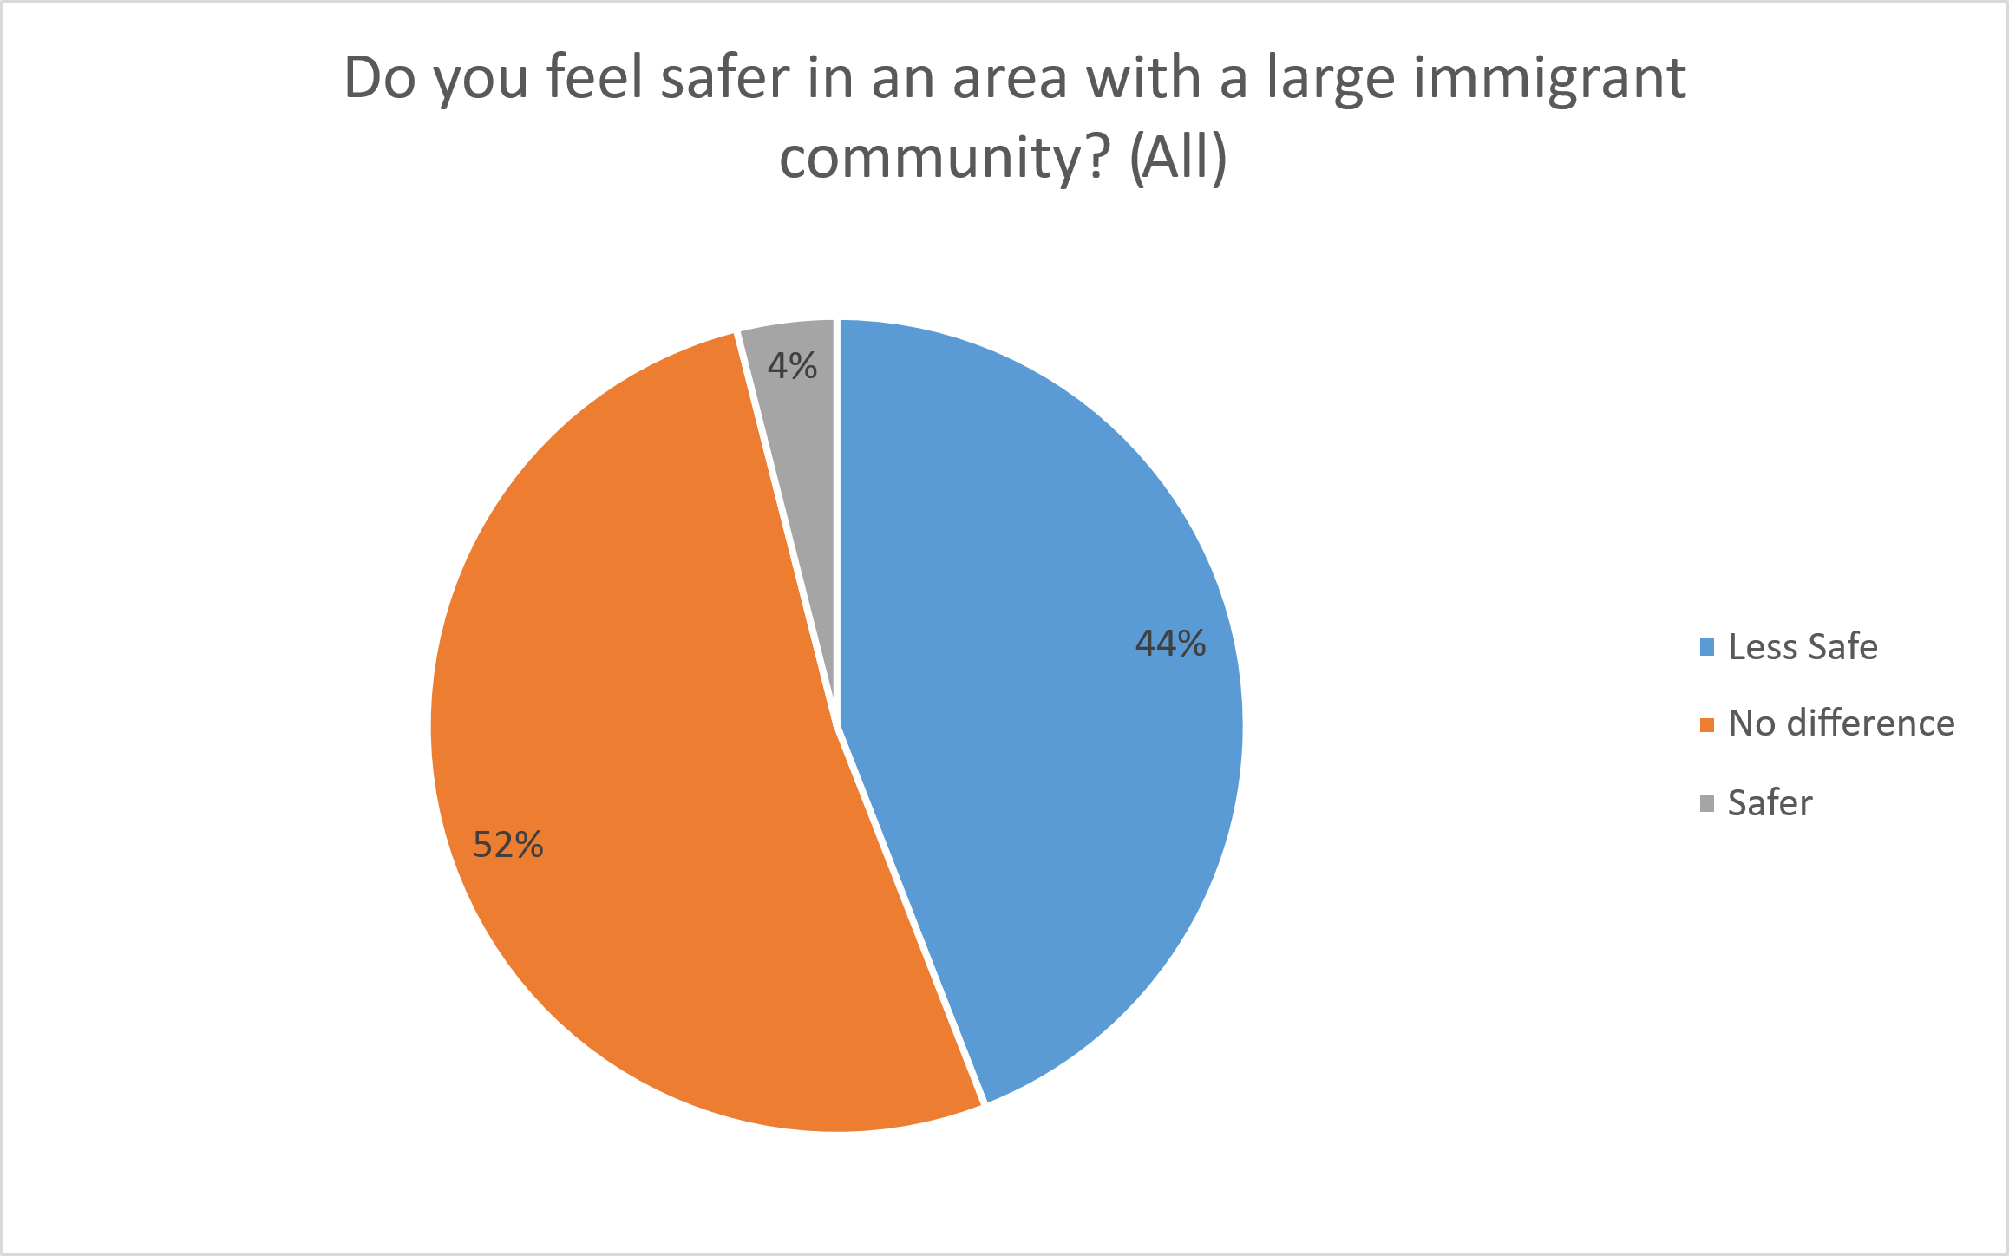

Graph 9:

Graph 10:
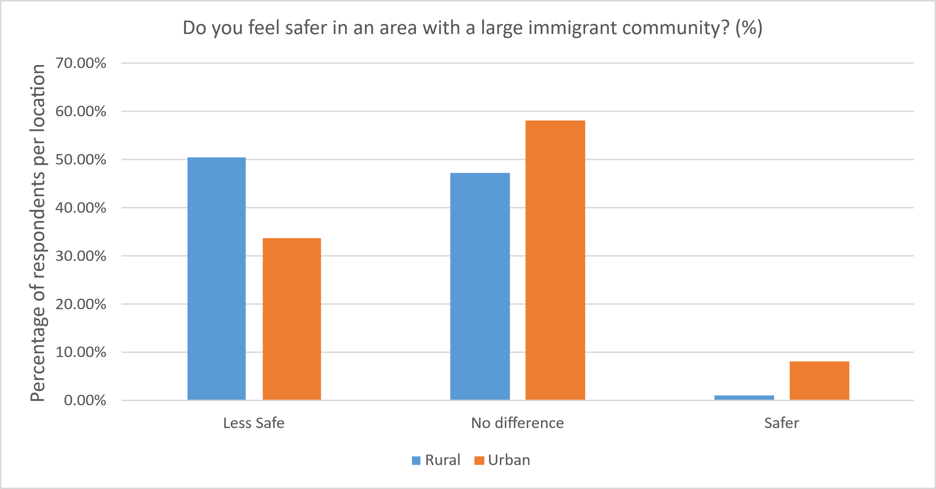

The data shows that 93 people said they live in a rural area, while 62 live in urban areas. Then, the respondents were asked about living in an area with a larger immigrant community, a significant minority ,44, reported feeling less safe, the majority ,52, felt no difference and 4 felt safer.
The data shows 50% of people who live in rural areas said they feel less safe in areas with larger immigration community. Potentially this is because rural areas have less exposure to immigration population, making them less familiar and more threating. In contrast, 58% of people in urban areas were saying they felt no difference in safety, which could reflect that urban areas are more used to diversity. Also, urban areas said they felt safer with immigrant communities which could be because they see immigrants bringing benefits to their neighbourhood – this could be because they are more familiar and accepting of diversity and see them as not a threat or urban people tend to be more indifferent about this.
However, an article written and published by the London School of Economics suggests that the relationship between feeling safe in a city and the size of the immigrant population is more complex. Research suggests that people living in large cities tend to feel less safe when the city size is above a certain threshold. Usually, a city above that threshold will have a higher number of immigrants living there and stronger immigrant communities over smaller homologous cities that report stronger feelings of safety. This suggests that the relationship between immigrant population and feelings of safety are more complex than just immigrants cause feelings of danger, and these other factors can’t be ignored when discussing this topic (London school of economics, 2021).

Section 4 -
Graph 11:
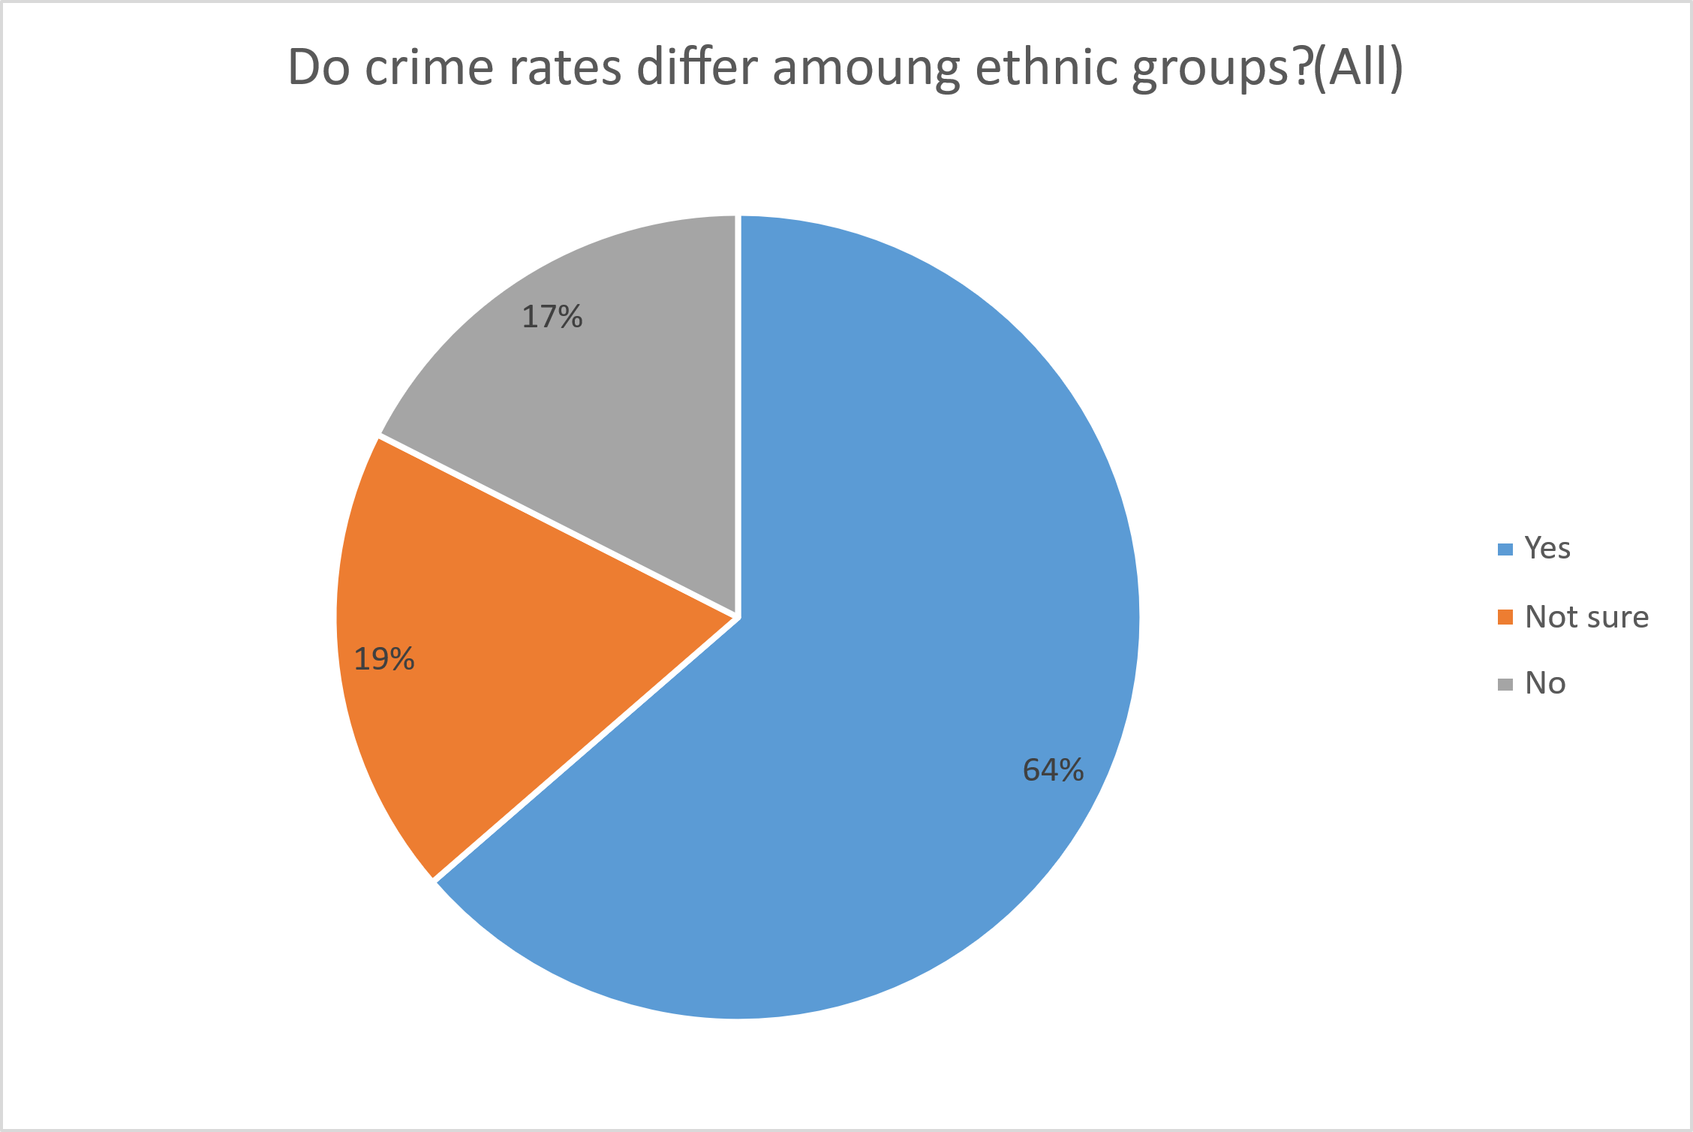

Graph 12:

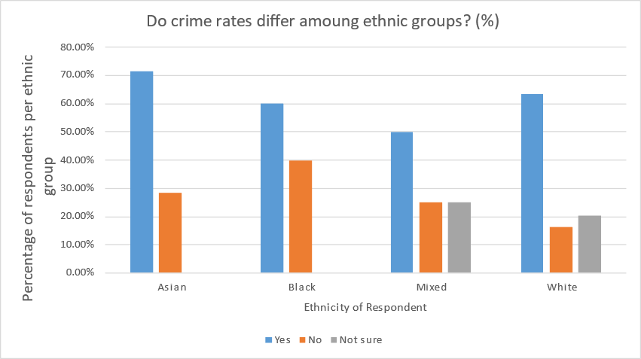
Graph 13:

Graph 14:

The results show that 139 was white, black 5, Asian 7, mixed 4. The respondents were asked if crime differs among ethnic groups which showed that 64 responses believe crime does differ among ethnic group, 19 believe it does not, and 17 were unsure. This shows that a large portion perceive difference in crime rates or types of crime among ethnic group, suggesting that many people associate crime with certain communities. However, a smaller group believes there is no difference, which shows a more neutral or non-biased view of crime.
This shows there is a shared perspective across all ethnic groups which means that they all believe certain ethnic groups may experience or associate with different types of crime. These findings reflect societal views or stereotypes about crime and ethnicity and personal experience that shape people’s view. This could also show there is deeper issues related to systemic inequalities or biases in how crime is reported or experienced by different ethnic groups. However, this data may not reflect accurately of crime statics but rather how people perceive or interpret crime (Hetey et al., 2018).
Government data shows that for most ethnic groups there is a disparity between the UK’s population and the ethnic population of the UK’s prisons. For example, in 2022, 4% of the UK’s population was black but 12% of the prison population was black. That means, in prison, there are three times as many black people relative to the incarcerated population. For Asian people, who made up 9% of the UK’s population in 2022, they made up 8% of the prison population. This shows that there is both positive and negative disparities between the amount of ethnic people in the UK and those committing crimes which justifies the response by the respondents in the questionnaire (Ministry of Justice, 2024).
The response to the question “do you think culture and environment affects immigrants’ likelihood to commit crime” shows that 115 said yes there is an impact, 10 believe there is no impact and then 27 were unsure. This shows that people believe there is a connection between immigrants’ culture background is a likelihood to commit crime. This shows that people may view social economic or culture factors as influencing criminal behaviour particularly among immigrants. The London school of economics published a study that concluded that socio-economic groups that have a poorer labour market are more likely to commit property crime compared to groups that have stronger labour markets. This means that migrants, legal or illegal, are more likely to commit non-violent crimes involving property, such as many people living under one tenancy, than non-migrants. This supports most respondents who believe that culture and environment play a role in non-violent criminal activity (Bell et al., 2011).

Section 5-
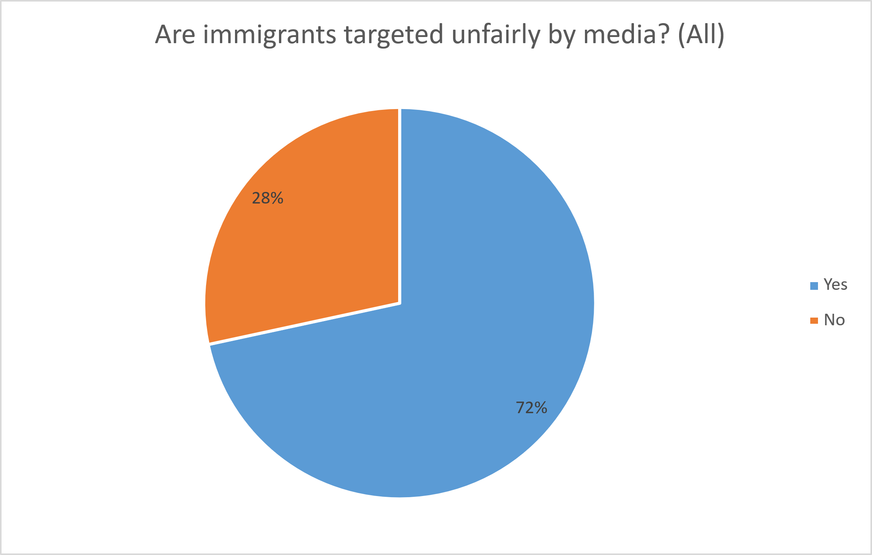
Graph 15:

Graph 16:

Graph 17:

Graph 18:
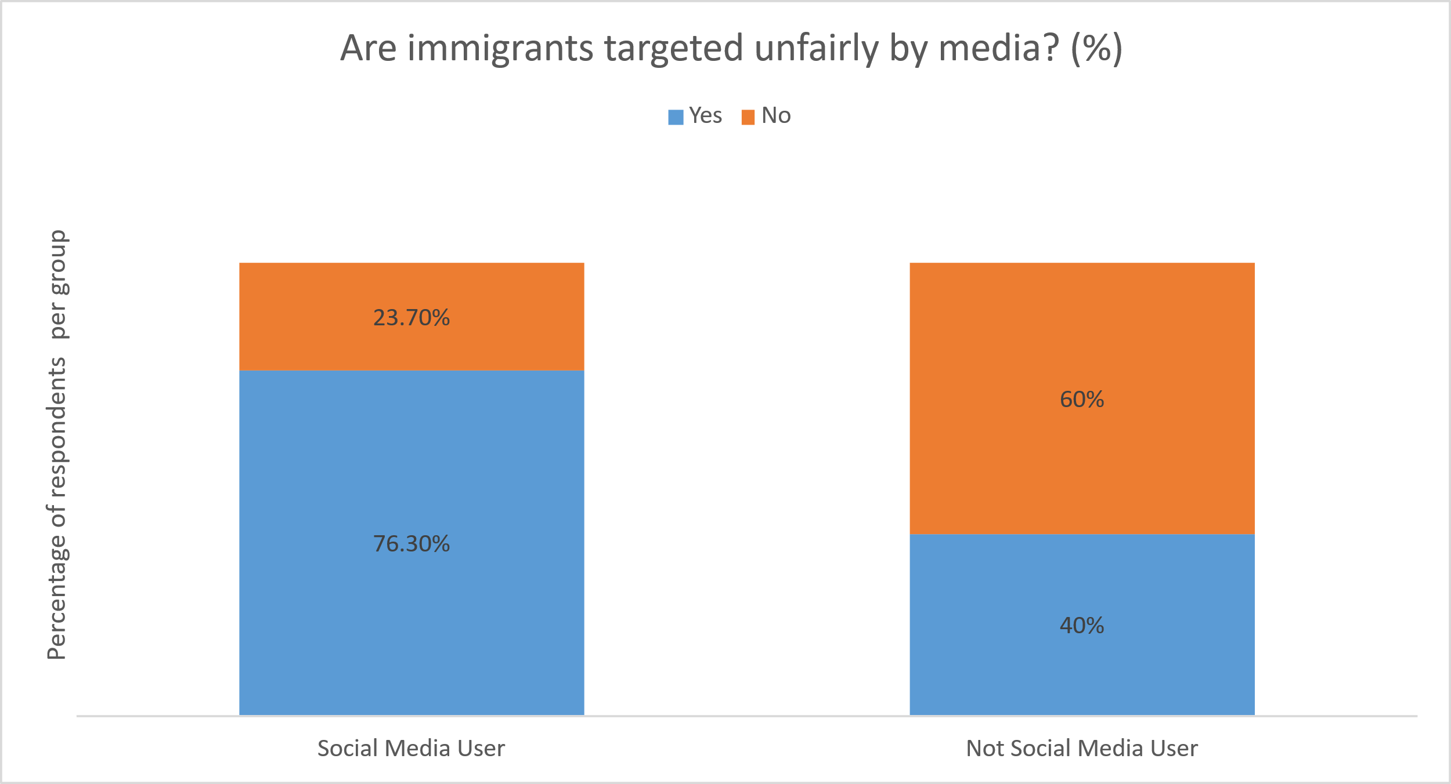

The respondents were asked about social media usage, most responses, 133, said they use social media, while only 20 said they do not. This indicates that most people in the sample are regularly exposed to online content for example news and media narratives. They were then asked about media coverage of immigrants and 72% said they believed they was unfairly targeted by media, while 28% disagreed. This indicates that most people not only engage with social media but also believe that media coverage of immigrants is unfair. This reflects a growing awareness of how immigrants are portrayed in the news and online platform. Since social media is a massive role in our lives it may be shaping these perspectives; either by exposing people to biased narratives or by allowing space for alternative perspectives that challenge mainstream media. However, the age of the respondents and fact they mostly all use social media could skew the data.
The results were then combined about immigrants being unfairly targeted by media with social media usage this gives a clear idea of perceptions emerged between social media usage and non-users. Among social media users 76.3% believe immigrants are unfairly targeted by media whilst 23.7% did not share this view. In contrast non- social media users, only 40% believe immigrants are unfairly targeted by media while 60% believed they are not unfairly targeted. These results show that social media users believe immigrants are unfairly targeted by social media compared to who do not use media. This could also show greater media awareness of thinking among social media users about how certain groups like immigrants are represented. Studies suggest that social media is full of diverse and extreme opinions about migrants, true and untrue, meaning that users are exposed to a wider range of views about the topic and most, if not all, will see extremely negative views about migrants at some point. This could justify why social media users think migrants are unfairly treated by media more than non-users (Triandafyllidou et al., 2024)
On the other hand, non-social media users rely more on traditional media sources and may have less exposed to counter narratives or critical discussions about media bias, which could explain their lower concern. In conclusion this shows that the data highlights the influence of social media fairness in relation to sensitive topics such as immigration.
When asked about whether the news coverage is positive or negative 122 people said it was negative, while 34 said it was positive. These results show that most people perceptive media coverage of immigrants is negative. This could show a widespread belief that media tends to focus on negative stories involving immigrants such as crime, conflict or economic strain rather than highlighting positive stories. This study shows that traditional media tends to portray migrants in three specific ways: “illegal”, “Eastern European” or “highly skilled”. This shows that traditional press works on two extremes to push narratives about migrants: either they are extremely bad, or they are extremely good for the UK. Media pieces focusing on illegals and Eastern Europeans attempt to paint a negative picture of all immigrants by focusing on these key phrases that have negative connotations. However, pieces that focus on highly skilled migrants attempt to paint a picture that a person is only good for the UK if they have unique or rare skills to contribute to the economy. This shows that traditional press stick to more traditional narratives about law, culture and economics and explains why non-users of social media tend to have a more negative view on migrants as they see more articles about the downsides of migration and associate highly skilled immigrants as rare (Blinder et al.,2017).

Section 6 -
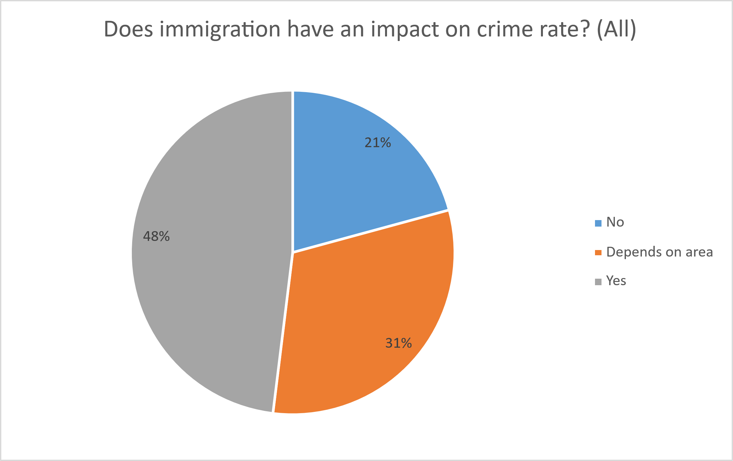
Graph 19:

Graph 20:

Graph 21:
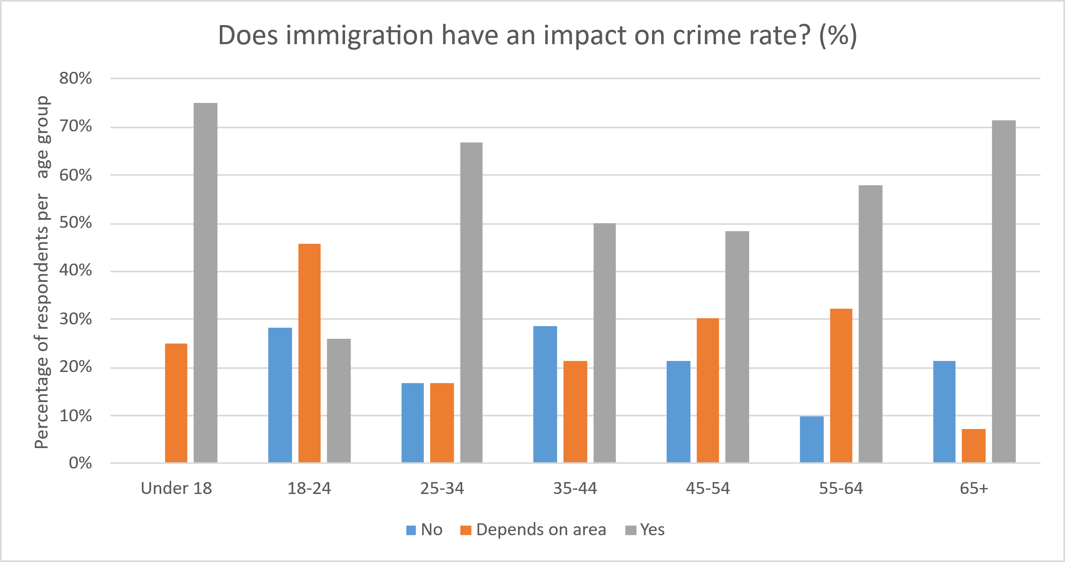

Respondents were then asked whether immigration has impact on crime rates 48% said yes, 21% said no and 31% said it depended on the area. These results show that opinions are mixed, but a larger portion believe immigration does effect crime rates. While some people it depends on the area suggesting that local context such as community integration, economic conditions or support services may play a role. A smaller portion said no believing there is no direct link between immigration and crime – the ones who said yes could believe that immigration contribute to crime which may be shaped by personal experiences, media or community held beliefs that link immigration with criminal activity. The ones who sad no may have said this because crime is influenced by factors such as poverty, education or media rather than someone’s immigration status. They could also view immigration as positively to society and reject the stereotypes that link immigration to increase to crime. The ones who said it depended on the area reflect as more neutral view. This suggests people recognise the impact of local conditions, for example, economic opportunities, community support or policing on crime levels (Kent, 2021).

Section 7 -
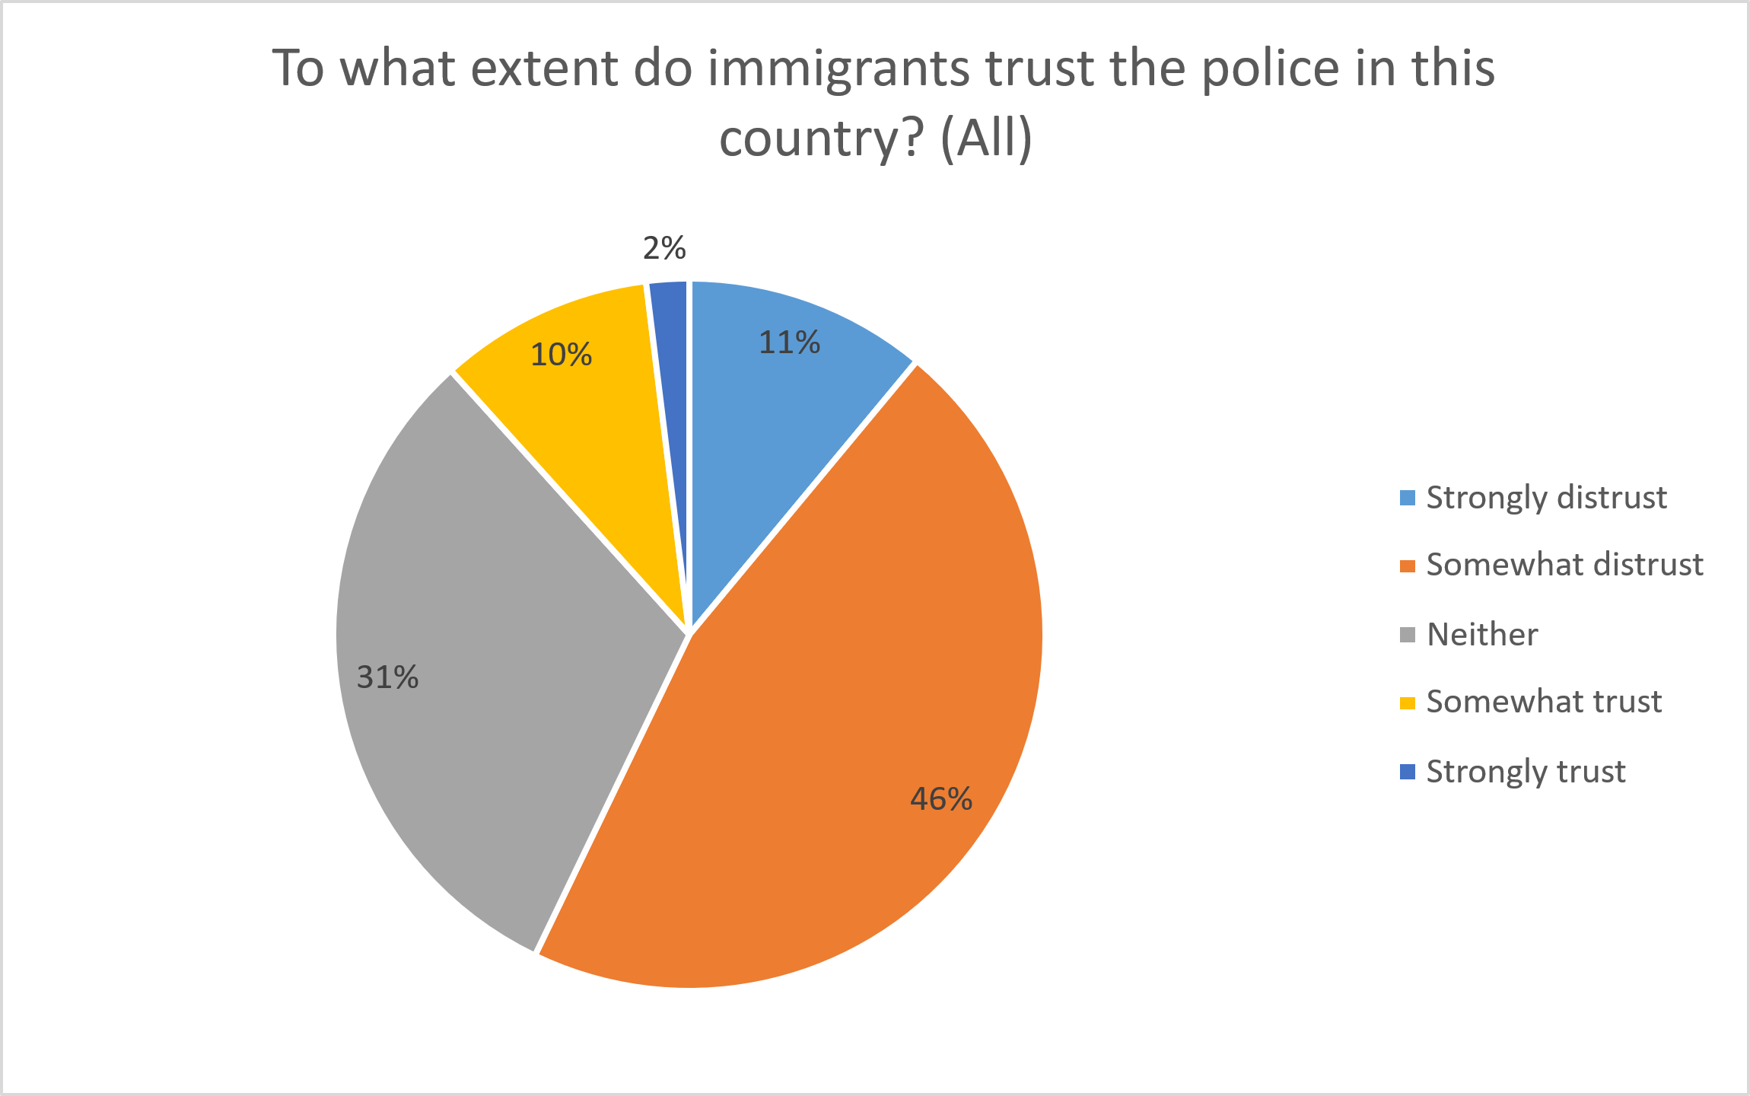
Graph 22:

Over 57% of respondents believe that immigrants distrust the police in the UK to varying degrees whilst only 12% believe that immigrants trust police in any capacity. This shows that, from the outside, people believe that immigrants see the police as an adversary force and something to be avoided rather than a force of protection or help. This is likely due to how the police have historically treated immigrants in the UK and media that become national scandals such as the 2005 shooting of a Brazilian immigrant Jean Charles de Menezes where police shot and killed this man and then proceeded to imply he was killed as part of the war on terror rather than the truth, that his death was a mistake. These incidents make people feel like immigrants can’t trust the police (BBC News, 2015).

Section 8 -
Graph 23:
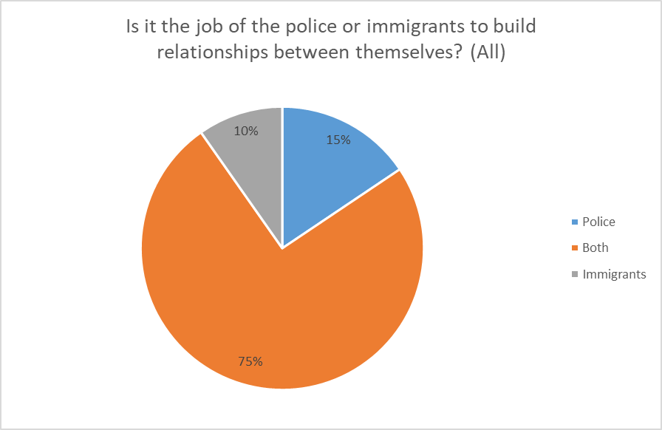

The data shows that most respondents believe it is the job of both the police and immigrants to build and improve relationships. Out of the respondents that didn’t reply both, most believed that it was the job of the police to foster relationships. This could be because of past incidents and mistakes by the police which make people feel as if the police are the main cause of the issues in this dynamic (Chenane et al., 2018).

Chapter 6: Conclusion

This research was set out to investigate the societal, historical and political elements of immigration. The findings showed a complex issue of immigration. This research paper shows that immigration policies have evolved significantly from the restrictive measures such as the 1905 alien act to more modern-day issues such as political and social debates around Brexit and the Rwanda policy. Events such as the Windrush scandal shows how legal and policy failures can have lasting impacts on communities. By this research paper analysing how political and economic factors such as climate change will shape migration trends this research has given insight into the future of global migration.
This research paper also examines the influence of traditional and social media on public perception of immigration. This paper showed a finding that media narratives originate from right wing outlets. These outlets played a role in shaping negative narratives towards immigrants. The way the media portrays immigrants have influenced public opinion. This paper shows that media can frame immigration debates and its impact on society and attitudes towards immigrants.
This research paper also explores the link between immigration, policing and crime rates. This study found no evidence to support that immigrants increase crime rates. On the other hand, it did show that police do face challenges such as resources limitations and community relations among immigrant communities. The paper also highlights the importance of community policing and building trust between police and immigrant community to address these challenges effectively.
The survey result shows insight into how immigration is perceived in relation to crime and policing. Whilst the data does not show a proven link between immigration and increase in crime, it does show how public opinion is shaped by the media and social factors to shape these beliefs.
The survey showed that many people associate immigrants with crime especially from the rural area where there is less exposure to immigrants. Conversely urban people felt less affected by immigrants possibly because of cultural integration. This shows how location and exposure influence perceived safety, this is important to gain a better understanding how immigration is linked to feelings of crime.
Another point from the survey is perception of how crime differs among ethnic groups with many people believing crime differs by ethnicity. This highlights social biases and stereotypes rather than data. This data shows that people think crime is influenced by background rather than individual behaviour.
The people who use social media was more aware that immigrants are unfairly targeted by the media proposing people who use social media are more exposed to viewpoints which makes these people more aware of how immigrants are being portrayed. On the other hand, those who don’t use social media tend to rely more on traditional news sources and more likely to believe what is said about immigrants. This shows how media is shaping people opinions about immigrants and crime.
Another point is that over half the people believe immigrants distrust the police and most people felt that it was both the job of the police and immigrants to build better relationships. This aligns with the research title by showing how immigrants not only effects public perception of crime, but it also impacts community police relations.
Lastly, several people lacked basic understanding about the terms such as the difference between asylum seeker and illegal immigrants. The lack of knowledge could feed into negative perception affecting how people view immigrants in relation to crime.
One of the limitations of the research paper was finding reliable and up to date refences. This is due to the topic of immigration and crime is a sensitive topic and complex. Some of the sources were biased or not suitable for academic use. There was also difficulty finding studies on the UK.
Another limitation was that the survey mainly reached people of similar age, background and location which meant the results may not fully represent wider public views.
This research shows that the media is mainly constructing the public perception that immigrants commit crime, this is done through scare tactics for more engagement on their articles. This is very damaging for many minorities within the UK and it is recommended that people do more research into the issue and look at official statistics instead of taking everything that the media tells them at face value and hopefully society can be less hateful and more compassionate towards people.

Chapter 6: Reference list
Armenta, A. and Rosales, R. (2019). ‘Beyond the fear of deportation: Understanding unauthorized immigrants’ ambivalence toward the police’. American Behavioural Scientist. Available at: https://doi.org/10.1177/0002764219835278 (Accessed: 29 November 2024).
Bansak, C., Simpson, N.B. and Zavodny, M. (2021). The economics of immigration. London: Routledge.
BBC News (2015). Profile: Jean Charles de Menezes. Available at: https://www.bbc.co.uk/news/uk-33080187 (Accessed: 4 May 2025).
Bell, B. and Machin, S. (2011). The Impact of Migration on Crime and Victimisation A report for the Migration Advisory Committee. Available at: https://assets.publishing.service.gov.uk/government/uploads/system/uploads/attachment_data/file/257233/lse-consulting.pdf (Accessed: 4 May 2025).
Benhabib, S. (2020). ‘The End of the 1951 Refugee Convention? Dilemmas of Sovereignty, Territoriality, and Human Rights’. Jus Cogens, 2(1), pp.75–100. Available at: https://link.springer.com/article/10.1007/s42439-020-00022-1 (Accessed: 29 November 2024).
Blinder, S. and Jeannet, A.-M. (2017). ‘The ‘Illegal’ and the skilled: Effects of Media Portrayals on Perceptions of Immigrants in Britain’. Journal of Ethnic and Migration Studies, 44(9), pp.1444–1462. Available at: https://www.tandfonline.com/doi/full/10.1080/1369183X.2017.1412253 (Accessed: 4 May 2025).
Borjas, G.J. and Cassidy, H. (2020). The Adverse Effect of the COVID-19 Labor Market Shock on Immigrant Employment. Available at: https://www.nber.org/papers/w27243 (Accessed: 29 November 2024).
Boyce, G.A. (2020). ‘Immigration, policing, and the politics of time’. Geography Compass. Available at: https://compass.onlinelibrary.wiley.com/doi/abs/10.1111/gec3.12496 (Accessed: 25 October 2024).
Braber, B. (2020). Changes in Attitudes to Immigrants in Britain, 1841-1921. London: Anthem Press.
Chavez, L.R. (2023). Covering Immigration: Popular Images and the Politics of the Nation. London: University of California.
Chenane, J.L. and Wright, E.M. (2018). ‘The Role of Police Officer Race/Ethnicity on Crime Rates in Immigrant Communities’. Race and Justice, 11(1). Available at: https://doi.org/10.1177/2153368718777278 (Accessed: 6 May 2025).
Chigbu, U.E., Atiku, S.O. and Du Plessis, C.C. (2023). ‘The Science of Literature Reviews: Searching, Identifying, Selecting, and Synthesising’. Publications, 11(1), pp.2. Available at: https://www.mdpi.com/2304-6775/11/1/2 (Accessed: 25 October 2024).
Clarke, H.D., Goodwin, M. and Whiteley, P. (2017).’ Why Britain Voted for Brexit: An Individual-Level Analysis of the 2016 Referendum Vote’. Parliamentary Affairs, 70(3), pp.439–464. Available at: https://doi.org/10.1093/pa/gsx005 (Accessed: 29 November 2024).
Cojocaru, A. (2022). ‘Representations of Eastern European Jewish Immigrants in Early Twentieth-Century British Press: Judaism and the Urban Regeneration of London’. Dialogo, 9(1), pp.34–45. Available at: https://philpapers.org/rec/COJROE (Accessed: 5 May 2025).
De Coninck, D. (2022). ‘The Refugee Paradox During Wartime in Europe: How Ukrainian and Afghan Refugees are (not) Alike’. International Migration Review, 57(2), pp.578–586. Available at: https://doi.org/10.1177/01979183221116874 (Accessed: 5 May 2025).
De Coninck, D. (2019). ‘Migrant categorizations and European public opinion: diverging attitudes towards immigrants and refugees’. Journal of Ethnic and Migration Studies, 46(9), pp.1667–1686. Available at: https://www.tandfonline.com/doi/full/10.1080/1369183X.2019.1694406 (Accessed: 29 April 2025).
Douglas, P., Cetron, M. and Spiegel, P. (2019). ‘Definitions matter: migrants, immigrants, Asylum Seekers and Refugees’. Journal of Travel Medicine, 26(2). Available at: https://academic.oup.com/jtm/article/26/2/taz005/5315619 (Accessed: 5 May 2025).
Douglas, P., Cetron, M. and Spiegel, P. (2019). ‘Definitions matter: migrants, immigrants, Asylum Seekers and Refugees’. Journal of Travel Medicine. Available at: https://academic.oup.com/jtm/article/26/2/taz005/5315619 (Accessed: 29 November 2024).
Dubow, S. and Drayton, R.H. (2020). Commonwealth history in the twenty-first century. Switzerland: Palgrave Macmillan.
El-Enany, N. (2020). ‘Aliens: Immigration law’s racial architecture’. Manchester University Press. Available at: https://doi.org/10.7765/9781526145437.00007 (Accessed: 29 November 2024).
Ethical Consumer Research & Consultancy (2022). Addressing Subtle Forms of Hate in UK Media Coverage of Migration. Available at: https://research.ethicalconsumer.org/research-hub/addressing-subtle-forms-of-anti-migrant-hate-2022 (Accessed: 5 May 2025).
European Commission (2024). Consequences of climate change. Available at: https://climate.ec.europa.eu/climate-change/consequences-climate-change_en (Accessed: 5 May 2025).
Felstead, A. and Reuschke, D. (2020). ‘HOMEWORKING IN THE UK: BEFORE AND DURING THE 2020 LOCKDOWN’. Wiserd. Available at: https://eprints.soton.ac.uk/444076/1/Homeworking_in_the_UK_Report_Final_3_3.pdf (Accessed: 5 May 2025).
Fernández-Reino, M., Vargas-Silva, C. and Brindle, B. (2022). ‘Migrants and Housing in the UK’. Migration Observatory. Available at: https://migrationobservatory.ox.ac.uk/resources/briefings/migrants-and-housing-in-the-uk/ (Accessed: 5 May 2025).
Forkert, K., Oliveri, F., Bhattacharyya, G. and Graham, J. (2020). How media and conflicts make migrants. Manchester: Manchester University.
Gerlach, I. and Ryndzak, O. (2022). ‘Ukrainian Migration Crisis Caused by the War’. Studies in European Affairs, 26(2), pp.17–29. Available at: https://www.ceeol.com/search/article-detail?id=1062749 (Accessed: 29 November 2024).
Glover, D. (2012). Literature, Immigration, and Diaspora in Fin-de-Siècle England: A Cultural History of the 1905 Aliens Act. New York: Cambridge University.
Goodfellow, M. (2020). Hostile Environment: how immigrants became scapegoats. London: Verso.
Greetham, B. (2019). How to Write Your Undergraduate Dissertation. London: Bloomsbury Publishing.
Hampshire, J. (2024). ‘Immigration and Asylum Policy after Brexit: An Introduction’. The Political Quarterly, 95(2), pp.219–250. Available at: https://doi.org/10.1111/1467-923X.13415 (Accessed: 29 November 2024).
Harris, C.T. and Gruenewald, J. (2019). ‘News Media Trends in the Framing of Immigration and Crime, 1990–2013’. Social Problems, 67(3), pp.452–470. Available at: https://academic.oup.com/socpro/article-abstract/67/3/452/5545185 (Accessed: 25 October 2024).
Heddlu Police Dyfed - Powys (2024). Communications and Engagement Strategy 2024-2028. Available at: https://www.dyfed-powys.police.uk/SysSiteAssets/foi-media/dyfed-powys/disclosure-2024/july/communications-and-engagement-strategy-2024-2028-for-foi-715.24.pdf (Accessed: 6 May 2025).
Helbing, M. and Leblang, D. (2018). ‘Controlling immigration? How regulations affect migration flows’. European Journal of Political Research, 58(1), pp.248–269. Available at: https://doi.org/10.1111/1475-6765.12279 (Accessed: 29 November 2024).
Helgason, B.A. and Effron, D.A. (2022). ‘From critical to hypocritical: Counterfactual thinking increases partisan disagreement about media hypocrisy’. Journal of Experimental Social Psychology. Available at: https://doi.org/10.1016/j.jesp.2022.104308 (Accessed: 6 May 2025).
Hepburn, A. (2016). Around 1945: literature, citizenship, rights. London: McGill-Queen’s Press.
Hetey, R.C. and Eberhardt, J.L. (2018). ‘The numbers don’t speak for themselves: Racial disparities and the persistence of inequality in the criminal justice system’. Current Directions in Psychological Science, 27(3), pp.183–187. Available at: https://journals.sagepub.com/doi/full/10.1177/0963721418763931 (Accessed: 6 May 2025).
Hewitt, G. (2020). ‘The Windrush Scandal. Caribbean Quarterly’. A Journal of Caribbean Culture, 66(1), pp.108–128. Available at: https://doi.org/10.1080/00086495.2020.1722378 (Accessed: 29 November 2024).
His Majesty’s Inspectorate of Constabulary and Fire & Rescue Services (2023). Police performance: Getting a grip. Available at: https://hmicfrs.justiceinspectorates.gov.uk/publication-html/police-performance-getting-a-grip/ (Accessed: 6 May 2025).
Immigration and Social Security Co-ordination, EU Withdrawal Act (2020). Available at: https://www.legislation.gov.uk/ukpga/2020/20/contents/enacted (Accessed: 2 February 2025).
Iryna Maidanik (2023). ‘The forced migration from Ukraine after the full-scale Russian invasion: dynamics and decision-making drivers’. European Societies, pp.1–12. Available at: https://doi.org/10.1080/14616696.2023.2268150 (Accessed: 5 May 2025).
Jones, T. and Lister, S. (2019). ‘Localism and police governance in England & Wales: Exploring continuity and change’. European Journal of Criminology, 16(5), pp.552–572. Available at: https://doi.org/10.1177/1477370819860689 (Accessed: 29 November 2024).
Kaufmann, E. and Goodwin, M.J. (2018). ‘The diversity Wave: A meta-analysis of the native-born white response to ethnic diversity’. Social Science Research, 76(1), pp.120–131. Available at: https://doi.org/10.1016/j.ssresearch.2018.07.008 (Accessed: 29 November 2024).
Kelly, J. (2023). Domestic-abuse victims fear deportation if they go to police. Available at: https://www.bbc.co.uk/news/uk-67357025 (Accessed: 6 May 2025).
Kent, J. (2021). ‘Can urban fabric encourage tolerance? Evidence that the structure of cities influences attitudes toward migrants in Europe’. Cities. Available at: https://doi.org/10.1016/j.cities.2021.103494 (Accessed: 6 May 2025).
Khannolainen, D. (2023). Media Framing of Immigration in the United Kingdom: A Critical Discourse Analysis of. Available at: https://dspace.cuni.cz/bitstream/handle/20.500.11956/186184/120456262.pdf (Accessed: 5 May 2025).
Konietschke, F., Schwab, K. and Pauly, M. (2020). ‘Small sample sizes: A big data problem in high-dimensional data analysis’. Statistical Methods in Medical Research, 30(3), pp.687–701. Available at: https://doi.org/10.1177/0962280220970228 (Accessed: 6 May 2025).
Kubrin, C.E. and Ousey, G.C. (2023). ‘Immigration and Crime: What We Know and What Remains Unknown’. Springer Briefs in criminology, 1(1), pp.47–69. Available at: https://link.springer.com/chapter/10.1007/978-3-031-22839-1_4 (Accessed: 2 February 2025).
Lazzarato, M., and Hurley, R. (2021). Capital hates everyone: fascism or revolution. London: South Pasadena.
Leal, D.L. (2024).’ Democracy In Britain: A Primer’. Hoover Institution. Available at: https://www.hoover.org/research/democracy-britain-primer (Accessed: 5 May 2025).
London school of economics (2021). ‘How the size of a city’s immigrant population influences feelings of trust and safety in urban Europe – EUROPP’. EUROPP - European Politics and Policy. Available at: https://blogs.lse.ac.uk/europpblog/2021/10/05/how-the-size-of-a-citys-immigrant-population-influences-feelings-of-trust-and-safety-in-urban-europe/ (Accessed: 29 April 2025).
Mahler, J. and Rutenberg, J. (2019). HOW RUPERT MURDOCH’S EMPIRE OF INFLUENCE REMADE THE WORLD. Available at: https://www.kooriweb.org/foley/news/2000s/2019/nyt3april2019.pdf (Accessed: 29 November 2024).
Majdub, Z. (2024). Rivers of Blood – The Oxford Student. Available at: https://www.oxfordstudent.com/2024/08/10/rivers-of-blood/ (Accessed: 5 May 2025).
McLaren, L., Boomgaarden, H. and Vliegenthart, R. (2017). ‘News Coverage and Public Concern About Immigration in Britain’. International Journal of Public Opinion Research, 30(2), pp.173–193. Available at: https://doi.org/10.1093/ijpor/edw033 (Accessed: 29 November 2024).
Migration Yorkshire (2023). Illegal Migration Act briefing October 2023. Available at: https://www.migrationyorkshire.org.uk/policy/policy-briefings/illegal-migration-act-briefing-october-2023 (Accessed: 6 May 2025).
Ministry of Justice. (2016) 'Offender Management Statistics Bulletin, England and Wales', Foreign National Offenders, pp. 7. Available at: https://assets.publishing.service.gov.uk/government/uploads/system/uploads/attachment_data/file/541499/offender-management-statistics-quarterly-bulletin-jan2-mar-2016.pdf#page=8 (Accessed: 24 October 2024).
Ministry of Justice (2024). Statistics on Ethnicity and the Criminal Justice System, 2022. Available at: https://www.gov.uk/government/statistics/ethnicity-and-the-criminal-justice-system-2022/statistics-on-ethnicity-and-the-criminal-justice-system-2022-html (Accessed: 4 May 2025).
Morrow, S. (2019) 'Social & News Media’s Effects on Law Enforcement', Global Journal of Forensic Science & Medicine. Available at: https://www.researchgate.net/profile/Shawn-Morrow/publication/333827561_Social_News_Media's_Effects_on_Law_Enforcement/links/5d07c8f2a6fdcc35c155bdb9/Social-News-Medias-Effects-on-Law-Enforcement.pdf (Accessed: 25 October 2024).
Mweshi, G. and Sakyi, K. (2020). ‘Application of sampling methods for the research design’. Archives of Business Research, 8(11), pp.180–193. Available at: 10.14738/abr.811.9042. (Accessed: 2 February 2025).
Nationality and Borders Act (2022). Available at: https://www.legislation.gov.uk/ukpga/2022/36/contents (Accessed: 2 February 2025).
Navarrete, M.S., Adrián, C. and Bachelet, V.C. (2022). ‘Respondent-driven sampling: Advantages and disadvantages from a sampling method’. Medwave, 22(01), pp. Available at: http://viejo.medwave.cl/link.cgi/English/Reviews/GeneralReviews/8514.act?ver=sindiseno (Accessed: 6 May 2025).
Nortio, E., Niska, M., Renvik, T.A. and Jasinskaja-Lahti, I. (2020). ‘The nightmare of multiculturalism: Interpreting and deploying anti-immigration rhetoric in social media’. New Media & Society, 23(3). Available at: https://journals.sagepub.com/doi/abs/10.1177/1461444819899624 (Accessed: 25 October 2024).
Obeng-Odoom, F. (2021). Global Migration Beyond Limits. Oxford: Oxford University
Office for National Statistics (2025). Public opinions and social trends, Great Britain: March 2025 | Backup. ONS. Available at: https://backup.ons.gov.uk/2025/04/17/public-opinions-and-social-trends-great-britain-march-2025/ (Accessed: 5 May 2025).
Osuagwu, L. (2020). ‘Research Methods: Issues and Research Direction’. Business and Management Research. Available at: https://www.sciedupress.com/journal/index.php/bmr/article/view/19078 (Accessed: 25 October 2024).
Pavezi, I.B. (2021). ‘Refugees: Status and Rights’. Encyclopaedia of the UN sustainable development goals. Available at: https://link.springer.com/referenceworkentry/10.1007/978-3-319-69625-6_46-1 (Accessed: 29 November 2024).
Pellew, J. (1989). ‘The Home Office and the Aliens Act, 1905’. The Historical Journal, 32(2), pp.369–385. Available at: https://www.jstor.org/stable/2639607 (Accessed: 5 May 2025).
Remenyi, D. and Bannister, F. (2020). Writing up your Research for a Dissertation or Thesis. University of Johannesburg: UJ Press.
Rodolfo, L. (2020). ‘Media Ethics, Regulations, And Effects: How the British Right-Wing Press Disregards All Three & Undermines Democratic Deliberations’. Journal of Computer, Media and Telecommunications Law, 25(2) pp.5–7. Available at: https://www.researchgate.net/profile/Rodolfo-Leyva/publication/342354487_Media_ethics_regulations_and_effects_how_the_British_right-wing_press_disregards_all_three_and_undermines_democratic_deliberations/links/5ff768a6a6fdccdcb83b466c/Media-ethics-regulations-and-effects-how-the-British-right-wing-press-disregards-all-three-and-undermines-democratic-deliberations.pdf (Accessed: 25 Oct. 2024).
Routledge (2019). Does more immigration lead to more violent and property crimes? A case study of 30 selected OECD countries. Available at: https://www.tandfonline.com/loi/rero20 (Accessed: 29 November 2024).
Schöpfel, J., Primož, J., Prost, H., Malleret, C., Češarek, A. and Koler-Povh, T. (2015). ‘Dissertations and Data’. Univ-lille.fr. Available at: https://hal.univ-lille.fr/hal-01285304 (Accessed: 2 February 2025).
Sen, P., Crowley, G., Arnell, P., Katona, C., Pillay, M., Waterman, L.Z. and Forrester, A. (2022). ‘The UK’s exportation of asylum obligations to Rwanda: A challenge to mental health, ethics and the law’. Medicine, Science and the Law, 62(3), pp.165–167. Available at: https://doi.org/10.1177/00258024221104163 (Accessed: 29 November 2024).
Sharma, S., Carballo, M., Feld, JJ and Janssen, H. (2015).'Immigration and viral hepatitis ', Journal of Hepatology, 63(2), pp.515-522. Available at: https://www.sciencedirect.com/science/article/pii/S0168827815003207 (Accessed: 25 October 2024).
Siddharth, V. (2025). ‘From Disinformation to Violence: The UK Far Right and 2024 Riots’. Ebsco.com. Available at: https://openurl.ebsco.com/EPDB%3Agcd%3A4%3A23699476/detailv2?sid=ebsco%3Aplink%3Ascholar&id=ebsco%3Agcd%3A183930248&crl=c&link_origin=scholar.google.co.uk (Accessed: 5 May 2025).
Suffolk Constabulary (2025). New policing model continues strengthen community links. Available at: https://www.suffolk.police.uk/news/suffolk/news/news/2024/october/new-policing-model-continues-strengthen-community-links/ (Accessed: 6 May 2025).
Taplin, R.H. (2024). ‘Quantifying data quality after removing respondents who fail data quality checks’. Current Issues in Tourism, pp.1–12. Available at: https://doi.org/10.1080/13683500.2024.2378611 (Accessed: 29 April 2025).
Taherdoost, H. (2022). ‘What are different research approaches? Comprehensive review of qualitative, quantitative, and mixed method research, their applications, types, and limitations’. Journal of Management Science & Engineering Research, 5(1), pp.53–63. Available at: https://hal.science/hal-03741840/document (Accessed: 2 February 2025).
Taras, V., Steel, P. and Kirkman, B.L. (2010). ‘Negative practice–value correlations in the GLOBE data: unexpected findings, questionnaire limitations and research directions’. Journal of International Business Studies, 41(8), pp.1330–1338. Available at: https://link.springer.com/article/10.1057/jibs.2010.30 (Accessed: 2 February 2025).
Terrell, S.R. (2022). WRITING A PROPOSAL FOR YOUR DISSERTATION: guidelines and examples. New York: Guilford.
The Migration Observatory (2016). A Decade of Immigration in the British Press - Migration Observatory. Available at: https://migrationobservatory.ox.ac.uk/resources/reports/decade-immigration-british-press/ (Accessed: 5 May 2025).
The Migration Observatory (2016) A Decade of Immigration in the British Press. Available at: https://migrationobservatory.ox.ac.uk/resources/reports/decade-immigration-british-press/ (Accessed: 24 October 2024).
The Migration Observation (2020). BRIEFING Migrants in the UK: An Overview. Available at: https://web.archive.org/web/20220119084820id_/https:/migrationobservatory.ox.ac.uk/wp-content/uploads/2017/02/Briefing-Migrants-in-the-UK-An-Overview.pdf (Accessed: 29 November 2024).
The National Archives (2025). Coming to Britain: Collection highlights. Available at: https://beta.nationalarchives.gov.uk/explore-the-collection/explore-by-topic/migration-and-citizenship/coming-to-britain/ (Accessed: 5 May 2025).
The UN Refugee Agency (2024). ‘Asylum in the United Kingdom’. UNHCR United Kingdom. Available at: https://help.unhcr.org/uk/asylum/ (Accessed: 6 May 2025).
Thomas, M. and Wendling, M. (2024). Donald Trump repeats baseless claim about Haitian immigrants eating cats and dogs in Springfield, Ohio. Available at: https://www.bbc.co.uk/news/articles/c77l28myezko (Accessed: 5 May 2025).
Tomlinson, S. (2017). ‘Enoch Powell, empires, immigrants and education’. Race Ethnicity and Education, 21(1), pp.1–14. Available at: https://doi.org/10.1080/13613324.2017.1365055 (Accessed: 29 November 2024).
Triandafyllidou, A. and Monteiro, S. (2024). ‘Migration narratives on social media: Digital racism and subversive migrant subjectivities’. First Monday. Available at: https://doi.org/10.5210/fm.v29i8.13715 (Accessed: 4 May 2025).
UK Government (2021). Rapid evidence assessment on the impacts of climate change on migration patterns. Available at: https://www.gov.uk/research-for-development-outputs/rapid-evidence-assessment-on-the-impacts-of-climate-change-on-migration-patterns (Accessed: 5 May 2025).
United Nations (2024). UK’s Rwanda asylum moves undercut core human rights protections - UN Human Rights Chief. Available at: https://www.ohchr.org/en/press-releases/2024/02/uks-rwanda-asylum-moves-undercut-core-human-rights-protections-un-human (Accessed: 6 May 2025).
Waitzman, E. (2024). ‘Windrush scandal and compensation scheme’. House of Lords Library. Available at: https://lordslibrary.parliament.uk/windrush-scandal-and-compensation-scheme/ (Accessed: 5 May 2025).
Williams, K. and Reid, M. (2023). Planning Your Dissertation. London: Bloomsbury Publishing.
Wyrwich, M. (2019). 'Migration restrictions and long-term regional development: evidence from large-scale expulsions of Germans after World War II', Journal of Economic Geography, 20(2), pp.481-507 reference. Available at: https://academic.oup.com/joeg/article/20/2/481/5556381?login=false (Accessed:25 October 2024).
Yıldz, D. (2023). EFFECTS OF CLIMATE CHANGE AND MIGRATION ON MUNICIPALITIES. Available at: https://policycommons.net/artifacts/9769285/effects-of-climate-change-and-migration-on-municipalities/10658536/ (Accessed: 29 November 2024).

Appendix

Examine how immigration impacts crime and its effect on policing?
Hello, my name is Charlotte, and I am a third-year student at the University of Wales Trinity Saint David’s, studying Professional Policing BSc. As part of my dissertation, I am conducting this survey to explore the public’s views on immigration and its connection to crime and policing.
By participating in this survey, you agree to have your responses used for this research. All answers will be kept confidential and anonymous. The data collected will be stored securely and will be deleted once it is no longer needed. Your participation is completely voluntary, and you are free to withdraw from the study at any time.
The purpose of this research is to explore how immigration impacts crime and policing. The study will begin by examining the history and background of immigration, focusing on how future developments may shape public perceptions of different groups, including natives, migrants, immigrants, refugees, and asylum seekers. It will then assess how traditional and social media influence the public’s views on immigration. Finally, the research will explore the connection between immigration, crime rates, and policing, aiming to understand how these factors are interlinked and the challenges faced by policing in addressing them.

- Do you agree to participating in this study and consent to your responses being used for this study?
Yes
No

- What is your gender?
Women
Man
Other
Prefer not to say

- What is your age?
Under 18
18 – 24
25 – 34
35 – 44
45 – 54
55 – 64
65 +

- How would you describe the area in which you live in?
Rural
Urban

- Which of the following best describes your ethnicity?
White
Black
Asian
Mixed
Other
Prefer not to say

- Do you identify with any of the following religious groups?
Christianity
Islam
Buddhism
Judaism
Hinduism
Atheist
Agnostic
Other
Prefer not to say

- Do you understand the difference between the terms: migrant, immigrant, asylum seeker and refugee?
Yes
No

- Have historical events or movements, such as the World Wars or the Refugee Crisis, significantly influenced public perceptions of immigrants and refugees?
Yes
No
I’m not sure

- Do you believe immigrants are unfairly targeted by media?
Yes
No

- Do you use social media?
Yes
No

- Do you feel that news coverage about immigrants is generally positive or negative?
Positive
Negative

- What effect do you think immigration policies have on immigrant communities?
Positive effect
Negative effect
No effect
Mixed effect
I’m not sure

- Do you believe immigration has an impact on crime rate?
Yes
No
Depends on the area

- Do you believe that crime rates differ among ethnic groups?
Yes
No
I’m not sure

- Do you think culture or environment affects an immigrant’s likelihood to commit crimes?
Yes, it has a significant impact
No, it does not have an impact
I’m not sure

- Do you feel safer or less safe in an area with a large immigrant community?
Safer
Less safe
No difference

- To what extent do you believe immigrants trust the police in this country?
Strongly trust
Somewhat trust
Neither trust nor distrust
Somewhat distrust
Strongly distrust

- Do you feel it is the job of the police or immigrants to build relationships between themselves?
Police
Immigrants
Both

