
Assignment 2:
Marriott International
[Financial statement]

[30.11.2022]
UNIVERSITY OF WALES TRINITY SAINT DAVID

STUDENT ID:2024720
STUDENT NAME: MARIANA CAROLINA ANDREI
MODULE NAME: FINANCIAL MANAGEMENT FOR THE HOTEL INDUSTRY
(BMIH5007, BMIH5002)
SUBMISSION DATE: 30.11.2022

Executive Summary
Marriott International manages and operates hotels in the United Kingdom. The hotel's financial data for 2020 and 2021 is instantaneously represented in the corporate accounts supplied to the Chief Executive by the following ratios, which will assist in the study of that data. Hilton will be able to make appropriate judgements about the hotel's profitability, liquidity, and gearing if it analyses its earnings and balance sheet in light of the patterns shown by these data.
According to the study's ratio analysis, the corporation will continue to pile on debt in 2021, even as its profits climb and its credit score falls. Nonetheless, at a relatively modest interest rate. Wages and maintenance have soared, according to the company's likelihood ratio. Normal wages have increased by 20%. demonstrates the company's propensity for making repairs rather buying dropping shares. As a consequence, insurance premiums rise. The company is upbeat since rates, automobile expenses, bad debts, and loan interest have all stayed consistent or decreased. Overall, the lower cost of gross profits increases profit projections for this year. Everything is cheaper in debt, even the liquidity ratio. Despite gains in stock prices and income, the long-term debt of a bank loan has stayed constant as borrowing has increased.
Despite good sales in 2020 and 2021, the company's debt has limited its ability to grow. There has been a misallocation of funds. As a result, many people seem to be concerned about the company's future. Since the loan interest has been cut, the company may now buy new items in order to minimise maintenance and insurance expenses, as well as negotiate new agreements that will raise sales in order to pay off creditors.

Table of Contents
Executive Summary 1
Introduction 4
Analysis Trends 6
Profitability 6
Liquidity 7
Gearing 8
Knowledge from Ratio Analysis 8
Benefits and Limitations of Ratio Analysis 9
Conclusion 11
Bibliography 12

Introduction
Marriott International runs hotels in the United Kingdom and handles their finances. In the corporate accounts provided to the Chief Executive, the hotel's financial data for 2020 and 2021 is instantly reflected by the following ratios, which will aid in the analysis of that data. If Hilton examines its profits and balance sheet in light of the trends exhibited by these measurements, it will be able to make suitable judgments regarding the hotel's profitability, liquidity, and gearing.
The merger has a high probability of success based on the statistical evidence supplied at the predetermined level of significance. The fact that Hilton was able to accurately calculate the data shows that the hotel may use a previous model like this to help develop an auxiliary option that will help support the appropriate equipment and tools to identify the hotels ratio over the past two years.
Knowledge of how to manage and evaluate a hotel's revenues and costs is a crucial talent for managers in the hospitality business.
Keeping tabs on planned revenue may provide hotels an idea of their financial standing. This will show if the ratio is optimum, or whether one option needs to see more income before the other in order to keep customers happy. Both internal (by hotel management) and external (by auditors) metrics will be used to assess financial success (by banks, rating agencies, and investors).
Hotel financial performance analysis is conducted to identify variances between actual and expected hotel financial results. Before diving into the data, one must decide which ratios will be used as focal points, such as (1) profitability ratios, (2) liquidity ratio, and (3) gearing ratio. Using the aforementioned ratios and computations, you may evaluate the present state of your operations in relation to your plans and forecasts from the previous two years. Variance localization, quantification, and root-cause analysis are all essential parts of financial analysis.
The success of the hotel in the future may be estimated by looking at how well it did in its first two years. The ratios, which are often stated as percentages, give a way to measure the extent to which a company's financial performance has changed. using the trends to evaluate the current financial health of the business.
A financial analysis study has been ordered since an objective evaluation of their effectiveness is necessary. However, with the help of this report, the company will be able to compare its performance to that of similar businesses in the hospitality industry. The terminology is widely understood, and the company benefits from consistent operational data that can be used as a yardstick against the industry standard.

Analysis Trends

Profitability
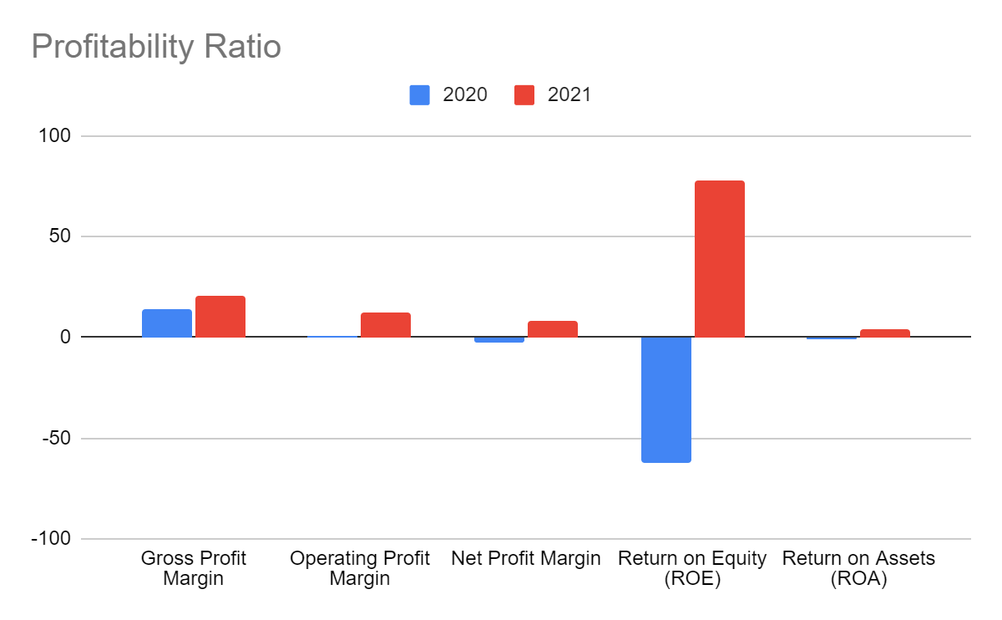
Graph 1: Profitability Ratio
Profitability ratios are a kind of financial indicator that compares a firm's profits at a particular point in time to its sales, operating expenditures, balance sheet assets, and shareholders' equity. This type of analysis is done to get a better understanding of how profitable a company is. Efficiency ratios, as opposed to after-cost earnings, investigate how well a firm makes use of its own resources to create income.
When calculating profitability, there are five ratios that are employed. The analysis of the data showed that the company's net profit margin had decreased by 4.38 percentage points, which is evidence that the business is being poorly managed. The increase in sales that resulted in revenue showed a gross profit increase of 2.69%. The target margin for the business is set at forty percent. The return on capital employed (ROCE) has seen a decrease of 15.1%, which is low and shows that revenue shares are low in comparison to the quantity of assets possessed (Nyangwe and Buhalis, 2018). The below-average earnings are an indication that the company's resources are being managed in an inefficient manner. The time it takes to transfer over an asset in 2021 is three days longer than the time it takes in 2020.

Liquidity
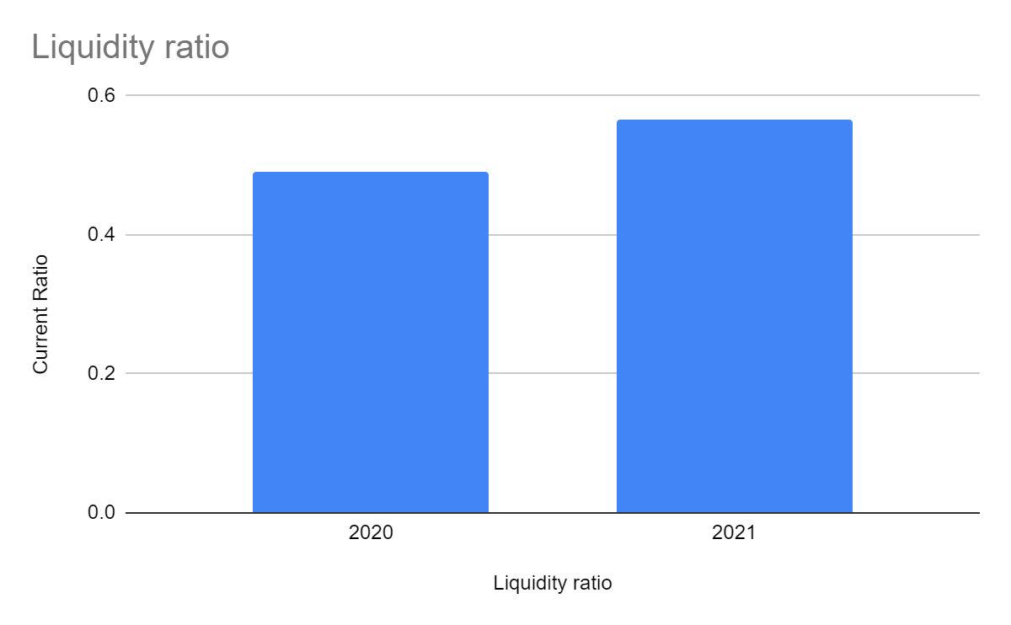
Graph 2: Liquidity Ratio
When conducting a financial analysis, the liquidity ratio is of the utmost importance because it places an emphasis on payment obligations. This is the case despite the fact that it takes into consideration expenditures that are less costly and those made by debtors. One example of this would be an inadequate term loan in comparison to long-term debt. The ratio of current values has seen a 0.24 percent increase. At the end of the financial analysis, it should be evident whether or not the company has adequate cash on hand to satisfy the conditions of its payment schedule for its obligations and costs. This should be the case if it is clear that the company does have sufficient cash on hand. When evaluating a business's liquidity, it is important to consider not just the firm's own present assets but also the cash that the company has available to pay off its existing commitments when those obligations become due (Yepes et al. 2019).
Both finished-goods stockpiles and accounts receivable from customers in the target market are consistent components of liquid assets. It is very necessary for all payment commitments to be satisfied in order to guarantee the continuous financial health of the company. After deducting running expenses like insurance and maintenance, the liquidity ratio mandates that payments be paid to suppliers in the form of debts. These payments must take place before the ratio is calculated. A timely payment of long-term debt and the maintenance of increasing instalments are required to accomplish the goal of achieving financial stability.

Gearing
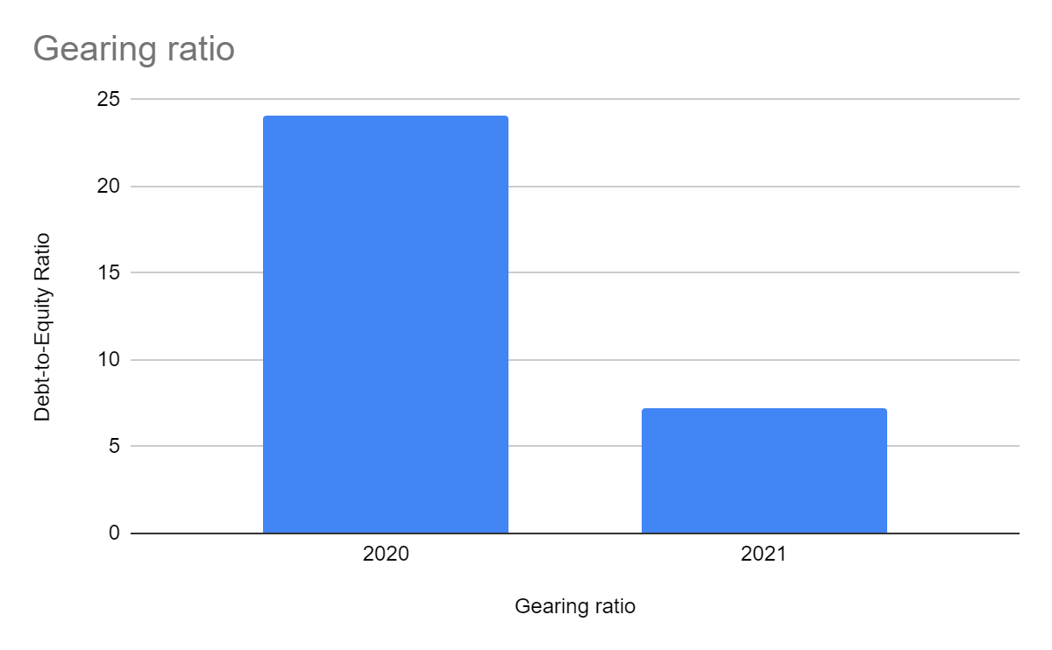
Graph 3: Gearing Ratio
Capital, debt, and money borrowed from creditors like banks are all included in the Gearing ratio's analysis. It is important to give credit where it is due, and the firm's financial management deserves much of the praise for deciding how best to allocate shareholder capital vs creditor capital. Compared to before, there are now 2% fewer borrowers for every creditor (Neves et al. 2022).

Knowledge from Ratio Analysis
The financial ratios of a debtor are an important class of financial metrics that are used to determine whether or not they are able to pay off their current debt obligations without the need to obtain extra cash from other outside sources. When calculating liquidity ratios, there are three different metrics that are taken into consideration. These are the current ratio, the quick ratio, and the operational cash flow ratio. These ratios are used to ascertain not just a company's ability to fulfil its financial commitments but also the margin of safety it enjoys (Markova, 2020).
A crucial aspect of liquidity is the ability to convert assets into cash in a quick and cost-effective manner. The use of liquidity ratios in the context of direct comparison is where they are most helpfully utilised. It is feasible that this analysis will be carried out either inside or outside of the organisation (Mangano et al. 2018).
For instance, in order to carry out an internal audit of liquidity ratios, it is required to employ a variety of accounting periods, all of which are required to be documented in accordance with the same accounting standards. Analysts are able to track changes in the company by contrasting actions from earlier time periods with those that are taking place at the present time. A higher liquidity ratio suggests that a company is more fluid and has excellent insurance of current loans if the company has a bigger amount of liquid assets. When the ratio is larger, this is the situation that often arises.

Benefits and Limitations of Ratio Analysis
When businesses make use of ratios as a tool to assist in analysis, regulatory compliance, and process improvement, they face the danger of coming across some of the method's flaws. The reputation predictors are those that centre their attention on a company's commercial bank majors or credit managers and the assessment of ratios that determine a company's capacity to pay off its obligations by these individuals. The performance of a company and its future growth are the key areas of attention for stock forecasts. The ratio analysis is not without its limits, despite the fact that it does give significant insights into the activities of the firm and the financial position of the organisation. Because it is not seen to be intrinsically ethical to get only ordinary outcomes, the vast majority of firms aim to achieve results that are superior to the average. This strategy is designed for more sophisticated execution since the management ratios have been enhanced.
The economic accounts may be thrown off by inventory value, differing techniques of depreciation, and other factors like these, which can lead to divergent evaluations across organisations that employ different secretarial practices. As a result of the fact that leased assets don't always perform as expected on the balance sheet, it's conceivable for a company's assets to be relatively low in relation to its transactions. On the other hand, leasing has the potential to significantly increase both the repayment of debt and the turnover of inventory, especially in situations where the contractual duty is not jeopardised by debt. In addition, it is difficult to make sweeping statements about whether a certain ratio is "honest" or "corrupt." For instance, a high existing ratio may imply a solid liquidity situation, which is accurate; yet, hoarding an excessive amount of cash is dishonest since having an excessive amount of cash on hand has long been considered as a corrupting effect. And in a similar vein, the capacity of a corporation to create profits from its own assets may be used as a measure to determine whether or not the company has enough funding. The use of ratio analysis may provide the appearance of robust health to certain companies, even while their financial circumstances are rather unstable. However, we will make use of numbers in order to investigate the characteristics of the ratios that we establish. Quantitative methods are used by a variety of financial institutions, including banks, to analyse a company's economic statistics. These statistics serve as the foundation of an institution's analysis and categorise a business according to the likelihood that it will be successful or experience financial distress. While there is value in analysing profitability ratios, analysts need to be aware of the hurdles that come along with doing so in order to maximise its potential worth. If ratio analysis is utilised in a way that is power-driven and without thinking, it may be harmful. However, if ratio analysis is used wisely and with good judgement, it may give significant insights into the operations of an organisation.

Conclusion
The ratio analysis in the research shows that the corporation continues to rack up debt in 2021 despite healthy profits and declining credit. Nonetheless, at a very reasonable interest rate. The organization's probability ratio indicates that pay and upkeep costs have increased dramatically. The standard pay has increased by 20%. indicates the company is prioritising repairs over buying depreciating shares. In turn, this causes an increase in insurance rates. Rates and vehicle expenses, bad debts, and loan interest have all stayed consistent or decreased, contributing to the company's optimism. Overall, the odds of making a profit this year are lower due to the reduction in the cost of gross earnings. Similarly, to how everything is less expensive in debt, the liquidity ratio is better. Even when stock prices and revenues have gone up, the long-term liability of a bank loan has stayed the same due to the growth in borrowing.
The company's debt has hampered any further expansion despite good sales in 2020 and 2021. The profits have been improperly allocated. A lot of people seem to be concerned about the company's future as a result of this. Since the loan interest has decreased, the company will be able to show a bright future as it orders new inventory to cut maintenance and insurance expenses and to negotiate new agreements that will raise sales to pay off creditors.

Bibliography
Nyangwe, S. and Buhalis, D., 2018. Branding transformation through social media and co-creation: lessons from marriott international. In Information and communication technologies in tourism 2018 (pp. 257-269). Springer, Cham.
Darsin, J., Rosner, J., Urdaneta, C. and Yepes, M., 2019. Marriott International: Exploring and Understanding Disruption in the Hospitality Industry in South Florida. Journal of Multidisciplinary Research, 11(1), pp.99-119.
Neves, D.D., 2022. Marriott international inc. equity research-the hotel Giant´ s recovery (Doctoral dissertation).
Mangano, C., 2018. Strategic human resources management impact on organizational performance: a case study of Marriott International.
Ivanov, S., Seyitoğlu, F. and Markova, M., 2020. Hotel managers’ perceptions towards the use of robots: a mixed-methods approach. Information Technology & Tourism, 22(4), pp.505-535.
Filimonau, V., Derqui, B. and Matute, J., 2020. The COVID-19 pandemic and organisational commitment of senior hotel managers. International Journal of Hospitality Management, 91, p.102659.
Bonfanti, A., Vigolo, V. and Yfantidou, G., 2021. The impact of the Covid-19 pandemic on customer experience design: The hotel managers’ perspective. International Journal of Hospitality Management, 94, p.102871.

