EFFECTIVE TEAM WORKING AND COMMUNICATION
BMSW4002-SWAN

Name: Ionut Cerbagi
Student number: 2123839

UNIVERSITY OF WALES TRINITY SAINT DAVID

CONTENTS PAGE NO.

INTRODUCTION………………………………………3
MAIN FINDINGS……………………………………3-4
TEAM DYNAMIC……………………………………4-5
BRUCE TUCKMAN’S THEORY……………..5
THOMAS KILMANN THEORY…………….5
BELBIN’S 9 ROLES…………………………….6
TEAM FORMATION AND COMMUNICATION…………………………………6-7
SHANON-WEAVER MODEL…………………….7
SCHRAMM’S MODEL……………………………..8
SMCR MODEL………………………………………..9
TWO-WAY COMMUNICATION………………9-11
CONCLUSION………………………………………..11
REFERENCES…………………………………………..12

- Introduction
The report is based on a case study in which a considerable number of problems were identified that Andrea Jones, the new Head of Social Services, faced.
The problems identified are the absence of employees from the workplace, the comfort of working online, the inexperienced teams constantly formed, stress, weak relations between employees, the information provided informally, lack of two-way communication, lack of face-to-face communication, and very low productivity. All these problems are caused by two great deficiencies in the departments of social workers, lack of communication, and effective teams.

What is communication?
Communication is the process of changing information such as thoughts, ideas, feelings, and emotions between two or more people and which can be verbal, non-verbal, written, or visual, which is carried out when the sender receives a response from the receiver following the respective information. (Rigotti and Rocci, 2006)

- Main Findings
Among the Main Findings will be presented a series of theories that helps to solve the problems highlighted in the studied case by developing communication between the social workers, forming teams, and increasing productivity. The theories which help to find solutions are:
- Tuckman's theory helps to understand the term team and its formation in departments
- Belbin’s 9 Roles that help to understand the role and importance of each person in the team
- Three Communication Models for a wider understanding of the importance of communication among team members.
- the model of Weaver and Shannon
-SMCR model by David K Berlo
-Schramm model, two-way communication

With the help of these theories, communication will be implemented among the team members, teams will be able to be formed as a result productivity will be very high, trust will be present in the teams having very high importance, a pleasant environment will be created between teams with understanding each role that everyone has so that the problems will be removed, and Andrea Jones will be able to coordinate the departments.

- Team Dynamics
The dynamics of a team refers to the behavior and personality of the members of a team that act as psychological forces and that influence the direction and performance of a team. ( )
At the level of the case study, many problems were identified, and the lack of staff was one of them. With the pandemic, social workers started working from home and this made the social workers appreciate the convenience of working online much more. The employees are not aware of the benefit that face-to-face work has both for the emotional state also for the relationships with those around them, the feeling of appreciation and importance.
The dynamism in the departments of social workers is completely lacking due to the lack of motivation, low productivity, lack of experience, etc. Andrea Jones is required to motivate the staff so that those who work from home want to return to physical work and after which they can form teams. Employees can be motivated through various methods, letters, vouchers, recognition, awards, an employee of the month, or an extra day off.
For a company to be productive, it needs to have effective teams that give results, but to have effective teams, they must first be formed. A big problem facing social worker departments is the lack of teams that are crucial for a company.

What is a team?
A team is a dynamic entity comprising one or more people who work together, communicate, trust, and help each other, and exchange mutual help to achieve the same goal and goals. (Peralta et al., 2018)
Andrea Jones needs strong, efficient teams with good results to overcome the situation in which the departments are.
A theory that can help form teams is Bruce Tuckman's theory from 1965, which represents the stages a team must go through to be formed and become an efficient team. There are 5 of them and they are Forming, Storming, Norming, Performing, and Adjourning.
The first training stage is Forming, where the team members chosen by Andrea get to know each other, communicate, and establish common goals, and group responsibilities.
The second stage is Storming where conflicts do not take long to appear due to rivalries between team members for roles and positions. At this stage, the social workers will be rivals because each member of a team wants a better position, and wants to lead, but not everyone has the necessary capabilities to lead.
To avoid these conflicts that only lead to the breakdown of the newly formed team, the head of the department can apply Thomas Kilmann’s theory to avoid these conflicts. This theory studies the behaviors of people in a conflict and will help Andrea to understand much better the reaction and approach that every social worker has in a conflict. There are different types of behaviors such as Avoiding, Competing, Collaborating, Compromising, and Accommodating. (Thomas and Kilmann, 2008)
After the period of conflicts, the Norming stage follows, where things begin to unfold normally, the social workers begin to understand each other because they are reconciled with the roles and positions they have received.
The Performing stage is the stage where the social workers will work without the manager's supervision because things are going according to plan, everyone respects their role and tasks, and this makes productivity the desired.
And the last Adjourning stage will take place after the formed teams have fulfilled their objectives.

For the new head of social services to form solid teams, she must know each member of the team well to know what skills and knowledge he possesses to offer him a task capable of his knowledge.
To understand how important, the roles of an individual in a team are, another theory jumps to Andrea's aid, namely Belbin's 9 roles. Belbin says that the presence of the nine roles in a team is vital for its balance and good functioning. The 9 roles are the following: Team worker, Specialist, Completer-Finisher, Shaper, Coordinator, Resource-Investigator, Monitor-Evaluator, Plant, and Implementer. This theory will help Andrea to understand the role of everyone in the team, to form the teams so that all nine roles are present, and in the absence of one, the others can complete it.

- Team Formation and Communication.
Communication is vital because with its help all the processes carried out within a company work, it represents a key for collaborative teams, cooperation between company members, and for the best possible productivity. In the departments of social workers, communication is completely lacking. There is no communication between employees, considering that they carry out common tasks, but neither between managers-employees, or team leaders’ employees. The information addressed to the employees is informal, unclear, and verbal, without having the opportunity for a respond after receiving the information and sometimes the information does not reach completely.
The team leader proceeds very wrongly by addressing the team through messages, without having the opportunity to see how the information is received by the employees and if their opinion is also received after it. For an understanding of the importance of communication, Andrea Jones can use which of the following communication models.

The first model is that of the Shannon-Weaver Mathematical model established in 1949.

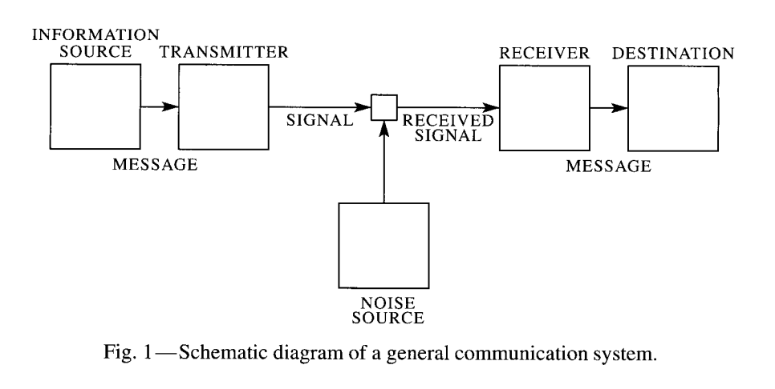

This communication model is made up of the following components: Sender, Encoder, Channel, Decoder, and Receiver among which an element was added, namely the noise that can disrupt this message by not reaching the receiver clearly. Shannon-Weaver's model aims to develop efficient communication between sender and receiver (Sabah, 2012).
A component that is missing from the communication model is feedback, which is vital in two-way communication because the sender must know if the message has reached the receiver, what opinion he has about the received message, and receive a response based on the receiver's opinion.

The second communication model is Schramm's model established in 1954 but based on Shannon-Weaver's model.

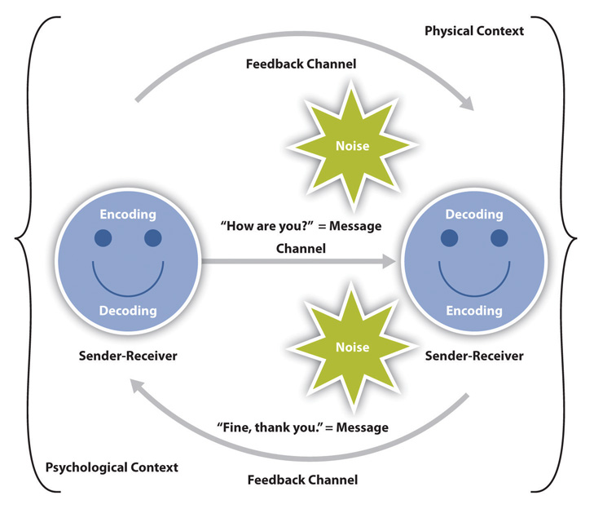

In Schramm's opinion, communication is a circular model rather than a linear one. Schramm defines communication as a flow of information exchange from the sender to the receiver, and from the receiver to the sender. (Huang, 2003)

The SMCR model was written in 1960 and represents a sender-message-channel-receiver communication process, being a very simple form of communication.
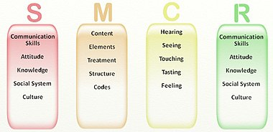

Two-way communication in a workplace builds progress between team members, and relationships, and improves the fluctuation of ideas in the company.
Andrea is forced to encourage and develop communication among employees through different methods. The managers and team leaders must provide the information to the social workers face to face so that the messages from the place are received and in return, feedback is provided so that the employees will understand the tasks received and will have much higher productivity.
Meetings must be established with the employees in which the team leaders can find out their opinions about various tasks or problems that have arisen along the way. During the tasks assigned to the employees, each head of the department must check the teams and their productivity to ensure that the tasks will be completed on time.
Benefits of two-way communication
- increased productivity
- increased employee engagement
- fewer conflicts
- better understanding
- better collaborating
- increased trust between members
Communication is of two kinds, verbal and non-verbal.

Verbal communication is present every day at the workplace and represents oral communication made up of words. This is essential in a company and is used in meetings, meetings with employees, and press conferences.
Non-verbal communication is communication made through gestures, facial expressions, and visual contact, also used every day like verbal communication. (Kaplan, 2022)
Communication is a process that can be interrupted very easily by means of barriers. These can be environmental barriers and personal barriers. Communication Barriers are in fact a series of obstacles that disrupt this communication by no longer being understood.
Environmental barriers - can be time, space, climate, news
Personal barriers are a series of personal factors that negatively affect communication.
The new head of social services must ensure that communication is not interrupted and that it is completed, with the help of a series of responsibilities that both the sender and the receiver have.
The sender’s responsibilities are it must be ensured that the message is understood, but the sender must also listen and understand, have clear ideas before communicating the message, the information must be valuable, follow the communication, highlight the content of the message, and communicate frequently.

The receiver must listen carefully, not speak while the sender communicates the information, be calm, ask, and eliminate any distractions.

CONCLUSION
In conclusion, with the help of the theories presented above, the problems identified in the case study will be solved with the formation of teams, the development of trust among social workers, the implementation of communication, and the understanding of the role of each member of the team. With the achievement of efficient teams and the existence of effective communication among team members, productivity will be very high, and the success of the company will be ensured.

References:
- Rigotti E. and Rocci A., 2006, Towards a Communication of Definition Context, Foundations of an Interdisciplinary Approach to Communication, Studies in Communication Sciences Vol6, Iss2, pp155-180
- Peralta C. F. et al, 2018, Team Development: Definition, Measurement, and Relationship with Team Effectiveness, Human Performance, Vol 31, Iss2, pp97-124
- Jones A., 2019 The Tuckman’s Model Implementation, Effect, and Analysis and the New Development of Jones LSI Model on a small group, Journal of Management, Vol6, iss4, pp23-28
- Peralta C. F. et al, 2018, Team Development, Definition, Measurement, and Relationship with Team Effectiveness, Human Performance, vol31, Iss2, pp97-124
- Barbara S, 1998, An empirically based assessment of Belbin’s team roles, Human Resources Management Journal, Vol 8, Iss3, pp54-60
- Thomas K. W. and Kilmann R. H.,2008, Thomas-Kilmann Conflict Mode Instrument, Profile, and Interpretive Report, Vol1, pp1-11
- Sabah F. 2012, A foundation for the Shannon-Weaver Model of Communication, International journal of soft computing, Vol7, Iss2, pp12-19
- Kaplan Z. 2022, What are verbal communication skills? [Available at https://www.theforage.com/blog/skills/verbal-communication], {Accessed on 15 December 2022}
- Huang C. 2003, Transitional Media vs Normative theories: Schramm, Altschul and China, Journal of Communication, Vol54, Iss3, pp444-459
- Lunenburg F. T. 2010, Communication: The process, Barriers, And Improving Effectiveness, Schooling, Vol1, Iss1, 1-10

