Module code ACDA5000
Communications and protocols
HND Electronic Engineering
Nick Regan

1a) 16Kbps

1b)

1c)

1d)

1e)

2a)
A CRC-enabled device calculates a short, fixed-length binary sequence, known as the check value or CRC, for each block of data to be sent or stored and appends it to the data, forming a codeword.
When a codeword is received or read, the device either compares its check value with one freshly calculated from the data block, or equivalently, performs a CRC on the whole codeword and compares the resulting check value with an expected residue constant.
If the CRC values do not match, then the block contains a data error.
The device may take corrective action, such as rereading the block or requesting that it be sent again. Otherwise, the data is assumed to be error-free (though, with some small probability, it may contain undetected errors; this is inherent in the nature of error-checking)
This has a good effect on transmitted data as it can detect and correct errors in data however this could take a while if data needs to be sent again, also this could prove to be expensive if there is a lot of incorrect data. This could also have a bad effect if there is a problem with the device.

2b)

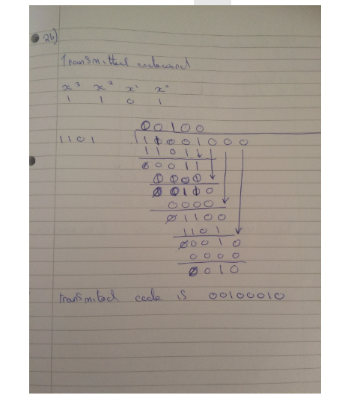

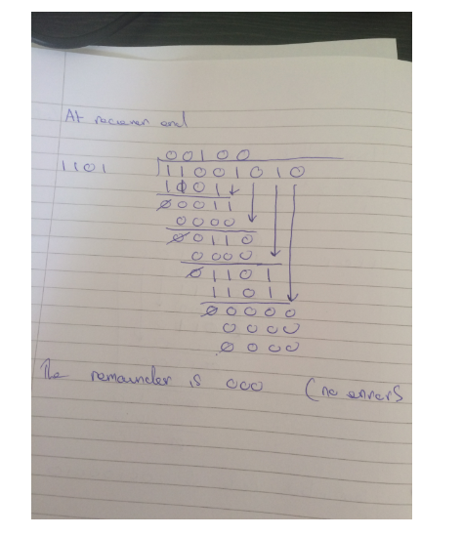2c) the main difference between selective repeat and go-back-n is that go-back-n re transmits all the frames where as selective repeat re transmits only the frame that is damaged

3a)
b)
c)

4a)
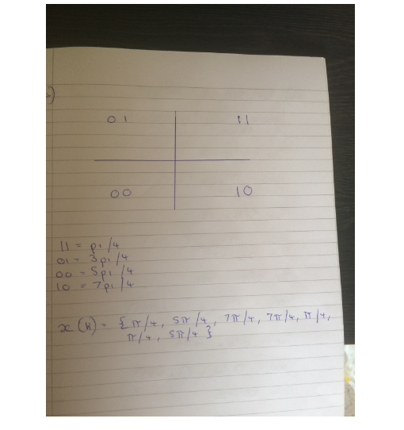

4b)
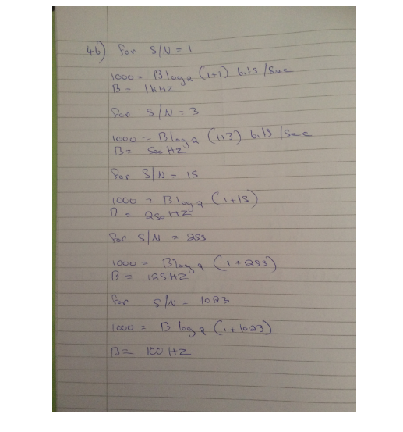

4c)


