DS 1 Template

My Screenshots/Photos
- Please add 4–6 screenshots or photos of your digital life.
- You can use your phone or laptop.
- For each screenshot, write one or two sentences explaining what it shows.

Screenshot/Photo 1
[WhatsApp]
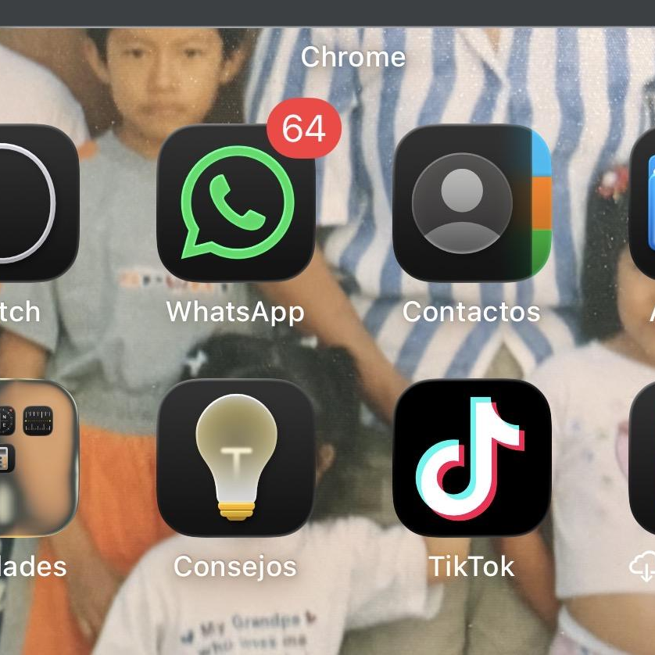. I use WhatsApp every day to communicate to my family and my friends and work. This app to help me to stay connect.

Screenshot/Photo 2
[Google]
. This platform is the most importantly to search information
Google has many special features to help me find exactly what I am looking

Screenshot/Photo 3
[Google maps]
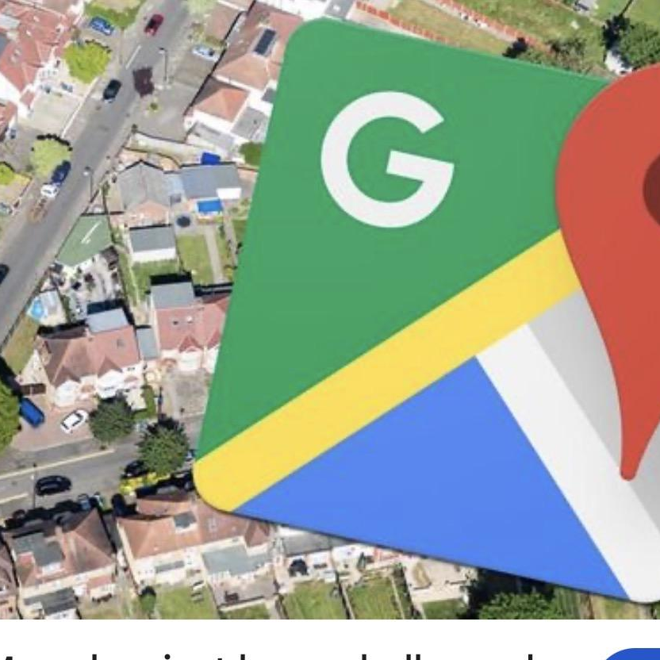
I am usually everyday this app because they help to find different place and location.
This app to help me get location and shows me how to get bus, train or walking the correct way.

Screenshot/Photo 4
[Microsoft word]
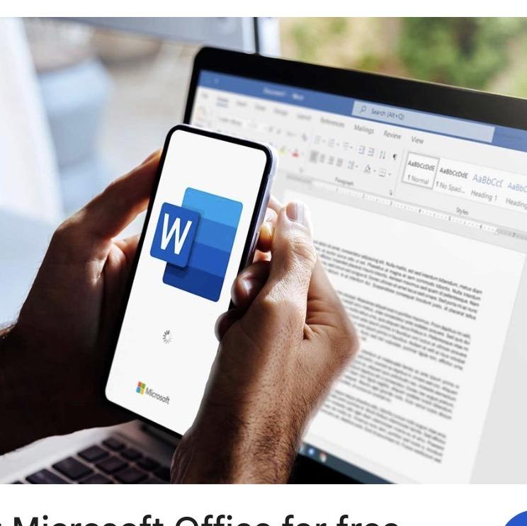
This app helps me with my university work. I use it to write assessments,
add pictures and organise my documents. I am learning to use this app
Because it’s very important for my studies.

Screenshot/Photo 5
[Moodle]

The module it’s the more important to use for my university the have all course I needed and check everything about my assessment, timetable, lessons etc. All about my course.

Screenshot/Photo 6
[Google Gmail]
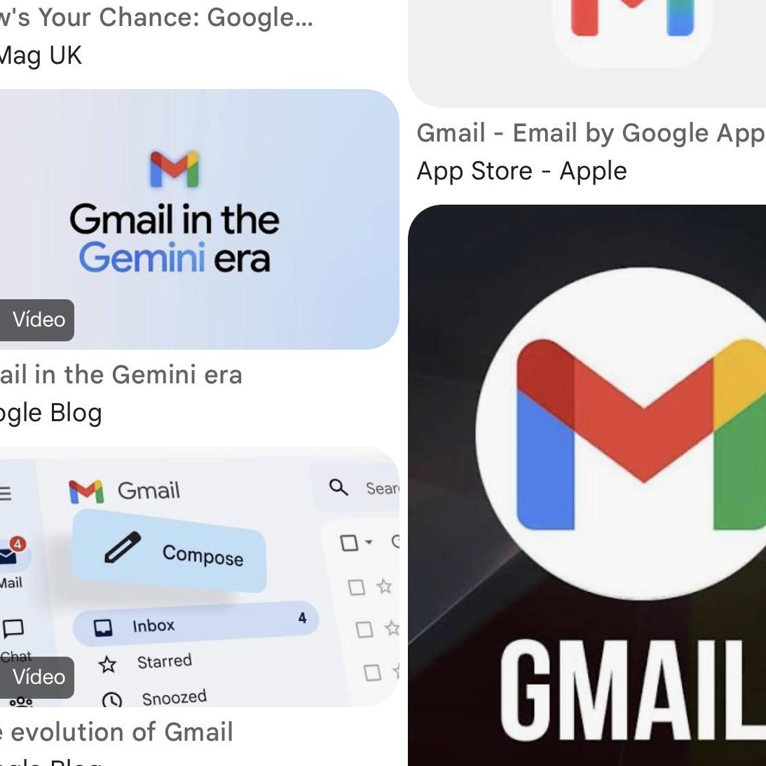
I use this app for save my email the have all information about my life.
Event, travels. Bills, etc. I use for sending email received email
It’s helping to organise my emails

My Short Reflection
- Write 5–8 simple sentences about your digital life.
- You can use the sentence starters below if helpful.
I use different digital tools in my daily life such as Microsoft Word,
WhatsApp, Google, Facebook and ’Moodle.
I feel confident when I use my phone or my laptop to communicate apps with the other people.
I would like to improve my skill in different apps.
The most important for my study example I need to improve in Microsoft word, excel… to use for making document, saved.
I need to learn to create, organise and saved to documents for my studies.
Digital skill is very important for me because it help me with my study and my working life.
I Know that technology-its is important, so I want to keep learning and improve my digital knowledge.

Sentence starters
- I use digital tools to …
- I feel confident when I …
- I want to improve …
- I often use these tools: …
- I sometimes feel nervous about …
- I hope this module will help me …
- Digital skills are important for me because …
You can write more if you want.

Submission Checklist
Before you submit, please check:
✅​​​☐ I added 4–6 screenshots
☐✅ I wrote short sentences for each screenshot
☐ ✅I wrote my short reflection
☐ ✅My work is my own
☐ ✅My file opens correctly
​​☐✅ My file opens correctly

