Worksheet 1: Building a Virtual LAN using type 2 Hypervisor Management Software

Network Operating Systems and Services (ACCA5023)
March 2021

Abstract
This report will firstly narrate the practical tasks set out in the Network Operating Systems and Services (NOSS) Worksheet 1. Namely, creating four virtual machines, two using Windows Server 2019 and two using Windows 10; then configuring the virtual machines with IP addresses, disabling the local firewalls, and testing connectivity. The second section of the report will discuss type 1 and 2 hypervisors, the benefits and drawbacks of each, and a discussion of some vendors. The significance of the subnet mask in IPv4 addressing will then be discussed, and the pros and cons of cloud computing. Finally, there is a discussion of various networking terminologies that were found in the course of completing Tasks 1 and 2.

Table of Contents
Abstract 1
Table of Contents 2
Table of Figures 3
1 Task 1: VM creation and Operating System installations 5
1.1 Creating the Client VMs 5
1.2 Creating the Server VMs 16
2 Task 2: Virtual Network Configurations 25
2.1 Configuring Server 1 25
2.2 Configuring Client 1 30
2.3 Configuring Server 2 32
2.4 Configuring Client 2 35
2.5 Disabling Firewalls 37
2.6 Testing Connectivity 39
3 Task 3: Observational Tasks 42
3.1 Describe the main differences between Type 1 and Type 2 Hypervisors 42
3.1.1 Benefits and Drawbacks 42
3.1.2 Vendors 43
3.2 What is the significance of the subnet mask in IPv4 addressing? 43
3.3 Describe the use of cloud computing including its benefits and drawbacks and identify example vendors within the industry 44
3.3.1 Benefits 44
3.3.2 Drawbacks 45
3.3.3 Vendors 45
3.4 Describe different terminologies and its purposes. Compare their operations/functionality with other Network Operating Systems 45
3.4.1 Ping 45
3.4.2 Server Management 46
3.4.3 Firewalls 46
3.4.4 PAE/NX 46
4 References 47

Table of Figures
Figure 1 - Client 1 VM settings 5
Figure 2 - Client 1 VM settings 5
Figure 3 - Client 1 VM settings 6
Figure 4 - Client 1 VM settings 6
Figure 5 - Client 1 VM setup 7
Figure 6 - Client 1 VM setup 7
Figure 7 - Client 1 VM crash 8
Figure 8 - Client 1 VM installation retry 8
Figure 9 - Client 1 VM installation retry 9
Figure 10 - Client 1 VM partitions 9
Figure 11 - Client 1 VM installation retry 10
Figure 12 - Client 1 VM product key 10
Figure 13 - Client 1 VM OS options 11
Figure 14 - Client 1 VM installation crash 11
Figure 15 - Client 1 VM installation retry 12
Figure 16 - Client 1 VM password 12
Figure 17 - Client 1 VM installation retry 13
Figure 18 - Client 1 VM installation retry 13
Figure 19 - Client 1 VM installation complete 14
Figure 20 - Client 1 VM windows updates 14
Figure 21 - Client 1 VM guest additions 15
Figure 22 - Client 1 guest additions restart 15
Figure 23 - Server 1 VM settings 16
Figure 24 - Server 1 VM settings 16
Figure 25 - Server 1 VM crash 17
Figure 26 - Server 1 VM crash error 17
Figure 27 - Server 1 VM ISO file 18
Figure 28 - Server 1 VM crash error 18
Figure 29 - Server 1 VM new VDI 19
Figure 30 - Server 1 VM crash error 19
Figure 31 - Server 1 VM setup 20
Figure 32 - Server 1 VM OS selection 21
Figure 33 - Server 1 VM setup T&Cs 21
Figure 34 - Server 1 VM setup 22
Figure 35 - Server 1 VM setup blank partition 22
Figure 36 - Server 1 VM setup 23
Figure 37 - Server 1 user password 23
Figure 38 - Server 1 VM setup complete 24
Figure 39 - Server 2 VM setttings 24
Figure 40 - Server 1 PublicNet setup 25
Figure 41 - Server 1 PublicNet setup 25
Figure 42 - Server 1 PublicNet setup 26
Figure 43 - Server 1 PublicNet setup 26
Figure 44 - Server 1 PublicNet setup 27
Figure 45 - Server 1 PublicNet setup 27
Figure 46 - Server 1 PublicNet setup 28
Figure 47 - Server 1 PrivateNet1 setup 28
Figure 48 - Server 1 PrivateNet1 setup 29
Figure 49 - Server 1 PrivateNet1 setup 29
Figure 50 - Client 1 PrivateNet1 setup 30
Figure 51 - Client 1 PrivateNet1 setup 30
Figure 52 - Client 1 PrivateNet1 setup 31
Figure 53 - Server 2 PublicNet setup 32
Figure 54 - Server 2 PrivateNet1 setup 32
Figure 55 - Server 2 PublicNet setup 33
Figure 56 - Server 2 PublicNet setup 33
Figure 57 - Server 2 PrivateNet1 setup 34
Figure 58 - Client 2 PrivateNet2 setup 35
Figure 59 - Client 2 PrivateNet2 setup 35
Figure 60 - Client 2 PrivateNet2 setup 36
Figure 61 - Server 1 Firewall config 37
Figure 62 - Server 2 firewall config 37
Figure 63 – Client 1 firewall config 38
Figure 64 - Client2 firewall config 38
Figure 65 - Server 1 to client 1 ping 39
Figure 66 - Server 2 to client 2 ping 39
Figure 67 - Server 2 to server 1 ping 40
Figure 68 - Server 1 to client 2 ping 40
Figure 69 - Server 2 to client 1 ping 41
Figure 70 - Type 1 & 2 Hypervisors 42

Task 1: VM creation and Operating System installations
VirtualBox was installed onto the host machine which had VT-x virtualisation enabled via the BIOS.

Creating the Client VMs
The first Virtual Machine (VM) to set up was the Windows 10 client. The VM was given 8GB of RAM and 2 dedicated host CPU cores initially as VMs generally require more resources during the OS installation and setup phases. This can then be reduced back down to 2-4GB for normal usage.
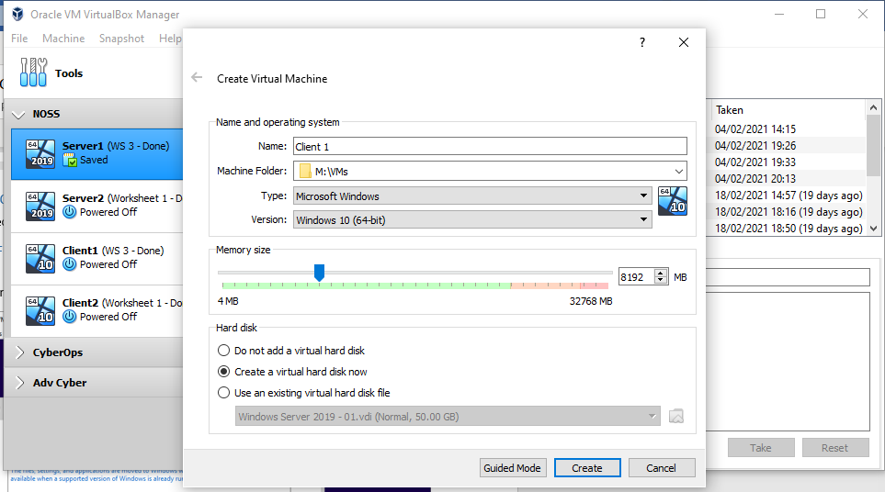
Figure 1 - Client 1 VM settings
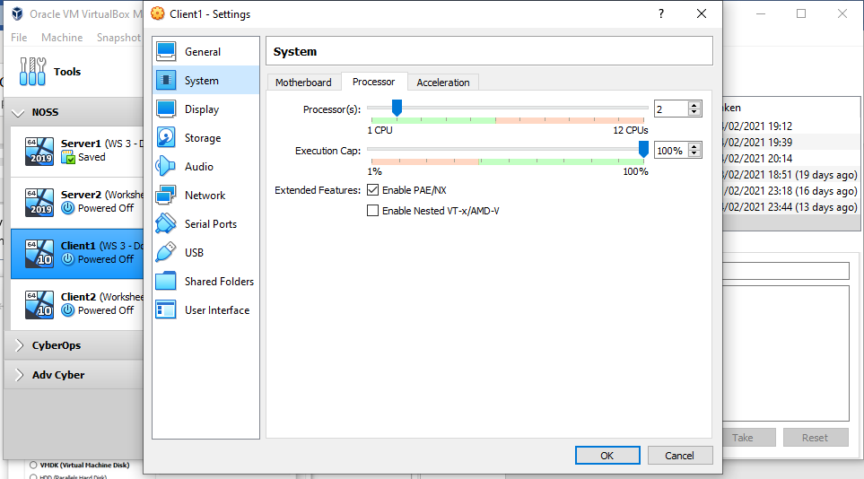
Figure 2 - Client 1 VM settings
A Virtual Disk Image (VDI) was created with a maximum size of 50GB which is dynamically allocated to reduce initial host machine storage impact.
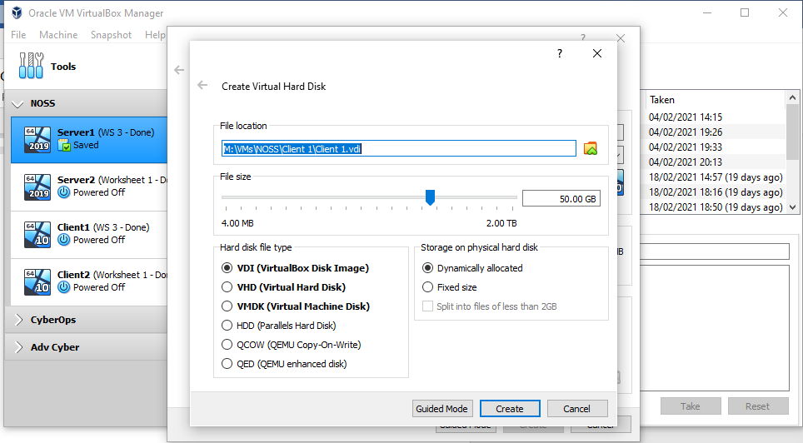
Figure 3 - Client 1 VM settings

A windows 10 installation image was connected to the VM as a virtual
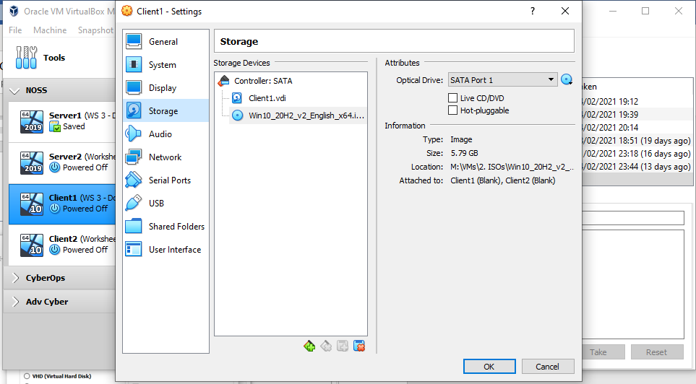
Figure 4 - Client 1 VM settings

The first attempts at installing Windows 10 on the VM failed during the “getting files ready for installation” phase as the VM crashed.
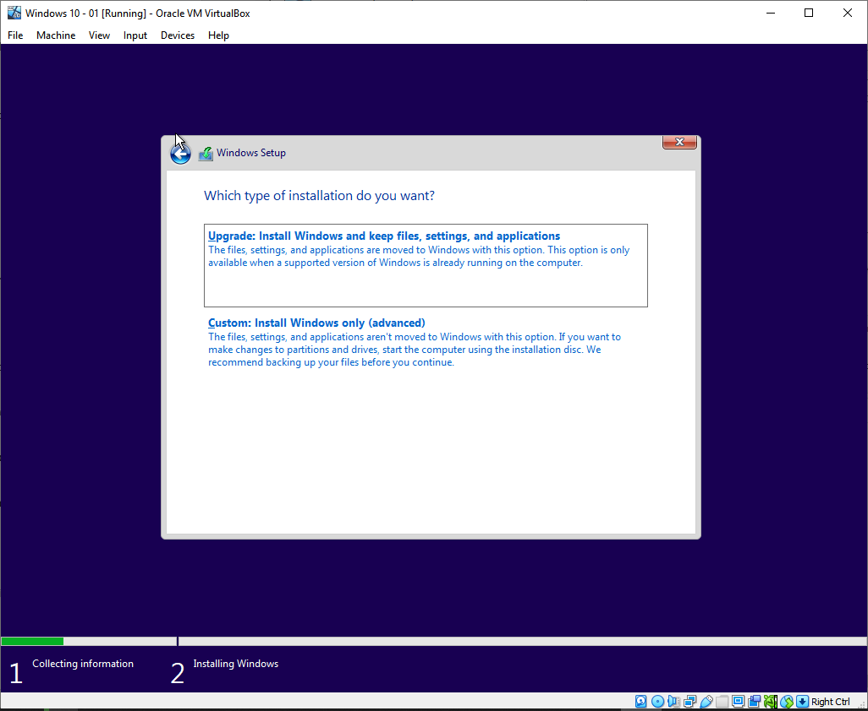
Figure 5 - Client 1 VM setup
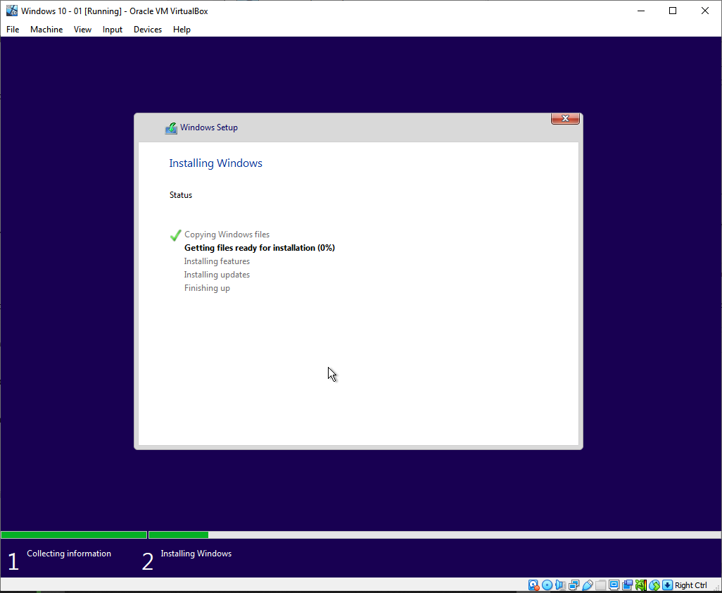
Figure 6 - Client 1 VM setup

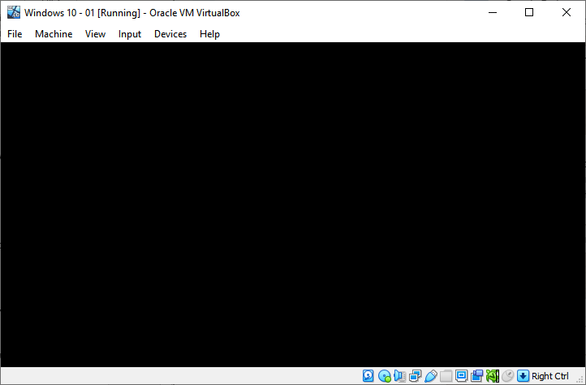
Figure 7 - Client 1 VM crash

The OS installation was attempted again and reached the next phase, however due to the previous attempt there were disk partitions that need to be removed to do a fresh installation.
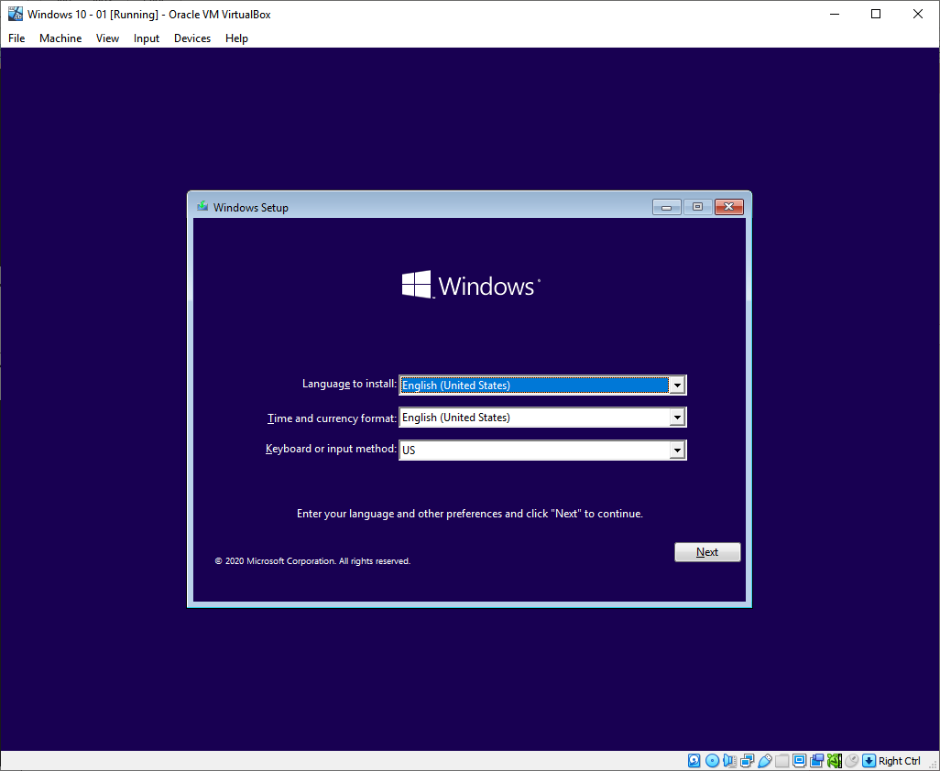
Figure 8 - Client 1 VM installation retry

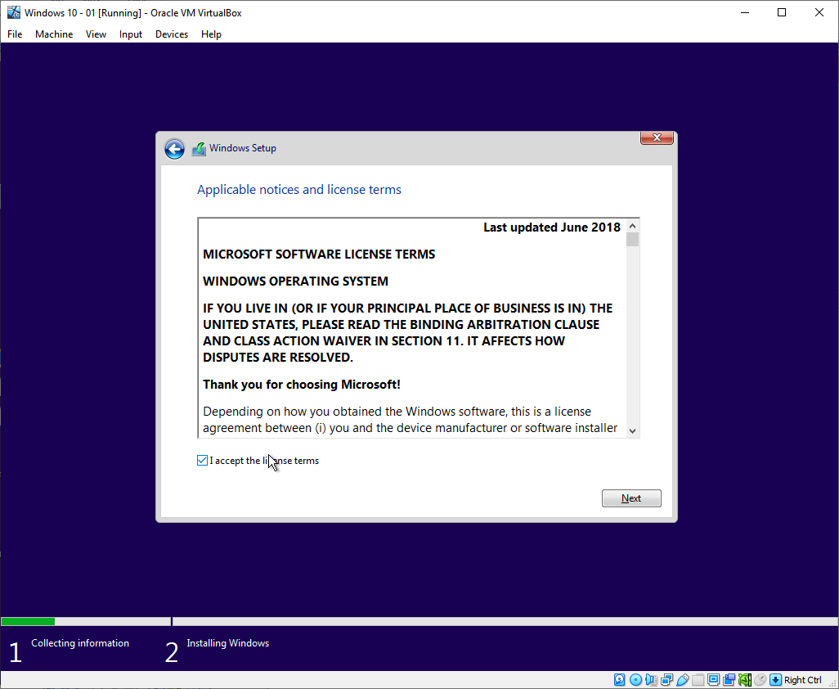
Figure 9 - Client 1 VM installation retry
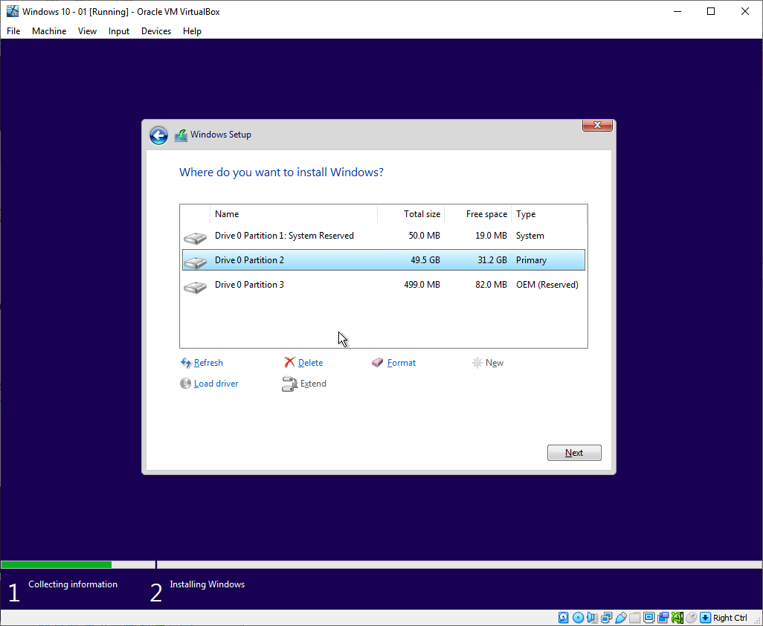
Figure 10 - Client 1 VM partitions

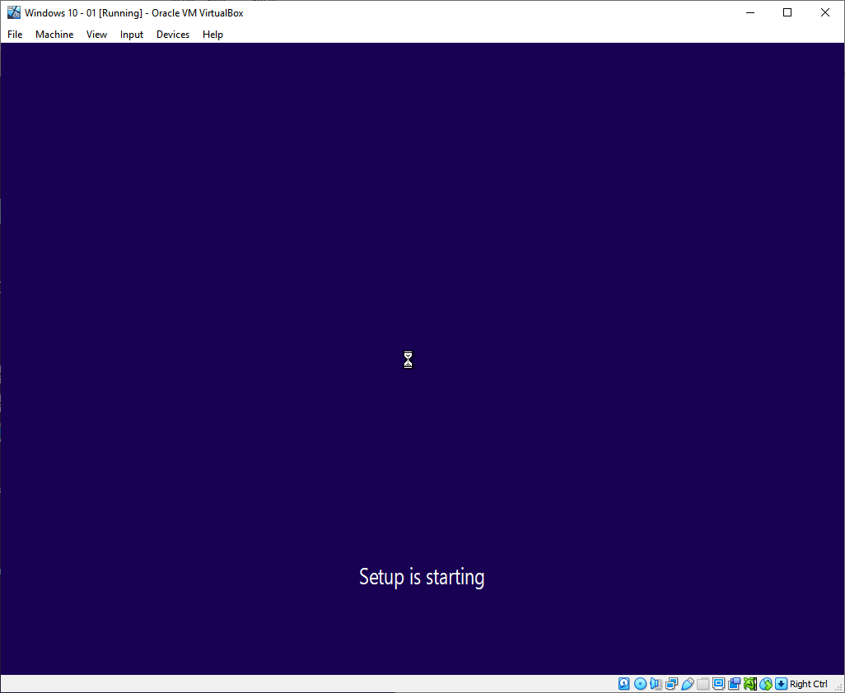
Figure 11 - Client 1 VM installation retry
As this VM will not be used in a production environment or for extended periods of time it wasn’t necessary to input a product key.
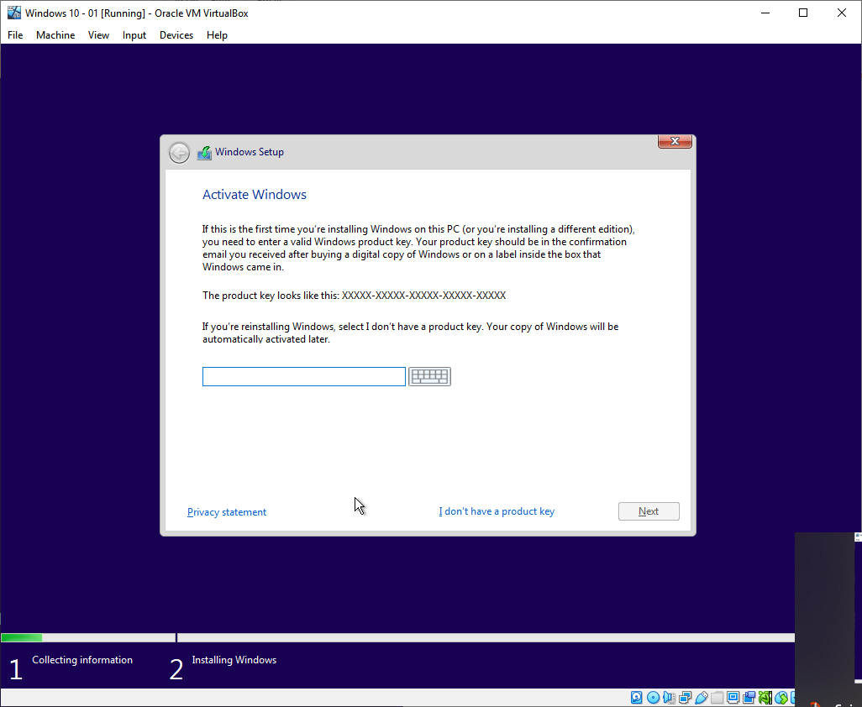
Figure 12 - Client 1 VM product key

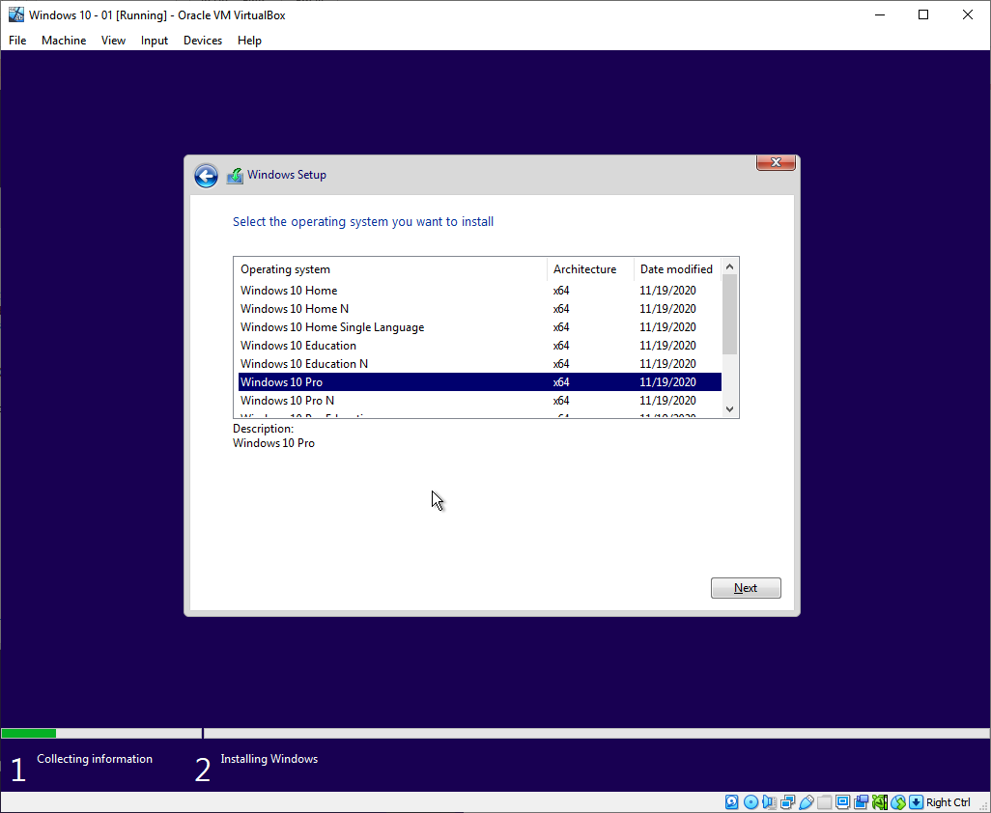
Figure 13 - Client 1 VM OS options
Unfortunately, this installation also failed. However, after giving the VM even more host resources and restarting the machine the installation was completed.
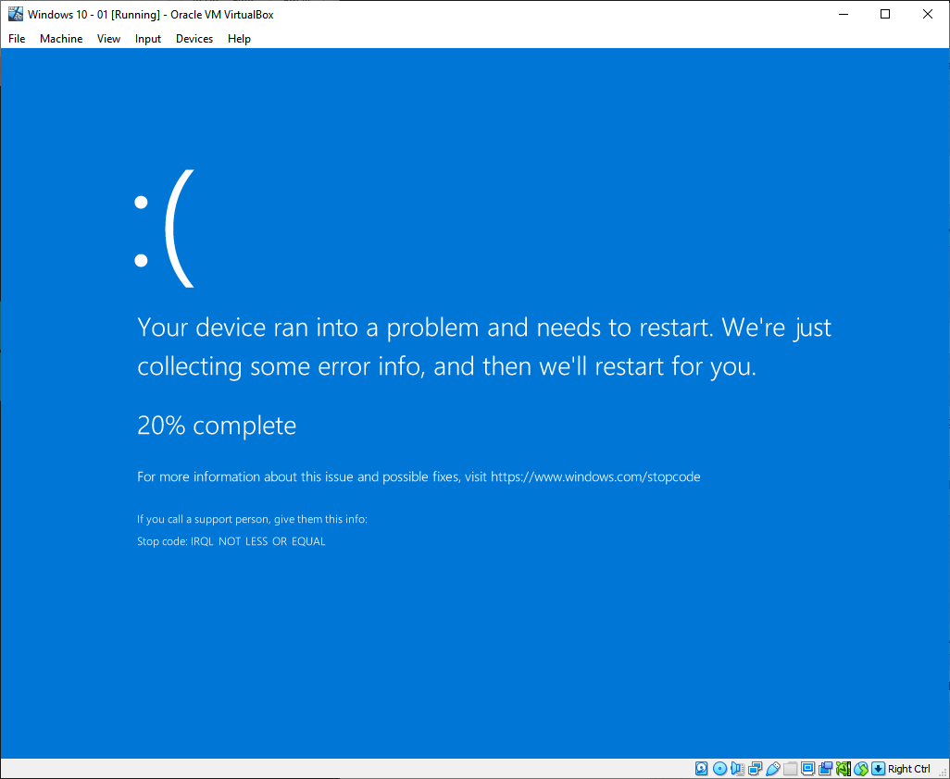
Figure 14 - Client 1 VM installation crash

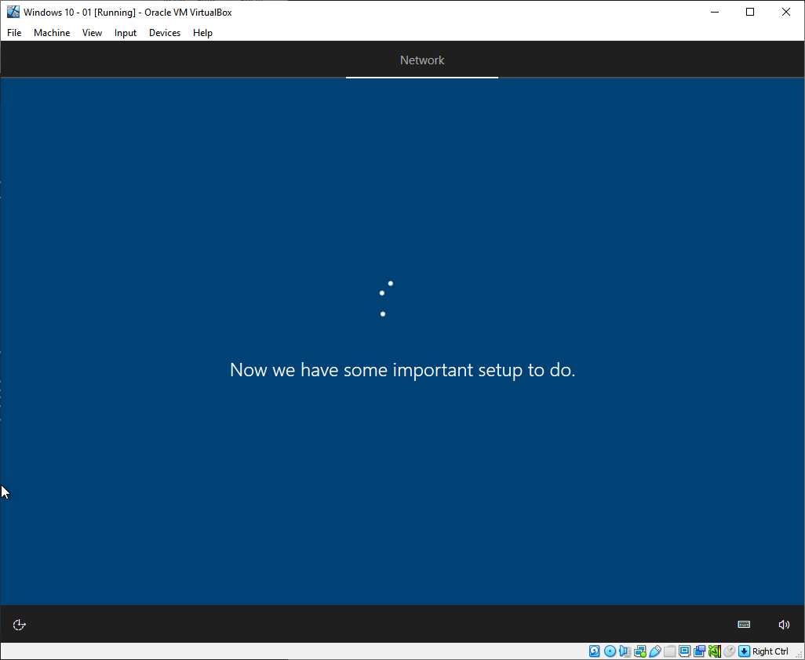
Figure 15 - Client 1 VM installation retry
The password “P@ssw0rd” was used as per the instructions.
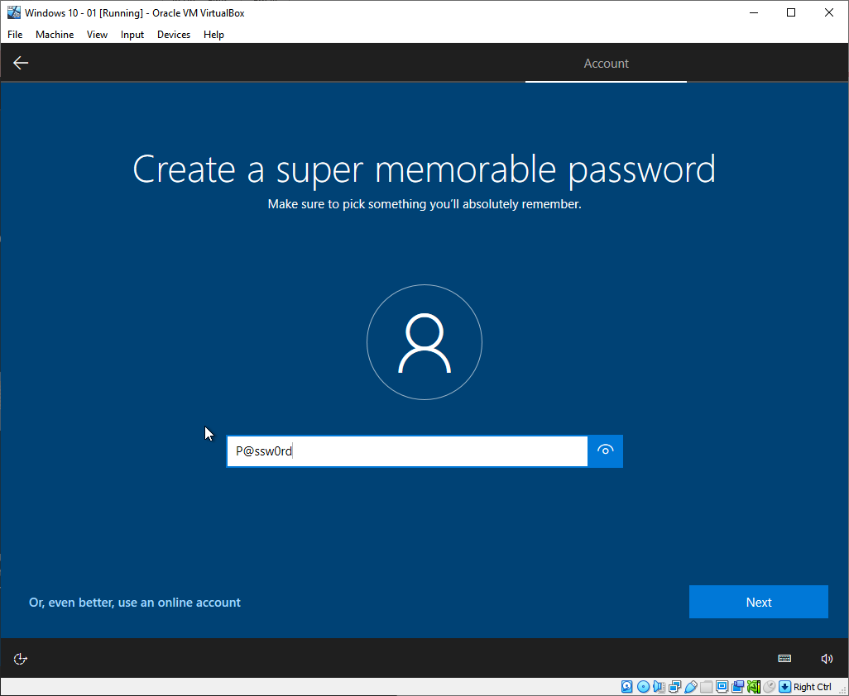
Figure 16 - Client 1 VM password

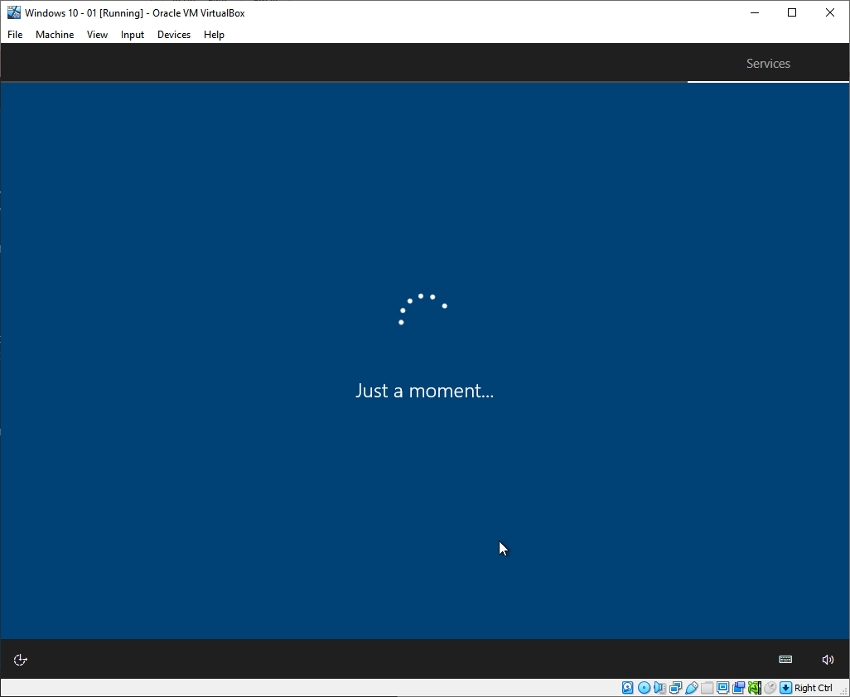
Figure 17 - Client 1 VM installation retry
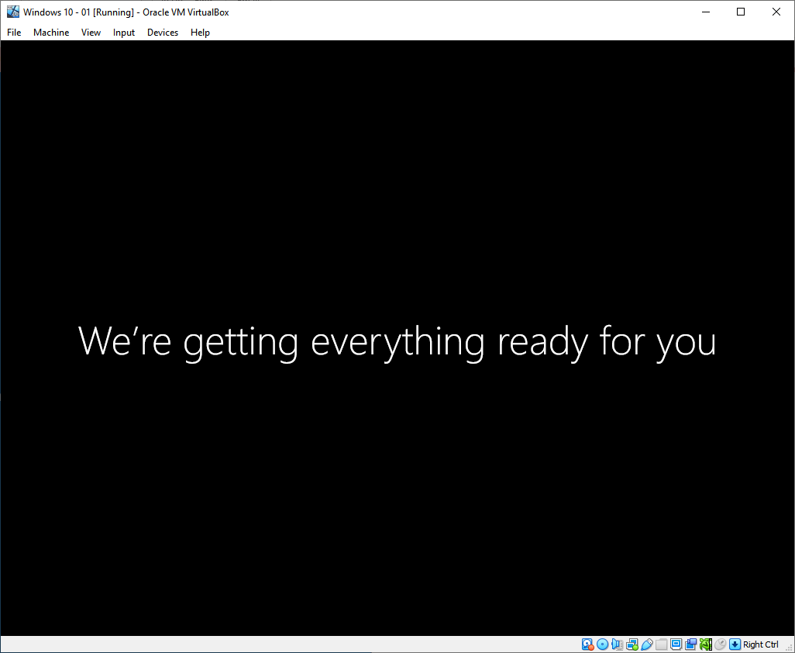
Figure 18 - Client 1 VM installation retry

Once the OS installation was complete, the necessary windows updates were installed and the VirtualBox Guest Additions utility was installed for better VM performance and usability.
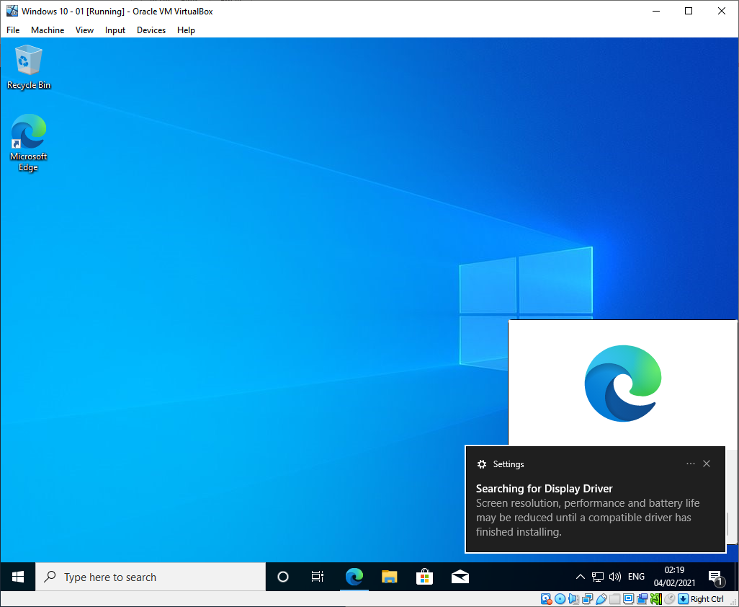
Figure 19 - Client 1 VM installation complete
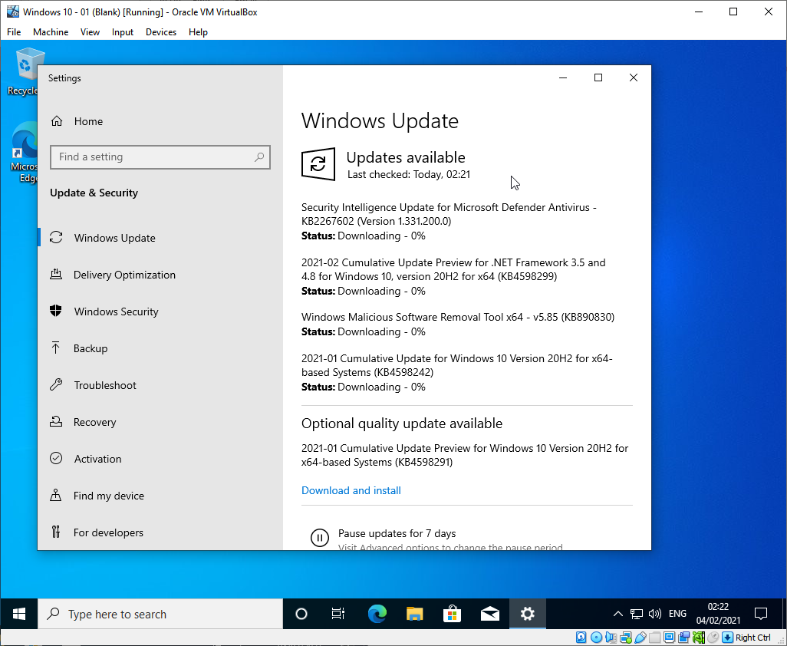
Figure 20 - Client 1 VM windows updates
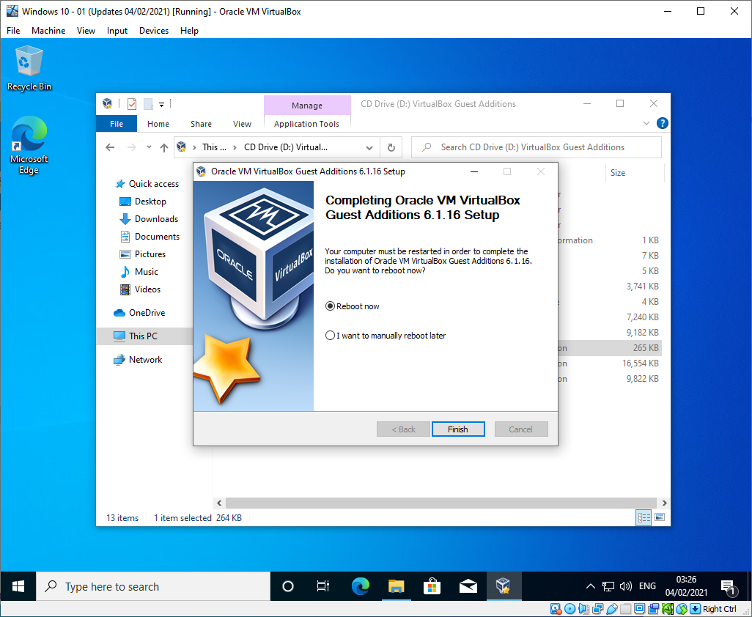
Figure 21 - Client 1 VM guest additions
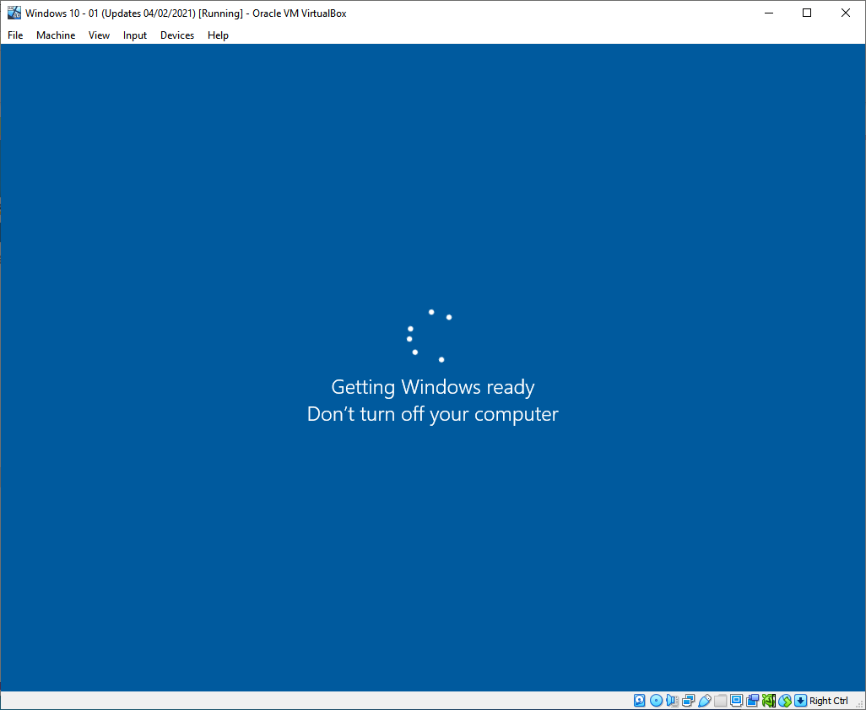
Figure 22 - Client 1 guest additions restart
All of these steps were completed again for the “Client 2” VM.

Creating the Server VMs
The “Server 1” VM was created similarly to the client ones, with a new VDI being created and sufficient host resources allocated to it. A Windows Server 2019 installation image was mounted to the VM as a boot drive.
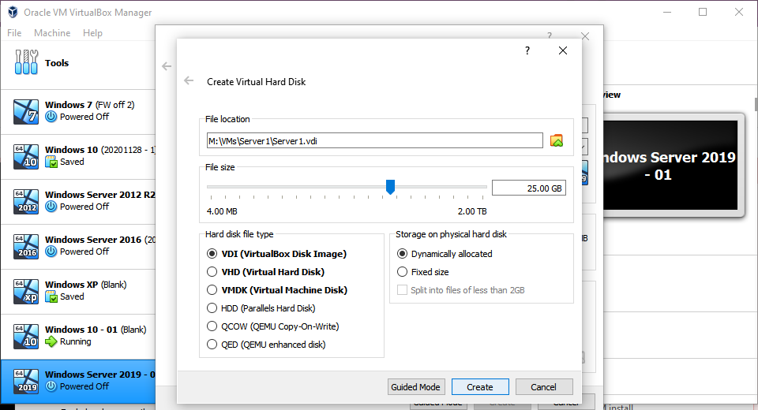
Figure 23 - Server 1 VM settings
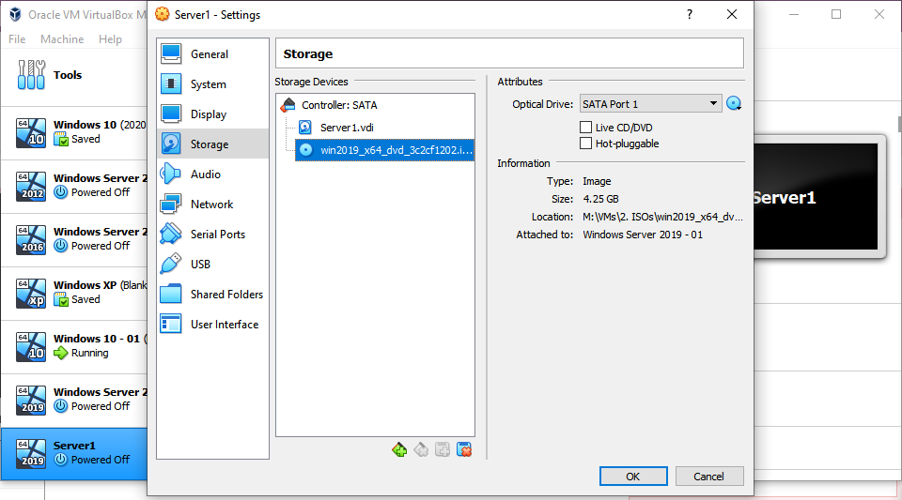
Figure 24 - Server 1 VM settings

However, as soon as the VM was launched, it would consistently crash with a critical error.
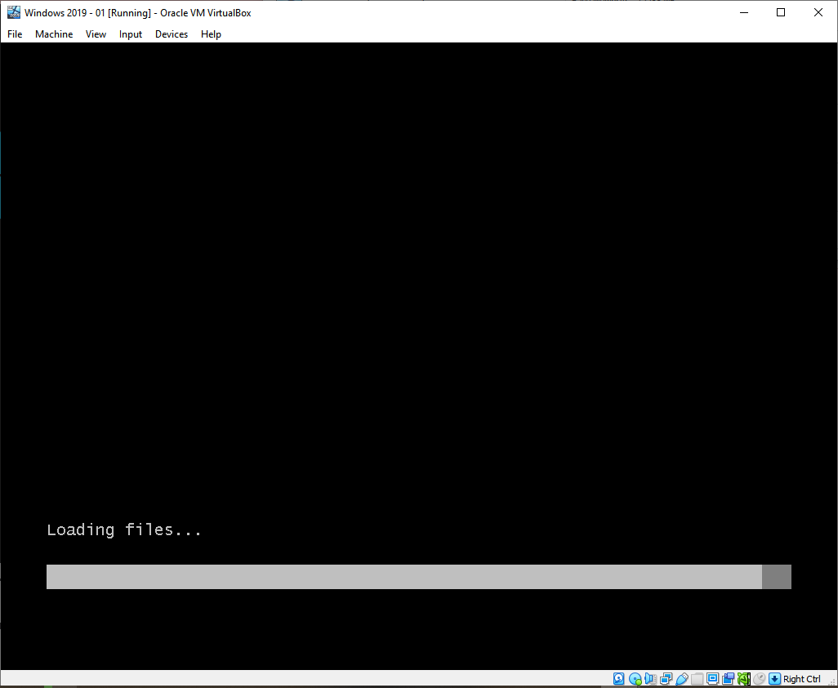
Figure 25 - Server 1 VM crash
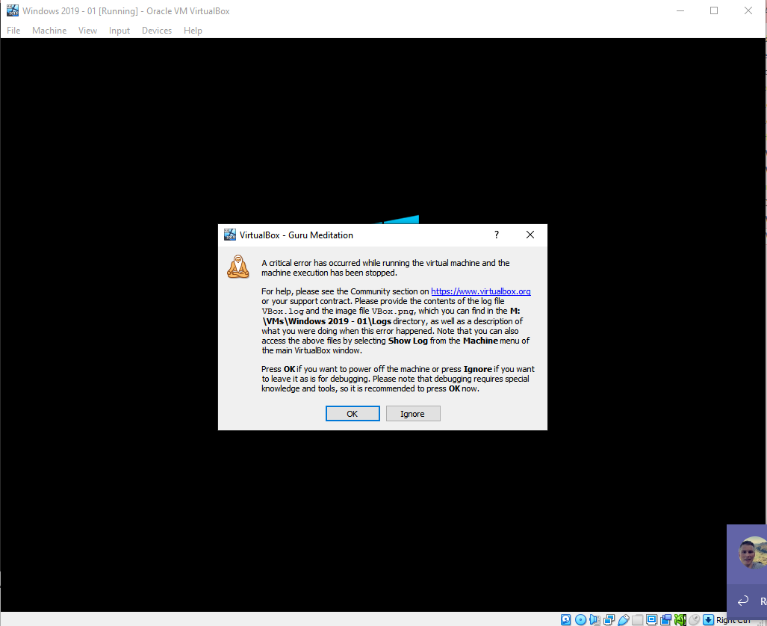
Figure 26 - Server 1 VM crash error

A different Windows Server 2019 ISO file was tried to see if a corrupted installation image was the issue.
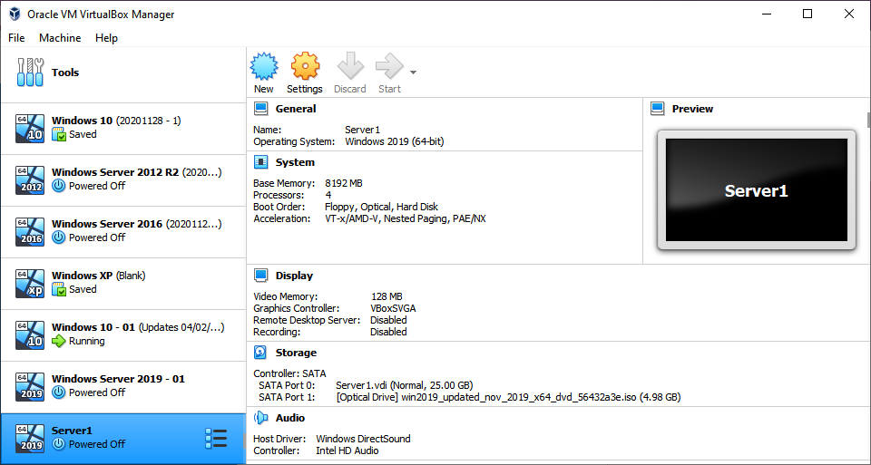
Figure 27 - Server 1 VM ISO file
This unfortunately didn't resolve the issue.
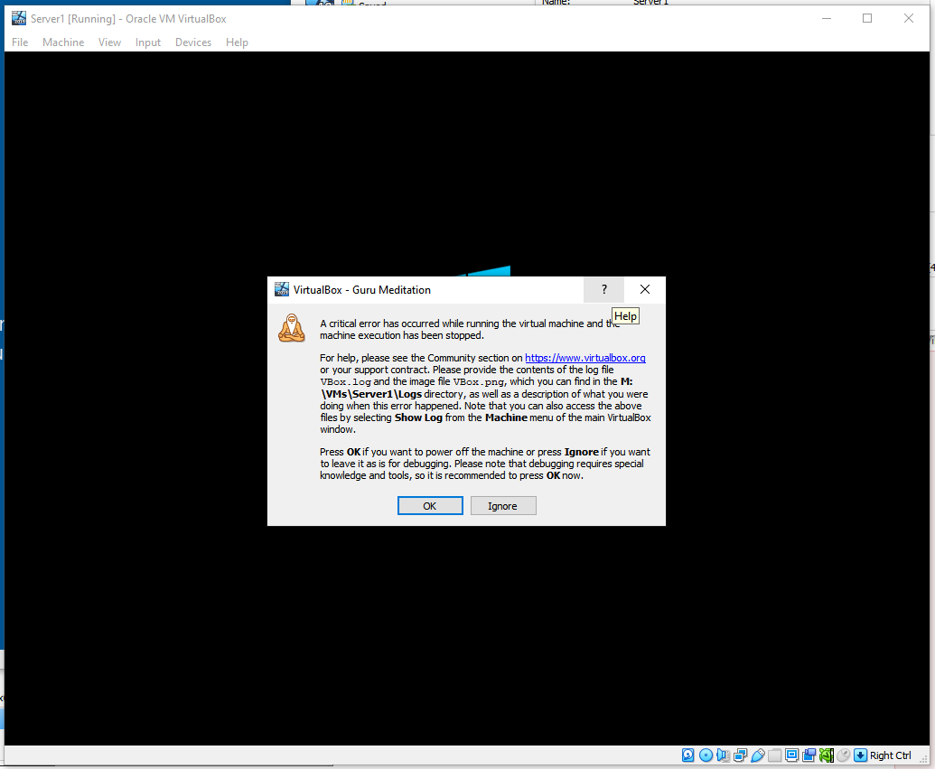
Figure 28 - Server 1 VM crash error
Next, a new VDI file was created to ensure the installation drive was clean as it was thought the repeated failed installations may have affected the VDI.
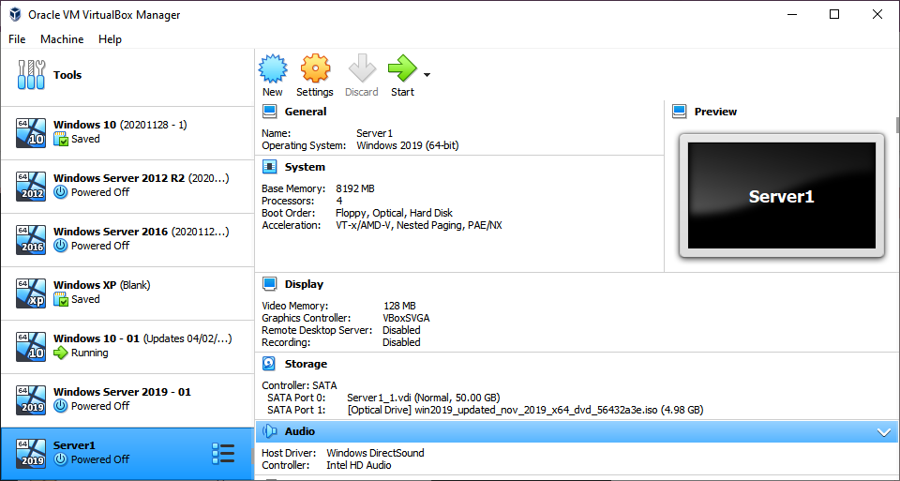
Figure 29 - Server 1 VM new VDI
This also didn't fix the issue:
Figure 30 - Server 1 VM crash error

After further investigation it was found that the issues were caused by an adverse interaction between Hyper-V and VirtualBox on the host machine[1]. This was causing the guest machine to run incredibly slowly and resulting in fatal crashes.
The solution to this error was to disable Hyper-V on the host machine via the command prompt using the following command:
bcdedit /set hypervisorlaunchtype off
After changing this setting and restarting the host machine, running the Windows Server 2019 VM resulted in the setup working:
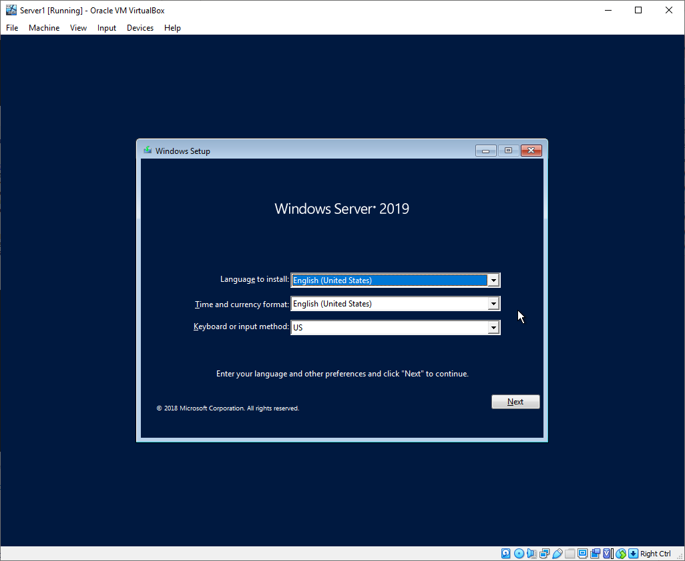
Figure 31 - Server 1 VM setup

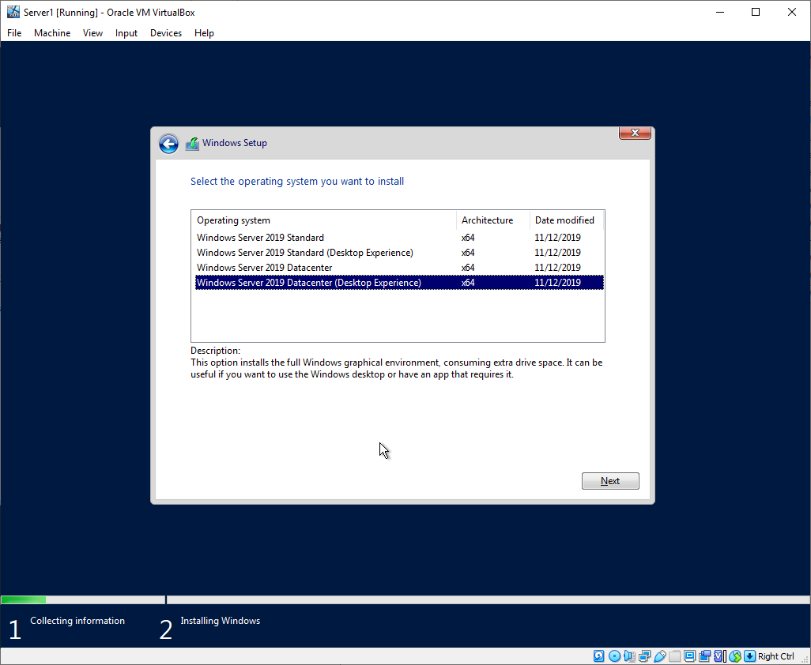
Figure 32 - Server 1 VM OS selection
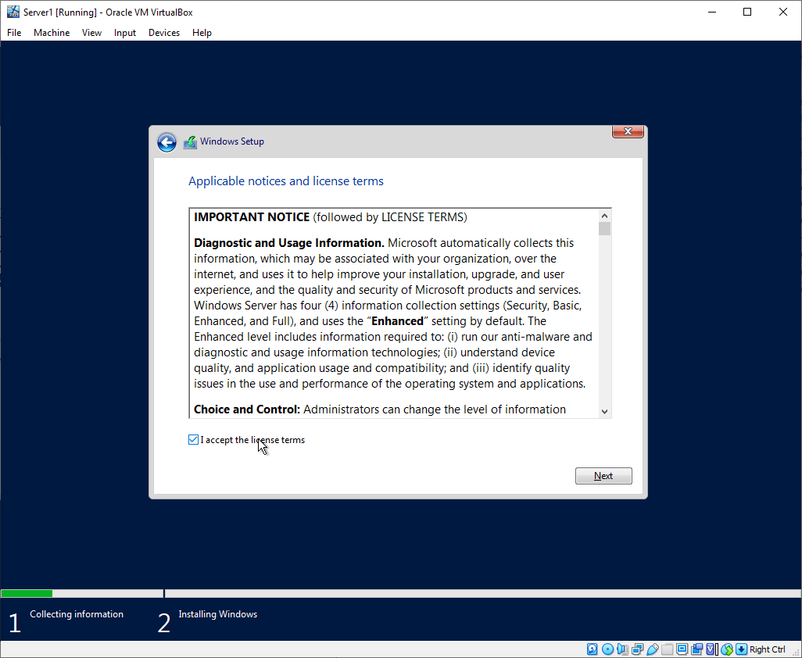
Figure 33 - Server 1 VM setup T&Cs

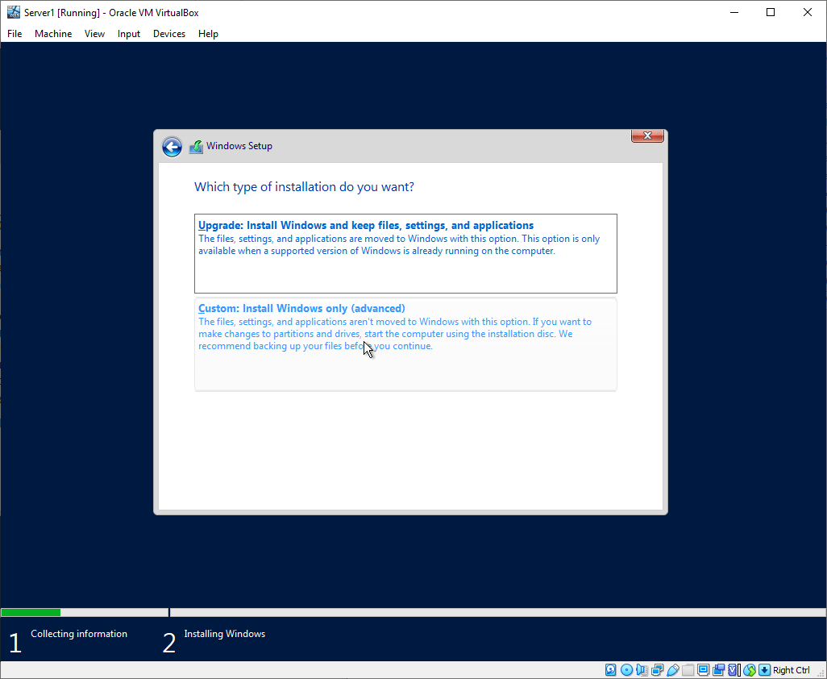
Figure 34 - Server 1 VM setup
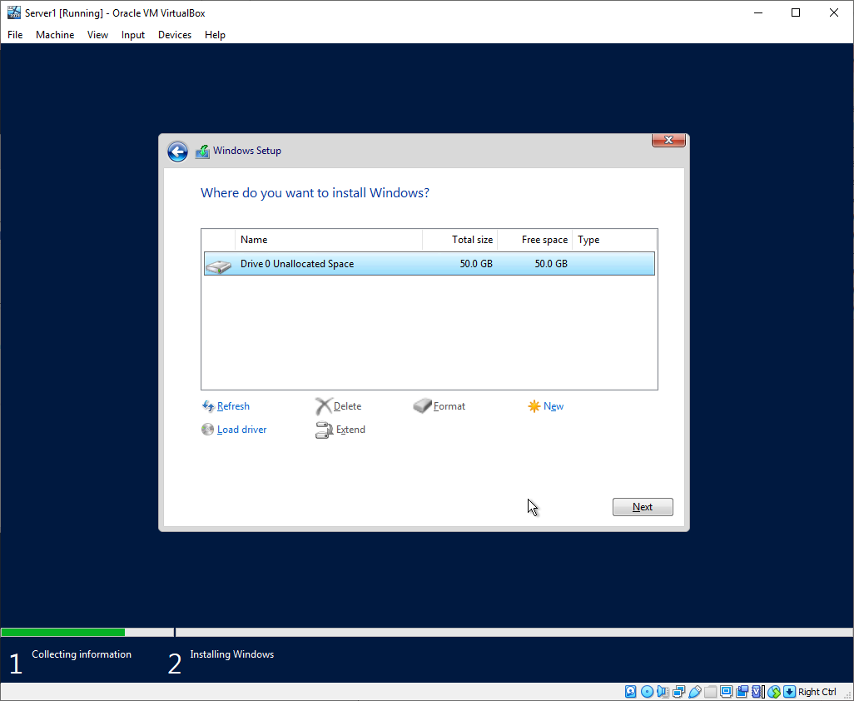
Figure 35 - Server 1 VM setup blank partition

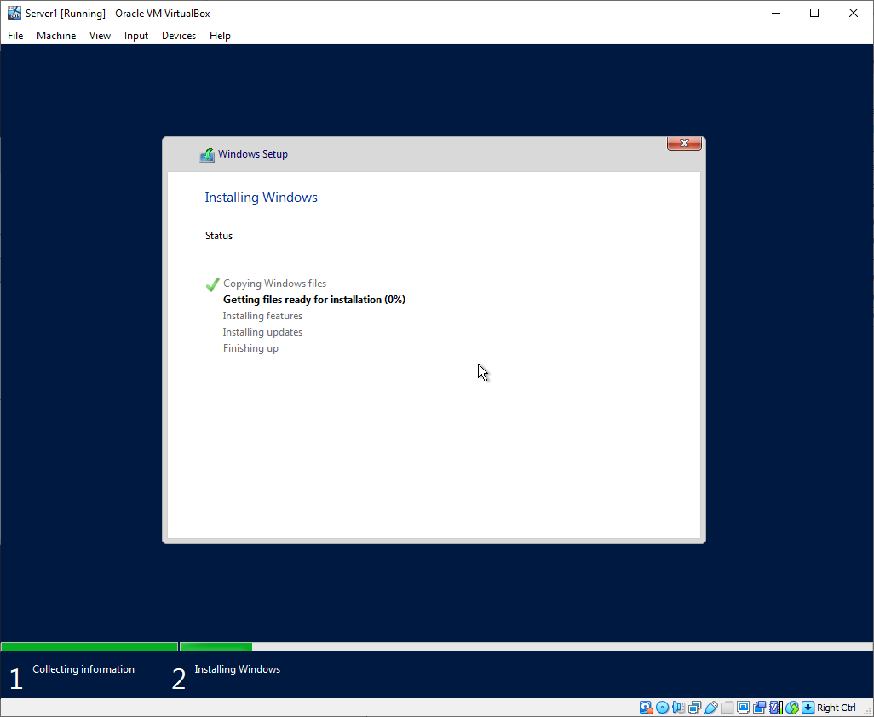
Figure 36 - Server 1 VM setup
The administrator password chosen was “P@ssw0rd” as per the instructions.
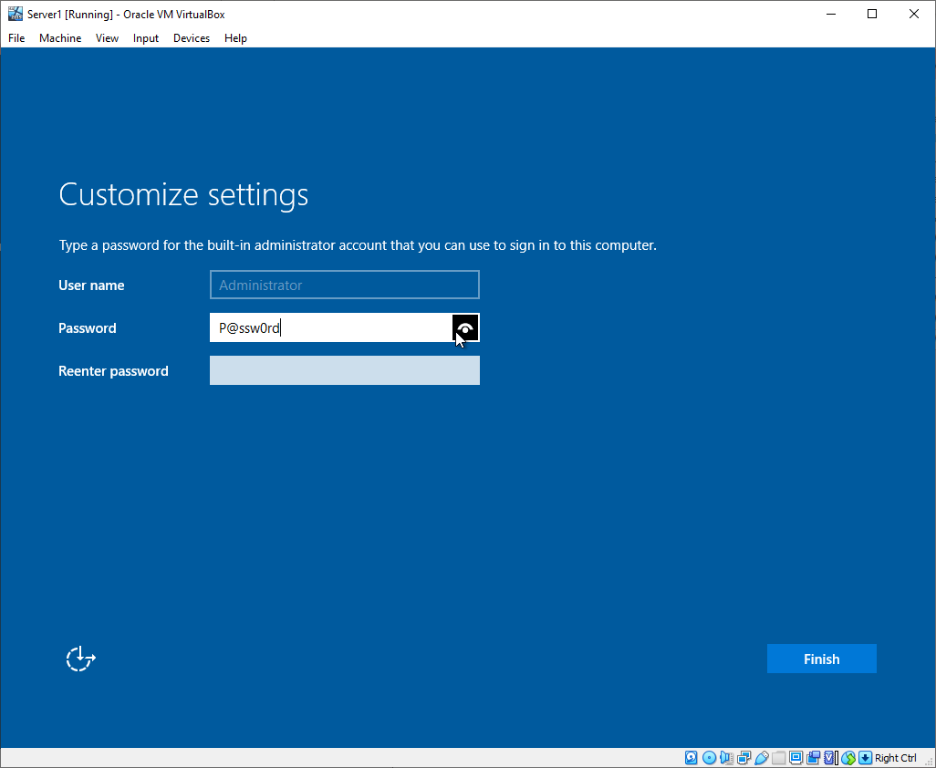
Figure 37 - Server 1 user password

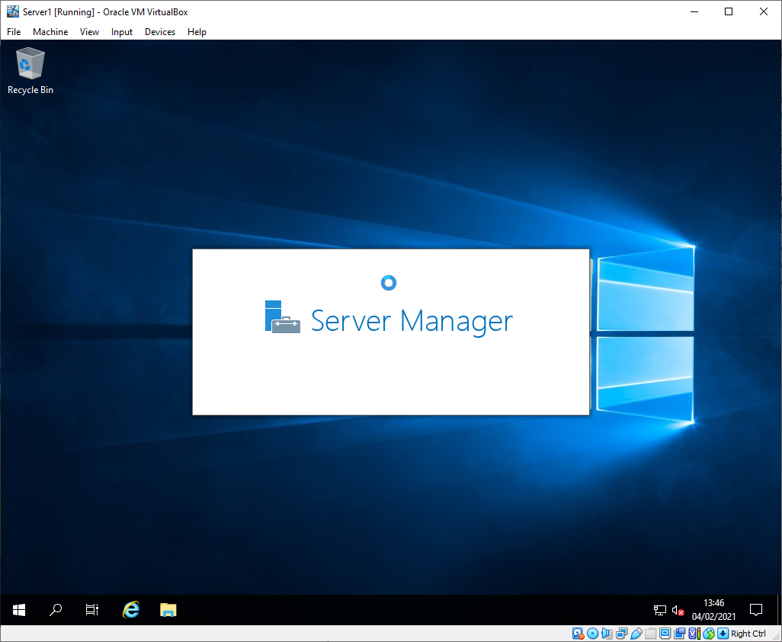
Figure 38 - Server 1 VM setup complete
The second server VM installation was completed without errors, proving the Hyper-V interaction was indeed the root cause of the issue.
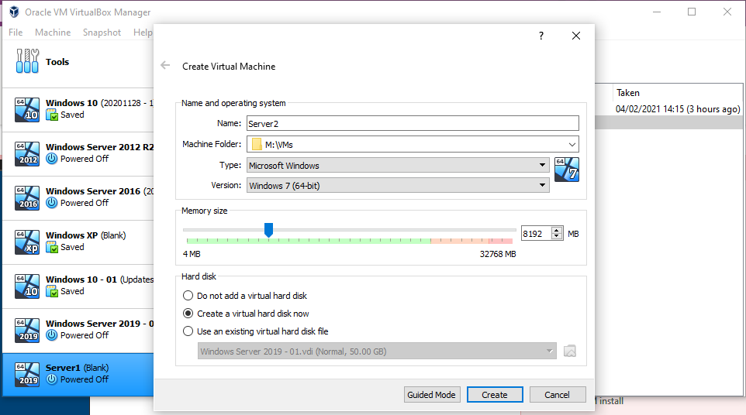
Figure 39 - Server 2 VM setttings

Task 2: Virtual Network Configurations

Configuring Server 1
The PublicNet LAN was set up on Server 1 via the VirtualBox network settings.
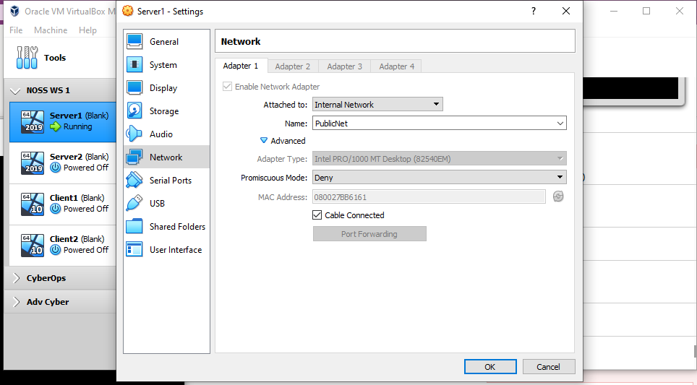
Figure 40 - Server 1 PublicNet setup
The VM was then launched, and the network interface was re-named to match the network diagram.
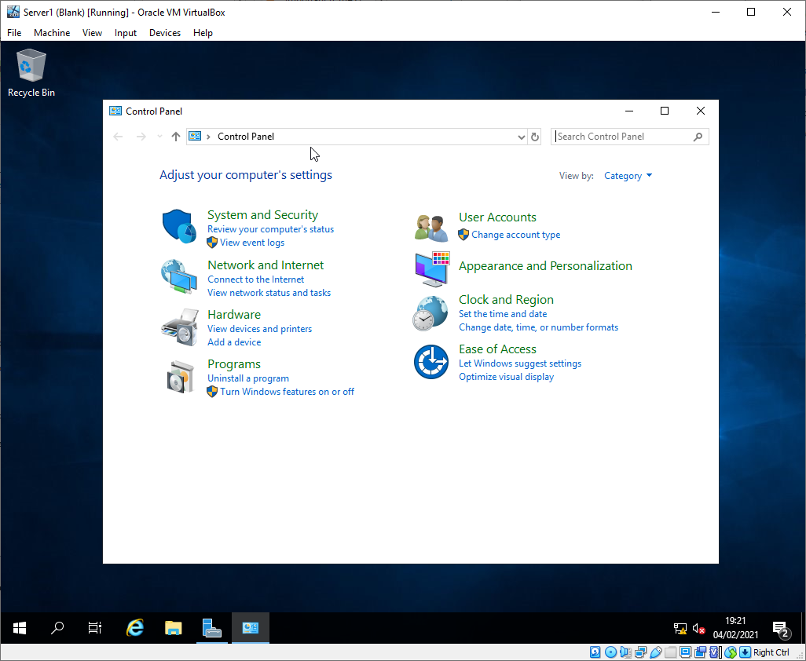
Figure 41 - Server 1 PublicNet setup
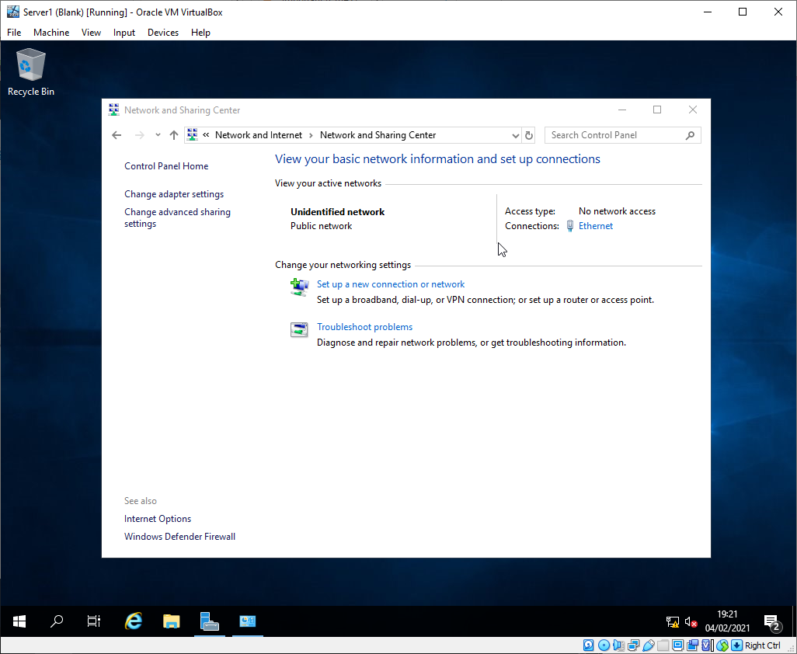
Figure 42 - Server 1 PublicNet setup
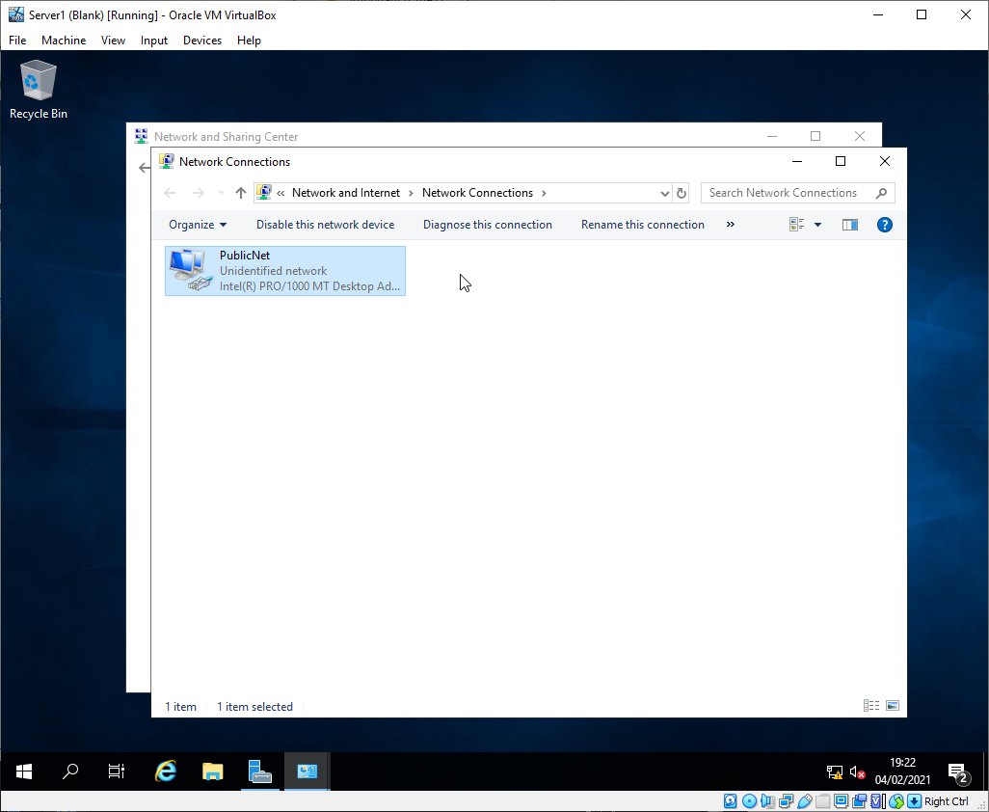
Figure 43 - Server 1 PublicNet setup

The interface was then configured with a static IP and subnet mask to match the network diagram.
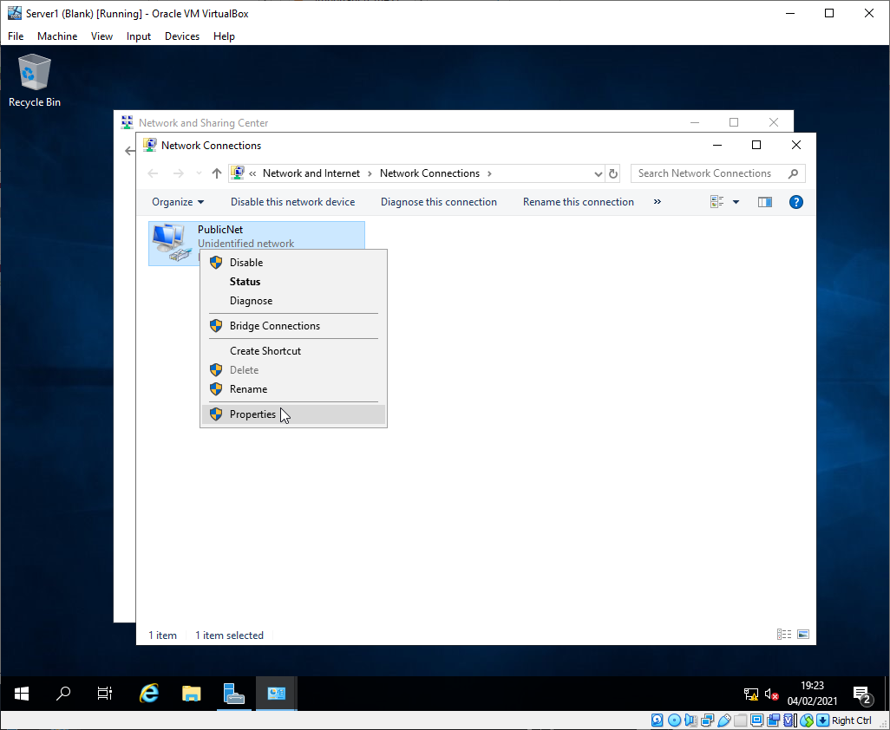
Figure 44 - Server 1 PublicNet setup
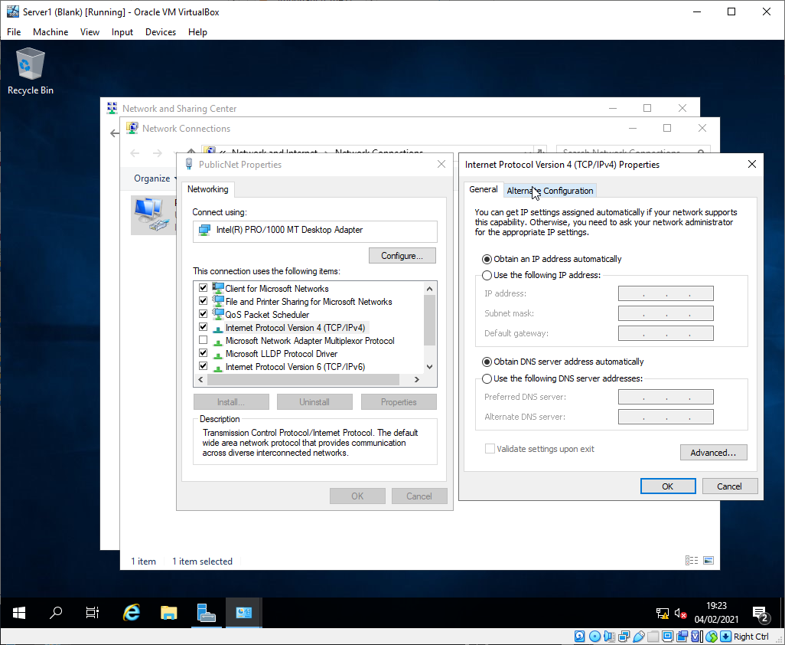
Figure 45 - Server 1 PublicNet setup

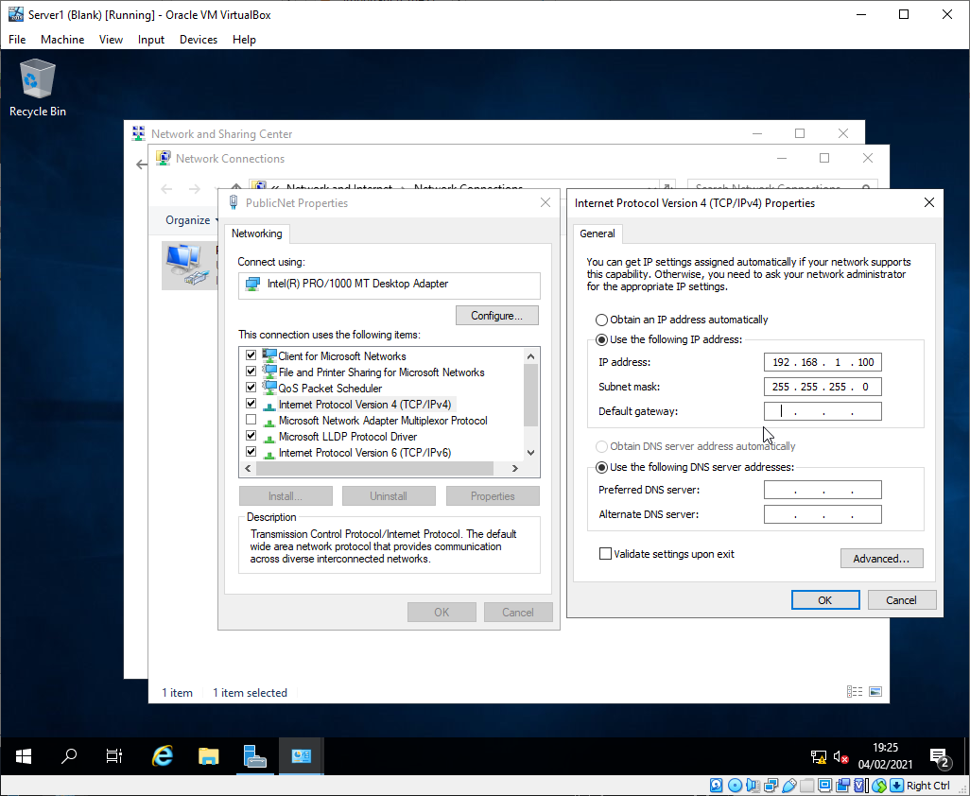
Figure 46 - Server 1 PublicNet setup
This process was repeated for PrivateNet1 on Server 1.
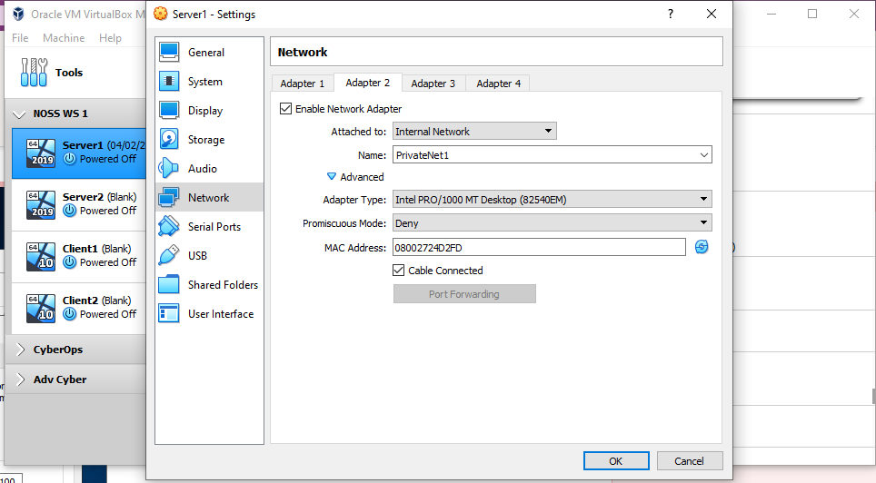
Figure 47 - Server 1 PrivateNet1 setup

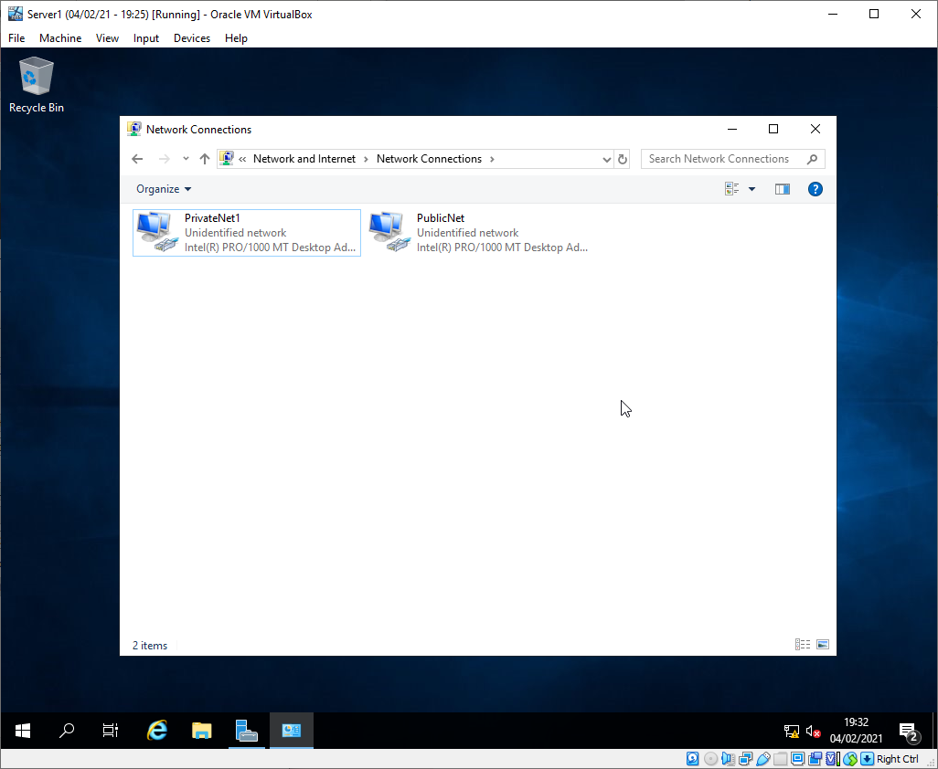
Figure 48 - Server 1 PrivateNet1 setup
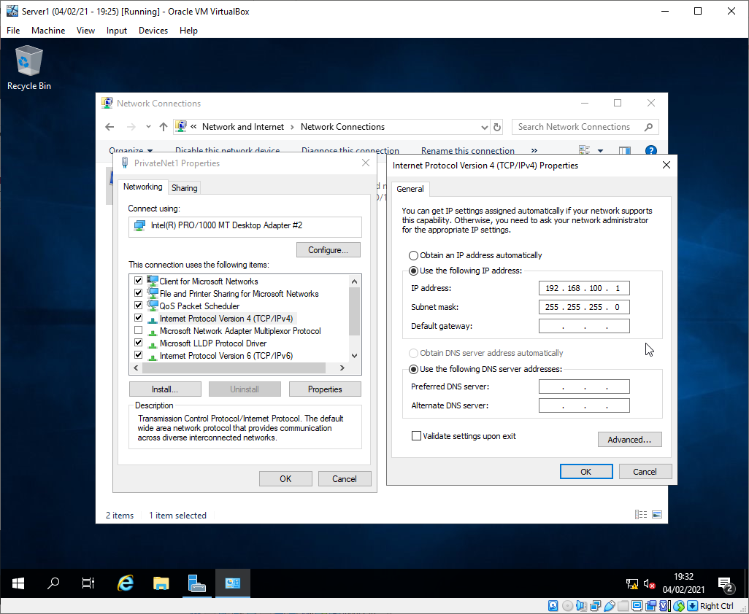
Figure 49 - Server 1 PrivateNet1 setup

Configuring Client 1
The PrivateNet1 network was configured on Client 1.
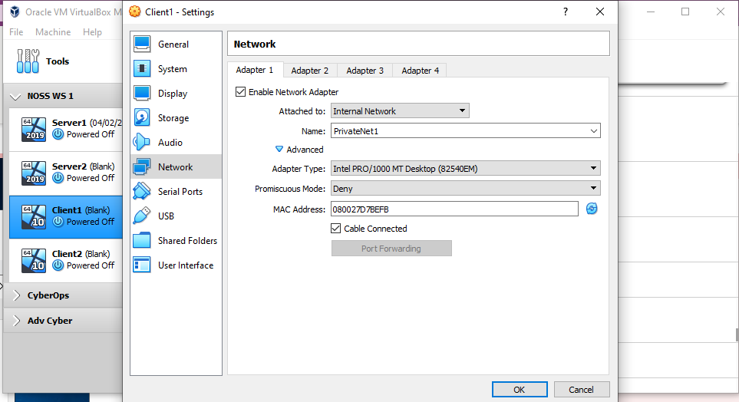
Figure 50 - Client 1 PrivateNet1 setup

The VM network interface was configured with a static IP as per the network diagram.
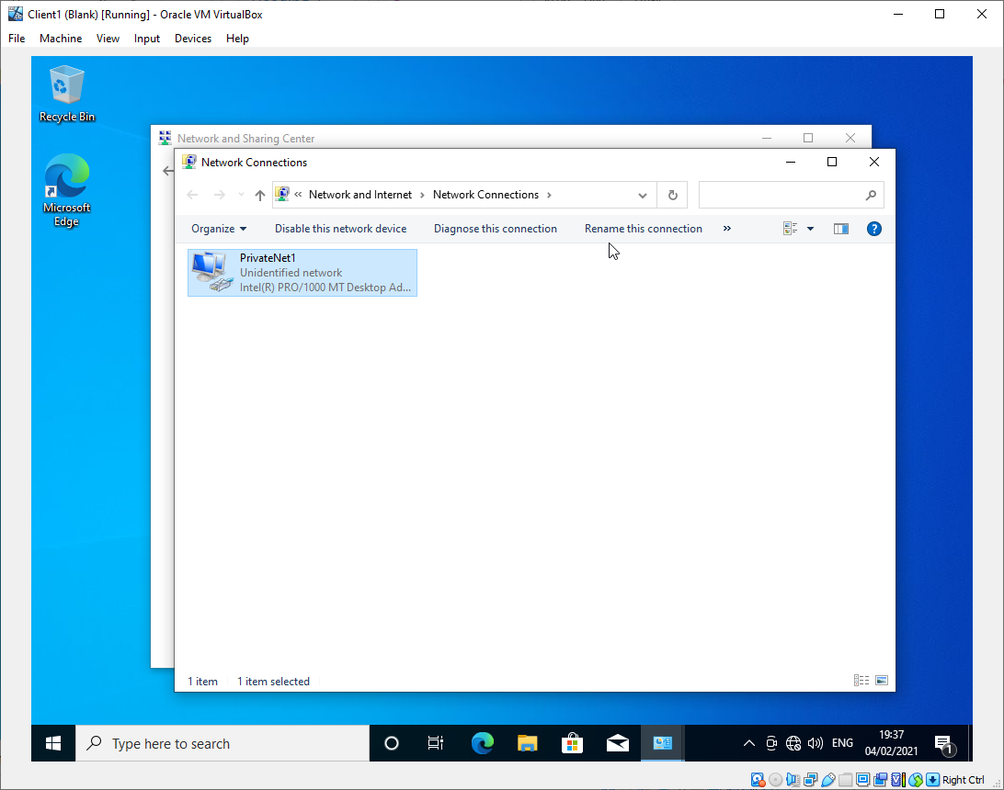
Figure 51 - Client 1 PrivateNet1 setup
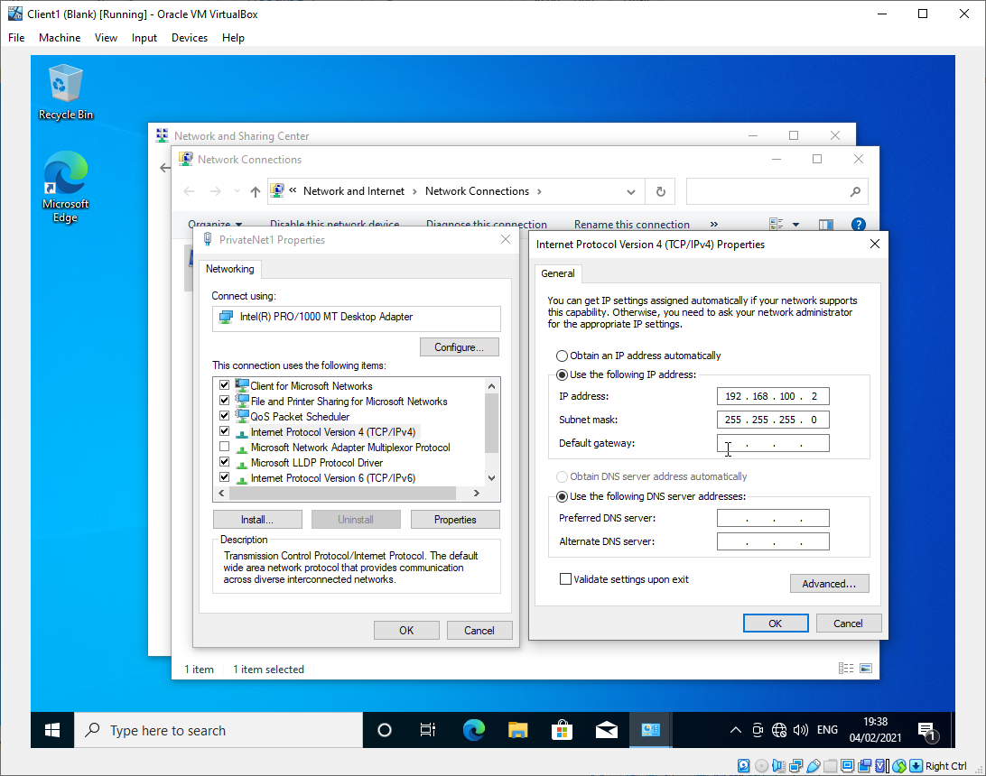
Figure 52 - Client 1 PrivateNet1 setup

Configuring Server 2
The two virtual LANs were created on the Server 2 VM.
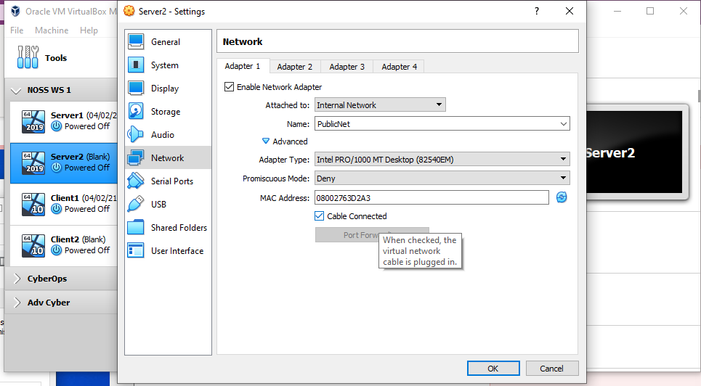
Figure 53 - Server 2 PublicNet setup
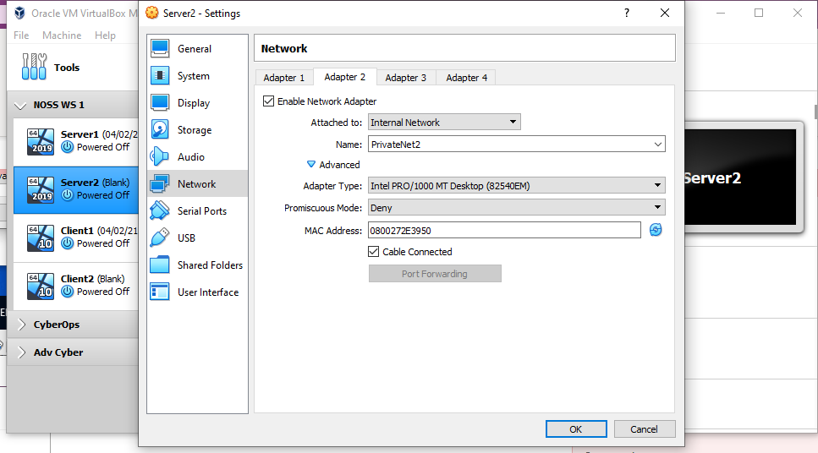
Figure 54 - Server 2 PrivateNet1 setup

The two network interfaces were then configured with static IPs as per the network diagram.
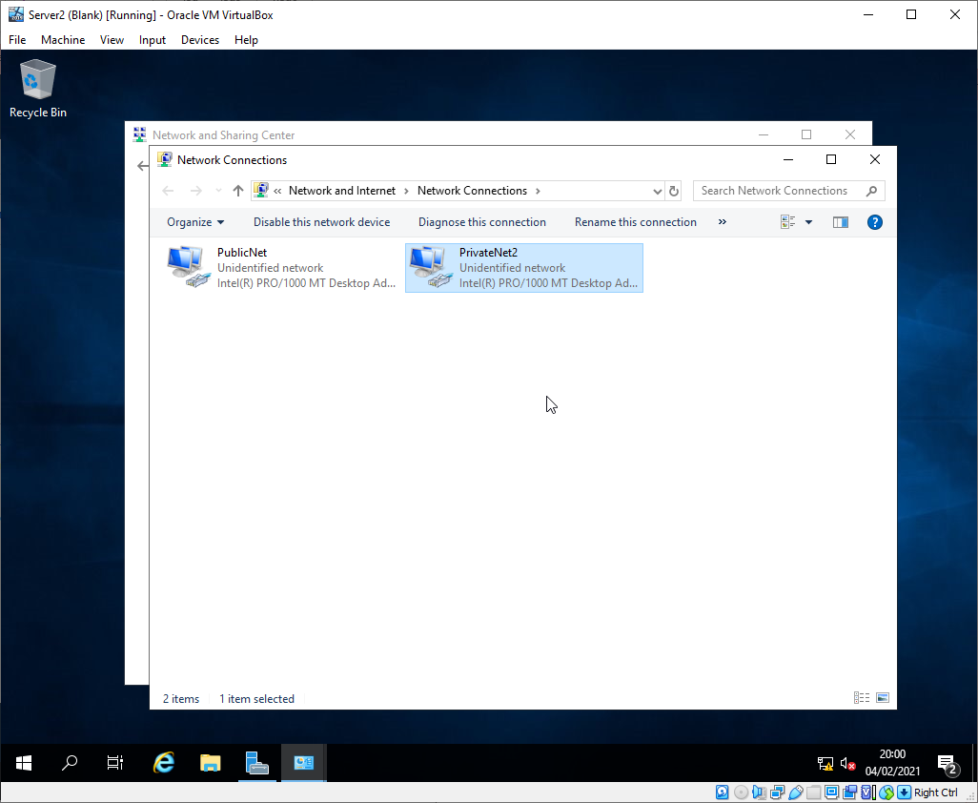
Figure 55 - Server 2 PublicNet setup
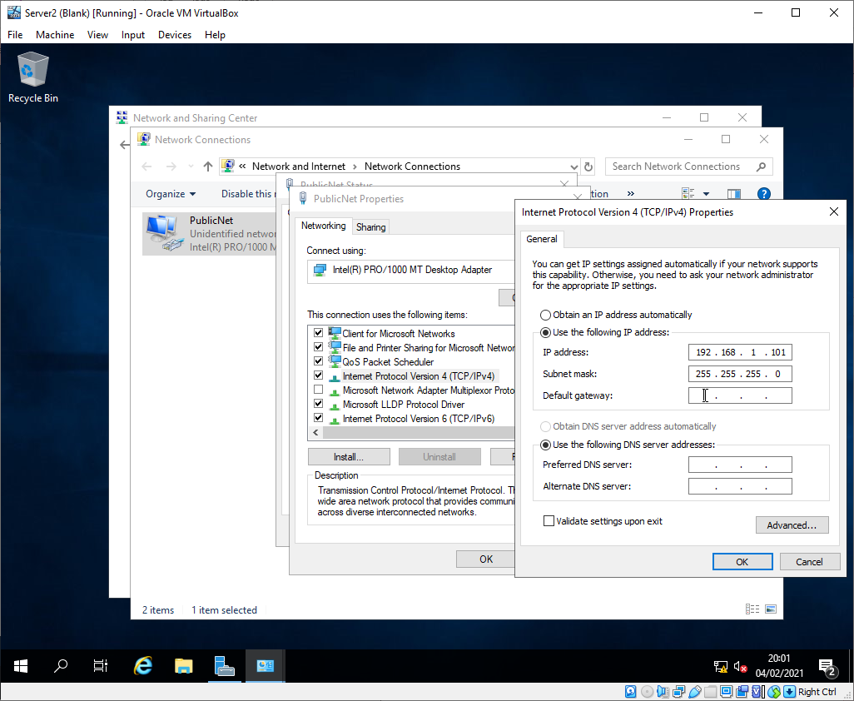
Figure 56 - Server 2 PublicNet setup

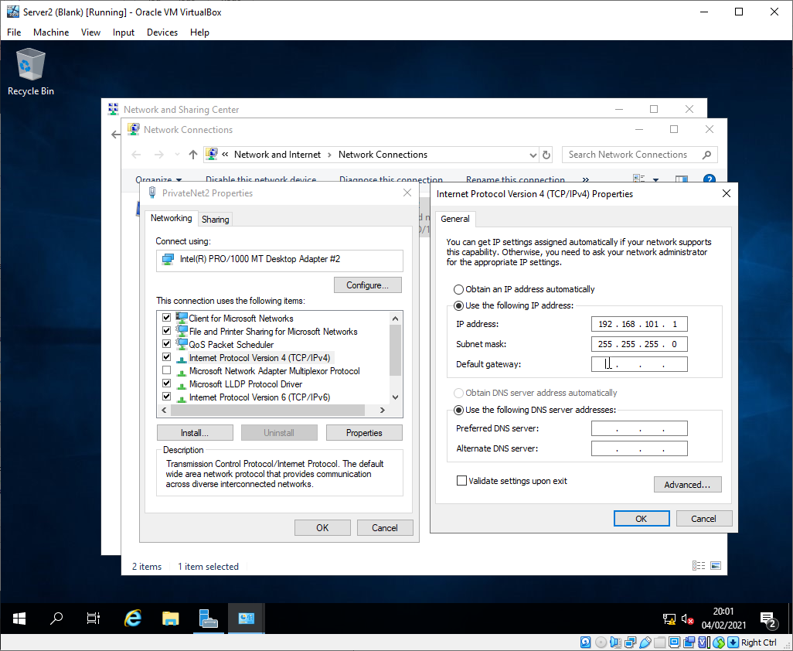
Figure 57 - Server 2 PrivateNet1 setup

Configuring Client 2
The VM was configured with the PrivateNet2 network.
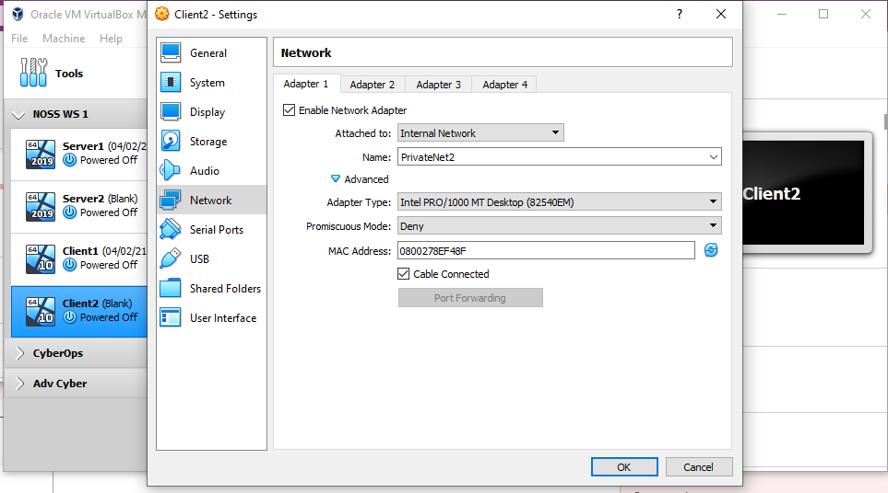
Figure 58 - Client 2 PrivateNet2 setup
The network interface was then configured with a static IP as per the network diagram.
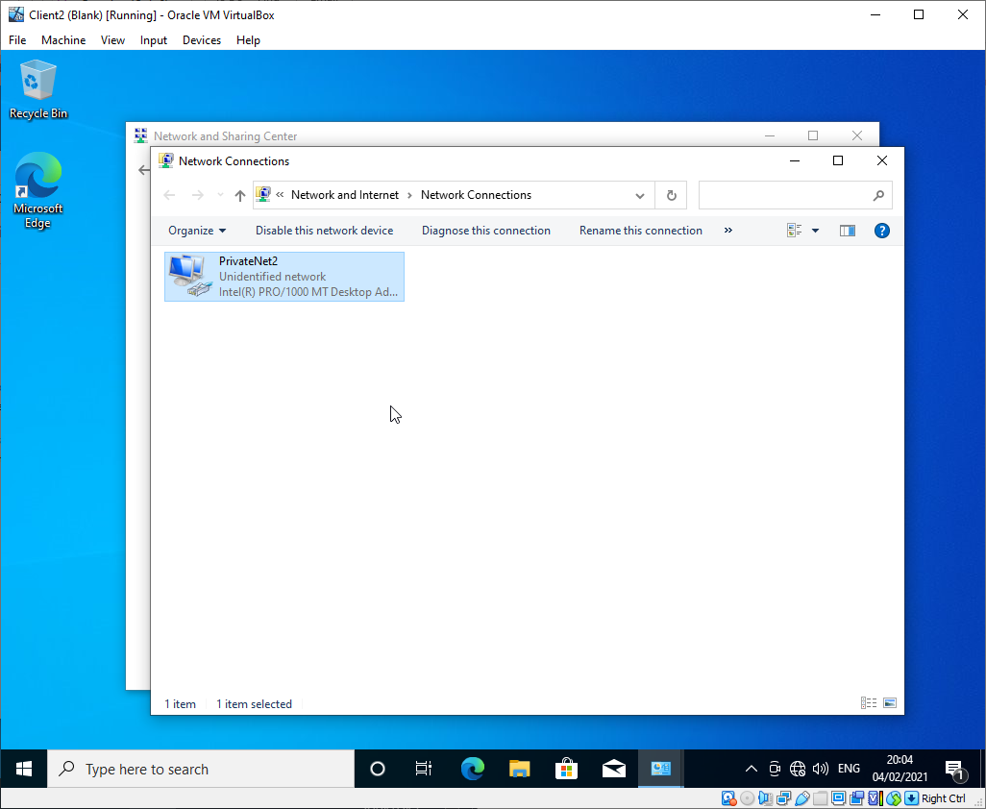
Figure 59 - Client 2 PrivateNet2 setup

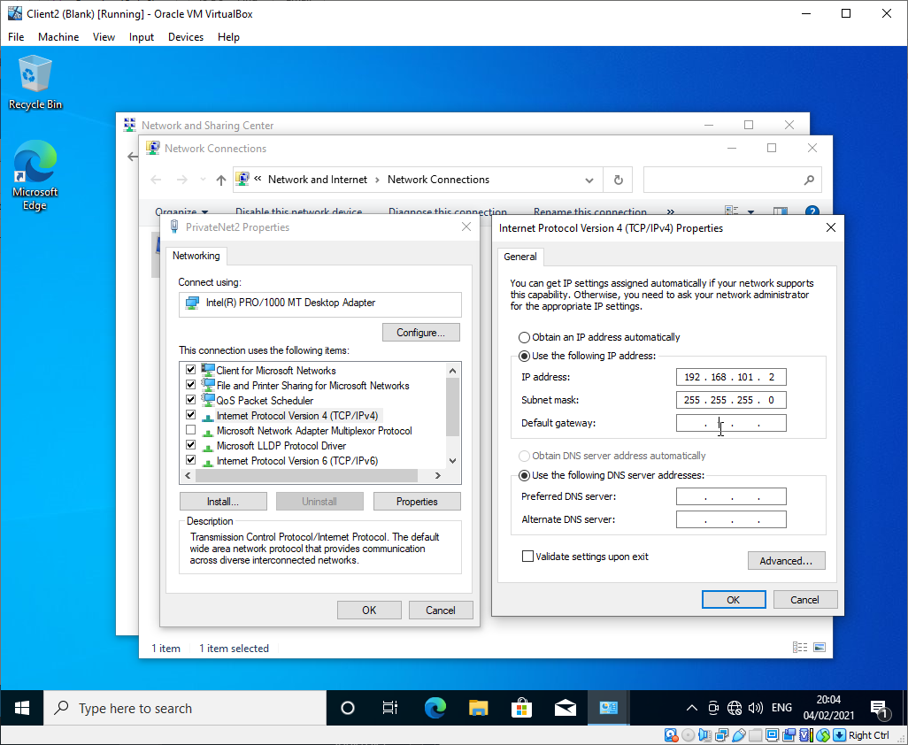
Figure 60 - Client 2 PrivateNet2 setup

Disabling Firewalls
In order to test the connectivity of the virtual network of the 4 VMs created, the local firewalls must first be disabled to allow for ping packets to be sent between VMs. This was completed on all 4 VMs.
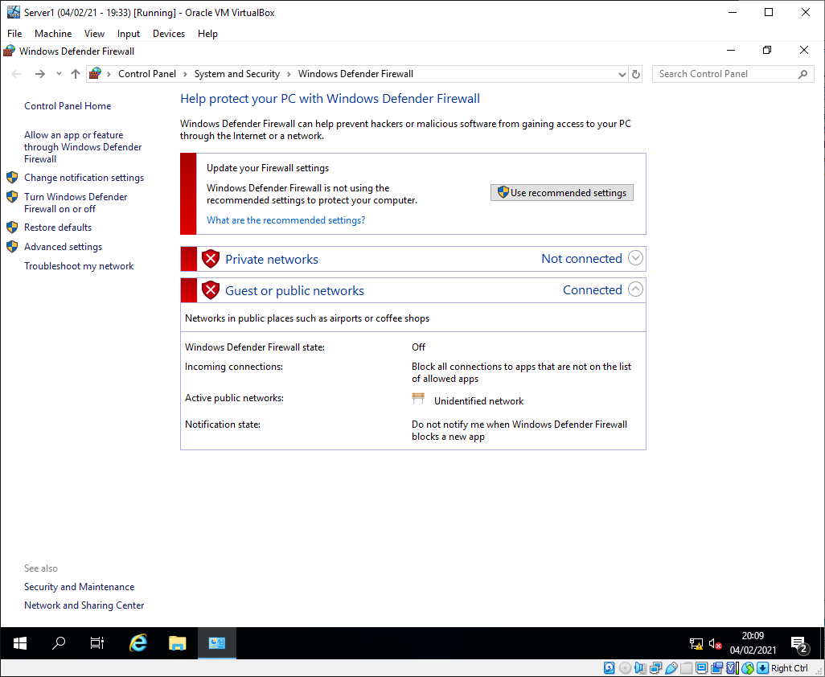
Figure 61 - Server 1 Firewall config
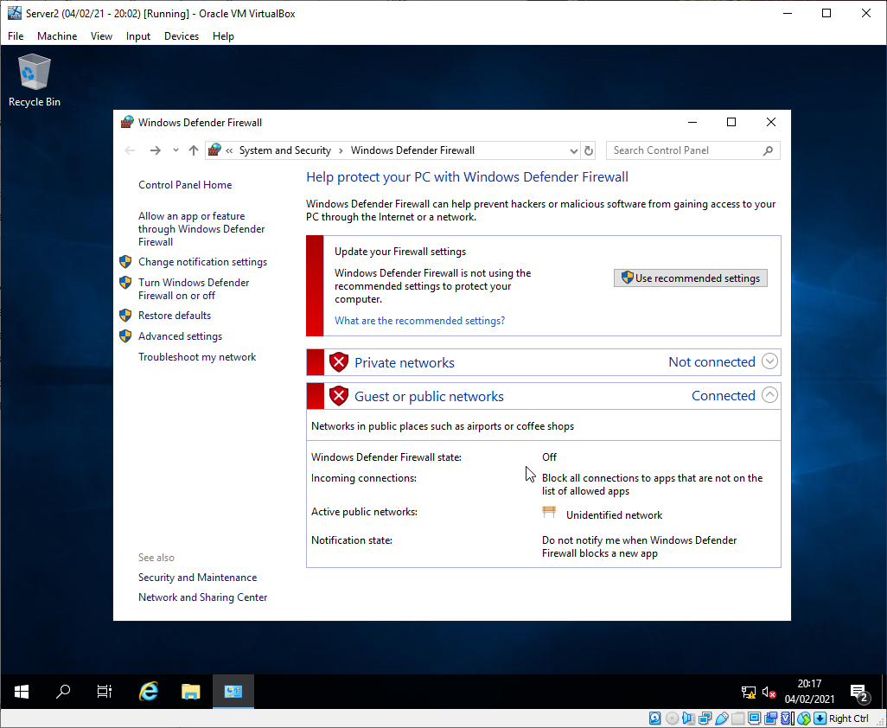
Figure 62 - Server 2 firewall config
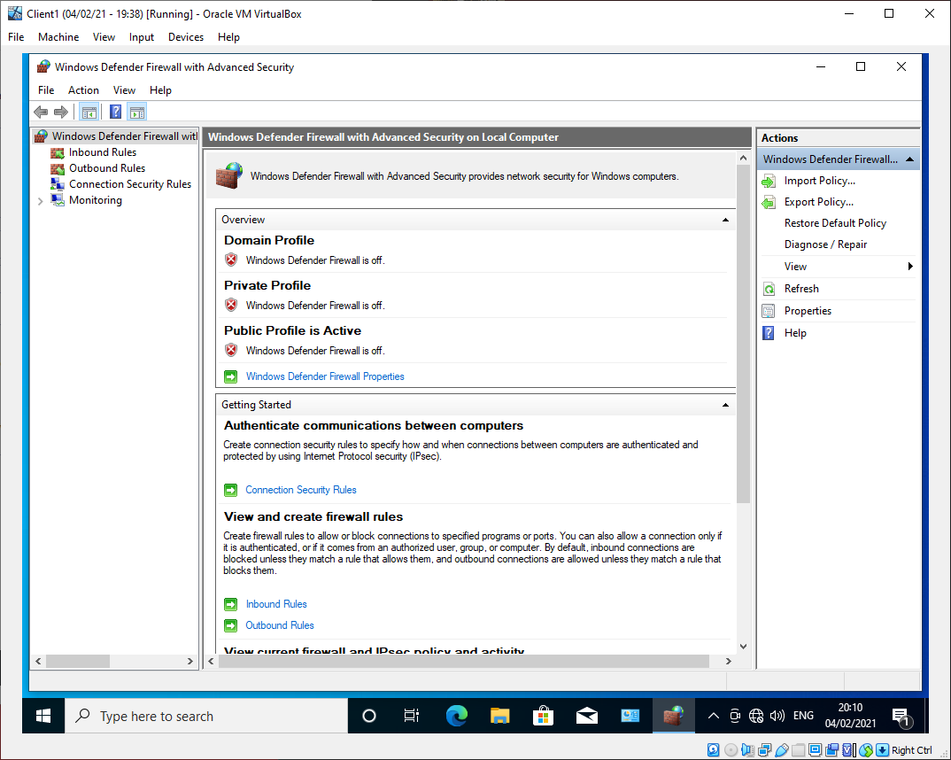
Figure 63 – Client 1 firewall config
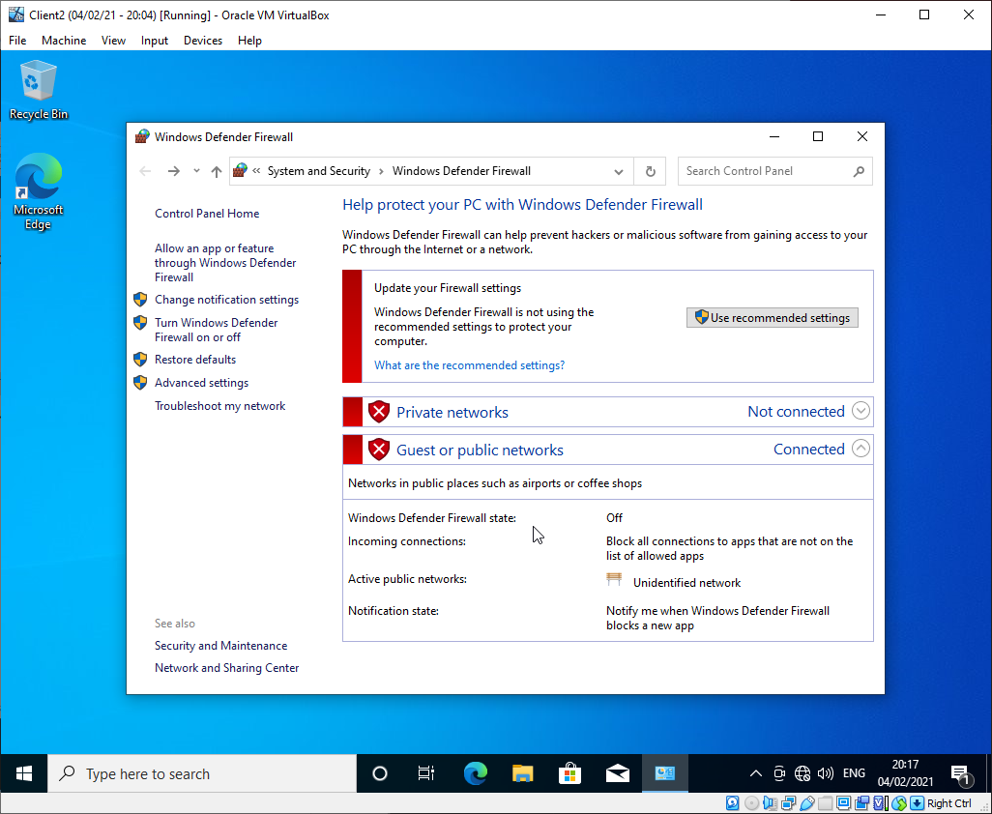
Figure 64 - Client2 firewall config

Testing Connectivity
Connectivity was tested between all VMs.
The ping from Server 1 to Client 1 was successful as expected.
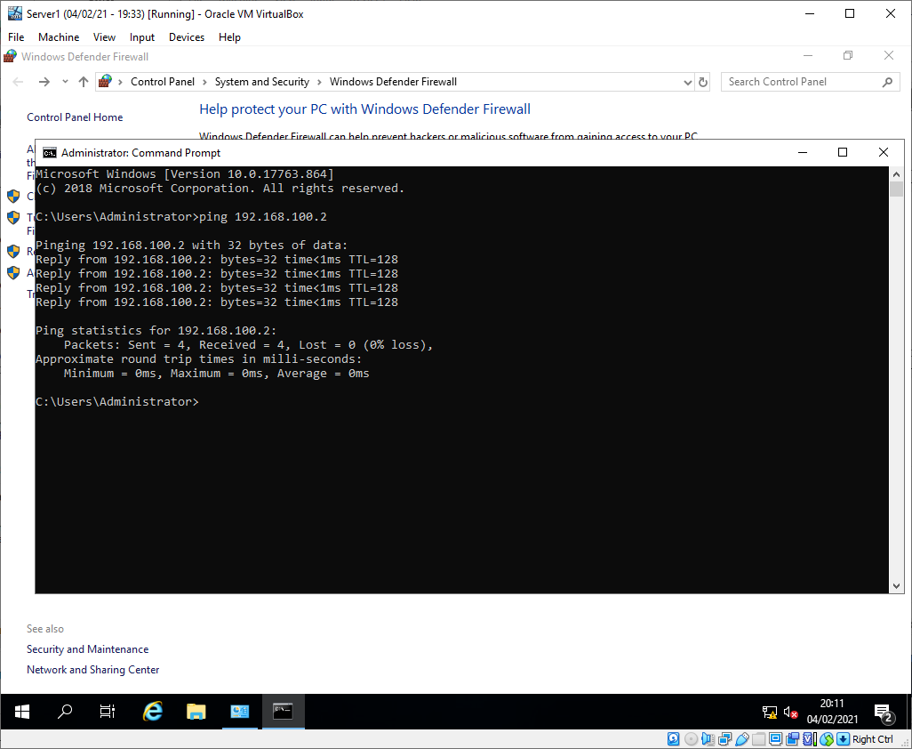
Figure 65 - Server 1 to client 1 ping
The ping from Server 2 to Client 2 was successful as expected.
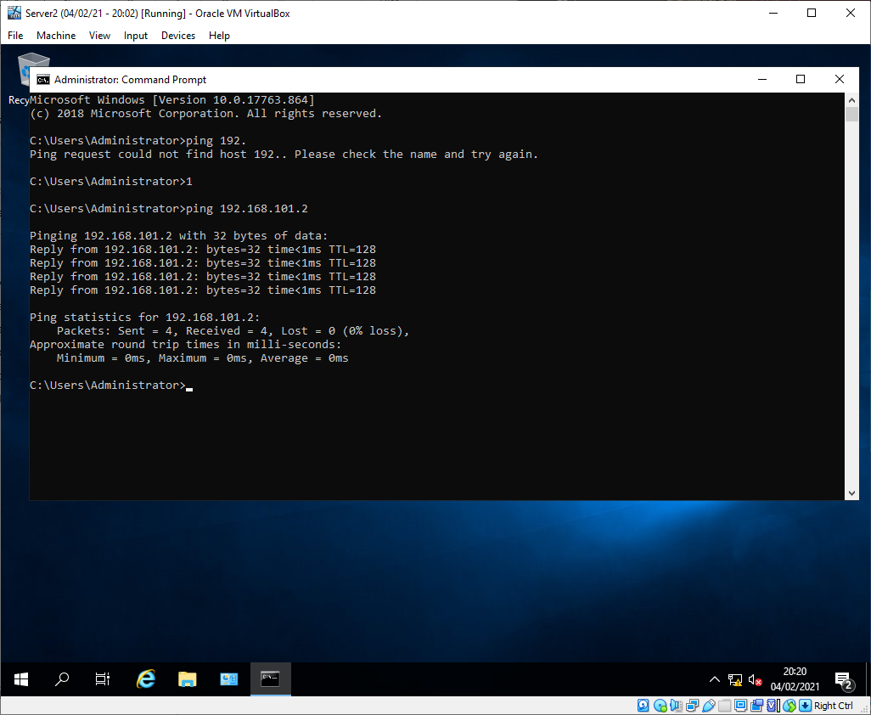
Figure 66 - Server 2 to client 2 ping
The ping from Server 2 to Server 1 was successful as expected.
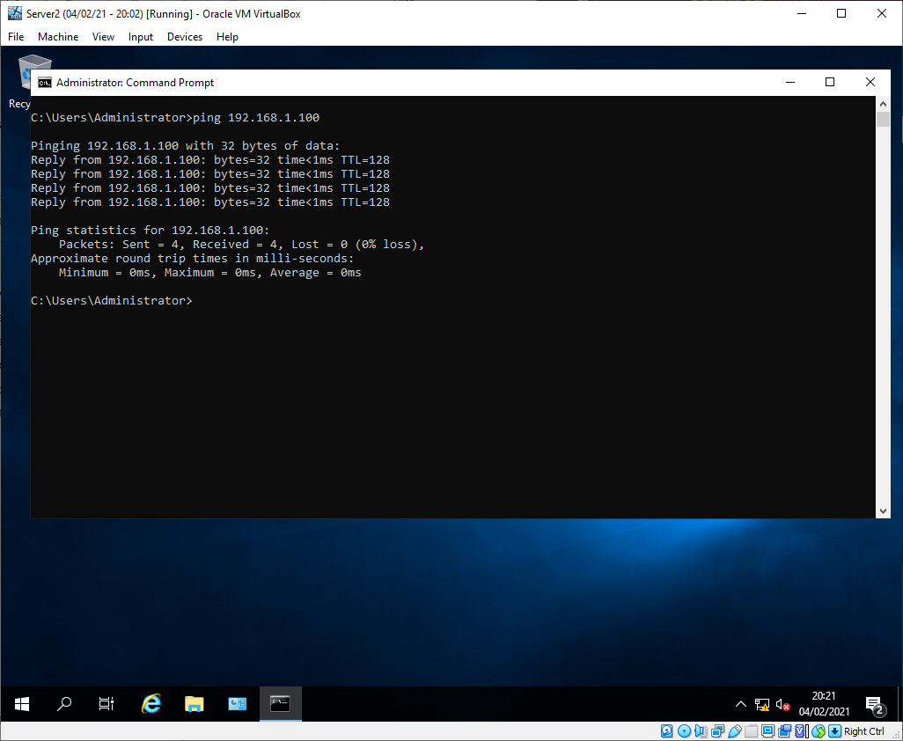
Figure 67 - Server 2 to server 1 ping
The ping from Server 1 to Client 2 failed as expected as it is in a different LAN with no router.
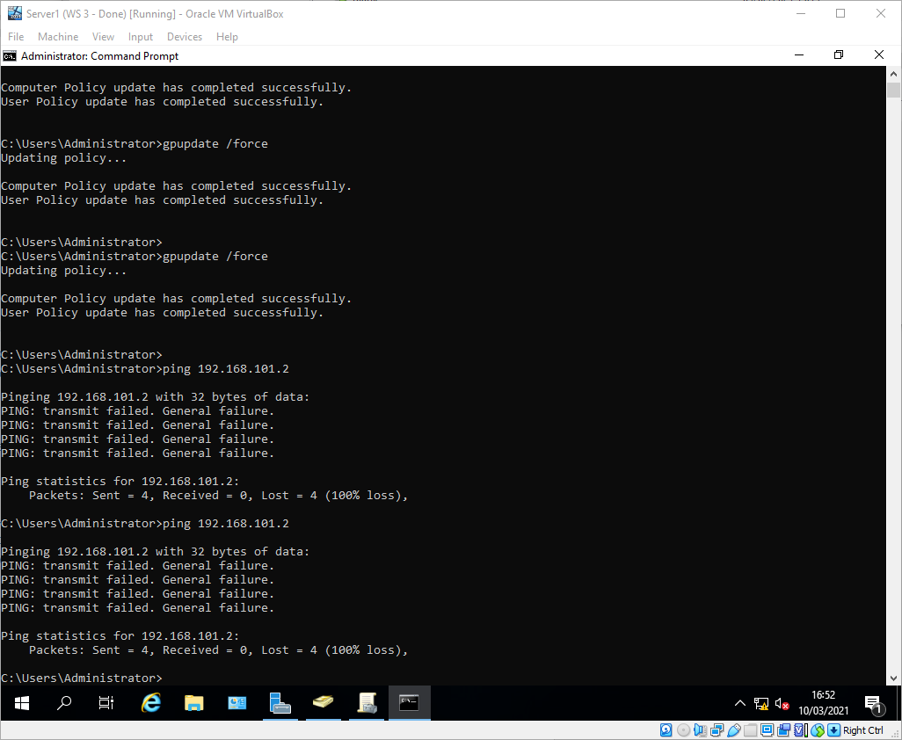
Figure 68 - Server 1 to client 2 ping

The ping from Server 2 to Client 1 failed as expected as it is in a different LAN with no router.
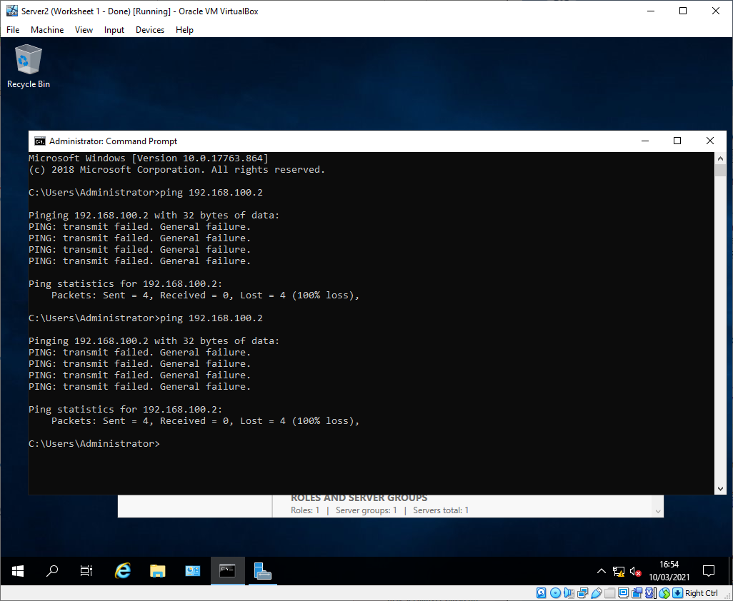
Figure 69 - Server 2 to client 1 ping

Task 3: Observational Tasks

Describe the main differences between Type 1 and Type 2 Hypervisors
A type 1 hypervisor, also known as a native or bare-metal hypervisor, runs directly on the hardware of the host machine. A type 2 hypervisor, also known as a hosted hypervisor, runs on top of the host machine’s Operating System (OS)[2].
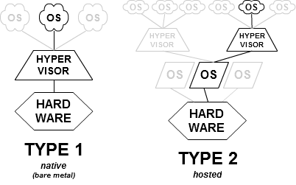
Figure 70 - Type 1 & 2 Hypervisors

Benefits and Drawbacks
The benefits of a type 2 hypervisor are that the host machine is useable for tasks other than hosting VMs. For instance, a machine could have Windows 10 installed as the host OS, with Oracle VirtualBox installed on the host OS as a type 2 hypervisor for use in emulating different OSs or conducting networking labs. This would allow for the host machine to be used for other applications, whilst a type 1 hypervisor such as VMWare ESXi would not allow for this. The drawbacks of a type 2 hypervisor are that any issues with the host OS, also affect all of the VMs. For instance, if the host OS was vulnerable to a certain exploit, this would compromise the security of all of the guest OSs also. Another drawback of type 2 hypervisors is the performance, as the host OS adds another layer of abstraction and therefore latency between the VMs and the host hardware.

Vendors
Some of the largest vendors of enterprise hypervisors are Microsoft, VMWare, and Oracle. Microsoft provides Hyper-V, which is a type 1 hypervisor. When Hyper-V is enabled on a windows machine, it in effect takes the existing host OS, converts it into a VM, and runs below it. This can cause confusion for those that think it acts like a type 2. VMWare provide ESXi and workstation. VMWare workstation is a type 2 hypervisor which runs on Windows and Linux operating systems with a free version and a paid pro version of the software[3]. ESXi (previously just ESX) is a type 1 hypervisor which allows for VMs up to “128 virtual CPUs, 6 TB of RAM and 120 devices”[4]. Oracle provides VirtualBox as a free type 2 hypervisor under the GNU GPL2 licence[5]. VirtualBox is available for Windows, Mac OS X, and Linux Operating Systems.

What is the significance of the subnet mask in IPv4 addressing?
The subnet mask in IPv4 addressing is used to specify the size of a network or subnetwork. An IPv4 IP address is a 32-bit number, which is typically represented by 4 decimal numbers from 0 to 255 (e.g. 192.168.1.10)[6]. A subnet mask is also a 32-bit number, which denotes how many digits of an IP address are reserved for the network portion, and how many for the host portion[7].
For example, given the following IP address and subnet mask:
11000000.10101000.00000001.00001010 - IP address (192.168.1.10)
11111111.11111111.11111111.00000000 - Subnet mask (255.255.255.0)
The 1’s in the subnet mask ‘mask’ the network portion of the IP address (highlighted in green), leaving the host portion (highlighted in blue). This means that the network portion of the IP address is 192.168.1.0, and the host portion is the .10 remaining.
The ability to determine the host and network portion of an IP address is critical to many functions of networking, most notably being routing.
Classful subnetting was a network architecture used until the early 90’s which involved only using 5 different classes to partition the whole IPv4 address space. Only three of these classes were used for practical subnetting:
- Class A – 255.0.0.0
- Class B – 255.255.0.0
- Class C – 255.255.255.0

Whilst these subnet masks are still in use, the introduction of Classless Inter-Domain Routing (CIDR) in 1993[8] allowed for various other sized subnetworks which significantly reduced wasted addresses in networks. Now a point-to-point link can have a subnet mask of 255.255.255.254, using only the addresses necessary, instead of wasting 253 had a Class C space been used[9].

Describe the use of cloud computing including its benefits and drawbacks and identify example vendors within the industry
Cloud computing is the delivery of computing services such as servers, storage and databases over the internet[10]. This can be implemented on the consumer level with services such as google drive or iCloud, or on the enterprise level via services such as Amazon Web Services (AWS) or Microsoft Azure.

Benefits
One of the main benefits of the massive surge in cloud computing is the simplicity in expanding an enterprise network to match a growing organisation. Cloud computing allows network administrators to simply purchase additional resources from their cloud hosting provider, whereas with on-premise hosting, the physical servers would need to be purchased, which would then need to be installed into the datacentre. The server would then need to be asset managed internally, and would likely need to be resilient, which would require doubling the work already completed. All on-premise hardware also has a certain lifetime, and would need to be consistently refreshed with new hardware, and or have preventative maintenance completed. All of this increases the overhead for an organisation. All cloud hosting providers supply physical resilience as standard, and most supply geographical resilience as well. This avoids the duplication of effort and costs that come with on-premise hosting.

Drawbacks
The drawbacks of cloud computing are that it can be difficult to secure a network that contains cloud services as the concept of a ‘network perimeter’, where machines/users inside the perimeter can be trusted is eroded. This can make it especially hard to secure networks that have previously been completely on-premise, and have included cloud elements. This is because the previous security measures will not be as effective in the new infrastructure.
Another drawback to the explosion of cloud computing in recent years is that it has allowed for a near monopoly to form over huge swaths of the internet. This can be incredibly dangerous to the freedom the defines the internet. With a third of cloud computing being own by one company[11], it allows for a very small group of people who own the company to control the content of the internet. For instance, if Amazon decided that they would no longer host any content that was disparaging to Amazon in any way or promoted their competitors, they would be able to vastly influence the content that people view, and subsequently their opinions.

Vendors
The main vendors of cloud computing are Microsoft with Azure, Amazon with AWS, Google with Google Cloud. AWS leads the market with 32% of all cloud computing being provided by Amazon[12].

Describe different terminologies and its purposes. Compare their operations/functionality with other Network Operating Systems

Ping
Ping can be the generic term given for any client-initiated check of a target machine[13] (as opposed to a heartbeat, which is where the target machine initiates the check back to the client). Ping can also refer more specifically to the Internet Control Message Protocol (ICMP) ECHO message. The ICMP ECHO message is defined in the Internet Engineers Task Force (IETF) Request For Comments (FRC) 792[14], and can be used to troubleshoot various network connection errors. The main message types are 0 (Echo Reply) which denotes a successful ping, and 3 (Destination Unreachable) which denotes that the ping was unsuccessful[14]. A destination unreachable message will have a code which represents the type of error encountered[14]:
- 0 - net unreachable
- 1 - host unreachable
- 2 - protocol unreachable
- 3 - port unreachable
- 4 - fragmentation needed and DF set
- 5 - source route failed
These codes can then be used to troubleshoot the connection issue, be it due to a firewall rule blocking traffic between hosts, a routing issue, or a physical cable break between the hosts.

Server Management
The server management software used in Task 1 and 2 was Windows Server Manager which is built into Windows Server 2019. It is used to help provision and manage both local and remote windows servers[15]. It allows for the grouping of servers, for instance grouping the DCs on a network to monitor their performance and/or manage them collectively. Cockpit is a server management tool for Linux built by RedHat[16]. Cockpit allows for the monitoring and management of multiple Linux servers at once, with administrators able to start and stop services remotely, diagnose network issues, and find problematic VMs.

Firewalls
Firewalls are network security devices that filter traffic using internal rules. Rudimentary firewalls will filter traffic using port numbers and source and destination addresses in the form of packet filtering. More advanced firewalls can detect malicious traffic using heuristics and signatures much like a host Anti-Virus would detect malware.

PAE/NX
Physical Address Extension (PAE) is a method by which 32-bit (x86 architecture) can use more than 4GB of memory directly by extending the page table hierarchy from 2 levels of 32 bits to 3 levels of 64 bits. This feature is supported by all versions of windows since Windows XP[17]. It is supported by Mac OS X Tiger to Snow Leopard, with versions after Snow Leopard not supporting 32-bit processors[18]. The Linux kernel includes support for PAE from version 2.2.23[19].

References
[1] “Critical Error on when installing windows server 2019 standard,” virtualbox.org Forums, 2020. [Online]. Available: https://forums.virtualbox.org/viewtopic.php?f=6&t=97100. [Accessed: 04-Feb-2021].
[2] A. Syrewicze, “VMware vs. Hyper-V: Architectural Differences | Andy Syrewicze,” Syrewicze IT, 2013. [Online]. Available: http://syrewiczeit.com/vmware-vs-hyper-v-architectural-differences/. [Accessed: 11-Mar-2021].
[3] “Workstation Pro | VMware,” VMWare, 2021. [Online]. Available: https://www.vmware.com/uk/products/workstation-pro.html. [Accessed: 11-Mar-2021].
[4] “ESXi | Bare Metal Hypervisor | VMware,” VMWare, 2021. [Online]. Available: https://www.vmware.com/uk/products/esxi-and-esx.html. [Accessed: 11-Mar-2021].
[5] “Oracle VM VirtualBox,” Oracle, 2012. [Online]. Available: https://www.virtualbox.org/. [Accessed: 11-Mar-2021].
[6] “TCP/IP addressing and subnetting - Windows Client | Microsoft Docs,” Microsoft, 2020. [Online]. Available: https://docs.microsoft.com/en-us/troubleshoot/windows-client/networking/tcpip-addressing-and-subnetting. [Accessed: 11-Mar-2021].
[7] “Subnet Mask - an overview | ScienceDirect Topics.” [Online]. Available: https://www.sciencedirect.com/topics/computer-science/subnet-mask. [Accessed: 11-Mar-2021].
[8] “RFC 1518 - An Architecture for IP Address Allocation with CIDR,” IETF, 1993. [Online]. Available: https://tools.ietf.org/html/rfc1518. [Accessed: 11-Mar-2021].
[9] “RFC 3021 - Using 31-Bit Prefixes on IPv4 Point-to-Point Links,” IETF, 2000. [Online]. Available: https://tools.ietf.org/html/rfc3021. [Accessed: 11-Mar-2021].
[10] “What is cloud computing? A beginner’s guide | Microsoft Azure,” Microsoft. [Online]. Available: https://azure.microsoft.com/en-gb/overview/what-is-cloud-computing/. [Accessed: 11-Mar-2021].
[11] F. Richter, “Amazon Leads $130-Billion Cloud Market | Statista,” Statistica, 2021. [Online]. Available: https://www.statista.com/chart/18819/worldwide-market-share-of-leading-cloud-infrastructure-service-providers/. [Accessed: 12-Mar-2021].
[12] K. Stalcup, “AWS vs Azure vs Google Cloud Market Share 2021: What the Latest Data Shows - ParkMyCloud,” Park My Cloud, 2021. [Online]. Available: https://www.parkmycloud.com/blog/aws-vs-azure-vs-google-cloud-market-share/. [Accessed: 11-Mar-2021].
[13] “Difference between a ping and a heartbeat? - Stack Overflow,” Stack Overflow. [Online]. Available: https://stackoverflow.com/questions/23183185/difference-between-a-ping-and-a-heartbeat. [Accessed: 11-Mar-2021].
[14] J. Postel and et al, “RFC 792 - Internet Control Message Protocol,” IETF, 1981. [Online]. Available: https://tools.ietf.org/html/rfc792. [Accessed: 11-Mar-2021].
[15] “Server Manager | Microsoft Docs,” Microsoft, 2017. [Online]. Available: https://docs.microsoft.com/en-us/windows-server/administration/server-manager/server-manager. [Accessed: 12-Mar-2021].
[16] “Cockpit Project — Cockpit Project,” Cockpit.org, 2021. [Online]. Available: https://cockpit-project.org/. [Accessed: 12-Mar-2021].
[17] “Physical Address Extension - Win32 apps | Microsoft Docs,” Microsoft, 2018. [Online]. Available: https://docs.microsoft.com/en-us/windows/win32/memory/physical-address-extension. [Accessed: 11-Mar-2021].
[18] P. McLean, “Road to Mac OS X Snow Leopard: 64-bits, Santa Rosa, and more | AppleInsider,” Apple Insider, 2008. [Online]. Available: https://appleinsider.com/articles/08/09/03/road_to_mac_os_x_snow_leopard_64_bits_santa_rosa_and_the_great_pc_swindle.html. [Accessed: 12-Mar-2021].
[19] “PAE - Ubuntu,” Ubuntu. [Online]. Available: https://help.ubuntu.com/community/PAE. [Accessed: 11-Mar-2021].

