Business Plan for

SMOKEHOUSE EXPRESS

Produced By:

GROUP MEMBERS:
Student Name | Student No.
Mohammad Abul Kalam Ali | 2234300
Constantin Vasiliu | 2229175
Yaqoob Talukdar | 2126722
Siddi Arachcige Lalani de Silva | 2230713

Dated: __31.05.2024____________

Module Name: Entrepreneurship
Module Code: BMIH5001
Lecturer Name: _____Charlotte Joyner____________

CONTENTS

 |  |  |  | PAGE
1. | Executive Summary |  |  | 3
2. | The Business Idea |  |  | 4
3. | The Team |  |  | 5
4. | Market Research |  |  | 7
5. | Marketing Plan |  |  | 8
6. | Key Resources |  |  | 9
7. | Finances & Start-Up Support |  |  | 13
APPENDICES:
Appendix A |  |  |  | SWOT Analysis
Appendix B |  |  |  | PEST Analysis
Appendix C |  |  |  | Copy of Pitch Supporting Material

- EXECUTIVE SUMMARY

Smokehouse Express is a pioneering and forward-thinking enterprise that aims to transform the BBQ dining experience by delivering it directly to our clients using a mobile trailer setup. Our main goal is to provide good, flavourful barbecue meals to various areas, guaranteeing convenience and great quality for our customers.
.

2. THE BUSINESS IDEA

2.1 The Product/Service

Smokehouse Express will function from a mobile trailer that captures the ambiance of a barbecue restaurant while providing the convenience and ease of a food truck. Food truck will be equipped with charcoal BBQ equipment to assure the consistent delivery of high-quality cuisine, regardless of the location. This configuration enables us to deliver our delectable barbecue cuisine straight to our customers at diverse venues, such as metropolitan areas, corporate gatherings, festivals, and exclusive gatherings (McGill and Slocum,. 1994).

Smoking and grilling:

The trailer will showcase high-capacity smokers that can slow-cook substantial amounts of meat to attain an ideal smoky flavour and softness.
Furthermore, apart from catering to smokers, we will also provide high-quality grills for the purpose of swiftly cooking foods and imparting a charred texture to specific dishes (Teyin and Secim, 2023).

Preparation Stations:

Designated workspaces for meat, vegetables, and side dishes, guaranteeing that all ingredients are treated with meticulousness and accuracy.
Refrigerated storage facilities are utilised to preserve the freshness of products and uphold food safety regulations.
Efficient counter space and storage solutions created to optimise operations and maintain a well-organized workspace.
Smokehouse Express will provide a varied cuisine that caters to a wide array of preferences, highlighting the flavourful and smoky tastes of genuine barbecue. The products and services we will provide are: Smoked Meats, Grilled Meats, Grilled Veggies.

2.2 SWOT Analysis Summary

Our strength is that we redefine the dining to more casual and relaxed mode. According to studies BBQ is a seasonal food and can be a weakness. But with our marketing plan and strategies we will become the top BBQ trailer with future possibility of franchising.
3. THE TEAM

3.1 Key Personnel

Name and Company Position: Constantin Vasiliu, Senior Advertiser
Skills and Experience: 3 years of experience in website built and advertising.

Role and Responsibilities: Take care of advertising, find new target audience.

Name and Company Position: Mohammad Abul Kalam Ali, Chef
Skills and Experience: 15 years experience of Head Chef, menu creator.

Role and Responsibilities: Creating and developing new recipes.

Name and Company Position: Yaqoob Talukdaar. PR and Marketing
Skills and Experience: Over 10 years looking after marketing and PR for restaurants developments.

Role and Responsibilities: Finding new clients, new way of promoting and advertising.

Name and Company Position: Siddi Arachchige Lalani De Silva, Customer Relation
Skills and Experience: Over 10 years in customer relationship advisor.

Role and Responsibilities: Taking orders, handling payments and customer phone service.

Name and Company Position:
Skills and Experience:

Role and Responsibilities:

3.2 Skills Gaps & Key Partners
3.2.1 Additional Staff Requirements (Roles and Responsibilities):
- Cashier
Responsibility
The main responsibility of the cashier will be to interact with the customers in a friendly manner along with taking orders effectively (Enes and Koşan, 2024). Payments should also be processed effectively to avoid confusion. Moreover, customer feedback should also be collected.
Skill gap
Gap in communication with customers will be filled along with representing the restaurant positively.
- Social media manager
Responsibility
Social media managers will be responsible for developing and implementing strategies regarding marketing effectively along with handling social media platforms of the restaurant effectively (Enes and Koşan, 2024). Moreover, performance of the marketing campaigns should also be analysed efficiently.
Skill gap
Gap in the creation of creative content will be filled to increase engagement. Skill gaps in data analysis will also be fulfilled to improve the marketing efforts.
- Procurement manager
Responsibility
The procurement manager will be responsible for purchasing high-quality ingredients along with buying those items at the best price (Giombelli and Triches, 2020). Moreover, inventory and stock levels should be managed effectively.
Skill gap
Gap related to cost management and strategic sourcing will be filled.

3.2.2 Training and Development:
Training: To ensure excellence in customer service.
Provide by
In-house operation manager and local training centres will be responsible for providing the training.
Filling gap
Enhancing skills required for customer interaction along with resolution of complaints (Miller, 2020). Through this, higher customer satisfaction can be ensured.
Cost
The total cost of every customer service workshop will be around 200 pounds per person.
3.2.3 Outsourced Support / Key Partners:
- Local butcheries and farms
These key partners will enable the business to obtain locally produced, fresh and high-quality ingredients. They will supply raw ingredients, meats, and vegetables. Throughout the month they will provide raw materials which will cost around 2000 to 4000 pounds.
- Sanitation and food safety services
These services will be helpful for the trailer to maintain high standards and cleanliness. Specialist services that will be provided by these key partners are food safety audits, regular sanitation and providing training to staff regarding hygiene practices (Miller, 2020). Estimated costs related to these services are around 600 pounds per month.
4. MARKET RESEARCH

4.1 Market Information, Trends and External Factors
The food truck sector in the UK, particularly Glasgow, has experienced a consistent growth, driven by an increasing need for a wide range of top-notch street food.
The UK has seen a surge in the popularity of barbecue cuisine, namely American-style smoked meats, due to customers desire for genuine and distinctive culinary experiences (Gopi and Samat, 2020).
The development trajectory of the UK food truck sector is projected to persist, propelled by urbanisation, busy lifestyles, and the surging popularity of food festivals and outdoor events.
Rising fascination with street food and portable dining choices, especially in metropolitan regions and during festivals.
The increasing inclination of consumers for genuine and handcrafted culinary encounters, emphasising excellence and distinctive tastes (Miah and Mahmud, 2023).
The significant level of user interaction on social media platforms is exerting a strong influence on individuals' dining preferences. Food trucks are leveraging these channels to establish their brand and entice customers.
There is a growing demand for the implementation of environmentally sustainable practices, which includes the use of eco-friendly packaging and the utilisation of locally sourced ingredients.

4.2 Customer Profiles

- Barbecue Enthusiasts: These are individuals who have a deep appreciation for the traditional method of cooking meat over an open flame. Typically, they fall within the age range of 25 to 55 and appreciate the rich, smoky flavours and the genuine experience of slow-cooked meats.
- Target Audience: Busy individuals and families that need convenient and tasty meals without the formalities associated with traditional restaurants.
- Office Workers: That need fast and reliable service for their short break.

4.3 Competitor Profiles

- Korean BBQ Restaurants: They are quite famous and will be our number one restaurant competitor. But because in their place usually you cook your meats, so here is what is define from us. We grill to perfection and serve you at your convenience without the hustle of having BBQ smell al over your clothes. Because we are placed in city center and open early, we have advantage.
- Other BBQ Restaurants: There are few others competitor within our industry, but they are overpriced and dine-in restaurants concept. That means you must wait to be served for a long period of time, to be dressed nice. If you want to be comfortable, we are your solution, our food you can eat it everywhere.
- Other Food Trailers: In the last couple of years food truck industry has developed so we have other competitors, wich they are the last to take them in consideration due they have different cuise, but being in the market ahead of us they already have a customer list. But now it depends on people taste and desire of what food they want to have at it.

5. MARKETING PLAN

5.1 Price

The way of pricing was done by exploring other competitors within St Enoch shopping centre as well as researching other smokehouses such as Holy Smokes BBQ (2024) in London. We have looked into one of the restaurants located in ST Enoch called Namaste by Delhi Darbar (2024) and can see that their prices are leaning more towards the high-end prices with starters ranging from £5.50 - £11.00 and mains ranging from £12.00-£20.00. The Grill section of the menu ranges from £15.00 for chicken tikka and £20.00 for lamb chops. The price reflects our competitors but we are also trying to ensure that there is a balance of quality food for a reasonable price whilst taking into account the location of our trailer. (See Appendix 1). Our meat will be sourced from local farms such as Duncan MacKenzie’s craft butchers in Greenock and our organic meat from Hugh Grierson Organic (2022). This company gets their 100% organic meat from their own farm in Perthshire and they can deliver it to us which again will reflect on the prices we have come up with due to it being organic.

5.2 Product

The colour scheme of the packaging will be black and orange, we have added the flame design to give that smoke effect on the boxes which matches the menu and name “Smokehouse Express.” We will avoid using plastic to stay environmentally friendly. Recycled cardboard packaging will be easier to recycle and get our customers to recycle, helping the environment and contributing to waste reduction as well as reducing the amount of greenhouse gasses released into the environment (Squarebird, 2023). We have also got the option of paper takeaway bags for the same reason. (See Appendix 2/3/4)

5.3 Placement

Our products and services will be sold at the trailer in St. Enoch shopping centre in the heart of Glasgow. There is a lot of foot traffic here and people will be at work within the shopping centre which will help generate trade during lunch and dinner. We have also decided to explore other avenues such as Just Eat, Uber Eats and Deliveroo, making that visible on our menus (Appendix 1) so that the target market is aware that we are available to deliver as well as collection orders. This will expand consumers for several reasons such as eating in the comfort of their own home.

5.4 Promotion

We are going to raise awareness by having flyers (Appendix 5) displayed around the shopping centre as well as advertising on social media platforms such as Instagram, TikTok and online delivery platforms. Delivery platforms are widespread across the UK and have approximately 11 million users (Lord et al., 2023, P.494) and is a promotion strategy due to the high number of users online. We have considered what other food companies do; for example, Big Johns and Nandos have loyalty cards where you can collect a stamp each time you order, but then after a certain number of stamps or visits you receive a free item. We are thinking of having Loyalty discounts and loyalty cards where if customers order 5 times, they will get a 15% discount or a free side with their order. We think that this will increase revenue of people locally wanting to get the 15% discount.

6. KEY RESOURCES

6.1 Premises
Smokehouse Express's trailer needs parking and moving. This layout works well in Glasgow St. Enoch because of its proximity to shopping centre, company offices, and residential districts. The trailer needs power and water for cooking, refrigeration, and other purposes (Grasso and Bordiga, 2023). Location, size, facilities, and market conditions determine rent and company rates. Glasgow Industrial rent and business rates may cost up to 1200£ per month, depending on landlord or property manager agreements. Businesses may find affordable plces through local real estate brokers or listings. Choose a corporate location based on accessibility, visibility, parking, and zoning. Different premises can be cost-benefit analysed to facilitate decision-making. Smokehouse Express can maximise revenue and client reach by considering location and costs.

Aspect | Description
- Physical Space Requirement | - Parking and maneuvering space for the mobile trailer, potentially outdoor seating or serving areas.
- Ideal Location | - Within or near the Glasgow St. Enoch area for strategic positioning and proximity to potential customer venues.
- Utility Requirement | - Access to electricity and water for supporting cooking equipment, refrigeration units, and other facilities (Nguyen, 2022).
- Rent & Business Rates | - Estimated monthly costs range up to 1200£, depending on location, size, facilities, and market factors.

6.2 Equipment
Equipment | Description | Potential Suppliers | Costs
- Mobile barbecue trailer | - Equipped with charcoal BBQ equipment, smokers, and grills for cooking meats and vegetables (Bui, 2023). | - McKenzie Butchers | Up to 10.000£
- Refrigeration units | - For storing perishable ingredients and maintaining food safety standards. | - WebstaurantStore, Catering Appliance Superstore | Up to 1300£
- Food preparation stations | - Designated workspaces for meat, vegetables, and side dishes. | - Commercial Kitchen Suppliers, Restaurant Supply Stores | Up to 2000£
- POS (Point of Sale) system | - For processing customer orders and accepting payments (Nguyen, 2022). | - Barclays | 240£/year  +  1.6% per transaction
- Cleaning and sanitation equipment | - For maintaining hygiene standards in the kitchen and serving areas. | - Cleaning Supply Companies, Janitorial Equipment Suppliers | Up to 250£

6.3 Key Suppliers
Key Suppliers | Description | Potential Suppliers | Costs
- Meat suppliers | - Provide lamb, beef, chicken of premium quality (Leung et al., 2022). | - Duncan McKenzie Butcher | - Varies depending on quantity and type
- Vegetable suppliers | - Supply fresh vegetables and produce used in side dishes and grilled items. | - Local Farmers Markets, Wholesale Distributors | - Varies depending on quantity and type
- Sauce and seasoning suppliers | - Offer barbecue sauces, marinades, and seasonings to enhance flavors. | - The Smokey Carter, Angus & Oink | - Varies depending on quantity and type
- Packaging suppliers | - Provide eco-friendly packaging solutions including utensils, and napkins. | - Vegware, Biopac (Grasso and Bordiga, 2023). | - Varies depending on quantity and type

These crucial suppliers keep the organisation running smoothly and provide high-quality goods. Dunca McKenzie supplies fresh meats every morning. Fresh side and grilled veggies are sold by wholesalers and farmers markets (Genadinik, 2018). Smokey Carter and Angus & Oink sauces improve the taste. Lastly, Vegware and SquareBird offer eco-friendly packaging for company sustainability. These commodities prices vary by quantity and type.

7. FINANCES AND START-UP SUPPORT

EXPENDITURE | YEAR 1
Company Registration | 50
Rent/Rates | 12000
Staff Wages | 25000
Travel/Accomodation | 800
Telephone (mobile) | 250
Broadband | 150
Utilities | 6000
Marketing and materials | 1500
Insurance | 550
Capital Expenditure/Equipment | 13000
Training & Development | 400
Accounting/Legal | 1200
Outside Services | 250
Stock/Materials Purchases | 18000
Bank Charges | 6500
Office Consumables | 700
Loans Repayments | 6000
Total Expenditure | £ 92.350
INCOME | YEAR 1
Uber Eats | 45000
Just Eat | 52000
Direct Sale | 54000
Capital Introduced | 2500
Funding | 1800
Loans/Borrowing | 10000
Total Income | £ 165.300
YEAR 1 PROFIT/LOSS | £
Total Income | 165.300
Total Expenditure | 92.350
Profit/Loss | £ 72.950

7.1 Financial Summary
From the above table, various expenditures can be addressed which are related to the new business plan. It can be observed that company registration is highly necessary when it comes to starting a new business within any industry (Beynon-Davies, 2019). Based on the legal and regulatory compliances a cost of 50 pounds will be required for the new business named “Smokehouse Express” regarding its company registration which is an expected value. This is highly crucial to register a company before starting any kind of operation to remain hassle-free from any kind of legal issues and consequences. Along with this, various other expenditures can be figured out which are also considered as an expected value and can differ based on the circumstances of the business's operations. The rental charges for the trailer can cost around 12000 pounds and along with that, the new businesses will require staff to handle different operations. Based on the accumulated value of the average salary 25000 pounds is considered as the staff wages, because in our first year we will not earn wages. We will save it up for reinvesting in the company. There are some additional expenses like travel and accommodation of staff, telephone charges, and broadband charges which are expected to be 800, 250, and 150 pounds respectively and these expenses also may vary based on the usage. Marketing is one of the most effective things and it should be performed efficiently to grab customers’ attention, and, in this regard, it is expected that a cost of 1500 pounds will be required for the marketing of “Smokehouse Express”. It is also important to have an insurance plan to remain safe from any kind of uncertain accidental damage and to cover financial losses (Blank and Dorf, 2020). Thus, 550 pounds are considered as the expenses regarding insurance. The new business will require a trailer as well as other necessary equipment to deliver barbecues and it can cost about 13000 pounds. Due to the new business with a trailer which will provide barbeque dishes and excellent services the new business will have to train its staff and it may cost around 400 pounds which is expected. Along with all these expenses a cost of 700 pounds and 500 pounds are considered for legal expenses and outside services. Based on the type of businesses around 18000 pounds are expected as the stock purchase expenditure along with a bank charge of 6500 pounds. Moreover, the office consumable costs are expected to be around 700 pounds. Based on the borrowed loan which can be seen in the table of income 6000 pounds are considered as loan repayments. As per the initial year of the businesses, it is expected to have a sale of 45000 pounds from UberEats, 52000 pounds from JustEat, and 54000 pounds from direct sale. There will also be a funding of 1800 pounds and capital will be introduced worth 2500 pounds as well as a 10000 pounds loan will be borrowed. The total expected expenses can be seen as 92.350 pounds and the total year income 165.300 which will help to generate the new business an expected profit of 72.950 pounds.

APPENDICES

Appendix A – SWOT Analysis
Strengths | Weaknesses
Smokehouse Express has a unique concept of offering barbeque cuisine to customers which is a mobile trailer-based setup. This will help the businesses to provide new customer experiences and grab customers attention at higher rates. Moreover, the new business is equipped with equipment like state-of-art to provide delicious barbecue dishes. USP organic and locally sourced. | Barbeque dishes are considered seasonal foods for many people, and this is one of the major weaknesses of this business and can negatively impact its revenue during off-seasons. Moreover, having a mobile trailer set up, the business will have to face limited food production challenges.
Opportunities | Threats
The new businesses SmokeHouse can offer different additional services like catering for parties, functions, and events to generate new revenue streams. Along with this, adding innovative and unique barbeque items to its menu will also be beneficial to grab customers attention and generate higher revenue. | Due to the high competition of the existing food trucks and restaurants that provide barbeque dishes, Smoker House might face difficulties in operating efficiently and smoothly. However, after the pandemic, the health and safety regulations are strictly imposed by the governments which can create challenges for the new businesses to comply with and maintain all legal instructions effectively.

Appendix B – PEST Analysis

Political | The UK has one of the most effective governments as well as one of the most effective and stable political systems. Thus, it can be stated that starting a new business in any kind of industry will not be disrupted by any negative political influences within the UK. However, a new business Smoker House might have to face a 19% charge of tax as businesses that generate profits under 50,000 pounds annually are charged 19% of their profits for taxes (Campbell and Ferris, 2024).
Economical | The current inflation rate in the UK as per the report of April 2024 fell to 2.3% which is less than expectations. The expectation was 2.1% though it is 0.20% short of the expected fall (Inman, 2024). However, it indicates that starting a new business will not create any economic or financial constraints as the inflation rate in the UK is under control and effective as well. This will create opportunities for Smoker House to purchase materials and resources at standard pieces and maintain a favourable profit margin.
Social | Due to the major impact of the pandemic people in the UK as well as people in other countries globally become highly health conscious and they prefer foods which are healthier and sustainable as well. Thus, it can be stated that being a barbeque-based business Smoker House might face difficulties in serving dishes with the preferred choices of the UK people.
Technological | The UK is one of the most technologically developed nations and is also transforming rapidly considering digital advancements. In this regard, it will be highly beneficial for Smoker House to have technological advancements in its business operations as well as it can focus on creating innovative menus as well as attracting customers through emerging technology assistance.

Appendix C – Copy of Pitch Supporting Material
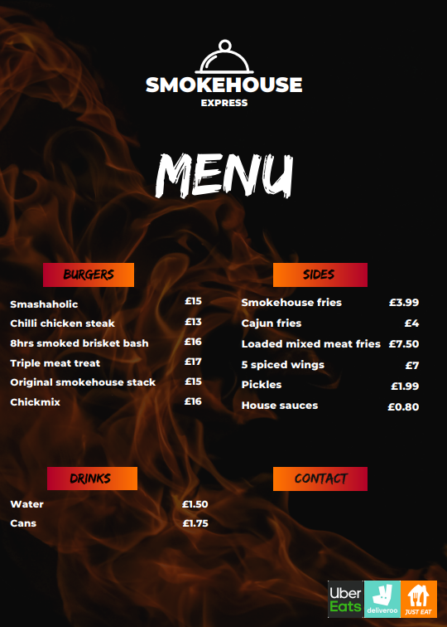
Appendix 1 – Menu

Appendix 2 – Burger box single or sides single packaging
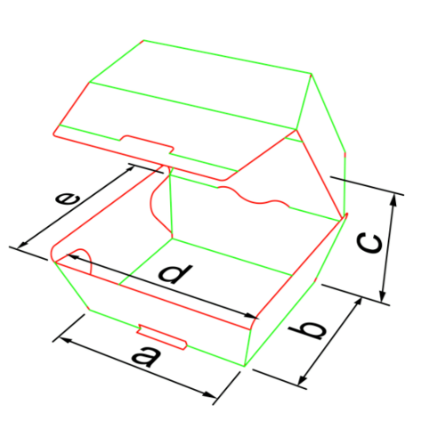

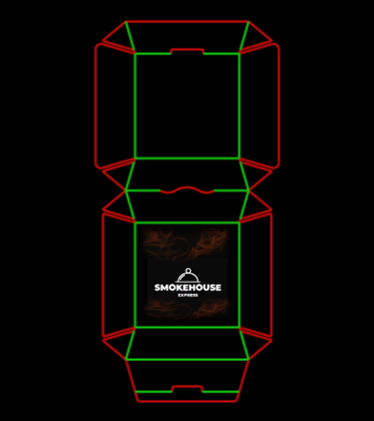
Appendix 3 – burger meal box packaging
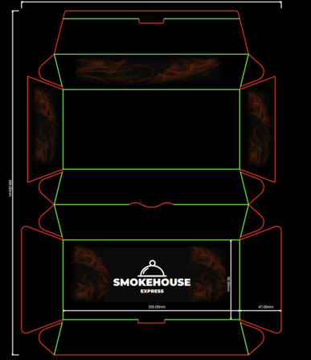

Appendix 4 – Paper bag packaging
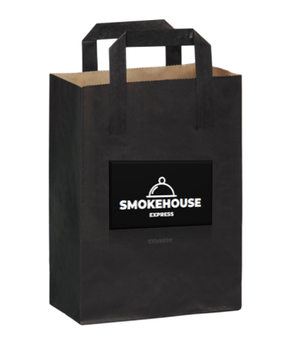

Appendix 5 - Flyer
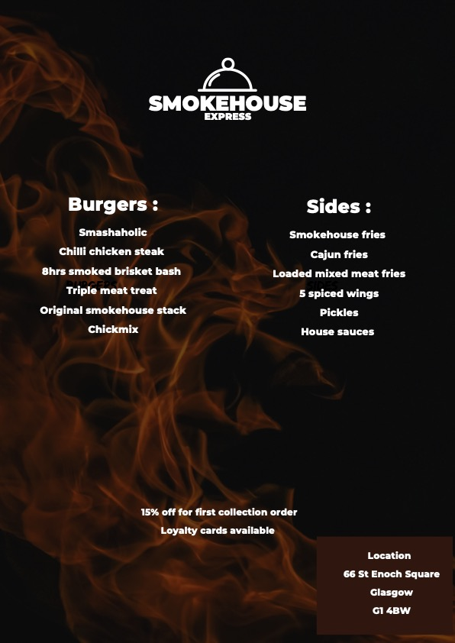

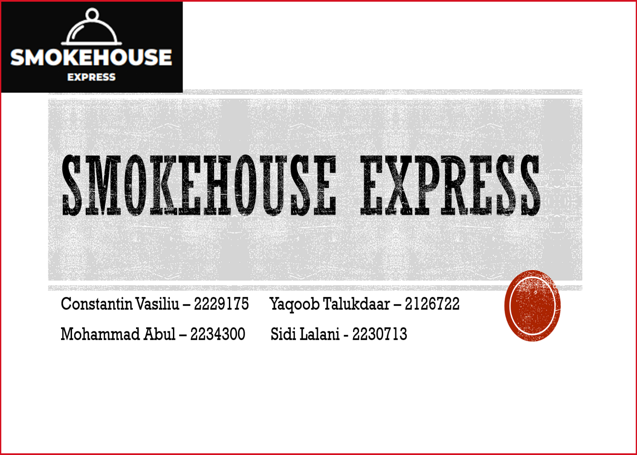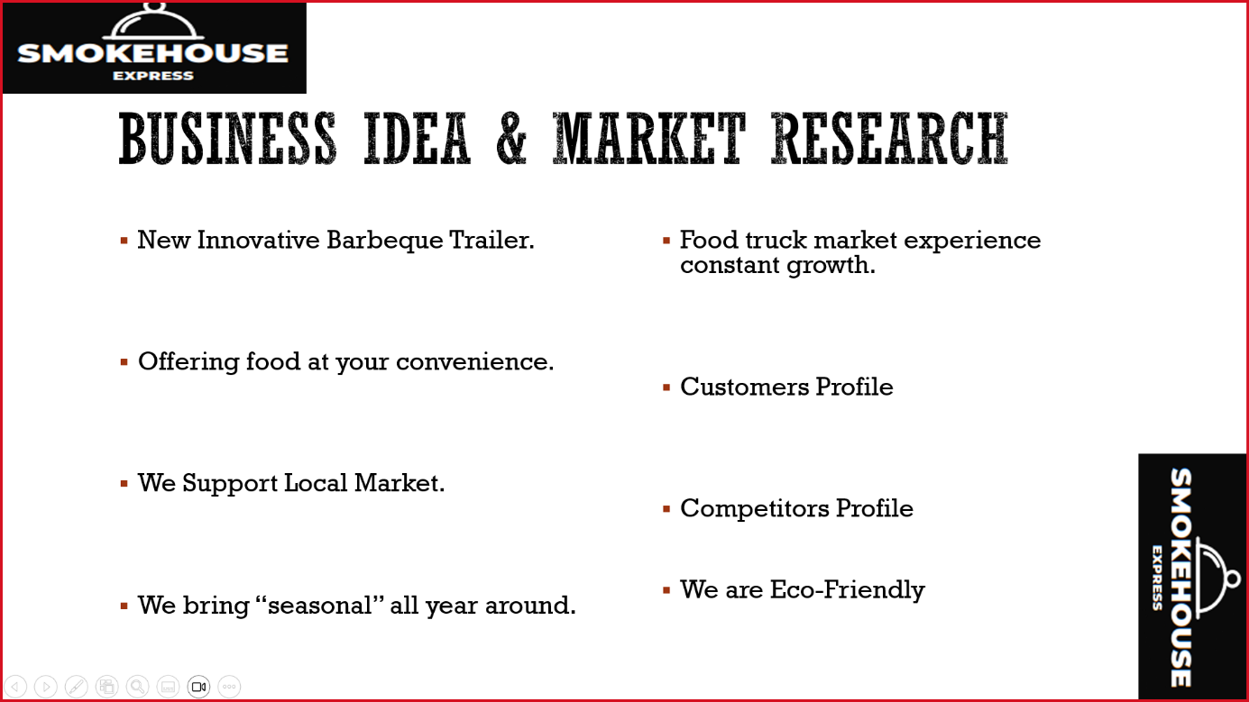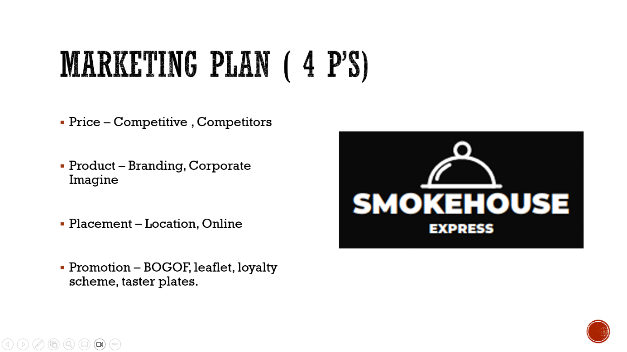
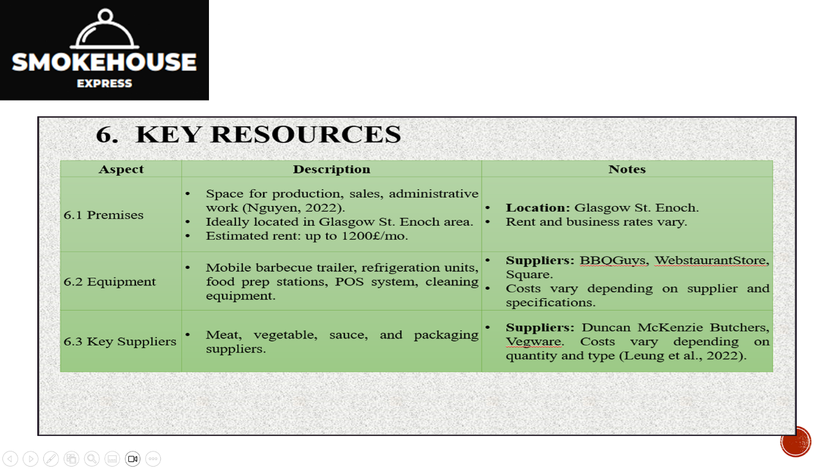
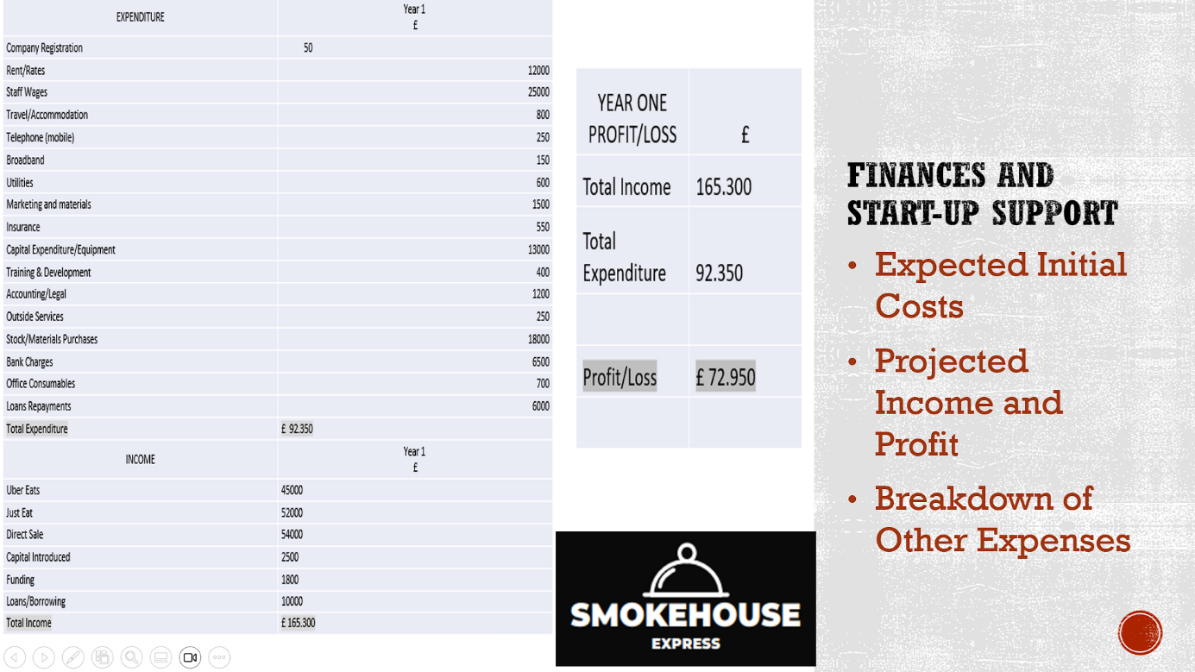
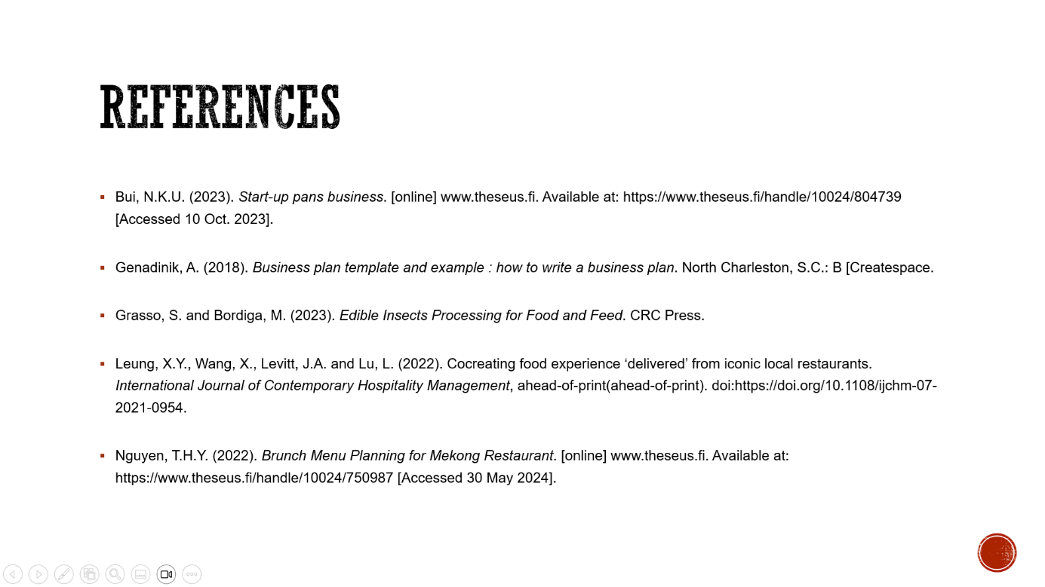

REFERENCE LIST:

Bui, N.K.U. (2023). Start-up pans business. [online] www.theseus.fi. Available at: https://www.theseus.fi/handle/10024/804739 [Accessed 10 Oct. 2023].
Genadinik, A. (2018). Business plan template and example : how to write a business plan. North Charleston, S.C.: B [Createspace.
Grasso, S. and Bordiga, M. (2023). Edible Insects Processing for Food and Feed. CRC Press.
Leung, X.Y., Wang, X., Levitt, J.A. and Lu, L. (2022). Cocreating food experience ‘delivered’ from iconic local restaurants. International Journal of Contemporary Hospitality Management, ahead-of-print(ahead-of-print). doi:https://doi.org/10.1108/ijchm-07-2021-0954.
Nguyen, T.H.Y. (2022). Brunch Menu Planning for Mekong Restaurant. [online] www.theseus.fi. Available at: https://www.theseus.fi/handle/10024/750987 [Accessed 30 May 2024].
McGill, M.E. and Slocum, J.W., 1994. The smarter organization: How to build a business that learns and adapts to marketplace needs. John Wiley & Sons.

Palonen, J., 2022. Developing a customer value proposition for the street food segment: Case Teuvan Keitintehdas.

Teyin, G. and Seçim, Y., 2023. Opinions of Kitchen Workers on Industrial Kitchen Planning. Journal of Culinary Science & Technology, 21(2), pp.328-341.

Gopi, B. and Samat, N., 2020. The influence of food trucks' service quality on customer satisfaction and its impact toward customer loyalty. British Food Journal, 122(10), pp.3213-3226.

Miah, N. and Mahmud, M., 2023. The marketing accomplishment of good food: from kitchen to market.

Asim, Z., Shamsi, I.R.A., Wahaj, M., Raza, A., Abul Hasan, S., Siddiqui, S.A., Aladresi, A., Sorooshian, S. and Seng Teck, T., 2022. Significance of sustainable packaging: A case-study from a supply chain perspective. Applied System Innovation, 5(6), p.117.

Beynon-Davies, P., (2019). Business information systems. Bloomsbury Publishing. Available at: https://books.google.co.in/books?hl=en&lr=&id=aB5HEAAAQBAJ&oi=fnd&pg=PP1&dq=importance+of+company+registration+in+UK+for+new+business&ots=axKY_7gmLy&sig=ZI75AETphZC3hG1zCvXF53UQVGU&redir_esc=y#v=onepage&q&f=false

Blank, S. and Dorf, B., (2020). The startup owner's manual: The step-by-step guide for building a great company. John Wiley & Sons. Available at: https://books.google.co.in/books?hl=en&lr=&id=3p_ODwAAQBAJ&oi=fnd&pg=PR7&dq=how+insuarnce++helps+new+stratups&ots=eQnFxje1Qm&sig=S3Td3AwWGqbQgNnxa9V3WSXp0O0&redir_esc=y#v=onepage&q=how%20insuarnce%20%20helps%20new%20stratups&f=false

Campbell, C. and Ferris, D., (2024). Business Tax in the UK: Everything You Need to Know. [online] NerdWallet UK. Available at: https://www.nerdwallet.com/uk/business/business-tax/#:~:text=Profits%20under%20%C2%A350%2C000%3A%20You.

Enes, K. and Koşan, L., (2024). Using time-driven activity-based costing in restaurant business: Levelled application of a case study. Heliyon, 10(4).Available at: https://www.cell.com/heliyon/pdf/S2405-8440(24)01188-5.pdf

Giombelli, G.P. and Triches, R.M., (2020). Public food procurement for restaurants of Federal Universities in Brazil: advances and setbacks in the implementation of sustainability transition. Agroecology and sustainable food systems, 44(4), pp.490-508.Available at:https://www.researchgate.net/profile/Rozane-Triches/publication/335752091_Public_food_procurement_for_restaurants_of_Federal_Universities_in_Brazil_advances_and_setbacks_in_the_implementation_of_sustainability_transition/links/5d7c483892851c87c388096a/Public-food-procurement-for-restaurants-of-Federal-Universities-in-Brazil-advances-and-setbacks-in-the-implementation-of-sustainability-transition.pdf?origin=journalDetail&_tp=eyJwYWdlIjoiam91cm5hbERldGFpbCJ9

Inman, P. (2024). UK inflation: which goods and services have changed most in price? The Guardian. [online] 22 May. Available at: https://www.theguardian.com/business/article/2024/may/22/uk-inflation-which-goods-and-services-have-changed-most-in-price#:~:text=The%20UK [Accessed 25 May 2024].

Miller, A., (2020). Development through vocational education. The lived experiences of young people at a vocational education, training restaurant in Siem Reap, Cambodia. Heliyon, 6(12).Available at: https://www.cell.com/heliyon/pdf/S2405-8440(20)32608-6.pdf

Hugh Grierson Organic. (2022). Buy Organic Beef - Hugh Grierson Organic - delivery available. Available at: https://www.hughgrierson.co.uk/organic-beef/ [Accessed 31 May 2024].

St Enoch. (2024). Home - St Enoch - Shopping Centre in Glasgow City Centre. Available at: https://st-enoch.com/ [Accessed 31 May 2024].
Holysmokes-bbq.co.uk. (2024). Holy Smokes BBQ London- Eleanor street. Available at: https://holysmokes-bbq.co.uk/ [Accessed 31 May 2024].

‌Namastebydelhidarbar.com. (2024). Our Menu | Namaste by Delhi Darbar. Available at: https://www.namastebydelhidarbar.com/menus/#main [Accessed 31 May 2024].

‌Squarebird (2023). SL Recycling. [online] SL Recycling. Available at: https://www.slrecyclingltd.co.uk/why-do-we-recycle-cardboard-the-benefits-of-recycling-cardboard/#:~:text=If%20cardboard%20was%20to%20be,the%20environment%20is%20heavily%20reduced. (Accessed 31 May 2024].

Lord, C., Bates, O., Friday, A., McLeod, F., Cherrett, T., Martinez-Sykora, A. and Oakey, A. (2023). The sustainability of the gig economy food delivery system (Deliveroo, UberEATS and Just-Eat): Histories and futures of rebound, lock-in and path dependency. International Journal of Sustainable Transportation, 17(5), pp.490-502.

